Best Practice Case submitted to WHO from Georgia: Progress towards ART and viral suppression targets through implementing treat all policy in the country of Georgia

Dear Mrs Jakab (WHO), Dear Mr. Sands (The Global Fund)
Dear Mr. Saldanha (UNAIDS)
Dear Ministers,
Dear hosts …
First of all, please accept my sincere gratitude for inviting me to this very important Ministerial Policy Dialogue that, I am sure, will have strong positive impact on the control of HIV epidemic in Europe. It is the first time that such attention is placed on the region where, despite considerable efforts, the HIV epidemic in on the rise. Also, Georgia has managed to keep its epidemic low, if before the major route of transmission was injecting use of drugs, during the last several years the sexual transmission route became dominant, especially among men who have sex with men.
The country has prioritized Treatment as Prevention approach for HIV epidemic control and the best practice case submitted by us is related to ARV treatment.
Georgia has universal health care program enjoyed by all citizens since 2013. Although, with support of the Global Fund and increasing state contributions, the universal access to HIV treatment and care is guaranteed for all included the people living in conflict-affected regions since 2004. The WHO Treat All guideline released in September 2015 gave the green light for the country to remove all limitations for ART eligibility and. Since than all People living with HIV receive quality care regardless of CD4 cell count, risk behavior, gender or ethnicity.
Annual Global AIDS Monitoring (GAM) reports show that over the last decade Georgia has the highest ART coverage (81% of all diagnosed people) in the EECA. 90% target of viral suppression was nearly reached among persons on ART – overall 87% (3598/4144) in 2017. Mobile ART teams support close monitoring of PLHIV on ART and their retention in care. Strong collaboration between HIV and tuberculosis services ensures effective management of TB/HIV co-infected patients, with Georgia showing highest in the region for ART coverage among person with known TB/HIV status. Hepatitis care has been fully integrated in HIV care. For HIV/HCV co-infected persons free HCV treatment is universally available since 2011 with the Global Fund’s support. In 2015 with the support of U.S. CDC and a private pharmaceutical manufacturer Gilead, Georgia launched the world’s first hepatitis C elimination by 2020, and from that point all people, including HIV/HCV co-infected persons now receive direct acting antivirals for free. As of today, About 1/3 of population is already screened on HCV and 48,000 HCV positive people were enrolled in HCV treatment program which is about 35% of the elimination target. The comprehensive package of care in Georgia also includes support services provided both by healthcare workers and by community-based self-support organizations.
Along with ART, another best practice case of Georgia is related to OST. Country was one of the first in our region to start Opiate Substitution Treatment program with support of the Global Fund (in 2005), including in prisons and since July 2017 this service is fully funded by the government and offered to anyone in need. After the transition to domestic funding the State removed all financial barriers and has achieved the coverage rates as high as 1/3 of total projected number of injecting drug users (up to 8000 people).
Last year (2017), Georgia was the first country in our region to introduce PrEP among MSM community also.
The most critical challenge for our HIV national program is low detection rate and late diagnosis. In order to improve early detection of the disease several innovative interventions were supported through the Global Fund Program, including using saliva tests for community testing, self-testing and new models of primary care based integrated screening programs.
Integration of 3 diseases: The hepatitis C elimination program has created a unique momentum for scale-up detection of HIV, HCV and TB cases in Georgia. In 2018, Georgia started a pilot project in one of the highest prevalence regions of Georgia (Samegrelo) to test the potential integration of HIV, TB and HCV screening services at the regional level and to engage primary healthcare providers in detection and management of all three diseases under the "one umbrella."
We hope that this new interventions highlighted in the National Strategic Plan (NSP) for 2019-2022 will support acceleration of HIV case detection in the country and will improve our position for the first 90. Although, it will require considerable additional efforts and resources to sustain the sound achievements that the country has for the second and third 90th.

Brief explanation note (not for sharing with WHO):
Georgia is among low HIV prevalence countries, with concentrated HIV epidemic among Key Affected Populations – people who inject drugs (PWID), female sex workers (FSW) and men who have sex with men (MSM).
First case of HIV was detected in 1989 in Georgia.
Since the beginning of the epidemic, 7 012 individuals have been registered with HIV, out of them 1 440 have died and 4 310 individuals are on ARV treatment. Estimated number of adults living with HIV was 10500 in 2017. For the past 5 year, annually, there were 500 to 719 new cases registered. However, in 2017, the number of newly registered HIV cases declined by 12%. The national level HIV prevalence among adult population is 0.4 (2017).

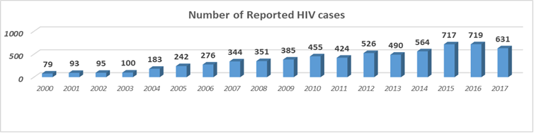

Antiretroviral (ARV) treatment was initiated in 2004 with the Global Fund to fight AIDS, Tuberculosis and malaria (TGF).
Before 2011 ART enrolment CD4 cell’s number based criteria was CD4 count <350 cells/mm³ (less than 350 cells in microliter); From 2013 the threshold for the ART initiation became <500 cells/mm^{3;}
Since September 2015 the country started implementation of WHO Treat All Strategy and has removed all ART enrolment criteria (no CD4 count based evaluation is required) and all people living with HIV are offered free ART.
Distribution of HIV cases by the transmission routes indicate that more than half of the cases are attributed to the sexual transmission route (45.6% hetero and 10.7% homo), followed by the injecting use of drugs (41%).
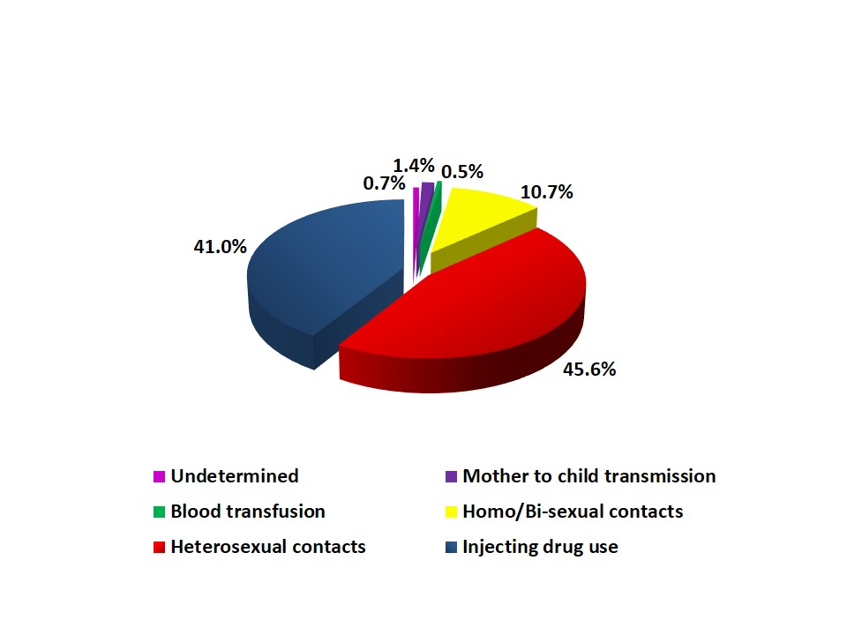

UNAIDS 90-90-90
90% of people living with HIV is aware of their status
90% of them are enrolled in HIV treatment and care
90% of those who are on treatment have HIV virus suppressed (viral load test result shows <1000 in mcl).
Georgia’s position for 90-90-90 by the end of 2017: 48%-81%-89%

PrEP – pre-exposure HIV prophylactics – the most recent evidence based intervention to prevent HIV transmission among the Key Affected Population (KAP) groups, first of all among MSM.
At present with the Global Fund Support the country pilots PrEP among MSM. 58 MSM are enrolled in the pilot program with the aim to reach 100 people. During 2019 the number will be increased up to 200.

Half-pager requested by WHO:

“Treat all” Strategy in Georgia
Georgia has universal access to HIV care and treatment in the country, enjoyed by all citizens, included in conflict-affected regions. Georgia was the first in the region to introduce "treat all" strategy, and currently, there are 4.3 thousand individuals on the treatment. Besides, HIV testing and counseling services, condom and needle and syringe distribution and opiate maintenance treatment are among other preventive measures freely available for the key affected community groups and mostly delivered by, or with the close engagement of community-based organizations.
Introduction of this approach was linked to not only financial constraints, but also with difficulties in service provision, stigma among public and other factors. Georgia responded to those challenges by being innovative: We have introduced "one umbrella" approach to detection, care, and treatment of Hepatitis C, HIV and TB. As we were the first country in our region to embark on a challenge to eliminate hepatitis C, we have used this channel and integrated HIV detection into this program. Under the on-going pilot, we have primary care doctors providing focused screening for all 3 diseases and referring patients to needed care, which is also offered for free. These innovations touch financing schemes as well: local government bodies provide financial incentives to primary care specialists to achieve higher coverage rates.
One of the primary results of this approach is that Georgia has managed to keep its HIV epidemic low, in spite of all the challenges: such as proximity with high prevalence counties, general raise of HIV epidemics in EECA, changing patterns of HIV transmission and others.
With the transition from Global Fund, the financial burden of HIV response is substantially increased to the state. However, Georgia has embarked on an ambitious goal to eliminate hepatitis C, achieve 90-90-90 for HIV and stop TB. This ambitious goal is entrenched in the appropriate Government strategies, such as the National Strategic Plan for HIV/AIDS 2019-2022, which is drafted with the target to achieve 90-90-90 and government is willing to continue increasing investment into this goal.

Brief explanation note for the Minister:
Georgia is among low HIV prevalence countries, with concentrated HIV epidemic among Key Affected Populations – people who inject drugs (PWID), female sex workers (FSW) and men who have sex with men (MSM).
First case of HIV was detected in 1989 in Georgia.

Since the beginning of the epidemic, 7 012 individuals have been registered with HIV, out of them 1 440 have died and 4 310 individuals are on ARV treatment. Estimated number of adults living with HIV was 10500 in 2017. For the past 5 year, annually, there were 500 to 719 new cases registered. However, in 2017, the number of newly registered HIV cases declined by 12%. The national level HIV prevalence among adult population is 0.4 (2017).

Antiretroviral (ARV) treatment was initiated in 2004 with the Global Fund to fight AIDS, Tuberculosis and malaria (TGF).
Before 2011 ART enrolment CD4 cell’s number based criteria was CD4 count <350 cells/mm³ (less than 350 cells in microliter); From 2013 the threshold for the ART initiation became <500 cells/mm^{3;}
Since September 2015 the country started implementation of WHO Treat All Strategy and has removed all ART enrolment criteria (no CD4 count based evaluation is required) and all people living with HIV are offered free ART.
Distribution of HIV cases by the transmission routes indicate that more than half of the cases are attributed to the sexual transmission route (45.6% hetero and 10.7% homo), followed by the injecting use of drugs (41%).

UNAIDS 90-90-90
90% of people living with HIV is aware of their status
90% of them are enrolled in HIV treatment and care
90% of those who are on treatment have HIV virus suppressed (viral load test result shows <1000 in mcl).
Georgia’s position for 90-90-90 by the end of 2017: 48%-81%-89%

PrEP – pre-exposure HIV prophylactics – the most recent evidence based intervention to prevent HIV transmission among the Key Affected Population (KAP) groups, first of all among MSM.
At present with the Global Fund Support the country pilots PrEP among MSM. 58 MSM are enrolled in the pilot program with the aim to reach 100 people. During 2019 the number will be increased up to 200.

