Title of project: Integrating HCV screening and simplified treatment services in primary healthcare

Project Lead: Tengiz Tsertsvadze, MD, PhD, Infectious Diseases, AIDS and Clinical Immunology Research Center
Collaborators: Selected primary healthcare providers, representatives of MoLHSA, NCDC, CDC, LIFER, ECHO.

Executive summary:

- HCV care will be integrated at 4 primary health care (PHC) sites
- “One-stop shop” approach will be used, by which patients will receive all HCV screening and care services in selected PHCs, without need for going to other locations
- Necessary paperwork and registration with the MoLHSA will be completed by PHC’s dedicated case managers on behalf of patients
- Extension for Community Healthcare Outcomes (ECHO) telemedicine model will be used to train and support primary healthcare providers. Training curriculum developed by the clinical group of the national elimination program will be used. Regular teleECHO videoconferencing will be conducted every two weeks to provide primary care providers with advice and clinical mentoring.
- Primary healthcare facilities will provide care to HCV treatment-naïve patients with mild fibrosis using simplified diagnostics and treatment monitoring approach, while persons with more advanced liver damage will be referred to specialized clinics in close proximity. Persons with FIB-4 score >1.45 will be referred to specialized clinics for further assessment. Persons with FIB-4 score <1.45 will continue care at PHCs
- The plan is to screen a total of 12,500 persons in 4 selected PHCs (5,000 persons in Tbilisi and 2,500 persons per each non-urban site).
- Pre-treatment and treatment monitoring approach will be simplified for PHCs.
- Integrating HCV screening and treatment services in primary healthcare will simplify current modalities and will be beneficial for patient and the program. It is expected that integrated model will increase diagnosis and linkage to care and eventually will improve treatment uptake

Rationale/Background for project:

Integration of screening and treatment services in primary healthcare offers opportunity to eliminate barriers and to improve engagement in the entire continuum of HCV care from testing through cure. It has been shown internationally that integrated models of care are effective ensuring high diagnosis, treatment and cure rates.

Project design:

This will be prospective project of integrated screening and treatment program in primary healthcare settings. A total of 4 primary healthcare clinics (PHC), including 1 in the capital city of Tbilisi and 3 in other locations (Khashuri, Telavi, and Senaki), will be involved in the program.

So called “one stop shop” approach will be used, by which patients will receive all HCV screening and care services in selected PHCs, without need for going to other locations. After confirming diagnosis, patients will be informed about diagnosis, they will be given information about the disease and treatment options and will be offered enrollment in HCV treatment within elimination program. Necessary paperwork and registration with the MoLHSA will be completed by PHC’s dedicated case managers on behalf of consenting patients. Registered patients will be treated at selected PHCs by their regular primary care providers under the supervision of IDACIRC.
PHC personnel will be trained on hepatitis C related issues through accredited training program using curricula developed by the clinical group of the national elimination program. This curriculum covers various aspects related to hepatitis C, including epidemiology, natural history, treatment and details on the national elimination program.

The plan is to screen a total of 12,500 persons in 4 selected PHCs (5,000 persons in Tbilisi and 2,500 persons per each non-urban regional PHCs). Based on 7.7% HCV antibody prevalence and 5.4% HCV RNA prevalence estimated 963 persons will be positive for anti-HCV and 675 will have chronic hepatitis C.

Primary healthcare facilities will provide care to HCV treatment-naïve patients with mild fibrosis using simplified diagnostics and treatment monitoring approach, while persons with more advanced liver damage will be referred to specialized clinics in close proximity.

Pre-treatment evaluation
Figure 1 provides simplified algorithm for pre-treatment evaluation. Briefly, persons with confirmed chronic HCV infection will be assessed for degree of liver damage using FIB-4 score (for this purpose complete blood count, ALT and AST will be measured). Persons with FIB-4 score >1.45 will be referred to specialized clinics for further assessment. Persons with FIB-4 score <1.45 will continue care at PHCs and will undergo additional examinations as per simplified algorithm (Figure 1). Suggested pre-treatment evaluation is tailored to patients with mild fibrosis and examinations are limited to only essential ones.

Figure 1. Algorithm for pre-treatment evaluation

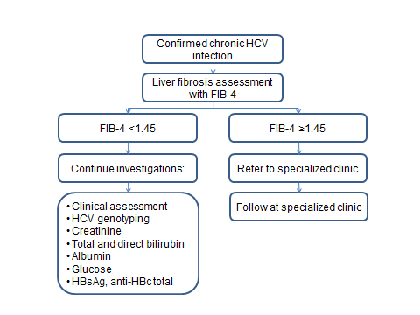

Monitoring during antiviral therapy
Treatment monitoring approach will be simplified for PHCs, which will include the following scheme:

- Every 4th week participant will come to the clinic for clinical assessment and will be given a bottle containing LDV/SOF.
- Every 4th week participant receiving LDV/SOF without Ribavirin will be tested for ALT only, while participant receiving LDV/SOF in combination with Ribavirin will be tested for ALT and complete blood count
- Quantitative HCV viral load testing will be performed only at 12-24 weeks following completion of therapy.
- To ensure medication adherence and to monitor for adverse events and potential drug-drug interactions with LED/SOF, nurse will call each week to the patients until end of treatment.
Figure 2. Algorithm for HCV treatment monitoring

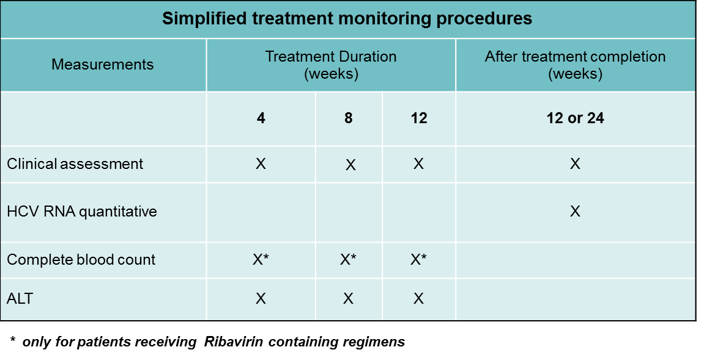

Infectious Diseases, AIDS and Clinical Immunology Research Center (IDACIRC) together with other partners will provide guidance and supervision on integrated model implementation. This will include:

- Training on PHC personnel on hepatitis C related issues using curricula developed by the clinical group of the national elimination program. This curriculum covers various aspects related to hepatitis C, including epidemiology, natural history, treatment and details on the national elimination program.
- Utilizing the Extension for Community Healthcare Outcomes (ECHO) telemedicine model to train and support primary healthcare providers. Regular teleECHO videoconferencing will be conducted every two weeks to provide primary care providers with advice and clinical mentoring.
- Establishing monitoring and evaluation (M&E) framework for assessing program effectiveness.

Expected outcomes

Integrating HCV screening and treatment services in primary healthcare will simplify current modalities and will be beneficial for patient and the program. It is expected that integrated model will increase diagnosis and linkage to care and eventually will improve treatment uptake.

