The US covert biological weapons program

The US grossly violates the UN Biological Weapons Convention and tests possible biological weapons at Pentagon’s laboratories across the world. Acting under diplomatic cover and under the pretext of non-proliferation, the US Department of Defense has developed and funded dangerous programs for research on pathogens and toxins, which can be easily weaponized. The Defense Threat Reduction Program, run by the Pentagon’s Defense Threat Reduction Agency (with $2.1 billion budget for biological threat reduction projects between 1997-2014 – for reference Archive Folder, DoD Budget for BTR File, p. 41), serves as a secret biological weapons program. Another Pentagon Agency – DARPA runs a highly controversial $ 65 million program for gene editing in insects and rodents. This dangerous dual-use technology, if misused, could lead to employment of genetically modified insects as weapons of bio-war. Evidence prove that the Pentagon has been carrying out experiments with genetically modified insects, as well as especially dangerous pathogens research in Georgia and Ukraine.

US DoD Agencies with military research projects

Experiments at Pentagon’s Laboratories outside of the US:

- Georgia – Lugar Center:
1.1. Diplomatic cover of the program granted by the USA-Georgia Umbrella agreement (diplomatic status of the US personnel, contractors and their vehicles, working on the Pentagon program in Georgia) – for reference: Archive Folder - Georgia-Agreements Subfolder
1.2. USAMRU-G – US military scientists and microbiologists perform tests on pathogens, insects and bats in the laboratory which is Biosafety Lever 3, meaning that they operate with especially dangerous pathogens and bio agents (USAMRU-G subfolder); scientists, previously engaged in biological weapons programs, are also commissioned to the program (for reference CH2M subfolder, Threat Reduction File)
1.3. The Pentagon US contractors have a long history and experience in world outbreaks like Ebola virus in West Africa or have been previously engaged in the US biological weapons program):

DTRA contractors working at Lugar Center, Georgia (2008 – present)
    - Bechtel National – federal contracts under DTRA program:

https://govtribe.com/contract/idv/dtra0101d0011
The company declined the contract because of technical problems and biosafety issues with the construction of the Lugar Center building. The contract was transferred to CH2M Hill Inc. (which is on the Top100 list of US government contractors).

1.3.2 CH2M Hill Inc. – $336.9 m DTRA contracts for the Pentagon’s projects in Georgia, Uganda, Tanzania, Iraq, Afghanistan, South East Asia. Half of that sum ($161.1 m) was allocated for The Lugar Center under the contract for Georgia.

All DTRA contracts of CH2M Hill – $336.9 million (4/8/08 - 1/31/13 (4 years) with extension)
https://govtribe.com/contract/idv/hdtra108d0008

Georgia – $161.1 million BTRP GEORGIA (1/6/11 - 12/31/17 (6 years)
https://govtribe.com/contract/award/hdtra108d0008-0002?facets=&page=2

West Africa – Uganda – $42.7 million (8/11/16 - 4/2/19 (2 years)
https://govtribe.com/contract/award/hdtra108d0008-0011

According to CH2M Hill’s presentation of their project in Georgia, the company has employed former bio warfare scientists to work at Lugar Center (for reference CH2M Hill subfolder)
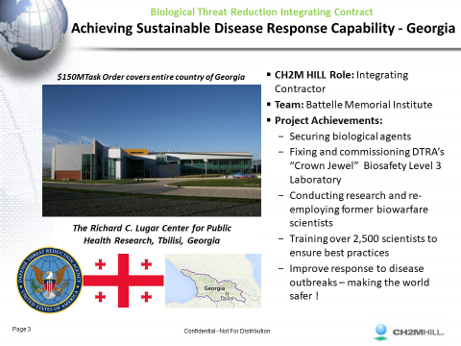

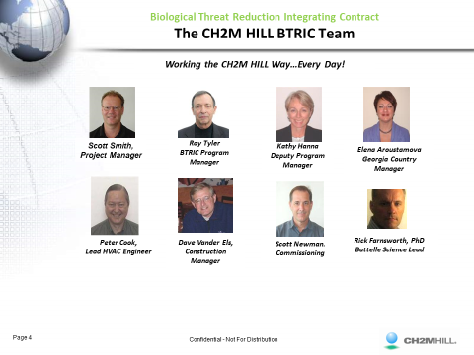
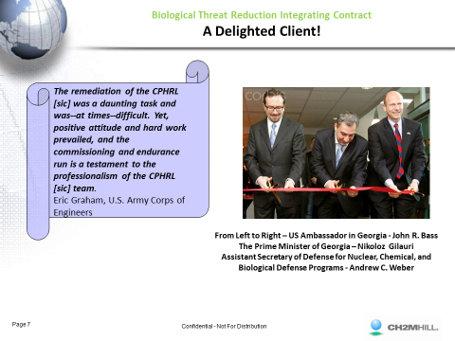
Andrew C. Weber, then Assistant Secretary of Defense, is currently working for Metabiota (another US company, commissioned by the Pentagon under the DTRA program to manage the laboratories in Georgia and Ukraine)

https://www.ch2m.com/what-we-do/environment/threat-reduction-health-security

http://www.iqls.net/?Pn=Assignment_View&Id=60
http://www.iqls.net/?Pn=Article_View&Article_Id=150
https://www.linkedin.com/in/ned-pennock-a6559a64/

CH2M Hill - Research for the Pentagon on software for simulations of release of chemical and biological weapons inside and outside of a building
http://www.dtic.mil/dtic/tr/fulltext/u2/a440998.pdf
ABSTRACT: This project reviewed existing technologies that could protect the supply air systems of buildings from chemical/biological contaminants. This CH2M HILL research: (1) analyzed existing filtration technologies for building heating, ventilating, and air-conditioning systems, and (2) examined numerical models for predicting air flows in and around buildings during a release of chemical or biological agents. Researchers identified modeling products that would depict the results of a chem/bio release, and rated the models on resolution, cost, convenience, and accuracy. Four models were examined in depth, two for external and two for internal releases. The results provide a modeling approach that can be used to simulate the dispersion of contaminants inside buildings.

1.3.3 TMC – Technology Management Company – Global Professional Services:
Contracts with the Pentagon for the Lugar Center:
- with WRAIR – $22.5 m
https://tmcgps.com/news/tmc-continues-to-deliver-technical-services-in-the-republic-of-georgia
https://tmcgps.com/news/tmc-awarded-georgian-laboratory-information-management-system-prime-contract
https://govtribe.com/project/walter-reed-army-institute-of-research-wrair-bioresearch-support-to-the-lugar-center-the-republic-of-georgia
https://govtribe.com/project/a-bioresearch-scientific-support-in-tbilisi-republic-of-georgia/activity
https://www.fbo.gov/index?s=opportunity&mode=form&tab=core&id=c8f0db2decf4fa16c676b4da877e45f4&_cview=0

- With DTRA- $ 1.2 m (Georgia Laboratory Information Management System in support of the Cooperative Biological Engagement Program)
https://govtribe.com/project/georgia-laboratory-management-syst
https://govtribe.com/contract/award/hdtra117c0041
- With Department of the Army – $1.8 m (SCIENCE SERVICES TO SUPPORT THE LUGAR CENTER, GEORGIA)
https://govtribe.com/contract/idv/w81xwh16d0022
https://govtribe.com/contract/award/w81xwh16d0022-0004
- With the Navy – interpreters in Georgia
https://govtribe.com/contract/award/w564kv15c0183

    - Metabiota – DTRA program in Georgia and Ukraine

Contract with DoD $18.4 m
https://govtribe.com/contract/award/hdtra114c0104

Contract with DoD $3.1 m – Ebola in Sierra Leone
https://govtribe.com/contract/award/hdtra112c0024

Contract with Department of Homeland Security
https://govtribe.com/contract/award/hshqdc13cb0048
VALIDATION OF ANIMAL MODELS FOR VIRAL HEMORRHAGIC FEVER SYNDROME USING ACUTE HUMAN DATA

https://www.defense.gov/News/Contracts/Contract-View/Article/606852/
DTRA - Metabiota Inc., San Francisco, California, was awarded a modification P00017 to previously awarded contract HDTRA1-14-C-0104 under the terms of broad agency announcement HDTRA1-09-14-FRCWMD-BAA (Fundamental Research to Counter Weapons of Mass Destruction). This modification increases the value of the option period by $7,097,401. This contract is for scientific and technical consulting services. Work will be performed in U.S. and overseas locations, and is expected to be complete May 15, 2016. Fiscal 2015 Cooperative Threat Reduction funds in the amount of $5,024,564 were obligated on the option period. The Defense Threat Reduction Agency in Fort Belvoir, Virginia is the contracting activity. (Awarded May 15, 2015)

http://www.sbaic.org/member-profile/Metabiota
Metabiota products and services include: global field-based biological threat research, pathogen discovery, outbreak response and clinical trials.
Metabiota Inc specializes in pandemic threat management. The Company investigates infectious disease through pathogen discovery, disease detection, and threat characterization.
Countries:
Global, Australia, Cambodia, Cameroon, Canada, Central African Republic, Chad, China, Congo, Congo (Zaire), Cote d'Ivoire (Ivory Coast), Gabon, Georgia, Guinea, Iraq, Jordan, Kazakhstan, Kenya, Laos, Liberia, Malaysia, Nigeria, Senegal, Sierra Leone, Singapore, South Africa, Uganda, Ukraine, United States of America, Vietnam

Report on Metabiota’s work in Sierra Leone on the Ebola crises

A July 17, 2014 report drafted by the Viral Hemorrahagic Fever Consortium, a group which includes Tulane University, lays the blame on Metabiota Inc. for issues at the lab, saying that the company is failing to abide by an existing agreement on how to report test results and bypassing the Sierra Leonean scientists working there. The report also raises the possibility that Metabiota is culturing blood cells at the lab, something the report says is dangerous, as well as misdiagnosing healthy patients.
https://www.documentcloud.org/documents/2752219-20140717-Report-on-Ebola-Response-by-Viral.html#document/p1/a282170

Metabiota emplpoyees – former Pentagon servicemen
- Andrew Weber, head of Global partnerships for Metabiota and former Assistant Secretary of Defense for Nuclear, Chemical and Biological Defense Programs, took part in Project Sapphire
https://www.belfercenter.org/publication/former-assistant-secretary-defense-andrew-weber-joins-belfer-center-senior-fellow
https://www.linkedin.com/in/andrew-weber-0b6a4ab6/
https://www.aaaspolicyfellowships.org/sites/default/files/pdfs/Syria%20Handout%20Agenda%20+%20Bios.pdf
https://en.wikipedia.org/wiki/Project_Sapphire

Joseph Fair, PhD –co-founder and former vice-president of Metabiota (also worked previously for the Pentagon before joining Metabiota)
http://www.centerforhealthsecurity.org/our-work/events/2014_Ebola%20Congressional%20Seminar/Speakers.html

  - Projects and experiments at Lugar Center – (for reference Lugar Center Subfolder, Georgia Annual Reports Subforder (Annual Report 2014, Annual Report 2016)

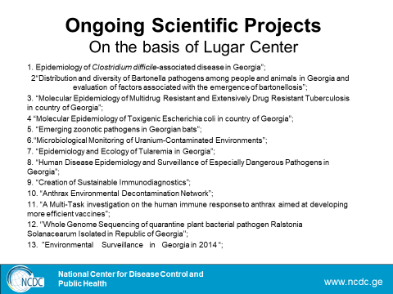
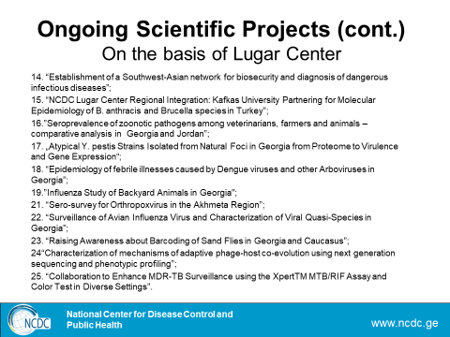

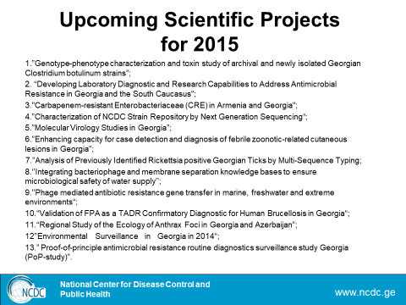

1.4.1 Sand Flies Projects (for reference Sand Flies Subfolder) –
- “Raising Awareness about Barcoding of Sand Flies in Georgia and Caucasus (project 23 – 2014 at Lugar Center)
http://www.ncdc.ge/AttachedFiles/Lugar%20Center2_5982284c-f82e-440b-8152-9efc6068cd16.pdf

The project covers large geographic area outside of Georgia – Caucasus

- SURVEILLANCE WORK ON ACUTE FEBRILE ILLNESS (AFI)”, Global Disease Detection (GDD) project component (C1), CDC,USA; Project implementation timeline: 1.09.2014 - 28.08.2014.
http://www.ncdc.ge/Category/Article/1613
Collection of Phlebotomine sand fly species will be performed as well by CDC standard light traps. Will be identified their species and all (female) sand flies will be tested on PCR to determine the infectifity rate.

- Development of Surveillance System and Control Strategy for Leishmaniasis in Georgia
http://www.ncdc.ge/Category/Article/1491 - new potential candidates will be identified for a vaccine development against VL (duration 2005-2015)
https://en.wikipedia.org/wiki/Visceral_leishmaniasis

- Epidemiology of febrile illnesses caused by Dengue viruses and other Arboviruses in Georgia (mosquitos and ticks)
http://www.ncdc.ge/Category/Article/1480

- Incrimination of Phlebotomus kandelakii and Phlebotomus balcanicus as Vectors of Leishmania infantum in Tbilisi, Georgia
http://journals.plos.org/plosntds/article?id=10.1371/journal.pntd.0001609
According to this 2012 study, the sand fly season in Georgia is exceptionally short beginning in early June, peaking in July and August, then declining to zero in early September. Since the start of the Sand Fly project at Lugar Center in 2014 though, such insects have massively spread throughout Georgia and neighboring Russia. They can be seen anytime, even in the winter, and everywhere, even in the mountains, which was not typical of sand flies before, meaning that these newly appeared species are resistant to cold and low temperatures. Sand flies are a subfamily of Drain flies, which live in drains and bathrooms, but unlike them, female sand flies bite and feed on human and animal blood. Because of their small size, they can easily pass through screens, small cracks and openings. Sand flies in Georgia and Russia live mainly indoors in bathrooms where they bite humans while naked and pose a serious hazard to human health. Sand flies carry dangerous parasites in their saliva and transmit them through a bite to humans. Dual-use experiments with insects have already been done in the US. In 2016, the Pentagon launched a special program called Safe genes for gene editing in insects and rodents. Moreover, gene editing in sand flies was one of the experiments, performed by the US National institute of health. The scientists changed the typical sand flies’ yellow color switching off the so-called yellow gene (For more on sand flies gene editing go to 4.1.1)

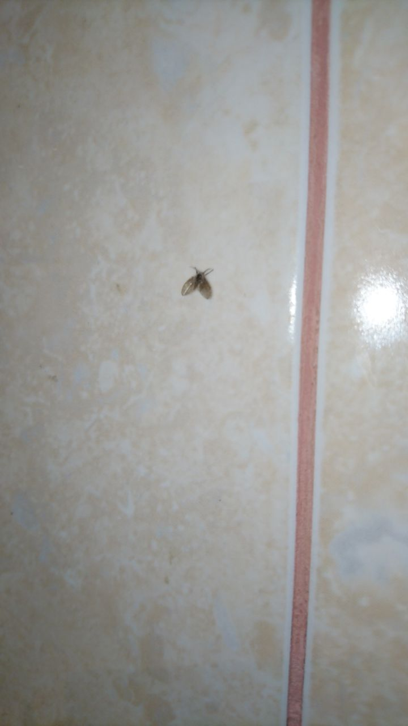

The disease, which these flies carry, is of high interest to the Pentagon. It is caused by parasites called Leishmaniasis, which live in the fly’s saliva and are transmitted in human blood by the bite of certain types of sand flies.
- Leishmaniasis (black fever) in US military personnel – 2003 Invasion of Iraq
http://media.washingtonpost.com/wp-srv/health/documents/2003LeshMedicalAdvisory.pdf
https://www.cdc.gov/mmwr/preview/mmwrhtml/mm5312a4.htm

- Walter Reed Institute (Leishmania Diagnostics Laboratory)
http://www.wrair.army.mil/OtherServices_TropMed_AandW_LDL.aspx

- Federal Project, rabbit blood for WRAIR Leishmania Diagnostics lab
https://govtribe.com/project/notice-of-intent-to-sole-source-2890/activity

- Federal Solicitations and Contracts related to Leishmaniasis
https://govtribe.com/project/a-bioresearch-scientific-support-in-tbilisi-republic-of-georgia/activity

- https://www.fbo.gov/index?s=opportunity&mode=form&tab=core&id=c8f0db2decf4fa16c676b4da877e45f4&_cview=0

- https://www.cdc.gov/mmwr/preview/mmwrhtml/mm5312a4.htm

- Sand Fly Research Peru – federal project
https://govtribe.com/project/namru-six-in-lima-peru-south-america-requires-to-develop-a-study-in-peru-the-purpose-of-this-acquisition-is-to-provide-research-and-development-services-in-support-of-the-study-co-occurrence-of-leishmaniasis-and-bartonellosis-in-the-peru-ecuador-fron

- Sand Fly Study – Peru – federal project
https://govtribe.com/contract/award/n3239815p0547

https://govtribe.com/project/to-provide-technical-and-administrative-personnel-support-for-epidemiology-and-molecular-studies-of-parasites-taking-place-in-lima-iquitos-and-puerto-moldonado-peru

- Mali – leishmania is being researched in Mali as well
https://govtribe.com/project/scientific-technical-and-administrative-staff-to-support-the-mali-icer

- Department of the Army – war fighter protection against malaria and leishmaniasis
https://govtribe.com/project/a-deployed-war-fighter-protection-dwfp-competitive-grant-pre-proposal-call-for-submissions/activity

- Sand Fly collection traps – US Navy
https://govtribe.com/contract/award/n0018915p0717
- Sand Fly Vaccine Trial – 2011 Walter Reeds Army Medical Center (for reference Sand Fly Subfolder)

- NIAID/WRAMC project "Immunogenicity and Leishmania Vaccine Potential of Sand fly Saliva in Humans"
https://govtribe.com/project/professional-administrative-and-management-support-services-12/activity

Statistics – leishmaniasis cases in Georgia, morbidity of the disease:
- 2013 – 104 cases NCDC-Georgia
- 2014 – 46 cases NCDC-Georgia
- 2015 – 68 cases NCDC-Georgia
http://www.ncdc.ge/AttachedFiles/2013_eng_2b165575-911e-4596-b6b0-f1e0f1540c6c.pdf
http://www.ncdc.ge/en-US/Statistics/StatisticalYearbook
http://www.who.int/leishmaniasis/resources/Georgia_CP_2014.pdf
- Sand Fly – life span – up to 98 days
https://www.getridoffliesguide.com/how-long-do-flies-live/

- Research on Sand Fly leishmaniasis at Lugar Center - 2016
https://www.researchgate.net/publication/303090666_Seroepidemiology_and_molecular_diversity_of_Leishmania_donovani_complex_in_Georgia
- Military Research on sand flies back in the 1980’s by USAMRIID (Sand fly could be a vector of Rift Valley Virus – a virus which, according to a declassified 1977 Army Report on the US Biological Weapons Program, was researched as a possible bio weapon) – (for reference USAMRIID1982 and USAMRIIS1987Annual Reports in Sand Fly Subfolder - Determine the RVF virus vector potential of several species of mosquitoes and sandflies from Africa, Southeast Asia, South America and the United States which are known to feed on both humans and domestic animals, p. 68)
- Transmission of Rift Valley Fever Virus by the Sand Fly, Phlebotomus duboscqi
http://www.ajtmh.org/content/journals/10.4269/ajtmh.1990.42.185
- In 1970 and 1972, tests with Sand Fly Fever were performed on humans according to partially declassified 1977 US Army report (for reference Sand Fly Subfolder, 1972 Tests – US Bioweapons Program – operation Whitecoat)
- During the Pentagon operation Whitecoat volunteers were exposed to Sand Fly Fever. Operation Whitecoat was a biodefense medical research program carried out by the United States Army at Fort Detrick, Maryland between 1954 and 1973.
https://health.mil/Search-Results?query=sand%20fly
- 1982 Research on Sand Fly Fever performed by USAMRIID – (for reference USAMRIID-Annual Report-1982-Sand Fly Fever Virus Subfolder)
The Pentagon has a long history in using insects as possible biological weapons. According to a partially declassified 1981 US Army report, the Pentagon carried out a number of operations to test insects as vectors for biological weapons. These operations were part of the US Entomological Warfare (use of insects as vectors for weaponized pathogens) under the Program for Biological Weapons of the US (for reference - Entomological Warfare Subfolder/1981 US Army Report).
Parts of the report such as “Mass production of Aedes aegypti” were not declassified, meaning that the project is still ongoing. Aedes aegypti, also known as yellow fever mosquito, was massively used in US military operations. The same type of mosquito is alleged to be the vector for dengue, chikungunya, yellow fever and Zika virus, which causes genetic malformations in newborns.

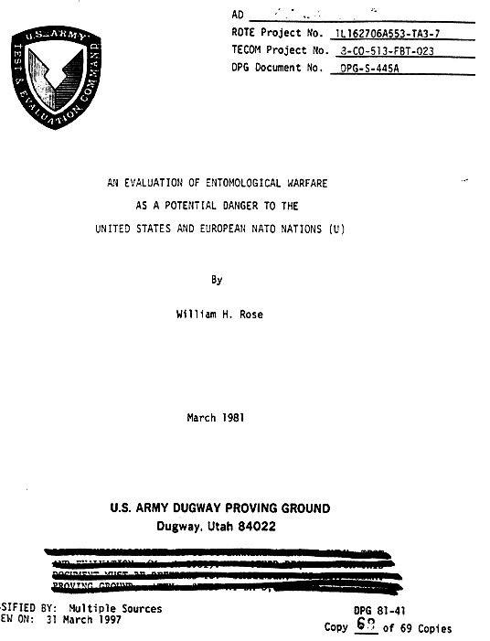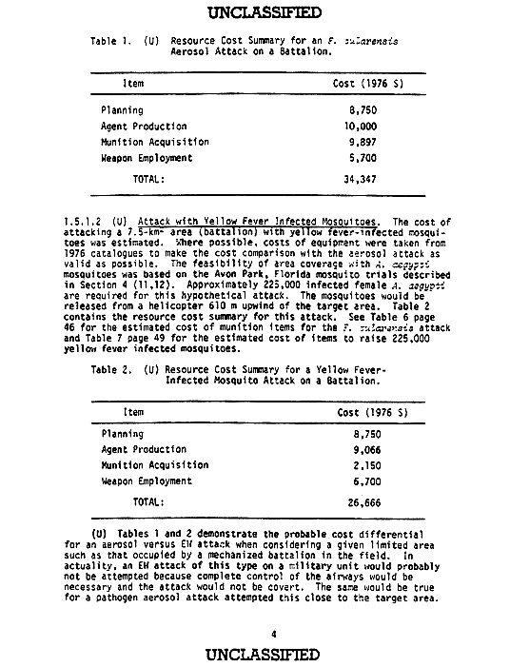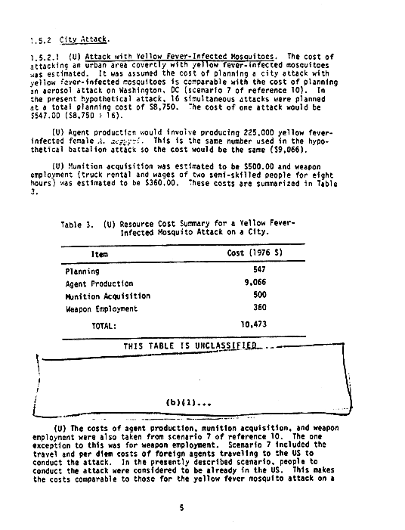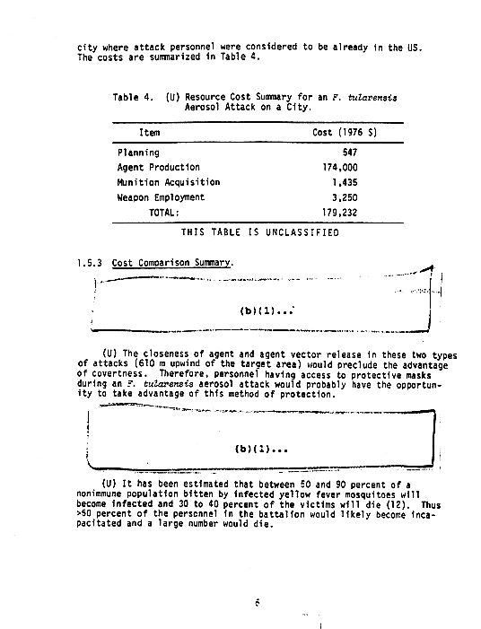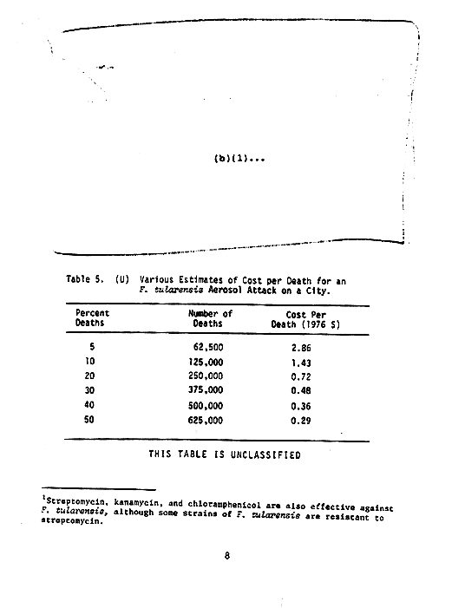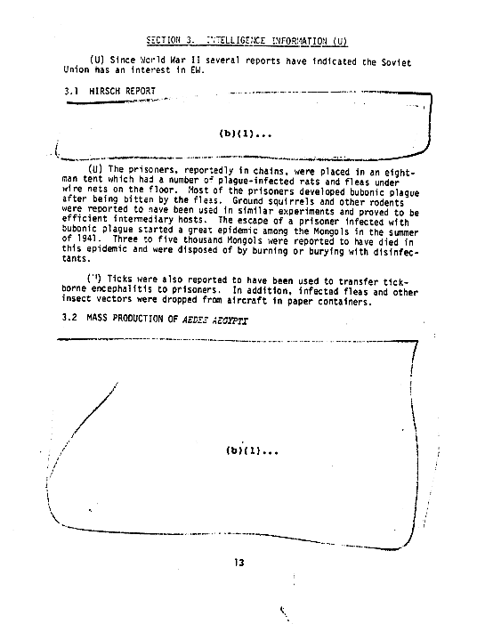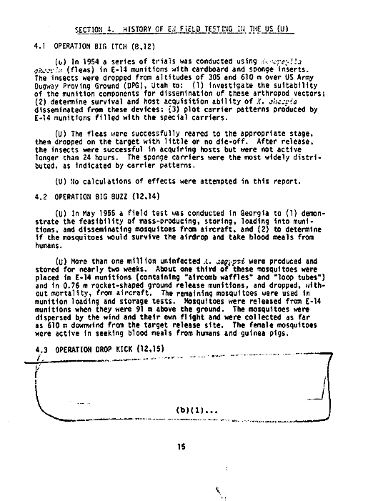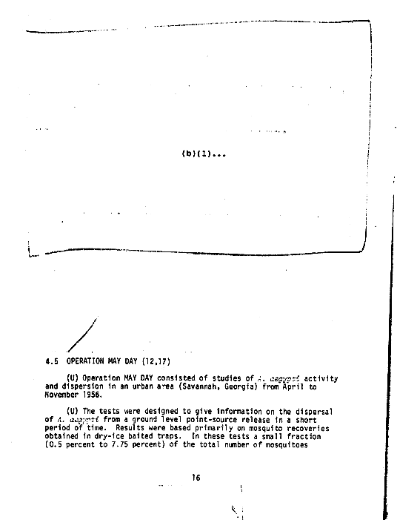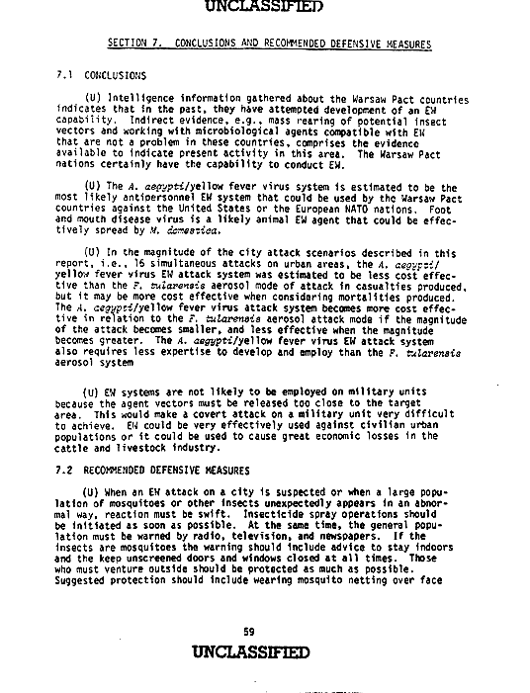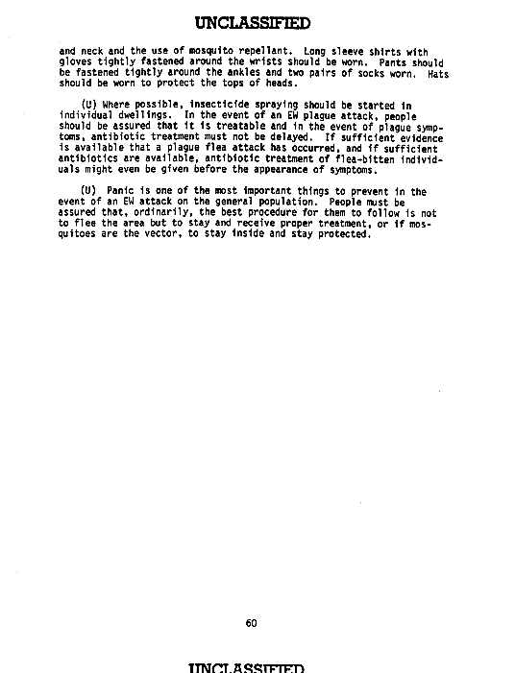

The Pentagon bio warfare scientists dropped from aircraft munitions with 1 million Aedes Aegypti mosquitos and Xenopsylla cheopis fleas (The Oriental rat flea Xenopsylla cheopis, also known as the tropical rat flea, is a parasite in rodents, and is a primary vector for bubonic plague and murine typhus. This occurs when the flea has fed on an infected rodent, and then bites a human)
https://en.wikipedia.org/wiki/Oriental_rat_flea
Such species of mosquitos and fleas (used by the Pentagon in the past under the US Entomological Warfare Program) were also collected and tested in Georgia (for reference Georgia-Annual Reports Subfolder/ Annual Report 2014) Abstract of the 2014 Annual report:
“Virus and Other Arboviruses in Georgia” (TAP 8, DTRA), a training was conducted on the arthropods surveillance issues; specimens of virus carrier ectoparasites were collected in various districts of Georgia (South Georgia and Ajara). The main vectors of Dengue virus and Chikungunya virus – Aedes albopictus, Aedes aegypti and Culex pipiens were identified in Georgia for the first time.
15. “Support of Flea Borne Disease Surveillance Diagnostics and Response”; Global Disease Detection Project component (647), CDC, USA; Project duration: 01.09.2013 – 30.09.2014

1.4.2. Research on Anthrax at Lugar Center in Georgia (for reference Anthrax Subfolder)
In 2007, Georgia ended its policy of compulsory annual livestock anthrax vaccination
http://www.sciencedirect.com/science/article/pii/S0264410X17313348
As a result, the morbidity of the disease reached its peak in 2013. Coincidentally, the next year NATO started a project to test a possible new vaccine against anthrax on humans at Lugar Center in Georgia. It is not clear why the Georgian government terminated the compulsory vaccination for 7 years, given the increasing number of anthrax cases.

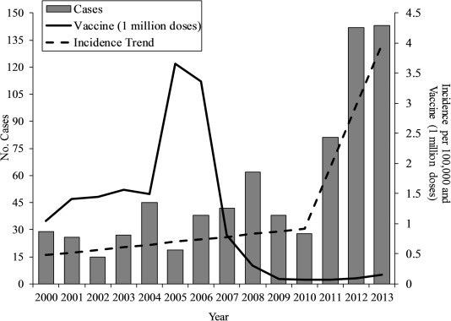

NATO project for anthrax vaccine at Lugar Center - Georgia
http://www.ncdc.ge/Category/Article/2874
Statistics:
2012 – 142 cases
2013 – 143 cases
2014 – 57 cases
http://www.ncdc.ge/en-US/Statistics/StatisticalYearbook

In 2013, the government resumed the mandatory vaccination.
http://www.ijidonline.com/article/S1201-9712(16)30363-0/pdf

Another project at Lugar Center – Anthrax 2016 Russian Vaccine Strain

Genome Sequence of the Soviet/Russian Bacillus anthracis Vaccine Strain 55-VNIIVViM
The research was funded by the U.S. Defense Threat Reduction Agency’s Cooperative Biological Engagement Program in Tbilisi, Georgia, administered by Metabiota.
http://genomea.asm.org/content/4/6/e01401-16.full
http://genomea.asm.org/content/4/6/e01401-16.full.pdf+html?sid=00c08d0e-9666-4242-ac97-a45820003a65
https://www.ncbi.nlm.nih.gov/pmc/articles/PMC5180381/

1.4.3 Research on bats at Lugar Center

Bats are allegedly vectors of Ebola Virus and Middle East Respiratory Syndrome (MERS)
https://www.cdc.gov/vhf/ebola/resources/virus-ecology.html
https://www.defense.gov/News/Article/Article/603404/
Andrew Weber, currently working for Metabiota, was the US government coordinator during the Ebola outbreak in West Africa

221 bats were euthanized at Lugar Center for research purposes
https://www.cbdstconference.com/agenda-download-abstract?AbstractId=870

Research on Bats under DTRA’s CBEP – (for reference CBEP subfolder/ 2017 CBEP)

A number of studies were carried out under the Pentagon DTR program to test bats as vectors for Middle East Respirator Syndrome (MERS).
US Center for Disease Control (CDC) information on MERS
https://www.cdc.gov/coronavirus/mers/about/transmission.html
https://www.cdc.gov/coronavirus/mers/index.html
https://www.cdc.gov/coronavirus/mers/us.html
Only two known MERS cases in the US
According to Metabiota, the MERS outbreak in South Korea in 2015 resulted in $23 billion loss for the country’s economy in one year only.
http://archive.stat.uconn.edu/qprc17/media/slides/Volodymyr_Serhiyenko.pdf
The Pentagon started a project for development of a MERS vaccine at WRAIR, which is still ongoing and in an early phase.
MERS-WRAIR-vaccine trial
https://www.hivresearch.org/mers-studies
https://www.hivresearch.org/sites/default/files/MERS%20press%20release.pdf
https://www.clinicaltrials.gov/ct2/show/record/NCT02670187?term=GLS-%C2%AD%E2%80%905300&cond=MERS&rank=1
MERS US funded project in Jordan
https://govtribe.com/project/mers-cov-ncov-novel-coronavirus-proteins
MERS is one of the viruses, which have been genetically modified by the US, as well as Influenza and SARS. Confirmation of that practice is the 2014 Obama’s temporary ban on government funding for such dual-use researches of concern. The ban was lifted in 2017 and experiments continue. Such experiments aim to increase the transmissibility and/or virulence of pathogens and do deadly diseases more deadly (for scientific purposes). Enhanced Potential Pandemic Pathogens (PPPs) experiments are legally carried out in the US.
https://www.nytimes.com/2014/10/18/us/white-house-to-cut-funding-for-risky-biological-study.html
http://www.phe.gov/s3/dualuse/Documents/gain-of-function.pdf
https://www.ncbi.nlm.nih.gov/pmc/articles/PMC4996883/
https://osp.od.nih.gov/biotechnology/gain-of-function-research/

Gain of Function Research
https://osp.od.nih.gov/biotechnology/gain-of-function-research/
https://www.phe.gov/s3/dualuse/Documents/P3CO-FinalGuidanceStatement.pdf
Dual Use Research of Concern
https://www.phe.gov/s3/dualuse/Pages/default.aspx
https://sites.nationalacademies.org/cs/groups/pgasite/documents/webpage/pga_176433.pdf

1.4.4 Research on Tularemia at Lugar Center – the first case of Tularemia in a human in Tbilisi – for reference Georgia-Annual Reports Subfolder/Annual Report 2014)
http://www.ncdc.ge/Category/Article/1478
https://www.cdc.gov/tularemia/
Tularemia is classified as a bio agent and was developed as a bio weapon by the US. The declassified 1981 Army Report reveals that the Pentagon developed a project for a hypothetical aerosol Tularemia attack on military personnel and on a city.
Tularemia Research in Georgia
http://www.ncdc.ge/Category/Article/2875

http://www.ncdc.ge/AttachedFiles/Annual%20Report_NCDC%202014_c39d8614-24c7-4a4a-8803-4b1a98ea2102.pdf

http://www.ncdc.ge/AttachedFiles/Report%202016-ENG%20-%20Final_cd44d806-2265-4370-bbd5-c4118521ca3c.pdf

http://www.ncdc.ge/AttachedFiles/Lugar%20Center2_5982284c-f82e-440b-8152-9efc6068cd16.pdf

as well as on other bio agents designated as such by the US ( Full list of US projects in Georgia):
http://www.ncdc.ge/en-US/ProgramsAndProjects/ScientificResearch

- Ukraine – 14 Pentagon Laboratories
2.1. Legal Agreement for the US military bio labs in Ukraine + provisions for secret information, banning the Ukrainian government from dissemination of secret/sensitive information (for reference Ukraine-Agreements subfolder)
Agreement between the Ministry of Health of Ukraine and the Department of Defense of the United States of America concerning cooperation in the area of prevention of proliferation of technology, pathogens and expertise that could be used in the development of biological weapons
https://2001-2009.state.gov/documents/organization/95251.pdf
http://usa.mfa.gov.ua/en/ukraine-us/legal-acts

2.2 Science and Technology Center in Ukraine (STCU) – Among the set of bilateral agreements between the US and Ukraine was the establishment of STCU - International organization funded mainly by the US government. The center has been granted diplomatic status. STCU officially supports projects of scientists previously involved in the Soviet biological weapons program (for reference STCU subfolder)
http://www.stcu.int/documents/stcu_inf/gbm/gbm43/
http://www.bilat-ukraina.eu/en/273.php

2.3. 14 Bio labs across Ukraine (for reference Ukraine-Laboratories Subfolder)
https://ua.usembassy.gov/embassy/kyiv/sections-offices/defense-threat-reduction-office/biological-threat-reduction-program/
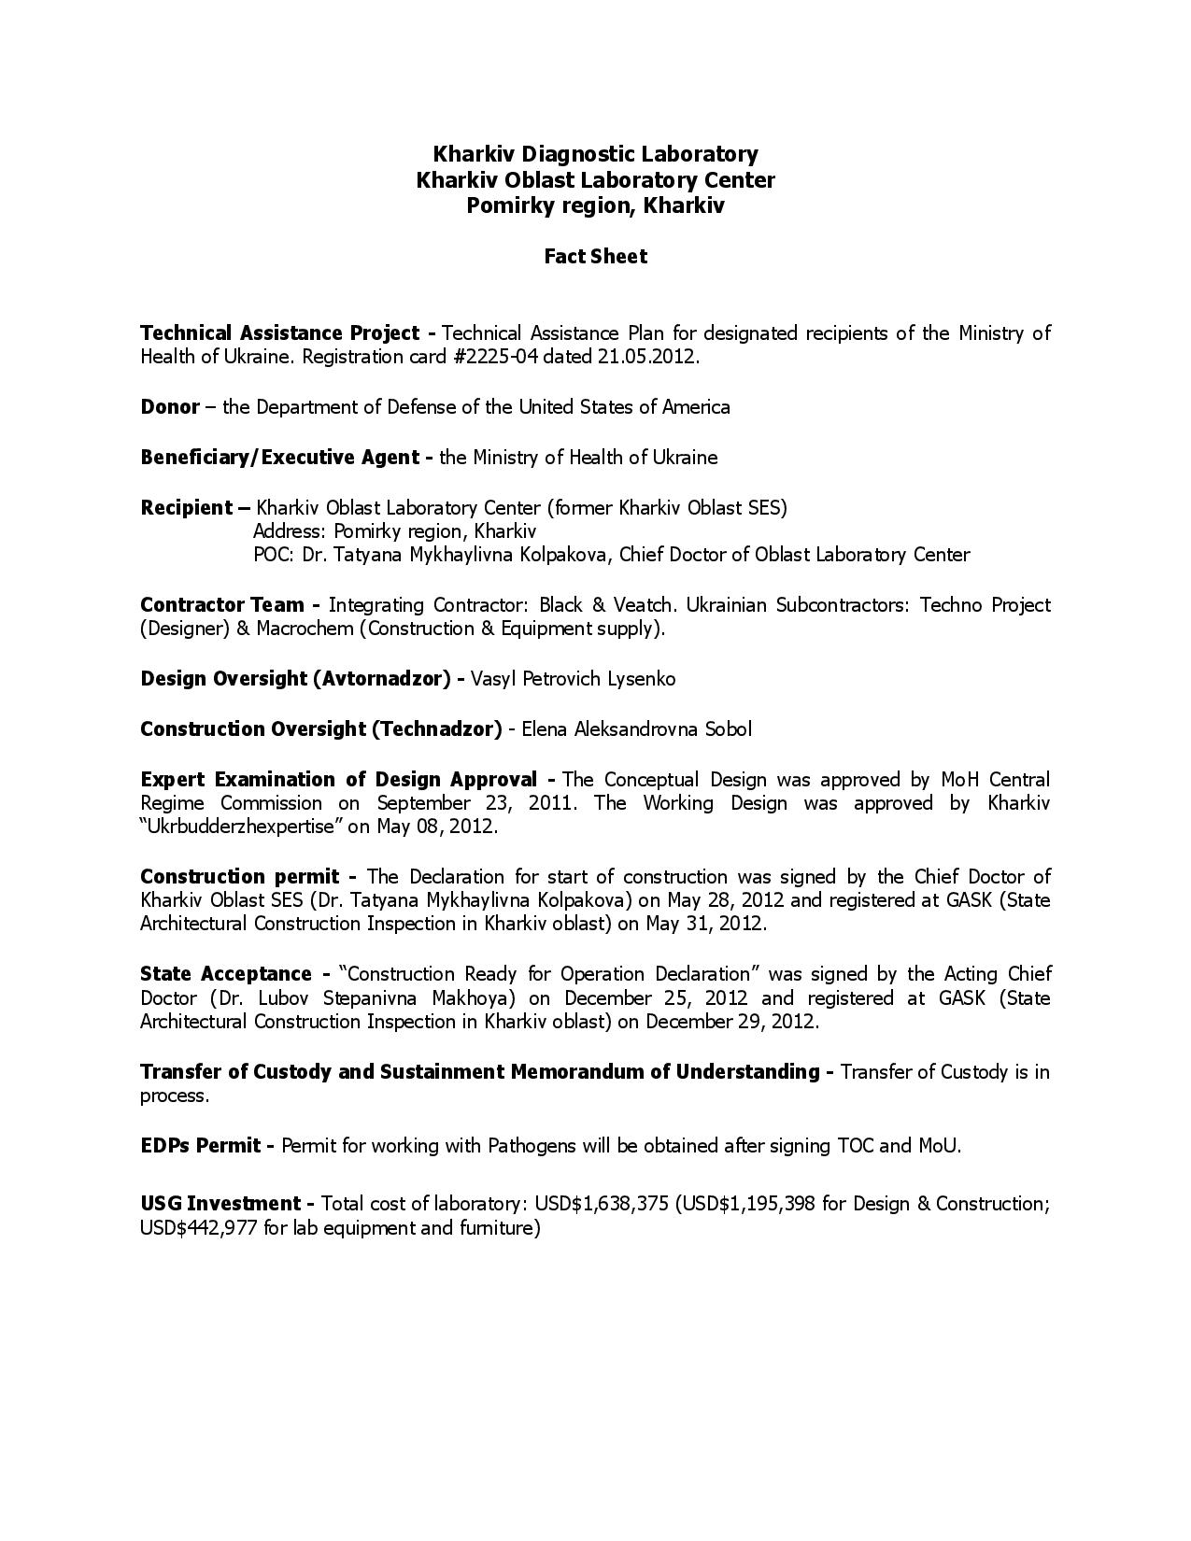

One of the laboratories is in Kharkov, where in January 2016 at least 20 Ukrainian soldiers died from Flu-like virus for two days alone and 200 more were hospitalized, according to DPR intelligence.
https://dninews.com/article/deadly-virus-leaked-us-laboratory-donbass-dpr-army-and-intelligence

The Ukrainian government did not report on the death cases among Ukrainian soldiers in Kharkov.

Flu Outbreak in Ukraine 2016 – as of 11th March 2016 in total 346 reported deaths (81.3 % of which were caused by Swine Flu A (H1N1) pdm09 – the same strain which caused world pandemic in 2009.
http://moz.gov.ua/ua/portal/pre_20160204_c.html
http://moz.gov.ua/ua/portal/mtfu_operative_info/
http://moz.gov.ua/ua/portal/pre_20151230_0.html

Other outbreaks in Ukraine:
- June 2016 The epidemic in Ismail
https://strana.ua/news/18771-massovoe-otravlenie-v-izmaile-vse-novosti-k-etomu-chasu-obnovlyaetsya.html
- 2017 Botulism: 76 cases, one death, anti-toxin was received by the UN as Ukraine had not had any since 2014
http://outbreaknewstoday.com/ukraine-botulism-update-76-cases-year-anti-toxin-received-67131/

Botulinum toxin was weaponized by the US army and CIA and used in covert operations abroad, reveal partially declassified US intelligence documents. In 1975, or 5 years after President Nixon terminated the US biological weapons program, the CIA kept on storing secretly bio agents and toxins which were not listed anywhere, shows a declassified CIA letter from the time. It turns out the CIA stored botulinum toxin in quantity, which by inhalation route could kill over 6 million people.
(For reference Entomological Warfare Folder, CIA-intelligence activities subfolder)
https://www.intelligence.senate.gov/sites/default/files/94intelligence_activities_I.pdf
CIA internal memo entitled “Contingency Plan for Stockpile of Biological Warfare Agents”, page 189 - 199

http://www.cidrap.umn.edu/infectious-disease-topics/botulism
The lethal dose for a 70-kg person by the oral route is estimated at 70 mcg, by the inhalational route 0.80 to 0.90 mcg
5 g toxin – 5 000 000 mcg: 70 mcg = 71 428 deaths (by oral use)
5 g toxin – 5 000 000 mcg: 0.8 mcg =6 250 000 deaths (by inhalation)

The Senate Committee, which was set up to investigate the issue, recommended that the bio agents and toxins be donated instead of being destroyed. (page 186)
“The Committee believes that it might be appropriate for the CIA to consider donating these toxins to properly supervised research facilities, which can use these poisons for benign uses such as curing such debilitating diseases as multiple sclerosis.” The CIA secret stockpile included also weaponized anthrax, tularemia, encephalitis, brucellosis, Valley Fever Virus, tuberculosis, salmonella (food poisoning), smallpox, Botulinum Type A, Paralytic Sellfish Poison, lethal snake venom, intestinal flu, toxiferine (paralytic effect)

Entomological Warfare Subfolder
CIA project MKULTRA (Documents from the Senate Committee)
Pdf file – page 6, 11, 65, 68, 72

+ part of the original documents here:
https://archive.org/details/mkultrafiles?&sort=-downloads&page=2

Besides the botulism poisoning of 75 people, another dangerous bacteria with a history as bioweapon in the past, caused outbreak in Ukraine - cholera.

Two Cholera outbreaks in Ukraine:
Cholera Outbreak in 2015 – 800 cases
https://www.youtube.com/watch?v=K47S1DarhTE
More than half of the beaches in the major Ukrainian port and tourist resort of Odessa on the Black Sea have been closed by local authorities as part of nationwide measure to combat the spread of cholera. The main outbreak this summer is centered around the city of Nikolayev where nearly 100 people were diagnosed with the disease. At least one person has died. Odessa's tourist industry is already suffering from a slump as the rich head for foreign locations while even domestic resorts are beyond the reach of ordinary citizens. Despite daily cholera warnings, those who make it to Odessa for their summer holidays are still determined to bathe in the sea. Doctors say this shows both extraordinary bravery and an ignorance of cholera. Fish imported from the Nikolayev region is subject to stringent tests and the sea water is tested regularly for the cholera bacillus. According to sanitation experts, the bacillus has yet to be discovered in the waters of Odessa. They believe that if the virus were to arrive, they would flourish in the city's main beaches. More than 800 people across the Ukraine were reported to have contracted the disease.
Cholera outbreak in 2011
https://www.kyivpost.com/article/content/ukraine-politics/area-in-ukraine-hit-by-cholera-outbreak-109266.html
One of the US contractors, working at the Pentagon Laboratories in Ukraine, Southern Research Institute, specializes in studies of the very same pathogens as those, which caused inexplicable outbreaks in Ukraine.
https://southernresearch.org/drug-discovery/infectious-diseases/
https://en.wikipedia.org/wiki/Vibrio_cholerae
Expertise in wide variety of pathogens:
“Our current focus is on pathogens such as Vibrio cholerae (primarily as a model system), Pseudomonas aeruginosa (in the context of cystic fibrosis), Salmonella sp. and the re-emerging pathogen Bordetella pertussis. The virology program focuses on viruses of global health significance, such as Encephalitic Alphaviruses, Flaviviruses, Influenza (including seasonal, pandemic, and avian (H5N1) strains), Ebola and Marburg. The program concentrates on several critical areas including viral pathogenesis at the cellular and molecular levels, target identification and development of novel target-based assays, discovery of small molecule antivirals, and development of contemporary vaccines.”

  - Pentagon Contractors in Ukraine:

DTRA Contracts under the Pentagon program in Ukraine
2.4.1 Black&Veatch Special Project Corp. - $198.6 m DTRA contracts
https://govtribe.com/contract/idv/hdtra108d0007
Ukriane
https://govtribe.com/contract/award/hdtra108d0007-0004

Germany
https://govtribe.com/contract/award/hdtra108d0007-0009
Philippines
https://govtribe.com/contract/award/hdtra108d0007-0012
Azerbaijan
https://govtribe.com/contract/award/hdtra108d0007-0005
https://govtribe.com/project/etfo-cbep-implementation-in-azerbaijan - Azerbaijan
Cameroon
https://govtribe.com/contract/award/hdtra108d0007-0008
Thailand
https://govtribe.com/contract/award/hdtra108d0007-0013
Ethiopia
https://govtribe.com/contract/award/hdtra108d0007-0013

Vietnam
https://govtribe.com/contract/award/hdtra108d0007-0006
Armenia
https://govtribe.com/contract/award/hdtra108d0007-0002

2.4.2 Southern Research Institute – subcontractor of Black&Veatch in Ukraine.

Black&Veatch – $175 m contract for 5 years (2008-2012)
http://www.securityinfowatch.com/news/10499768/southern-research-wins-37-million-black-veatch-sub-contract-for-biological-threat-reduction-program

Southern Research Institute – subcontractor – $37 m
https://southernresearch.org/
https://southernresearch.org/news/southern-research-institute-continues-to-play-a-role-in-u-s-governments-program-to-make-world-safer/ - $85 m (2013-2017)
In total for Ukraine under DTRA program – $260 m

Southern Research Institute was a prime Pentagon contractor under the US Biological Weapons Program for research and development of bio agents with 17 contracts between 1950-1970. (for reference Entomological Warfare Subfolder/1977 Army Report, photo 038)

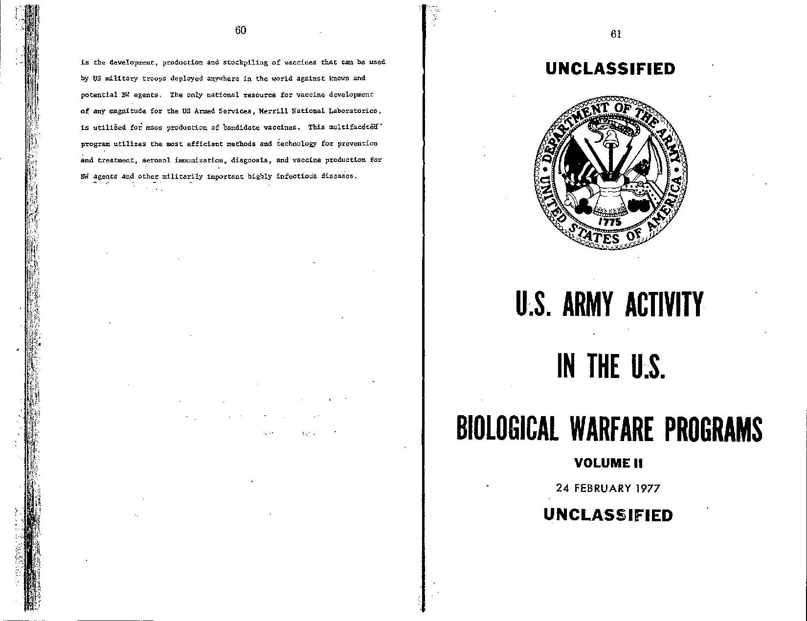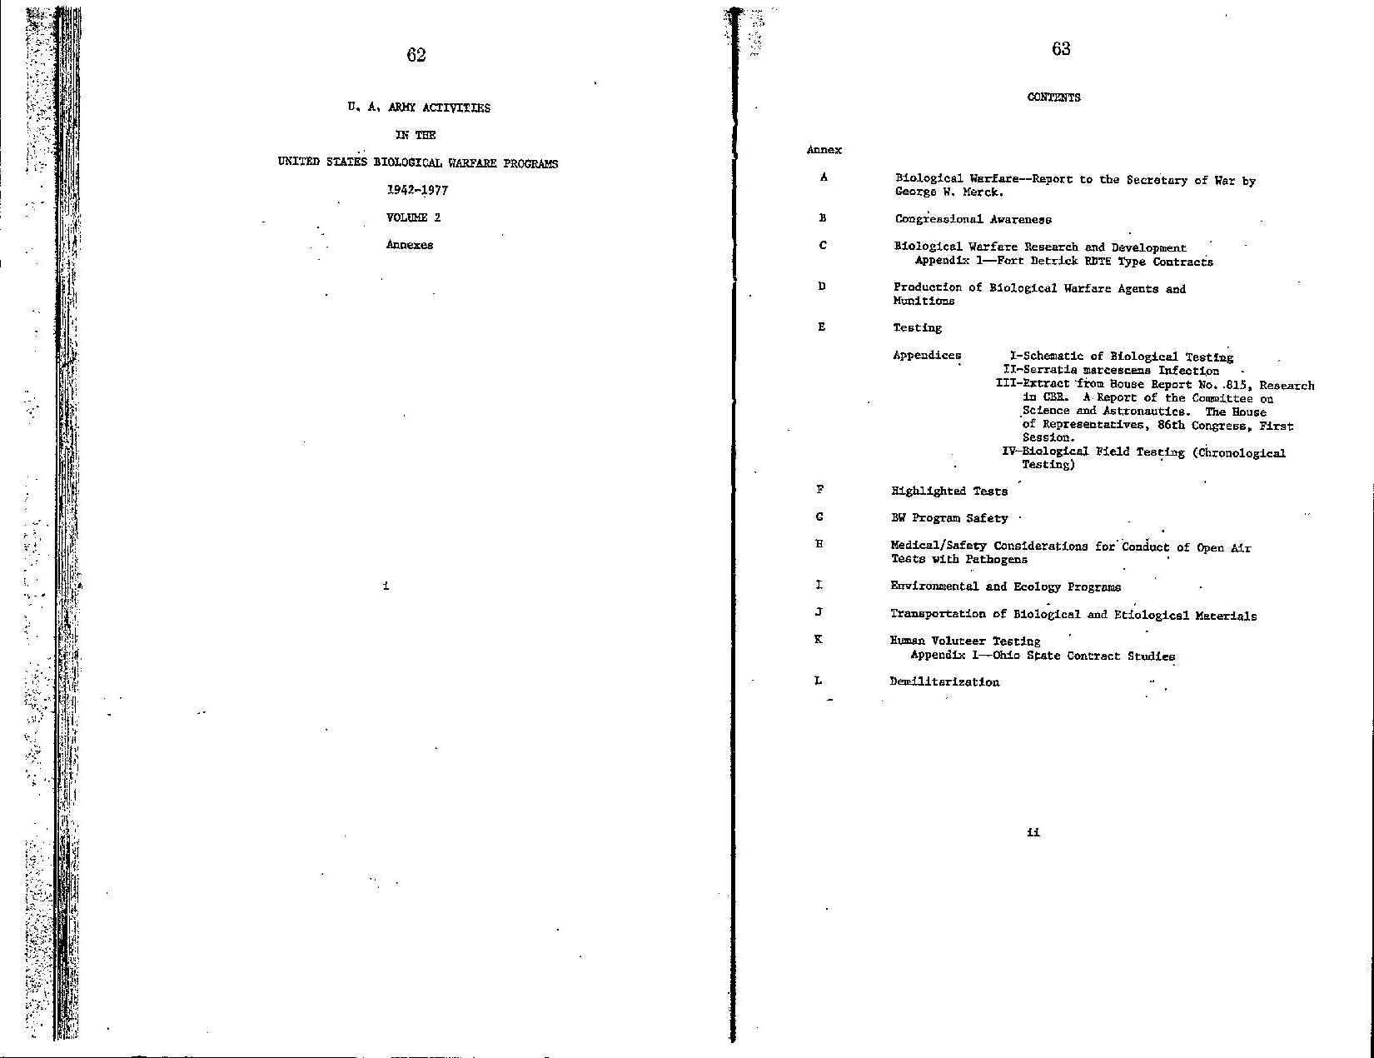
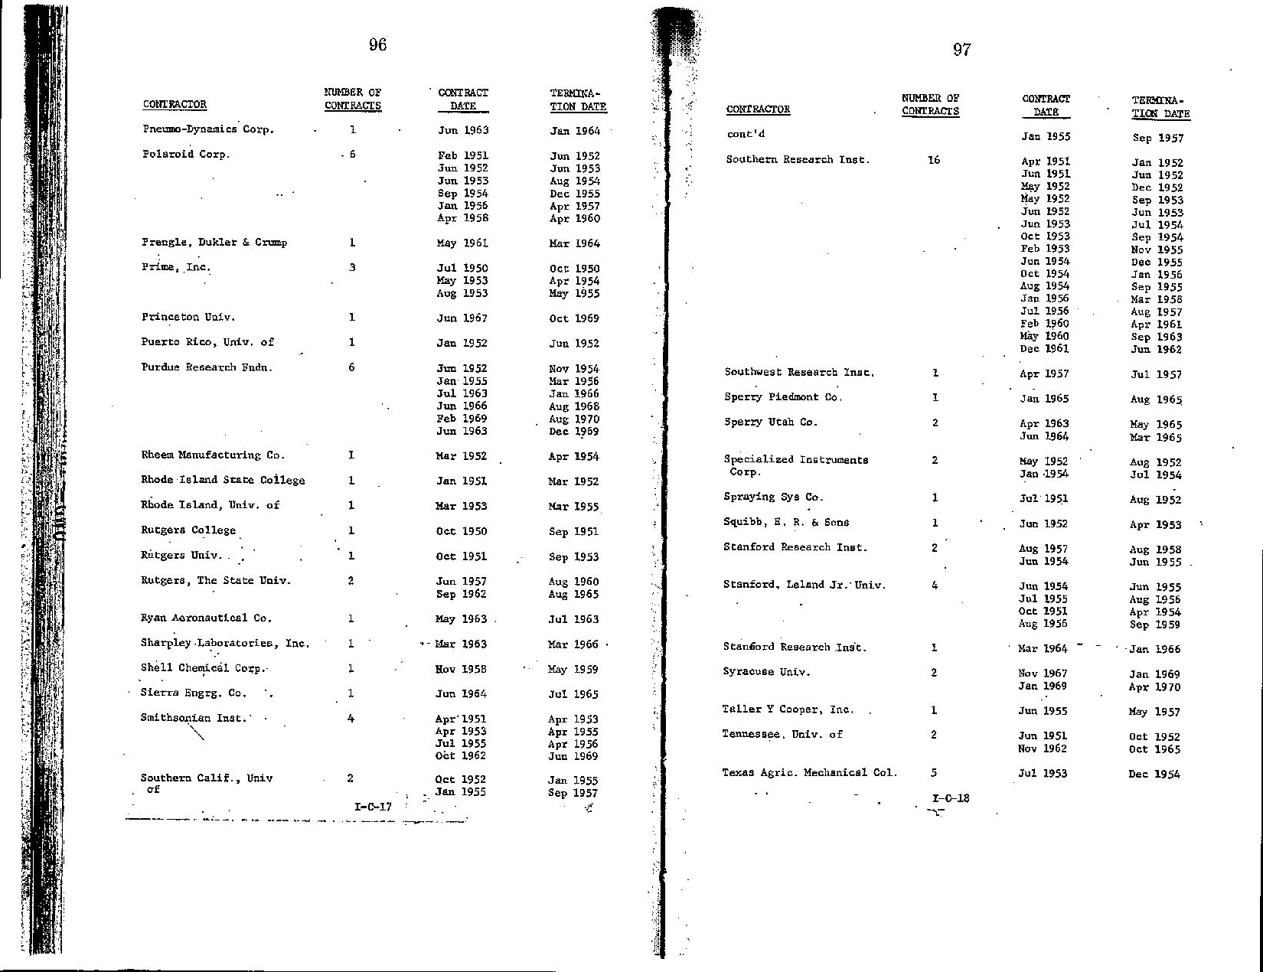

Southern Research Institute was also a subcontractor on a Pentagon program for anthrax research in 2001. The prime contractor Advanced Biosystems was awarded $10 million in Defense Advanced Research Agency (DAPRA) contracts since the company was founded in 1999.
https://www.bizjournals.com/washington/stories/2002/08/05/daily52.html
http://www.channelingreality.com/Competitiveness/Oklahoma/Hadron_Analex/2001_PR_Hadron,%20Inc_Anthrax_Contract.pdf

President of Advanced Biosystems at the time was Ken Alibek, a former Soviet microbiologist and biological warfare expert who defected to the US in 1992.
https://en.wikipedia.org/wiki/Ken_Alibek

Other Southern Research federal contracts:

Influenza Vaccine Avian flu
https://govtribe.com/project/serological-assays-for-pandemic-influenza-vaccines/activity
https://govtribe.com/contract/award/hhsf223200910300p

40 ferrets for vaccine studies
https://govtribe.com/project/collecting-monitoring-and-reporting-activity-of-40-ferrets-for-scientific-analysis

https://southernresearch.org/news/southern-research-influenza-program/
Research on a new drug against flu

https://govtribe.com/contract

https://govtribe.com/contract/award/hhsf223200910300p

https://govtribe.com/contract/award/hhsn272200700041c

https://govtribe.com/contract/award/hdtra113c0093
BAA SEED AWARD - HTS ASSAY FOR IDENTIFICATION OF SMALL MOLECULE INHIBITORS OF VENEZUELAN EQUINE ENCEPHALITIS
https://en.wikipedia.org/wiki/Venezuelan_equine_encephalitis_virus

1997
Southern Research Institute Lands Army Contract for Research to Protect Army Troops from Disease, Chemical Warfare – $10.5 m
https://www.thefreelibrary.com/Southern+Research+Institute+Lands+Army+Contract+for+Research+to+...-a019528301

PRIMATE HOUSING CYNOMOLQUS MACAQUE
https://govtribe.com/contract/award/w81xwh08p0290

https://southernresearch.org/drug-development/toxicology/

Other contracts
2011 – $1.1 m
https://southernresearch.org/news/southern-research-receives-barda-award-to-develop-new-models-for-biological-threat-countermeasures/
https://govtribe.com/contract/idv/hhso100201100007i

2017
https://southernresearch.org/news/bio-threats/

HHSO100201700017I
https://govtribe.com/contract/idv/hhso100201700017i

HHSO100201700018I
https://govtribe.com/contract/idv/hhso100201700018i

BARDA Biological Animal Model Development Federal Project
https://govtribe.com/project/barda-biological-animal-model-development
In the animal models, the challenge dose generally should be the same as that which produces the human disease or condition and the pathophysiological mechanism of its toxicity should be reasonably well-understood and mimic the human disease/condition as closely as possible. When these models are used to test the efficacy of potential medical countermeasures (MCMs) against biological threats, the mechanism of action of the countermeasure will need to establish the utility of the animal model as a surrogate for humans.
The offeror(s) shall provide personnel who possess the necessary education, training, and experience to conduct nonclinical safety studies involving common species used in toxicology and safety pharmacology studies. This includes rodents, rabbits, swine, dogs, nonhuman primates and other commonly used species.

2. Objectives

Scenario for Sample RTOR: The technical approach should consider the following scenario.
1. The required study design is a juvenile toxicity study of a molecule that will be used for 14 days in adults and children from 6 months to 17 years of age.
2. In patients, the molecule will be administered by intravenous infusion (iv) at doses of 400-800 mg twice daily.
3. The compound is a small molecule, new molecular entity (NME) that has been shown in previous studies to cause reversible testicular toxicity, immunotoxicity, and potential effects on the cardiovascular and respiratory systems.
The USG seeks laboratories that can conduct studies to establish the pathophysiology/natural history of selected biological threat agents or infectious pathogens in appropriate animal species at different ages in response to government needs.
H.7. POSSESSION USE AND TRANSFER OF SELECT BIOLOGICAL AGENTS OR TOXINS

The work being conducted under this contract may involve the possession, use, or transfer of a select agent or toxin. The contractor shall not conduct work involving a Select Agent or Toxin under this contract until it and any associated subcontractor(s) comply with the following:
Prior to conducting a restricted experiment with a Select Agent or Toxin under this contract or any associated subcontract, the contractor must discuss the experiment.

https://www.selectagents.gov/SelectAgentsandToxinsList.html

Zika Virus Vaccine
https://govtribe.com/contract/award/hhsn272201000022i-hhsn27200006

https://southernresearch.org/news/niaid-zika-contract/
https://southernresearch.org/news/southern-research-demonstrates-zika-virus-infection-in-cynomolgus-macaques/

The funds have been awarded for the development of a non-human primate model of ZIKV infection for product evaluation.

HIV
$24 m (2014 – 2020), 7-year contract
https://southernresearch.org/news/southern-research-continues-24-years-of-hiv-work-with-new-nih-contract/

https://govtribe.com/contract/award/hhsn272200700042c
https://govtribe.com/contract/award/hhsn272201400010i-hhsn27200001

Southern Research and UAB Part of Multi-site Study on Effects of Chemical Nerve Agents
https://southernresearch.org/news/southern-research-and-uab-part-of-multisite-study-on-effects-of-chemical-nerve-agents/

https://govtribe.com/contract/award/hhsn273201300010c
SUPPORT OF THE RESEARCH EFFORT TO EVALUATE TOXICITY FOLLOWING EARLY LIFE EXPOSURE TO TEST ARTICLES FOR THE NTP
https://southernresearch.org/news/southern-research-institute-selected-to-evaluate-long-term-health-effects-of-early-life-chemical-exposures-for-the-national-toxicology-program-ntp/

2.5 Lobbying (Legal Bribes)
The Pentagon secret biological weapons program, presented publicly as defensive program against possible terrorist threats, has been generously granted 4 billion dollars budget by the US Congress in the last decades. The American taxpayer money has been recklessly spent on dangerous experiments with possible pandemic pathogens in order to make them more easily transmissible and pathogenic, as well as on lucrative Pentagon contracts with private pharmaceutical and bioresearch companies. They all have spent a huge amount of money on lobbying in the US Senate and House of Representatives, and the US Department of Defense in order to get more money from the US state. Besides paying for lobbying, those companies, involved in the Pentagon program, have also paid generous donations for the election campaigns of a number of prominent politicians and US presidents alike.

Southern Research Institute lobbied extensively in the US Senate and House of Representatives for “issues related to research and development for US intelligence” and “defense related research and development”. The company paid $ 250 000 to lobby before then Senator Jeff Sessions (now the US general attorney appointed by Donald Trump) in 2008-2009, when the institute was awarded a number of federal contracts. For a 10-year period (2006-2016) Southern Research Institute paid $1.28 m for lobbying in the US Senate and House of Representatives (for reference Southern Research Institute Subfolder).

Southern research Institute – lobbying reports
https://www.opensecrets.org/lobby/client_reports.php?id=D000056970&year=2008

https://www.opensecrets.org/lobby/clientsum.php?id=D000056970&year=2009

Sen. Jeff Session

2008-2009
https://soprweb.senate.gov/index.cfm?event=getFilingDetails&filingID=C9A038FA-7C00-4FC2-8E56-685D8C26334D&filingTypeID=78

https://soprweb.senate.gov/index.cfm?event=getFilingDetails&filingID=00FFC6AA-1039-4643-B9D5-A32D09098684&filingTypeID=51

https://soprweb.senate.gov/index.cfm?event=getFilingDetails&filingID=5B3E2D00-D2CD-42B3-9367-78BD735BF029&filingTypeID=51

https://soprweb.senate.gov/index.cfm?event=getFilingDetails&filingID=F127EB4B-62E7-4FFD-BBE9-0D5C86B09A59&filingTypeID=60

https://soprweb.senate.gov/index.cfm?event=getFilingDetails&filingID=6F421569-D630-417B-B0B1-BDB7E5DAAC88&filingTypeID=60

https://soprweb.senate.gov/index.cfm?event=getFilingDetails&filingID=1D821B18-1355-4D3E-919B-23913A9FDDEB&filingTypeID=69

https://soprweb.senate.gov/index.cfm?event=getFilingDetails&filingID=DCAB0996-369C-48BE-9B12-17E383C384B7&filingTypeID=71

2011
https://soprweb.senate.gov/index.cfm?event=getFilingDetails&filingID=9ABA8662-F3A6-4C3D-B456-43E1B3707093&filingTypeID=51

2011
https://soprweb.senate.gov/index.cfm?event=getFilingDetails&filingID=22E680C6-3EA8-4226-AD09-DBE656544ECE&filingTypeID=78

2014
https://soprweb.senate.gov/index.cfm?event=getFilingDetails&filingID=BAB26545-F985-4358-A74D-021E83B0609C&filingTypeID=78

Senator Jeff Sessions’aide in the Senate now works with Southern Research Institute
https://southernresearch.org/about/southern-research-directory/watson-donald/
https://en.wikipedia.org/wiki/Jeff_Sessions
The Senator is from Alabama, where is the headquarters of Southern Research Institute

The other prime Pentagon Contractor in Ukraine Black&Veatch lobbied for bio surveillance and funding for defense threat reduction.

Black&Veatch – Lobbying Reports (for reference Black&Veatch Subfolder)

https://soprweb.senate.gov/index.cfm?event=getFilingDetails&filingID=8E635C52-DCF9-4FD3-9A09-111DB4C0CDF0&filingTypeID=51
Funding for defense threat reduction - 2013

Metabiota which manages the Pentagon programs both in Georgia and Ukraine, paid a total of $360 000 for lobbying for “public health funding and global health”.

Metabiota – Lobbying Reports (for reference Metabiota Subfolder)

https://soprweb.senate.gov/index.cfm?event=processSearchCriteria

https://soprweb.senate.gov/index.cfm?event=getFilingDetails&filingID=D861B5A6-674B-4C74-9B85-8691C963D1B0&filingTypeID=51
https://soprweb.senate.gov/index.cfm?event=getFilingDetails&filingID=951D9231-C040-4322-BB2D-795F05D53BE0&filingTypeID=55

https://soprweb.senate.gov/index.cfm?event=getFilingDetails&filingID=15FBAA12-A0E7-4E22-A790-1EF26C92EF2E&filingTypeID=60

Donations for politicians:

Black&Veatch – PAC donations
https://www.opensecrets.org/pacs/pacgot.php?cycle=2008&cmte=C00012310

Black&Veatch – donations (22 politicians since 2004 to 2016)
https://www.opensecrets.org/search?q=veatch&cx=010677907462955562473%3Anlldkv0jvam&cof=FORID%3A11&type=orgs
These tables list the top donors to candidates in the 2011 - 2016 election cycle. The organizations themselves did not donate, rather the money came from the organizations' PACs, their individual members or employees or owners, and those individuals' immediate families. Organization totals include subsidiaries and affiliates.

NOTE: All the numbers on this page are for the 2011 - 2016 election cycle and based on Federal Election Commission data released electronically on May 16, 2017.

Black&Veatch
Clinton and Trump - 2016
https://www.opensecrets.org/orgs/recips.php?id=D000024371

Black&Veatch
Romney and Obama - 2012
https://www.opensecrets.org/orgs/recips.php?id=D000024371&type=P&state=&sort=A&cycle=2012

Black&Veatch
Obama - 2008
https://www.opensecrets.org/orgs/recips.php?id=D000024371&type=P&state=&sort=A&cycle=2008

Black&Veatch
Bush - 2004
https://www.opensecrets.org/orgs/recips.php?id=D000024371&type=P&state=&sort=A&cycle=2004

Southern Research Institute – Donations by Southern Research Institute

https://www.opensecrets.org/orgs/totals.php?id=D000056970&cycle=2016#affiliates

Southern Research Institute – Obama
https://www.opensecrets.org/orgs/recips.php?id=D000056970&type=P&state=&sort=A&cycle=2012

https://www.opensecrets.org/orgs/recips.php?id=D000056970&type=P&state=&sort=A&cycle=2008

Southern Research Institute – Bush
https://www.opensecrets.org/orgs/recips.php?id=D000056970&type=P&state=&sort=A&cycle=2004

Southern Research Institute – Jeff Sessions
https://www.opensecrets.org/orgs/recips.php?id=D000056970&type=P&state=&sort=A&cycle=2014

Bechtel Group – H. Clinton, R. Lugar
https://www.opensecrets.org/pacs/pacgot.php?cmte=C00103697&cycle=2006
https://www.opensecrets.org/pacs/pacgot.php?cmte=C00103697&cycle=2004

Bechtel Group - McCain
https://www.opensecrets.org/pacs/pacgot.php?cmte=C00103697&cycle=1998

Bechtel Group – Jeff Sessions
https://www.opensecrets.org/pacs/pacgot.php?cmte=C00103697&cycle=2008

Bechtel Group – donations for R. Lugar
2007 - 2012
https://www.opensecrets.org/members-of-congress/contributors?cid=N00001764&cycle=2012&recs=100&type=C
2005-2010
https://www.opensecrets.org/members-of-congress/contributors?cid=N00001764&cycle=2010&recs=100&type=C
2003-2008
https://www.opensecrets.org/members-of-congress/contributors?cid=N00001764&cycle=2008&recs=100&type=C

Bechtel Group – donations for many politicians (170 since 2000, both democrats and republicans, both Senators and members of the House of the Representatives), members of the US Congress
https://www.opensecrets.org/search?cof=FORID%3A11&cx=010677907462955562473%3Anlldkv0jvam&q=bechtel&type=orgs

Bechtel Group – donations for McCain
2013-2018
https://www.opensecrets.org/members-of-congress/contributors?cid=N00006424&cycle=2018&recs=100&type=I

2011-2016
https://www.opensecrets.org/members-of-congress/contributors?cid=N00006424&cycle=2016&recs=100&type=I

Another unexpected lobby – the tobacco companies, paid also for lobbying for bioresearch in the Congress and the Pentagon. The reason – the biggest American tobacco companies are also engaged in the Pentagon research programs to develop vaccines against some of the deadliest outbreaks.
Medicago – Lobbying reports ($488,000)
https://soprweb.senate.gov/index.cfm?event=getFilingDetails&filingID=6769B1A4-43AA-444D-9848-35D957C7E4BF&filingTypeID=78
https://soprweb.senate.gov/index.cfm?event=getFilingDetails&filingID=882C3437-DED7-4465-AAC5-3AFB46B6BAEC&filingTypeID=51
https://www.opensecrets.org/lobby/clientsum.php?id=D000053565&year=2010

(Full list of the Mediacago Lobbying reports - Mediacago Subfolder)

3. Pentagon Blue Angel Project – development of tobacco vaccines

Blue Angel program manager Dr. John Julias, DAPRA
http://www.pharmaceutical-technology.com/features/featureblue-angel-darpas-vaccine-manufacturing-challenge-4171658/

http://archive.defense.gov/News/NewsArticle.aspx?ID=61520

Two American companies have been involved in the project – Mediacago Inc. (co-owned by Philip Morris) and Kentucky BioProcessing, a subsidiary of Reynolds American (owned by British American Tobacco). Now they are developing vaccines against Flue and Ebola from tobacco plant.
The $100 million Project Blue Angel was funded by the Pentagon’s Defense Advanced Research Agency (DARPA). It started in 2009 a month before the onset of the Swine flu pandemic. Medicago was awarded $21 m to produce 10 000 million doses of influenza vaccine in only one months’s time. In a press release out of the agency’s office in 2010, scientists with DARPA say they have reached an important step in being able to combat a flu pandemic that might someday decimate the Earth’s population. By working with the Medicago Inc. vaccine company, the Pentagon’s lab says that they have used a massive harvest of tobacco plants for vaccines. Researchers have before relied on using chicken eggs to harvest compounds to use in influenza vaccines. With a future outbreak requiring scientists to step up with a solution as soon as possible, though, they have turned to tobacco plants to help produce the vaccines.

Ebola vaccine
https://govtribe.com/contract/idv/hr001113d0003

Medicago USA Inc

https://govtribe.com/contract/award/hr001113d0003-hhso100201500004u
https://govtribe.com/contract/vehicle/idiq-darpa-pbpdm

Philip Morris – shareholder in Medicago
http://www.prnewswire.com/news-releases/medicago-announces-agreement-to-be-acquired-by-mitsubishi-tanabe-pharma-in-a-transaction-valued-at-357m-215195011.html

https://www.wired.com/2010/08/darpa-turns-to-canadian-tobacco-to-fight-viral-terror/
http://www.fiercepharma.com/pharma/medicago-shareholders-approve-investment-by-philip-morris-investments-b-v

Medicago (Mitsubishi Pharma (60 %) + Philip Morris (40 %) is aiming for 80 billion yen ($702 million) in U.S. sales by fiscal 2020, according to last year's medium-term plan. As a key driver for that goal, the flu vaccine is projected to sell tens of billions of yen every year.
https://asia.nikkei.com/Tech-Science/Tech/Tobacco-leaves-enlisted-for-speedy-flu-vaccine-production?page=2

Kentucky BioProcessing – Reynolds America (British American Tobacco)
http://www.courier-journal.com/story/news/2014/10/13/kentucky-company-turns-sole-focus-ebola-drug/17211709/

http://www.tristatehomepage.com/news/kentucky-bioprocessing-ramping-up-ebola-drug-production/173640255

Mapp Biopharmaceutical – Ebola vaccine (works with Kentucky BioProcessing –subsidiary of British American Tobacco)
https://en.wikipedia.org/wiki/Mapp_Biopharmaceutical

https://en.wikipedia.org/wiki/Reynolds_American

https://govtribe.com/contract/award/hdtra113c0018

https://govtribe.com/contract/award/hhso100201700017c

https://govtribe.com/contract/award/hhso100201600021c

https://govtribe.com/contract/award/hdtra114c0115

https://govtribe.com/contract/award/hhso100201400009c

https://en.wikipedia.org/wiki/Nicotiana_benthamiana

https://modernfarmer.com/2014/04/making-flu-vaccine-tobacco/

Research on tobacco vaccine against Zika

Zika Virus
https://www.mosquitosquad.com/blog/archives/2017/08/14/august-14-2017-asu-researcher-says-hes-developed-tobacco-based-zika-virus-vaccine/

http://newatlas.com/tobacco-plant-vaccine-polio/50913/

https://www.nature.com/articles/s41598-017-08247-9

http://www.tobaccoasia.com/news/tobacco-plant-based-zika-vaccine-developed/

4. Other military bioresearch projects

4.1.DARPA

4.1.1 Gene Editing – $65 m DARPA program called Safe Genes– the project includes gene editing of insects and rodents

https://www.darpa.mil/news-events/2017-07-19

DARPA plans to invest $65 million in its Safe Genes project over the next four years, across seven teams, to collect data and develop tools that can be applied to support bio-innovation and combat bio-threats. Each team is working on different aspects of achieving this goal, such as:
The Broad Institute of MIT and Harvard: A team led by Dr Amit Choudhary is developing means to switch on and off genome editing in bacteria, mammals, and insects, including control of gene drives in a mosquito vector for malaria, Anopheles stephensi. Gene drive is a technique that promotes the inheritance of a particular gene to increase its prevalence in a population. The team will also construct synthetic genome editors for precision genome engineering.
Massachusetts General Hospital: A team led by Dr Keith Joung aims to develop novel, highly sensitive methods to control and measure on-target genome editing activity—and limit and measure off-target activity—and apply these methods to regulate the activity of mosquito gene drive systems over multiple generations.
Massachusetts Institute of Technology: A team led by Dr Kevin Esvelt has been selected to pursue modular 'daisy drive' platforms with the potential to safely, efficiently, and reversibly edit local sub-populations of organisms within a geographic region of interest. The team then aims to adapt this system in the laboratory for up to three key mosquito species relevant to human and animal health.
North Carolina State University: A team led by Dr John Godwin aims to develop and test a mammalian gene drive system in rodents. The team’s genetic technique targets genetic variants found only in particular invasive communities of animals. If successful, the work will expand the tools available to manage invasive species that threaten biodiversity and human food security, and that serve as potential reservoirs of infectious diseases affecting native animal and human populations.
University of California, Berkeley: A team led by Dr Jennifer Doudna will investigate the development of novel, safe gene editing tools for use as antiviral agents in animal models, targeting the Zika and Ebola viruses. The team will also aim to identify anti-CRISPR proteins capable of inhibiting unwanted genome-editing activity.
University of California, Riverside: A team led by Dr Omar Akbari seeks to develop robust and reversible gene drive systems for control of Aedes aegypti mosquito populations, to be tested in contained, simulated natural environments.

CRISPR-Cas9 is a tool for making precise edits in DNA, discovered in bacteria.
The acronym stands for “Clustered Regularly Inter-Spaced Palindromic Repeats”.
The technique involves a DNA cutting enzyme and a small tag, which tells the enzyme where to cut.

https://www.fbo.gov/index?s=opportunity&mode=form&id=1f54e69797b94552e7a951551d16a91f&tab=core&_cview=0
https://govtribe.com/project/safe-genes

https://www.darpa.mil/program/safe-genes
https://www.darpa.mil/news-events/2016-09-07
https://www.ncbi.nlm.nih.gov/pubmed/22745249
https://www.fbo.gov/index?s=opportunity&mode=form&id=9eeb8015fe08ce14143d5fd77f21f38c&tab=core&_cview=0

https://www.dni.gov/files/documents/SASC_Unclassified_2016_ATA_SFR_FINAL.pdf
James R. Clapper
Director of National Intelligence

February 9, 2016
Genome editing increases the risk of the creation of potentially harmful biological agents or products.

Excerpt from the intelligence report:
Research in genome editing conducted by countries with different regulatory or ethical standards than those of Western countries probably increases the risk of the creation of potentially harmful biological agents or products. Given the broad distribution, low cost, and accelerated pace of development of this dual-use technology, its deliberate or unintentional misuse might lead to far-reaching economic and national security implications. Advances in genome editing in 2015 have compelled groups of high-profile US and European biologists to question unregulated editing of the human germline (cells that are relevant for reproduction), which might create inheritable genetic changes. Nevertheless, researchers will probably continue to encounter challenges to achieve the desired outcome of their genome modifications, in part because of the technical limitations that are inherent in available genome editing systems.

GENE EDITING IN SAND FLIES BY CRISPR/CAS9 TECHNOLOGY
Laboratory of Malaria and Vector Research. NIAID/NIH United States
http://worldleish2017.org/documentos/Abstracts_Book_web.pdf

All sgRNA showed high activity in vitro. 539 and 422 embryos were microinjected for KMO and YELLOW experiment, respectively. The G0 hatching rate was 11.4% and 14.22% for each group. After microinjection of sand fly embryos with Cas9 and specific sgRNA a visual phenotype was observed in the second generation of insects (5,244 and 6,314 Lu. longipalpis were screened for KMO and YELLOW experiments, respectively). This visual phenotype corresponds to the homozygous individuals coming from the heterozygous intercrosses on the G1.
Conclusions: Here we report the first demonstration of gene editing in sand flies by CRISPR/Cas9 technology in an experiment targeting the KMO and YELLOW genes. Gene editing in sand flies is feasible and will allow us to do loss of function studies with salivary genes to better understand the role of saliva in blood feeding process and parasite transmission.

4.1.2 The Pentagon wants to genetically engineer humans by adding 47th artificial chromosome
Mammalian Genome Engineering project
https://sbirsource.com/sbir/topics/88854

SynPloid Biotek LLC
The company has only two employees and no previous records on bioresearch

https://sbirsource.com/sbir/awards/161413-advanced-tools-for-mammalian-genome-engineering

https://sbirsource.com/sbir/awards/152846-advanced-tools-for-mammalian-genome-engineering

https://sbirsource.com/sbir/people/71556-daniel-wattendorf

https://www.sbir.gov/node/697107
https://govtribe.com/contract/award/ind15pc00008
https://govtribe.com/contract/award/ind14pc00018

4.2. Department of the Air Force
RNA and Synovial tissue from Russians

https://www.fbo.gov/index?s=opportunity&mode=form&id=5891545db8f955e347e3493a9575e7df&tab=core&tabmode=list&

