From: Thon Hotels <newsletter@i.thonhotels.no>
Sent: Tuesday, April 17, 2018 10:43 AM
To: Georgian Mission
Subject: Confirmation - Thon Hotel EU - 333020267

View in Browser

 |  | 
  Tamila Barkalaia

 |  | 
  Hotels | Promotions | Login

WELCOME TO Thon Hotel EU

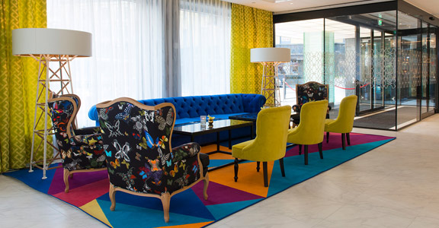

Hi Tamila,
Thank you for choosing to stay with us. This is your confirmation for your stay at Thon Hotel EU.
Located in the European Quarter of Brussels, Thon Hotel EU is your eco-friendly hotel and ideal starting point for both business and leisure travelers. Most of the European Institutions are within easy walking distance and the historical city center is about a stone’s throw away.

READ MORE ABOUT THE HOTEL

RESERVATION NO: 333020267

Arrival: 24.04.2018 | Departure: 26.04.2018
1 room, 2 nights, 1 adult
Thon Hotel EU
Rue de la Loi/Wetstraat 75, B-1040 Brussels
Belgium
Email address: eu@thonhotels.be
Phone number: +32 2 204 3911
Org.no: BE 0434 223 765



YOUR RESERVATION

ROOM 1
Classic Room Double
1 adult
Guest: Tamila Barkalaia
You will receive the final receipt when checking out at the hotel.
Price | 898.00 | EUR
City tax €4.24 per room per night is not included and will be charged upon check-out. Price per night and includes accommodation, breakfast, WiFi and VAT. Cancellations allowed until 21 days prior to arrival date. If you are planning to arrive after 16:00, you need to pay for the first night upon reservation. The amount will not be refunded if you do not show or cancel within 21 days prior to arrival. Our minimum check-in age (unaccompanied) is 18 years.

CANCELLATION

if you would like to cancel your reservation you can do so by Clicking here

 |  |  |  |  |  | 

Booking: tlf 815 52 400 | service@thonhotels.no
Member of Global Hotel Alliance



