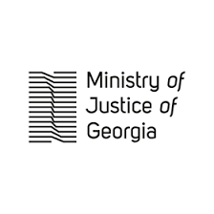
Ministry of Justice of Georgia
2018, 22 January
Agenda

10:00-10:10 Openiong Remarks
Minister of Justice/Chairperson of the Council
Mrs Thea Tsulukiani
10:10-10:45 Positions on Drug Policy Reform

- Chairperson of the Healthcare and Social Issues Committee of the Parliament of Georgia, Mr. Akaki Zoidze
- Minister of Internal Affairs of Georgia, Mr. Giorgi Gakharia
- Minister of Labour, Health and Social Affairs of Georgia, Mr. Davit Sergeenko
- Deputy Chief Prosecutor of Georgia, Mr. Giorgi Gabitashvili
- Chairperson of the Legal Issues Committee of the Parliament of Georgia, Ms. Eka Beselia
- Chairperson of the Human Rights and Civil Integration Committee of the Parliament of Georgia, Ms. Sophio Kiladze
10:45 – 11:15 Discussion
11:15 – 11:30 Closing Remarks
Mrs Thea Tsulukiani

