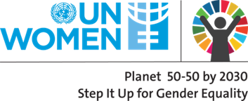
Agenda

Meeting with the UN Women Responsible Parties

Date: Thursday, 8 February 2018
Time: 09:30-15:00
Place: Hotel Radisson Blu Iveria
09:30-10:00 | Registration, Welcome Coffee
10:00-10:10 | Opening Remarks  Erika Kvapilova, UN Women Country Representative in Georgia
 | Programmatic Reporting
10:10-10:40 | General Overview of UN Women Georgia Country Programme and 2018 Annual Work-plan  Tamar Sabedashvili, UN Women Programme Specialist
10:40-11:30 | Narrative Reporting – new template and guidance  Tamar Vashakidze, UN Women Programme Analyst
11:00-11:45 | Q&A
11:45:12:00 | Coffee Break
 | Financial Reporting
12:00-12:15 | General Overview on Partners’ Cash Advance Modalities  Irina Bagrationi, Operations Manager, UN Women Georgia
12:15-13:00 | Review of the FACE and Supporting Financial Reporting Forms (detailed expenditure list, assets log book)  The Common Areas for Improvement  Rusudan Tutberidze, Finance Associate, UN Women  David Samunashvili, Project Assistant, UN Women
13:00-14:00 | Lunch
14:00-14:30 | Filling in the FACE Form (Practical Exercise)  Rusudan Tutberidze, Finance Associate, UN Women  David Samunashvili, Project Assistant, UN Women
14:30-15:00 | Q&A

