German delegation visit to Georgia, 30.05-02.06.2018
Members of the German Parliament
Dr. Georg Kippels, MP (CDU – Christian democrat)  Dr Kippels is a lawyer by training and a member of parliament since 2013. In the current legislative period, he is a member of the Committee on Economic Cooperation and Development, which deals intensively with the many factors that impact on development, such as climate change, population growth, world trade, basic services (education, healthcare, social security systems), good governance, food sovereignty, minimum standards, gender and inclusion.  Before entering Parliament, he worked as an independent lawyer in Bedburg. During this time, he gained political experience at the communal level, including as mayor for Central Bedburg. | 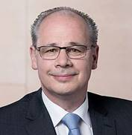
Dr. Wolfgang Stefinger, MP (CSU - Christian Social Union of Bavaria – sister party of the Christian democrats)  Dr Stefinger holds a doctorate in business administration and is a member of parliament since 2013. In the current legislative period he is a member of the Committee on Economic Cooperation and Development, as well as a member of the Committee on Education, Research and Technology Assessment. He is also vice-chair of the Parliamentary group on Southern Africa.  Previously, Mr Stefinger worked for a large German health insurance company. | 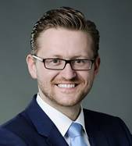
Dagmar Ziegler, MP (SPD – Socialist)  Ms Ziegler graduated in economics and is a member of parliament since 2009. In the current legislative period, Ms Ziegler is executive secretary of the SPD faction in parliament, member of the Committee on Economic Cooperation and Development and is a member of the Council of Elders (it comprises the President of the Parliament, the Vice-Presidents and 23 other members. It assists the President in his/her work, helping to ensure good and effective coordination. The Council also sets agendas, reviews disputes and appoints commissions).  Previously, Ms Ziegler was member of the local parliament of State Brandenburg, as well as Brandenburg State Minister for Labor, Health and Social Affairs, and State minister for Finance. | 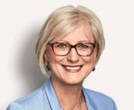

Civil Society
Katja Tielemann-Ruderer, Deutsche Stiftung Weltbevölkerung (DSW)  (German Foundation for World Population)  Katja joined DSW in 2015 and is specialist for development policy, with a special focus on global health. Prior to DSW, she worked 9 years at GIZ ( for a program at GIZ (the German provider of international cooperation services), for a program that advised the Federal Ministry for Economic Cooperation and Development (BMZ) on HIV and related themes.  Katja studied Geography, Sociology and European Ethnology of the Humboldt University of Berlin. | 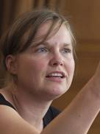
Peter Wiessner, Aktionsbündnis gegen AIDS (AgA)  (Action against AIDS Germany)  Peter graduated in social sciences and has been active in the HIV field for more than 25 years. Currently, he is the coordinator of the umbrella network Action against AIDS Germany. He is a member of the German Delegation of the Global Fund Board and also participates in UNAIDS Program coordination meetings. For many years, he has been an honorary member of several European HIV networks, including the European AIDS Treatment Group (EATG). For several years, he was also on the board of the European Public Health Alliance (EPHA). | 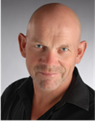

Private Sector
Klaus Ridderbusch, former CEO, Unilever Food Solutions Germany  Klaus holds a degree in business administration from the Münster University and held top positions in the Consumer Good Industry across operational and strategic assignments, both local and international, in and outside Europe. From 2012 to 2017, he was CEO Unilever Food Solutions Germany/Austria/Switzerland. Prior positions included several managerial roles for Unilever in Germany and Scandinavia, as well as managing director for Streets Ice Cream Australia/New Zealand and development business director for Langnese-Iglo GmbH.  Klaus is the President of the United Against Waste Foundation, a member of the Advisory Board of Institute of Culinary Arts and a member of the Refugee support Initiative in Hamburg. | 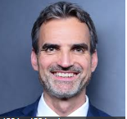

Friends of the Global Fund Europe
Sylvie Chantereau, Executive Director, Friends of the Global Fund Europe (Friends Europe)  Sylvie has been Executive Director of Friends Europe since the creation of the organisation. Friends Europe is a non-profit organisation founded in April 2005, under the high patronage of the President of the French Republic, to engage with Europe’s political and institutional decision-makers, public opinion, media, civil society organisations and private sector on the task of combating AIDS, tuberculosis and malaria, and more specifically to mobilise support for the Global Fund to fight AIDS, Tuberculosis and Malaria (the Global Fund). Its actions include political advocacy to support investment in the Global Fund by the international community and to succeed in eradicating three of the most devastating pandemics affecting the developing world.  Previously, Sylvie held managerial positions at the French national research agency against AIDS. |  | 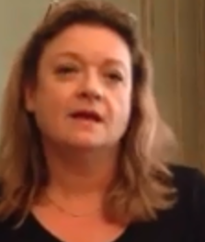
Sergius Seebohm, Advisor for Germany, Friends Europe  Sergius Seebohm is an expert for public affairs with about 15 years experience in political communication and consulting. His expertise combines a background from consulting civil society organizations and foundations with political and business know-how. | 