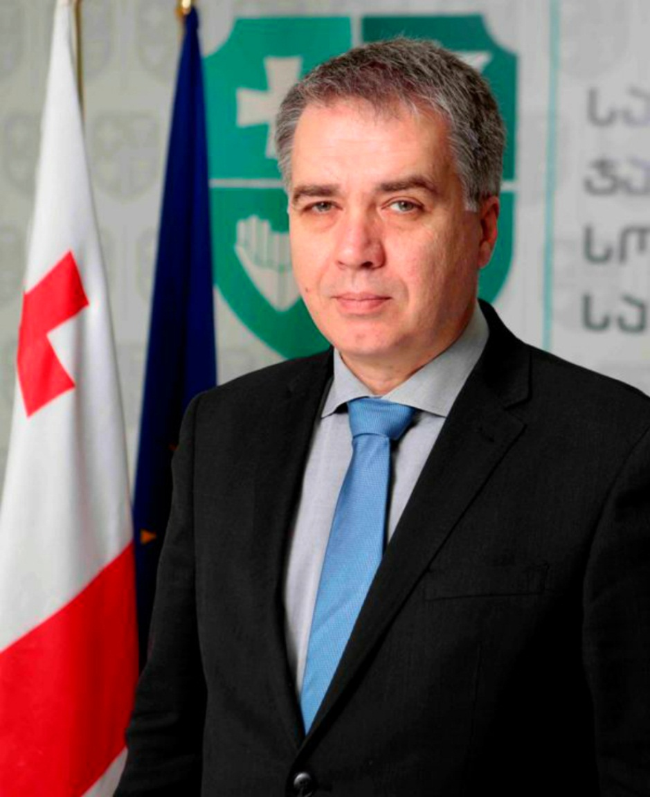
Dr David Sergeenko, Minister of Labour, Health and Social Affairs of Georgia
David Sergeenko was appointed as a Minister of Labour, Health and Social Affairs of Georgia in 2012. Prior to this position, Dr. Sergeenko worked as a general director of Sachkhere Medical Center; as Medical Service Manager at the MediClub-Georgia, and the Head of Medical Care Unit at Georgian Sports Department. Mr. Sergeenko graduated from Tbilisi State Medical University from faculty of pediatrics. He continued his education in Intensive Care Medicine at Berlin Heart Institute and received training in Pediatric Cardiac Intensive Care at Boston’s Children’s Hospital, Harvard Medical School.

