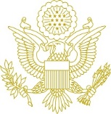

The Ambassador of the United States of America
Ian C. Kelly and Francesca Kelly
request the pleasure of the company of

Davit Sergeenko

at their farewell cocktail reception

on Monday, March 19, 2018
from 6:30 p.m. to 8:30 p.m.

Dress: Business Ambassador’s Residence
R.S.V.P. Digomi 9, 26 N. Beradze St.
NanobashviliN@state.gov See the map below
599 17 70 30

Please have a print out of this invitation and an ID card for admission.

Digomi 9
DIGOMI 9, CMR
TBILISI
MTSKHETA

NEW LIGHT STORE
TBILISI MALL
Digomi 8

AMBASSADOR’S RESIDENCE

