n

Management and Leadership
GIZ Program Georgia

Module 2: Managing an Organization

Bert Baks
Hans Rieger

1. Normative modern management

Modern organizations are developing in the following direction:

 | Traditional administration | New Public Management
Structures | bureaucratic  hierarchic  centralist | strictly restricted centre  flat hierarchies  decentralised
Systems | strictly centralised control  detailed supervision performed on several levels | performance goals, bench marking, project groups, reporting, cost accounting, internal markets, decentralised resource management, quality management
Personnel | large number of staff  permanent, fixed,  periodic promotion | small core staff  flexible, large ”periphery”, continuous training and further vocational training,  achievement principle
Role/culture | authoritarian thinking  legal and financial honesty  professionalism  quantity of public achievements | flexible management  responsibility for results  management: focus on customers’ needs/ quality of achievements

Nowadays also other concepts of administration than pure NPM arise. Those apart from managerial part put also attention on values, that can be universal characteristics for good governance:
- Co-operation of all stake holders in the organization
- Transparency
- Equality (in law and in front of the law)
- Ethics and integrity
- Responsibility
- gender
This approaches are topic in Module 3.
To follow the direction towards NPM, the top management of an organization has to implement several tools and instruments.

Asking staff members what are they missing from their managers the answer has very often 2 dimensions:
- Communication
- Clear task and objective

In this chapter we focus on the second point.

What is the Strategic Plan?

A strategic plan describes the purpose, or mission, of an organization, the major challenges it faces and the goals and strategies it will use to meet those challenges.

Organizations develop strategic plans so that everyone, from the Chief Executive Officer to “front line” employees, will know what is important to the organization and what it is trying to accomplish.

Some strategic plans also include a “vision” for the organization, which is a statement of a desired future that all employees can work to achieve together.

1.1 Vision

To get started there should be a clear vision what the particular organization stands for. It is a most abstract the vision statement.
Definition:
A vision statement can be called a picture of your organization in the future but it is so much more than that. Your vision statement is your inspiration, the framework for all your strategic planning which you develop based on the vision statement.
What you are doing when creating a vision statement is articulating your dreams and hopes for your organization. It reminds you of what you are trying to build.
Whether for all or part of an organization, the vision statement answers the question, "Where do we want to develop ourselves?"
The following are examples for vision statements. Sometimes a vision statement can be summarized in one sentence. Examples include:
- To help people be safe,
- To help people to get an affordable solution to health care,
- A just world without poverty (Oxfam, 5 words)
- A hunger-free America (Feeding America, 4 words)
- Equality for everyone (Human Rights Campaign, 3 words)

Local organizations might aspire to be the best organization in the country. Vision statements may also be longer as well. Some examples include:
- The Organization will inspire its employees to be the best they can be. “We will engage in sustainable practices and anticipate the needs of our citizens. We will maximize return to the country while still maintaining quality in our work and results.”
- To become a world leader at connecting people to wildlife and conservation (San Diego ZOO, 12 words)

In each of these examples, the vision statement helps to define goals, creating something to work towards in the future.
Examples for further Vision statements:
- The Court and its employees strive to become recognized for their service excellence, dedication, integrity, impartiality, competence and diversity, as well as their commitment to ensuring equal access to court services and enhancing public confidence in the court system (Superior Court of California, County of Alameda).
- Vision Statement defines the desired state of the Court in the future and provides us with a reference point as to how we would like the Court to operate in the future. The Justice of the Peace Court will:
- Be sensitive and responsive to the needs of a diverse community.
- Use cutting edge technology to increase: citizens' access and convenience in using the Court and the Court's ability to reach sound decisions through the best available access to factual and legal information.
- Treat all individuals using the Courts with the utmost respect.
- Have a service oriented approach in dealing with users of the Court.
- Use strategic planning to develop and maintain the highest possible level of services to the public and to responsibly seek, use and account for public resources.
- Insure that court procedures and structure best facilitate the expeditious and economical resolution to disputes.
- Insure equal application of the judicial process to all cases, which are fairly decided based upon legally relevant factors.

Writing a Good Vision Statement
Looking at these vision statement examples should give you a good jumping off point for knowing what a vision statement is and how to write one. Vision statements are a challenge for many people because they aren't sure what form the statement is supposed to take.
- A typical organizartion´s vision statement will be brief and succinct; it will say a lot in just a few words, so those words must be very carefully chosen.
- The key to a good vision statement is to think of things in a long-term, broad sense, without sounding generic.
- If you're too specific, you will limit your vision and it won't be applicable ten years down the road: for example, if your current goal for your organization is to move into a larger building, that's a vision for the future but it's not the vision for the future of your entire organization. It's too narrow in focus.
- On the other hand, if you say that you want to achieve success – well, any organization in the world could say that. It's too generic. The best statement will be clear about who you are as a organisatioin as well as who you wish to become.
IN SHORT:
VISION STATEMENT (DESIRED END Version)
A one sentence statement describing the clear and inspirational long-term change, resulting from your work.
These should be practical, tangible tools you can use to lead your group or organization in achieving quality results.
NEEDS TO…
- …be clear and simple
- …avoid elaborate language & buzz words
- …easily explained by those involved
QUESTIONS TO CONSIDER
What needs to be changed?
Why should issues be addressed?
What are the strengths and assets?
What is your dream end-version?
What would success look like?
Writing a good vision statement isn't difficult. Think about what your organization does and what, in an ideal world, you would like it to do and how you would like to appear to the outside world. Consider the services and attributes that your organization provides. Then imagine how it would be if you provided the very best version of them possible. List those visions, and incorporate them into a brief statement that gives a good overview of the kind of image you want to represent.
Understanding your goals and being able to state them clearly is the first step toward making them happen and to give clear way forward to your staff members as well.
WHAT DOES THIS MEANS FOR YOU?

Is your vision statement longer than 20 words? Can you get it below 15? Below 10? Design your vision statement to clearly communicate what you are working to achieve in a way that people can remember and communicate this to others. If you can’t get your full vision below 15 words, consider also vision tagline (2-6 words) which people can more easily remember.

Exercise 1: Formulation of Vision Statement
Formulate a vision statement for the your Organization in Georgia in Georgia.
1.2 Mission statement

Having the vision in place the next step is to formulate a mission statement. Out of the formulated and shared vision the mission statement gives already direction where the organization has to develop to.
Definition:
A mission statement is a statement of the purpose of an organization. Its reason for existing; a written declaration of an organization's core purpose and focus that normally remains unchanged over a long period of time.
Properly crafted mission statements serve as filters to separate
- what is important from what is not,
- clearly state which position the organization has and will be served and how,
- communicate a sense of intended direction to the entire organization.
A mission is different from a vision in that the former is the cause and the latter is the effect; a mission is something to be accomplished whereas a vision is something to be pursued for that accomplishment.
The mission statement should guide the actions of the organization, spell out its overall goal, provide a path, and guide decision-making. It provides "the framework or context within which the organization´s strategies are formulated." It is like a goal for what the organization wants to do for their country.

Examples for mission statements:

Mission Statement Inspector General:
The mission of the Office of the Inspector General (OIG) is to provide strong, independent and effective oversight of the Los Angeles Police Department (LAPD) and to ensure that the LAPD, its officers, and employees act with honesty, integrity, dignity, and respect towards the public, as well as ensuring that both the OIG's as well as the LAPD's responsibilities under the Federal Consent Decree with the U.S. Department of Justice (Consent Decree) are being met. In addition, the OIG conducts community outreach to educate the community about the OIG, the Police Commission (Commission), and the LAPD on a periodic basis, but especially in the wake of high-profile use of force incidents and other newsworthy developments of particular interest to the community. The OIG carries out its mission through three discrete sections: the Complaint Section, the Audit Section, and the Use of Force section. The responsibilities and objectives of each section are described below

Mission Statement, Superior Court of California, County of Alameda
The Court shall fairly and efficiently resolve disputes arising under the law and shall apply the the law consistently, impartially, and independently to protect the rights and liberties guaranteed by the Constitutions of California and the United States. The employees of the Court shall strive for service excellence and through their dedication and professionalism, implement the policies and procedures established by the judiciary and legislature. The judges and employees are committed to ensuring equal access to court services and enhancing public confidence in the court system.

A process for developing a useful mission statement boils down into five steps:

1. Start with a “market-defining” story
Do think it through: Imagine a real citizen or party being your client or customer. Use your imagination to see why want, need and what they are doing with your services and decisions. The more concrete the imagination, the better.
A really good mission statement defines the target customers. And it defines how your tasks is different from most others, or even unique.

2. Define how your citizens life is better because your organization exists
Start your mission statement with the good you do. Use your market-defining story to trigger out whatever it is that makes your tasks special for Georgian society.
Don’t undervalue your task. This is a part of your mission statement, and a pretty crucial part at that—write it down.

3. Consider what your organization does for own staff
These days, good organizations want to be good for their employees. If you’re interested in culture and staff satisfaction, then defining what your organization offers its employees is an obvious part of your strategy.
Stating that you value fair compensation, room to grow, training, a healthy, creative work environment, and respect for diversity is probably a good idea, even if that part of your mission statement isn’t unique. That’s because the mission statement can serve as a reminder—for owners, supervisors, and workers—and as a lever for self-enforcement.
If you have a special view on your relationship with employees, write it into the mission statement. If your organization is friendly to families, or to remote virtual workplaces, put that into your mission.

4. Add what your organization does for Georgia

The mission of management is to enhance the value of the country. The democratic country somehow the society is the owner of a court. Normally that goes without saying that a organization exists to enhance the position of its owner.

5. Discuss, digest, cut, review, revise
Whatever you wrote for points 2-4 above, go back and cut down the wordiness.
Good mission statements serve multiple functions, define objectives, and live for a long time. So edit. This step is worth it.
As you edit, keep a sharp eye out for the buzzwords and hype that everybody claims. Cut as much as you can that isn’t unique to your organization, except for those special elements that—unique or not—can serve as long-term rules and reminders.
Make sure you actually believe in what you’re writing—your customers and your employees will soon spot a lie.

Your mission statement is about you, your organization, and your ideals. Three key components are suggest:
- What are you doing for your clients / customers? This is something that sets you apart, makes you different, and that your Clients / customers will recognize.
- What are you doing for your employees? Fair compensation, good tools, professional development, encouragement, or whatever. If you’re serious about it, put it in the mission statement. If it’s in the mission statement, get serious about it.
- What does the organization do for its owners? Don’t apologize for needing profits to stay in business, or for generating return on investment for those who invested. Say it as part of your mission statement.

Additional tips for a mission statement:
- Don’t “box” yourself in. Your mission statement should be able to withstand the changes that come up over time in your product or service offerings, or customer base.
- Keep it short. The best mission statements tend to be 3-5 sentences long.
- Ask for input. Run your mission statement draft by your employees. Is it clear and easily understood, or does it sound artificial or academic.
- Aim for substance, not superlatives. Avoid saying how great you are, what great quality and what great service you provide.

IN SHORT:

MISSION STATEMENT (WHY YOU EXIST)

A one sentence statement describing the reason an organization exists.
This should be a practical, tangible tool you can use to make decisions about priorities, actions, and responsibilities.

NEEDS TO…
- …be clear and simple
- …avoid elaborate language & buzz words
- …easily explained by others
- …not be confused with a vision statement
- …be recognizably yours

1-5 WORD ANSWERS

What type of entity? Is this important?
Why do you exist? (problem/needs)
What’s the broadest way to describe the work?
For whom do you do this work?
Where do you work? (geographic boundaries)

Exercise 1.2: Mission statement
Formulate a Mission statement for your Organization in Georgia.
Follow the 5 steps mentioned in the text.
Do not forget about the dimensions
- Customers, clients citizens
- Staff members
- State of Georgia

Example – Supreme Court of Singapore
Mission
- Integrity and Independence
Public trust and confidence in the Supreme Court rests on its integrity and the transparency of its processes. The public must be assured that court decisions are fair and independent, court staff are incorruptible, and court records are accurate.
- Quality Public Service
As a public institution dedicated to the administration of justice, the Supreme Court seeks to tailor its processes to meet the needs of court users. We therefore adopt a customer-focused approach to the development of our services, with an emphasis on the accessibility, quality and timely delivery of services.
- Learning and Innovation
The Supreme Court recognises that to be a world-class Judiciary, we need to continually improve ourselves and our processes. We therefore encourage learning and innovation to take the Supreme Court to the highest levels of performance.
- Ownership
We value the contributions of our staff and our staff are committed and proud to be part of the Supreme Court.
Example – District of Columbia Courts
Vision
Open to All, Trusted by All, Justice for All

Mission
To protect rights and liberties, uphold and interpret the law, and resolve disputes peacefully, fairly and effectively in the District of Columbia.

Goals
The Plan identifies 5 priority areas, called goals, to be addressed. The goals are:
1. Fair and Timely Case Resolution
2. Access to Justice
3. A Strong Judiciary and Workforce
4. A Sound Infrastructure
5. Public Trust and Confidence
Within each goal, the Plan identifies objectives to be accomplished and strategies to accomplish them. For example, Objective 2A under Access to Justice is: the D.C. Courts will ensure access to court services for all persons. One of the strategies to accomplish this goal is to increase the establishment of community-based service centers and provide additional after-hours services.

Values
One element of the 2013-2017 Strategic Plan is an updated statement of Court Values. Whereas the Vision statement describes the Courts’ preferred future and the Mission statement describes our purpose, the Values describe how we achieve our purpose – the means and methods of accomplishing the Courts’ work.

The DC Courts’ Strategic Plan contains A Strong Judiciary and Workforce goal. The selection of Values to support the objectives under this, as well as all of the Plan’s objectives, was critical. An organization can produce a great product or service, but if it uses unethical or illegal means to do so, or treats its people poorly, or employs other practices which reflect questionable values, it will eventually be subject to criticism, scrutiny or failure.

1.3 Strategy

Definition
1. A method or plan chosen to bring about a desired future, such as achievement of a goal or solution to a problem.
2. The art and science of planning and marshalling resources for their most efficient and effective use.
For example, and depending on scope and circumstances, you may want to develop strategies i.e. to:
- Increase approval ratings,
- boost customer / citizens satisfaction
- Complete a project under budget

Strategy creation follows a three-stage process:
- Analyzing the context in which you're operating. This is also based on your mission statement.
- Identifying strategic options
- Evaluating and selecting the best options.

Stage 1: Analyzing Your Context and Environment
In this first stage, you ensure that you fully understand yourself and your environment. Do the following: Analyze Your Organization
Firstly, examine your resources, liabilities, capabilities, strengths, and weaknesses. A SWOT Analysis is a great tool for uncovering what you do well and where you have weaknesses, providing that you use it rigorously. It's much easier to achieve your objectives when your strategy uses your strengths without exposing your weaknesses. Also, look at your Core Competencies.
Analyze Your Environment. Now you need to examine your current operating environment to predict where things are moving. Are there exciting opportunities that you should pursue? What future scenarios are likely in your environment, and how will these impact the work that you do?
As you prepare to create your strategy, make sure that you're working in a way that's aligned with changes in your operating environment, rather than working against them. These external factors are often beyond your control, so if you pursue a strategy that requires a change in one of these elements, you may have a long, exhausting, unprofitable battle ahead of you.
Analyze Your Clients: Your strategy defines how you'll win, and winning is typically framed by how well you satisfy your clients. Governments, nonprofits, and project teams all have other stakeholders to satisfy as well. Strategy creation must consider these needs.
Identify your clients and stakeholders. What do your clients want? And who are the key stakeholders in your success? A Stakeholder Analysis will help you uncover these needs and preferences.

Stage 2: Identifying Strategic Options
In Stage 1, you developed an understanding of how your organization or team fits within the context of the internal and external environments. Now it's time to think about the different things that you could do to create a clear advantage, and meet your objectives. Here are some fundamental activities that can help you make this decision.
Brainstorm Options: Use creativity tools like Brainstorming or Reverse Brainstorming to explore projects that you could run to develop competitive advantage.
Examine Opportunities and Threats: Your SWOT Analysis identified some of the main opportunities and threats you face. Using this as a starting point, brainstorm additional ways to maximize your opportunities, minimize your threats, or perhaps even turn your threats into opportunities.
Solve Problems: A problem-solving approach can also help at this stage. If your problem is that you're not achieving your goals, ask yourself how you can ensure that you do

Stage 3: Evaluating and Selecting Strategic Options
The final stage is to evaluate strategic options in detail, and select the ones that you want to pursue.
Evaluate Options: By this stage, you've probably identified a range of good projects that you could run. You must now evaluate these to choose the best strategic options. Consider every option you've identified, but don't make a final judgment until you've completed your assessment.
Start by evaluating each option in the light of the contextual factors you identified in Stage 1.
Techniques like Risk Analysis , Failure Modes and Impact Analysis can help you spot the possible negative consequences of each option, which can be very easy to miss.
Many options will be analyzed on a financial basis. Here, techniques like Cost-Benefit Analysis are helpful.
Choose the Best Way Forward: With your evaluation complete, you now must choose the best strategic option or strategic options, making sure that you don't choose so many options that you spread your resources too thinly.

- Analyse your Organization
  - Strength / Weaknesses and Opportunities / Threats Analyzes (SWOT-Analyses)

The point of a SWOT analysis is to help you develop a strong strategy by making sure you’ve considered all of your strengths and weaknesses, as well as the opportunities and threats it faces.
Strengths and weaknesses are internal to the organization. You can change them over time but not without some work. Opportunities and threats are external. They are out there in the environment, happening whether you like it or not. You can’t change them directly.
Existing organization can use a SWOT analysis, at any time, to assess a changing environment and respond proactively. In fact, it is recommended conducting a strategy review meeting at least once a year that begins with a SWOT analysis:

How to Conduct a SWOT Analysis
To get the most complete, objective results, a SWOT analysis is best conducted by a group of people with different perspectives and stakes in your organization. Moreover, the SWOT analysis process is an opportunity to bring your team together and encourage their participation in and adherence to your organization´s resulting strategy. A SWOT analysis is typically conducted using a four-square SWOT analysis template.
We recommend holding a brainstorming session to identify the factors in each of the four categories. Then meet to discuss and compile the results. As you work through each category, don’t be too concerned about elaborating at first; bullet points may be the best way to begin. Just capture the factors you believe are relevant in each of the four areas.
Once you are finished brainstorming, create a final, prioritized version of your SWOT analysis, listing the factors in each category in order from highest priority at the top to lowest priority at the bottom.
Questions to Ask During a SWOT Analysis
Find some questions below to help you develop each section of your SWOT analysis. There are certainly other questions you could ask; these are just meant to get you started.
Strengths (internal, positive factors):
Strengths describe the positive attributes, tangible and intangible, internal to your organization. They are within your control.
- What do you do well?
- What internal resources do you have?
- What advantages do you have?
- Do you have strong research and development capabilities?
- What other positive aspects, internal to your organization, add value?
Weaknesses (internal, negative factors)
Weaknesses are aspects of your organization that detract from the value you offer or place you at a competitive disadvantage. You need to enhance these areas in order to compete with your best competitor.
- What factors that are within your control detract from your ability to obtain or maintain a competitive edge?
- What areas need improvement to accomplish your objectives?
- What does your organization lack (for example, expertise or access to skills or technology)?
- Does your organization have limited resources?
- Is your organization in a poor location?

Opportunities (external, positive factors)
Opportunities are external attractive factors that represent reasons your organization is likely to prosper.
- What opportunities exist in your environment that you can benefit from?
- Is the perception of your organization positive?
- Is the opportunity ongoing, or is there just a window for it? In other words, how critical is your timing?

Threats (external, negative factors)
Threats include external factors beyond your control that could place your strategy, or the business itself, at risk. You have no control over these, but you may benefit by having contingency plans to address them if they should occur.
- Who are your existing competitors (i.e. for budget)?
- What factors beyond your control could place your organization at risk?
- Are there challenges created by an unfavorable trend or development that may lead to probems?
- What situations might threaten your efforts?
- Has a new product or technology been introduced that makes your products, equipment, or services difficult?

Developing Strategies from Your SWOT
Once you have identified and prioritized your SWOT results, you can use them to develop short-term and long-term strategies for your organization. After all, the true value of this exercise is in using the results to maximize the positive influences on your business and minimize the negative ones.
For example, look at the strengths you identified, and then come up with ways to use those strengths to maximize the opportunities (these are strength-opportunity strategies). Then, look at how those same strengths can be used to minimize the threats you identified (these are strength-threats strategies).
Continuing this process, use the opportunities you identified to develop strategies that will minimize the weaknesses (weakness-opportunity strategies) or avoid the threats (weakness-threats strategies).
The following table might help you organize the strategies in each area:
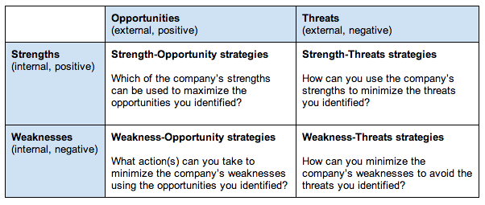

Once you’ve developed strategies and included them in your strategic plan, be sure to schedule regular review meetings. Use these meetings to talk about why the results of your strategies are different from what you’d planned (because they always will be) and decide what your team will do going forward.

  - Balanced score Card (BSC)

Balanced ScoreCard - Definition
What exactly is a Balanced Scorecard? A definition often quoted is: 'A strategic planning and management system used to align business activities to the vision statement of an organization'. More cynically, and in some cases realistically, a Balanced Scorecard attempts to translate the sometimes vague, pious hopes of a organization's vision/mission statement into the practicalities of managing the business better at every level.
A Balanced Scorecard approach is to take a holistic view of an organization and co-ordinate MDIs so that efficiencies are experienced by all departments and in a joined-up fashion.
To embark on the Balanced Scorecard path an organization first must know (and understand) the following:
- The organization's mission statement
- The organization's strategic plan/vision
Then
- The financial status of the organization
- How the organization is currently structured and operating
- The level of expertise of their employees
- Customer satisfaction level
The following table indicates what areas may be looked at for improvement (the areas are not exhaustive and are often organization-specific):

balanced scorecard - factors examples
Department | Areas
Finance | Return On Investment  used budgets  Return on Capital Employed  Financial Results (Quarterly/Yearly)
Internal Business Processes | Number of activities per function  Duplicate activities across functions  Process alignment (is the right process in the right department?)  Process bottlenecks  Process automation  Process described
Learning & Growth | Is there the correct level of expertise for the job?  Employee turnover  Job satisfaction  Training/Learning opportunities
Customer | Delivery performance to customer  Quality performance for customer  Customer satisfaction rate  Customer percentage of market  Customer retention rate

Once an organization has analysed the specific and quantifiable results of the above, they should be ready to utilise the Balanced Scorecard approach to improve the areas where they are deficient.
The metrics set up also must be SMART (commonly, Specific, Measurable, Achievable, Realistic and Timely) - you cannot improve on what you can't measure! Metrics must also be aligned with the organization's strategic plan.
A Balanced Scorecard approach generally has four perspectives:
- Financial
- Internal business processes
- Learning & Growth (human focus, or learning and development)
- Customer
Each of the four perspectives is inter-dependent - improvement in just one area is not necessarily a recipe for success in the other areas.
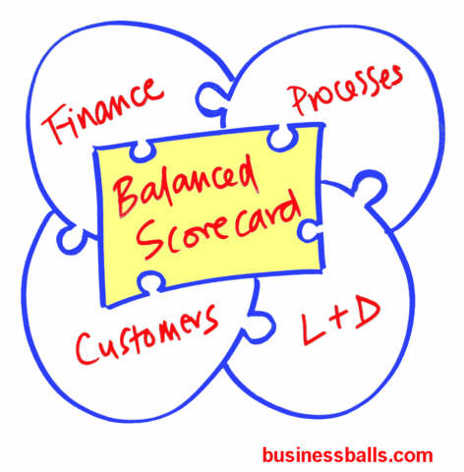

balance scorecard implementation
Implementing the Balanced Scorecard system organization-wide should be the key to the successful realisation of the strategic plan/vision.
A Balanced Scorecard should result in:
- Improved processes
- Motivated/educated employees
- Enhanced information systems
- Monitored progress
- Greater customer satisfaction
- Increased financial usage
Feedback is essential and should be ongoing and contributed to by everyone within the organization (remember module 1)
And it should be borne in mind that Balanced Scorecards do not necessarily enable better decision-making!

The balanced scorecard is a strategic planning and management system that is used extensively in, government, and nonprofit organizations worldwide to align business activities to the vision and strategy of the organization, improve internal and external communications, and monitor organization performance against strategic goals. It was originated by Drs. Robert Kaplan (Harvard Business School) and David Norton as a performance measurement framework that added strategic non-financial performance measures to traditional financial metrics to give managers and executives a more 'balanced' view of organizational performance.
The balanced scorecard has evolved from its early use as a simple performance measurement framework to a full strategic planning and management system. The “new” balanced scorecard transforms an organization’s strategic plan from an attractive but passive document into the "marching orders" for the organization on a daily basis. It provides a framework that not only provides performance measurements, but helps planners identify what should be done and measured. It enables executives to truly execute their strategies.
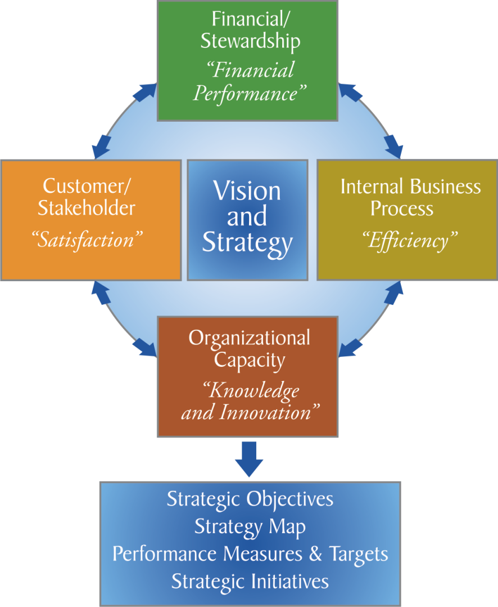

Perspectives
The balanced scorecard suggests that we view the organization from four perspectives, and to develop metrics, collect data and analyze it relative to each of these perspectives:
The Learning & Growth Perspective
This perspective includes employee training and corporate cultural attitudes related to both individual and corporate self-improvement. In a knowledge-worker organization, people -- the only repository of knowledge -- are the main resource. In the current climate of rapid technological change, it is becoming necessary for knowledge workers to be in a continuous learning mode. Metrics can be put into place to guide managers in focusing training funds where they can help the most. In any case, learning and growth constitute the essential foundation for success of any knowledge-worker organization.
Kaplan and Norton emphasize that 'learning' is more than 'training'; it also includes things like mentors and tutors within the organization, as well as that ease of communication among workers that allows them to readily get help on a problem when it is needed. It also includes technological tools; what the Baldrige criteria call "high performance work systems."
The Business Process Perspective
This perspective refers to internal business processes. Metrics based on this perspective allow the managers to know how well their business is running, and whether its products and services conform to customer requirements (the mission). These metrics have to be carefully designed by those who know these processes most intimately; with our unique missions these are not something that can be developed by outside consultants.
The Customer Perspective
Recent management philosophy has shown an increasing realization of the importance of customer focus and customer satisfaction in any business. These are leading indicators: if customers are not satisfied, they will eventually find other suppliers that will meet their needs. Poor performance from this perspective is thus a leading indicator of future decline, even though the current financial picture may look good.
In developing metrics for satisfaction, customers should be analyzed in terms of kinds of customers and the kinds of processes for which we are providing a product or service to those customer groups.
The Financial Perspective
Kaplan and Norton do not disregard the traditional need for financial data. Timely and accurate funding data will always be a priority, and managers will do whatever necessary to provide it. In fact, often there is more than enough handling and processing of financial data. With the implementation of a corporate database, it is hoped that more of the processing can be centralized and automated. But the point is that the current emphasis on financials leads to the "unbalanced" situation with regard to other perspectives. There is perhaps a need to include additional financial-related data, such as risk assessment and cost-benefit data, in this category.
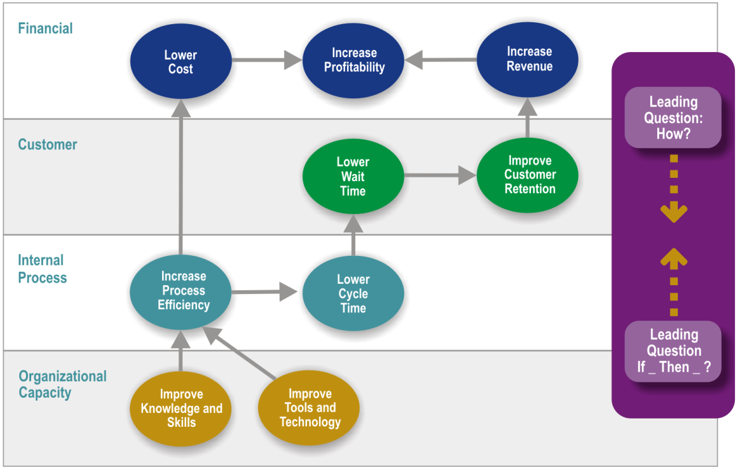
Reference: The Institute Way: Simplify Strategic Planning & Management with the Balanced Scorecard.

Attachment: Examples of strategic plan of:
  - HCoJ - http://hcoj.gov.ge/ge/162-2017
  - MoD - https://mod.gov.ge/uploads/archive/pdf/SDR-GEO.pdf
https://mod.gov.ge/ge/page/48/ministris-direqtivebi
  - HSoJ – http://www.hsoj.ge/uploads/Uploads/strategiuli_gegma.pdf
  - http://www.mfa.gov.ge/MainNav/ForeignPolicy/ForeignPolicyStrategy.aspx

2.3 The 7-S Framework
Another approach for analyse of an Organization is described by Mc Kinsey 7S Model. See the similar aspects of SWOT and BSC in that model.
7 S Model: Ensuring That All Parts of Your Organization Work in Harmony
Use the 7S Framework when things aren't quite working in harmony.
How do you go about analyzing how well your organization is positioned to achieve its intended objective?
This is a question that has been asked for many years, and there are many different answers. Some approaches look at internal factors, others look at external ones, some combine these perspectives, and others look for congruence between various aspects of the organization being studied. Ultimately, the issue comes down to which factors to study.
While some models of organizational effectiveness go in and out of fashion, one that has persisted is the McKinsey 7-S framework. The basic premise of the model is that there are seven internal aspects of an organization that need to be aligned if it is to be successful.
The 7-S model can be used in a wide variety of situations where an alignment perspective is useful, for example, to help you:
- Improve the performance of a company.
- Examine the likely effects of future changes within a company.
- Align departments and processes during a merger or acquisition.
- Determine how best to implement a proposed strategy.
The McKinsey 7-S model can be applied to elements of a team or a project as well. The alignment issues apply, regardless of how you decide to define the scope of the areas you study.
We'll explore the seven elements of the model in more detail and explain how you can align them to improve performance in your organization.

2.3.1 The Seven Elements
The McKinsey 7-S model involves seven interdependent factors which are categorized as either "hard" or "soft" elements:
Hard Elements | Soft Elements
Strategy  Structure  Systems | Shared Values  Skills  Style  Staff
"Hard" elements are easier to define or identify and management can directly influence them: These are strategy statements; organization charts and reporting lines; and formal processes and IT systems.
"Soft" elements, on the other hand, can be more difficult to describe, and are less tangible and more influenced by culture. However, these soft elements are as important as the hard elements if the organization is going to be successful.
The way the model is presented in Figure 1 below depicts the interdependency of the elements and indicates how a change in one affects all the others.
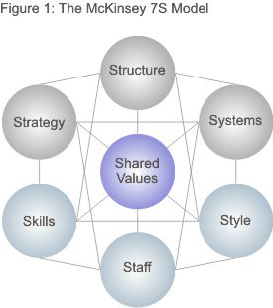
Figure reproduced with permission from Mckinsey & Company, www.mckinsey.com. Copyright © 2016. All rights reserved.

Let's look at each of the elements specifically:
- Strategy: the plan devised to maintain and build competitive advantage over the competition.
- Structure: the way the organization is structured and who reports to whom.
- Systems: the daily activities and procedures that staff members engage in to get the job done.
- Shared Values: called "superordinate goals" when the model was first developed, these are the core values of the company that are evidenced in the corporate culture and the general work ethic.
- Style: the style of leadership adopted.
- Staff: the employees and their general capabilities.
- Skills: the actual skills and competencies of the employees working for the company.

Placing Shared Values in the middle of the model emphasizes that these values are central to the development of all the other critical elements. The company's structure, strategy, systems, style, staff and skills all stem from why the organization was originally created, and what it stands for. The original vision of the company was formed from the values of the creators. As the values change, so do all the other elements.
2.3.2 How to Use the Model
The model is based on the theory that, for an organization to perform well, these seven elements need to be aligned and mutually reinforcing. So, the model can be used to help identify what needs to be realigned to improve performance, or to maintain alignment (and performance) during other types of change.
Whatever the type of change – restructuring, new processes, organizational merger, new systems, change of leadership, and so on – the model can be used to understand how the organizational elements are interrelated, and so ensure that the wider impact of changes made in one area is taken into consideration.

2.3.3 The 7-S Checklist Questions
Here are some of the questions that you'll need to explore to help you understand your situation in terms of the 7-S framework. Use them to analyze your current (Point A) situation first, and then repeat the exercise for your proposed situation (Point B).

Strategy:
- What is our strategy?
- How do we intend to achieve our objectives?
- How do we deal with competitive pressure?
- How are changes in customer demands dealt with?
- How is strategy adjusted for environmental issues?

Structure:
- How is the company/team divided?
- What is the hierarchy?
- How do the various departments coordinate activities?
- How do the team members organize and align themselves?
- Is decision making and controlling centralized or decentralized? Is this as it should be, given what we're doing?
- Where are the lines of communication? Explicit and implicit?

Systems:
- What are the main systems that run the organization? Consider financial and HR systems as well as communications and document storage.
- Where are the controls and how are they monitored and evaluated?
- What internal rules and processes does the team use to keep on track?

Shared Values:
- What are the core values?
- What is the corporate/team culture?
- How strong are the values?
- What are the fundamental values that the company/team was built on?

Style:
- How participative is the management/leadership style?
- How effective is that leadership?
- Do employees/team members tend to be competitive or cooperative?
- Are there real teams functioning within the organization or are they just nominal groups?

Staff:
- What positions or specializations are represented within the team?
- What positions need to be filled?
- Are there gaps in required competencies?

Skills:
- What are the strongest skills represented within the company/team?
- Are there any skills gaps?
- What is the company/team known for doing well?
- Do the current employees/team members have the ability to do the job?
- How are skills monitored and assessed?

2.3.4 The 7-S Matrix Questions
Using the information you have gathered, now examine where there are gaps and inconsistencies between elements. Remember you can use this to look at either your current or your desired organization.
- Start with your Shared Values: Are they consistent with your structure, strategy, and systems? If not, what needs to change?
- Then look at the hard elements. How well does each one support the others? Identify where changes need to be made.
- Next look at the other soft elements. Do they support the desired hard elements? Do they support one another? If not, what needs to change?
- As you adjust and align the elements, you'll need to use an iterative (and often time consuming) process of making adjustments, and then re-analyzing how that impacts other elements and their alignment. The end result of better performance will be worth it.

- Preparing Action Plan
  - Objectives: From Strategy to action plan
Based on the vision and mission statement (see chapter 1) the following steps should be undertaken to implement a strategic plan.

State the objectives
State the objectives with
- how much of what the group or organization hopes to accomplish by when
- develop (or refine) objectives and write down
- Benchmarks that would help to assess where you are now (baseline or pre-intervention) and where we would be if the initiative were successful (objectives). What baseline markers could you access and how would you hope they would change if success were attained?
- Review the objectives to determine if they are:
  - Specific
  - Measurable (at least potentially)
  - Achievable
  - Relevant (to the mission)
  - Timed (date for attainment)
  - Challenging (requiring extraordinary effort)
Behavioral objectives: the changes in behaviors we would see if i.e. the group's efforts were successful:
- What would people be saying and doing differently?
- Population-level objectives: the changes in community-level indicators we would see if the group's objectives were met.
Be flexible with deadlines in creating objectives. Defining objectives is time consuming and may require second and third considerations for completeness.
Related resources:
VMOSA (Vision, Mission, Objectives, Strategies)
The next question to answer is: What different levels and target groups of your problem or goal will you target?
- For each strategy, consider if it will be universal or targeted
- The personal and environmental factors to be addressed by the initiative
- Personal factors may include: knowledge, beliefs, skills, education and training, experience, cultural norms and practices, social status, cognitive or physical abilities, gender, age, genetic predisposition
- Environmental factors may include: social support, available resources and services, barriers (including financial, physical, and communication), social approval, policies, living or working conditions, and disparity in status

Thinking about the implementation take into consideration:
      - Those who can most benefit and contribute and how they can be reached or involved in the effort
      - Targets of change: those who may at particular risk for the issue or whose actions are critical for success. For you, who would this include?
      - Agents of change: those who may be in a position to contribute to the initiative, including targets of change. Who would this include?
      - Behavioral strategies to be used. Approaches may include:
        - Providing information and enhancing skills (e.g., conducting a social marketing campaign to educate people about the problem or goal and how to address it)
        - Modifying barriers, access, exposures, and opportunities (e.g., increase availability of affordable childcare for those entering work force)
        - Changing the consequences
        - Enhancing services and supports
      - Review the strategies and comment on their appropriateness to the situation and sufficiency in addressing the mission and objectives. Review the strategies for:
  - Consistency with the overall vision, mission, and objectives
  - Goodness of fit with the resources and opportunities available
- Anticipated resistance and barriers and how they can be minimized
- Whether those who are affected are reached
- Whether those who can contribute are involved

Related resources:
Developing Successful Strategies: Planning to Win
Identifying opponents
Identifying Targets and Agents of Change: Who can benefit and who can help
Identifying risk and protective factors:
Involving key influentials in the Initiative
Involving People most affected by the problem

  - Develop (or refine) the action plan
Develop the action plan by stating the specific community/system changes to be sought that will result in the accomplishment of your goals and objectives. For each strategy, identify specific community and system changes (i.e., new or modified programs, policies, and practices) to be sought. After compiling a list of potential changes, review each candidate community or system change and rate it on two dimensions:
- Importance to the mission (1=not at all, 5=very); and
- Feasibility (1=not at all, 5=very)
Secure a formal decision from the group on what community or system changes (intervention components and elements) will be sought (or implemented), with priority given to those changes with high importance and high feasibility
Related resources:
Model of Practice: Building Capacity for staff and System Change
Obtaining Feedback from Constituents: What changes are important and feasible
Providing information and enhancing skills
Overview of tactics for modifying access, barriers, and opportunities

  - Action steps
Identify action steps for every key system change (who is going to do what by when). Describe:
- What specific change (e.g., in program or policy) or aspect of the intervention that will occur?
- Who will carry it out?
- When the intervention will be completed or for how long it will be maintained?
- Resources (money and staff) needed/available?
- Communication - who should know what about this?
Related resources:
Developing an Action Plan
Identifying Action Steps in Bringing About Community and System Change
Designing Community Interventions
3.5 Evaluate critically the appropriateness of the action plan
To evaluate critically the appropriateness of the action use the criteria that follow:
- Completeness - Are all the intended activities or system changes included in your plan? Are a wide variety of strategies and sectors utilized?
- Clarity - Is it apparent what will be done and who will do what by when, to bring about change?
- Sufficiency - If all that is proposed were accomplished, would it meet the group's mission and objectives? If not, what additional changes need to be planned and implemented?
- Resources (money/staff) needed/available?
- Currency - Does the action plan reflect the current work and situation?
- Flexibility - As the plan unfolds, is it flexible enough to respond to new opportunities, barriers, and changes in the community? Can it be modified as objectives are accomplished or goals adjusted?
Modify your proposed changes and action plans based on your answers (if necessary).
Related resources:
Developing an Action Plan
3.6 Use
Indicate how you will use the strategic and action plans. Consider the following potential uses:
- Communicate the initiative's purpose to others.
- Indicate who should know about the group's vision, mission, objectives, strategic and action plans.
- Describe how the initiative will communicate this new framing of what it does and why.
- Check the organization's core functions.
- Indicate who should know about the group's vision, mission, objectives, and the core functions of the organization represented (e.g., advocacy, training).
- Find common ground and anticipate potential conflict.
- Identify potential disagreements about ends and means that the group is facing.
- Indicate how you might use this new framing of the problem or goal to build consensus.
- Plan how to detect or discern opportunity
- Identify the criteria that will be used to judge an "opportunity". These might include qualities such as:
  - Consistency with the vision
  - Consistency with the mission
  - Contributes to the action plan
- Identify potential partners
- Indicate who is out there who can help the group achieve its vision and mission. List organizations that share this common work or can support.
- In light of the vision, mission, and action plan, identify some potential partners that the community initiative or organization should collaborate with.
Related resources:
Developing an Action Plan
Developing a Plan for Communication
Discovering and Creating Possibilities
Coalition Building I: Starting a Coalition
  - Implementation of an action plan
Begin implementing action planning steps. Choose the order by considering:
- Which changes need to be completed before others can? Some changes may require other changes and relationships to be established.
- Which changes are easier or quicker to bring about? Could completing them give the organization's membership a sense of success and provide the organization with much needed media exposure?
- Which changes are the most important or key to the initiative's objectives?
- Which changes would inspire and encourage participants and build credibility within the community?

4. Action Plan
Action plans are a key component of successful project management, helping you summarize how you will achieve objectives and by when. When action planning, aim to break down each of your objectives into detailed tasks. This has two purposes:
- It ensures that all areas of required action have been taken into account
- It breaks the achievement process down into manageable chunks
To deliver your project on time and to budget, you will need to define all necessary actions and assign responsibility to individuals for delivering these actions within agreed timescales.
Steps to produce an action plan(see also chapter 1: From strategy to action plan):
- Firstly, establish your current position, by asking questions such as 'Where are we now?'
Objective | Actions | By whom | By when | Possible issues
1 | 1.1
 | 1.2
 | 1.3
2 | 2.1
 | 2.2
 | 2.3
 | 2.4
3 | 3.1
 | 3.2
 | 3.3
- Define your objectives by asking ‘Where do we want to get to?'
- Next, establish the steps to achieve each objective by asking ‘What do we need to do to get to our desired position?'
- Finally, decide ‘Who is required to achieve the action, and what is the target date?'
The final column is an optional extra if you feel the need to capture issues that could possibly thwart the action.
Once you have produced the action plan, you need to review it regularly to ensure that actions are being completed. You could aid this by pinning the action plan up somewhere that the whole team can continually view what actions are outstanding.

An alternative format for action plan you find in the following table:
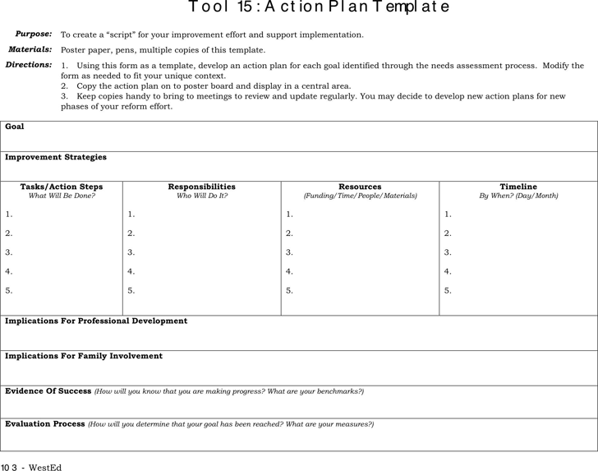

- Work load analyses

Strategies, objectives, changes and related action plans very often base on a Workload Analysis. Workload Analyses is a methodology to determine the time, effort and resources necessary to carry out the department’s operations, resulting in identifying the organization’s actual needs of human resources both in terms of quality and quantity, and develop these resources to achieve the goals and strategies that the organization wants to achieve in the various work sites. In this methodology, the workload is analyzed by evaluating the current human resources structure, and then the organization’s actual needs of human resources are identified in order to implement the processes necessary to provide a particular service.
The impact of workload analysis on increasing service customers’ satisfaction
- Identifying the actual needs of human resources both in terms of quality and quantity in the short term and long term.
- Identifying the current and future training needs, which facilitate designing training programs according to actual needs.
- Maintaining the appropriate number of employees in the work system, to ensure not to prevent or delay processing the customers’ transactions.

Receiving the support and approval of the organization’s senior management is the starting point for the project, ensuring support for the project’s decisions and obtaining the needed funding to implement the project. It is necessary to link the organization’s strategic plans with the projects it plans to implement. Examples of the strategic objectives of the workload analysis project include:
- Creating a competitive organization by enabling it to predict and adapt to current and future requirements
- Improving the performance of the various units of the organization.

At this stage, the divisions that most need the workload analysis are identified depending on the severity and depth of their problems. A number of indicators are adopted for this purpose. Indicators
Indicators that can be used to determine the scope of work
- umber of customers’ complaints
- Number of employees’ complaints
- Customer’s satisfaction level
- Number of customers
- Previous institutional performance results
- Rate of employee’s performance evaluation
- Employees’ satisfaction level

There are two different methods in place:
The first method: recording data relating to a particular transaction (it includes the operation steps, the person responsible for implementation and the time needed); the transaction is followed-up from the beginning at the division under study until it leaves the division. This is the most widely used method to analyze the workload.
The second method: recording the number of transactions performed by the division under study in a specific time period (one hour for example) in a single process, then using the equation below to find out the average time spent per transaction in a particular process, taking into account to consider the different types of transactions performed by the division when using the equation, so that the average is calculated for each type of transactions separately.
Calculating the average time needed for each type of service provided by each division.
Determine the number of customers (the number of transactions) within the department’s current work system, where the number is determined by customers who have received the services which is revealed by reviewing the annual statistics.

The following steps are needed:
- Determine the average work time available per employee per year (minutes/ employee).
- Determine productivity
This amount represents the actual proportion of the time spent by employees to provide services to the public; productivity is calculated using one of these two equations:
When using the second equation, the work team is asked to observe the employees to determine the utilized time spent by these employees in providing services to the public and the unutilized time.
- Determine the expected number of customers for the next time period (customer/ process)

The number of transactions expected to be completed in the coming year is calculated using one of these methods:
- Naïve Forecasting
- Weighted Moving Average
- Exponential Smoothing
- Simple Moving Average

This is the most common way; the forecast depends of the data of at least three previous years in order to find out the correct number of transactions expected to be completed in the coming year by using the following equation:

Productivity = Total (number of completed transactions per year for the current year average time needed to process a single transaction per minute) the time available for the employees in the same division per minute
Or
Utilized time (Unutilized time utilized time)

When using the second equation, the work team is asked to observe the employees to determine the utilized time spent by these employees in providing services to the public and the unutilized time.

Low productivity is not necessarily a sign of employees’ inefficiency; it may reflect the lack of sufficient workload (low number of transactions completed per year), which implies the importance of investing employees’ time in performing other work.
Determine the expected number of customers for the next time period (customer/ process) :
A surplus in the number of employees in the division. The need to increase the division's employees
Determine the number of employees required in each division
The number of employees required in each division is calculated using the following equation:
Number of employees required in the division for the coming year =
(Number of expected annual transactions the time needed to complete a single transaction) ÷
Available average time per employee
- If the number of employees calculated using the equation is greater than the number of current employees, this implies the need to hire more employees.
- If the number of employees calculated using the equation is less than the number of current employees, this implies the need to redistribute some employees in the division or transfer them to other divisions.

The next step is to determine the corrective actions. Possible scenarios after the workload analysis are:
- If there is a need to increase the division’s employees, this lack is compensated by internally transferring the employees or redistributing them between the different divisions as needed (redistribution of tasks). The organization may have to resort to external recruitment.
- If there is a surplus in the number of employees in the same division, they can be redistributed to other vacant positions in the organization, taking into account the job requirements necessary to carry out the tasks that will be distributed to employees.
- Staff Development Dialogue (SDD)
Why hold SDD?
A staff development dialogue (SDD) is an annual dialogue between managers and individual members of staff.
The SDD focuses on the staff member’s daily working life, and the dialogue gives the manager and the staff member the opportunity for more in-depth dialogue and a reconciliation of mutual expectations as regards the staff member’s goals, tasks, well-being, cooperative relations and professional and personal development. The SDD thus links the employee’s professional and personal competence development with the development of the workplace.
The dialogue is intended to ensure that the development of the employee’s competences is approached strategically and systematically. Strategically, by ensuring a direction for the competence development that matches the needs of the workplace while supporting the overall strategy of Your Organization. Systematically, in that the employee and his or her manager complete an agreement form and follow up on what has been agreed in the course of the year. At the your Organization, it is recommended that the manager and the staff member hold an SDD dialogue once a year.
Moreover, the SDD dialogue must, according your organization personnel policy, support competence development that helps guarantee the employee good job prospects in the labour market both at and outside the Your Organization. In addition, the personnel policy standards as regards professional staff management, professional and personal competence development, an appreciative approach management and the balancing of family and working life are adhered to through the holding of SDD.
The manager and the staff member have a shared responsibility for ensuring that the dialogues have an effect. The manager must ensure that the dialogues are held and that it is possible for the necessary competence development to take place. For their part, the employees must work to fulfil their development goals and complete the planned development activities.
In this way, SDD is a mutual development dialogue with a forward-looking focus. SDD does not replace the ongoing daily dialogue and feedback between managers and staff members. Nor is SDD an occasion to focus exclusively on problems at which the manager or the staff member focuses on accumulated criticisms. Such issues must be handled in separate dialogues.
Finally, it is important to remember that SDD is not a pay negotiation. For this reason, the SDD dialogues are held in the autumn so they are quite distinct from and take place at a different time to the pay negotiations which are held in the spring.

Dialogue in your organization for manager and staff member
It is recommended to discuss SDD as a competence development initiative and to ensure that it is sufficiently clear who is responsible for the SDD for which groups of employees in the year in question.
It is the management’s responsibility to define which managers hold SDD with which members of staff. SDD can be conducted whether or not the manager conducting the SDD dialogue is authorised to make decisions/promises of a financial nature. As a manager, it may be necessary to examine the unit’s overall competence development needs or seek financial assurances before making any definite promises to individual employees. Here, it is simply important to state in the agreement form when a definite promise can be made, and how to follow up on it.
Basically, the manager must ensure that the dialogue addresses the employee’s past, present and future in the workplace.

Preparing for SDD – as a manager
It is recommended that the SDD process starts with the manager informing his or her members of staff about the forthcoming SDD dialogues. The information must ensure that the staff are aware of the purpose, framework and schedule for the SDD process, including Your Organization´s and the unit’s respective goals, strategies and tasks etc. This creates a common frame of reference for managers and employees in advance of the individual dialogues. To provide inspiration for the coming SDD process, the manager can briefly describe the competence development work which has taken place in the unit.
As part of the SDD process, the intention is that the manager and the employee give each other feedback on, for example, work performance and collaboration during the past year. To ensure that the feedback can be used constructively, it is a good idea to use this simple feedback model:
Checking communication: Constructive feedback
1. Describe facts
• Start with a specific example, for example a situation or a word-for-word quotation which prompts feedback. Repeat facts without trying to interpret them.
2. Describe your experience
• Your experience is about you, so therefore use expressions such as “I feel …” and “I am … ”.
• For example impressed, confused, unsure, sceptical, happy, relieved, inspired, unhappy, proud or angry.
• Judgemental expressions are not suitable for giving feedback, for example "You are …", "You will be …".
3. Say what you want
• Say what you want the other person to do.
• Say what you want and what you want in future rather than what you don’t want.

If possible, it may be a good idea also for the manager and employees to discuss which competence-related challenges the unit faces, and how these can be addressed.
In preparing for SDD, it is recommended that the manager read ‘Checklist for the manager – the three phases of the SDD process’. The manager then prepares for the individual dialogue to make his or her own notes to take to the dialogue.
As a manager, it is preferable if you have held your SDD dialogue with your own manager before holding SDD dialogues with the staff in the unit. This is a way of ensuring strategic alignment of the employee development efforts with Your Organization´s objectives. By having attended a staff development dialogue with your own manager, you are likely to have a clearer picture of his or her expectations and the strategic objectives for the unit in the coming year.

Preparing for SDD – as an employee
Before the dialogue, the employee should complete the necessary preparations to make his or her own notes to take to the dialogue.
It is the employee’s job to raise topics which are important to discuss in relation to his or her work. The employee may also want to consider:
- What is particularly important to discuss with my manager?
- What are my ambitions and development wishes?
- How do my present competences and wishes in relation to my future working life harmonise with the objectives and development of my workplace?
- What is my feedback to my manager?
Clarifying the above helps to ensure that you get to talk about what is most important during the dialogue.

Holding SDD – the dialogue
To ensure that an SDD dialogue is characterized by quality, meaning and effect, both the staff member and manager must do their utmost to have a forward-looking and developing dialogue.
A developing dialogue requires that both the manager and employee listen to each other and seek to understand what the other person is saying by asking elaborating questions rather than by arguing.
If it becomes apparent during the dialogue that there is a pressing need for a different type of dialogue (e.g. discussion of problems, coaching etc.), it is agreed when this can take place, after which the SDD dialogue continues according to the dialogue guide.
It is recommended that approx. 1½ hours be allocated for an SDD dialogue.

The agreement form
The SDD always ends with the manager and employee agreeing what should be entered in the agreement form for the coming year. The more specific the agreement form, the easier it is to relate to and follow up on (see writing objectives in booklet 1). It is important to agree who is responsible for implementing the individual items listed in the form. Is it the manager or employee who is responsible for initiating the activity in question?
The form is confidential between the manager and the employee, and these are the only two people who can access it. If a new unit manager is appointed, the employee decides for him/herself whether to submit previous agreement forms in paper format to the new manager if it is deemed beneficial for their future collaboration.

Follow-up on SDD
After holding all the SDD in a unit, it is advisable that the manager provides general feedback to the staff at a follow-up meeting or as an item on the agenda of a meeting which is already scheduled. This is an opportunity for the manager to report back from a general organizational and developmental perspective and outline which particular points the dialogues have raised and how follow-up will be handled in the unit. For reasons of confidentiality, it is important that no reference is made to specific content from the individual dialogues.
The manager also plays an important role in relation to following up on whether the individual development activities are on the right track and whether the employee is benefiting as intended. If some of the activities are not going as expected, the manager and the employee should discuss why, and whether new initiatives are needed. Experience shows that individual follow-up is vital for both the manager and the employee to feel that the SDD process is effective.

The following annual schedule is specifically intended for managers.
Step1: It is recommended that the SDD process is kicked off each year by including it on the agenda at a meeting.
The manager decides on a timetable for holding SDD dialogues and a date for a joint meeting on SDD in the unit.
Step 2: Managers summon employees to SDD dialogues The managers invite their employees to participate in an SDD. Relevant materials, e.g. strategy etc. are enclosed.
Step 3: Joint meetings in the units. The managers inform their employees about the coming SDD dialogues at a joint meeting or at a pre-scheduled departmental meeting, at which everyone discusses competence development challenges and needs etc. in the unit. The aim is to clarify the SDD framework – e.g. strategic objectives and competence development needs. If necessary, it must also be announced who will be holding the SDD dialogues and with whom.
Step 4: Dialogues held and agreement forms approved. Managers and employees prepare for the dialogues and the dialogues are held. The dialogue is confidential. The dialogue ends with the manager and employee agreeing.
Step 5: Consent in relation to activities. Once the year’s SDD dialogues have been held, the manager assesses the unit's overall development needs. Once he/she has clarified the unit's development needs (and if the manager does not have budgetary responsibility: once budgetary approval has been obtained), consent is given to the individual employees
Step 6: Follow-up in the units The manager provides general feedback on the themes for the year's SDD dialogues and the agreed competence development. Did the dialogues, for example, identify recurring themes of general relevance to the unit?
Step 7: Evaluation of the year's SDD process Evaluation of the year's SDD process and competence development is put on the agenda in LSU, which sends any wishes regarding changes to the SDD concept to Competence Development, AU HR.
Step 8: Follow-up A follow-up dialogue may be held in the spring to review the agreements made at the SDD dialogue. Have both parties adhered to the agreements?

In summary there are 3 phases of SDD:
Phase 1: Preparing for the dialogue:
• Prepare a status on agreements and follow-up since the last SDD dialogue.
• It is a good idea if you refer to the questions in the dialogue guide.
• Prepare acknowledging and constructive feedback on the employee's assignments and development.
Phase 2: The dialogue
• Plan the dialogue to allow time for addressing all the main themes and special focus areas.
• It is recommended that you allow about 1½ hours for the actual dialogue.
• Allocate sufficient time to agree on what to write afterwards in the agreement form – who will be responsible for what, and when to follow up.
Phase 3: Following up on the SDD dialogue
• Coordinate any competence development needs locally before making any final commitments to the employees.
• Hold a follow-up meeting (possibly as part of a departmental meeting) at which significant themes and general issues from the dialogues are discussed, including how follow-up will be handled in the unit. For reasons of confidentiality, it is important that no reference is made to specific content from the individual dialogues.
• To follow up on the individual dialogues, it is recommended that follow-up dialogues are held after approx. six months.

The Phases of the dialogue
The following dialogue guide is consultative, and the questions are intended as a source of inspiration, i.e. they do not necessarily all have to be answered, and other questions may certainly be asked, by both the manager and the employee. The idea is that it is a fluid dialogue with both the manager and employee asking the questions which come to them naturally. However, the dialogue should, as a minimum, address the three main themes around which the dialogue is structured. The three main themes are:
1. What has happened since the last SDD? – A good starting point for talking about the future
2. Well-being and job satisfaction
3. Future tasks and competence development
Each main theme comprises related questions. In addition, the dialogue starts with a reconciliation of expectations and desired outcome between manager and staff member and ends with a summary of the agreements made in an agreement form (you can use action plan format).
In this way, SDD is a mutual development dialogue with a forward-looking focus.

Introducing SDD: Expectations of the dialogue
The dialogue starts with the manager and staff member presenting and agreeing on which themes to prioritize. This increases the likelihood of a satisfactory outcome. The following procedure is recommended:
a. The manager outlines the dialogue framework, i.e. its duration, content and any priorities or special focus areas as well as the expected outcome of the dialogue.
b. The employee adds his/her expectations with respect to outcome and any special topics he/she would like to discuss.
c. Together, the topics are prioritized and time allocated to the individual themes.

Main theme 1: What has happened since the last SDD? – A good starting point for talking about the future
A dialogue about the work experiences and challenges over the past year can provide a shared understanding of what works and what may need to be done differently in the year ahead. Here, the intention is also for the manager and employee to give each other feedback on how successful they have been – in performing their tasks and in undertaking their managerial functions (See feedback tableau above).
a. Agreements resulting from last year’s SDD dialogue – how have they been followed up on, what has the effect been?
b. Which professional and collaborative tasks and challenges have you undertaken and tackled in the past year?
c. How have you and your job developed as a result of these challenges?
d. The manager’s feedback to the employee on the performance of tasks and development points
Can be angled to focus on what you want more/less of.
e. The employee’s feedback to the manager on the manager’s leadership and development points
Can be angled to focus on what you want more/less of.

Main theme 2: Well-being and job satisfaction
Well-being is a central theme in any SDD dialogue and is important for employees to be able to perform their work satisfactorily, develop and achieve their goals. It can be a good idea to base the dialogue on specific work situations to get a shared idea of how to enhance well-being. If there are any special personal or other factors which have a bearing on the work which the employee wants to discuss, it is a good idea to mention it here.
a. What motivates and inspires you at work?
b. To what extent are you thriving with your current tasks? Is there anything you would like more/less of?
c. How is your collaboration with your colleagues and other close partners?
d. In terms of my management, what would you like more/less of to improve your sense of well-being?
e. How is your collaboration with other units at your Organization? Do you have any suggestions for improvements?

Main theme 3: Future tasks and competence development
In particular focus on judging procedures, administration procedures, publications, presenting activities, supervision and consultancy etc. The questions are a selection which could be relevant to ask, depending on the employee’s tasks. The manager and the employee are encouraged to choose the most important questions at the dialogue.
a. What are your goals for the coming year?
b. What are your plans as regards publications in the coming year?
c. What are your goals for your presenting and supervisory and other activities?
d. What are your plans and wishes with regard to maintaining and developing your professional level over the next year?
e. Which career and development options do you find interesting, both internally and externally?

Conclusion and agreement
At the end of the dialogue, it is necessary to agree on what to write in the agreement form, who will follow up on it and when (see also action plan).

