Appendix 1
Critical assessment of the strategic purchasing situation and key development needs in Georgia

Objective: This assessment will be used as an input to start the scoping of the strategy for strategic purchasing during the policy seminar.

Framework for the assessment: Assessment could follow the WHO health financing policy framework by linking it to the Universal Health Coverage (UHC) goals and intermediate objectives (see Figure below). Main emphasis of the assessment should be put to the strategic purchasing function. However, some aspects of other health financing functions might be important to keep in the picture, especially those that need good alignment with strategic purchasing (see below).

Figure. UHC goals and intermediate objectives influenced by health financing policy
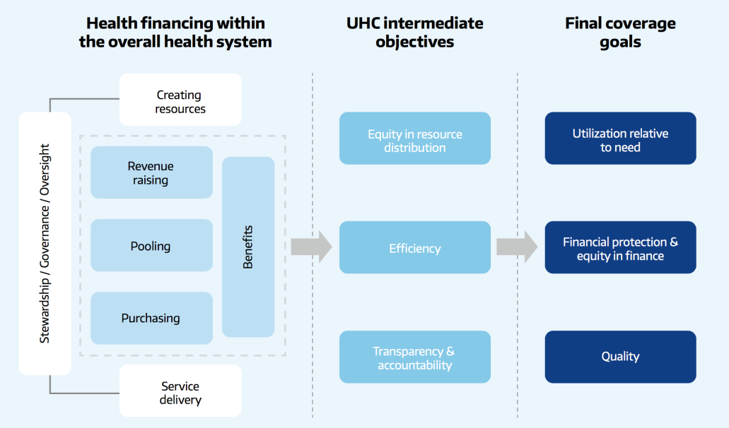
Source: http://www.who.int/health_financing/documents/health-financing-strategy/en/

Outline for the assessment:

- Performance of the health financing system
Assessment should include situation analysis (AS IS) how Georgia is achieving UHC goals related to financing policies and some preliminary thinking about what should change (SHOULD BE). Quantitative approach is preferred; qualitative assessment could be used data is absent.

Performance dimension | AS-IS | SHOULD-BE
Financial protection (e.g. level and distribution of out of pocket spending and catastrophic and impoverishing out-of-pocket payments) | OOP - 57% from THE; 64% OOP on drugs | OOP - 20-25% from THE
Access to the health services and medicines by different population groups and regions | services High  medicines - low | services High  medicines - High
Performance of health service providers across different settings regarding efficiency and quality aspects | efficiency – not high  quality – not high | efficiency - High  quality - High
Public awareness about entitlements and satisfaction | services High  medicines - low | services High  medicines - High
Other..(please add if some additional important dimensions exist)

- Situation with strategic purchasing
In general, health financing policy covers three core functions:
- raising revenue
- pooling of funds
- purchasing of services

as well as
- coverage policies: who is covered (the basis for entitlement), what is covered (the benefits package) and how much of the cost is covered (user charges), plus issues around timely access to services
- governance of the above functions and policies

The scope for the strategic purchasing strategy in detail will be discussed during the seminar. Assumably it will predominantly focus on functions 3 and 4 but it would be important to critically assess which aspects of other functions should be part of the strategy to assure good alignment with overall health financing policy in Georgia.

You may keep in mind the aspects below (list is not fully comprehensive and you may add additional aspects) of health financing functions when preparing situation analysis. Assessment should include situation analysis (AS IS) and some preliminary thinking about what should change (SHOULD BE).

Health financing functions |  | AS-IS | SHOULD-BE
REVENUE SOURCES
Level and predictability of public funding |  | Sources: Government budget, Municipal budgets, International donors, Insurance premiums, OOP.  predictability of public funding is not high | Adapted to health care needs
Transition from external funding (e.g. TB) |  | Elaborated transition plan; The state fulfills the duties: TB, HIV, Immunization | The state should take care of the necessary activities, funded by the international donors
Health sector budget preparation process including forecasting and planning in 1 year and mid-term term (3-5 years) perspective |  | Forecasting and planning in 1 year and  mid-term term (4 years) perspective | Analysing, Population health need assessment and planning mid-term and short term budgets
Other..(please add if some additional important aspects exist)
POOLING REVENUES
Fragmentation risk between different health programs |  | yes | The risk of fragmentation should be reduced
Other..(please add if some additional important aspects exist)
PURCHASING
Population health need assessment and how it is linked to the purchasing decisions | In accordance with the financial resources, most are considered |  | Main priorities should be taken into consideration
Contracting (SSA to providers) arrangements in place for primary health care (PHC) and specialist care | GoG decree is contract for providers, participating in UHC or other state programs |  | Selective contracting for effectiveness and high quality services
Provider selection | High level of trust to provider |  | Selective criteria
Payment methods and incentives including incentives to provide care in the right level of care | Not implemented performance based payment yet (only for delivery services) |  | Must be P4P in PHC and secondary level
Tariff setting principles | difficult tariff setting principles in UHC |  | More simple and transparent
Fraud detection mechanisms | Is several level of control and surveillance |  | should be a strict mechanism for Fraud detection mechanisms
Access and quality control mechanisms | Increased Access of services; starting implementation of quality control mechanisms |  | should be a strict mechanism for quality control
Cost containment mechanisms | Started elaboration of cost containment mechanisms by support of international experts |  | Should be implemented cost containment mechanisms
Providers’ performance monitoring | There are mechanisms that need to be refined
Reporting, feedback and other communication elements with providers | Fragmented, several sources of information;
Reporting, feedback and other communication elements with public | Weak mechanism for communication with public |  | Less fragmented reporting, feedback and communication mechanisms
Other..(please add if some additional important aspects exist)
COVERAGE POLICIES
The basis for entitlement to publicly financed health care (who is covered) |  | Hole population stratified by the income | Should be continue
The scope/content of the benefit package (what is covered) |  | Basic package is comprehensive | Medications should be covered too
Procedure to revise the content of the benefit package: decision making over adding new services and drugs or revising existing benefits |  | SSA/ MoLHSA assess needs of population and is considered by the possibility
The design of the user charges policy (to what extent is covered) |  | 0%-30%, Plus difference tariffs and limits… very difficult system | Should be more easy and transparent for population
Procedure to revise user charges: decision making over cost sharing policy (co-payments) |  | As a result of the analysis, the policy is established by the Ministry in coordination with the Agency
Mechanisms in place to align coverage design with provider payment mechanisms and budgetary constraints
Waiting times policies in place to assure timely access |  | UHC include Waiting times policies;
Role of voluntary and/or private insurance |  | Only 5% of population are insured in private insurance companies | PPP strengthening is required
Other..(please add if some additional important aspects exist)
GOVERNANCE OF THE PURCHASING FUNCTION
Regulatory and accountability mechanisms in place |  | Yes, but fragmented; | Must be more stronger and centralised
Other..(please add if some additional important aspects exist)

