Appendix 1
Critical assessment of the strategic purchasing situation and key development needs in Georgia

Objective: This assessment will be used as an input to start the scoping of the strategy for strategic purchasing during the policy seminar.

Framework for the assessment: Assessment could follow the WHO health financing policy framework by linking it to the Universal Health Coverage (UHC) goals and intermediate objectives (see Figure below). Main emphasis of the assessment should be put to the strategic purchasing function. However, some aspects of other health financing functions might be important to keep in the picture, especially those that need good alignment with strategic purchasing (see below).

Figure. UHC goals and intermediate objectives influenced by health financing policy
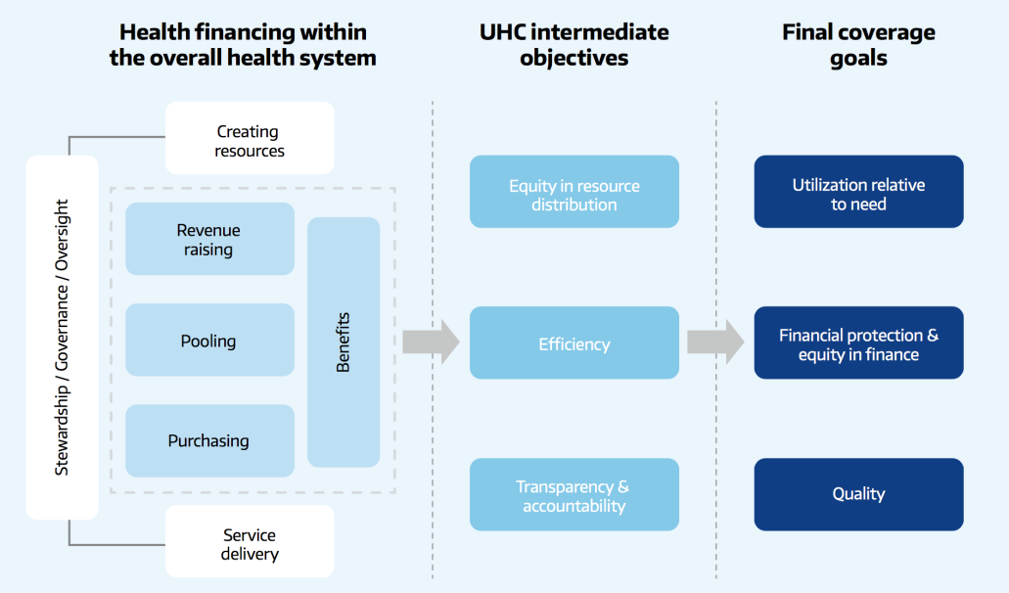
Source: http://www.who.int/health_financing/documents/health-financing-strategy/en/

Outline for the assessment:

- Performance of the health financing system
Assessment should include situation analysis (AS IS) how Georgia is achieving UHC goals related to financing policies and some preliminary thinking about what should change (SHOULD BE). Quantitative approach is preferred; qualitative assessment could be used data is absent.

Performance dimension | AS-IS | SHOULD-BE
Financial protection (e.g. level and distribution of out of pocket spending and catastrophic and impoverishing out-of-pocket payments)
Access to the health services and medicines by different population groups and regions
Performance of health service providers across different settings regarding efficiency and quality aspects
Public awareness about entitlements and satisfaction
Other..(please add if some additional important dimensions exist)

- Situation with strategic purchasing
In general, health financing policy covers three core functions:
- raising revenue
- pooling of funds
- purchasing of services

as well as
- coverage policies: who is covered (the basis for entitlement), what is covered (the benefits package) and how much of the cost is covered (user charges), plus issues around timely access to services
- governance of the above functions and policies

The scope for the strategic purchasing strategy in detail will be discussed during the seminar. Assumably it will predominantly focus on functions 3 and 4 but it would be important to critically assess which aspects of other functions should be part of the strategy to assure good alignment with overall health financing policy in Georgia.

You may keep in mind the aspects below (list is not fully comprehensive and you may add additional aspects) of health financing functions when preparing situation analysis. Assessment should include situation analysis (AS IS) and some preliminary thinking about what should change (SHOULD BE).

Health financing functions | AS-IS | SHOULD-BE
REVENUE SOURCES
Level and predictability of public funding
Transition from external funding (e.g. TB)
Health sector budget preparation process including forecasting and planning in 1 year and mid-term term (3-5 years) perspective
Other..(please add if some additional important aspects exist)
POOLING REVENUES
Fragmentation risk between different health programs
Other..(please add if some additional important aspects exist)
PURCHASING
Population health need assessment and how it is linked to the purchasing decisions
Contracting (SSA to providers) arrangements in place for primary health care (PHC) and specialist care
Provider selection
Payment methods and incentives including incentives to provide care in the right level of care
Tariff setting principles
Fraud detection mechanisms
Access and quality control mechanisms
Cost containment mechanisms
Providers’ performance monitoring
Reporting, feedback and other communication elements with providers
Reporting, feedback and other communication elements with public
Other..(please add if some additional important aspects exist)
COVERAGE POLICIES
The basis for entitlement to publicly financed health care (who is covered)
The scope/content of the benefit package (what is covered)
Procedure to revise the content of the benefit package: decision making over adding new services and drugs or revising existing benefits
The design of the user charges policy (to what extent is covered)
Procedure to revise user charges: decision making over cost sharing policy (co-payments)
Mechanisms in place to align coverage design with provider payment mechanisms and budgetary constraints
Waiting times policies in place to assure timely access
Role of voluntary and/or private insurance
Other..(please add if some additional important aspects exist)
GOVERNANCE OF THE PURCHASING FUNCTION
Regulatory and accountability mechanisms in place
Other..(please add if some additional important aspects exist)

