Medical education system in Georgia
In Georgia, education of doctors is implemented according to World Federation for Medical Education (WFME) global standards which contains 3 stages - undergraduate education, postgraduate education and continuous professional development:
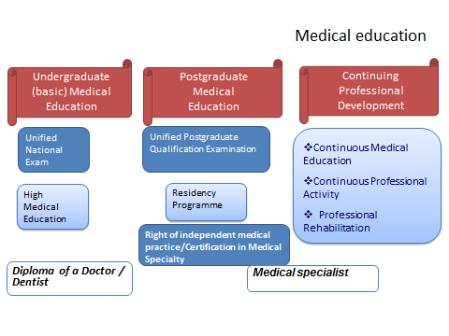
The undergraduate medical education stage is under the Ministry of Education and Science competence, postgraduate medical education and continuous professional development - under the Ministry of Labor, health and social affairs competence:
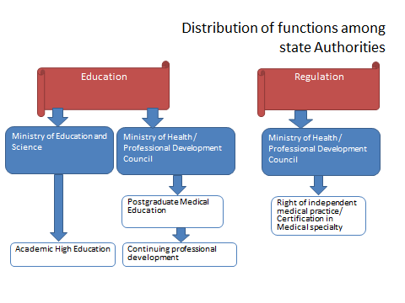
Postgraduate education
Postgraduate education (professional preparation) is required term for getting the right of independent medical practice/state certificate, which has been implemented in resident’s preparation format since 1999. After finishing residency preparation, applicant is given opportunity to get state certificate and start the medical practice permitted by the state certificate. It should be noted, that residency preparation undergoes within the residency program, which duration is similar to EU countries analogical programs.
Georgian postgraduate medical education system analysis according to World Federation for Medical Education (WFME) basic standards shows, that the existing system of postgraduate medical education (Including existing residency programs, as well as the education process and institutional accreditation environment) for the most part meets the basic standards of WFME (process, structure, content, earning environment of postgraduate medical education).
Legal bases of postgraduate medical education are regulated by law of Georgia about medical activities and proper normative acts.
Changes:
- From 2014 until today the residency program has been updated/prepared in 56 medical specialties
- From 2014 until today 15 programs of medical sub-specialty were prepared/updated
- For the purpose of improving the doctor’s assessment system:
  - Since 2013 was prepared the certification exam tests - “closed base” (25% of tests)
  - Since 2013 until today fully have updated/prepared state certification tests in 10 medical specialties
  - In 2017, unified postgraduate qualification was conducted by renewed instrument (tests)
Challenges:
- Education
    - Supporting development of university clinics
    - Constant update of programs and literature
    - Perfection/improvement of authorization/accreditation standards
    - Gradual implementation of periodical confirmation (re-certification) system of doctors
- Supporting development of medical science

Continuous professional development
Country profile:
Mandatory | Not mandatory (except obstetrician gynecologists and neonatologists working in perinatal service)
Optional | Yes
CPD (Continuous Professional Development)Requirement grounds | Ethical obligations of a doctor, sometimes – employer
Suppliers of CPD | Vocational organizations, universities, medical organizations and medical institutions
Monitoring | Doctor, sometimes employer
Connection between CPD and certification | No connection
Mechanism of accreditation | Accreditation by Ministry of Labour, Health and Social Affairs of Georgia Professional Development Council
Source of financing | Doctor, sometimes employer and/or donor organizations

Legal bases of continuous professional development are regulated by law of Georgia about medical activities and proper normative acts.
Changes:
- Since 2016, with the support of Defense Threat Reduction Agency of the United State (DTRA) has begun an implementation of online platform of the British Medical Journal (BMJ) in Georgia. Respectively Georgian doctors will be able to use BMJ Best Practice (“BMJ BP”) and BMJ Learning (“BMJ-L”) for 3 years
- The procedure for recognition of education received abroad was prepared in 2017
- New instrument for accreditation of continuous medical education activities was prepared in 2017
- Since 2018, it became mandatory to participate in CPD (Continuous Professional Development)for obstetrician-gynecologists and neonatologists working in perinatal service
Challenges:
- Integration with EU
- Mobility of personnel
- Safety of a patient and quality of medical service.

