European Association for the Study of the Liver – The International Liver Congress™
EASL-CDC Session - Faculty Agreement

I agree to participate in the EASL-CDC Session at The International Liver Congress™ to take place from 19-23 April 2017 in Amsterdam, The Netherlands, as a part of the Faculty and comply with the reimbursement policy, travel arrangements and regulations outlined in the letters of invitation, and the enclosed disclosure form.

Rights Granted to EASL
I grant EASL permission to use my name, title, affiliation, photo and professional bio for the promotion of the program and my presentation. I also grant EASL the right to use my presentation(s) to create handouts and other related congress materials.

Copyright
My presentation and accompanying documents contain either original materials, or material owned by other authors from whom I have obtained permission. Thus, I take responsibility for materials I use and I take responsibility for following copyright laws.
Unless otherwise disclosed, the statements made by me represent my own opinions and not necessarily those of the organisation I represent or that of EASL.

Indemnification and Hold Harmless
I hereby insure and hold EASL harmless from and against any and all claims, expense, and liability whatsoever arising, directly or indirectly, out of my actions or inaction at, or participation.

Presentation Requirements
- I agree to meet all due dates for all deliverables to the best of my ability.
- I understand that I am required to use the designated EASL congress PowerPoint template provided to me.
- I agree to assist in finding a replacement if I am unable to attend.

Participation to Industry Symposia
I understand that EASL sets a limit to the number of invitation a member of the faculty can accept to take part in industry sponsored satellite symposium. I will not accept more than two invitation to such symposia.

European Association for the Study of the Liver Speaker
By: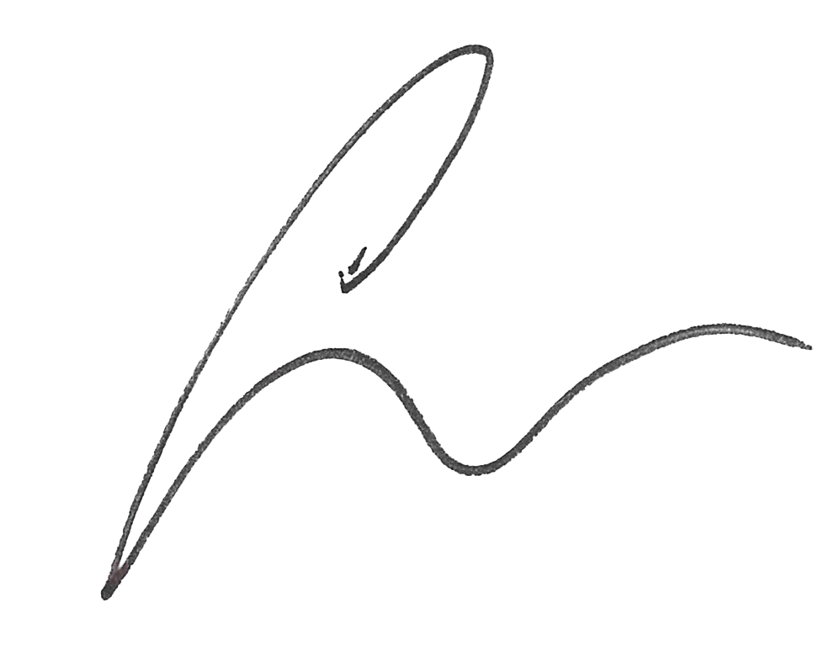
Laurent Castera
EASL General Secretary

Name: Click here to enter text
Date: Click here to enter date

