Medical education system in Georgia
In Georgia, education of doctors is carried out according to the global standards of the World Federation for Medical Education (WFME) which covers 3 stages - undergraduate education, postgraduate education and continuous professional development:
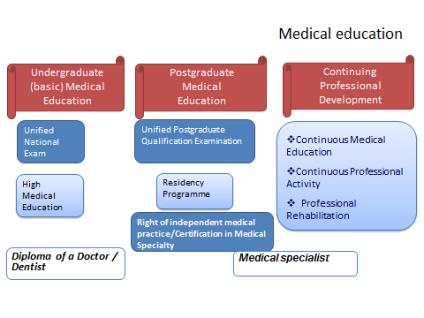
The undergraduate medical education stage is within the competence of the Ministry of Education and Science, postgraduate medical education and continuous professional development are under the competence of the Ministry of Labour, Health and Social Affairs of Georgia:
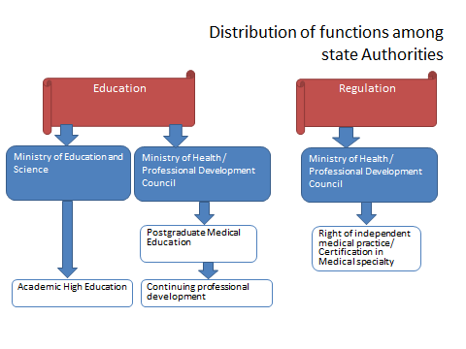
Postgraduate education
Postgraduate education (professional preparation) is required to obtain the right of independent medical practice/State Certificate in Georgia. Postgraduate education is being implemented in the framework of residency programs since 1999. After finishing residency preparation, applicants are given the opportunity to get the State Certificate and start the medical practice in medical specialty permitted by the state certificate. Duration of residency programs is similar to EU countries’ programs.
Georgian postgraduate medical education system (including existing residency programs, as well as the education process and institutional accreditation environment) is in compliance with the basic standards of World Federation for Medical Education (WFME).
Postgraduate medical education is regulated by the Law of Georgia on Medical Activities and corresponding normative acts.
Changes in postgraduate medical education:
Since 2014, the residency program has been updated/prepared in 56 medical specialties;
Since 2014, 15 programs of medical sub-specialty were updated/prepared;
For the purpose of improving the doctor’s assessment system, the certification exam tests - “closed base” (25% of tests) was prepared in 2013.
The State certification tests in 10 medical specialties were fully updated/prepared from 2013;
In 2017, test for unified postgraduate qualification exams were fully renewed.
Challenges:
- Education
    - Supporting development of university clinics
    - Constant update of programs and literature
    - Perfection/improvement of authorization/accreditation standards
    - Gradual implementation of periodical confirmation (re-certification) system of doctors
- Supporting development of medical science

Continuous Professional Development
It is not mandatory to undergo Continuous Professional Development (CPD) in Georgia, except obstetrician gynecologists and neonatologists working in perinatal service. Continuous professional development is ethical obligations of a doctor and sometimes of an employer.
CPD activities providers are universities, medical professional organizations and medical institutions.
Accreditation of the CPD activities is obligatory, which is provided by the Professional Development Council under the Ministry of Labour, Health and Social Affairs of Georgia.
Mainly, CPD activities are financed by the doctors, employers and donor organizations.
Continuous Professional Development is regulated by the law of Georgia on Medical Activities and corresponding normative acts.
Changes in Continuous Professional Development:
Since 2016, with the support of Defense Threat Reduction Agency of the United States (DTRA) an implementation of online platform of the British Medical Journal (BMJ) in Georgia has been started. Respectively, Georgian doctors will be able to use BMJ Best Practice (“BMJ BP”) and BMJ Learning (“BMJ-L”) for 3 years.
Requirements for accreditation of continuous medical education activities were renewed in 2017.
Since 2018, it became mandatory to participate in CPD programs for obstetrician-gynecologists and neonatologists working in perinatal services.
Challenges:
- Establishment of mandatory system of CPD
- Safety of a patient and quality of medical service

