AGI Install Instructions

What OS are you running?
Win7 – go to 2a.
XP – go to 2b.
2a. | Win7:  Run menu.cmd as administrator. | Open the “International AGI Install” folder.  Left-click on menu.cmd  Select “Run as administrator”  Enter the administrator password. | Elevated command prompt opens.  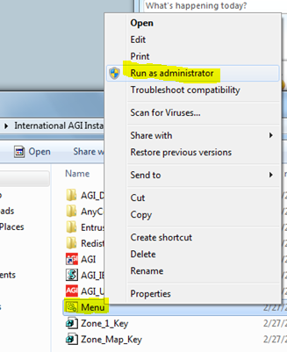
2b. | XP:  Run menu.cmd as administrator. | Open a command prompt as administrator.  Change directories to the desktop and run menu.cmd. | 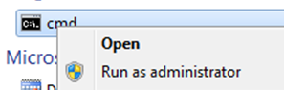
 | Run Install | Type 1, then ENTER.  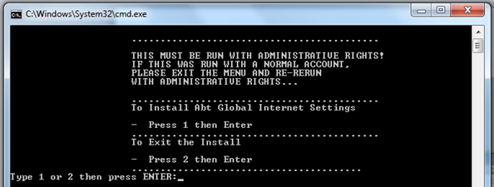 | Second prompt appears.
 | Select OS | For XP: type 1, then ENTER.  For Win7: type 2, then ENTER.  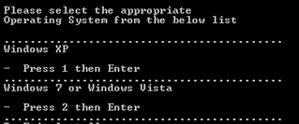 | Install begins running.
 | Install runs… |  | A series of windows should open and close as programs install. When it is finished all windows should close.  You should now see the AGI icon on the desktop.
 | From the start menu browse to Programs -> Entrust Entelligence and click on Enroll for Entrust Digital ID | When dialog box opens, click NEXT. | 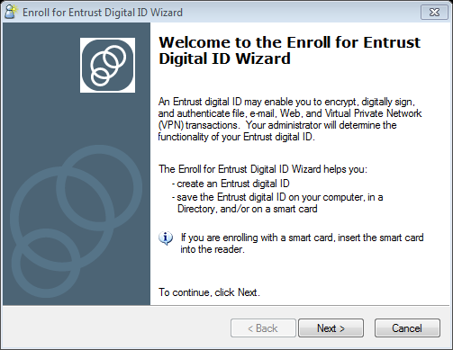
 | Receive reference number from IT Service Center Alerts.   | Search the employee’s inbox for an email from ITServiceCenterAlerts that includes the reference number.
 | Retrieve the authorization number. | Go to http://certenroll.abtassoc.com  [NOTE: You must be in an office with a working firewall for this link to load] | The browser window will load a new page asking for your credentials.
 | Retrieve your authorization number. | Have the employee enter their username and password (what you use for Abtremote). | A page will load listing your authorization code if the form of:  XXXX-XXXX-XXXX.
 | Enter reference number (from your email) and authorization code (from the webpage). | Click NEXT.  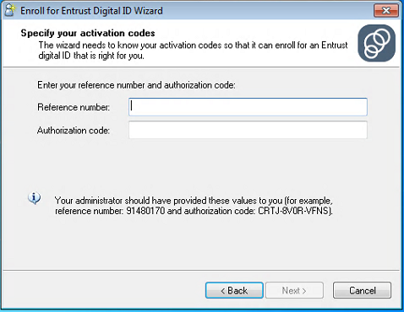
Click NEXT.
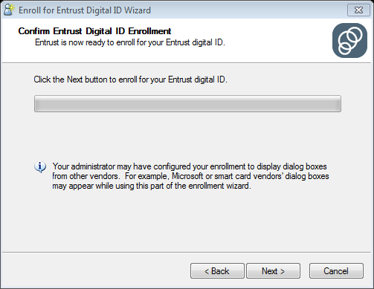
 | Security Certificate presented. | Click YES.  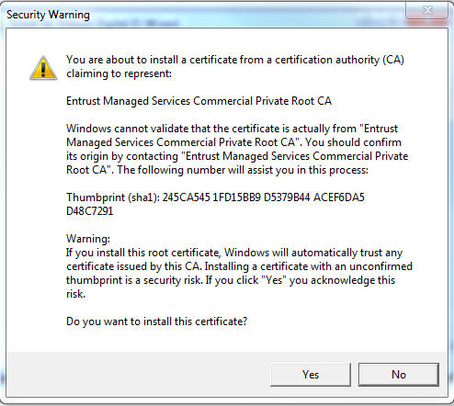
 | Finish. | Verify that you receive this exact dialog box that says that everything ran smoothly. Click FINISH.  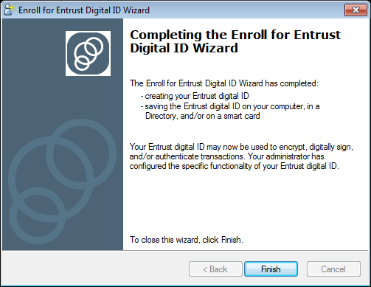
 | Reboot machine.
 | Verify that the certificate is installed. | Go to your system tray and right click on the Entrust icon.  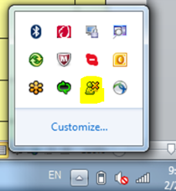  Select “Entrust Certificate Explorer”. |  | You should see a “Commercial Private Sub CA1” certificate listed.  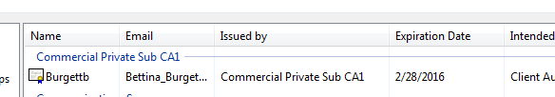
 | Verify that AnyConnect is connected. | Go to your system tray and click on the AnyConnect icon.  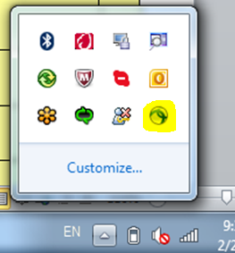 |  | If you are in the office with a firewall it should say: On a trusted network.  If not, it should say “Connected to agigw”  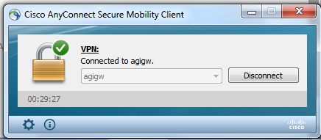
 | Open IE and clear browser data. | Make sure that “Preserve Favorites website data” is unchecked. |  | 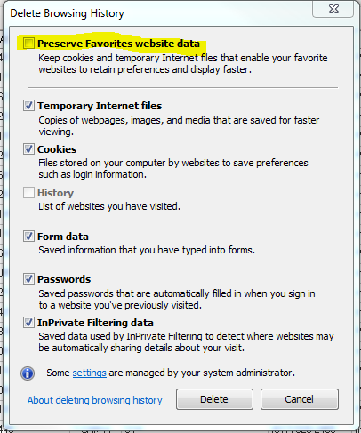
 | Go to http://agigw.abtassoc.com |  |  | The page should appear blank.
 | Go to http://abtnet.corp.abtassoc.com |  |  | Abtnet should load without asking for credentials
- Go | Go to http://mail.office365.com |  |  | The mailbox should open without asking for credentials.

For each employee, complete the tracking sheet:
IT Manager Tracking
In Main Office? | Package installed on machine | Enrollment Process Complete | agigw.abtassoc.com loads blank screen?  Step 18 above | abtnet.corp.abtassoc.com loads?  Step 19 above | mail.office365.com loads?  Step 20 above
y/n | y/n | y/n | y/n | y/n | y/n

