Completing your Timesheet

Logging in
- Open Internet Explorer  and go to Abtremote (http://abtremote.abtassoc.com).
- Login with your username and password. Your username is generally your last name and first initial
(ex. John Smith is SmithJ).
- Click on the “Oracle” link and log in with the same username and password.
Day one - Create a timecard and enter your hours.
- Log in.
- From the home page select Abt US International Timecards.
- Select Create Timecard
- Click Project, enter a 5-digit code, click Task, and enter a 4-digit code, and then click Type and select an expenditure type from the list of values.
- Tip: After you type each of the codes for your project, task and type, press Tab to automatically fill in the appropriate description, and then press Tab again to go to the next field and repeat the process.
- Tip: To enter time for paid time off (vacation, holiday, sick, etc.), use the Public Templates which will automatically populate the Project, Task, and Type codes for you.
- For multiple projects, tasks, or types, add new lines if needed and repeat with a new Project, Task and Type code until you enter all the hours worked that day.
- Click Review, and then Save.
- Click Complete Save Process.
- View the confirmation message: Confirmation - The timecard has been saved successfully.

Days 2-4 - Enter your hours.
- Sign in to Oracle (log into Abtremote and then click on the Oracle link).
- From the home page select Abt US International Timecards.
- Select Time Entry. Click the pencil next to your current timesheet to update.
- Enter your hours.
- Click Review, and then Save.
- Click Complete Save Process.
- View the confirmation message: Confirmation - The timecard has been saved successfully.
- Log out of Oracle.

Day 5 – Enter your hours and submit your timecard.
- Repeat steps 1-4 from above.
- Click Begin Submit Process.
- Review your timecard and click Submit Timecard.
- View the confirmation message: Confirmation – Time entries for the given timecard period have been submitted successfully.
- Log out of Oracle.

** If you enter your hours late (after 12 pm the following day), you are prompted to add a late comment. Select the L code (Late) from the drop down and include a reason in the Comment field.
*** If you change a previously saved entry, you are prompted to add a change comment. Select the C code (Change) from the drop down and enter a reason in the Comment field

Electronic Timesheet Correction to Clear Time from Subaccount
You receive an email or notification telling you that your timesheet has been swept to the subaccount and you need to correct and resubmit your timesheet.
To correct timecard and clear from the subaccount:
- Go to the Time Entry window.

- If necessary, use Timecard Search to locate the timecard that was generated by the sweep process. Swept timecards needing your attention will be in “Working” status.

- Open the timecard by clicking on the yellow pencil.

- Do not delete the subaccount detail line (task code 9998 or 9999). Make sure there are “0” hours in the subaccount detail line. If necessary, change all daily entries to “0” hours in the subaccount detail line, and make sure the total subaccount hours on the far right also reads “0”.

- Add the detail line(s) for your project charge code(s). Enter the correct hours for each day and charge code. Make sure the new total on the bottom right is “40” hours.

- Click Begin Submit Process.

- Click Submit Timecard.

- View the confirmation message: Confirmation-Time entries for the given timecard period have been submitted successfully.

- Log out of Oracle.

** When making a timesheet correction, you will be prompted for late and / or change comments. In addition to selecting L (Late) or C (Change), you MUST enter a reason in the Comment field. If this is omitted, Compliance may reject the correction.

Electronic Timesheet Correction for Incomplete Timesheets
You receive an email or notification telling you that your timesheet has been swept to the subaccount because it was incomplete, and you need to submit a correction.
To correct timecard and clear from the subaccount:
- Go to the Time Entry window.

- If necessary, use Timecard Search to locate the timecard that was generated by the sweep process. Swept timecards needing your attention will be in “Working” status.

- Open the timecard by clicking on the yellow pencil.

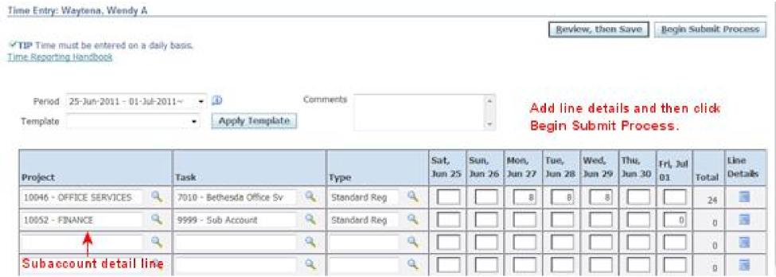
Figure 32- Correction for Incomplete Timecard

- Do not delete the subaccount detail line (task code 9998 or 9999). Make sure there are “0” hours in the subaccount detail line.

- Add the detail line(s) for your project charge code(s). Enter your time for the days that are missing, so that your total time is now “40” hours.

- Click Begin Submit Process.

- Click Submit Timecard.

- View the confirmation message: Confirmation-Time entries for the given timecard period have been submitted successfully.

- Log out of Oracle.

** When making a timesheet correction, you will be prompted for late and / or change comments. In addition to selecting L (Late) or C (Change), you MUST enter a reason in the Comment field. If this is omitted, Compliance may reject you’re the correction.

Electronic Timesheet Correction to Change Hours or Project and/or Task Codes
It may happen that your supervisor rejects a timecard because your time was incorrectly charged. You may be asked to change an entry to a different charge code, or change the number of hours that you charged to a particular charge code.
Or, you may have submitted a timecard and realized later on that although all of the charge codes you used were correct, you incorrectly split your time among them and need to submit a correction.
To correct timecard and resubmit:
- Go to the Time Entry window.

- If necessary, use Timecard Search to locate the timecard that needs to be corrected. Look for the “week ending” date.

- Open the timecard by clicking on the yellow pencil.

- To correct time already charged, simply locate the entry you want to change, highlight the hours under the correct days and charge codes, and type in the correct hours. Make sure you still have a daily total of “8” hours for each day.

- To move hours from an incorrect charge code to the correct one, first correct the time entered to the wrong code. Change the hours to either “0” (no time should be charged to that code on that day) or the correct number (some hours were charged, but the number is incorrect). Then enter the correct hours for each day and different charge code the same way as above (“8” if a full day is being charged, or the correct number of hours for a part—day). If necessary, add the detail line(s) for the correct project and task charge code(s) if it doesn’t already appear on the timecard. Make sure the new total is “8” for each day, and “40” for the week.

Note: You cannot delete a row or change the charge code in a line that has already been saved. Set the hours to zero on the line with the wrong charge code and add the new charge code on a separate line.

- Click Begin Submit Process.

- Click Submit Timecard.

- View the confirmation message: Confirmation-Time entries for the given timecard period have been submitted successfully.

- Log out of Oracle.

** When making a timesheet correction, you will be prompted for late and / or change comments. In addition to selecting L (Late) or C (Change), you MUST enter a reason in the Comment field. If this is omitted, Compliance may reject the correction.

