Health System Strengthening Project (HSSP)

Financing Module

Draft

The document was developed on | 17.12.2011
The document was corrected on | 27.12.2011

Contents

Contents 2
Introduction 4
1. Budget Management Component 5
1.1. State-funded Program Implementers 5
1.2. Budget Structure 8
1.3. Building Hierarchical Structure of Budget 8
1.3.1. Program 11
1.3.2. Component 13
1.3.2.1. Organizational and Treasury Codes 16
1.3.2.2. Economic Classeifications 16
1.3.3. Subcomponent 19
1.3.3.1. Financing unit 21
1.4. Entering Annual Budget 27
1.4.1. Budget Unit 27
1.5. Changes to Budget 30
1.6. Monitoring of Spending Budget 32
2. Contract 33
2.1. General Information 33
2.2. Entering Data Concerning Organization 34
2.3. Entering Data Concerning Contract 37
2.4. Changes to Contract and Provided Services 41
2.5. Service Quality Monitoring 42
2.6. Expiration, Termination/Cancellation of Contract 42

3. Report Management Component
4. Treasury Bills Document Management Component
5. Payment Order Management Component
6. Register Management Component
7. Monitoring and Analysis Component

Introduction
State-funded healthcare programs (hereinafter the Program) aim at creating financial guarantees for the target population to ensure access to medical care and improve health status of the population.
Program budgets are made by the Ministry of Labor, Health and Social Affairs of Georgia (MoLHSA) in agreement with the Ministry of Finance which are approved by the Parliament of Georgia under the Law on State Budget. Detailed program description i.e. budget expanded to components and subcomponents, beneficiary categories, geographic scope, financing methodology and administrative rules are approved under the Order of the Minister of Labor, Health and Social Affairs of Georgia.
Servcies under the programs are provided by:
- MoLHSA;
- LEPL Social Service Agency (SSA);
- LEPL L. Sakvarelidze Center for Disease Control and Public Health (NCDC).
The Financing Module of Healthcare Management Information System (HMIS) has the following goals: reflect state-funded programs and their budgets in the system, monitor the budget, administer and reflect budget changes, automatize reporting services provided under the program and corresponding treasury bills and payment order management process in order to ensure timely and purposeful management of public funds.

Budget Management Component
Budget management process includes the following stages:
- Entering data concerning state-funded programs, their components, subcomponents and budget units
- Entering data concerning the budget for reporting year
- Making changes to the budget
- Budget monitoring

State-funded Program Implementers
The state-funded healthcare programs approved by the Law on State Budget are administered by the MoLHSA, the SSA and the NCDC.
The SSA has Adjara and Abkhazia branches and regional coordination centers, which administer programs at the regional level (sign contracts with healthcare facilities; receive reports from them, conduct monitoring, etc.). The contracted facilities are paid centrally by the SSA. The NCDC also has regional representations, though program management process is centralized.
Funds allocated for state-funded programs may be administered by the head office of implementing organization or its affiliated agency. In the Budget Module both options will be discussed i.e. the budget will be reviewed in details at all levels of hierarchical organizational structure (see Fig. 1.1, 1.2).

Figure 1.1 – Example of Structure of Implementing Organization
Program 1
Program 2
........
Program 1
Program 2
........
Program 1
Program 2
........

Figure 1.2 – Registration of Program Implementer in Financing Module
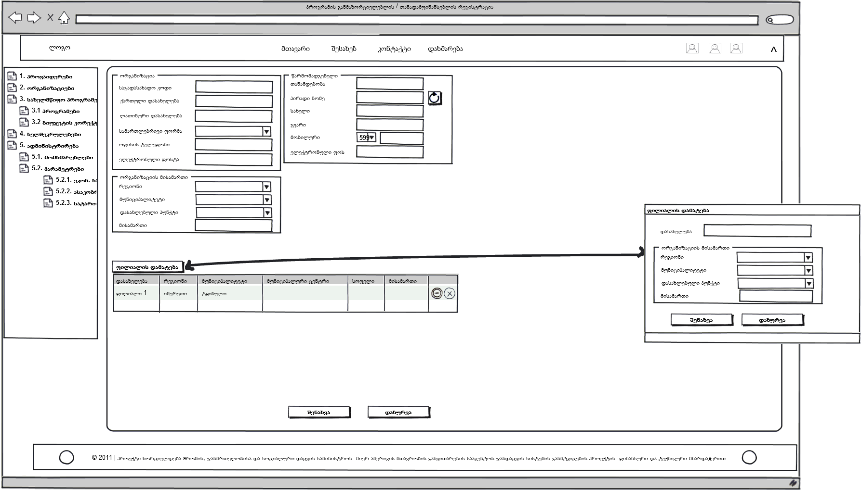

Budget Structure
The budget of the MoLHSA is grouped according to administrative, social and healthcare programs. Please, see below the budget structure (see Fig. 1.3).

Figure 1.3 – Budget Structure

The administrative expenses not related to social and healthcare programs, are reviewed as independent programs.
Every program has its hierarchical structure. It consists of one or more components. Each component has one or more subcomponents. Each subcomponent can be viewed according to so called budget units – geographic scope (region, rayon) and effective period (year, quarter, month).

Building Hierarchical Structure of Budget
The budget of the MoLHSA has a hierarchial structure: a program, a component and a subcomponent. First of all, a hierarchical tree of the budget must be created in order to reflect the budget for reporting year in the HMIS:
- Enter program, component and subcomponent names and their main characteristics;
- Enter specific data regarding each program, component and subcomponent: budget units, treasury and organizational codes, economic classifications, etc..
Hierarchical structures of state-funded programs are built in the so called state-funded program budget management window (see Fig. 1.4). It includes three levels: programs, components and subcomponents. Add, edit and delete buttons will be used at each level. When the user selects a program, the system will show him/her all program components and subcomponents of the program.
A reporting year is selected here. Accordingly, relevant budget units (components/subcomponents) and budgets will be displayed after selecting the year.

Figure 1.4. State-funded Program Budget Management Window
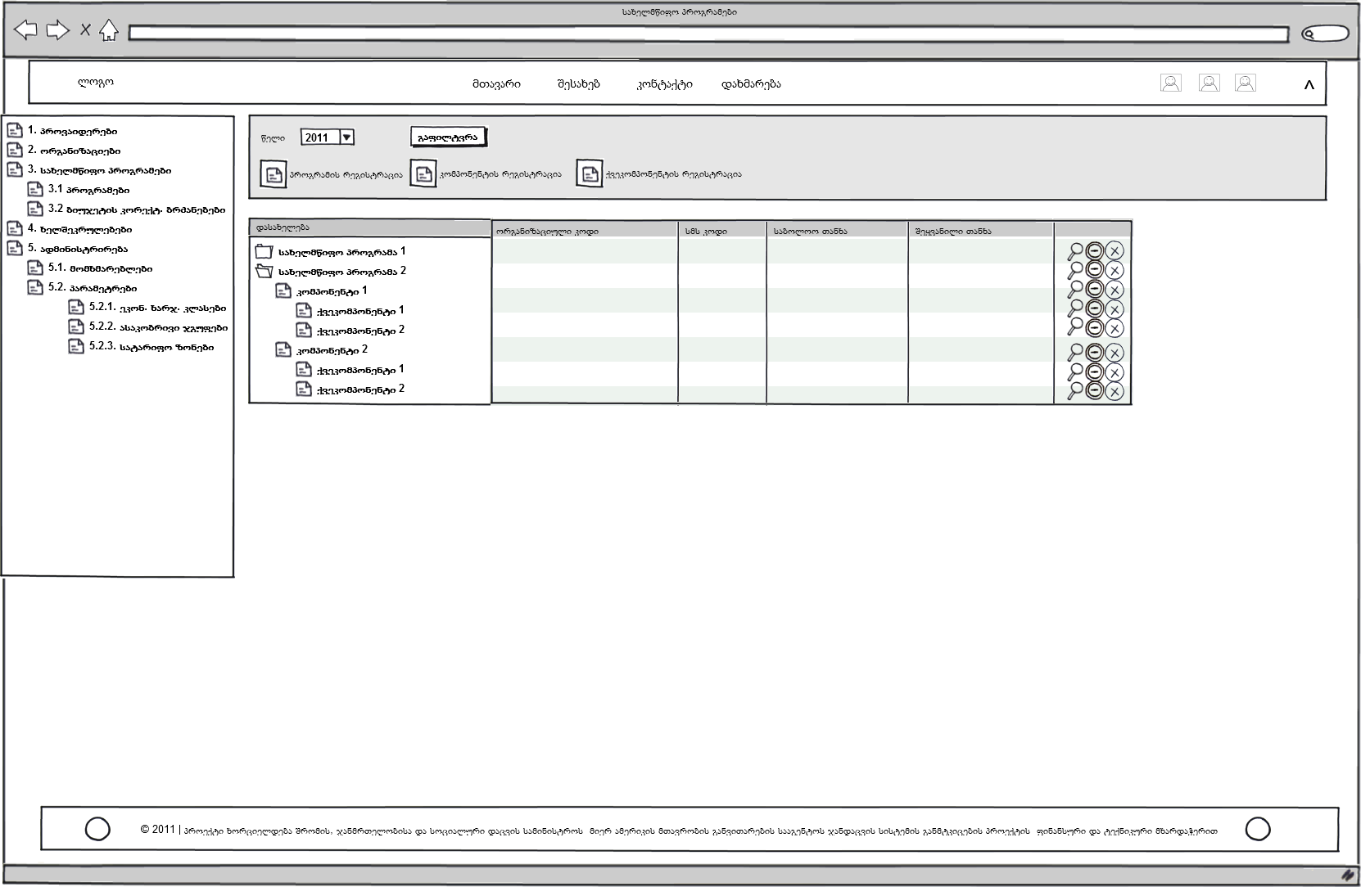

Program
State-funded programs are divided into three groups:
- Social programs;
- Healthcare programs;
- Administrative programs.
Please, see Table 1.1 for the characteristics required to add a new program to the database of the Budget Module.
Table 1.1 – Program Characteristics.
Field Name | Description | Note
Name of Program Implementer | E.g. SSA
Program Name | Exact name of the program in Georgian and English | Mandatory
Program Type | Type of program: health, social or administrative | Mandatory
Organizational Code of Program | A 6-8 digit code assigned by the state budget | Mandatory
SSA Code for Program | One digit code assigned by the SSA
Reporting Year | It is used for information purposes only and indicates reporting year of budget process

The above-mentioned fields must be filled out in order to register state-funded programs in the Budget Module. A special form for adding a new program will be displayed by clicking on the Add button on the program panel. The program parameters will be entered into the form (see Fig. 1.5). After entering the program data, click on the Save button. If you have entered the data accidentally into the form and do not want to add the program, click on the Close button.
Select the program name and click on the Edit button on the right side of the program panel to edit the program. An editing form will be displayed (similar to the form for adding a new program).
Click on the Delete button on the right side of the program panel to remove an unnecessary program. The program cannot be deleted if budget and contracts are linked to it.

Figure 1.5 – Program Registration
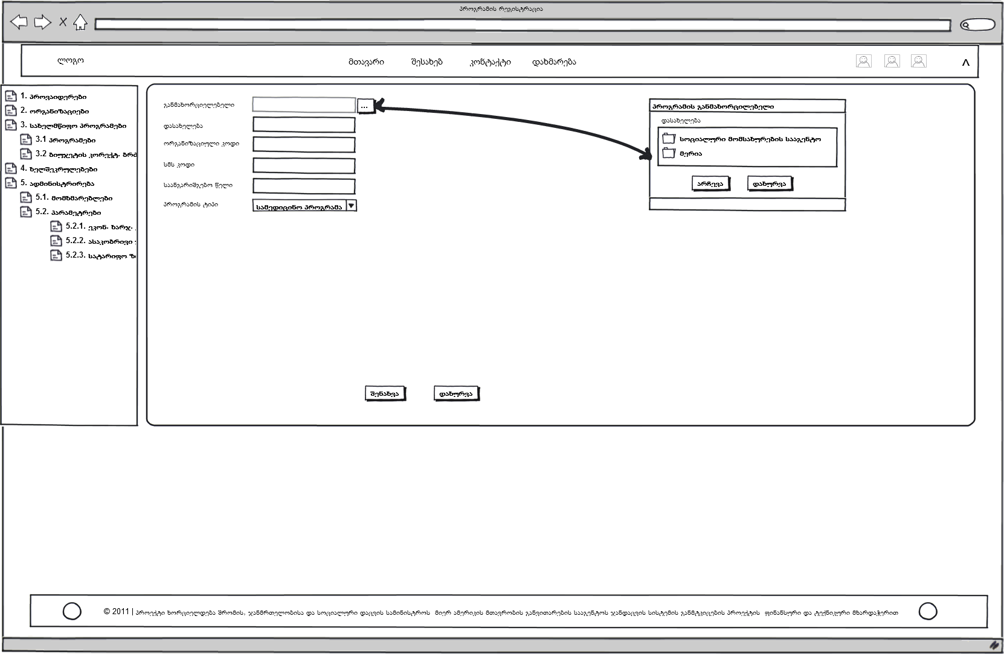

Component
Please, see Table 1.2 for the characteristics required to enter program components into the database of the Budget Module.
Table 1.2 – Component Characteristics
Field Name | Description | Note
Reporting Year | It is used for information purposes only and indicates reporting year of budget process | Only readable
Component Name | Exact name of the component in Georgian and English
Organizational Code of Component | The code is taken from the state budget classification that is added to the organizational code of the program
SSA Code for Component | One digit code (letter of the alphabet) assigned by the SSA. It is an abbreviation for the component.
Time Period | It indicates time periods: year, quarter, month (quarter is the recommended time period).
Geographic Scope | The budget plan according to geographic scope: country, region (it is recommended to use regional level)
Final Amount | The amount of money allocated for the component during the current year
Entered Amount | The total amount of money shown in budget units of subcomponents. It is calculated (Check button) by comparing it with the total amount (these amounts must be equal).
“Approved” Button | If the final amount equals to the entered amount they are correct
Component Approval Status | It indicates whether the component is approved or not. The component can be confirmed if the data for the current year are entered correctly.
Budget Plan Button | By clicking the button a current year budget plan for a specific component can be entered according to territorial units and time periods
List of Economic Classifications of Expenses | The list includes economic classifications of expenses related to the component (code and name of economic classification of expenses). These classes are related to treasury bill documents and are used for submitting reports to the Treasury.
Table of Treasury Codes | Codes (used while communicating with the Treasury) assigned to components by the Treasury

The component panel in the program budget management window ensures adding, editing and deleting components (see Fig. 1.4). A new component registration form is displayed by clicking on the Add button (1.6). The above-mentioned fields must be filled out in order to register components in the Budget Module.
The user enters the amount of money allocaled for the component under the budget in the final amount field. The entered amount is the sum of budgets related to subcpomponents of the component that is automatically displayed in the field. Click on the Check button to check if the two amounts are equal. Click on the Approve button if they are equal.
We should be able to enter, edit and delete economic classifications and treasury codes in order to ensure comprehensive data concerning the component in the database.
After completion of the operations related to components, they must be approved (the Approve button) for safety purpose. After that the user is not allowed to make changes without the system administrator’s permission.
A budget plan for the specific component will be automatically displayed by clicking on the button for adding a budget plan. The plan is drawn up according to territorial units and time periods and is the sum of budget units of subcomponents of the components.
Figure 1.6 – Component Registration 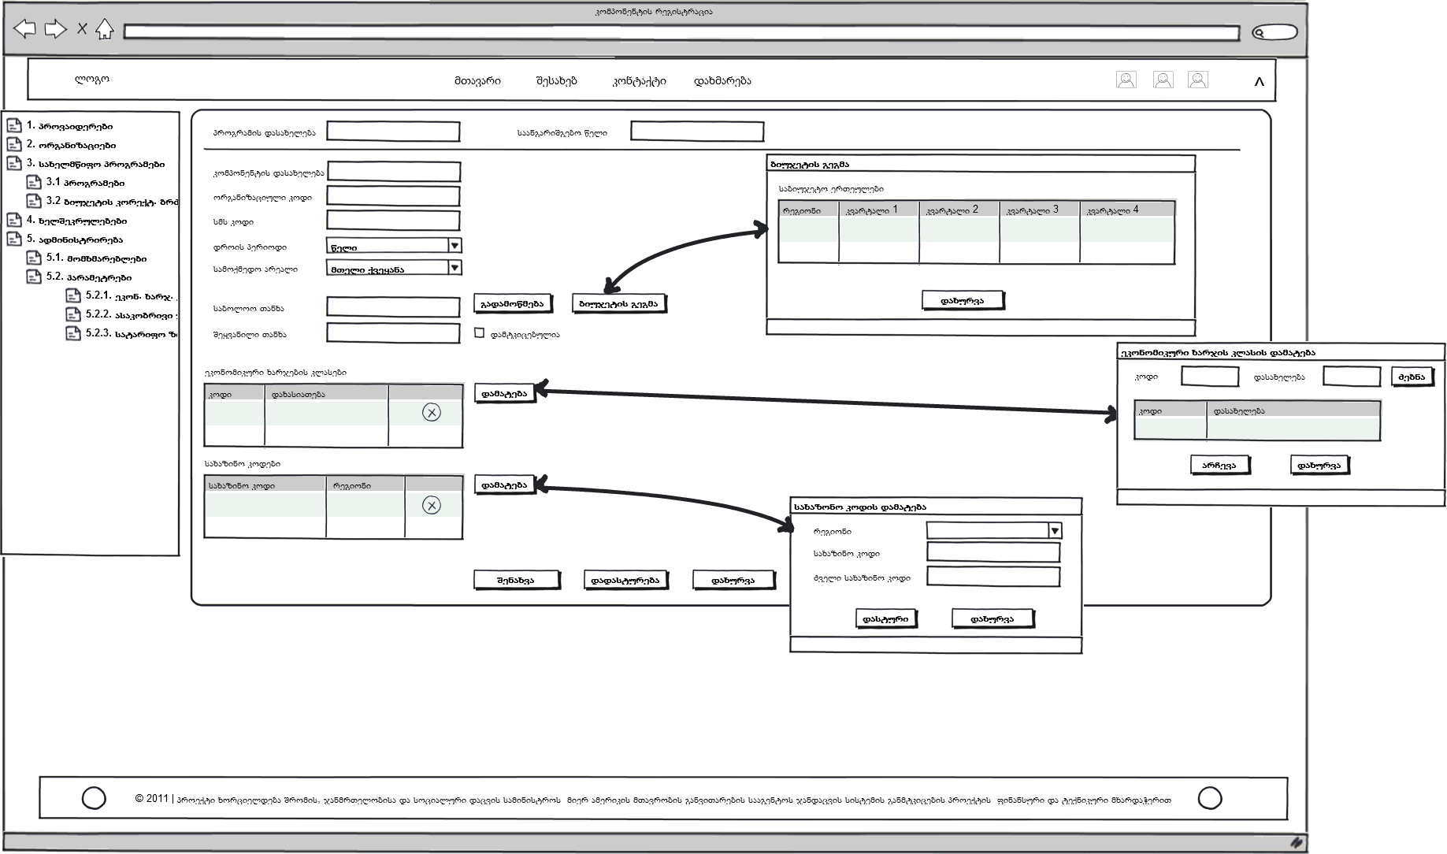

Organizational and Treasury Codes
Treasury codes must be entered into the new component form. Treasury codes are assigned to components by the State Treasury that are contained in reports submitted to the treasury. They are three-digit codes. Codes are not assigned to subcomponents by the Treasury.
As for the organizational code, it is assigned to the program and components by the Ministry of Finance and approved by the law on State Budget. There is a 6-digit code for a component and an 8-digit code for subcomponent (Table 1.3).
Table 1.3 Example of Organizational and Treasury Codes
Organizational Code | Treasury Code | Name | განმკარგავი
351201 | 206 | Health Insurance | SSA
25120201 | 600 | Adjara Branch of the SSA – psychic health | SSA
25120201 | 643 | Guria Branch of the SSA – psychic health | SSA
25120201 | 644 | Imereti Branch of the SSA – psychic health | SSA
... | ... | .... | ....

Add a new treasury code in the new component form by clicking on the Add button on the right side of treasury code lists. Please, see Table 1.4 for the characteristics of treasury code fileds.
Table1.4. Characteristics of Treasury Code Fileds:
Field Name | Description | Note
Region Identifier | Default region for a treasury code
Component | The component a treasury code of which is indicated in the table | A treasury code is assigned to the component or the subcomponent. Both of them are not entered simultaneously.
Treasury Code | Code assigned by the Treasury
Old Treasury Code | Old codes of the system used only for relevant purposes

Select a region and enter relevant new and old treasury codes into the treasury code form.

Economic Classifications
The economic classification of expenses is a standard classification that describes expenses according to national classification of economic activities. It has a six-digit code. The SSA uses limited quantity of economic codes (see Table 1.5).

Table 1.5 – Characteristics of Economic Classification Fields
Field Name | Description | Note
Code | The code of economic classification assigned to the activity in accordance with the national classification
Description | Brief description of economic classification
Component Identification Number | The identification number of the component with what this budget program is related to

A form for adding economic classifications is displayed by clicking the Add button on the right side of the list of economic classifications of expenses. Economic classification codes and names are selected in the form. New classifications may be added to the list (see Fig. 1.7).
Figure 1.7 – Economic Classifications of Expenses
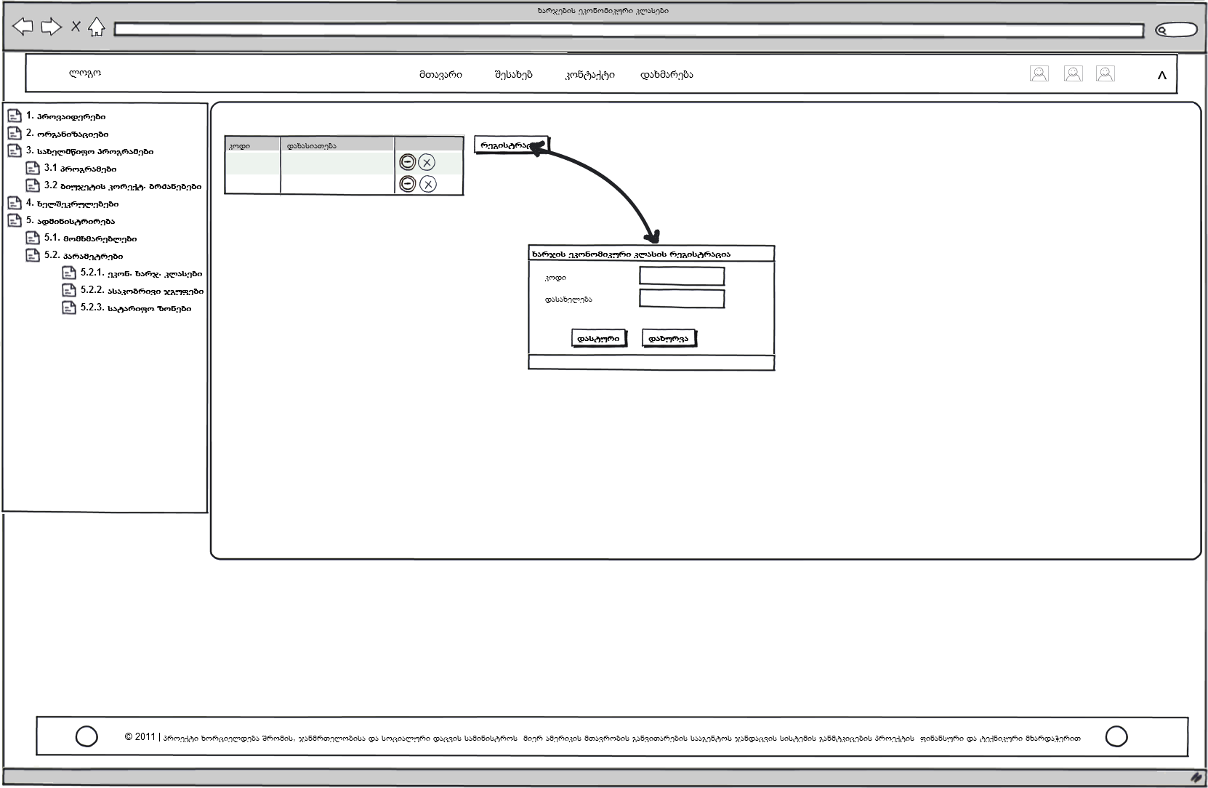

Subcomponent
Please, see Table 1.6 for the characteristics required to enter subcomponents of the selected components into the database of the Budget Module.
Table 1.6 – Characteristics of Subcomponents
Field Name | Description | Note
Name of Subcomponent | Name of subcomponent in Georgian and English
Organizational Code | The code assigned to the subcomponent. A 6-8 digit code is assigned to the program
SSA Code | One digit code (for programs and subcomponents and one letter of Georgian alphabet for components)
Table of Treasury Codes | Codes (used while communicating with the Treasury) assigned to subcomponents by the Treasury
Final Amount | The amount of money allocated for the subcomponent during the current year
Amount Entered into Subcomponent | The total amount of money shown in budget units. It is calculated (Check button) by comparing it with the total amount (these amounts must be equal).
Type of Subcomponent: Reserve or Not | A component must have minimum one subcomponent. If the list of subcomponents is not specified, a reserve subcomponent is added. A component may have only one reserve subcomponent.
Hidden or Not | The user marks the subcomponent as hidden if it must not be shown in some reports
List of Budget Units | It includes budget units related to subcomponents
List of Financing Units | It includes financing units related to subcomponents (identification number, type and name of budget unit, method of determining a tax)

The above-mentioned fields must be filled out in order to register subcomponents in the Budget Module. The subcomponent panel enables changing/adding financing units, treasury codes and budget units to the subcomponents (see Fig. 1.8).

Figure 1.8 – Subcomponent Registration

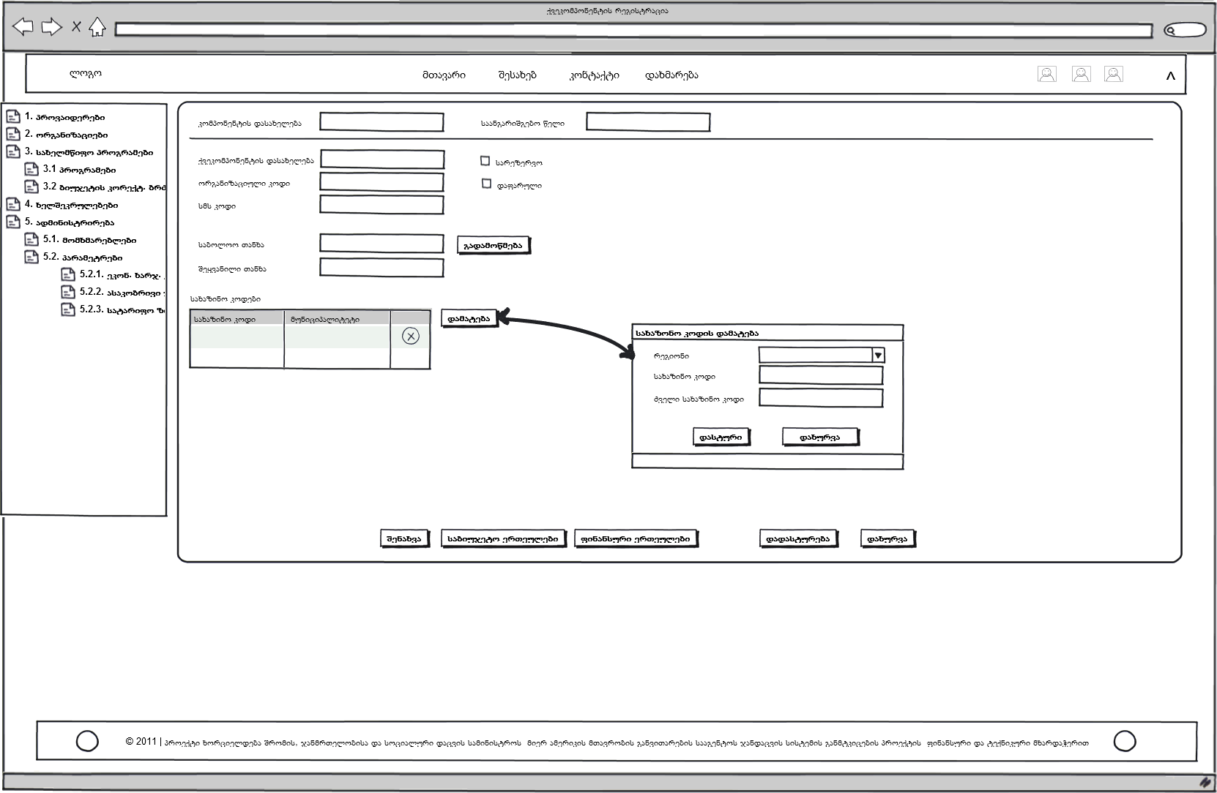
If the information about changes to the budget made at subcomponent level is unknown the so called “reserve/virtual component” is used, which is not a part of the component. A component may have only one reserve component.
A subcomponent may have a hidden status if the component does not consist of subcomponents. The user should add one subcomponent to maintain the hierarchical structure. In this case the added subcomponent should be marked as hidden and neglected in some reports.

Financing unit
The financing unit is further generalization of nosologies funded by subcomponents. It is used for reporting and regulating costs related to services envisaged by the contract under certain limits (Table 1.7). The financing unit has the following parameters: identification number, name, government’s participation share, artificial code, determining service types (medical and non-medical services), age of beneficiary, financing method (bed-day, global budget, fee for service, per capita payment, non-financial (statistical), etc.), price limit, price zone (geographic scope) (Table 1.8).
Table 1.7- Example of Financing unit
Artificial Code | Classification Code | Name | Region | Age Group | Gender | ...... | Price
11001 | O81 | Forceps delivery | Kakheti | 13-50 | Female |  | 500
11002 | O81 | Forceps delivery | Adjara | 13-50 | Female |  | 700
11003 | O82 | Cesarean section | Georgia | 13-50 | Female |  | 1200

Table 1.8. Characteristics of Financing unit
Field Name | Description | Note
Financing Unit Name | Name of the financing unit. It is copied automatically in case of selection of nosology. Nosology name can be edited to specify the unit name.
Financing Unit Type | Type: nosology or non-medical expense
Nosology/Nosology Group | It is one of the two financing units (non-medical expenses are the other one). In this case medical service is a budget unit. It is used only for healthcare programs.
Name of Nosology/Nosology Group | List of nosologies and name of the selected nosology or nosology group. It cannot be edited after selection. The selected name is copied to the Financing Unit Name field.
Age Group of Population | List of age groups of the population
Non-medical Expenses | If we click on it administrative expenses will be a budget unit. It is used for all forms of non-healthcare programs.
Recipient of Non-medical Expenses | It shows the recipient. The organization/individual or tax department may be recipients. It is used in reports and payment orders.
Treasury Code of Non-medical Expenses | The code assigned by the Treasury for tax payment. The code is used only in case the tax department is the recipient.
Artificial Code | It consists of digits and letters and enables identification of the financing unit. It is used in report.
Accrual Method | Method of invoice calculation, the principle by which payment is made: monthly (global budget), per case, non-financial (statistical), quarterly, per capita
Unit of Measurement | The smallest unit according to which quantities and costs are counted for financed service or goods, such as cases, man-day, bed-day, visits, analysis, litre, etc.
Share of Payer | It is used for the purpose of financing and indicates the funding share to be paid by the payer for services.
List of Price Zones
Price Zone | The geographic area where there are common prices for all services.
Price Limit | The price/amount for the specific geographic zone that limits the price for this financing unit.
Identifier of Subcomponent | The identifier(s) of the component(s) to which this financing unit belongs to.

The above-mentioned fields must be filled out in order to register financing units in the Budget Module. The form of a list of financing units must ensure closing the form without adding, editing, deleting or changing a financial unit (Fig. 1.8).
Move to the form for adding financing units by clicking on Financial Units on the subcomponent registration page. A nosology/a group of nosologies (name, code) is selected in the list of classifications (ICD-10, NCSP) in the Classification Module. After selection name of nosology is automatically displayed in the Financing Unit Name field that can be edited. An artificial code consists of 8 digits and is filled out manually. The age group is selected in the list of age groups (Fig. 1.9, 1.10).
In case of non-medical expenses the type of recipient (facility/organization) is selected and its treasury code is entered.
Accrual method is the tool determining methodology for financing the service (it is selected in the list of methods). Measurement unit is the small unit according to which the cost is calculated (selective field).
Financing sources are selected and funding share is entered manually in the table of financing sources and funding share. There is a special form for adding the price zone and the limit where the category of coverage area (selective field) and price zone i.e. the geographical area where this financing unit is used (selective field) are indicated and the relevant limit is entered (1.11).

Figure 1.8 – List of Financing units
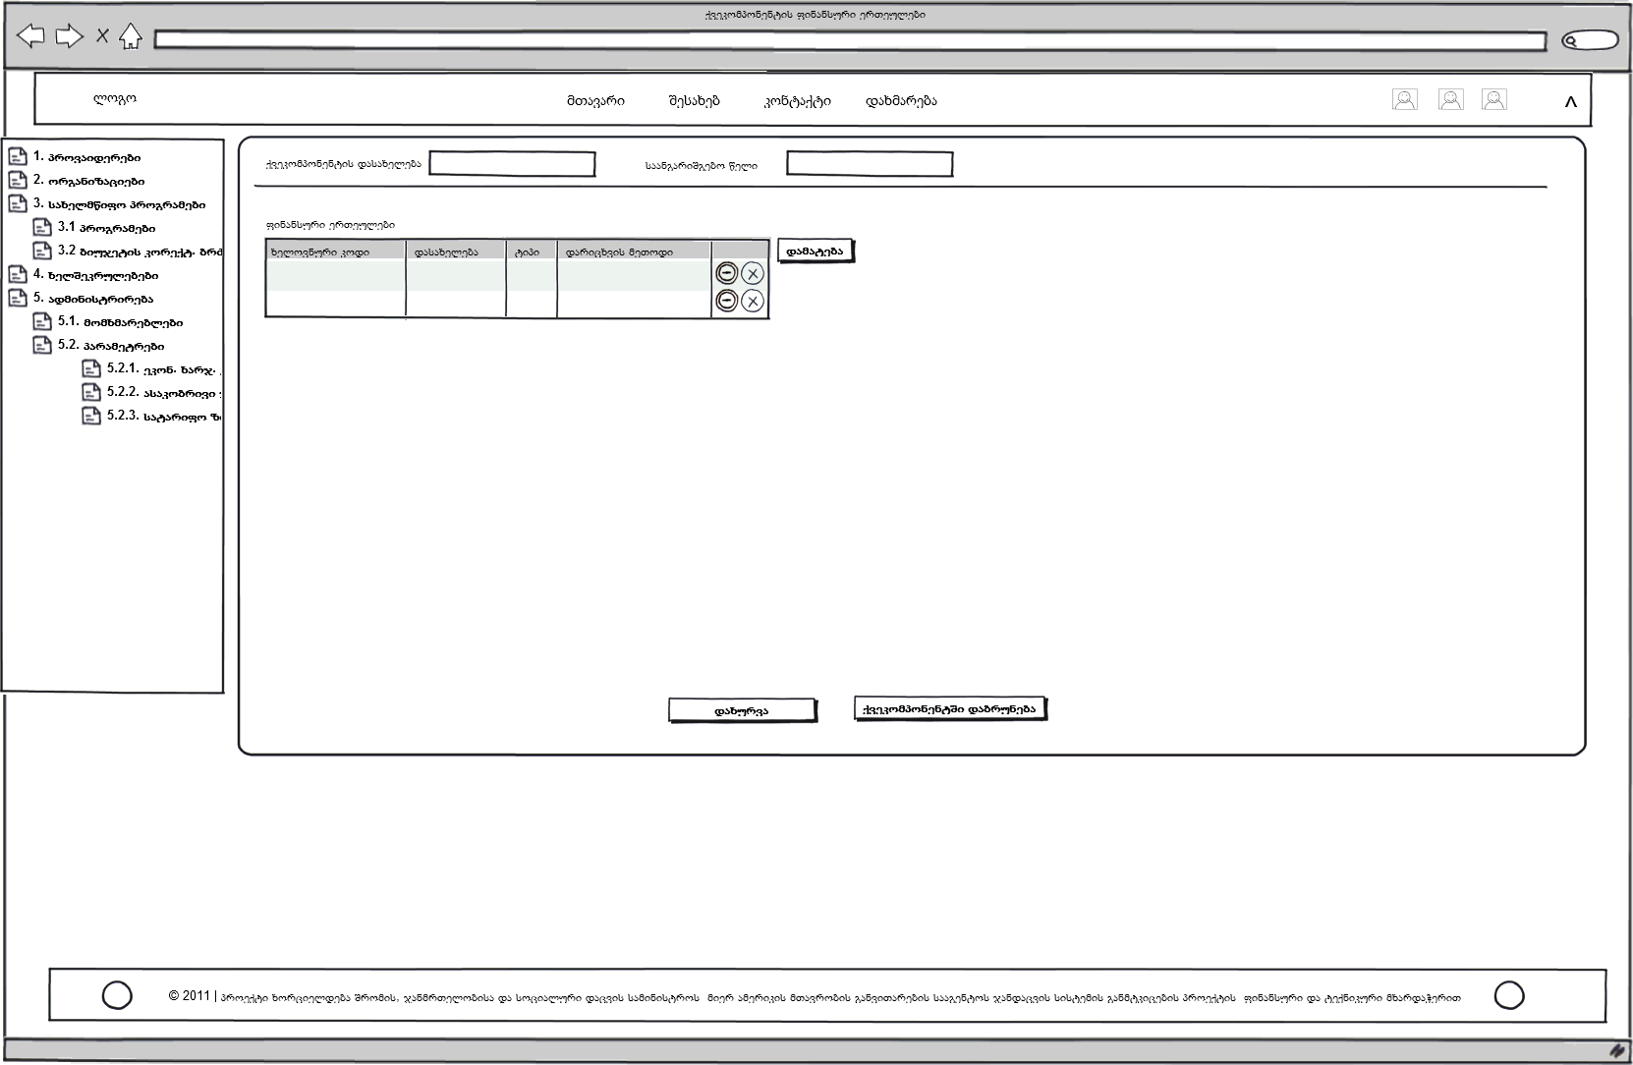

Figure 1.9 – Financing Unit Registration
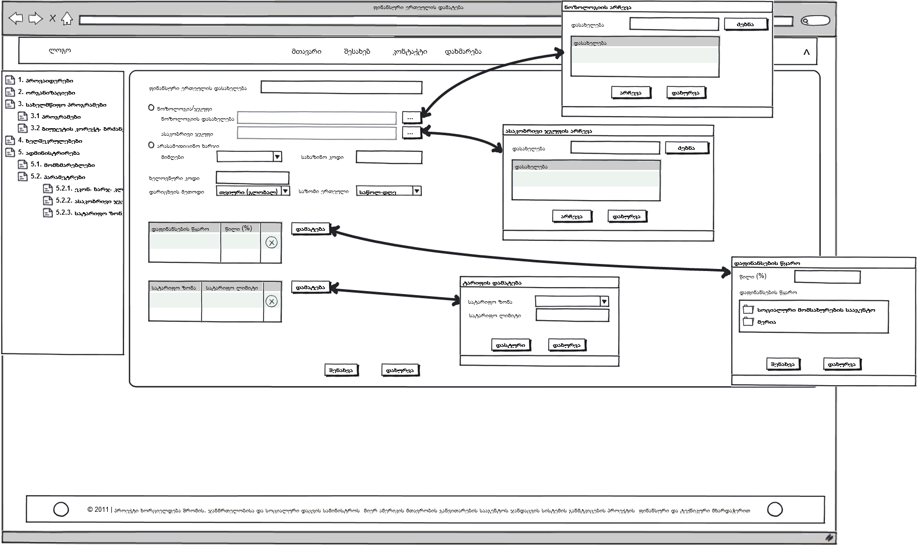

Figure 1.10 – Age Group Registration
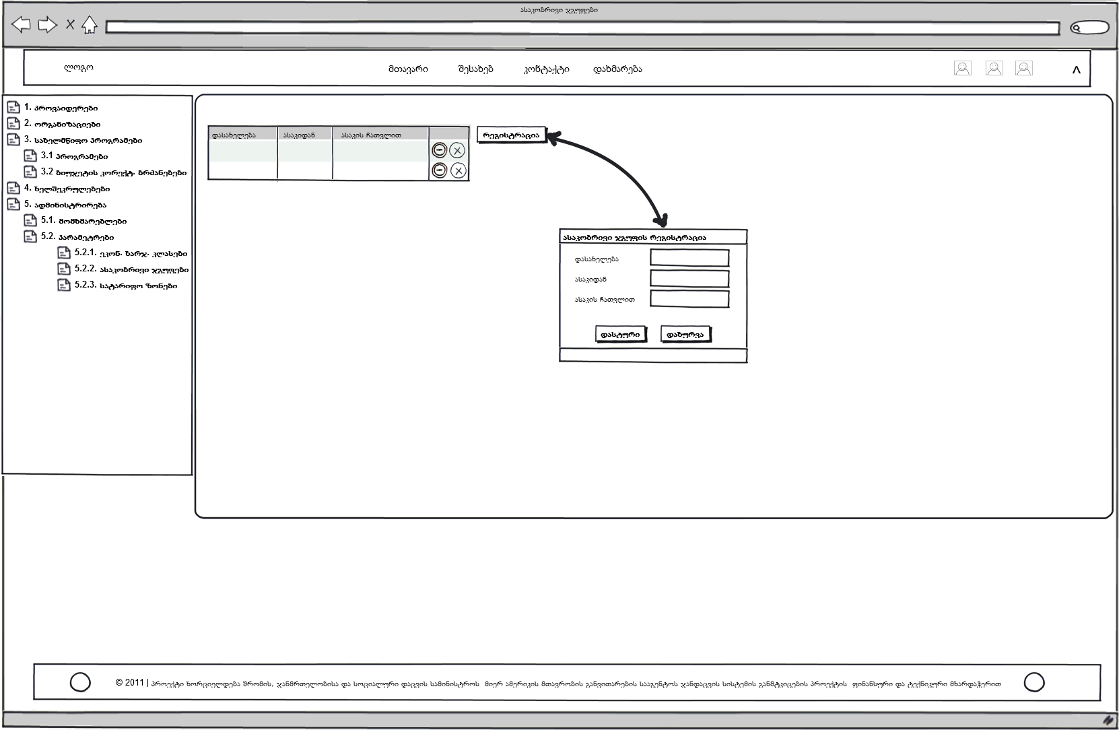

Figure 1.11 – Price Zone Registration
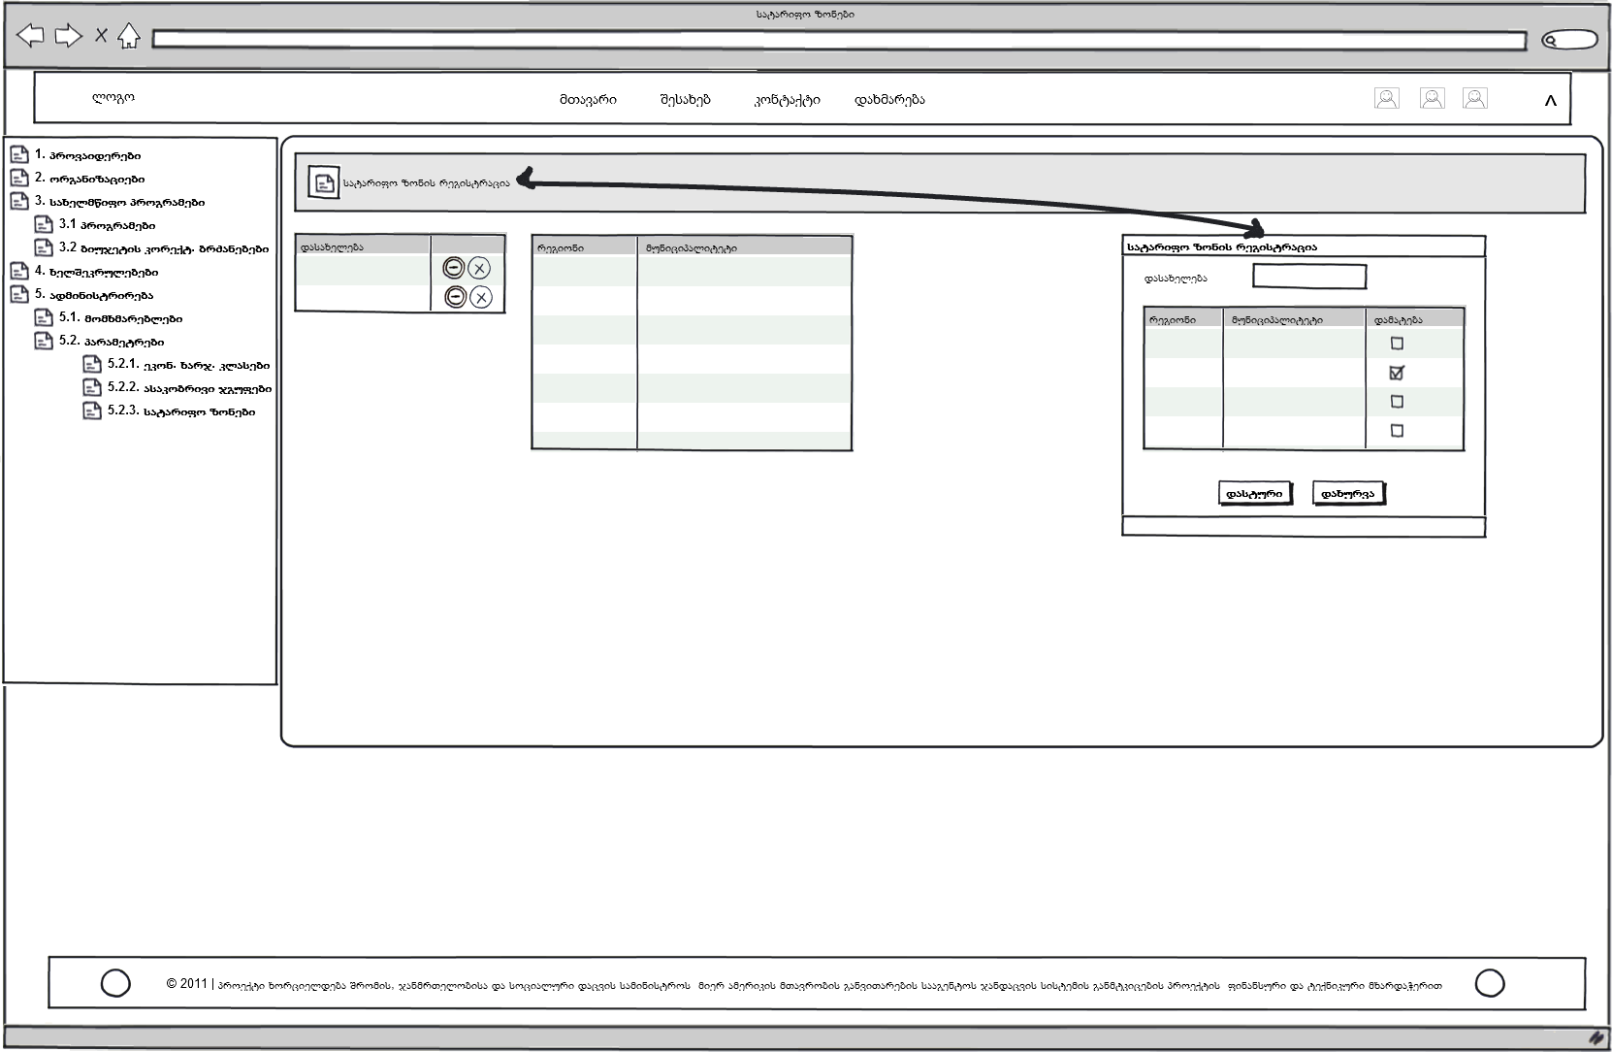

Entering Annual Budget
An annual budget is entered into the database once a year. First of all, budget units of subcomponents must be entered into the database. If the component does not consist of subcomponents, a default subcomponent (with the same name) must be added to it. Budget units are linked to the default subcomponents.
After entering the subcomponent into the target budget database, the sum of budget units related to this subcomponent i.e. the so called submitted budget is calculated (the Check button). If the two budgets are equal, the accuracy is verified or approved. The subcomponent budget cannot be modified after the approval. Amendments shall be made to the budget only in accordance to the amendment order.
The same procedure is followed for entering component budgets into the database: the component budget equals to the sum of subcomponent budgets. Accuracy of the entered data is checked and “approved”.

Budget Unit
The budget unit contains the utmost amount of money that can be spent at the subcomponent level during a year. Under the budget unit subcomponent budgets can be viewed according to regions, months and quarters (Table 1.9).
Table 1.9 – Example of Budget Units
Annual Budget for the X Subcomponent | Quarter 1 | Quarter 2 | Quarter 3 | Quarter 4
Region 1 | 100 | 120 | 200 | 200
Region 2 | 50 | 100 | 70 | 100
...... | .... | .... | .... | ....

Quarterly budget distribution at the component level is done by the Ministry of Finance. The budget is distributed according to regions, months and quarters by the SSA. Moreover, funds of budget unit are spent by the principle of cumulative sum. It means that the remainder of the budget for the previous quarter can be used in the next quarter. This remainder is calculated as the difference between the budget for the previous quarter and liabilities registered in the Treasury. The budget unit can be corrected. Any change to the subcomponent budget in the system is reflected as correction of the budget unit.
Please, see table 1.10 for the characteristics required to enter budget units into database of the Budget Module.

Table 1.10 – Characteristics of Budget Units
Field Name | Description | Note
Region Identifier | Default region for the specific budget unit
Time Interval | Time interval. The quarter is indicated.
Amount of Money of Budget Unit | Budget (amount of money) allocation for the subcomponent.
Reporting Year
Identifier of Amendment Order for Budget Unit | Identifier of the order to make change to the budget unit
Date for Changing Budget Unit | Date for changing the budget unit
Amount of Money of Budget Unit Before Changing | Amount of money of the budget unit before changing
Amount of Money of Budget Unit After Changing | Amount of money of the budget unit after changing

A list of budget units contains the data concerning regional and quarterly budget distribution and history of corrections made to the funds. The total amount of money entered into the table is displayed by clicking on the Display the Total Amount button. The target amount is entered into manually. If the funds entered into the table are correct there will be no difference (see Fig. 1.12).
A form for adding budget units is displayed on the subcomponent registration page by clicking on the Budget Units button. A form for adding the budget unit related to the specific subcomponent is displayed by clicking on the Add button on the right side of the list of budget units. The region is selected in the list of regions. Numbers are entered manually.

Figure 1.12 – Budget Unit

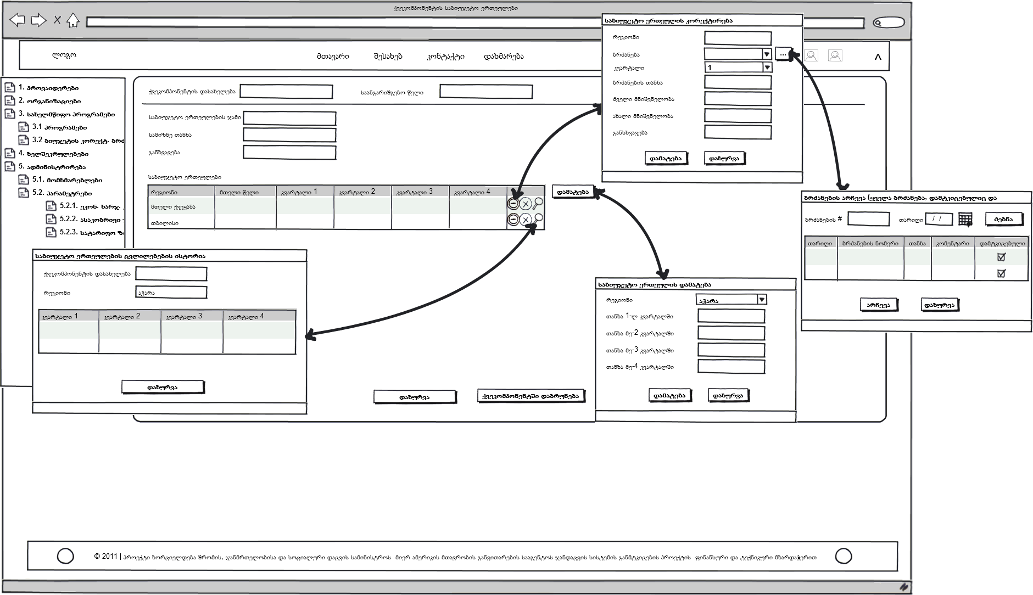

Amendments to Budget
A budget forecast report is required to amend the budget (any amendment is made at the level of budget units). It enables to determine potential deficit for budget units or exceeding budget and total amounts.
Amendments are prepared and the approved amendments are made to the budget at the level of subcomponent budget unit (all amendments and their history should be stored in the database).
In the middle of the year a new component is added to the system with the approved zero indicator. Then mechanism of amendment order is used to add some money to this component. The procedure determines accurate initial amount, changed amount and final amount.
In order to enter the amendment order into the system (which is mandatory) click on the Add button in the wondow of the list of orders and enter the date and registration number of the order, the total amount and reason for making the amendment (see Fig. 1.13). Then select the subcomponent that requires amendments on the subcomponent panel in the program budget management window. A correction window is displayed by clicking on the Add Correction where the following fields are filled out: time period (quarter), new meaning and amendment. The amendment order is automatically selected in the list of orders. Amendments are also stored in the Correction History on the subcomponent panel.

Figure 1.13. Budget Amendment Order

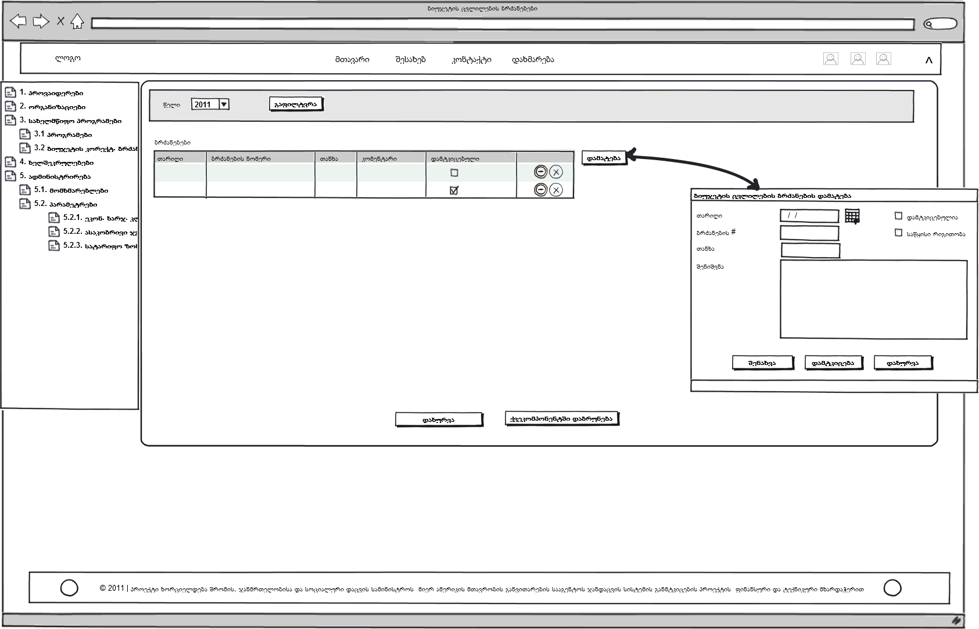

Monitoring Budget Spending
Budget monitoring is required in order to track the money paid for services rendered by contracted facilities. Purchasing, budget and budget spending reports must be made that enable the institutions administering state-funded programs to track spending and react accordingly.
There are the following reports to monitor the budget:
- Purchasing report
- Budget report
- Budget status report
Limits set under the subcomponent must be checked to reimburse services rendered by the contracted facilities within the subcomponent. That is done in the following way: the budget of the institution administering the program or its affiliated agency must not exceed the sum of budgets of the state-funded programs administered by the institution.

Contract

General Information
Services provided within the programs are paid under the terms and conditions of the contract concluded with the service/commodity provider. The entity that meets relevant requirements envisaged under the law of Georgia, signs a contract with the program implementer or expresses a wish to participate in the voucher program and fills out an application.
There exists a formally approved application that includes the following fields: Requisites of Organization, Bank Details, Requisites of Person in Charge of Healthcare Facility, List of Voucher Programs/Components and Information about Licensing/Permits for Healthcare Facility.
Main and labor-consuming functions of the program implementer are to conclude a contract with the service/commodity provider and monitor the contract performance.
If the cost of the work to be performed under the signed contract does not exceed 5000 GEL the information about the contract is posted on the website of the Treasury (eTresaury). The program implementer fills out the following fields: Contract Status, Contract Type, Long-term (it should be marked), Treasury and Organizational Codes of Program Implementer, Identification Code of Service Provider, Contract Number and Date, Total Amount (GEL, international currency), Notes, Contents of Contract (selective).
If the cost of the work to be performed under the signed contract exceeds 5000 GEL the scanned contract is sent to the State Procurement Agency. The State Treasury receives the information about the contracts from the Procurement Agency and makes a complete list of contracts. The list contains the following information: name of program implementer, identification number (treasury code) of service provider, contract date and number, amount of money, tender number and currency.
The main objective of the contracting component is automation of contract conclusion and its management. This process includes five blocks:
- Enter data concerning the service/commodity provider
- Enter data concerning the contract and its conclusion process
- Monitor provided services
- Close expired contracts and terminate problematic contracts

Entering Data Concerning Organization
Involvement of the provider in the state-funded program includes two stages: register the provider in the system and conclude a contract with the program implementer.
The module can administer such cases when the provider has several contracts according to different financing sources to finance a specific nosology within the state program.
In order to conclude a contract with the organization the following steps should be taken:
- Check if the organization is in the list of providers. Check tax code and the organization name;
- If the organization is in the list of providers, check and update its requisites, if necessary;
- Add the organization if it is not in the list of providers.
The provider is presented in the system as a two-level hierarchy: as a legal entity with its legal characteristics and information about its authorized representative (first level) and branches of the provider with their physical addresses (second level). If the provider has no branch it is registered as a branch in order to maintain structure of the system. Different medical and non-medical services are rendered in branches of the provider. The provider is presented on two levels due to arrangement of the network of healthcare facilities in the country. Please, see below an example of the contract concluded between the SSA and My Family Clinic – a legal entity that has several branches (see Fig. 2.1.)
Table 2.1. Contract between the SSA and Provider

Please, find below the fields to be filled out while registering the provider or its branch (Table 2.1, 2.2). A special form is displayed to add a branch.
Table 2.1 – Characteristics of Provider as Legal Entity
Groups | Fields | Notes
Organization | Tax Code
Organization | Georgian Name
Organization | Latin Name
Organization | Legal Form | Individual Entrepreneur, Ltd. Or JSC
Organization | Selective field, healthcare provider or non-medical service provider
Organization | Provider Type
Organization | Office Telephone
Organization | E-mail | Official e-mail of the provider
Organization | E-Health e-mail
Organization Address | Region
Organization Address | Municipality
Organization Address | Settlement | Name of the selected municipality and a list of surrounding villages will be displayed here
Organization Address | Registration Address
Bank Details of Organization | Bank Code | International code of the bank where the provider has opened an account
Bank Details of Organization | Name of Recipient | Name of the recipient who receives money
Bank Details of Organization | Settlement Account | Provider’s account number
Bank Details of Organization | Button main
Representative | Position
Representative | Personal Number
Representative | First Name
Representative | Second Name
Representative | Mobile
Representative | E-mail | Office e-mail of the representative
Organization Status | Status of Organization’s Record: Active, Passive, Initially Entered, Annulled | Only an active organization participates in the contract

Table 2.2 – Characteristics of Branches of Provider
Groups | Fields | Notes
Field Name | Name
Physical Address | Region
Physical Address | Municipality
Physical Address | Settlement
Physical Address | Registration Address

All the fields except the Latin Name field must be filled out while registering the provider and its branches (a special form is displayed). Please, see Fig. 2.2 for the provider/branch registration form.
Registration address of the provider is indicated in the field – Organization Address. One organization may have several bank accounts but the main one must be indicated. The form for adding an account will be displayed to add a bank account.
The natural person – legal representative of the provider is the “provider’s representative”. Issues related to contracts are discussed with the representative. While registering the provider the representative’s personal number is checked in the database of the Civil Registry and his/her full name is entered automatically. One tax code cannot be used for registering more than one provider.
The status of the organization may have one of the following statuses in the list: entered early, active, passive, annulled (mistakenly entered).

Figure2.2 – Provider Registration
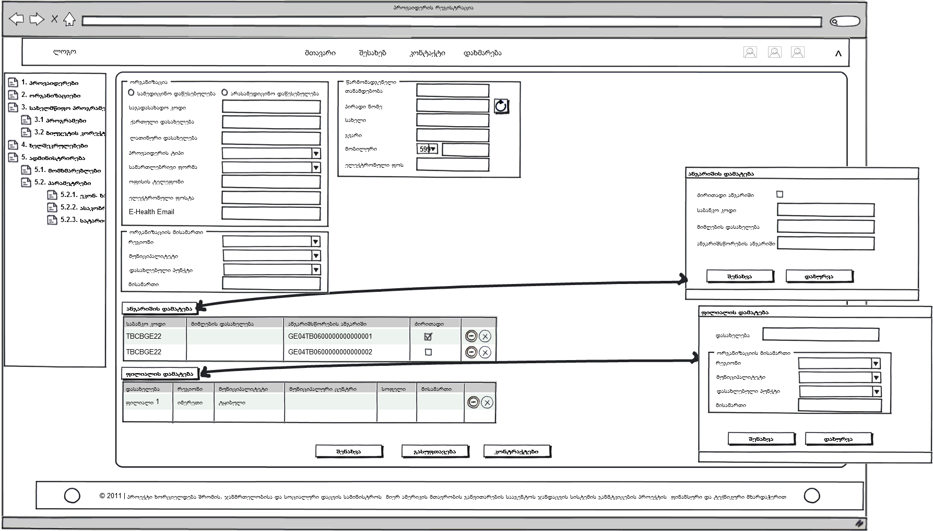

Entering Data Concerning Contract
The following information must be indicated to register the provider contract (Table 2.3):
Table 2.3. Characteristics of Provider Contract
Groups | Fields | Notes
Requisites of Contract | Contract # | Automatically generated
Requisites of Contract | Provider
Requisites of Contract | Contract Year | Effective period of the contract. Automatically generated, e.g. 2009 or 2010-2011.
Requisites of Contract | Tender Number
Requisites of Contract | Tender Commencement Date
Requisites of Contract | Start Date
Requisites of Contract | End Date
Requisites of Contract | Signing Date
Requisites of Contract | Status
Requisites of Contract | Organization | Program implementation agency
Requisites of Contract | Subcomponent | It determines state program within which a contract is concluded with the provider.
Requisites of Contract | Budget Year | From budget of which year the state program is funded
Representative of Healthcare Facility | Position | Position of the representative in the provider
Representative of Healthcare Facility | Personal #
Representative of Healthcare Facility | First Name
Representative of Healthcare Facility | Second Name
Representative of Ministry | Position | Position of the representative in the MoLHSA
Representative of Ministry | Personal #
Representative of Ministry | First Name
Representative of Ministry | Second Name
 | Branch of Provider | The branch, which is a party to the contract
 | Geographic Scope of Branch | The territorial unit (region or municipality) covered by the branch. One branch may have several geographic scopes. Amount of funding differs according to the scope.
Contract Amount | Total Amount
Contract Amount | Advance %
Add Amount Button | Type of Financing
Add Amount Button | Adding Date
Add Amount Button | Amount
Add Amount Button | Advance %
Add Amount Button | Comment
List of Amount Button | Date
List of Amount Button | Amount
List of Amount Button | Advance %
List of Financing Units | List of Financing Units
Scanned Contract
Type of Document | A List of Documents to be Submitted by the Organization to Get Reimbursed

Please, see Fig. 2.3 for the provider’s contract registration form.
Figure2.3 – Contract Registration
(The form may be converted to Wizard due to technical details)
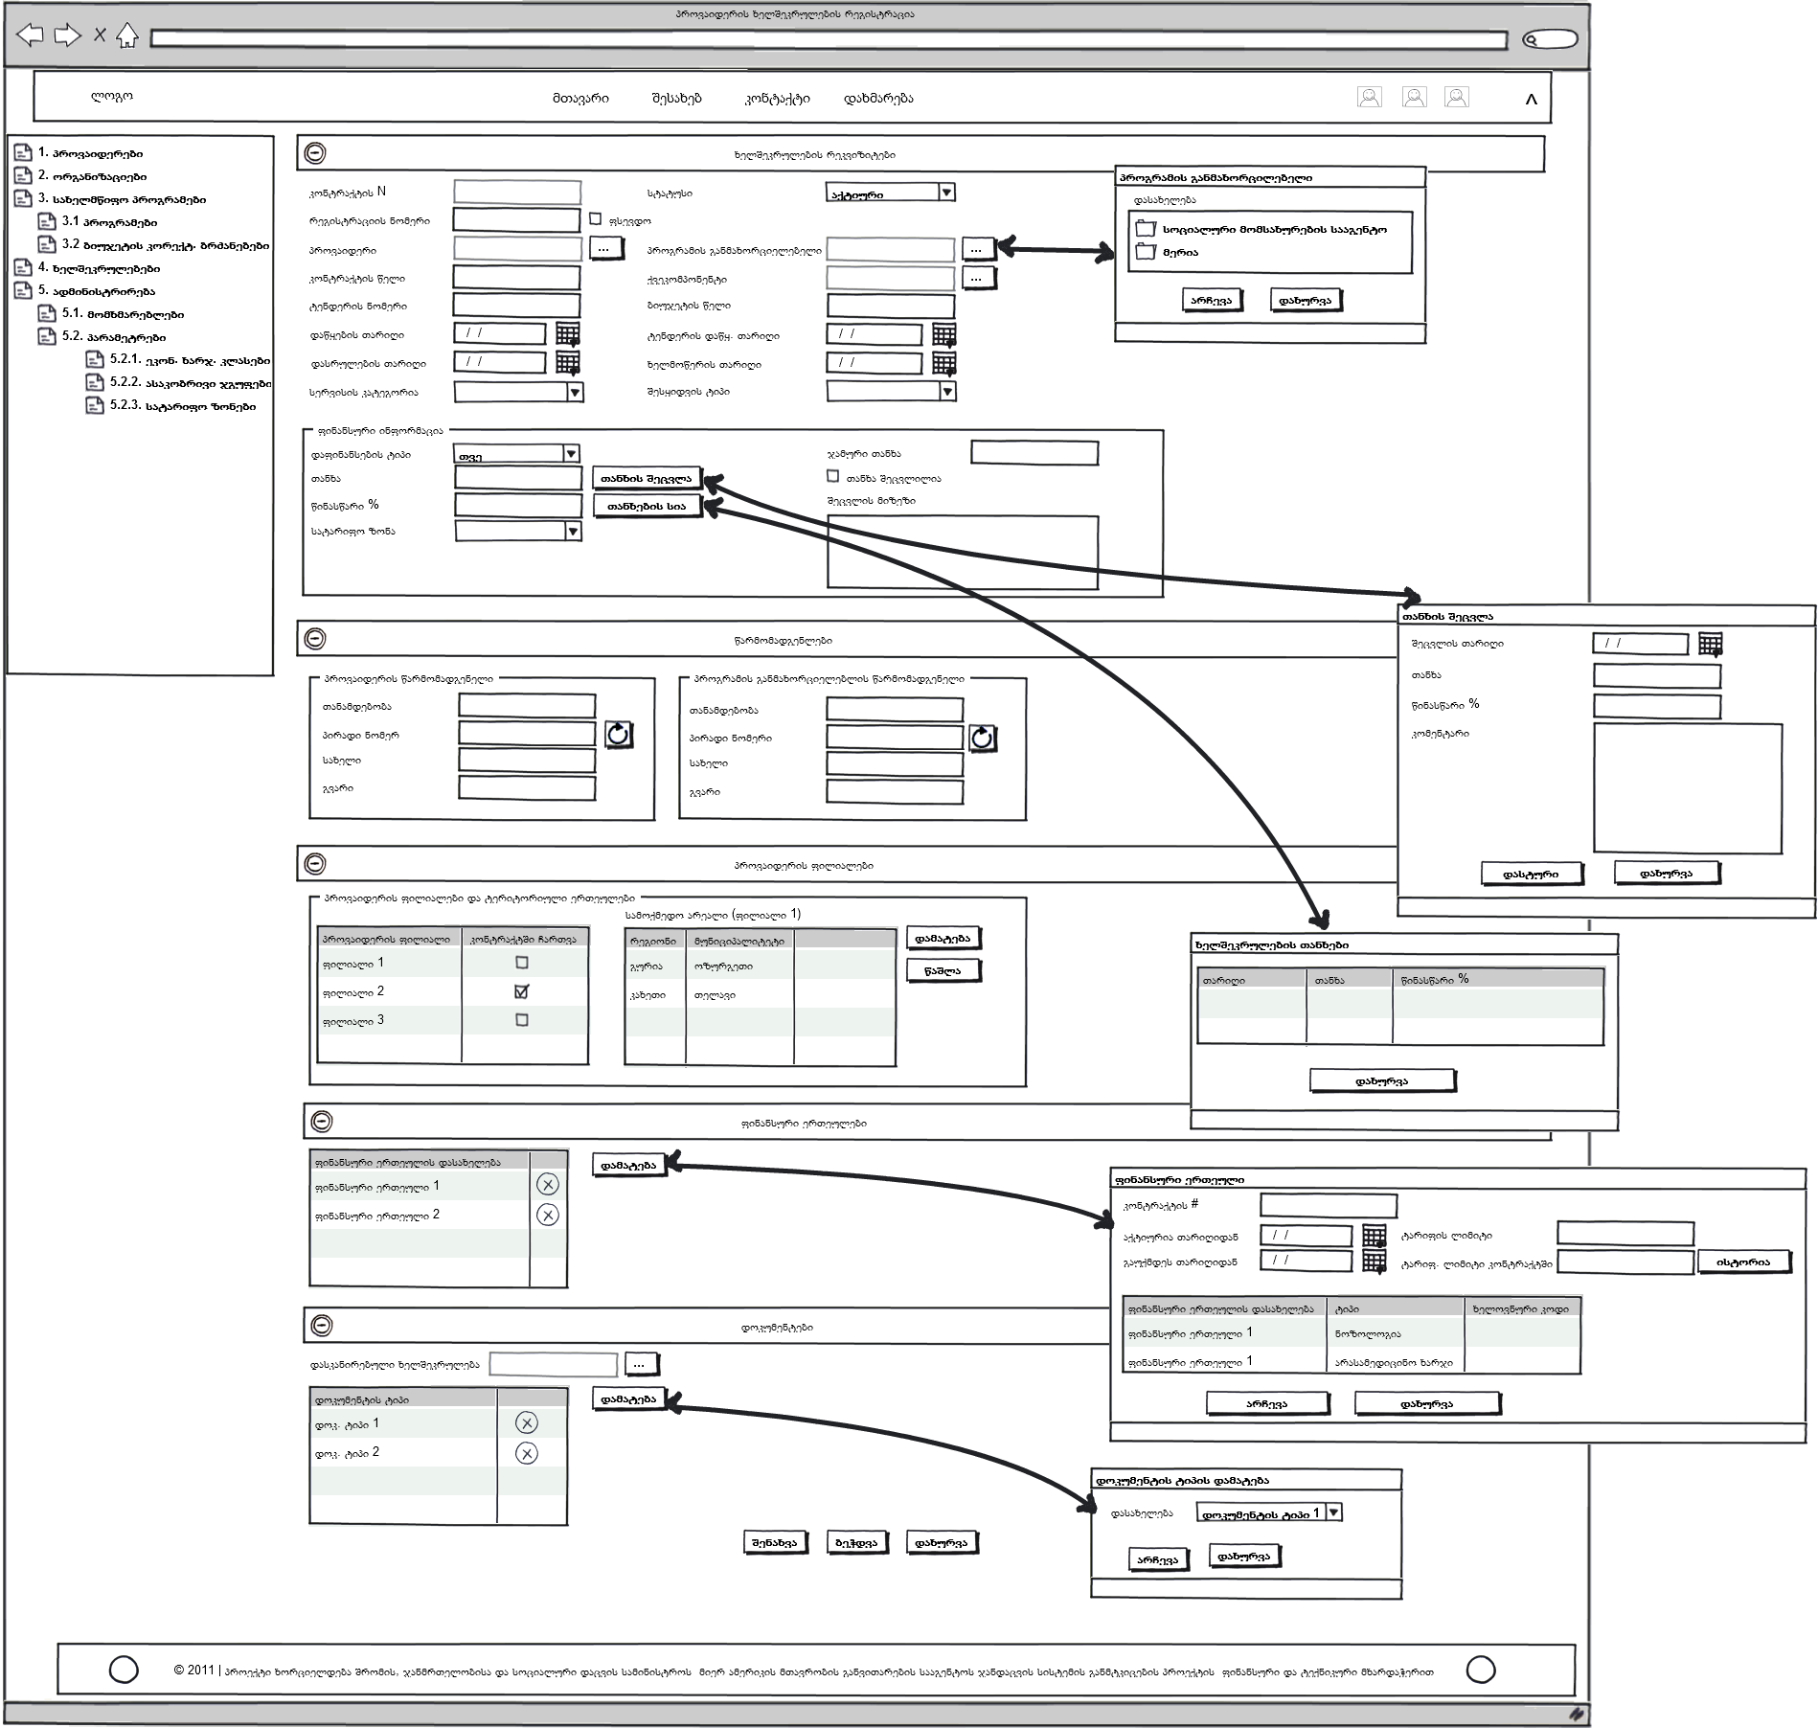

The contract may be signed only within the effective subcomponent or the subcomponent of the next year. The effective period of the contract must not exceed the effective period of the subcomponent.
You can move from the provider registration form to the contract page only in case of registration of a new contract. In other cases contracts can be viewed and new contracts are registered in the contract registration and provider list forms. While registering the provider, the Contract button is inactive until the data concerning the provider are saved (by clicking on the Save button).
The subcomponent within which a contract is being concluded must be selected in order to register a new contract. The provider’s name will be automatically entered.
A contract number is automatically generated on the new contract registration form by the system. The first digit of the number is the SSA code for the program; the second one is a component code, the third and fourth ones – a subcomponent code. The first digit in the contract number is a region code, the third and fourth digits – a district code and the last three digits – number of the healthcare facility in this disctrict. Digits after the character/letter indicate sequence of the contracts concluded by the provider within the subcomponent.
If the contract is pseudo (e.g. contract on reimbursement of treatment abroad) the Pseudo field must be marked.
The individuals signing the contract are representatives of the provider and the program implementer. If the provider has already been registered in the list of providers, the provider’s name, requisites and information about the representative are automatically moved from the list of providers. The provider’s representative can be replaced as another person may represent the provider by a notarized power of attorney.
The contract may be active, suspended, terminated, signed – in the implementation process, being performed, problematic or successfully expired, expired, annulled (erroneously entered). In case of suspension or termination of the contract the reason for change must be provided. It is automatically activated during the contract registration.
Type of purchasing is a selective field (negotiations with one person, price quotation, simple purchasing). Any kind of symbols may be entered into the Tender Number field.
A list of contracts signed by the providers contain the following data: number of branches, number of contracts, program implementation organization, identification code, provider name, program, component, subcomponent, action year, contract begin and end dates, contract status. The contract can be edited here.
The contract must include a list of documents (reporting forms and other documents) to be submitted by the organization to get reimbursed.
A special form is displayed to add financing units to the contract. The form contains the following data: financing unit activation and deactivation dates under the contract, limits and geographical scope.

Amendments to Contract and Changes to Provided Services
The main form must include Revise button in order to edit the contract. The contract amount and advance rate may be corrected, financial units may be changed or added (from the contract form).
The Amount and Advance Correction Form must include the fields described in Table 2.4.
Table 2.4. Fields of Amount and Advance Correction Form
Field Name | Description | Notes
Date | Date of formal amendment to the contract (when the attachment to the contract was formally signed)
New Amount | The corrected contract amount
New Advance | The corrected advance rate
Comment | Reason for correcting the contract

Two options may be discussed: 1. when a lump sum is added to the contract and 2. when the amount to be paid according to the special schedule is added to the contract.
The lump sum will be reflected in the contract as one record (one amount). The commencement date of the contract and date of adding this record will be the same. The amount will be effective until expiration of the contract.
If the contract amount changes according to the special schedule (e.g. three times during the effective period of the contract):
From | To | Contract amount
1/01/2011 | 31/03/2011 | 1000 GEL per month
1/04/2011 | 30/04/2011 | 2000 GEL per month
1/05/2011 | 31/12/2011 | 1500 GEL per month

three records will be added to the contract. The wrong amount and the advance must be deleted.
Date | New Amount
1/01/2011 | 1000
1/04/2011 | 2000
1/05/2011 | 1500

Service Quality Monitoring
Monitoring is one of the main tasks of the program implementer. The SSA may have several outreach visits to the relevant organization in relation to one contract. It also checks accuracy of reports. The system must enable entering main information related to monitoring and it should be indicated if the contract was monitored.
There is a Monitoring button in the contract form where monitoring records can be viewed.
The monitoring form must enable adding new records and editing or deleting the current ones.
The form for adding contract monitoring must contain the following data:
- Identification number
- Monitoring start and end dates. When a start date is entered the system will automatically display that the contract is being monitored. When an end date is entered the mark - Ongoing Monitoring will be displayed.
- Responsible person(s) – a list of the people who conduct outreach monitoring
- Comment – conclusions made during monitoring.
When a conclusion about starting monitoring is made the responsible person will add a new record concerning monitoring and enter a start date (the mark- Monitoring will display). The user may also enter reasons for travelling, a list of responsible persons and other relevant information.
After completion of the monitoring mission the user enters an end date, which will change the mark – Ongoing Monitoring, and conclusions and other relevant data into the comment field.
If serious problems arise during monitoring the contract the status must be changed from “signed contract – in implementation process” to “problems with implementation”. It shows to the managing staff that this contract needs special attention and it may be terminated.

Expiration, Termination/Cancellation of Contract
The contract can come to an end in two cases:
- When it successfully expired i.e. services under the terms and conditions of the contract are provided, money is paid. In such case the status “successfully expired contract” is assigned to the contract.
- If problems aroused while performing the contract and it should be terminated, the status of “terminated contract” is assigned to the contract.
The contract may be suspended for a specific period or indefinitely.
The contract status can be changed by changing the Status field in the contract editing form. If you click on the Save button a dialog box will appear: “Do you want to change the contract status?” in order to avoid accidental changes. It will happen only in case of changing the status together with other data. If you answer “yes”, the changed status and data will be saved. In other case the window for changing the contract will be activated to enable correcting the status and saving the contract.
The provider’s contract can be extended through a transitional contract. It is required in case of prolongation of the effective period of the state-funded program. In this case a transitional contract is concluded. An end date must be indicated in the transitional contract. The main contract can be extended this way several times. These two contracts must be connected to each other. The reason for extension must be indicated as a comment.

