How to access IHD’s AGI pages for the technical Communities of Excellence (CoEs)
1. On the AGI homepage, click on “Communities”
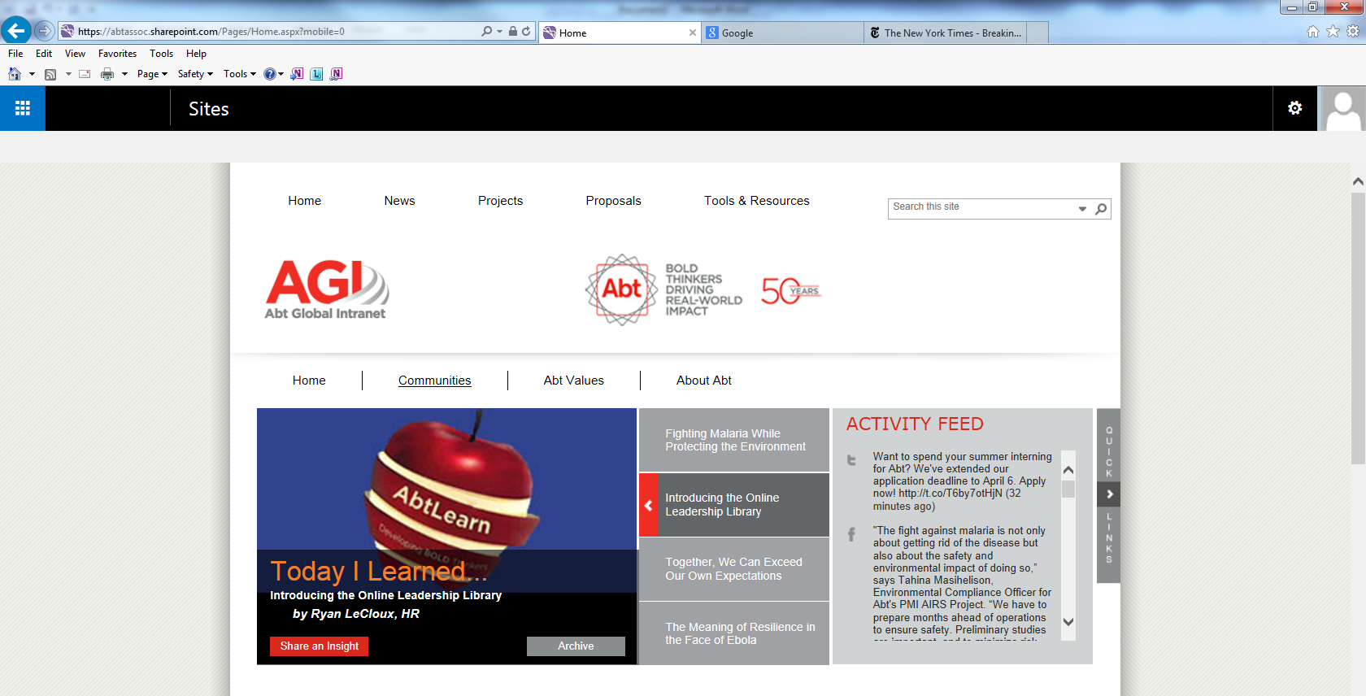

2. Click on IHD Communities of Excellence on the left hand side bar
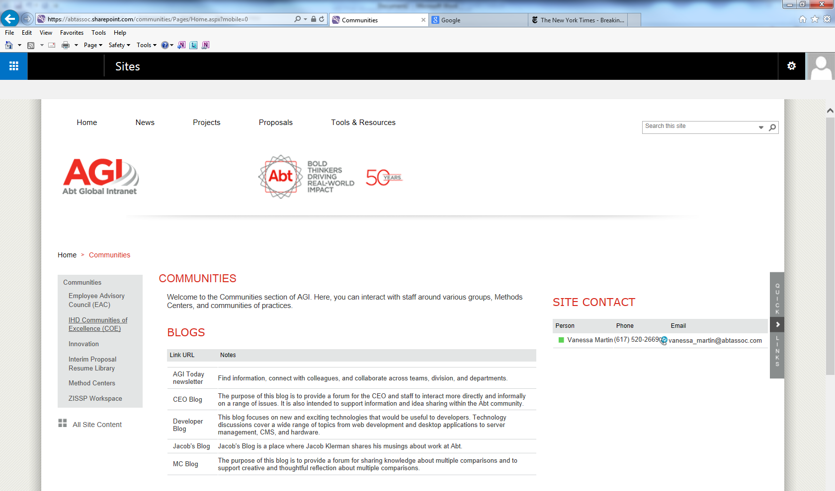
3. Browse the communities by selecting your area of interest from the list of communities, either on the IHD Communities of Excellence home page or via the left hand side bar.
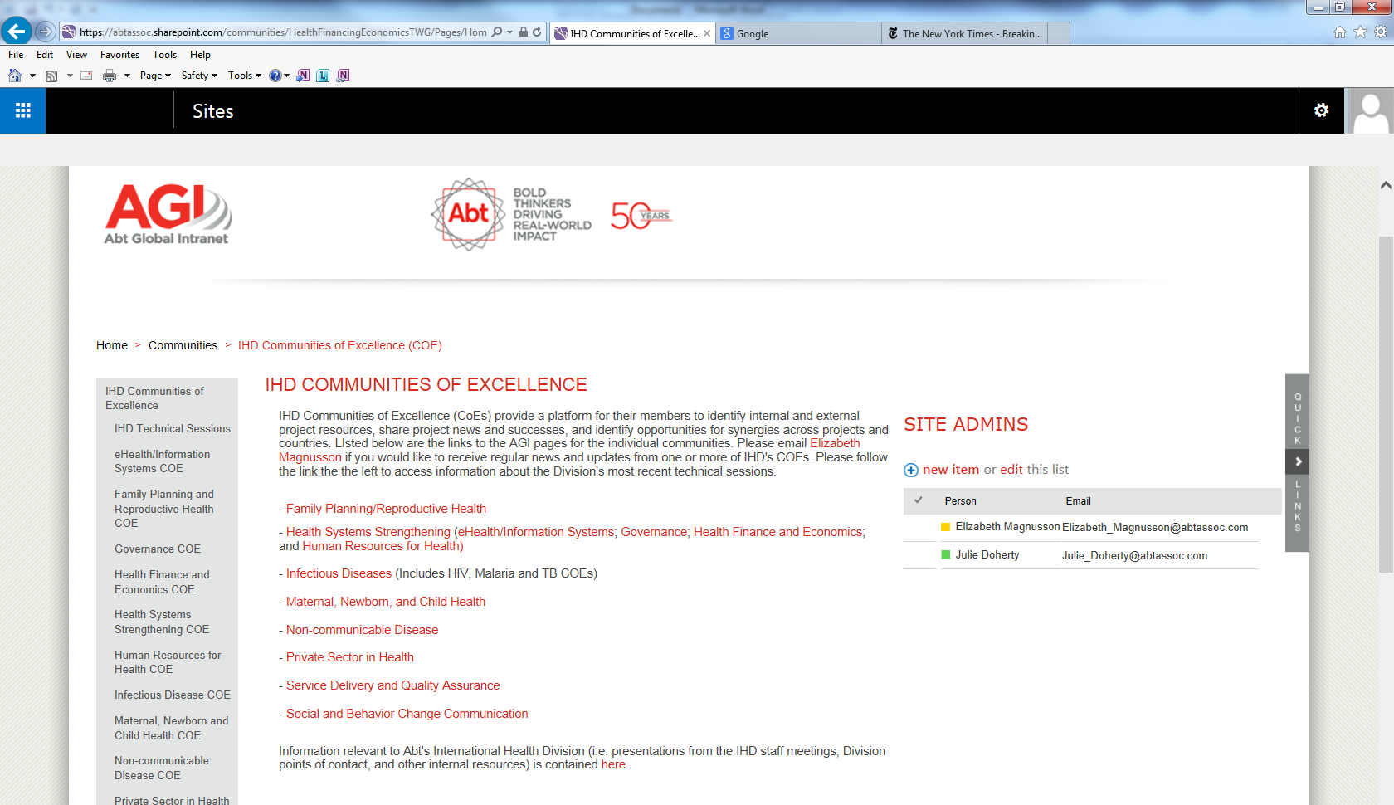
4. There are several “libraries” associated with each community pages. The libraries contain news and announcements, technical resources and tools and other content which may be of interest. The homepage for the community shows a preview of the most recent library content. To access the full library, click on the heading for the library. The headings are circled below.
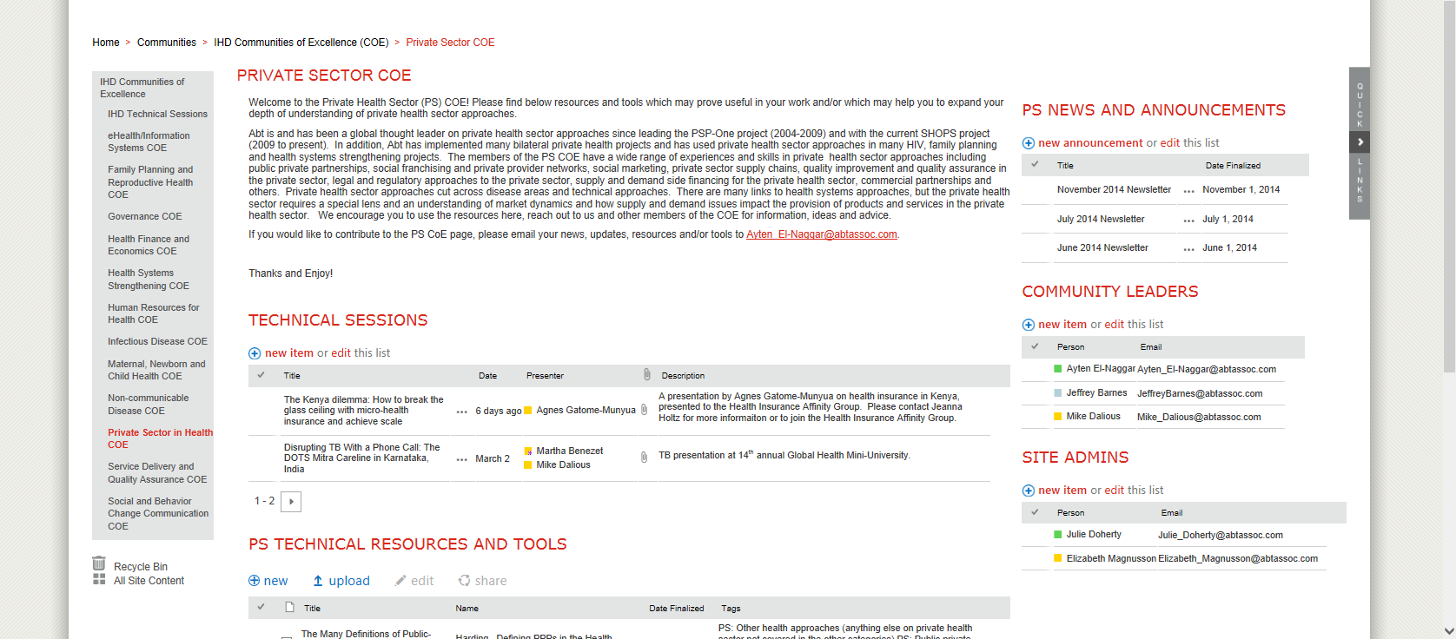

5. To open a technical resource, click on the name of the file.
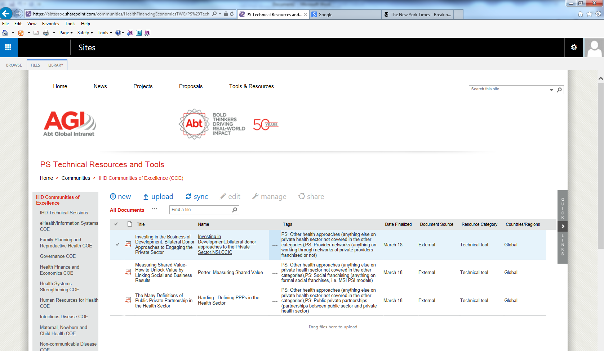
6. We are still working to fully populate the pages with the most relevant technical resources. If you have technical resources you’d like to contribute to a specific CoE please send those resource to:
CoE | Points of contact for technical resources
eHealth | Michael Rodriguez and Pam Riley
FP/RH | Saiqa Panjsheri and Samantha Lint
Governance | Alexandra Hulme
Health Finance and Economics | Karishmah Bhuwanee and Lauren Peterson
HSS | Julie Doherty
HRH | Sarah Dominis
Infectious Disease | Katherine Brouhard
MNCH | Lara Hensley
NCDs | Dasha Migunov
Private Sector | Mike Dalious and Ayten El-Naggar
Service Delivery and Quality Assurance | Ekpenyong Ekanem
SBCC | Page forthcoming – send resources to Helen Li and Chloe Revuz

