

Ministry of Labour, Health and Social Affairs of Georgia



Healthcare Management Information System
E-Health

Regulation Module
Certification

April 17
₂₀₁₂

Contents

1. Introduction 3
2. User Authorization 3
3. Navigation Description 4
2. Database, Filters 5
3. Adding New Medical personnel or Medium-Level Medical Personnel 6

Introduction
The Regulation Module is a part of the Health Management Information System (HMIS), which aims at registering medical personnel and medium-level medical personnel in the system. It ensures access to the information about distribution of the personnel among health care facilities, receipt of credible and timely information about potential, active and inactive medical personnel and provision of information about persons with medical background through intradepartmental relations, etc.
The Regulation Module is posted on the on the MoLHSA HMIS portal at the following address: http://ehealth.moh.gov.ge/Hmis/Medical personnel/Pages/Medical personnelList.aspx. The portal is supported by all common web browsers and is compatible with all operating systems.
The Regulation Agency for Medical Activities under the MoLHSA and future certified medical personnel and nurses are the system users.

2. User Authorization
The user must log in to system using his/her username and password to get access to the Certification Module (this information is provided by the system administrator of the Regulation Agency under the MoLHSA).

Type your username and password and click on the Enter button (see Fig.1).

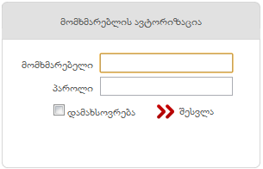
Fig. 1. Authorization Window

3. Navigation Description
After the successful authorization, the user gets access to the system (see Fig. 2).

Fig. 2

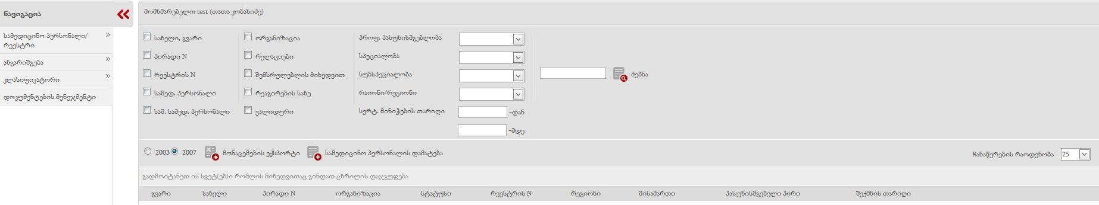

The database of medical personnel and medium-level medical personnel is displayed on the homepage of the system.

The navigation pane consists of the following types of information (see Fig.3):

Fig.3
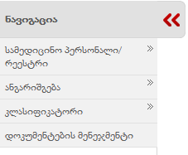
- Medical Staff/Registry including 2 additional fields:
    - A list of medical staff – a list of medical personnel and medium-level medical personnel registered in the system
    - A list of applications – a list of documents filled in by certificate seekers and linked to the system;
- Reporting including one additional field
    - Analysis means analysis of electronic information, many-sided analysis and also cross analysis of medical activities and staff in healthcare facilities;
- Classification including 2 additional fields:
    - Specialties – International Classifications of Specialties
    - Relations – compatibility between old and new specialties;
- Document Management including functionals for document development, linkage of analysis criteria to paper documents, identification by service and the archieve system of paper documents.

4. Database, Filters
Users can find all medical personnel and medium-level medical personnel in the database by clicking on this button 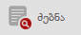.

It should be taken into account that users can find data by using different filters. There are the following filters:
- First Name and Surname
- Personal Number
- Registry Number
- Medical Personnel
- Medium-level Medical Personnel
- Healthcare Facility
- Relations
- Type of Response
- Valid

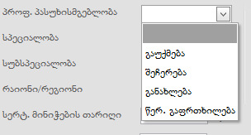
- Professional Responsibility (select it in the drop-down menu)

- Specialty (select it in the drop-down menu)
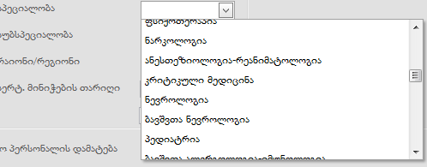
- Sub-specialty
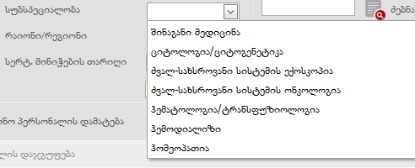
- District/Region
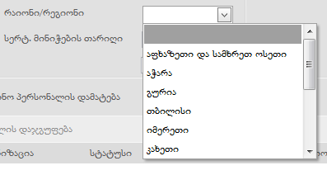
- Date of Issue of Certificate
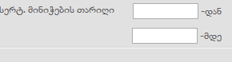

If users click on the Search button without using the filter, complete database of medical personnel is displayed in the interface.
They can export data into an Excel format by clicking on the button 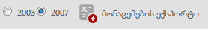

5. Adding New Medical Personnel or Medium-Level Medical Personnel
A Personnel Addition form (see Fig. 4) is displayed by clicking on the Add Medical Personnel button 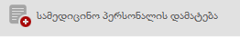

Fig.4
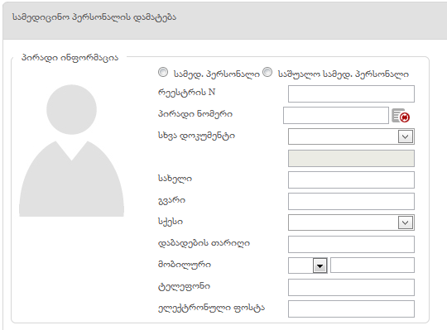
First of all, the user selects the type of medical personel .
He/she enters a registry number.

After entering the personal number the person is identified with the Civil Registry and the fields (First Name, Surname, Gender and Date of Birth) are filled out automatically by clicking on the synchronizatio button. If personal number is missing the field – “Other Document” is filled out 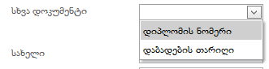 and the user can enter either diploma number or date of birth. In this case first name, surname, date of birth and gender are entered manually.

Mobile number and e-mail fields should be also filled out.

The user fills out a Higher Education form after entering personal data.
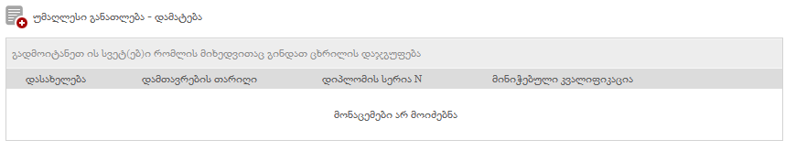
The following fields are displayed by clicking on the Add Higher Education button:
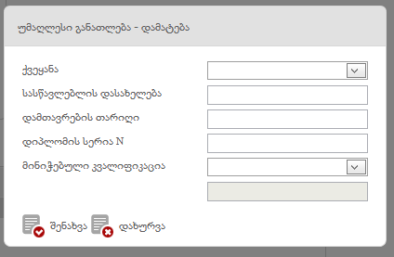
When all fields are filled out all data are saved in the relevant table by clicking on the Save button. The user can also add more than one higher education by clicking on the Add button.

It is followed by completion of a Post-Diploma Training form.
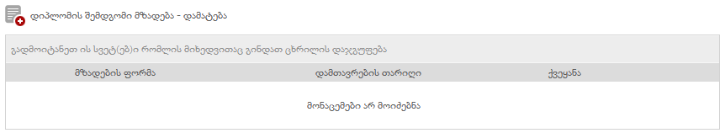
It includes the following fields:
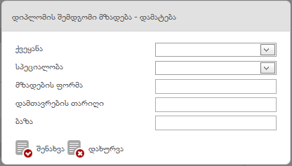
The data are saved in the relevant table by clicking on the Save button and more than one post-deploma training including relevant fields is added by clicking on the Add data, if necessary.

A Scientific Degree form is also filled out.
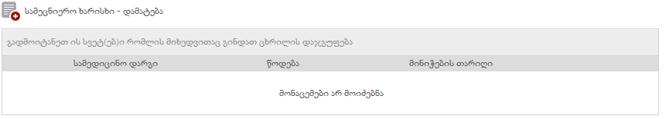

By clicking on the Add Scientific Degree button the following fields are displayed:
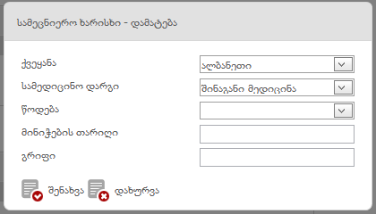

After filling out all the fields, the data are reflected in the relevant table by clicking on the Save button and more than one scientific degree including relevant fields is added by clicking on the Add data, if necessary.

The final step is to fill out a State Certificate form.
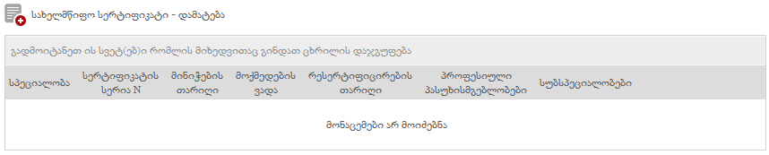

A State Certificate Addition form includes the following fields:
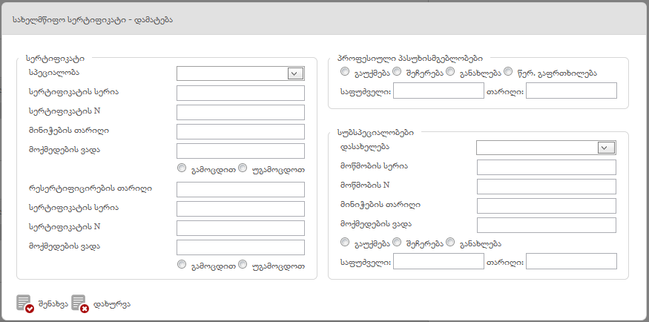
It should be noted that all fields must be filled out.

All the data are saved in the relevant table by clicking on the Save button and more than one post-deploma training field is added by clicking on the Add data, if necessary.

After filling out all the fields, the data are reflected in the relevant table by clicking on the Save button and more than one state certificate including relevant fields is added by clicking on the Add data, if necessary.

If the user marks Stay on Registration Page 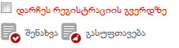 and saves the data, the user stays on the registration page, otherwise he/she automatically moves to the database of medical personnel.

By clicking on the relevant button the user can:
- view the data by clicking on the button
- edit the data by clicking on the button
- view history of the data by clicking on the button
- view detailed information by clicking on the button
- view reports by clicking on the button
- print data by clicking on the button

