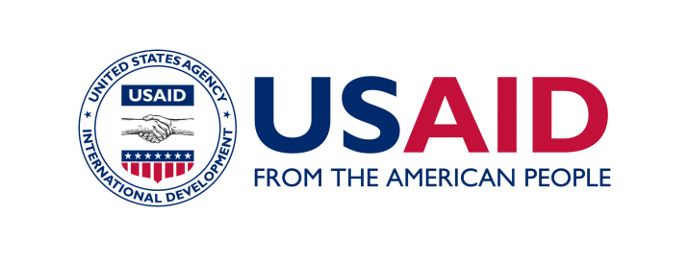

New Automated Health System Helps Georgians Save Money, Improve Health

A new USAID-supported modern registration system is quickly making health care services for state funded beneficiaries in Georgia more efficient. The electronic beneficiary registration system, developed and deployed through USAID’s Health Systems Strengthening Project in collaboration with the Georgian Social Service Agency, is already yielding significant results, including cost savings and improved monitoring.

Since the system’s official launch in November 2011, nearly 500,000 beneficiaries have been registered and more than 42,500 records errors were detected and resolved. The program is saving money and providing better services for beneficiaries, with shorter patient waiting lists, an increase in on-time payments to insurance providers, and greater predictability of provider’s monthly revenue stream.

The old registration system relied on a time consuming and resource-intensive manual process that involved collating non-standardized information on paper. The new system automates the process and uses standardized data collection forms, electronic submissions and validation tools. The system, compatible with all operating systems, is accessible through the Ministry of Labor, Health and Social Affairs’ (MoLHSA) website.

All 154 urban out-patient medical facilities across Georgia were required to register their beneficiaries through this new USAID-supported system. From March 2012, rural clinics are also using it to register their beneficiaries. The new registration system is an important step in the health reform efforts supported by USAID, which are aimed at improving the health status of the population, and increasing the quality of, access to, and satisfaction with health services in Georgia.

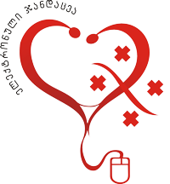
The official logo of Georgia’s Ministry of Labor, Health and Social Affairs’ e-health system.

