MoLHSA EMR 2.1
USER ACCEPTANCE TESTING PROGRAM
(EMR – HSSP integration)
59 pages

Tbilisi, 2015
Reconciliation sheet

Supplier
Position | Name | Signature | Date

Customer
Position | Name | Signature | Date

Table of Contents
LIST OF TABLES 5
LIST OF FIGURES 6
1 Terms and acronyms 6
2 Document purpose 7
3 UAT General definitions 7
3.1 The aim of the System testing 8
3.2 UAT actors 8
3.3 System testing and acceptance methodology 8
4 Conditions and prerequisites 9
4.1 Acceptance plan 9
4.2 UAT preparation 9
5 The scope of testing (Phase 2.1 brief scope description) 9
6 Test environment description 10
7 EMR 2.1 TEST CASES 11
7.1 EMR to HSSP Cases replication 11
7.1.1 EMR to HSSP Case Registration replication (urgent) 11
7.1.2 EMR to HSSP Case Registration replication (planned) 14
7.1.3 EMR to HSSP e-Reporting replication (other Cases) 16
7.2 External HIS to EMR to HSSP replication 18
7.2.1 External HIS to EMR to HSSP Case Registration replication 18
7.2.2 External HIS to EMR to HSSP e-Reporting replication 21
7.3 HSSP to EMR Cases replication 23
7.3.1 HSSP Case Registration to EMR replication 23
7.3.2 HSSP e-Reporting to EMR replication 25
7.3.3 HSSP Tuberculosis to EMR replication 27
7.3.4 HSSP Dialysis Program to EMR replication 29
7.3.5 HSSP Psychiatry Program to EMR replication 31
7.3.6 HSSP Immunization Management to EMR replication 33
7.3.7 HSSP Diabetes to EMR replication 35
7.3.8 HSSP AIDS to EMR replication 37
7.4 e-Prescription functionality 39
7.4.1 e-Prescription electronic Form creation 39
7.4.2 e-Prescription PDF search by Prescription No. and/or Patient Id 41
7.5 Auxiliary functionality 42
7.5.1 EMR Case creation by given Guarantee No (for planned Cases) 42
7.5.2 EMR Form 100 usage from the HSSP Guarantee Module side 43
7.6 EMC HIP clinical documents sharing 44
7.6.1 Patient Cases (CDA) access by using standard HL7 xDS protocol 44
7.6.2 Patient PDF e-Prescription access by using standard HL7 xDS protocol 45
7.6.3 Patient demographic data maintaining and using cEHR as a Master Patient Index (MPI) 46
7.7 cEMR Mobile applications 48
7.7.1 Process of access to EMR for patients 48
7.7.2 Process of access to EMR for doctors 54
8 Functional Specifications and UAT sections reference 57
9 System acceptance protocol 59

LIST OF TABLES
Table 1. EMR to HSSP Case Registration replication (urgent) 12
Table 2. EMR to HSSP Case Registration replication (planned) 15
Table 3. EMR to HSSP e-Reporting replication (other Cases) 17
Table 4. External HIS to EMR to HSSP Case Registration replication 19
Table 5. External HIS to EMR to HSSP e-Reporting replication 22
Table 6. HSSP Case Registration to EMR replication 24
Table 7. HSSP e-Reporting to EMR replication 26
Table 8. HSSP Tuberculosis to EMR replication 28
Table 9. HSSP Dialysis Program to EMR replication 30
Table 10. HSSP Psychiatry Program to EMR replication 32
Table 11. HSSP Immunization Management to EMR replication 34
Table 12. HSSP Diabetes to EMR replication 36
Table 13. HSSP AIDS to EMR replication 38
Table 14. e-Prescription electronic Form creation 40
Table 15. e-Prescription PDF search by Prescription No. and/or Patient Id 41
Table 16. EMR Case creation by given Guarantee No (for planned Cases) 42
Table 17. EMR Form 100 usage from the HSSP Guarantee Module side 43
Table 18. Patient Cases (CDA) access by using standard HL7 xDS protocol 44
Table 19. Patient PDF e-Prescription access by using standard HL7 xDS protocol 45
Table 20. Patient documents submit to EMR 46
Table 21. Process of access to EMR for patients 49
Table 22. Access patient clinical data from mobile application 55
Table 23. FS and UAT sections reference 57
Table 24. System acceptance protocol 59

LIST OF FIGURES
Figure 1. Registration of urgent-case by Class A clinic 11
Figure 2. Planned-case registration by Class А clinic 14
Figure 3. Registration of beneficiary visit by Class A clinic 16
Figure 4. Urgent-case registration from external HIS 18
Figure 5. Registration of beneficiary visit from external HIS 21
Figure 6. Urgent-case registration by Class B clinic 23
Figure 7. Registration of beneficiary visit by Class B clinic 25
Figure 8. Data replication of treatment and prevention of tuberculosis 27
Figure 9. Data replication on peritoneal and hemodialysis 29
Figure 10. Data replication of Psychiatry 31
Figure 11. Data replication about immunization 33
Figure 12. Data replication of diabetics 35
Figure 13. Data replication of AIDS 37
Figure 14. Medical appointments (prescriptions) print via Forms printing service 39
Figure 15. Data flows of process of access to EMR for patients 48
Figure 16. Data flows of process of access to EMR for doctors 54

Terms and acronyms
Case | The Case is CDA2-document, which contains the general clinical information about treatment of the one given Patient
CDA | Clinical Document Architecture
cEMR | Central Electronic Medical Records
HL7 | Health Level-7 or HL7 refers to a set of international standards for transfer of clinical and administrative data between software applications used by various healthcare providers.
HSSP | Health System Strengthening Project
MoLHSA, Customer | Ministry of Labour, Health and Social Affairs of Georgia
OU | Operational Unit (in cEMR)
Performer, Supplier | EMC
UAT | User Acceptance Testing
xDS | Cross-Enterprise Document Sharing

Document purpose
The document defines the order of MoLHSA cEMR 2.1 (the System) acceptance according to the SOW from .
There are following main sections in the document:
- Section 3 describes the general provisions of the acceptance procedure
- Section 7 contains the detailed description of the test-cases, which are used to test the System functionality
- Section 8 contains the mapping of the SOW requirements with the test-cases
- Section 1 will contain the results of System acceptance, the Customers remarks and comments

UAT General definitions
System acceptance are carried out on the Customer side (on testing environment, see chapter 1) and by using the Customer software, hardware and facilities.
UAT process based on the following project documents:
- SOW for Healthcare management Information System extension (phase 2.1) from
- Functional specification. Collaborative Health Environment of Georgia. EMR 2.1. Part 1. EHR and HSSP Integration (Case Management)
Document code: 02. TR-FS. MoLHSA EMR 2.1. Part 1. Case management
- Functional specification. Collaborative Health Environment of Georgia. EMR 2.1. Part 2. EHR and HSSP/USAID Integration (Clinical Data Exchange)
Document code: 02. TR-FS. MoLHSA EMR 2.1. Part 2. Clinical data exchange
- Functional specification. Collaborative Health Environment of Georgia. EMR 2.1. Part 3. EHR and HSSP/USAID Integration (Mobile platform)
Document code: 02. TR-FS. MoLHSA EMR 2.1. Part 3. Mobile platform
- The current UAT program

The aim of the System testing
The aim of the UAT process is to check that cEMR 2.1 was developed in accordance with Functional specifications and SOW for Healthcare management Information System extension (phase 2.1). The chapter 8 contains the correspondence between the Functional specifications (part 1 and part2) and UAT sections.

UAT actors
UAT is processed by the Acceptance Committee, which includes:
- Customer representatives;
- Performer representatives;
Acceptance Committee must approve the current UAT program before starting the acceptance process.

System testing and acceptance methodology
When testing the System functionality the method of scenario-oriented testing is using. This method assumes an execution of consistent flow scenarios, similar to the way the real users (patients, doctors etc.) uses the System.
For each step in particular scenario an expected result to be achieved is defined. Test scenarios used for testing the System are shown in Section 7. The tests are carried out fully in accordance with this program and test procedure, regardless of the intermediate results of the tests.
The structure of each scenario step is the following:
- Step number
- Step description – short description of the step
- User/Role – the role title of User name, which is used to perform the actions
- Actions – description of actions to perform in the System
- Expected result – short description of what is expected to get in the System after executing of the actions
After the completion of each scenario the result of testing is recorded in the System acceptance Protocol (see Section 1).

Conditions and prerequisites

Acceptance plan
The main acceptance steps all the following:
- STEP 1: System deployment, configuration and preparation to perform UAT
- STEP 2: System testing according to the approved test cases
- STEP 3: System acceptance protocol creation and approving by the Acceptance Committee

UAT preparation
Before UAT processing the working place must be organized and satisfied to the following requirements:
- PC must be provided with the OS Windows, Web-browser (Internet Explorer or Chrome or similar), monitor 17” diagonal at least, 512 Mb RAM
- PC must be connected directly to MoLHSA network or to the Internet (thought the cable or Wi-Fi adapter) and must be able to connect to TEST environment, described in Section 1
- (optionally) Projector connected to the PC and white board/wall to watch the projection.
- Mobile phone on iOS and/or Android platform with Internet connection (thought the Wi-Fi or SIM-card)

The scope of testing (Phase 2.1 brief scope description)
The current UAT program does not contain test cases for testing the functionality implemented within the previous cEMR project phases. The scope of testing is restricted by the functional requirements defined in Functional specification (part 1, part2 and part 3) mentioned in Section 3.

Test environment description
The testing must be performed on MoLHSA EMR testing environment.
Server/component name | IP address (internal) | Port | IP address (external) | Port
Test App Server wHospital Engine | 172.17.217.53 | 80 | 92.51.96.100 | 81
Test App Server wHospital Engine | 172.17.217.53 | 443 | 92.51.96.100 | 444
Test App Server wHospital Services | 172.17.217.54 | 80 | 92.51.96.101 | 81
Test App Server wHospital Services | 172.17.217.54 | 443 | 92.51.96.101 | 444
Test App Server wHospital Services | 172.17.217.54 | 8080 | 92.51.96.101 | 8081

EMR 2.1 TEST CASES

EMR to HSSP Cases replication

EMR to HSSP Case Registration replication (urgent)
The main purpose of the process is to provide Class A clinics with the possibility to register the case via EHR interface (with further replication of required information into HSSP / HSSP).

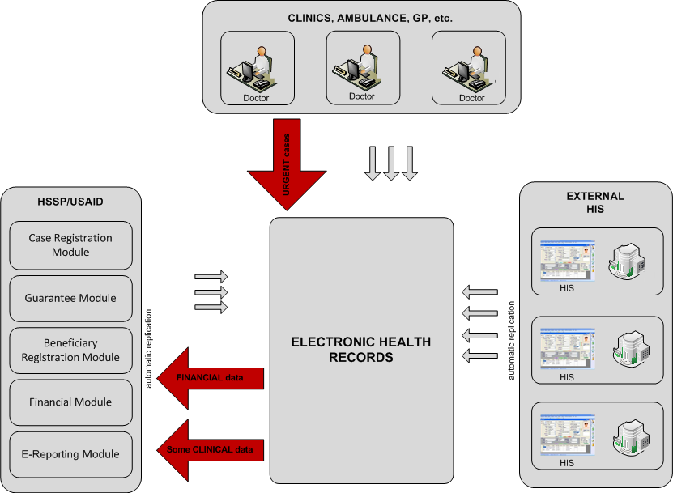
Figure 1. Registration of urgent-case by Class A clinic

The process scenario is described below in Table 1.

Table 1. EMR to HSSP Case Registration replication (urgent)
Step No. | Step description | User/Role | Actions | Expected result
 | Patient admit | Doctor | - Admit new patient to the OU | Patient admitted to OU
 | Problems section fulfil | Doctor | - Create new entry in Problems section of Patient Summary | New entry in Problems section created
 | Procedures section fulfil | Doctor | - Create new entry in Procedures section of Patient Summary | New entry in Procedures section created
 | Encounter section fulfil | Doctor | - Create new entry in Encounters section of Patient Summary. | New entry in Encounters section created
 | Urgent case financial information fulfil | Hospital Administrator | - Choice Financial Unit(s) in Financial administrator UI | Urgent case financial information fulfilled
 | Case replication | Hospital Administrator | - Find fulfilled case and replicate it manually – press “Send” button.  - Wait for a confirmation of successful replication.  - Ensure that HSSP Case ID is successfully stored in corresponding CEMR Case attribute. | Urgent case is successfully replicated to HSSP. HSSP Case ID successfully stored in corresponding CEMR Case attribute
 | Case replication check (HSSP Case Registration) | HSSP user | - Login to Case Registration module UI and find a case replicated on the previous step using HSSP case ID. Verify all case data.  http://case.moh.gov.ge/CaseRegistration  user: admin  pass: $sergo_r$ | Case is successfully found in Case Registration module.
 | Case replication check (HSSP e-Reporting for NCDC) | HSSP user | - Login to Case Registration module UI and find a case replicated on the previous step using HSSP case ID. Verify all case data.  http://reporting.moh.gov.ge/Reporting/?languagePair=en-US  - Find the replicated Case(s)

EMR to HSSP Case Registration replication (planned)
The purpose of the process is to enable Class A clinic case registration via EHR interface with indicating Guarantee No, provided by the patient.

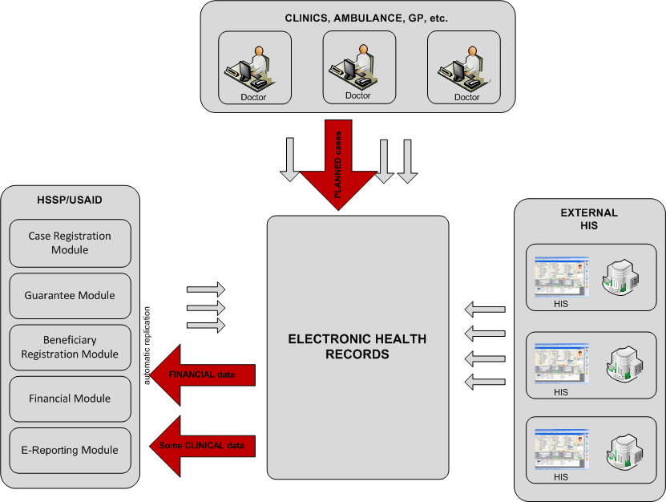
Figure 2. Planned-case registration by Class А clinic

The process scenario is described below in Table 2.

Table 2. EMR to HSSP Case Registration replication (planned)
Step No. | Step description | User/Role | Actions | Expected result
 | Patient admit | Doctor | - Admit new patient to the OU | Patient admitted to OU
 | Problems section fulfil | Doctor | - Create new entry in Problems section of Patient Summary | New entry in Problems section created
 | Procedures section fulfil | Doctor | - Create new entry in Procedures section of Patient Summary | New entry in Procedures section created
 | Encounter section fulfil | Doctor | - Create new entry in Encounters section of Patient Summary | New entry in Encounters section created
 | Planned case financial information fulfil | Hospital Administrator | - Enter Guarantee Number in Financial administrator UI | Planned case financial information fulfilled
 | Case replication | Hospital Administrator | - Find fulfilled case and replicate it manually – press “Send” button.  - Wait for a confirmation of successful replication.  - Ensure that HSSP Case ID is successfully stored in corresponding CEMR Case attribute. | Urgent case is successfully replicated to HSSP. HSSP Case ID successfully stored in corresponding CEMR Case attribute
 | Case replication check |  | - Login to Case Registration module UI and find a case replicated on the previous step using HSSP case ID. Verify all case data. | Case is successfully found in Case Registration module.

EMR to HSSP e-Reporting replication (other Cases)
Process purpose is to provide Class A clinic with the ability to register the case via EHR interface (with following replication demanded information into HSSP).
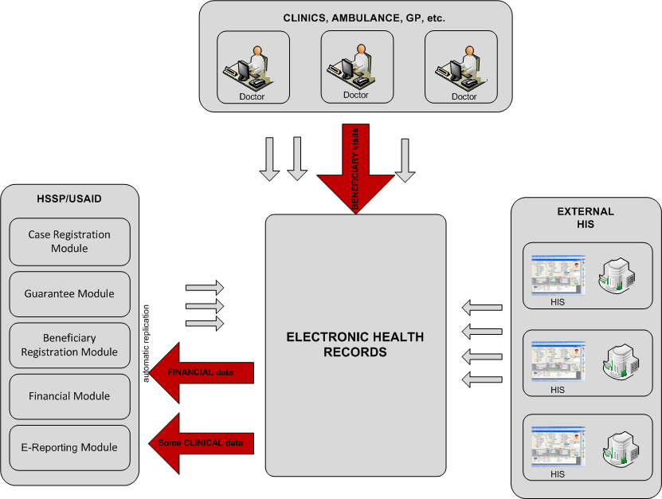
Figure 3. Registration of beneficiary visit by Class A clinic

The process scenario is described below in Table 3.

Table 3. EMR to HSSP e-Reporting replication (other Cases)
Step No. | Step description | User/Role | Actions | Expected result
 | Patient admit | Doctor | - Admit new patient to the OU | Patient admitted to OU
 | Problems section fulfil | Doctor | - Create new entry in Problems section of Patient Summary | New entry in Problems section created
 | Procedures section fulfil | Doctor | - Create new entry in Procedures section of Patient Summary | New entry in Procedures section created
 | Encounter section fulfil | Doctor | - Create new entry in Encounters section of Patient Summary | New entry in Encounters section created
 | Payers section fulfil | Doctor | - Create a new entry in Payers section of Patient Summary.  Use any value but not a “მოსახლეობის საყოველთაო ჯანმრთელობის დაცვის სახელმწიფო პროგრამა” as a value of Payment source attribute. | New entry in Payers section created
 | Case replication | Hospital Administrator | - Find fulfilled case and replicate it manually – press “Send” button.  - Wait for a confirmation of successful replication.  - Ensure that HSSP Case ID is successfully stored in corresponding CEMR Case attribute. | Case is successfully replicated to HSSP eReporting. HSSP Case ID successfully stored in corresponding CEMR Case attribute
 | Case replication check |  | - Login to HSSP eReporting module UI and find a case replicated on the previous step using HSSP case ID. Verify all case data. | Case is successfully found in HSSP eReporting module.

External HIS to EMR to HSSP replication

External HIS to EMR to HSSP Case Registration replication
The purpose of the process is provide Class A clinic with the ability to transfer the information about the case registered in HIS clinic into EHR (with followed replication the necessary information into HSSP).
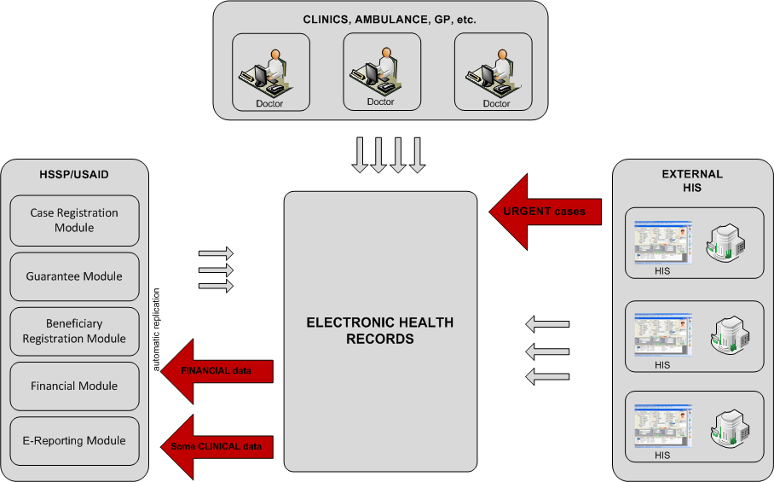
Figure 4. Urgent-case registration from external HIS

The process scenario is described below in Table 4.

Table 4. External HIS to EMR to HSSP Case Registration replication
Step No. | Step description | User/Role | Actions | Expected result
 | Import document from external HIS emulator |  | - Use external HIS emulator page –  http://92.51.96.100:81/wh_HL7/TestUsaidCdaHandler.aspx  to emulate document loading from external HIS.  - Import prepared cda2 document to cEMR.  Prepared CDA document must corresponds to approved In-patient or Out-patient CDA template (see HIS to cEMR clinical data replication manual).  Comment: External HIS can integrate with billing (HSSP Financing Module) and can call Web-service which returns the list of available Financial Unit by Patient ID, Diagnosis and Provider ID.  If particular HIS is connected to HSSP and gets Financial Units from it, according financial information can be stored in CDA document and transferred to cEMR (in this case cEMR transfers the vase to HSSP automatically). | New case is imported to the cEMR.
 | New case check | Doctor | - Open patient summary folder for particular patient whose case was imported on previous step (check patient id in xml file).  - Open patient summary sections (encounter, problems e.t.c) and check all case data. | All case data from previously imported xml is correctly parsed and available in patent summary sections.
 | Case Financial information fulfil | Doctor | - Add financial unit for previously imported case (modify encounter section entry)  Comment: If external HIS transfers CDA with Financial Units information, there is no need to fulfill this in cEMR UI manually. | Case financial information fulfilled
 | Case replication | Hospital Administrator | - Find fulfilled case and replicate it manually – press “Send” button.  - Wait for a confirmation of successful replication.  - Ensure that HSSP Case ID is successfully stored in corresponding CEMR Case attribute. | Urgent case is successfully replicated to HSSP. HSSP Case ID successfully stored in corresponding CEMR Case attribute
 | Case replication check |  | - Login to Case Registration module UI and find a case replicated on the previous step using HSSP case ID.  - Verify all case data. | Case is successfully found in Case Registration module.

External HIS to EMR to HSSP e-Reporting replication
The purpose of the process is to provide Class A clinic with the possibility to transfer the information about the case registered in HIS of clinic into EHR (with following replicated of demanded information into HSSP).
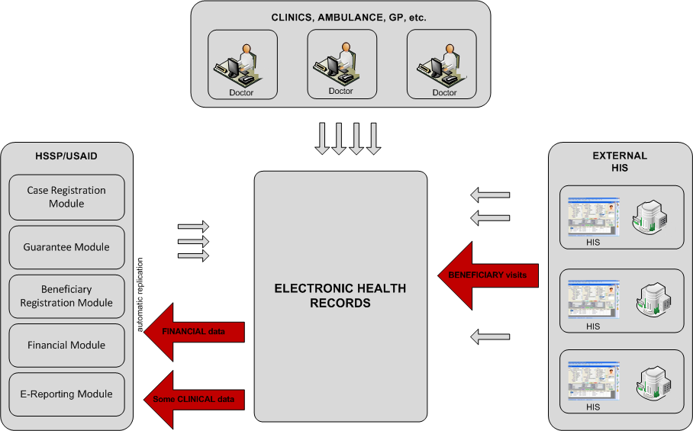
Figure 5. Registration of beneficiary visit from external HIS

The process scenario is described below in Table 5.

Table 5. External HIS to EMR to HSSP e-Reporting replication
Step No. | Step description | User/Role | Actions | Expected result
 | Import document from external HIS emulator |  | - Use external HIS emulator page –  http://92.51.96.100:81/wh_HL7/TestUsaidCdaHandler.aspx  to emulate document loading from external HIS. Import prepared cda2 document to cEMR. | New case is imported to the cEMR.
 | New case check | Doctor | - Open patient summary folder for particular patient whose case was imported on previous step (check patient id in xml file).  - Open patient summary sections (encounter, problems e.t.c) and check all case data. | All case data from previously imported xml is correctly parsed and available in patent summary sections.
 | Case Financial information fulfil | Doctor | - Add financial unit for previously imported case (modify encounter section entry) | Case financial information fulfilled
 | Case replication | Hospital Administrator | - Find fulfilled case and replicate it manually – press “Send” button.  - Wait for a confirmation of successful replication.  - Ensure that HSSP Case ID is successfully stored in corresponding CEMR Case attribute. | Urgent case is successfully replicated to HSSP. HSSP Case ID successfully stored in corresponding CEMR Case attribute
 | Case replication check |  | - Login to Case Registration module UI and find a case replicated on the previous step using HSSP case ID. Verify all case data. | Case is successfully found in Case Registration module.

HSSP to EMR Cases replication

HSSP Case Registration to EMR replication
Main purpose of the process is to provide Class B clinics the ability to perform the registration of the case in the old way, via HSSP / HSSP interface (with further replication of clinical information into EHR).

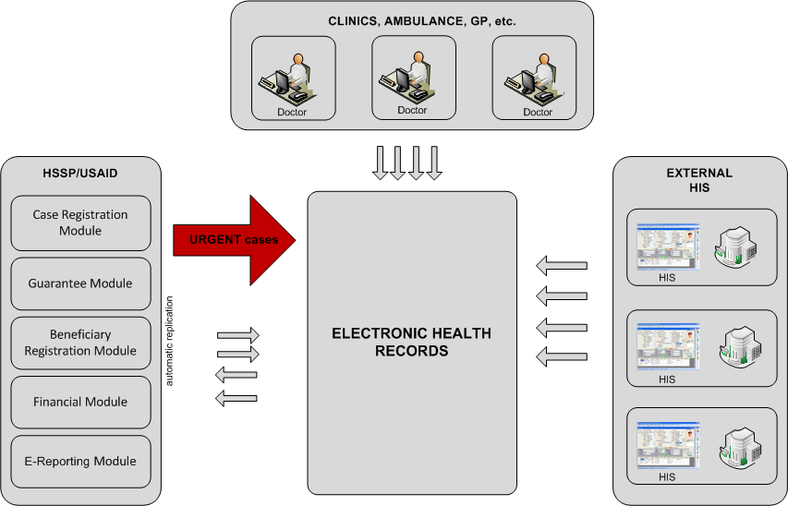
Figure 6. Urgent-case registration by Class B clinic

The process scenario is described below in Table 6.

Table 6. HSSP Case Registration to EMR replication
Step No. | Step description | User/Role | Actions | Expected result
 | cEMR Case import |  | - Open cEMR document loading page - http://92.51.96.100/wh_HL7/TestUsaidCdaHandler.aspx.  - Import previously prepared CDA2 document with case from HSSP Case Registration. | New case is imported to the cEMR.
 | Case clinical data check | Doctor | - Login to cEMR as a Doctor. Open patient summary for patient involved in replicated case.  - Check CaseID is fulfilled for new encounter section entry.  - Check that all case clinical data is successfully parsed into corresponding cEMR sections. | Case clinical data successfully parsed into corresponding cEMR sections. CaseID attribute has non empty value for new encounter section entry.

HSSP e-Reporting to EMR replication
Process purpose is to provide Class B clinic with the ability to register the case via HSSP interface (with following replication clinical information EHR).
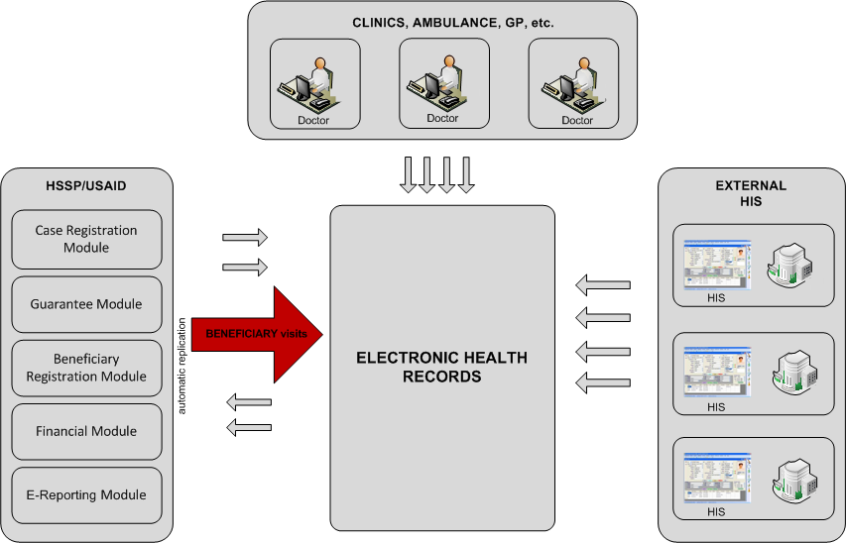
Figure 7. Registration of beneficiary visit by Class B clinic

The process scenario is described below in Table 7.

Table 7. HSSP e-Reporting to EMR replication
Step No. | Step description | User/Role | Actions | Expected result
 | Case selection for replication to cEHR | eReporting User | - Open eReporting HSSP module interface and choose particular case to replicate. | Particular case from eReporting is selected for the replication
 | Case replication to cEHR | eReporting user | - Initiate case replication from eReporting to cEHR | Case successfully replicated from eReporting to cEHR
 | cEHR case search | Doctor | - Open cEHR patient summary for particular patient involved into the case replicated on the previous step.  - Admit it if necessary. | cEHR patient found and admitted.
 | cEHR case check | Doctor | - Check all case clinical data from the case successfully parsed into corresponding cEHR patient summary section (Problems, Procedures, e.t.c) | All case clinical data is successfully parsed into corresponding cEHR patient summary sections.

HSSP Tuberculosis to EMR replication
Process purpose is to ensure the existence of information about the facts of services provision to the patients suffered from tuberculosis.
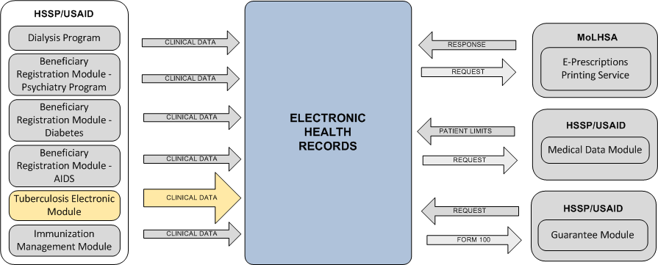
Figure 8. Data replication of treatment and prevention of tuberculosis

The process scenario is described below in Table 8.

Table 8. HSSP Tuberculosis to EMR replication
Step No. | Step description | User/Role | Actions | Expected result
 | cEMR Clinical data import |  | HSSP integration emulation approach:  - Open cEMR document loading page - http://92.51.96.100/wh_HL7/TestUsaidCdaHandler.aspx.  - Import previously prepared CDA2 document with case from HSSP Tuberculosis module.  HSSP JOB launching approach:  - Configure the replication JOB parameters to select only one (or several) Cases for replication  - Manually launch the JOB  - Open the log-file and make sure the Case(s) replication occurs successfully | New CDA2 document is imported to the cEMR.
 | cEHR patient admin | Doctor | - Login to cEMR as a Doctor. Open patient summary for particular patient.  - Admit it if necessary. | Patient admitted to cEHR. Patient already have clinical data in the patient summary.
 | cEHR clinical data check | Doctor | - Check all clinical data from CDA2 document is successfully parsed into corresponding cEHR patient summary sections (Problems, Lab results, e.t.c) | All clinical data from CDA2 document is successfully parsed into corresponding cEHR patient summary sections

HSSP Dialysis Program to EMR replication
Process purpose is to ensure the existence of information about the facts of patient services provision for peritoneal dialysis and hemodialysis in EHR.
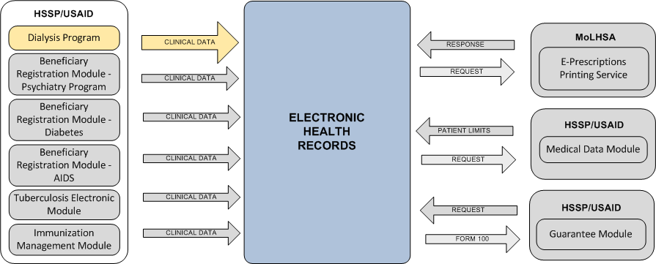
Figure 9. Data replication on peritoneal and hemodialysis

The process scenario is described below in Table 9.

Table 9. HSSP Dialysis Program to EMR replication
Step No. | Step description | User/Role | Actions | Expected result
 | cEMR dialysis clinical data import |  | HSSP integration emulation approach:  - Open cEMR document loading page - http://92.51.96.100/wh_HL7/TestUsaidCdaHandler.aspx (http://172.17.217.50/wh_HL7/TestUsaidCdaHandler.aspx).  - Import previously prepared CDA2 document with case from HSSP Dialysis module.  HSSP JOB launching approach:  - Configure the replication JOB parameters to select only one (or several) Cases for replication  - Manually launch the JOB  - Open the log-file and make sure the Case(s) replication occurs successfully | New dialysis procedure is imported to the cEMR for particular patient.
 | EMR Procedures records check | Doctor | - Login to EMR as a Doctor  - Open a patient summary for patient who involved in dialysis procedures on a previous steps.  - Open EMR Procedures section and check new records replicated from HSSP Dialysis module. | Corresponding dialysis procedures are correctly displayed as a content of EMR Procedures section.

HSSP Psychiatry Program to EMR replication
Process purpose is to ensure the existence of information about the facts of patient services provision in the direction of Psychiatry in EHR.
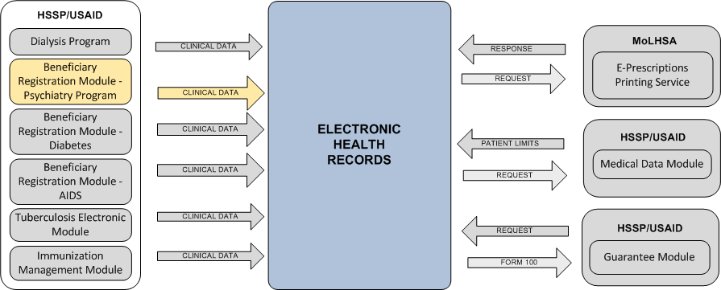
Figure 10. Data replication of Psychiatry

The process scenario is described below in Table 10.

Table 10. HSSP Psychiatry Program to EMR replication
Step No. | Step description | User/Role | Actions | Expected result
 | Psychiatry diagnosis registration |  | HSSP integration emulation approach:  - Open cEMR document loading page - http://92.51.96.100/wh_HL7/TestUsaidCdaHandler.aspx.  - Import previously prepared CDA2 document with case from HSSP Psychiatry module.  HSSP JOB launching approach:  - Configure the replication JOB parameters to select only one (or several) Cases for replication  - Manually launch the JOB  - Open the log-file and make sure the Case(s) replication occurs successfully | New psychiatry diagnosis record is successfully created for particular patient.
 | EMR Problems records check | Doctor | - Login to EMR as a Doctor. Open a patient summary for patient who got a new diagnosis on a previous steps.  - Open EMR Problems section and check new record replicated from HSSP Psychiatry module. | Corresponding diagnosis is correctly displayed as a content of EMR Problems section.

HSSP Immunization Management to EMR replication
Process purpose is to ensure the existence of information about vaccinations received by patients.
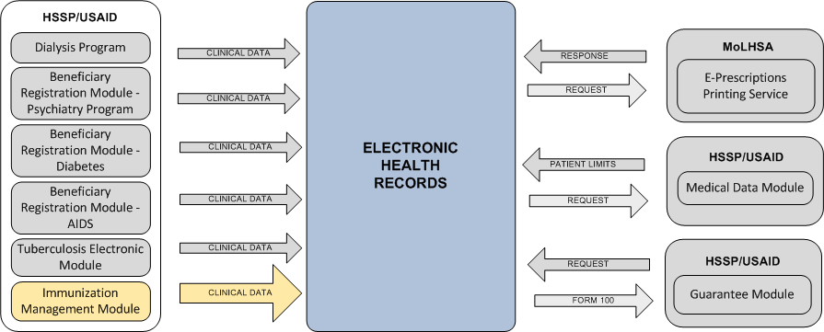
Figure 11. Data replication about immunization

The process scenario is described below in Table 11.

Table 11. HSSP Immunization Management to EMR replication
Step No. | Step description | User/Role | Actions | Expected result
 | Immunization record registration |  | HSSP integration emulation approach:  - Open cEMR document loading page - http://92.51.96.100/wh_HL7/TestUsaidCdaHandler.aspx.  - Import previously prepared CDA2 document with case from HSSP Immunization module.  HSSP JOB launching approach:  - Configure the replication JOB parameters to select only one (or several) Cases for replication  - Manually launch the JOB  - Open the log-file and make sure the Case(s) replication occurs successfully | New immunization record is successfully created for particular patient.
 | EMR Problems records check | Doctor | - Login to EMR as a Doctor.  - Open a patient summary for patient who got a new immunization record on a previous steps.  - Open EMR Immunization section and check new record replicated from HSSP Immunization module. | Corresponding immunization records are correctly displayed as a content of EMR Immunization section.

HSSP Diabetes to EMR replication
Process purpose is to ensure the existence of information about patients suffered from diabetics.

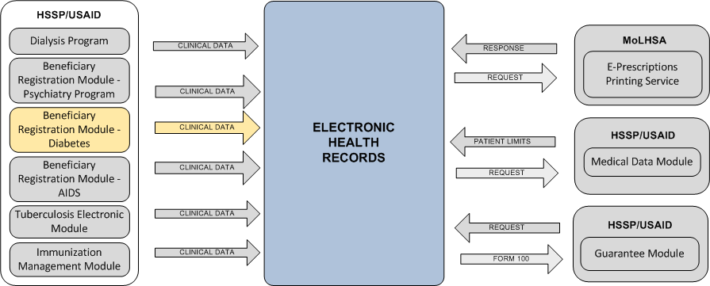
Figure 12. Data replication of diabetics

The process scenario is described below in Table 12.

Table 12. HSSP Diabetes to EMR replication
Step No. | Step description | User/Role | Actions | Expected result
 | Diabetes diagnosis registration |  | HSSP integration emulation approach:  - Open cEMR document loading page - http://92.51.96.100/wh_HL7/TestUsaidCdaHandler.aspx.  - Import previously prepared CDA2 document with case from HSSP Diabetes module.  HSSP JOB launching approach:  - Configure the replication JOB parameters to select only one (or several) Cases for replication  - Manually launch the JOB  - Open the log-file and make sure the Case(s) replication occurs successfully | New diabetes diagnosis record is successfully created for particular patient.
 | EMR Problems records check | Doctor | - Login to EMR as a Doctor.  - Open a patient summary for patient who got a new diagnosis on a previous steps.  - Open EMR Problems section and check new record replicated from HSSP Diabetes module. | Corresponding diagnosis is correctly displayed as a content of EMR Problems section.

HSSP AIDS to EMR replication
Process purpose is to ensure the existence of information about AIDS – infected patients.

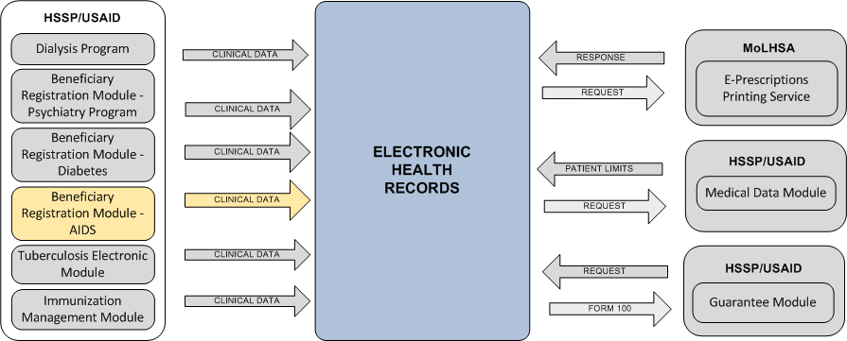
Figure 13. Data replication of AIDS

The process scenario is described below in Table 13.

Table 13. HSSP AIDS to EMR replication
Step No. | Step description | User/Role | Actions | Expected result
 | AIDS diagnosis registration |  | HSSP integration emulation approach:  - Open cEMR document loading page - http://92.51.96.100/wh_HL7/TestUsaidCdaHandler.aspx.  - Import previously prepared CDA2 document with case from HSSP AIDS module.  HSSP JOB launching approach:  - Configure the replication JOB parameters to select only one (or several) Cases for replication  - Manually launch the JOB  - Open the log-file and make sure the Case(s) replication occurs successfully | New AIDS diagnosis record is successfully created for particular patient.
 | EMR Problems records check | Doctor | - Login to EMR as a Doctor.  - Open a patient summary for patient who got a new diagnosis on a previous steps.  - Open EMR Problems section and check new record replicated from HSSP AIDS module. | Corresponding diagnosis is correctly displayed as a content of EMR Problems section.

e-Prescription functionality

e-Prescription electronic Form creation
The main purpose of the process is to allow Class A clinics to print a medical prescriptions (specified in the relevant patient / case section in EHR) on forms approved by the Ministry.
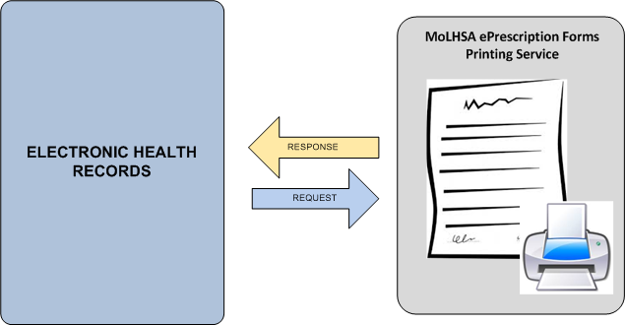
Figure 14. Medical appointments (prescriptions) print via Forms printing service

The process scenario is described below in Table 14.

Table 14. e-Prescription electronic Form creation
Step No. | Step description | User/Role | Actions | Expected result
 | Patient admit | Doctor | - Login to EMR as a doctor. Admit new patient. | New patient is successfully admitted.
 | ePrescription creation | Doctor | - Open patient summary for admitted patient.  - Open “Medications / ePrescriptions” section and create a new entry. | ePrescription entity is successfully created for particular patient.
 | ePrescription number check | Doctor | - Open ePrescription entry created on previous step. Ensure that ePrescription number attribute is initialized (has a non-empty value) | ePrescription number attribute has a non-empty value
 | ePrescription print form check | Doctor | - Open ePrescription entry created on previous step. Click “Create PDF” button. | File contains PDF print form of prescription should be downloaded. PDF file structure must exactly match current Georgian prescription form.
 | Check ePrescription publication to HIP | Doctor | - Open “Patient timeline” tab for particular patient.  - The last document in timeline must be a PDF representation of ePrescription created on a previous steps.

e-Prescription PDF search by Prescription No. and/or Patient Id
Table 15. e-Prescription PDF search by Prescription No. and/or Patient Id
Step No. | Step description | User/Role | Actions | Expected result
 | EMR Pharmacist logon | Pharmacist | - Login to EMR as a Pharmacist user.  pharmacist / pharmacist | Pharmacist user UI is available for searching of prescriptions.
 | ePrescription search (positive scenario) | Pharmacist | - Input to the corresponding UI controls as a values attributes of prescription (ePrescription No. and Patient ID) generated in a previous test and click “Submit”. | Result table appears and displays all prescription data.
 | ePrescription PDF view | Pharmacist | - Click “Download PDF” link under ePrescription search result table. | File contains PDF print form of prescription should be downloaded. PDF file structure must exactly match current Georgian prescription form.
 | ePrescription search (negative scenario) | Pharmacist | - Change any of two ePrescription search attribute controls values to non-correct and click “Submit” again. | Warning message “Prescription not found or your input is not correct. Please try again with correct data” will occurs.

Auxiliary functionality

EMR Case creation by given Guarantee No (for planned Cases)
Table 16. EMR Case creation by given Guarantee No (for planned Cases)
Step No. | Step description | User/Role | Actions | Expected result
 | Patient admit | Doctor | - Login to EMR as a doctor. Admit following patient:  Personal Number: 01036000771  First Name: თამთა  Last Name: ბაძგარაძე  Birth Date (dd.MM.yyyy): 02.01.1985 (02/01/1985)  First Name Eng: Tamta  Last Name Eng: Badzgaradze | New patient is successfully admitted.
 | Case creation | Doctor | - Open patient summary for admitted patient.  - Go to Encounters section and create new entry. | New Encounters section entry is created for particular patient.
 | Planned case data fetch from HSSP Guarantee management module | Doctor | - Open Encounters section entry created on a previous step.  - Fill the Guarantee No value – “18635” to the corresponding control and click “Load info” button. Save new entry. | Actual case data should be fetched from HSSP Guarantee management module and saved in EMR case.
 | Case data check | Doctor | - Check problems and procedures sections for new records, which also should be created during the previous step. | All particular guarantee data from HSSP Guarantee management module was successfully replicated.

EMR Form 100 usage from the HSSP Guarantee Module side
Table 17. EMR Form 100 usage from the HSSP Guarantee Module side
Step No. | Step description | User/Role | Actions | Expected result
 | cEHR Form 100 creation | Doctor | - Login to cEHR as a doctor.  - For particular patient with existing clinical data create a Form100 entry. | Form100 is successfully created in cEHR by doctor for particular patient.
 | Form100 request from HSSP Guarantee module | Guarantee module user | - Login to HSSP Guarantee module.  - Request Form100 for particular patient with particular search parameters set (Patient ID, creation time period, e.tc.) | Form100 is successfully obtained from cEHR by HSSP Guarantee module.
 | Form100 check |  | - Compare Form100 for particular patient from cEHR and from Guarantee module. | Form100 for particular patient from cEHR and from Guarantee module are identical.

EMC HIP clinical documents sharing

Patient Cases (CDA) access by using standard HL7 xDS protocol
Table 18. Patient Cases (CDA) access by using standard HL7 xDS protocol
Step No. | Step description | User/Role | Actions | Expected result
 | cEHR case search | Doctor | - Login to cEHR as a doctor.  - Find the patient with existing case (Encounters section record), which already replicated to HSSP | Found particular patient with case successfully replicated to HSSP.
 | XdsTools case search |  | - Open XdsTools tool (URL http://172.17.20.23:8080/xdstools2/)  - Find corresponding cda2 document (Find Document xdstools action) for particular patient by patient id in ISO format (<PatientID> ^^^&1.3.6.1.4.1.21367.2005.3.7&ISO). Example: EXT508641590^^^&1.3.6.1.4.1.21367.2005.3.7&ISO | CDA2 documents (doctype “Encounters” for encounters section and doctype USAID for whole case) represented a case for particular patient is successfully found in EMC HIP.
 | CDA2 documents check |  | - Open documents found in a previous step and compare documents content with cEHR sections data. | CDA2 documents contains all data from cEHR sections.

Patient PDF e-Prescription access by using standard HL7 xDS protocol
Table 19. Patient PDF e-Prescription access by using standard HL7 xDS protocol
Step No. | Step description | User/Role | Actions | Expected result
 | Patient search | Doctor | - Login to cEHR as a doctor.  - Find a patient involved into test scenario described in 7.4.1. | Patient with existing ePrescription record found in cEHR.
 | XdsTools prescription search |  | - Open XdsTools tool (URL http://172.17.20.23:8080/xdstools2/)  - Find corresponding cda2 document (Find Document xdstools action) for particular patient by patient id in ISO format (<PatientID> ^^^&1.3.6.1.4.1.21367.2005.3.7&ISO). Example: EXT508641590^^^&1.3.6.1.4.1.21367.2005.3.7&ISO | CDA2 document (doctype “Medications & ePrescriptions”) for particular patient is successfully found in EMC HIP.
 | CDA2 document check |  | - Open document found in a previous step and compare document content with cEHR “Medications & ePrescriptions” section data. | CDA2 document contains all data from cEHR sections.

Patient demographic data maintaining and using cEHR as a Master Patient Index (MPI)
Table 20. Patient documents submit to EMR
Step No. | Step description | User/Role | Actions | Expected result
 | Patient search | Doctor | - Login to cEHR as a doctor.  Any patient is suitable for the test scenario. | Particular cEHR patient is found.
 | Use cEHR HL7 gateway to obtain particular patient demographic data. |  | - Open cEHR HL7 Gateway test page (can be found on URL http://92.51.96.100/wh_HL7/TestWh7Listener.aspx).  - Select Message type “QBP_22”, format “Pipe”, HL7 version 2.5 and activate synchronous mode (Carica checkbox should be enabled).  - Send following message:  “MSH|^~\&| PDQ_Consumer^^|XXXX^^|WH_APPLICATION^^|WH_FACILITY^^|20150512113126||QBP^Q22^QBP_Q21|XXXX-20150512113126|P|2.5  QPD|PDQ Query|QRY1184848949494|@PID.5.1^<PatientSurname>~@PID.5.2^<PatientName>|  RCP|I”  (without quotes), where <PatientSurname> and <PatientName> should be replaced with family name and first name of patient found on step 1.
 | cEHR HL7 gateway response check |  | - Look into the response and compare returned patient demographic data with cEHR data (PatientID, birth date, Gender, e.t.c) | Demographical data from HL7 gateway and from cEHR are identical for particular patient.

cEMR Mobile applications

Process of access to EMR for patients
The process should allow to Georgian citizens to receive on-line information about the history of theirs visits to medical institutions.
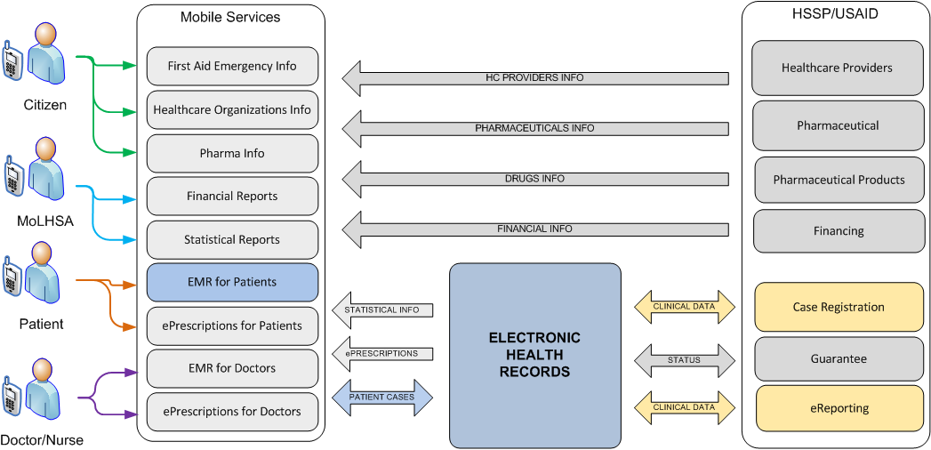
Figure 15. Data flows of process of access to EMR for patients

Table 21. Process of access to EMR for patients
Step No. | Step description | User/Role | Actions | Expected result
 | Login Mobile application | Patient | - Launch MoLHSA EMR mobile application  - Enter username and password  - Press “Login” button  - Ensure application opens patient profile screen (see next step) | 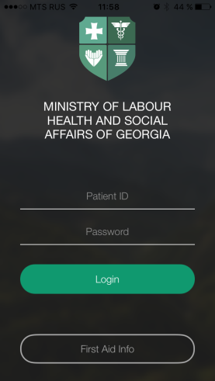
 | Open user profile | Patient | - After logging in user gets Patient profile screen  - Check the validity of user data | 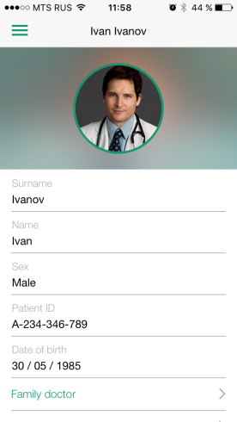
 | Open main menu | Patient | - Press menu button to the top-left of the screen  - Ensure application opens the menu with the following items:  My visists  My medications  My profile  First aid | 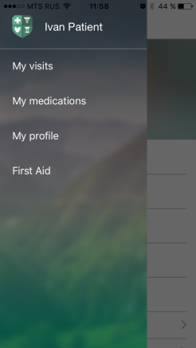
 | Open My Visits page | Patient | - Press My visits menu item  - Application opens the list of last visits  - Press filter button to the top-right of the screen  - Application opens the filter dialog  - Tyr to change default filter and ensure the list of visits changes upon filtering | 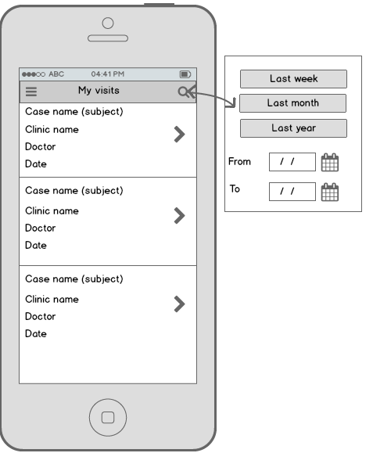
 | Open Case  (section Encounter) | Patient | - Open any case in the list  - Application opens the first section – Encounters with the attributes. Check the data.  - Ensure an existence of horizontal tabbar to the top of the screen | 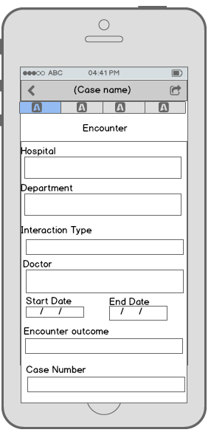
 | Open Case  (section Problems) | Patient | - Press the next tab on the tabbar to move to the next section  - Ensure application opens Problems section with an attributes  - Check the data in the section | 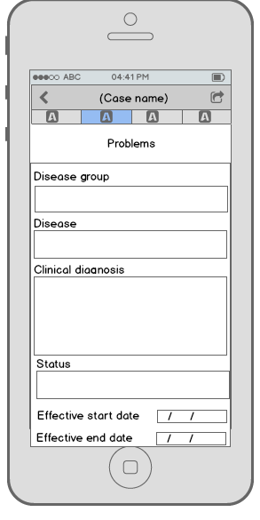
 | Open Case  (section Procedures) | Patient | - Press the next tab on the tabbar to move to the next section  - Ensure application opens Procedures section with an attributes  - Check the data in the section | 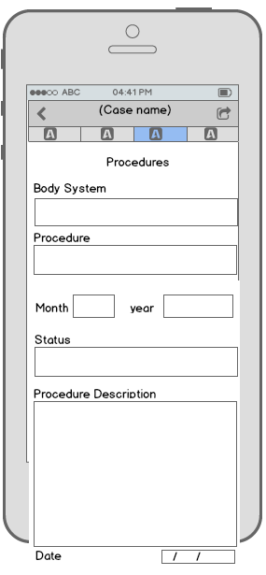
 | Open Case  (section Medications) | Patient | - Press the next tab on the tabbar to move to the next section  - Ensure application opens Medications section with an attributes  - Check the data in the section | 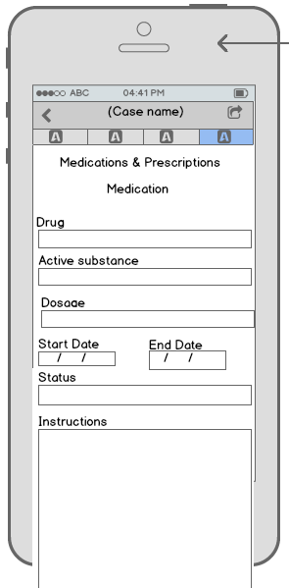
 | Open Case  (section e-Prescriptions) | Patient | - Press the next tab on the tabbar to move to the next section  - Ensure application opens e-Prescriptions section with an attributes  - Check the data in the section | 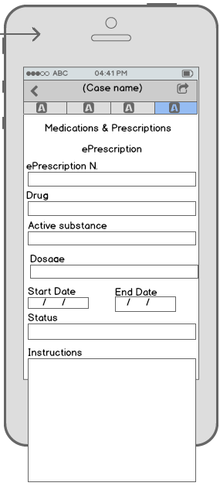
 | Send entire Case by e-mail | Patient | - Press share button to the top-left of the screen  - Press “email” button  - Ensure application allows to send the case description by email  - Check inbox and open the Case description  - Check the case data

Process of access to EMR for doctors
The process should allow doctors to receive on-line information about the history of patients’ visits to medical institutions. To gain the access to patients’ history doctors should first get an account in EHR. Except for view of existing records doctors have the ability to edit existing and create new records about the patients.
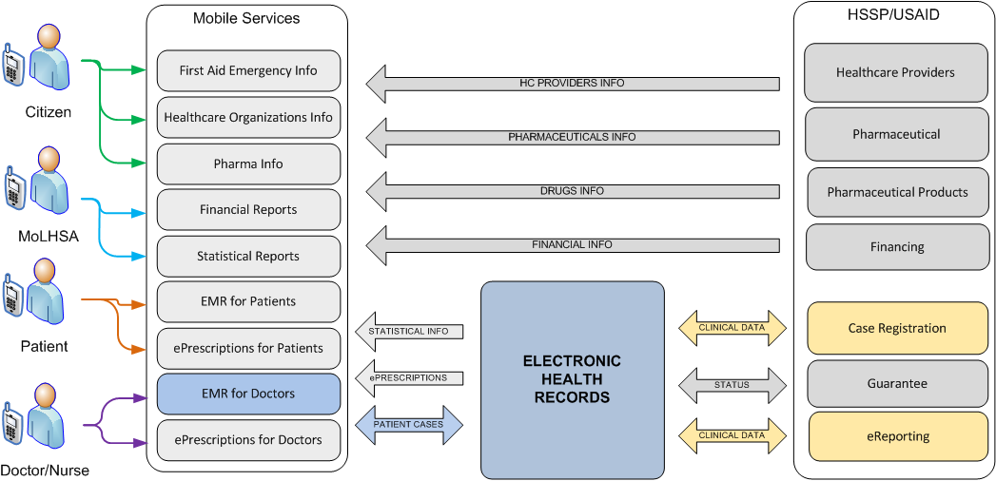
Figure 16. Data flows of process of access to EMR for doctors

The process scenario is described below in Table 22.

Table 22. Access patient clinical data from mobile application
Step No. | Step description | User/Role | Actions | Expected result
 | Opening patient summary for particular patient | Doctor | - Login to cEMR web interface as a doctor user;  - Find particular patient folder and open patient summary for particular patient | Patient summary for particular patient is opened.
 | Case creation | Doctor | - Create new Encounter section entry (create new case) | Case for particular patient is created
 | Clinical data fulfillment; Problems section | Doctor | - Within a case created on a previous step create new Problems section entry. | Problems section entry created for patient
 | Clinical data fulfillment; Plan of care section | Doctor | - Within a case created on a previous step create new Plan of care section entry. | Plan of care section entry created for patient
 | Clinical data fulfillment; ePrescription creation | Doctor | - Within a case created on a previous step create new ePrescription (Medications & ePrescriptions section entry) for patient | ePrescription created for patient
 | Export case to the HSSP | Clinic administrator | - Export case created on a previous steps to HSSP (via Clinic administrator UI) | Case exported to HSSP.
 | Patient login to the Mobile application | Patient | - Patient logs in to mobile application | Patient logged in mobile application
 | “My Visits” menu item testing | Patient | - Go to “My Visits” menu item in mobile application.  - Ensure that all information (dates, diagnosis, plans of care e.t.c) fulfilled on previous steps to the cEMR web interface is available (in read-only mode)

Functional Specifications and UAT sections reference
Table 23. FS and UAT sections reference
Functional Specification part | Functional Specification section No | Section description | UAT Section No
PART 1 | 4.2.1 | Registration process of urgent-case by Class A clinic | 7.1.1
PART 1 | 4.2.2 | Registration process of urgent-case by Class B clinic | 7.3.1
PART 1 | 4.2.3 | Urgent-case process registration from external HIS | 7.2.1
PART 1 | 4.3.1 | Registration process of planned-case by Class A clinic | 7.1.2  7.5.1
PART 1 | 4.3.2 | Registration process of planned-case by Class B clinic | 7.3.1
PART 1 | 4.3.3 | Planned-case process registration from external HIS | 7.2.1
PART 1 | 4.4.1 | Registration process of beneficiary visit by Class A clinic | 7.1.3
PART 1 | 4.4.2 | Registration process of beneficiary visit by Class B clinic | 7.3.2
PART 1 | 4.4.3 | Registration process of beneficiary visit from external HIS | 7.2.2
PART 2 | 3.2.1 | Data replication process Dialysis Program -> CEMR | 7.3.4
PART 2 | 3.2.2 | Data replication process from BRM Psychiatry Program to CEMR | 7.3.5
PART 2 | 3.2.3 | Data replication process from BRM Diabetes into CEMR | 7.3.7
PART 2 | 3.2.4 | Data replication process from BRM AIDS into CEMR | 7.3.8
PART 2 | 3.2.5 | Data replication process from Tuberculosis Electronic into HER | 7.3.3
PART 2 | 3.2.6 | Data replication process from Immunization Management into CEMR | 7.3.6
PART 2 | 3.2.7 | The process of generating, viewing and printing of recipes via CEMR interface | 7.4.1
-  Out of scope | -  Out of scope | e-Prescription PDF search by Prescription No. and/or Patient Id | 7.4.2
-  Out of scope | -  Out of scope | Patient Cases (CDA) access by using standard HL7 xDS protocol | 7.6.1
-  Out of scope | -  Out of scope | Patient PDF e-Prescription access by using standard HL7 xDS protocol | 7.6.2
-  Out of scope | -  Out of scope | Patient demographic data maintaining and using cEHR as a Master Patient Index (MPI) | 7.6.3
PART 2 | 3.3.1 | Patient limits information access | -
PART 2 | 3.3.2 | EMR Form 100 access from HSSP Guarantee Module | 7.5.2
PART 3 | 3.1.1 | Process of access to medical institutions directory | TBD
PART 3 | 3.1.2 | Process of access to a directory of medicines | TBD
PART 3 | 3.1.3 | Process of access to a directory of first aid | TBD
PART 3 | 3.2.1 | Process of access to EMR for patients | 7.7.1
PART 3 | 3.2.2 | Process of access to electronic prescriptions for patients | TBD
PART 3 | 3.3.1 | Process of access to EMR for doctors | 7.7.2
PART 3 | 3.3.2 | Process of access to electronic prescriptions for doctors | TBD
PART 3 | 3.4 | Processes of services of operational information | TBD

PART 1 - 02. TR-FS. MoLHSA EMR 2.1. Part 1. Case management PART 2 - 02. TR-FS. MoLHSA EMR 2.1. Part 2. Clinical data exchange

