





Georgia Health Care
Clinical Forms Specification

Document Control
01. Document reference
EMC_GeorgiaCentralEMR_ClinicalFormsDesign_Day1_WorkshopResults
EMC_GeorgiaCentralEMR_ClinicalFormsDesign_Day2_WorkshopResults
EMC_GeorgiaCentralEMR_ClinicalFormsDesign_Day3_WorkshopResults
EMC_GeorgiaCentralEMR_ClinicalFormsDesign_Day4_WorkshopResults
EMC_GeorgiaCentralEMR_ClinicalFormsDesign_GPWorkshop_WorkshopResults
EMC_GeorgiaCentralEMR_ClinicalFormsDesign_Payers_WorkshopResults
EMC_GeorgiaCentralEMR_Integration_Day1_WorkshopResults
EMC_GeorgiaCentralEMR_Integration_Day2_WorkshopResults
EMC_GeorgiaCentralEMR_Integration_Day3AM_WorkshopResults
EMC_GeorgiaCentralEMR_Integration_Day3AM_WorkshopResults
EMC_GeorgiaCentralEMR_Portals_Day1_WorkshopResults
EMC_GeorgiaCentralEMR_Portals_Day2_WorkshopResults
EMC_GeorgiaCentralEMR_Portals_Day3_WorkshopResults
EMC_GeorgiaCentralEMR_Portals_Day4_WorkshopResults
02. Document type
System Specification
03. Security classification
Classified
04. Synopsis
The purpose of this document is to provide the Clinical Forms Specification document compiled from the results of the Design Workshops with respective MoLHSA user representatives between the 24th June and 12th July, in relation to the Georgia Health Care Phase 1 project.

05. Document control
Author | Change controller | Distribution controller
Chris Hyams | Karen Cuschieri | Karen Cuschieri
Project Manager, 6pm | PMO Director, 6pm | PMO Director, 6pm
06. Authorisation
Issuing authority | Approval authority
Signature Date: | Signature Date:
Karen Cuschieri
PMO Director, 6pm
07. Modification history
Version | Date | Comments
0.1 | 6th August 2013 | Draft for review

Contents

1. Executive Summary 5
Family History Clinical Form 6
Social History Clinical Form 8
Functional Status Clinical Form 11
Immunisation Clinical Form 18
Allergies Clinical Form 20
Medication Clinical Form 22
Vital Signs Clinical Forms 24
Payers Clinical Form 26
Problems Clinical Form 28
Procedures Clinical Form 30
Plan of Care Clinical Form 32
Encounters Clinical Form 34
Visit Clinical Form 37
Form 100 Clinical Form 40

Executive Summary

Between the 26th of June and the 12th July a series of Design Workshops where undertaken with key MoLSHA representatives and the laserbiomed team to establish the configuration and content of the CEMR system based upon the requirements agreed in the Initial Requirements workshops undertaken between the 6th and 12th of June that will constitute the phase 1 release of the system.

A subsequent Clinical Forms review workshops was undertaken with key MoLHSA resources to review and agree the final content and layout of each form. The outcome of this workshop was that after the application of some minor amendments the forms where fit for purpose and would be the agreed final deliverable

This document contains all the agreed content, layout and configuration of the following clinical forms;

- Family History
- Social History
- New Functional Status
- Vital Signs
- Medication
- Allergies and Adverse Reactions
- Immunisation
- Payers
- Problems
- Procedures
- Plan of Care
- History of Encounters
- Form 100

The contents of this document form the specification upon which the ECMR system will be configured and installed by the Laserbiomed teams.

Any changes made to this specification after review and final sign off will be subject to the formal project Change Control process.

NB: The actual delivered system forms may deviate slightly from the form layouts shown in this document. However this will not affect the functionality of the system recorded in this specification document.

The following sections define the form functionality, illustrate the agreed form content and layout and a detailed specification of each field within the form.

Family History Clinical Form

HL7 Definition
This form contains data defining the patient’s genetic relatives in terms of possible or relevant health risk factors that have a potential impact on the patient’s healthcare risk profile.

Form Layout

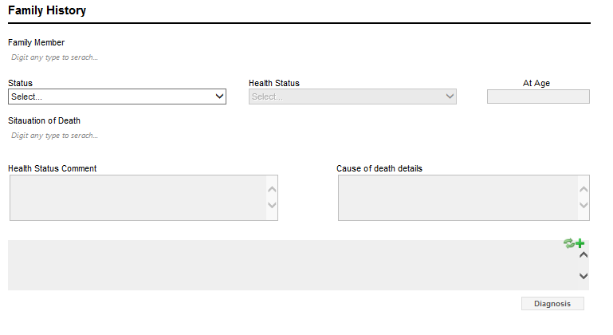

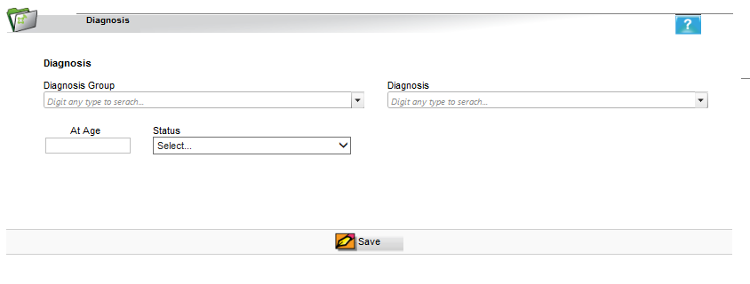

Field Specifications
Field Name | Type |  | Control |  | Visible |  | Allow Null Value |  | Dependency |  | List of Values |  | Default Value |  |  | Validation Rules
Main Form MAM
Family Member |  | Text |  | List Box |  | Y |  | N |  | None |  | HL7 Role Code FAMMEMB |  | None | None
Status |  | Text |  | List Box |  | Y |  | N |  | None |  | SNOMED Live Status |  | None | None
Health Status |  | Text |  | List Box |  | Y |  | N |  | Enabled if Alive option selected in Status |  | Problem Health Status Code CCD |  | None | None
At Age |  | Numeric |  | Text |  | Y |  | N |  | Enabled if Deceased Status is selected in Health Status |  | None |  | None | None
Situation of Death |  | Text |  | List Box |  | Y |  | N |  | Enabled if Deceased status is selected |  | ICD10 Chapter 20 |  | None | None
Health Status Comment |  | Text |  | Text |  | Y |  | Y |  | Enabled if Alive option selected in Status |  | None |  | None | None
Cause of Death Details |  | Text |  | Text |  | Y |  | Y |  | Enabled if Deceased option selected in Status |  | None |  | None | None
Diagnosis History |  | Text |  | Text |  | Y |  | N |  | None |  | None |  | None | None
Add Diagnosis Form
Diagnosis Group |  | Text |  | List Box |  | Y |  | N |  | None |  | ICD10 |  | None | None
Diagnosis |  | Text |  | List Box |  | Y |  | N |  | Filtered by the Diagnosis Group selected |  | ICD10 |  | None | None
At Age |  | Numeric |  | Text |  | Y |  | N |  | None |  | None |  | None | None
Status |  | Text |  | List Box |  | Y |  | N |  | None |  | Problem Status Code |  | None | None

Social History Clinical Form

HL7 Definition
This form contains data defining the patient’s occupational, personal (e.g. lifestyle), social, and environmental history and health risk factors, as well as administrative data such as marital status, race, ethnicity and religious affiliation. Social history can have significant influence on a patient’s physical, psychological and emotional health and wellbeing so should be considered in the development of a complete record.

Form Layout

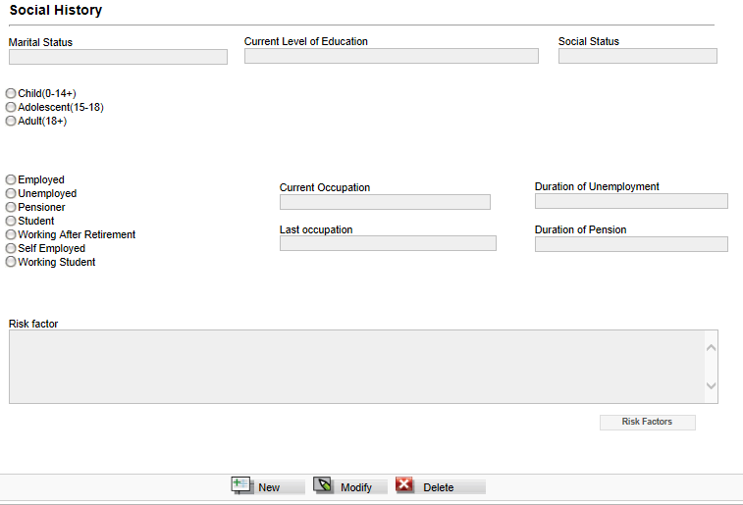

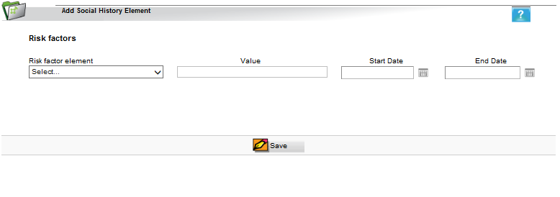

Field Specifications
Field Name | Type | Control | Visible | Allow Null Value | Dependency | List of Values | Default Value |  | Validation Rules
Main Form
Marital Status | Text | List Box | Y | N | None | NCDC | None | None
Current Level of Education | Text | List Box | Y | N | None | NCDC | None | None
Social Status | Text | List Box | Y | N | None | - Poor  - Middle Class  - Upper Class | None | None
Age Range | Yes/No | Radio Button | Y | N | None | - Child (14+)  - Adolescent (15-18)  - Adult (18+) | None | Nones
Employed Status | Yes/No | Radio Button | Y | N | None | - Employed  - Unemployed  - Pensioner  - Student  - Working After Retirement  - Self Employed  - Working Student | None | None
Current Occupation | Text | List Box | Y | N | Enabled if Employed, Working After Retirement or Working Student buttons selected | State Statistical Dept | None | None
Duration of Unemployment | Text | List Box | Y | N | Enabled if Unemployed button selected | - 1 Year  - 2 Years  - >3 Years  - >7 Years | None | None
Last Occupation | Text | List Box | Y | N | Enabled if Pensioner buttons selected | State Statistical Dept | None | None
Duration of Pension | Button | Button | Y | N | Enabled if Pensioner buttons selected | - 1 Year  - 2 Years  - >3 Years  >7 Years | None | None
Risk Factor History | Text | Text | Y | N | None | - None | None | None
Add Risk Factor Form
Risk Factor Element | Text | List Box | Y | N | None | - Smoking  - Exercise  - Diet  - Toxic Exposure  - Alcohol Intake  - Drug Use | None | None
Value | Text | Text | Y | N | None | None | None | None
Start Date | Date | Date | Y | Y | None | None | None | None
End Date | Date | Date | Y | Y | None | None | None | None

Functional Status Clinical Form

HL7 Definition

Functional Status describes the patient’s status of normal functioning at the time the Care Record was created. Functional statuses include information regarding the patient relative to:
- Ambulatory ability
- Mental status or competency
- Activities of Daily Living (ADLs), including bathing, dressing, feeding, grooming
- Home / living situation having an effect on the health status of the patient
- Ability to care for self
- Social activity, including issues with social cognition, participation with friends and acquaintances other than family members
- Occupation activity, including activities partly or directly related to working, housework or volunteering, family and home responsibilities or activities related to home and family
- Communication ability, including issues with speech, writing or cognition required for communication
- Perception, including sight, hearing, taste, skin sensation, kinaesthetic sense, proprioception, or balance

Any deviation from normal function that the patient displays and is recorded in the record should be included. Of particular interest are those limitations that would in any way interfere with self-care or the medical therapeutic process. In addition, an improvement, any change in or noting that the patient has normal functioning status is also valid for inclusion.

Form Layout
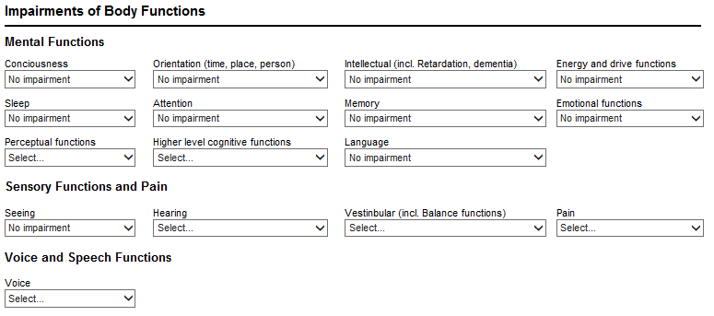
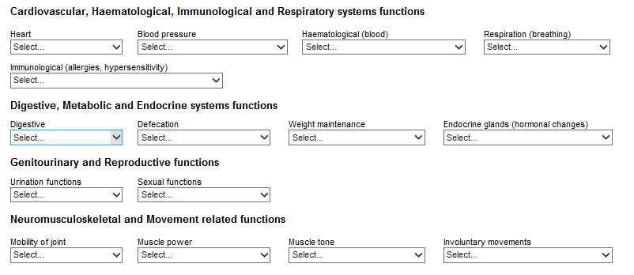
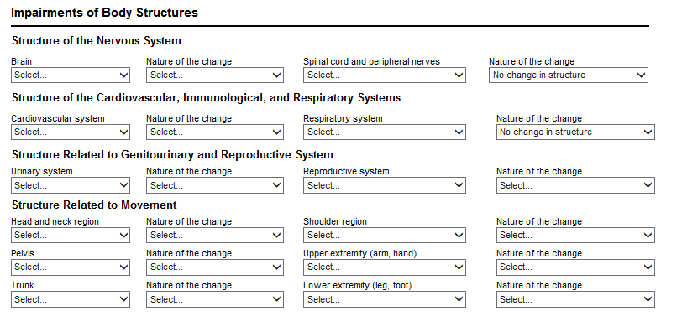
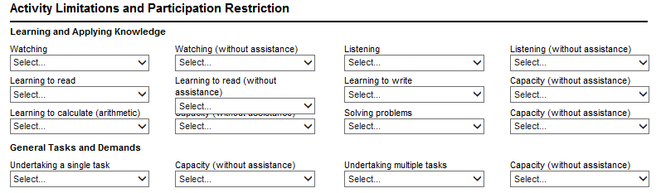
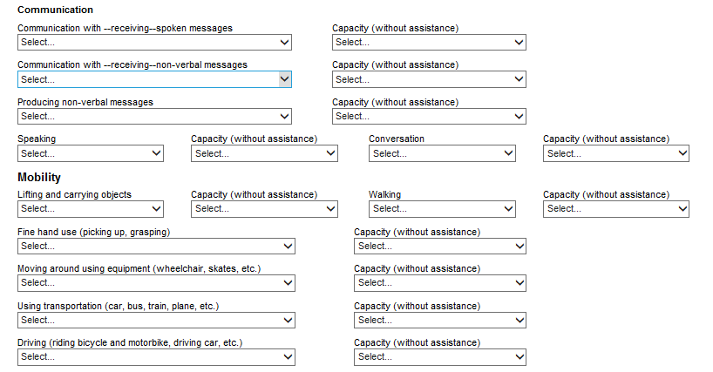
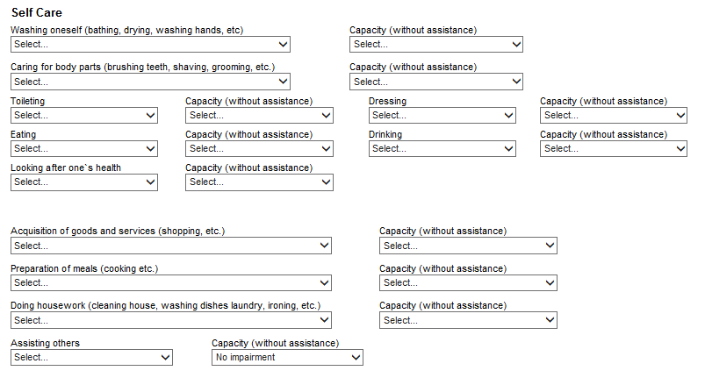

Field Specifications
Field Name | Type | Control | Visible | Allow Null Value | Dependency | List of Values | Default Value | Validation Rules
Impairments of Body Functions
Mental Functions
Conciousness | Text | List Box | Y | Y | None | None | No Impairment | None
Orientation (time, place, person) | Text | List Box | Y | Y | None | None | No Impairment | None
Intellectual (incl. Retardation, dementia) | Text | List Box | Y | Y | None | None | No Impairment | None
Energy and drive functions | Text | List Box | Y | Y | None | None | No Impairment | None
Sleep | Text | List Box | Y | Y | None | None | No Impairment | None
Attention | Text | List Box | Y | Y | None | None | No Impairment | None
Memory | Text | List Box | Y | Y | None | None | No Impairment | None
Emotional functions | Text | List Box | Y | Y | None | None | No Impairment | None
Perceptual functions | Text | List Box | Y | Y | None | None | No Impairment | None
Higher level cognitive functions | Text | List Box | Y | Y | None | None | No Impairment | None
Language | Text | List Box | Y | Y | None | None | No Impairment | None
Sensory Functions and Pain
Seeing | Text | List Box | Y | Y | None | None | No Impairment | None
Hearing | Text | List Box | Y | Y | None | None | No Impairment | None
Vestinbular (incl. Balance functions) | Text | List Box | Y | Y | None | None | No Impairment | None
Pain | Text | List Box | Y | Y | None | None | No Impairment | None
Voice and Speech Functions
Voice | Text | List Box | Y | Y | None | None | No Impairment | None
Cardiovascular, Haematological, Immunological and Respiratory systems functions
Heart | Text | List Box | Y | Y | None | None | No Impairment | None
Blood pressure
Haematological (blood) | Text | List Box | Y | Y | None | None | No Impairment | None
Respiration (breathing) | Text | List Box | Y | Y | None | None | No Impairment | None
Immunological (allergies, hypersensitivity) | Text | List Box | Y | Y | None | None | No Impairment | None
Digestive, Metabolic and Endocrine systems functions
Digestive | Text | List Box | Y | Y | None | None | No Impairment | None
Defecation | Text | List Box | Y | Y | None | None | No Impairment | None
Weight maintenance | Text | List Box | Y | Y | None | None | No Impairment | None
Endocrine glands (hormonal changes) | Text | List Box | Y | Y | None | None | No Impairment | None
Genitourinary and Reproductive functions
Urination functions | Text | List Box | Y | Y | None | None | No Impairment | None
Sexual functions | Text | List Box | Y | Y | None | None | No Impairment | None
Neuromusculoskeletal and Movement related functions
Mobility of joint | Text | List Box | Y | Y | None | None | No Impairment | None
Muscle power | Text | List Box | Y | Y | None | None | No Impairment | None
Muscle tone | Text | List Box | Y | Y | None | None | No Impairment | None
Involuntary movements | Text | List Box | Y | Y | None | None | No Impairment | None
Impairments of Body Structures
Structure of the Nervous System | Text | List Box | Y | Y | None | None | No Impairment | None
Brain | Text | List Box | Y | Y | None | None | No Impairment | None
Nature of the change | Text | List Box | Y | Y | None | None | No Change in Structure | None
Spinal cord and peripheral nerves | Text | List Box | Y | Y | None | None | No Impairment | None
Structure of the Cardiovascular, Immunological, and Respiratory Systems
Cardiovascular system | Text | List Box | Y | Y | None | None | No Impairment | None
Respiratory system | Text | List Box | Y | Y | None | None | No Impairment | None
Structure Related to Genitourinary and Reproductive System
Urinary system | Text | List Box | Y | Y | None | None | No Impairment | None
Reproductive system | Text | List Box | Y | Y | None | None | No Impairment | None
Structure Related to Movement
Head and neck region | Text | List Box | Y | Y | None | None | No Impairment | None
Shoulder region | Text | List Box | Y | Y | None | None | No Impairment | None
Pelvis | Text | List Box | Y | Y | None | None | No Impairment | None
Upper extremity (arm, hand) | Text | List Box | Y | Y | None | None | No Impairment | None
Trunk | Text | List Box | Y | Y | None | None | No Impairment | None
Lower extremity (leg, foot) | Text | List Box | Y | Y | None | None | No Impairment | None
Activity Limitations and Participation Restriction | Text | List Box | Y | Y | None | None | No Impairment | None
Learning and Applying Knowledge
Watching | Text | List Box | Y | Y | None | None | No Impairment | None
Watching (without assistance) | Text | List Box | Y | Y | None | None | No Impairment | None
Listening | Text | List Box | Y | Y | None | None | No Impairment | None
Learning to read | Text | List Box | Y | Y | None | None | No Impairment | None
Learning to write | Text | List Box | Y | Y | None | None | No Impairment | None
Learning to calculate (arithmetic) | Text | List Box | Y | Y | None | None | No Impairment | None
Solving problems | Text | List Box | Y | Y | None | None | No Impairment | None
General Tasks and Demands
Undertaking a single task | Text | List Box | Y | Y | None | None | No Impairment | None
Undertaking multiple tasks | Text | List Box | Y | Y | None | None | No Impairment | None
Communication
Communication with --receiving--spoken messages | Text | List Box | Y | Y | None | None | No Impairment | None
Communication with --receiving--non-verbal messages | Text | List Box | Y | Y | None | None | No Impairment | None
Producing non-verbal messages | Text | List Box | Y | Y | None | None | No Impairment | None
Speaking | Text | List Box | Y | Y | None | None | No Impairment | None
Conversation | Text | List Box | Y | Y | None | None | No Impairment | None
Mobility
Lifting and carrying objects | Text | List Box | Y | Y | None | None | No Impairment | None
Walking | Text | List Box | Y | Y | None | None | No Impairment | None
Fine hand use (picking up, grasping) | Text | List Box | Y | Y | None | None | No Impairment | None
Moving around using equipment (wheelchair, skates, etc.) | Text | List Box | Y | Y | None | None | No Impairment | None
Using transportation (car, bus, train, plane, etc.) | Text | List Box | Y | Y | None | None | No Impairment | None
Driving (riding bicycle and motorbike, driving car, etc.) | Text | List Box | Y | Y | None | None | No Impairment | None
Self Care
Washing oneself (bathing, drying, washing hands, etc) | Text | List Box | Y | Y | None | None | No Impairment | None
Caring for body parts (brushing teeth, shaving, grooming, etc.) | Text | List Box | Y | Y | None | None | No Impairment | None
Toileting | Text | List Box | Y | Y | None | None | No Impairment | None
Dressing | Text | List Box | Y | Y | None | None | No Impairment | None
Eating | Text | List Box | Y | Y | None | None | No Impairment | None
Drinking | Text | List Box | Y | Y | None | None | No Impairment | None
Looking after one`s health | Text | List Box | Y | Y | None | None | No Impairment | None
Domestic Life
Acquisition of goods and services (shopping, etc.) | Text | List Box | Y | Y | None | None | No Impairment | None
Preparation of meals (cooking etc.) | Text | List Box | Y | Y | None | None | No Impairment | None
Doing housework (cleaning house, washing dishes laundry, ironing, etc.) | Text | List Box | Y | Y | None | None | No Impairment | None
Assisting others | Text | List Box | Y | Y | None | None | No Impairment | None

Immunisation Clinical Form

HL7 Definition
The Immunizations form defines a patient’s current immunization status and pertinent immunization history. The primary use case for the Immunization section is to enable communication of a patient’s immunization status. The section should include current immunization status, and may contain the entire immunization history that is relevant to the period of time being summarized

Form Layout

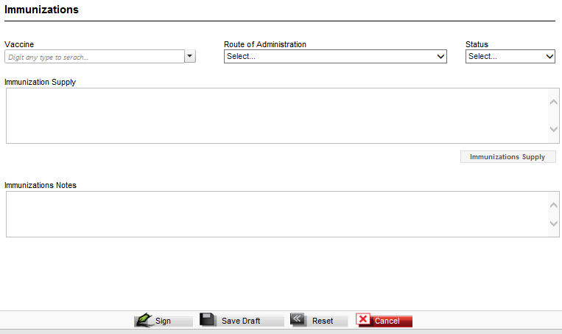

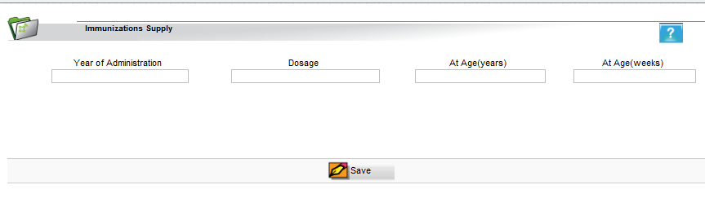

Field Specifications

Field Name | Type | Control | Visible | Allow Null Value | Dependency | List of Values | Default Value | Validation Rules
Main Form
Vaccine | Text | List Box | Y | N | None | RxNorm | None | None
Route of Administration | Text | Text | Y | Y | None | State Statistical Dept | None | None
Status | Text | List Box | Y | N | None | Problem Status Code | None | None
History of Immunisation Supply | Text | Label | Y | None | Populated automatically if previous records for the same vaccine for the patient were captured | None | None | None
Immunisation Notes | Text | Text | Y | Y | None | None | None | None
At Age | Numeric | Numeric | Y | N | None | None | None | None
Dosage | Text | Text | Y | N | None | None | None | None
Comment | Text | Text | Y | Y | None | None | None | None
Add Immunisation Supply Form
Year of Administration | Numeric | Text | Y | N | None | None | None | None
Dosage | Text | Text | Y | N | None | None | None | None
At Age (Years) | Text | Text | Y | N | None | None | None | None
At Age (Weeks) | Text | Text | Y | Y | None | None | None | None

Allergies Clinical Form

HL7 Definition

This form is used to list and describe any allergies, adverse reactions, and alerts that are pertinent to the patient’s current or past medical history. At a minimum, currently active and any relevant historical allergies and adverse reactions should be listed

Form Layout

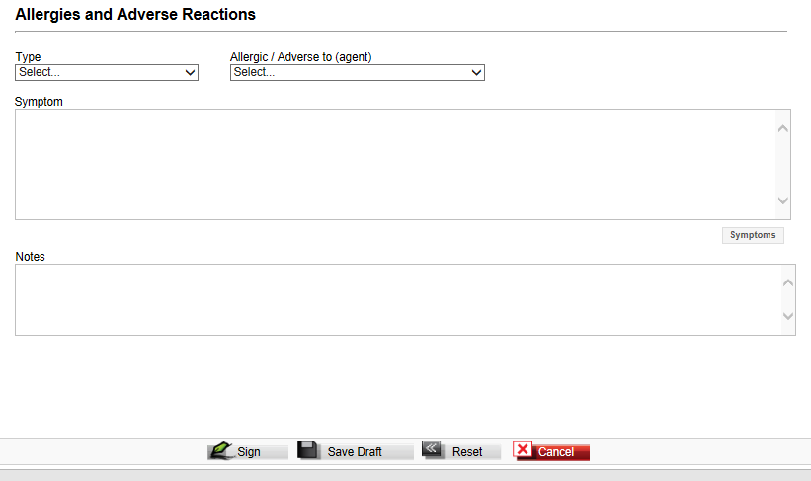

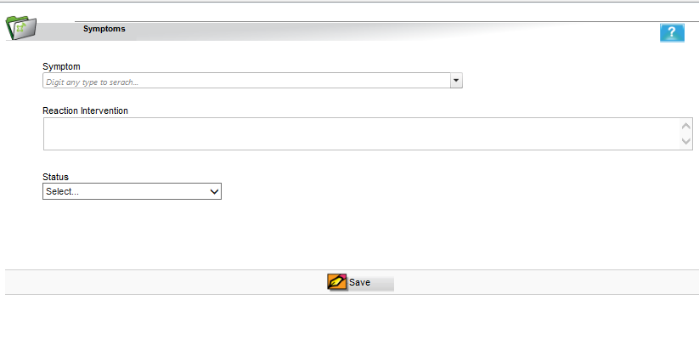

Field Specifications

Field Name | Type | Control | Visible | Allow Null Value | Dependency | List of Values | Default Value | Validation Rules
Type | Text | List Box | Y | N | None | SNOMED | None | None
Allergic / Adverse to (Agent) | Text | List Box | Y | N | None | State Statistical Dept | None | None
History of Symptoms | Text | List Box | Y | N | Populated automatically if previous records for Symptoms exist for the patient | None | None | None
Notes | Text | Text Box | Y | Y | None | None | None | None
Add Symptom Sub Form
Symptom | Text | List Box | Y | N | None | ICD10 Chapter 18 | None | None
Reaction Intervention | Text | Text | Y | Y | None | None | None | None
Status | Text | List Box | Y | N | None | Problem Status Code | None | None

Medication Clinical Form

HL7 Definition

This form defines a patient’s current medications and pertinent medication history. At a minimum, the currently active medications should be listed, with an entire medication history as an option, particularly when the summary document is used for comprehensive data export. The section may also include a patient’s prescription history, and enables the determination of the source of a medication list (e.g. from a pharmacy system vs. from the patient).

Form Layout

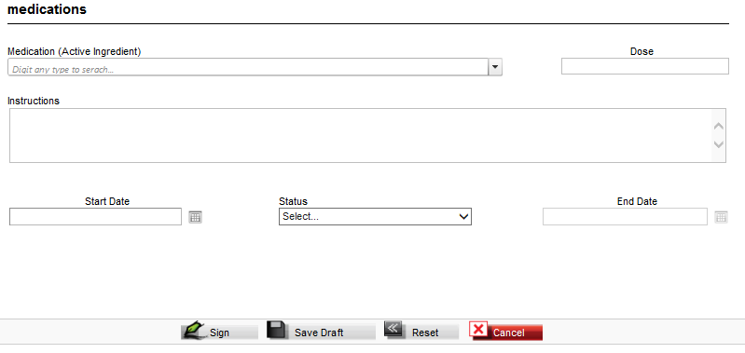

Field Specifications

Field Name | Type | Control | Visible | Allow Null Value | Dependency | List of Values | Default Value | Validation Rules
Medication (Active Ingredient) | Text | List Box | Y | N | None | MoLHSA regulation Dept | None | None
Dose | Text | Text | Y | N | None | None | None | None
Instructions | Text | Text Box | Y | Y | None | None | None | None
Start Date | Date | Calendar | Y | N | None | None | None | None
Status | Text | List Box | Y | N | None | Problem Status Code | None | None
End Date | Date | Calendar | Y | Y | Enabled when Active status is selected | None | None | None

Vital Signs Clinical Forms

HL7 Definition
This form contains current and historically relevant vital signs, such as blood pressure, heart rate, respiratory rate, height, weight, body mass index, head circumference, crown-to-rump length, and pulse oximetry. The section may contain all vital signs for the period of time being summarized, but at a minimum should include notable vital signs such as the most recent, maximum and/or minimum, or both, baseline, or relevant trends.

Form Layout

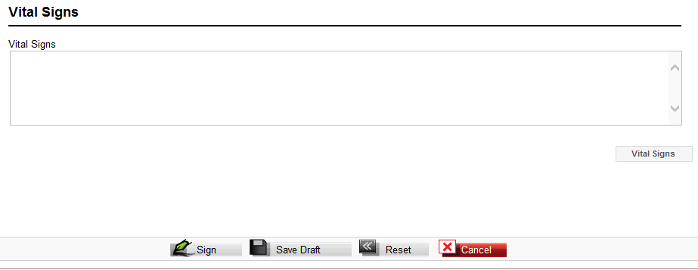

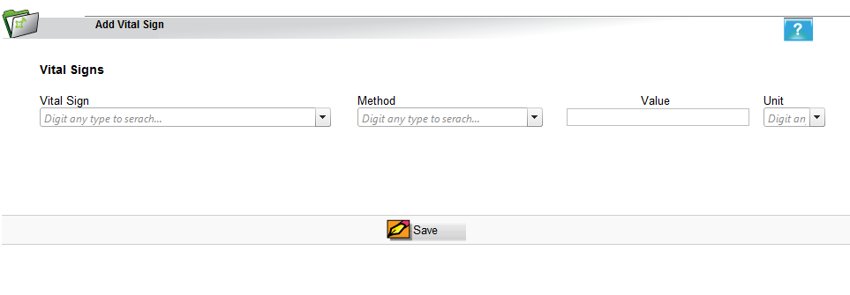

Field Specifications
Field Name | Type | Control | Visible | Allow Null Value | Dependency | List of Values | Default Value | Validation Rules
Main Form
History of Vital Signs | Text | Text | Y | N | Populated automatically if previous records for Vital Signs exist for the patient | None | None | None
Add Vital Sign Sub Form
Vital Sign | Text | List Box | Y | N | None | LOINC | None | None
Method | Text | List Box | Y | N | None | LOINC | None | None
Value | Text | Text | Y | N | None | None | None | None
Unit | Text | List Box | Y | N | None | LOINC | None | None

Payers Clinical Form
HL7 Definition
Payers contains data on the patient’s payers, whether a ‘third party’ insurance, self-pay, other payer or guarantor, or some combination of payers, and is used to define which entity is the responsible fiduciary for the financial aspects of a patient’s care.
Each unique instance of a payer and all the pertinent data needed to contact, bill to, and collect from that payer should be included. Authorization information that can be used to define pertinent referral, authorization tracking number, procedure, therapy, intervention, device, or similar authorizations for the patient or provider, or both should be included. At a minimum, the patient’s pertinent current payment sources should be listed.
The CCD represents the sources of payment as a coverage act, which identifies all of the insurance policies or government or other programs that cover some or all of the patient's healthcare expenses. The policies or programs are sequenced by order of preference. Each policy or program identifies the covered party with respect to the payer, so that the identifiers can be recorded.

NB During Clinical review Workshop the functionality of this form was deemed to be inappropriate for the Payers function and a decision was made to not amend this form until further analyse of the Payer form requirements.

Form Layout

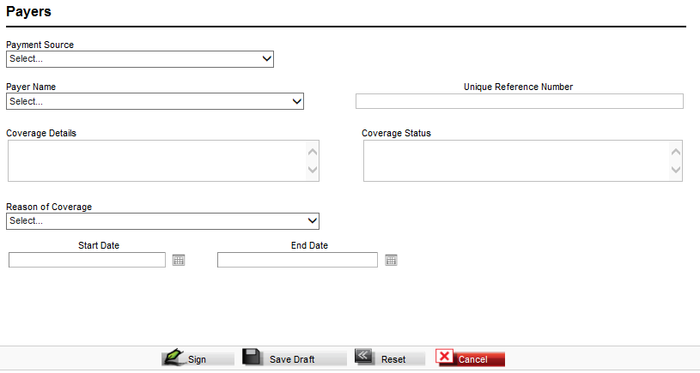

Field Specifications

Field Name | Type | Control | Visible | Allow Null Value | Dependency | List of Values | Default Value | Validation Rules
Payment Source | Selection | Radio Group | Y | N | None | Insurance  Government  Self Pay  Other | Insurance | None
Payer Name | Text | List Box | Y | Y | Enabled when Insurance option is selected in Payment Source field | List of Licensed Insurance Companies in Georgia | None | None
Other Payer Name | Text | Text Box | Y | Y | None | None | None | None
Unique Policy Number | Text | Text Box | Y | Y | Enabled when Insurance option is selected in Payment Source field | None | None | None
Policy Coverage Details | Text | Text Box | Y | Y | None | None | None | None
Policy Coverage Status | Text | Text Box | Y | Y | None | None | None | None
Start Date | Date | Calendar | Y | N | None | None | None | None
Status | Text | List Box | Y | N | None | Active  Not Active | None | None
End Date | Date | Calendar | Y | Y | Enabled when Status is set to Not Active | None | None | None

Problems Clinical Form
HL7 Definition
This form describes all relevant clinical problems at the time the summary is generated. At a minimum, all pertinent current and historical problems should be listed. CDA R2 represents problems as Observations.
A problem is a clinical statement that a clinician is particularly concerned about and wants to track. It has important patient management use cases (e.g. health records often present the problem list as a way of summarizing a patient's medical history).

Form Layout
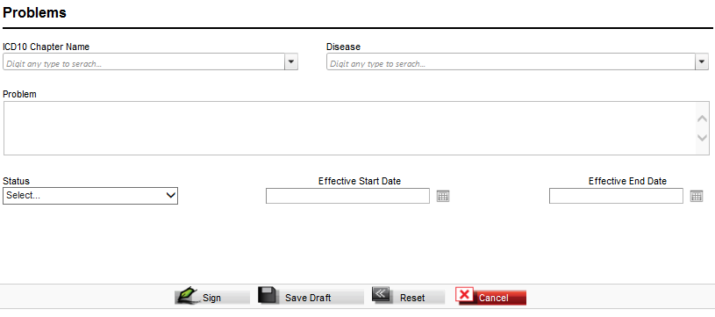

Field Name | Type | Control | Visible | Allow Null Value | Dependency | List of Values | Default Value | Validation Rules
Problem | Text | List Box | Y | N | None | ICD10 | None | None
Disease | Text | List Box | Y | N | None | ICD10 | None | None
Problem | Text | Text | Y | N | None | None | None | None
Status | Text | List Box | Y | N | None | Problem Status Code | None | None
Effective Start Sate | Date | Calendar | Y | N | None | None | None | None
Effective End Sate | Date | Calendar | Y | N | None | None | None | None

Procedures Clinical Form
HL7 Definition

This section defines all interventional, surgical, diagnostic, or therapeutic procedures or treatments pertinent to the patient historically at the time the document is generated. The section may contain all procedures for the period of time being summarized, but should include notable procedures.

Form Layout
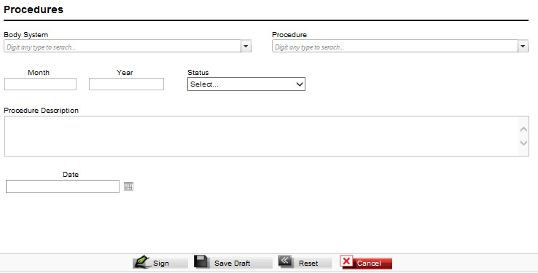

Field Name | Type | Control | Visible | Allow Null Value | Dependency | List of Values | Default Value | Validation Rules
Body System | Text | List Box | Y | N | None | NCSP | None | None
Procedure | Text | List Box | Y | N | None | NCSP | None | None
Month | Numeric | Text | Y | N | None | None | None | None
Year | Numeric | Text | Y | N | None | None | None | None
Status | Text | List Box | Y | N | None | Problem Status Code | None | None
Procedure Description | Text | Memo Text | Y | Y | None | None | None | None
Date | Date | Calendar | Y | N | None | None | None | None

Plan of Care Clinical Form
HL7 Definition
The plan of care section contains data defining pending orders, interventions, encounters, services, and procedures for the patient. It is limited to prospective, unfulfilled, or incomplete orders and requests only. All active, incomplete, or pending orders, appointments, referrals, procedures, services, or any other pending event of clinical significance to the current and ongoing care of the patient should be listed, unless constrained due to issues of privacy.

The plan of care section also contains information regarding goals and clinical reminders. Clinical reminders are placed here for purposes of providing prompts that may be used for disease prevention, disease management, patient safety, and healthcare quality improvements, including widely accepted performance measures.

Removed for Phase 2

Form Definition

Field Specifications
Form Part | Field Name | Type | Control | Visible | Allow Null Value | Dependency | List of Values | Default Value | Validation Rules
Main Form | Planned Activity | Text | Text | Y | None | None | None | None | View Only
Main Form | Activity Date | Text | Text | Y | None | None | None | None | View Only
Add Plan Form | Planned Activity | Text | List Box | Y | N | None | ICPM | None | None
Add Plan Form | Activity Date | Date | Calendar | Y | N | None | ICPM | None | None

Encounters Clinical Form
HL7 Definition
This form is used to list and describe any healthcare encounters pertinent to the patient’s current health status or historical health history. An Encounter is an interaction, regardless of the setting, between a patient and a practitioner who is vested with primary responsibility for diagnosing, evaluating, or treating the patient’s condition. It may include visits, appointments, as well as non face-to-face interactions. It is also a contact between a patient and a practitioner who has primary responsibility for assessing and treating the patient at a given contact, exercising independent judgment. This section may contain all encounters for the time period being summarized, but should include notable encounters.

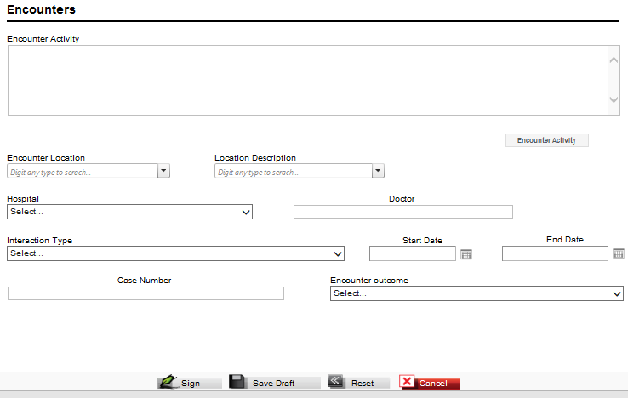

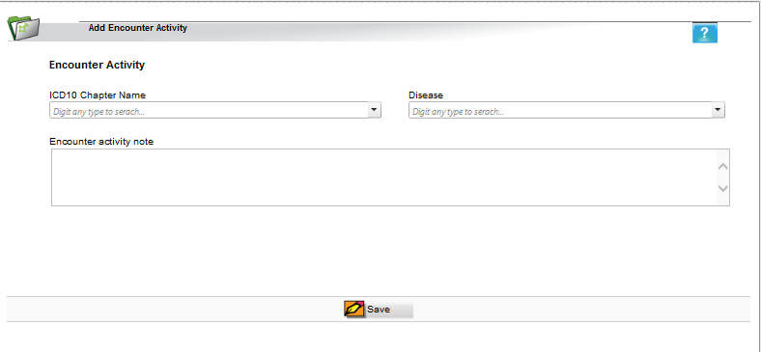

Field Specifications

Field Name | Type | Control | Visible | Allow Null Value | Dependency | List of Values | Default Value | Validation Rules
Main Form
History of Encounter Activity | Text | Text | Y | N | None | None | None | None
Encounter Location | Text | List Box | Y | N | None | - Ambulatory  - InPatient  - Emergency  - Home | None | None
Location Type | Text | List Box | Y | N | Enabled if Ambulatory or InPatient selected in Encounter Location | If Ambulatory selected  - Family Doctor  - Specialist  If InPatient selected  - Acute  - Non Acute  - Short Stay | None | None
Hospital | Text | List Box | Y | N | None | List of active hospitals in the system | None | None
Doctor | Text | Text | Y | Y | None | None | None | None
Interaction Type | Text | List Box | Y | N | None | - acute by self  - acute by ambulance  - acute transferred from other facility  - acute sent by GP/specialist  - planned by self  - planned transferred from other facility  - planned sent by GP/specialist | None | None
Start Date | Date | Calendar | Y | N | None | None | None | None
End Date | Date | Calendar | Y | Y | None | None | None | None
Case Number | Text | Text | Y | Y | None | None | None | None
Encounter Outcome | Text | List Box | Y | N | None | - Complete  - treatment;Interrupted  - treatment;Transferred to another facility  - Died | None | None
Add Encounter Activity Form
Disease Group | Text | List Box | Y | N | None | ICD10 | None | None
Disease | Text | List Box | Y | N | None | ICD10 | None | None
Encounter Activity Note | Text | Text | Y | Y | None | None | None | None

Visit Clinical Form
The visit form documents all patient information obtained by the medical practitioner during a patient visit.

Form Layout

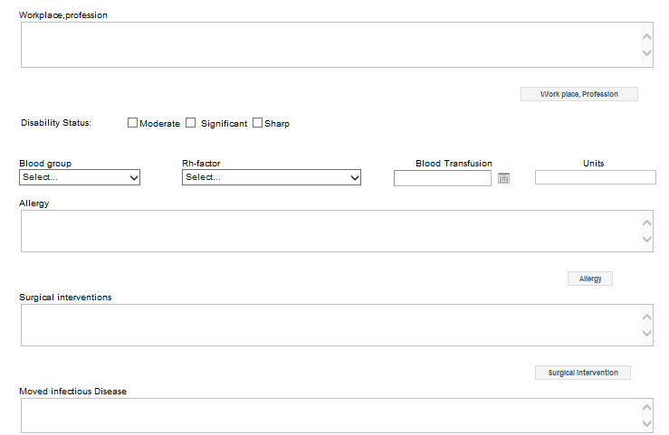
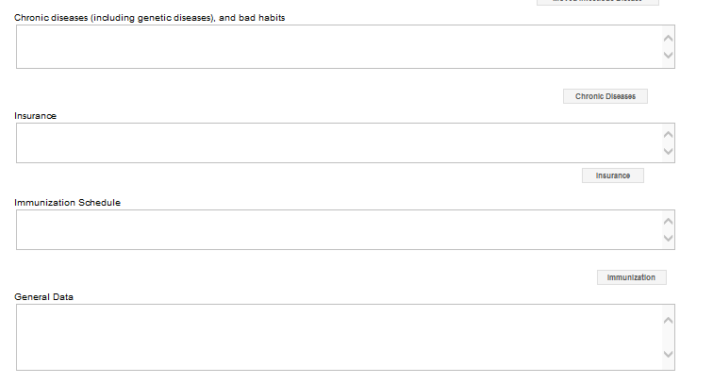
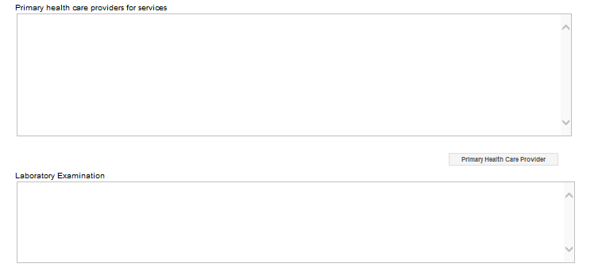
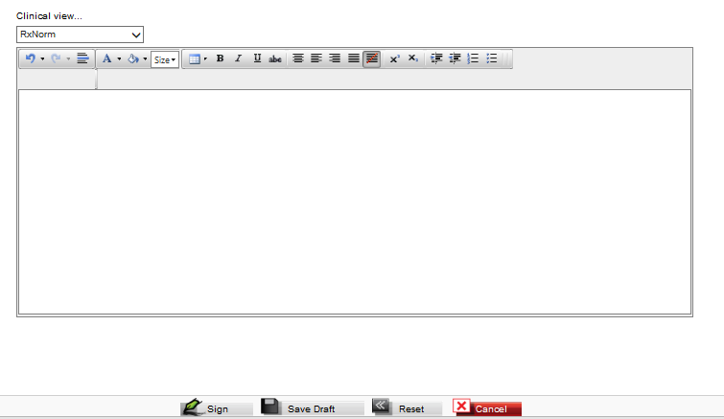

Field Specifications
Field Name | Type | Control | Visible | Allow Null Value | Dependency | List of Values | Default Value | Validation Rules
Workplace Profession | Text | Text | Y | N | None | None | None | Populated from Social History
Disability Status | Check Box | Check Box | Y | N | None | - Moderate  - Significant  - Sharp | None | None
Blood Group | Text | List Box | Y | N | None | - A+  - B+  - AB+  - O+  - A-  - B-  - AB-  - O- | None | None
RH Factor | Text | List Box | Y | N | None | Rh Negative  Rh Positive | None | None
Blood Transfusion | Date | Calendar | Y | N | None | None | None | None
Units | Text | Text | Y | Y | None | None | None | None
Allergy | Text | Text | Y | Y | None | None | None | Populated from Allergies
Surgical Interventions | Text | Text | Y | Y | None | None | None | Populated from procedures
Moved Infectious Diseases | Text | Text | Y | Y | None | None | None | Populated from Problems
Chronic Disease (including genetic diseases) and Bad Habits | Text | Text | Y | Y | None | None | None | Populated from Problems
Insurance | Text | Text | Y | Y | None | None | None | Populated from Payers
Immunisation Schedule | Text | Text | Y | Y | None | None | None | Populated from Immunisations
General Data | Text | Text | Y | Y | None | None | None | Populated from Vital Signs
Primary Health Care provider for Services | Text | Text | Y | Y | None | None | None | Populated from Payers
Laboratory Examinations | Text | Text | Y | Y | None | None | None | Populated from Lab Examinations
Clinical View | Text | Formatted Tex | Y | Y | None | None | None | None

Form 100 Clinical Form

The form 100 will be an editable HTML page with each field prefilled with data from the relevant clinical form or entered directly by the user.

Form Layout

Field Specifications

Report Ref. Number | Report Part | Type | Source
1 | Medical Establishment issuing the certificate or Physicians Name, speciality and Speciality Certificate Number |  | from user information of the user digitally signing the form
2 | Medical Establishment issuing the certificate |  | from user information of the user digitally signing the form
3 | Patient Name |  | From Patient Data
4 | Date of Birth (DD/MM/YYYY) |  | From Patient Data
5 | ID Number |  | From Patient Data
6 | Address |  | From Patient Data
7 | Employment |  | Current Employment Status concatenated with latest Occupation from the Social History Clinical Form
8 | Date of Patient Self Referral  Date of Referral to Hospital  Date of Hospital Admission  Date of Hospital Discharge |  | Non Mandatory Date Fields
9 | Conclusion on the current health condition or full diagnosis (Main disease , Accompanying disese and complications |  | Active problems from the Problems Clinical Form
10 | Previous Diseases |  | In-Active problems from the Problems Clinical Form
11 | History of Current Condition |  | Free Text
12 | Performed diagnostic tests and consultations |  | Encounters from the Encounters Clinical Form
13 | Course of the disease |  | Free Text
14 | Administered Treatment |  | Active medication from the Medication Clinical Form and all procedures from the Procedures Clinical Form
15 | Patient status prior to referral (If applicable) |  | Free Text
16 | Patient Status at referral |  | Free Text
17 | Recommendations |  | Free Text
18 | Physicians Name |  | from user information of the user digitally signing the form
19 | Administrator Signature |  | from user information of the user digitally signing the form
20 | Date of issue |  | from user information of the user digitally signing the form

