Login to gmail.com
account: healthtbilisi@gmail.com
pass: moh123321
Press “google Apps” (look Outlined in red)
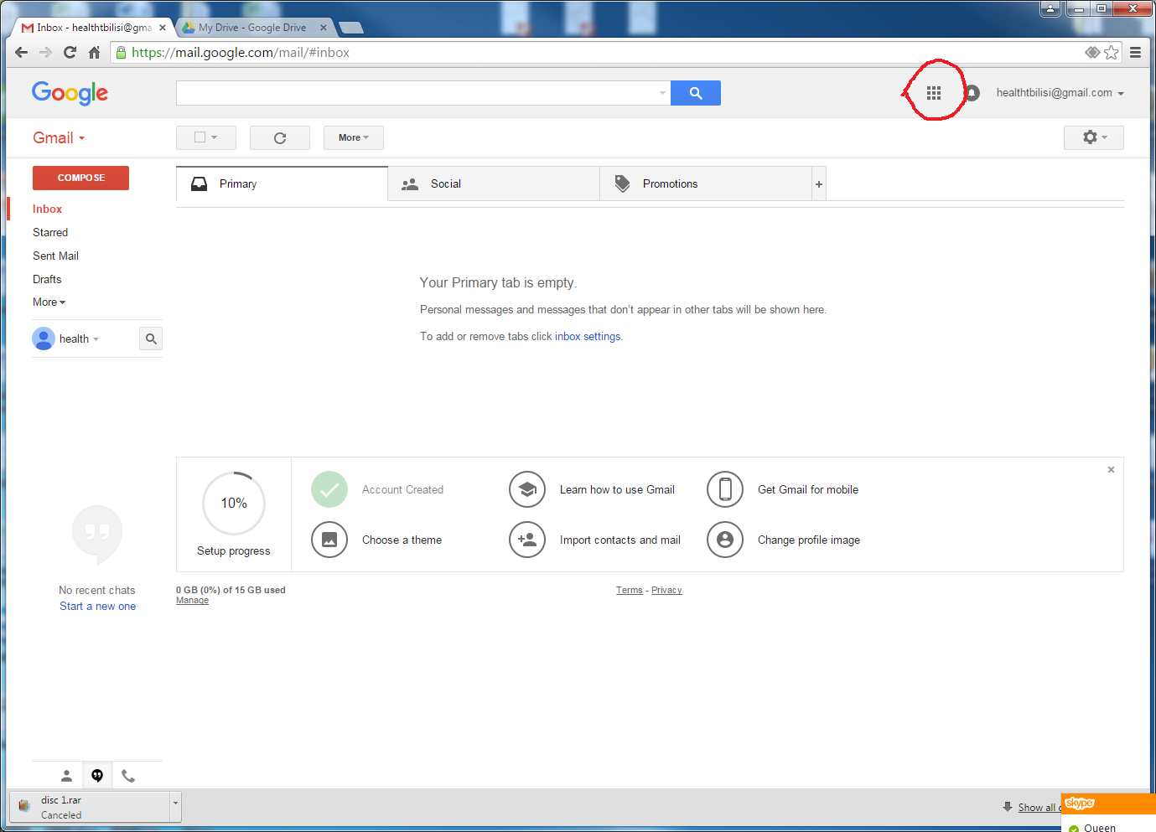
Press Drive (look Outlined in red)
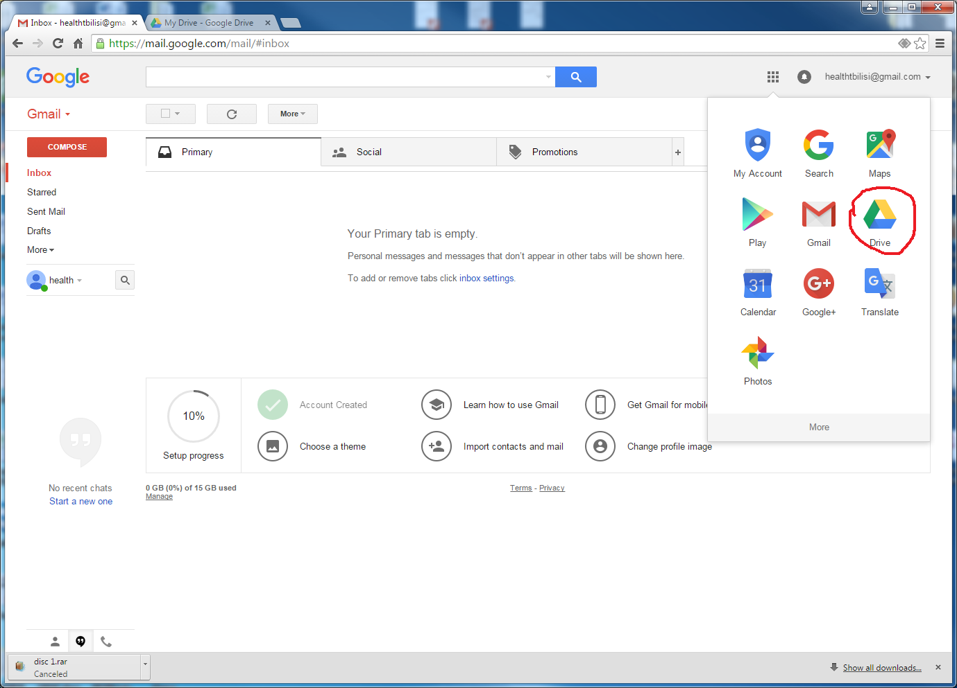

Right click on DICOM_DISK
Press on download (look Outlined in red)
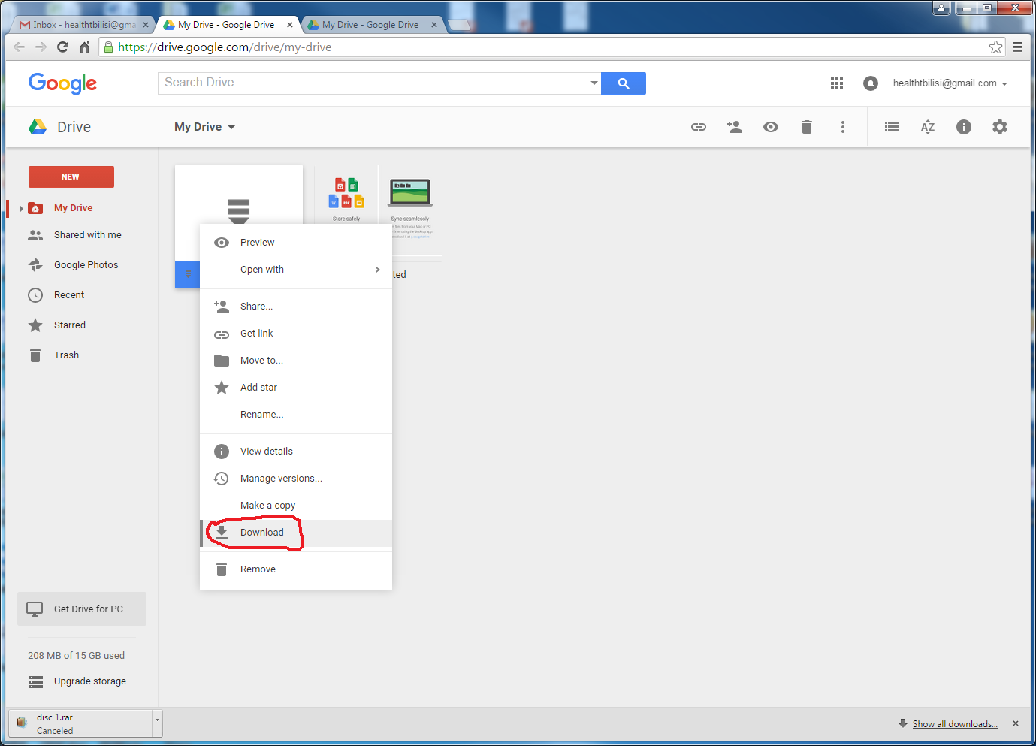
Unzip DICOM_DISK.zip file.

