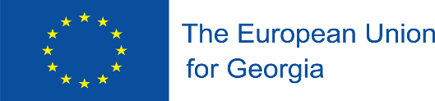

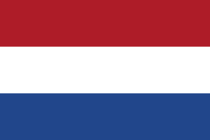


This project is funded by the European Union

“Strengthening Blood Safety System in Georgia”

Activity 2.4.1. Roundtable discussions on development of proposals including recommendations for transition to the mandatory non-profit organizational form for blood establishments regarding EU regulation

22 July 2020

STEs:

Ms. Laimute Stoniene, Head of Quality Assurance Department, National Blood Center, Lithuania;
Ms. Agne Kaminskiene, Lawyer, National Blood Center, Lithuania;
Mr. W.Martin Smid, Managing Director of Sanquin Consulting Service, Sanquin Blood Supply Foundation, Netherlands;
Mr. Wim de Kort, Professor of Donor Health Care, University of Amsterdam, Netherlands.

Wednesday, 22 July, 2020

14:00 – 14:10 | Adjustment of technical issues (voice, image)
14:10 – 14:15 | Opening speech – Ms. Babilina Turkia (RTA-C)
14:15 – 14:30 | Overview the current, profit-oriented organizational form of blood establishments, identify legal and political documents and discuss possibilities to transform for-profit to non-profit arrangements – Ms. Lali Ebanoidze (NCDC)
14:45- 15:00 | Questions - Answers
15:00 - 15:15 | Share Lithuanian practice of transforming profit-oriented to non-profit form of BE – Ms. Laimute Stoniene, Ms. Agne Kaminskiene
15:15- 15:30 | Questions - Answers
15:30 - 15:45 | Open – Dr. Martin Smit, Mr. Wim de Kort
15:45 – 16:00 | Questions - Answers
 | End of the Teleconference

