Country Background
Georgia is located at the crossroads of Western Asia and Eastern Europe; bounded to the west by the Black Sea, to the north by Russia, to the south by Turkey and Armenia, and to the southeast by Azerbaijan. The capital city is Tbilisi. Georgia covers a territory of 69,700 square kilometers (26,911 sq. mi). Population – 3,718,200 (January 1, 2017).
 | 2011-2012 | 2013 | 2014 | 2015 | 2016
GDP per capita (USD) | 3231-3523 | 3,600 | 3,676 | 3,767 | 3,865
Government expenditure on health as % of GDP | 1.7% | 2.0% | 2.4% | 2.9% | 3.0%
Health expenditure:
Public funding | 18.4% - 20.6% | 24.30% | 28.2% | 36.3% | 37%
Private funding | 79.1% - 77.1% | 73.4% | 69.9% | 61.9% | 62%
International Aid | 2.5% - 2.3% | 2.3% | 1.9% | 1.8% | 1%
Key Statistics
Birth Rate | 12.7 per 1000 | 12.9 per 1000 | 16.3 per 1000 | 15.9 per 1000 | 15.2 per 1000
Mortality Rate | 11.0 per 1000 | 10.8 per 1000 | 13.2 per 1000 | 13.2 per 1000 | 13.7 per 1000
Life Expectancy at Birth | 74.7 years | 75.2 years | 72.9 years | 72.9 years | 72.7 years
Maternal Mortality Ratio (per 100,000 live births) | 22.7 | 27.7 | 31.5 | 32.1 | 23.0
Infant Mortality Rate  (per 1000 live births) | 10.8 | 10.5 | 8.2 | 8.6 | 9.0
Under 5 Mortality Rate | 12.4 | 12 | 9.3 | 10.2 | 10.7

HCV Epidemiology
Based on available data, Georgia is among the countries with high hepatitis C (HCV) Prevalence, however, the reasons of the high burden of the disease has not been studied sufficiently. Collapse of the health care system in 1990s, sub-optimal quality standards of health services had negative influence on safe injection practices, infection control and blood safety in health care settings over the years. All these conditions along with the widespread practice of needle sharing among people who inject drugs (PWID) contributed to the spread of HCV in the general population.
General population | Prevalence | Source
Surveys among blood donors | 1) 7.3%  2) 7.8%  3) 2% overall | 1) Tbilisi blood donors 1998  2) Tbilisi, Batumi, Poti blood donors 1997-1999  3) “Safe Blood” Georgia State Program, 2012
Population-based surveys | 6.7% | Tbilisi population-based survey 2001-2002
Population-based surveys | 7.7% Anti-HCV+  5.4% HCV RNA+ | National Population survey, 2015
High risk populations
PWID | 1) 70%  2) 50%  3) 66.2% | 1) ever-IVDU 2002 (Tbilisi)  2) PWID 2006-2012 (Georgian Harm Reduction Network)  3) PWID (BSS, Curatio International Foundation)
HIV infected PWID | 73.4% | Chkhartishvili N et al. 2014
Other
STI patients | 11.3% | Tsertsvadze, 2008
TB patients | 21% | Lomtadze et al. 2013
Men who have sex with men (MSM) - Tbilisi | 7.1% | BSS among men who have sex with men in two cities of Georgia, 2015
MSM - batumi | 18.9%
Health care workers | 5% | Butsashvili M et al. 2012
There are no precise data available on HCV prevalence in Georgian prisons as no sero-prevalence study has been conducted. Data collected during the free HCV screening offered to prisoners as part of the prison-based HCV treatment program demonstrated a prevalence of ~48%. In the mortality structure among prison population deaths associated with HIV/AIDS and viral hepatitis are the third highest with 17.53% (including liver cirrhosis and cancer), only after cardiovascular and respiratory disease mortality rates. The HCV prevalence among HIV infected people is reported as 48,6% and as 73,4% among HIV infected PWID.
Characteristic | n | Weighted % | Estimated number of adults >18
Anti-HCV+ | 425 | 7.7% | 215,000
HCV RNA+ | 311 | 5.4% | 150,300
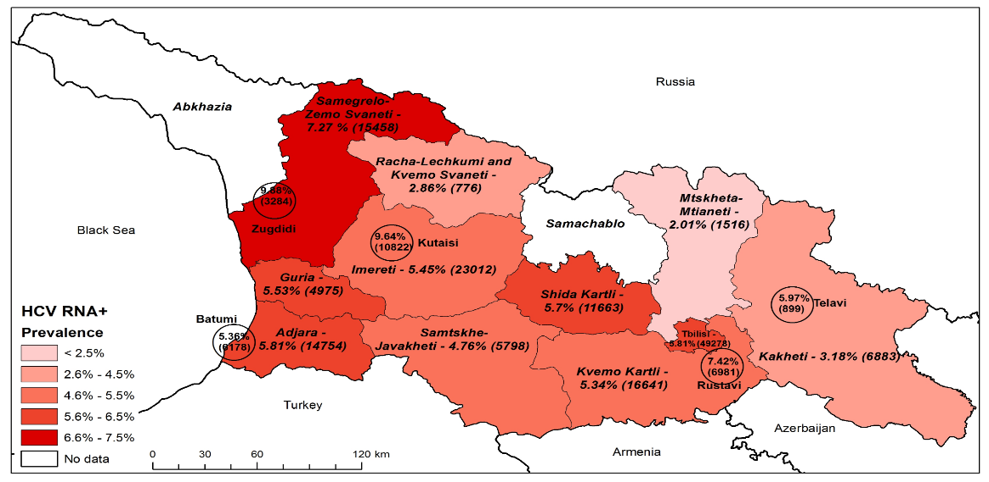
According to the Latest population-based seroprevalence survey, conducted by the National Center for Disease Control and Public Health (NCDC) and US Centers for Disease Control and Prevention (CDC) between May-August, 2015, estimated national seroprevalence of hepatitis C is 7.7% and the prevalence of active disease is 5.4%.
5,97%
899
Tbilisi
5,36%
6178
7,42%
6981
5,81%
49278
Prevalence and Estimated Number of HCV RNA+ Individuals by Regions and Cities
9,64%
10822
9,88%
3284

HCV Genotypes in Georgia
Genotype | General pop (2002)* | General pop (2003-2013)** | General pop (2015) *** | IDU (2012)† | HIV Co-infected
HCV GT 1b | 62% | 43% | 40.5% | 22% | 42%
HCV GT 2 | 11% | 24% | 23.6% | 20% | 18%
HCV GT 3 | 27% | 33% | 34.7% | 66% | 35%
Distribution of HCV genotypes by years has changed substantially in Georgia: according to the data of the 2015 population-based HCV seroprevalence survey, proportion of genotype 1 is 39.5%, much less compared to the proportion in 2002 that was estimated at 62%, while proportion of genotype 2 has increased. The genotype 3 is the most widespread after genotype 1 followed by genotype 2.
*Source: Stvilia, et al: J Urban Health; 83(2):2006:289-298; ** Georgian Infectious Diseases, AIDS and Clinical Immunology Research Center data for 2003-2013; *** 2015 seroprevalence survey. in appx. 2% GT is indeterminate; †Bouscaillou, J., et al. (2014). : Int J Drug Policy; Karchava, et al: Georgia Medical News: 2009 Dec; (177): 51-55

HCV Care and Treatment
- Until 2014 diagnostics and treatment of Hepatitis C in general population were neither financed by the state nor private insurance schemes, treatment was fully dependent on patient’s ability to pay out of pocket.
- The Global Fund HIV Program has been covering HCV treatment for HIV/HCV co-infected patients – 150 per year since 2011.
- Starting from 2013, Government of Georgia covers treatment of HCV infected patients with Pegylated Interferon + Ribavirin (Peg/Riba) regimen at the penitentiary system.
- In 2014, Ministry of Labour, Health and Social Affairs (MoLHSA) negotiated preferential pricing of Peg/Riba for the general population. The new price for standard dual therapy has been established at a price of 92.88 USD per vial of Peg/Riba. This has dramatically lowered a price for HCV standard treatment regimens to 1115 and 2230 USD for Genotypes 2, 3 and Genotype 1 respectively. Prior to initiation of the above programs, approximately 150-200 patients received the HCV treatment in the private sector per year.
- Specialists experienced in the HCV treatment and monitoring are mainly consolidated in Tbilisi. The expertise in this area outside Tbilisi is limited, but they have experience of managing infectious diseases and in 2015 they received basic training on HCV care and management using new Directly Acting Antiviral drugs (DAAs).
Major diagnostic methods implemented in Georgia
Method | Year of implementation
ELISA | 1984
Western Blot | 1985
Qualitative PCR | 1995
Quantitative PCR | 1996
HCV Genotyping | 2003
HCV RNA quantitative tests using real-time PCR | 2006
Transient liver elastography and other noninvasive markers | 2007
IL28B Genotyping | 2010
NS5B and 5’UTR/Core region sequencing | 2010
HCV core antigen testing for confirmation of active infection | 2017
Cepheid Xpert HCV viral load | 2017

Timing of implementation of HCV antiviral treatment approaches in Georgia
Treatment approach | Year of implementation
Interferon alpha monotherapy | 1996
Interferon alpha + ribavirin | 1998
Pegilated interferon alpha | 2001
Pegilated interferon alpha + ribavirin | 2002
Pegilated interferon alpha + ribavirin + telaprevir or  Boceprevir | 2011
Sofosbuvir + pegilatedinterferon alpha + ribavirin | 2014
Sofosbuvir + ribavirin | 2014
Sofosbuvir + ledipasvir | 2015
Sofosbuvir + daclatasvir | 2015
Ombitasvir + paritaprevir + ritonavir + dasabuvir | 2015

Progress towards elimination
The Government of Georgia declared intention to eliminate hepatitis C in Georgia and this initiative already received strong international support. The national Hepatitis C elimination program became operational in 2015.
- Over the past several years the Government of Georgia substantially stepped up its efforts against hepatitis C by implementing national programs such as free of charge hepatitis C treatment for HIV/HCV co-infected patients (funded under the Global Fund HIV Program since 2011); Free of charge hepatitis C treatment at the penitentiary system and 60% price reduction on combination of pegilated interferon and ribavirin for the general population.
- In February 2014, MoLHSA (Minister Dr. David Sergeenko) initiated discussion regarding strengthening Hepatitis C response in the country with US partners.
- In March 2014, the 1st National Workshop on Hepatitis C, organized by CDC, MoLHSA, NCDC, Georgian Infectious Diseases, AIDS and Clinical Immunology Research Center (IDACIRC), Bristol University, and Emory University, developed the first concept of hepatitis C elimination in Georgia. The concept was endorsed by the Government of Georgia and declared intention of eliminating HCV infection in the country. In April 2014, the concept was discussed at the WHO supported hepatitis summit in Geneva and later CDC helped to organize dedicated satellite meeting on hepatitis C elimination in Georgia during the 49th annual meeting of the European Association for the Study of the Liver (EASL) in London.
- In 2014, the Georgian Government started negotiation with pharmaceutical company Gilead which is one of the global leaders in research and manufacturing of potent DAAs, including Sofosbuvir and fixed-dose combination of Ledipasvir/Sofosbuvir regarding possible elimination of HCV in Georgia.
- Under the MoLHSA, a special commission on HCV was established that is in charge of overall coordination of national HCV elimination movement. In addition, a working group of experts was created to elaborate national strategy and action plan for HCV elimination. National Program for Short-term/urgent Measures of Hepatitis C Elimination Action Plan for Georgia has been developed.

- Georgian delegation with the support of the US CDC and Open Society Foundation Georgia visited Egypt in February 2015 to get familiar with the ongoing Sofosbuvir treatment program and use experience of Egypt in planning elimination strategy for Georgia.
- In March 2015, 2nd National HCV Workshop was organized. Short term/urgent measures of Hepatitis C elimination Action Plan for 2015 was discussed and finalized during the workshop and later in April was approved by the Georgian Government.
- Memorandum of Understanding between the Government of Georgia and US pharmaceutical company Gilead was prepared and officially signed on April 21, 2015.
Official signing of Memorandum of Understanding, April 21, 2015
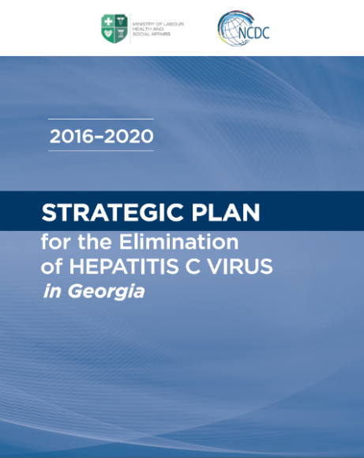
- Population-based HCV seroprevalence survey was conducted in May-August, 2015. It aimed to estimate the prevalence of HCV infection in the general population, to assess risk factors for HCV infection in Georgia, to describe HCV circulating genotypes and identify knowledge and perceptions towards hepatitis and its prevention and treatment. The survey estimated that 7.7% of population are anti-HCV positive and 5.4% are HCV RNA positive. Injection drug use and history of blood transfussion were identified as main risk-factors.
- Long-term elimination strategy for 2016-2020 was developed. To facilitate the process of elaboration, several workshops and meetings were organized with support of CDC and WHO. The Technical Advisory Group (TAG) composed of 12 international experts was established with support of the CDC and the first meeting was held in Tbilisi on November 3-4. After the meeting, TAG provided a set of recommendations on long-term elimination strategy. Strategy was approved by the Georgian government on August 18, 2016.
- The 2nd Technical Advisory group (TAG) meeting was held in Tbilisi on October 24-25, 2016. Recent progress towards elimination, monitoring and evaluation indicators and priorities for 2017 were discussed and TAG provided recommendations related to HCV care and treatment, screening, prevention and other directions of HCV elimination strategy.
- With Support of CDC, WHO and Eurasian Harm Reduction Network, MoLHSA and NCDC conducted 3rd National HCV Elimination workshop on April 6-8, 2016 in Tbilisi. National and international experts discussed results of national serosurvey, 1st phase of elimination program and Elimination Strategy for 2016-2020.
- In August, 2016 the Clinical and Scientific Committees were established with the aim of providing the volunteer leadership for the transparency and coordination of the research activities within Hepatitis C Elimination Program in Georgia. In total, 40 proposals were reviewed by the Scientific Committee by the end of February, 2018. Clinical guideline for management of HCV infection was elaborated by the Clinical Committee.
- 4th National HCV elimination workshop was conducted on March 9-10, 2017. The main subject of the workshop was to review the progress on implementation of the Hepatitis C Elimination Plan 2016-2020, to evaluate the work accomplished during the two years and to discuss the important aspects of Georgian Hepatitis C Elimination Program with particular emphasis on screening, treatment and linkage to care.
- 3rd TAG meeting was organized on November 30 - December 1, 2017. TAG members observed the ongoing processes and provided new recommendations to facilitate the progress.
2011-2012 | - The Global Fund Project “Improving management of HIV/HCV Co-infection in Georgia” - Free of Charge Hepatitis C treatment for HIV/HCV co-infected patients with Peg/Riba
2013 | - State Program “Hepatitis C Treatment in the Prison Population” - Free of Charge Hepatitis C treatment for prisoners  - Government negotiated for Peg/Riba treatment course price reduction to $4,500  - Ministry of Labour, Health and Social Affairs of Georgia (MoLHSA) negotiated for additional 10,000 treatments for civil population with price reduction of 60%
2014 | - MoLHSA started 10,000 civilians treatment program  - 1st National workshop on Hepatitis C was conducted, feasibility of elimination was discussed  - National commission on Hepatitis C was established  - The Georgian Government announced Hepatitis C as a high governmental priority  - Protocol for population-based HCV seroprevalence survey was developed by the CDC  - MoLHSA started negotiations regarding possibilities of HCV response strengthening and elimination with US partners and US pharmaceutical company Gilead  - HCV elimination perspectives in Georgia were discussed during the annual EASL meeting in London
2015 | - National Program for Short-term/urgent Measures (1st phase) of Hepatitis C Elimination Action Plan for 2015 was approved by the Georgian Government in April  - Long-term elimination strategy for 2016-2020 was developed  - 2nd National workshop on Hepatitis C was conducted  - Monitoring of Understanding (MoU) between Georgian government and company Gilead was signed on April 21  - Progress towards elimination of HCV in Georgia was discussed during the EASL meeting in Vienna, World Hepatitis Summit in Glasgow, WHO Euro regional committee in Vilnius and high-level ministerial meeting in Minsk  - HCV seroprevalence survey was conducted during May-August  - Technical Advisory Group (TAG) meeting was held in Tbilisi, November 3-4
2016 | - Sofosbuvir/Ledipasvir (Harvoni) was introduced in the elimination program  - 3rd National HCV Elimination Workshop was held in Tbilisi  - Long-term elimination strategy for 2016-2020 was approved by the government  - Inclusion criteria for enrolling in the HCV treatment program were removed  - Progress towards elimination of HCV in Georgia was discussed at the EASL meeting in Barcelona  - 10-year MoU between Georgian government and company Gilead was officially signed in Barcelona  - 2nd TAG meeting was held in Tbilisi, October 24-25  - HCV Elimination Clinical and Scientific Committees were established
2017 | - 4th National HCV Elimination Workshop was held in Tbilisi  - HCV Screening Protocol was approved by the MoLHSA in May  - Special session on EASL meeting in Amsterdam was dedicated to Georgia HCV Elimination Program  - Georgia was awarded the title of NOhep Visionary for the European Region at the World Hepatitis Summit in Sao Paulo, Brazil, on November 1st  - 3rd TAG meeting was held in Tbilisi, November 30-December 1

Recent progress by different directions of the Elimination Strategy
Promote advocacy, awareness and education, and partnerships for HCV associated resource mobilization
- Massive awareness raising campaigns
- Short text messages (SMS) regularly sent to invite population to the HCV screening
- HCV Hotline established at NCDC
- Facilitating establishment of patients’ association
- Significantly strengthened infection control and prevention monitoring and evaluation system in medical and non-medical facilities
Prevent HCV transmission
- Regular screening activities among PWID and their sexual partners
- Imrpoved quality control mechanisms for blood banks
- HCV screening in more than 600 centers countrywide, including inpatient and outpatient facilities, prisons, Georgian Harm Reduction Network (GHRN) centers, pharmacies, etc.
Identify persons infected with HCV
- Development of unified electronic screening registry that combines screening data from all sources
- Research activities for the simplification of HCV diagnostics, including studies on HCV cAg and various PCR approaches
Improve HCV Laboratory Diagnostics

- Introduction of external quality assessment in NCDC referral laboratory (Lugar Center)
- Starting with 4 sites in 2014, currently 32 service centers in different cities, including 1 center in penitentiary system, are providing diagnostic and treatment services to the elimination program beneficiaries. Since the launch of the program in 2015 through January 31, 2018, 38,985 patients completed the treatment, with overall cure rate – 98%.
* Of 37,500 patients eligible for SVR assessment, 28,806 were tested, 28,283 (98.2%) achieved SVR, 8,694 (23.2%) missing data
HCV elimination program care cascade, April 28, 2015 – January 31, 2018

Provide HCV Care and Treatment

- Ongoing study for Identification and Characterization of HCV-Attributable Hepatocellular Carcinoma is underway in collaboration with US CDC
Improve HCV Surveillance
- Ongoing study to find the barriers and facilitators to enrollment in the HCV treatment program with support of US CDC.

Unified Electronic HCV Screening Module
A unified electronic HCV screening module was created to capture data from all national HCV screening programs. Screening providers enter the data into the module on-site. The module is using personal IDs based on a link with Public Registry that allows to synchronize HCV-related data from different databases, such as HCV treatment database, unified electronic blood donor module, hospitalized patient’s electronic module and birth registry.
As of February, 2018, more than 1.5 million screenings were registered in the database, among which ~974,000 were unique individuals with positivity rate 10.6%.

HCV Screening Protocol

HCV screening protocol was developed for medical and public health personnel based on the international guidelines, including the WHO guideline for the screening, care and treatment of persons with chronic hepatitis C infection, nationwide HCV seroprevalence survey (2015) results and Technical Advisory Group recommendations. It was approved by the Government of Georgia on May 6, 2017.
- To identify population groups that need to be tested on HCV,
- To improve identification of HCV infected persons
- To reach the HCV Elimination Strategy goal – “90% of HCV infected persons have been tested for their infection” by 2020.
Aims of the protocol are

Population subgroups with high risks of HCV infection based on HCV Screening Protocol

- Current or past injection/intranasal drugs users
- Men who have sex with man
- Prisoners
- Sex workers
- Hospitalized patients
- HIV infected persons
- TB patients
- STI patients
- Blood donors
- Recipients of blood or blood products
- Persons ever on dialysis
- Persons with haemophilia
- Persons who have undergone tattooing, piercing or scarification procedures
- Pregnant women
- Children (≥18 months) born to HCV infected women
- Medical staff
- All individuals attending medical facilities
- Policemen
- Persons with history of medical/dental intervention
- Persons with unspecified liver disease and/or chronic hepatitis, including persons with elevated ALT

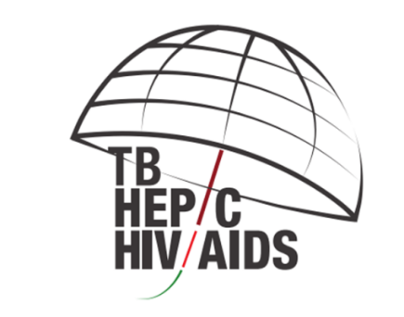
Integration of HCV, TB and HIV Detection at PHC level
A pilot project was initiated in September 2017 to improve case detection of Hepatitis C, Tuberculosis and HIV infection at the primary healthcare level in the Samegrelo-Zemo Svaneti region in the country of Georgia. The project will end in October 2018.
Samegrelo-Zemo Svaneti region has the highest prevalence of hepatitis C in the country with the 9.88% HCV RNA prevalence in the biggest city of the region – Zugdidi.
Project goals:
- To raise awareness among all stakeholders including general public on all three diseases in the region;
- To Develop the sustainable local public-private partnership for effective integration of TB/HIC/HCV screening and early disease detection;
- To strengthen PHC through development of integrated TB/HIC/HCV screening model with detailed protocol;
- To map the service providers at the regional level and establish effective referral systems to specialized clinics;
- To build the providers’ capacity and increase the stakeholders’ engagement in service quality monitoring;
- To generate the evidence-based recommendations for program expansion to promote service integration nationwide

Study tours

NCDC provides study tours for the interested audience to introduce them to the State HCV Elimination program, its management and organization, showing the steps taken to achieve the progress towards the elimination goals.

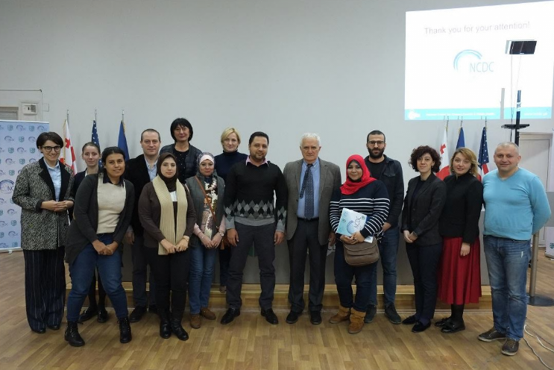
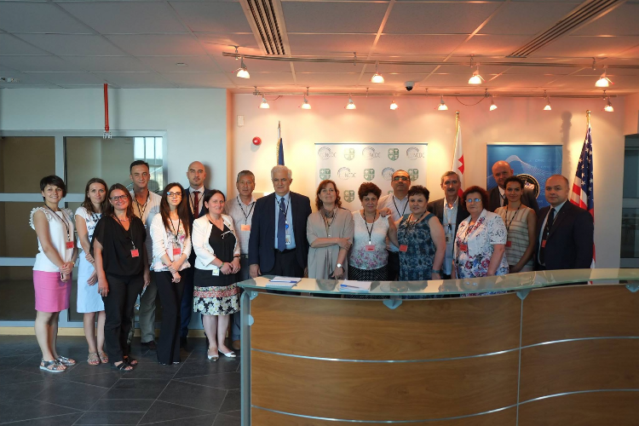
Within the study tour meetings are organized with different organizations – the Ministry, HCV Management Centers, HCV screening and treatment provider centers, NCDC referral laboratory (Richard Lugar Center for Public Health Research), Public Health Centers, etc.

Delegation from Egypt
Delegation from Post-Soviet countries

NOhep VISIONARIES Program
Georgia was awarded the title of NOhep Visionary for the European Region at the World Hepatitis Summit in Sao Paulo, Brazil, on November 1st, 2017. Georgia joined five other countries including Brazil, Bangladesh, Egypt, The Gambia and Mongolia to launch the NOhep Visionaries Programme worldwide.
The NOhep Visionaries Programme is a global campaign which engages governments to scale-up successful approaches to elimination and share key learnings, accelerating progress towards eliminating viral hepatitis by 2030.
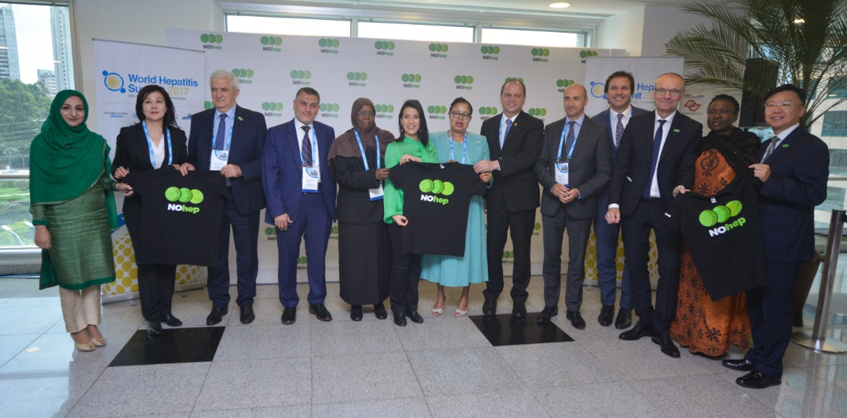
World Hepatitis Summit 2017, Sao Paulo, Brazil

Why is Elimination of Hepatitis C in Georgia Feasible and Achievable?
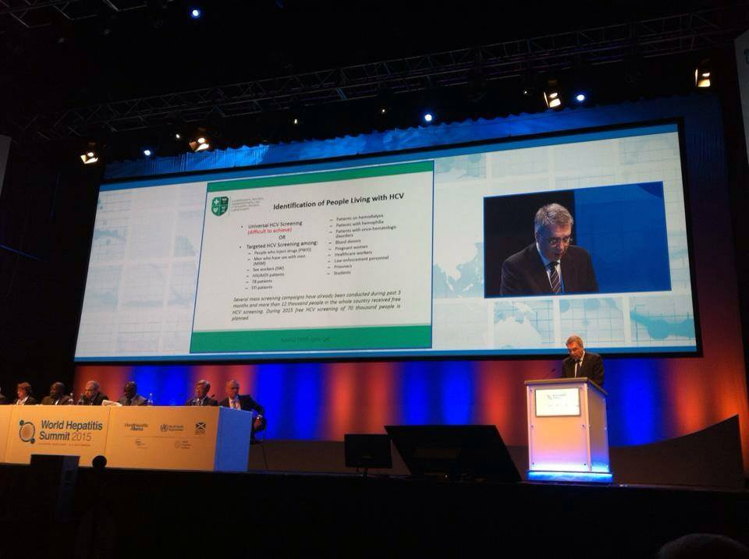
- High prevalence of HCV infection in general population;
- Small size of the country (69,700 km²) with population of 3.7 million people;
- Strong Governmental commitment towards elimination of HCV;
- Availability of all modern HCV diagnostic and treatment methods;
- Strong human resource capacity in the field of viral hepatitis, and particularly in hepatitis C;
- Adherence to principles of evidence-based medicine for hepatitis C as evidenced by the availability of national guidelines for many years;
Minister Davit Sergeenko on World Hepatitis Summit, Glasgow, 2015
- Existence of effective systems for implementing large-scale national and international health programs, including through multi-sectoral approach;
- Availability of logistic and control mechanisms within existing national HIV/AIDS, Tuberculosis and hepatitis C treatment programs that effectively prevent leakage of medicines to local and/or neighboring markets;
- Best practice experience in the field of HIV/AIDS that can be replicated for hepatitis C programs. Namely, achievement of universal access to antiretroviral therapy that remains unique in the Eastern European region for more than a decade.

