National Hepatitis C Virus Elimination Progress Report, Georgia, 2018-2019

TABLE OF CONTENTS
TABLE OF CONTENTS 2
ACKNOWLEDGEMENTS 4
LIST OF ABBREVIATIONS 6
INTRODUCTION 8
STRATEGY-SPECIFIC PROGRESS MADE TOWARDS HCV ELIMINATION 9
Strategy 1. Improve Advocacy, Awareness, Education, and Partnerships for HCV-Associated Resource Mobilization 9
Key Accomplishments and Findings 9
Strategy 2. Prevent HCV Transmission through Harm Reduction, Blood Safety, and Infection Prevention and Control 11
Harm Reduction 11
Key Accomplishments and Findings 11
Blood Safety 13
Key Accomplishments and Findings 13
Infection Prevention and Control 15
Key Accomplishments and Findings 15
Strategy 3. Identify and Link to Care Persons Infected with HCV 18
Key Accomplishments and Findings 18
Strategy 4. Improve HCV Laboratory Diagnostics 20
Key Accomplishments and Findings 20
Strategy 5. Provide Comprehensive HCV Care and Treatment 23
Key Accomplishments and Findings 23
Strategy 6. Improve HCV Surveillance 25
Key Accomplishments and Findings 25
STRATEGY-SPECIFIC CHALLENGES TO HCV ELIMINATION 26
Improving Awareness: 26
Preventing Transmission: 26
Harm Reduction: 26
Blood Safety: 26
Infection Prevention and Control: 26
Identifying Infected Persons and Linking them to Care: 27
Improving Laboratory Diagnostics: 27
Providing Care and Treatment: 27
Improving Surveillance: 27
Monitoring & Evaluation: Advocacy, Awareness and Education, and Partnerships 28
Monitoring & Evaluation: Harm Reduction 29
Monitoring & Evaluation: Blood Safety 34
Monitoring & Evaluation: Infection Control 37
Monitoring & Evaluation: Screening 39
Monitoring & Evaluation: Laboratory Diagnostics 41
Monitoring & Evaluation: Care and Treatment 43
Monitoring & Evaluation: Surveillance 47
RESEARCH AND SCIENCE 48
Progress and Outcomes 48
Challenges 52

ACKNOWLEDGEMENTS
This report is the result of a major collaborative effort of governmental institutions, non-profit organizations (NGOs) and individuals working on national hepatitis C elimination program, without whose contributions the data presented in this document could not have been collected.
The work was led by Lia Gvinjilia (TEPHINET, U.S. CDC, South Caucasus Office), Muazzam Nasrullah (U.S. CDC Division of Viral Hepatitis), Shaun Shadaker (U.S. CDC Division of Viral Hepatitis), and under the overall guidance of Francisco Averhoff ( U.S. CDC Division of Viral Hepatitis), Amiran Gamkrelidze (National Center for Disease Control and Public Health) and Ekaterine Tikaradze (the of Internally Displaced Persons from the Occupied Territories Labour, Health, and Social Affairs)
Many thanks to the following persons contributed to the report with supporting evidence and content:
Ministry of Internally Displaced Persons from the Occupied Territories Labour, Health, and Social Affairs : Tamar Gabunia, Eka Adamia, Marina Baidauri
Social Service Agency: Tamar Kavteladze
National Center for Disease Control and Public Health (NCDC): Paata Imnadze, Alexander Turdziladze, Maia Tsereteli, Vladimer Getia, Ana Aslanikashvili, Marina Topuridze, Maia Alkhazashvili, Nazibrola Chitadze, Eteri Kipiani, David Tsereteli, Nino Berishvili, Ana Papkiauri
Global Fund to Fight AIDS, Tuberculosis, and Malaria, NCDC: Irma Khonelidze, Ketevan Stvilia, Alexander Asatiani
U.S CDC, South Caucasus Office: Beth Skaggs, Tatia Kuchuloria, Irina Tskhomelidze, Lali Madzgarashvili, Marika Geleishvili
U.S. CDC, Division of Viral Hepatitis: Nancy Glass, Jan Drobeniuc, Geoff Beckett,
Georgian Harm Reduction Network: Marine Gogia
Infection Disease, AIDS and Clinical Immunology Research Center : Tengiz Tsertsvadze, Akaki Abutidze
Hepatology Clinic Hepa: Lali Sharvadze
Medical Center Mrcheveli: David Metreveli, Jaba Zarqua, Mamuka Zakalashvili
Health Research Union: Maia Butsashvili
Neolab: George Kamkamidze
Foundation for Innovative New Diagnostics: Maia Japaridze, Sonjelle Shilton

LIST OF ABBREVIATIONS
AASLD American Association for the Study of Liver Diseases
AMR Antimicrobial resistance
BBSS Bio-Behavioural Surveillance Survey
CAP College of American Pathologists
DAA Direct acting antivirals
DVH Division of Viral Hepatitis
EASL European Association for the Study of the Liver
ELPA European Liver Patients Association
EQA External quality assessment
ESfEQA European Society for External Quality Assessment
FIND Foundation for Innovative Diagnostics
GFATM Global Fund to Fight AIDS, Tuberculosis, and Malaria
GHRN Georgia Harm Reduction Network
GMP Good Manufacturing Practice
HAI Hospital acquired infection
HBV Hepatitis B virus
HCC Hepatocellular carcinoma
HCV Hepatitis C virus
HCVcAg Hepatitis C virus core antigen
HCW Health-care workers
HIV Human Immunodeficiency virus
HRU Health Research Union
ICAP International Center for AIDS Care and Treatment Programs
IDACIRC Infection Diseases, AIDS and Clinical Immunology Research Center
IPC Infection prevention and control
MoIDPLHSA Ministry of Internally Displaced Persons from the Occupied Territories Labour, Health, and Social Affairs
NAT Nucleic acid testing
NCDC Georgia’s National Center for Disease Control and Public Health
NSP Needle and syringe program
OST Opioid substitution treatment
PCR Polymerase chain reaction
PHC Primary health centers
PPS Point prevalence survey
PSH Public service halls
PT Proficiency testing
PWID Persons who inject drugs
RAMA Regulation Agency for Medical Activities
RIQAS Randox International Quality Assessment Scheme
SOPs Standard operating procedures
SSA Social Service Agency
SVR Sustained virologic response
TSMU Tbilisi State Medical University
TTI Transfusion transmissible infections
UHP Universal healthcare program
U.S. CDC United States Centers for Disease Control and Prevention
WASH Water sanitation and hygiene

INTRODUCTION
Since 2015, Georgia has been working towards the country-wide elimination of hepatitis C virus (HCV) infection, defined as a 90% reduction in HCV prevalence. Georgia’s elimination program stands out for its comprehensive approach, with strategies in place to not only identify those infected with HCV and link them to care and treatment services, but also to improve access to quality diagnostics, safeguard the nation’s blood supply, and reduce infection with blood borne pathogens among People Who Inject Drugs (PWIDs) and in healthcare settings.
This report highlights the impact of various policy changes and initiatives occurring during 2018-2019 aimed at improving outcomes across the continuum of hepatitis C care. This report supplements the findings in the National Hepatitis C Virus Elimination Progress Report, 2015–2017and National Hepatitis C Virus Elimination Progress Report, January 1, 2017-June 30, 2018 and includes the following:
- Highlights of accomplishments and key findings
- Challenges remaining to the achievement of the hepatitis C elimination goals
- Tables containing monitoring and evaluation data on key performance indicators for the reporting period
- Appendices (1-4)
A major hallmark in 2018 and 2019 for the Georgia program is the decision to integrate screening, care and treatment services in primary healthcare settings and harm-reduction centers throughout the country. The leadership exhibited by Georgia in hepatitis C elimination is the result of several factors including: the highest levels of political commitment, the allocation of significant resources, and the comprehensive nature of the program. The great success achieved by the program thus far has led to Georgia being named the world’s first European Association for the Study of the Liver (EASL)-International Liver Foundation Center of Excellence in HCV Elimination.
The information contained in this current progress report mirrors the following six elimination strategies presented in the larger Strategic Plan for the Elimination of Hepatitis C Virus in Georgia, 2016–2020.
- Improve Advocacy, Awareness, Education, and Partnerships for HCV-Associated Resource Mobilization
- Prevent HCV Transmission through Harm Reduction, Blood Safety, and Infection Prevention and Control
- Identify and Link to Care Persons Infected with HCV
- Improve HCV Laboratory Diagnostics
- Provide Comprehensive HCV Care and Treatment
- Improve HCV Surveillance

STRATEGY-SPECIFIC PROGRESS MADE TOWARDS HCV ELIMINATION

Strategy 1. Improve Advocacy, Awareness, Education, and Partnerships for HCV-Associated Resource Mobilization
The government of Georgia has supported communication campaigns to raise awareness of the importance of early HCV diagnosis and to ensure that all Georgians have the opportunity to be tested and receive highly effective treatment, for free. With the contribution of numerous stakeholders working across a range of settings, a variety of activities were undertaken during the reporting period to increase both professional and public understanding of hepatitis C to help find patients who are undiagnosed and untreated.

Key Accomplishments and Findings
- Implementation of public communication campaigns;
  - ”Time to test, Time to treat and Time to cure”, “Stop C” and “Future without C” were the primary communication campaign slogans during June-December 2018.
  - 2019 campaign (May-December) conveyed more targeted messages “You Too get involved,” “You Too get cured,” Invisible C -“Just because you can't see it, doesn't mean it doesn’t exists,” HCV Kills -“Causes Cancer” “Causes Cirrhosis” towards those with no screening tests for hepatitis C as well as HCV-infected persons who did not engage in treatment.
  - Various printed communication materials developed and promotional products designed: 8,000 posters, 38,000 booklets and 65,000 leaflets in Georgian, Azerbaijani and Armenian languages; 10,000 car window decals, 15 adhesive banners for public service halls, 8 billboards across Georgia, 100 caps and logo bags and 400 t-shirts.
- During 2018-2019, social media websites (c.moh.gov.ge and NCDC.ge) and TV media were used to provide real-time information about the elimination program for the general population, high-risk subgroups, patients, healthcare professionals, elimination-program providers, advocates, and international partners.
  - Overall, 172 HCV-related “Facebook” blog posts , 24 banners, 16 video blogs, over 15 live streaming videos of campaign activities, as well as HCV providers’ live chats on Facebook responding to the questions.
  - More than 200 TV reports and ten TV shows with invited guests (hepatitis experts, ministry and NCDC leadership), six radio shows and articles, three video clips for TV campaigns, and one animated video for social media have been produced.
- Similar to the previous year, a mobile communication strategy that involved using brief text messages was again implemented in 2018 (August and November) and in 2019 (July and December) targeting the general population (approximately 1.8 million people).
- During the World Hepatitis Day 2018 and 2019 campaigns, a number of communication activities were conducted throughout the country. These included:
  - “STOP C” high level meeting and press conference held by the government of Georgia, Ministry, NCDC and partner organizations;
  - Joint communication activity by Kahketi Administration of the State Attorney-governor and NCDC at Telavi State Museum conference hall;
  - Meeting with the governors of Shida Kartli and Kvemo Kartli regions to boost the visibility of HCV and contribute to increasing treatment engagement
  - HCV Screening activities at Public Service Halls in Tbilisi and other cities in the region along with text messaging (SMS) inviting people for hepatitis C screening and treatment where necessary;
  - Hepatitis C elimination program workshops for primary health care workers in Batumi and Adjara region;
  - Public discussions at Batumi Shota Rustaveli State University, Telavi City Hall and Zugdidi referral hospital carried out jointly by Hepatitis C Cured Patient Association and NCDC in collaboration with HCV service providers and public health centers;
  - More than 150 students from local universities were trained to volunteer for hepatitis C screening promotion activities at Public Service Halls operated at twelve sites throughout Georgia.
- Three Facebook surveys among 15,000 respondents revealed that most respondents had moderate knowledge about how people become infected with hepatitis C and how to prevent transmission. 21% of surveyed persons were not aware about possibility of DAA treatment in persons with opioid substitution therapy.
- In December 2018, Hepatitis C Cured Patient Association, in partnership with Georgian Corporate Sports Federation, organized a marathon at the lake Lisi. Volunteers included university students, health officials and other casual visitors. Free hepatitis C testing was performed at the site. The charitable donations were transferred to HCV-infected patients in need.
- Since December 2018, Hepatitis C Cured Patient Association has become a member of the World Hepatitis Alliance.
- Since June 2019, Hepatitis C Cured Patients Association has been accepted as a member of the European Liver Patients Association (ELPA). During December 1-5, 2019 Hepatitis C Cured Patients Association, together with other ELPA members from 24 countries, attended the multi-stakeholder meeting and training held in Barcelona, Spain, where participants had the opportunity to share some inspiring research projects for 2020 and beyond.
- During June-July 2019, a qualitative survey (six focus-group discussions among general population and four in-depth interviews with healthcare workers (HCWs)), was undertaken in Tbilisi, Kutaisi and Batumi to assess the barriers to HCV treatment access. Low level of information about elimination program, lack of motivation, other concurrent priorities as well as low trust toward HCWs resulted in lower treatment uptake.
- A study of barriers and facilitators to enrollment in Georgia’s HCV elimination program among PWID revealed a lack of information on elimination program, perceived high cost of care, lack of treatment sites and younger age to be significant barriers to treatment engagement.

Strategy 2. Prevent HCV Transmission through Harm Reduction, Blood Safety, and Infection Prevention and Control

Preventing new HCV infections is crucial to achieving the elimination goal. Although increased awareness of the risks associated with hepatitis C transmission can support prevention efforts, improvement is needed in other areas, including greater integration of HCV services at harm-reduction sites, continued provision of services and monitoring of coverage provided at needle and syringe programs (NSP) and opioid substitution treatment (OST) programs, and more robust blood bank and infection-prevention control practices.

Harm Reduction

Key Accomplishments and Findings
- Harm reduction (HR) services have been expanded considerably in both scope and scale through adding new service points, mobile laboratory services (9 in total) and peer-driven activities carried out by more than 88 HR workers.
- Since 2017, upon full transition of Global Fund to Fight AIDS, Tuberculosis and Malaria (GFATM)-supported OST programs to state-based funding, which means the abolishment of co-payment requirements for program beneficiaries, the number of PWIDs enrolled in OST increased from 5,228 in 2017 to 9,552 in 2019. As of December 31, 2019 out of the 8,426 PWIDs screened for anti-HCV antibodies at OST sites, 7,189 (85.3%) were positive, and of these 84.3% (5,224/6,198) had active hepatitis C infection. Of those infected, 4,364 (83.5%) had initiated treatment, and 96.6% (2,617/2,709) of those had no detectable virus, indicative of a sustained virologic response (i.e., cure).
- HCV screening efforts among PWID, both at NSP sites (14) and mobile van/laboratories (9), substantially increased the total number of PWID aware of their HCV infection status, from 13,736 in 2014 (baseline) to 23,819 in 2019 (Georgian Harm Reduction Network [GHRN] data).
The proportion of PWID testing positive for anti-HCV declined from 32.0% in 2017 to 16.6% in 2019. (Figure 2.1).
- Based on available data from the national HCV screening and treatment databases, of 16,590 registered beneficiaries of the HR program, 4,479 (27.0%) were anti-HCV positive, and of those 75.4% (n=3,377) received viremia testing; 84.4% (n=2,850/3,377) were positive. Of those with chronic HCV infection, 2,123 (74.5%) initiated treatment, and 98.6% (n=1,255/1,273) of those assessed for SVR were cured of their HCV infection as of December 31, 2019.

Figure 2.1 Number of PWID screened for HCV, and number and percent testing positive in Georgia, 2014–2019, Georgian Harm Reduction Network

- The Foundation for Innovative New Diagnostics (FIND), Geneva, Switzerland together with Georgia NCDC piloted Hepatitis C Elimination through Access to Diagnostics (HEAD Start) study in 2017. A primary aim of the study was to determine the impact of point-of-care hepatitis C viremia testing on care cascade among PWIDs. Preliminary results of this collaborative study demonstrated that collecting blood from anti-HCV positive PWID for HCV viremia testing at harm reduction centers improved access to such testing. Overall, 1,958 persons were evaluated for study eligibility.
  - From May 2018 through October 2019, of persons having blood drawn at HR centers with testing either done on site [Group 1; n=621] or sent to Lugar Center for centralized HCVcAg testing [Group 2; n=486]), 100% completed HCV viremia testing. In contrast, only 77.5% (n=438/565) of persons referred to service providers for their blood draw and HCV viremia testing (Group 3) completed such testing. The majority (98.0%; n=345/352) of HCV-infected persons from Group 3 have initiated treatment, followed by 77.4% (n=401/518) and 70.9% (n=273/385) in Group 1 and Group 2, respectively.
- During January-October 2019, with FIND technical and financial support in partnership with GHRN, a total of 293 beneficiaries of four harm reduction sites (in Tbilisi, Zugdidi, Kutaisi and Batumi) have received HCV RNA testing after cure from chronic HCV infection. Of these, 17 persons had possible reinfection with an overall incidence rate of 2.5 per 100 persons/years.
- Other projects focusing on PWID conducted during 2018-2019 include:
  - Implementation of hepatitis C treatment in four harm-reduction (HR) centers -3 NSP sites and 1 OST program (for more details, see Strategy 5 Provide Comprehensive HCV Care and Treatment)
  - Evaluation of integrated hepatitis C treatment programs within Georgia’s HR centers
  - A study of barriers and facilitators to enrollment in Georgia’s hepatitis C elimination program among PWID. The study results revealed that barriers to enrollment in the program include lack of information on the elimination program, perceived high cost of care, lack of treatment sites and younger age.
- In 2019, the survey on risk-taking behaviors among 987 beneficiaries of NSP revealed that out of 375 persons treated for hepatitis C within the elimination program, 66.4% (n=249) reported injecting drugs during treatment. In addition, of 339 PWIDs who completed treatment, 32.7% (n=111) resumed risky behavior after treatment.

Blood Safety

Key Accomplishments and Findings
- A total of 185,477 donations (91,020 donations in 2018 and 94,457 in 2019) were collected from 22 blood banks. Voluntary non-remunerated blood donations comprised 27.5% (n=25,064) and 32.7% (n=30,876) of total donations in respective years.
- In 2018, 51,289 donors (1.4% of the population of Georgia) were recorded in the national donor database, 66.8% (n=34,283) of whom were male. The majority were repeat donors (64.0%; n=32,807).
- In 2019, there were 55,779 blood donors. The proportion of first-time donors slightly decreased from 36.0% (n=18,482) in 2018 to 32.7% (n=30,928) in 2019.
- HCV antibody positive prevalence among the donor population decreased from 1.4% in 2017 to 1.1% in 2018 and 0.8% in 2019.
- In 2019 the highest prevalence was observed in middle-aged donors: 1.2% among those aged 40–49 and 1.4% among those aged 50–59 years. This was also the case in 2018, when the prevalence in these age groups was 1.8% and 1.9%, respectively.
- HCV antibody positive prevalence was higher among first-time donors (2.4% in 2018 and 1.2% in 2019) than repeat donors (0.3% in 2018 and 0.2% in 2019).
- The highest HCV antibody positive prevalence was observed in relative/replacement donors, followed by unpaid volunteer donors, and finally paid donors in both 2018: 2.2% (n=217/9,916) vs. 0.8% (170/20,055) vs. 0.7% (152/21,055) respectively, and 2019: 1.6% (129/8,293) vs. 0.7% (196/26,347) vs. 0.4% (82/20,266).
- Of blood donors previously tested anti-HCV negative, 33 screened positive in 2018 and 22 seroconverted in 2019.
- From 2015 through 2019, of 2,506 donors who screened positive for HCV antibody and received viremia testing, 69.6% (n=1,745) were diagnosed with active infection, and of those 71.9% (n=1,254) initiated treatment.
- From January through December 2018, a total of 2,983 blood aliquots randomly selected from blood banks participating in the State Safe Blood Program were submitted to the Lugar Center for retrospective testing for HCV, HIV, HBV and syphilis. Of these, 36 samples were rejected (because of spilled content) and 2,947 samples were retested by Lugar Center. Overall, 35 (1.2%) of these samples were found to have discrepant transfusion transmitted infection (TTI) antibody testing results from the blood banks: 1 false positive and 4 false negatives for HCV; 2 false positives and 7 false negatives for HBV; and 1 false positive and 20 false negatives for syphilis.
- All 15 blood banks in 2018 and all 16 blood banks in 2019 participating in the state program were involved in the Proficiency Testing (PT) program for TTI conducted by two internationally accredited laboratories (ESfEQA and RIQAS/Randox). Inconsistencies were found in 4 blood banks in 2018 (1 false negative for HIV, 1 false negative and 2 false positive for syphilis) and 4 blood banks in 2019 (1 false positive for HIV, 1 false positive for HCV and 3 false positives for syphilis).
- During January - December 2019, as part of routine external quality-control testing, a total of 1,501 blood samples were retested for HCV, HIV, HBV and Syphilis, which showed the following discrepancies: 5 false negatives and 2 false positives for Syphilis, and 6 false negatives for hepatitis B.
- In June 2019, two multiplex nucleic acid testing (NAT) machines were purchased with the financial support of the Global Fund to Fight AIDS, Tuberculosis and Malaria. Four laboratory specialists were trained in the operation of the multiplex NAT machine systems.
- The pilot project of centralized NAT testing of donations from selected Tbilisi blood banks will be launched within the State Blood Safety Program, in January, 2020.
- In July 2019, a Twinning Project on “Strengthening Blood Safety System in Georgia” aimed to approximate national blood safety regulations with EU directives, was approved by the European Commission. The Twinning Project envisages a comprehensive reformation of the blood transfusion system (BTS) in Georgia, including law approximation; establishment of both a regulatory body at central level (National Competent Authority) and National Reference Laboratory; BTS reorganization; introduction of effective quality mechanisms and a haemovigilance system; NAT implementation through development of testing standards; support transition to unpaid voluntary donations, and capacity building at administrative and service provider institutions.
  - In October 2019, the consortium of Lithuania, represented by the National Blood Center, together with the Netherlands, represented by the Central Project Management Agency was accepted as EU partner countries to Georgia in this joint twinning project. The launch is planned for early 2020.
- During 2018-2019, voluntary blood donation communication and recruitment campaigns were conducted. These included:
  - More than 9,300 motivational short text messages sent to blood donors;
  - Over 200 posts, 32 infographics, 7 video blogs and 10 personal stories of blood donors posted on the Facebook page “I am Donor”; https://www.facebook.com/gaxdidonori/
  - 16 TV programs, 14 radio visits, 19 educational articles in print and online media, and onscreen ads at the cinema were utilized to promote unpaid regular blood donation;
  - World Blood Donor Day celebrations and recognition ceremonies for blood donors took place on June 14;
  - 8 Banners in Tbilisi, 200 posters, 150 certificates, 300 t-shirts, 300 badges, 38,000 booklets, 400 blood donor awareness rubber bracelets, 2,000 cards and 200 calendars were distributed among the donor population;
  - One TV clip and video history was prepared and broadcasted.

Infection Prevention and Control
Based on the Ministry of Health Decree №01-5/ნ dated February 7th, 2018 about the approval of the Infection Control (IPC) System assessment framework for hospitals enrolled in the Universal Healthcare Program (UHP), a national IPC assessment team was established within Ministry of Internally Displaced Persons from the Occupied Territories Labour, Health, and Social Affairs (MoIDPLHSA) to periodically assess inpatient facilities in the country. The IPC team is comprised of representatives from Ministry, NCDC and State Regulation Agency for Medical Activities (RAMA).
A structured observational checklist is used to assess various IPC requirements including environmental control; water, sanitation and hygiene (WASH); waste management; IPC system organization; sterilization and disinfection; safe injection practices; nosocomial infection control; and antimicrobial stewardship.
MoIDPLHSA and NCDC team members conduct initial monitoring visits of hospitals. The first visit is conducted to assess the aforementioned checklist of IPC requirements; any compliance issues are identified, and recommendations given to bring the hospital into compliance. A follow-up visit is scheduled for non-compliant hospitals to verify the implementation of recommendations given. If hospitals are still not in compliance, recommendations are given a final time, and a list of these hospitals is sent to a RAMA representative for final inspections. Non-compliant hospitals at the end of this process are suspended from the UHP and sent to court, where they could be fined.
Inpatient facilities have a mandatory IPC assessment before they can be licensed, while dental clinics are assessed only during their practice based on selective criteria

Key Accomplishments and Findings
- From January 2018 through December 2019, an assessment team visited 54 hospitals in Tbilisi, Kutaisi, Batumi, Telavi, Zugdidi, Marneuli and Rustavi for the first round of monitoring and evaluation. Of those, 48 (89.0%) hospitals had poor compliance with national IPC system requirements and needed a follow-up assessment.
  - 92.6% (50/54) of hospitals had their own SOPs/IPC guidelines;
  - Safe injection practices were observed in 16.7% (9/54) of inpatient facilities.
  - 85.2% (46/54) of healthcare facilities received IPC training on the topics of injection and sharps safety;
  - 96.3% (52/54) of inpatient facilities appointed an IPC focal point, and 92.6% (50/54) had an active IPC committee;
  - 29.6% (16/54) of hospitals reported full compliance with national legislation requirements on sterilization and disinfection;
- During 2018-2019, a total of 44 hospitals had a visit by RAMA representatives. Of these, 43.2% (n=19) hospitals were suspended from the UHP. Fines were imposed on 17 hospitals due to substandard infection control practices and one hospital received a verbal warning.
- In October 2018, the national Coordination Council of IPC and Antimicrobial Resistance (AMR) renewed its efforts and commitments to coordinate IPC interventions across Georgia and to implement the national AMR strategy.
- An IPC national strategy and action plan are being developed and are expected to be finalized by the end of 2020 with technical assistance from US CDC.
- A comprehensive set of national IPC guidelines was developed in October 2019, by the IPC guidelines technical working group (TWG) in collaboration with U.S. CDC, MoIDPLHSA and NCDC, WHO, and the Infection Control Africa Network (ICAN).
  - Core components of IPC are covered in 18 chapters of the developed IPC guidelines. The topics range from the basics (e.g. standard and transmission-based precautions, hand hygiene, safe injection practices, and waste management) to IPC guidelines for intensive care units, blood banks and blood transfusions. A list of resources was included at the end of each chapter. An expansion of the IPC guidelines is planned to include additional modules on hemodialysis, dental procedures and other settings with risk of exposure to blood-borne pathogens.
- In 2019, the Georgian Dental Association updated the national guideline on “Infection Prevention and Control in Dentistry” and developed the guideline for “Waste Management in Dentistry”.
- IPC training courses are conducted by Tbilisi State Medical University (TSMU), University of Georgia, Caucasus University, Georgian Institute of Public Affairs and several professional associations.
- During 2018-2019, on-the-job training on IPC policies was provided to 150 epidemiologists and physicians and approximately 1,200 staff members from non-medical facilities (e.g., beauty salons, tattoo salons, and other facilities performing cosmetic procedures or providing non-traditional healthcare services). The training was conducted by the Georgian Association of Epidemiologists and Infection Control Specialists and epidemiology department of Tbilisi State Medical University.
- Since the launch of the hepatitis C elimination program, more than 4,000 dentists, dental nurses and staff responsible for decontamination procedures were trained in IPC by the Georgian Dental Association.
- As of December 31, 2019, over 1,700 dental clinics throughout the country were officially registered in the MoH database, including 238 new dental clinics that opened their practice during 2018-2019. Of 130 dental clinics monitored by RAMA for infection control measures in 2018-2019, non-compliance was observed in 63.1% (n=82) compared to 53.9% (420/778) of dental clinics visited during 2015-2017.
- In 2018, MoH, in collaboration with U.S. CDC and ICAP (the International Center for AIDS Care and Treatment Programs) at Columbia University's Mailman School of Public Health (formerly conducted interviews and observations at 41 randomly-selected medical facilities throughout Georgia to evaluate the performance of IPC systems and WHO core components of IPC.
  - 78.0% (32/41) of facilities reported having IPC guidelines in-place and only 43.9% (18/41) of clinics had facility-specific SOPs outlining the steps for how to implement the IPC guidelines;
  - 80.5% (33/41) of facilities had conducted an internal IPC audit within the past 6 months; only 60.6% (20/33) of these facilities documented the results;
  - 82.9% (34/41) of facilities did not have any monitoring/audit plan;
  - 19.5% (8/41) of facilities always used the IPC monitoring results to guide their IPC improvements;
  - 75.6% (31/41) of facilities reported doing Hospital Acquired Infection (HAI) surveillance, although 32.3% (10/31) of them used standardized case-definitions and data collection methods.
- During 2018-2019, a total of nine training courses on the Point Prevalence Survey (PPS) of antimicrobial use, healthcare associated infections (HAI) and AMR were conducted for hospital and public health center epidemiologists. The courses demonstrated the PPS methodology, survey design and critical elements of data collection.
- In 2018, PPS was conducted in 14 intensive care units (ICUs) from 10 hospitals. Nosocomial infection was identified in 28.6% (34/119) of ICU patients, of whom 64.7% had nosocomial pneumonia (n=22). In 2019, a similar survey carried out in 19 ICUs from 14 hospitals revealed 34.3% (82/239) of ICU patients had a nosocomial infection, of whom 51.2% had nosocomial pneumonia (n=42).
- Overall, 907 nosocomial infections were registered in the Electronic Integrated Disease Surveillance System (EIDSS) by hospitals during 2018-2019.
- As of December 2019, eight hospitals were participating in the HAIs surveillance state program.
- “Technical regulation on IPC sanitary norms for aesthetic and cosmetic procedures at facilities of public importance” was published in 2019.
- From January 2018 to August 2019, a total of 2,229 non-medical facilities were examined by NCDC and regional public health centers for IPC compliance in non-healthcare settings. Of these, non-compliance was observed in 33.2% (n=740) of facilities. Administrative sanctions were imposed on 2.6% (n=57) of non-medical facilities.

Strategy 3. Identify and Link to Care Persons Infected with HCV

Government of Georgia has prioritized resources and commissioned services to increase uptake of screening, testing and diagnosis for HCV, and to improve linkage to care for those diagnosed with HCV infection but not yet in treatment.

Key Accomplishments and Findings
- As of December 31, 2019, more than 1.9 million adults (67% of the adult population) have been screened with a rapid HCV antibody test at over 1,200 settings across the country.
- Among adults receiving their most recent HCV testing, the majority were screened during outpatient services (41.6%; n=687,866) and inpatient hospitalization (32.5%; n=536,273); other groups of persons receiving HCV screening included blood donors (10.2%; n=168,296), and pregnant women (2.8%; n=46,348).
- Of all persons screened, 128,799 (6.7%) had a positive anti-HCV result. The percentage of persons screened anti-HCV positive has gradually decreased from the launch of program (37%) in May 2015 to 2.6% in December 2019.
- Males aged 40-49 years had the highest rate of anti-HCV positivity (25.3%).
- On October 9, 2018, NCDC initiated free HCV antibody screening services at specially designated areas in Public Service Halls (PSH) operating under the Ministry of Justice. Over one year a total of 69,316 adults were screened for HCV antibody at PSHs in 12 cities across Georgia. The screening tests were evenly distributed by sex and were more common among younger age groups (24% 18-29 years; 24% 30-39 years; 20% 49-59 years; 17% 50-59 years; 15% >60 years) Of those screened, 2.8% (n=1,944) tested HCV antibody positive, 61.8% (n=1,202) received viremia testing and of those, 82.5% (n=992) were diagnosed with active HCV infection. Over 66% (n=658) had initiated HCV treatment.
- From January 2015 through December 2019, a total of 211,941 children under 12 years of age were screened and 0.3% were HCV antibody positive. Anti-HCV positivity prevalence was highest among those aged 0-2 years old (0.5%) (including passive maternal antibodies).
- An integrated TB/HIV/HCV screening program at primary healthcare facilities, piloted in Samegrelo-Zemo Svaneti region in April 2018 with financial support from GFATM, was expanded to every region across the country except Samtskhe-Javakheti and Shida Kartli. As of December 31, 2019, a total of 384,879 (84% of targeted adult population) persons have been screened, with 1.1% (n=4,308) of those tested positive.
- Despite a wide landscape and improved geographical accessibility of viremia testing, more than 23,000 anti-HCV positive persons had not yet received viremia testing and were not linked to HCV care as of December 31, 2019. Of them 29.9% had their most recent screening test done in hospitals and 26.2% in outpatient settings. However, out of 6,666 hospitalized patients who tested anti-HCV positive and did not have viremia testing, 63% (n=4,180) were tested before reflex core antigen testing was launched, covering all hospitals in the country, in March 2018.
- The implementation of reflex viral diagnostic testing in March 2018 increased the rate of identification of viremic individuals, though did not increase the rate of infected persons initiating treatment (Figure 3.1).

Figure 3.1 Hepatitis C virus RNA (HCV RNA) or HCV core antigen (HCVcAg) diagnostic testing and treatment initiation by test method and month of diagnosis, January 2015-December 2019

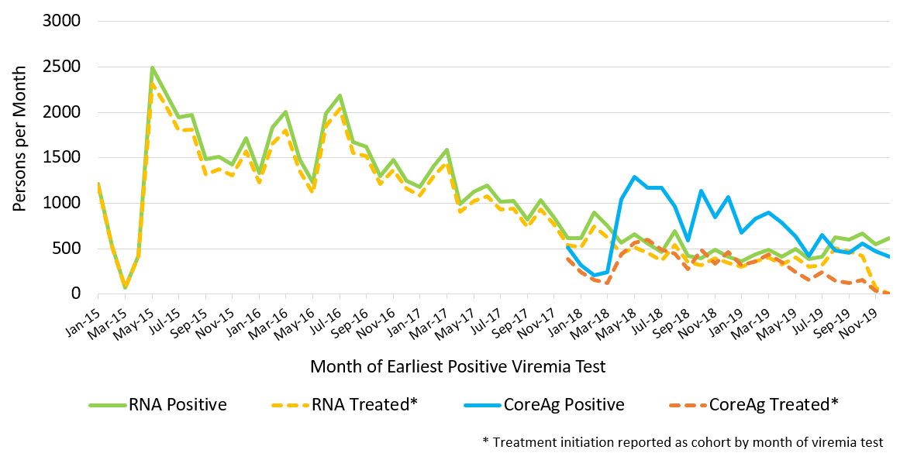
- A variety of strategies improving the linkage to viremia tests and treatment initiation have been implemented.
  - Active Follow-up of screened anti-HCV positives: During September - November 2018, NCDC in coordination with public health centers piloted a follow-up study of anti-HCV positive individuals who failed to receive viremia testing in 32 municipalities across Georgia. A total of 772 of 1,280 (60.3%) persons were reached. Of those, 336 (43.5%) were tested for viremia and 205 (61%) were positive. Only 26 (12.7%) persons were linked to HCV treatment.
  - Reflex RNA Testing: From November 6, 2018, in parallel with the centralized reflex HCV core antigen testing for hospitalized patients at the Lugar Center, six HCV service providers started performing viremia tests at their clinics for selected hospitals in Tbilisi. The proportion of anti-HCV positive inpatients who received viremia tests at HCV provider sites was slightly less (80.8%) when compared to those who had a reflex core antigen testing performed at Lugar Center (82.5%) during the same length of time. Among those who tested positive for viremic infection at these sites, the rate of treatment initiation was slightly higher for those tested at HCV provider sites (52.5%) than Lugar Center (49.5%).
  - Active Follow-up of viremic persons: From November 2018 to March 2019, Social Service Agency (SSA) staff successfully reached and conducted telephone interviews with 10,194 HCV-infected persons who were not yet enrolled in treatment using a standardized questionnaire. As of September 10, 2019, these efforts by Social Service Agency staff resulted in 14.3% (n=1,453) of patients initiating treatment.
  - Active Follow-up of viremic persons by HCV providers: Based on the Ministry of Health decree №01-1287/ო dated November 6th, 2018, which is related to interventions to increase case-finding and linkage to care within the national HCV elimination program, a total of 10 HCV provider clinics across the country agreed to contact HCV-infected persons who not engage in the treatment to invite them for treatment at their clinic. Data on approximately 29,400 persons diagnosed with HCV was released to those 10 HCV providers by SSA. As of September 10, 2019, these efforts resulted in 8,725 (29.7%) patients engaging in treatment.

Strategy 4. Improve HCV Laboratory Diagnostics

Georgia continues to use a mixed public-private model for the provision of HCV diagnostic and monitoring tests in accordance with the National Testing Algorithm (Appendix 2). In 2017, in collaboration with US CDC, Lugar Center produced a national HCV proficiency testing (PT) panel for viral load and genotyping based on College of American Pathologists (CAP) PT program model. Although the diagnosis rate has improved over the last 4 years from 26.9% in 2015 to 61.1% in 2019, Georgia has not yet met the HCV diagnosis target of 90% for 2020.

Key Accomplishments and Findings
- As of December 31, 2019, more than 500 laboratory service providers were registered in the Ministry of Health database.
- Primary detection of HCV infection in Georgia relies on voluntary testing for anti-HCV, which, if positive, should be followed by viremia testing. In 2019, the government purchased a total of 600,000 HCV rapid diagnostic test (RDT) kits from two manufactures Healgen and Acro Biotech Inc. as part of the hepatitis C elimination program. Local verification of these RDT kits, performed by Lugar Center, showed 100% sensitivity and specificity.
- The landscape of hepatitis C screening methods, including existing and approved assays to diagnose active HCV infection, has been broadened since the launch of hepatitis C elimination efforts (Table 1).

Table 1. Hepatitis C screening methods and diagnostic tests used in the HCV elimination program, December 2019
Methods | Facility/Population
Rapid diagnostic test (Government procurement) | Outpatient clinics, NCDC lab network, general population, pregnant women, harm reduction centers
Rapid diagnostic test ( from various vendors) | Hospitals (inpatients)
Laboratory based serology methods (ELISA;CLIA;CMIA ) | Blood banks (blood donors)
Quantitative HCV RNA  - All platforms  - GeneXpert® | HCV treatment provider sites (n=16)  Lugar Center for Public Health Research, NCDC  Harm Reduction centers (n=4)  NCDC laboratories (n=8)
Qualitative HCV RNA | HCV treatment provider sites (n=14)
HCV core antigen (HCVcAg) | Lugar Center for Public Health Research, NCDC

T

- In December 2017, reflex core antigen (HCVcAg) testing was introduced to increase access to free-of-charge HCV viremia testing. Since March 2018, centralized HCVcAg testing by National Reference Laboratory ,Lugar Center has been expanded to test anti-HCV positive persons screened at various settings:
  - HCV specialized and decentralized provider sites (n=15)
  - NCDC regional labs (n=2)
  - Georgian harm reduction network sites (n=13)
  - Hospitals, excluding day-patient care units (n=340)
  - Blood banks (n=22)
  - Antenatal clinics ( n=326)
- On November 6, 2018, based on ministerial order about interventions to improve case-finding and linkage to care for hepatitis C-infected persons, Tbilisi-based HCV specialized clinics with an appropriate HCV viremia testing capacity on-site and own willingness were able to perform reflex viremia testing, in addition to the Lugar Center, for the HCV-antibody positive patients hospitalized in Tbilisi hospitals.
- To perform HCV viremia testing regulatory changes were made to allow for the decentralization of HCV viremia testing among patients hospitalized in Tbilisi hospitals, which was enacted in November 2018. https://matsne.gov.ge/ka/document/view/4310537?publication=0
- During May-December 2019, the Foundation for Innovative New Diagnostics (FIND)-supported integration of HCV RNA testing on existing GeneXperts in Georgia resulted in a total of 3,511 HCV viremia tests using Xpert being performed at NCDC labs (n=8). Of these, 76.3% (n=2,680) were positive. Nearly 40% (n=1,050) initiated treatment.
- The efforts to improve access to free-of-charge HCV viremia testing increased the uptake of HCV diagnostic tests within hepatitis C elimination program (Figure 4.1)

Figure 4.1 Number of persons with HCV viremia testing per month by test methods, Georgia from September 2017 through August 2019

- The cost for diagnostic evaluation of HCV-infected patients (excluding screening and viremia testing) as well as monitoring tests during the treatment course was recognized as a deterrent to active scale up of testing and treatment services. To address this barrier government of Georgia took following measures:
  - HCV genotyping for individuals with active infection was provided free-of-charge from September 1, 2018 through the end of 2019; after which HCV genotyping was no longer required by the ministerial decree.
  - On August 1, 2019, all diagnostics for pretreatment assessment as well as monitoring during treatment became free-of-charge (Appendix 2).
- Since 2017 overall 17 laboratories (including the national reference laboratory) have been enrolled in the National External Quality Assurance (EQA) Program. During 2018-2019 HCV PT panels were distributed five times (twice in 2018 and three times in 2019) to each lab. In 2018, an HCV qualitative assay was added to the EQA Program in addition to HCV viral load and genotyping (Appendix 1). For each PT specimen, the mean and standard deviation (SD) of quantitative viral load results were calculated from all laboratories, including Lugar Center Reference Laboratory. The assessment of EQA results was based on the following criteria: +/- 1SD is regarded “Excellent”; +/-2SD is regarded as “Good” and +/-3SD is regarded as “Acceptable”.
- A total of 16 labs in 2018 and 15 labs in 2019 participated in at least one of the scheduled PT rounds and performed HCV RNA viral load and genotyping tests. Of them,13 laboratories performed qualitative HCV RNA tests.
- The cumulative 2018 EQA Program results for quantitative HCV RNA viral load were “excellent” in 78.1% of all PT specimens; “good” in 8.1%; and “acceptable” in 1.9%. According to 2019 EQA Program results, the results for quantitative HCV RNA viral load were “excellent” in 74.7%; “good” in 21.1%; and “acceptable” in 4.1%. In most cases, the problems identified were related to improper use of quantitative HCV PCR calibrators, or non-compliance to the manufacturer’s recommendations on PCR platform-reagent combinations.
- In 2018 all laboratories accurately detected common genotypes. Only 31.5% of laboratories (5/16) correctly interpreting an unusual genotype (1b/2). In 2019 nine laboratories reported incomplete genotype results and one laboratory reported a false genotype result.
- Six laboratories reported false negative results for the qualitative interpretation of HCV RNA specimen during 2019 EQA PT rounds. No false positive results were reported by any laboratories.
- The first National EQA Program Workshop was held on April 19-21, 2019 in Borjomi, Georgia. The workshop emphasized the important role of the national reference laboratory in quality assurance of the National EQA Program. The discussion topics included EQA program report evaluation; quality assurance of pre- and post-analytical stages; monitoring activities of EQA Panel preparation (labeling, packaging, cold chain, shipment, etc.); data management systems; and future steps to improve EQA Program effectiveness.

Strategy 5. Provide Comprehensive HCV Care and Treatment
Launched in April 2015, the initial risk of the HCV elimination program prioritized antiviral therapy for HCV for population at highest risk for HCV-associated morbidity and mortality: infected persons with advanced liver disease, defined as F3 or F4 by METAVIR fibrosis score and/or FIB-4 score >3.25. In June 2016, eligibility criteria expended, allowing all HCV-infected patients to enroll in the program regardless of live-disease severity. Curative antiviral therapy was provided free of charge through a partnership with Gilead Sciences.
At the start of the program, all participants received sofosbuvir (SOF)-based antiviral treatment regimens, in combination with ribavirin alone or pegylated interferon and ribavirin. Beginning in March 2016, the majority of patients began receiving sofosbuvir/ledipasvir (SOF/LED)-based regimens.

Key Accomplishments and Findings
- The number of treatment centers has increased since the launch of the elimination program, from four centers in April 2015 to 40 centers by December 31, 2019. A total of 11 decentralized HCV provider clinics were enrolled in the program during 2018, with four more joining during 2019.
- Since August 1, 2018, HCV-infected patients’ cases have been reviewed electronically in real-time by the treatment inclusion committee members, reducing the delays to treatment initiation. The median number of days between committee revision and treatment initiation was 28 (IQR: 21-38) during February-July 2018 compared to 9 days (IQR 5-16) after the implementation of electronic committee review (August 2018-January 2019).
- From December 2018, Velpatasvir/ Sofosbuvir (Epclusa) medicine available for patients with HCV genotype 2 and 3.
- On August 1, 2019, treatment guidelines were updated within the hepatitis C elimination program and clinical monitoring and laboratory assessment was simplified upon TAG recommendations (Appendix 2)
- The national screening registry and HCV treatment database allows for clinical monitoring and program evaluation across the care cascade. As of December 31, 2019, a total of 64,537 HCV-infected persons were enrolled in the treatment program, which represents 50.3% of national target of treating 95% of diagnosed persons by 2020
- Since peaking in 2016, treatment uptake has slowed to approximately 1,000 patients per month and it remains stable during 2019.
- Sustained viral response (SVR) reached 98.7% (42,194/42,734) among patients eligible and tested for SVR, including retreatments; the SVR rate calculated using an “intent to treat” analysis (which took into account persons who completed treatment but did not receive SVR testing) was 73.6%.
- A total of 1,552 persons were retreated with 94.2% (729/774) of those tested achieving SVR.
- In 2019 Georgia’s comprehensive HCV elimination program was recognized as the first European Association for the Study of Liver-international Liver Foundation (EILF) Center of Excellence in VIral Hepatitis Elimination.
- Since the launch of decentralized HCV care and treatment in August 2019, a total of 11 primary healthcare (PHC) facilities throughout the country have been providing HCV care services. At the initial phase of decentralization, only HCV treatment-naïve patients with no or mild fibrosis (FIB-4 score<1.45) were treated using simplified diagnostics and a treatment monitoring approach. Treatment eligibility criteria were later expanded to those with FIB-4 score between 1.45 and 3.25, while persons with cirrhosis were referred to specialized clinics.
- Overall, 557 patients received DAA treatment at PHC facilities by the end of 2019 and 97% (122/129) achieved SVR.
- Ministry of Internally Displaced Persons from the Occupied Territories Labour, Health, and Social Affairs has begun improving access for people who inject drugs (PWID) by decentralizing HCV treatment, offering therapy in three harm reduction centers and one OST site.
- As of December 31, 2019, a total of 801 HCV antibody positive PWIDs received HCV RNA or core antigen testing to determine active HCV infection after the launch of HCV decentralization in Harm Reduction sites; 672 persons (83.9%) had active HCV infection and 519 were tested for FIB-4 score on site. Overall, 269 persons initiated treatment and 10 persons discontinued treatment. Among 123 persons tested for SVR, 121 (98.4%) has been successfully cured.

Strategy 6. Improve HCV Surveillance

Key Accomplishments and Findings
- To focus on sentinel sites for HCV and HBV biomarker testing and collection of epidemiological information, four infectious disease hospitals were selected in Tbilisi, Imereti, Samegrelo and Adjara regions. NCDC has revised the case definitions for acute and chronic hepatitis B and C and developed surveillance reporting forms. The sentinel sites are obliged to fill the reporting forms and register hepatitis B and C confirmed cases in an Excel database (Governmental decree dated December 31st, 2019). https://matsne.gov.ge/ka/document/view/4762618
- From July through December 2018, within the research project (Descriptive, Retrospective Study on the Prevalence of Acute Viral Hepatitis in Georgia) a total of 222 cases with acute viral hepatitis and 40 cases of jaundice were studied using the medical charts from 24 medical facilities in 9 regions of Georgia. Study findings demonstrated that clinical diagnoses do not correspond to case definitions in the national epidemiological surveillance. More than half of cases clinically diagnosed with acute HCV were not laboratory confirmed.
- From November 2018 through January 2019, a total of 119 medical charts of liver cancer cases from multiple hospital types and regions were studied. The plurality (42.0%; n=50) were categorized as unspecified liver cancer, followed by 28.6% (n=34) cases with hepatocellular carcinoma (HCC). Nearly 50% of all HCC cases (by diagnosis) were reported to have chronic HCV infection. Symptoms and risk factors for HCC patients frequently were not properly described in the medical charts. Overall, 37 out of 119 patients (31.1%) were found to have hepatitis C screening results after data was linked with the national screening registry and of those, 75.7% (28/37) were anti-HCV positive.
- Based on the Governmental decree dated December 31st, 2019 about State programs, including Epidemiologic Surveillance program , the municipal public health centers should ensure tracking and linkage to care for HCV-antibody positive persons who have not yet received HCV viremia testing. https://matsne.gov.ge/ka/document/view/4762618

STRATEGY-SPECIFIC CHALLENGES TO HCV ELIMINATION

Improving Awareness:
- Limited time and scope of communication campaigns due to limited resources
- Low quality and effectiveness of campaigns due to:
  - Technical barriers to contract professional public relations (PR) companies due to complex bidding process
  - Professional PR companies not interested in the project due to low budget allocation for health promotion and awareness activities by the Government
- Inadequate involvement of primary healthcare workers in HCV awareness activities due to lack of information, low motivation, and poor interpersonal communication skills

Preventing Transmission:

Harm Reduction:
- Lack of trust regarding perceived confidentiality and anonymity among PWID enrolled in the national screening registry
- Inconsistencies in data between the harm reduction program and the national screening registry
- Existing drug addiction related stigma, particularly of female drug users, hinders access to harm reduction services and HCV care
- Lack of information about the hepatitis C elimination program among PWIDs
- Lack of educational programs in harm reduction sites to address misconceptions about the treatment program

Blood Safety:
- Decentralization and fragmentation of the blood transfusion service
- Lack of a supervisory body at the central level
- Existence of profit-based and unregulated blood banks
- The predominant practice of paying donors, which compromises blood safety practices
- Lack of standardization of clinical guidelines and deficient testing algorithms for donated blood in some blood banks
- Suboptimal donor selection and laboratory screening practices
- Reliance on semi-automated and rapid-test platforms for testing blood donations
- Lack of effective quality assurance and control systems
- Suboptimal national regulations and non-compliance with European standards

Infection Prevention and Control:
- Need for a national IPC strategy and action plan - only partially noted in national Antimicrobial Resistance Strategy and Hepatitis C Elimination Program Strategy documents
- Absence of IPC monitoring in facilities with ambulatory care
- Absence of mandatory pre-licensing IPC system assessment for new dental clinics
- Scarce data on HAI limits the opportunity for effective and timely IPC interventions
- Low engagement and involvement of professional medical associations to educate medical personnel about IPC
- Lack of standardized curriculums in IPC
- Lack of IPC measures in beauty salons, including inefficient and inadequate inspection processes

Identifying Infected Persons and Linking them to Care:
- Steadily declining rates of anti-HCV positivity among the screened population
- Suboptimal numbers of anti-HCV positive persons receiving viremia testing
- HCV Screening and testing for viremia often are conducted at different sites
- Insufficient counselling of patients diagnosed with HCVcAg
- Suboptimal rates of linkage to care among persons with HCV infection confirmed by HCVcAg

Improving Laboratory Diagnostics:
- Lack of a quality assurance system for HCV rapid tests
- No national system for licensing laboratory professionals
- Absence of uniform national standard operating procedures (SOPs) for the country’s HCV diagnostic laboratories
- Lack of standardized comprehensive training programs for laboratory personnel on quality and biosafety standards and practices
- Lack of HCV viremia testing sites in the regions

Providing Care and Treatment:
- Lack of European Association for the Study of the Liver (EASL) or American Association for the Study of Liver Diseases (AASLD) recommended regimens to guide therapy for patients who require retreatment after failing to achieve SVR with their initial DAA course
- Limited treatment options for patients with end-stage kidney disease, including hemodialysis
- Limited provider capacity and scarcity of treatment centers, especially PHCs in some rural and geographically disparate areas
- Need for futher simplification of treatment algorithms and patient management
- Need for increased training for PHC doctors and HR staff to improve their knowledge and skills in HCV management
- Hepatocellular carcinoma surveillance among cirrhotic patients with SVR not yet incorporated into the HCV elimination program

Improving Surveillance:
- Issues of timeliness, accuracy, and completeness of data collection associated with current HCV surveillance system
- Failure of current system to adequately capture and promptly identify seroconversion cases of HCV infection among populations at risk (e.g., PWID, persons receiving dialysis, repeat blood donors)
- Lack of an HCC surveillance system among cirrhotic patients treated within the hepatitis C elimination program

Monitoring & Evaluation: Advocacy, Awareness and Education, and Partnerships
Objective | Indicator name | Measurement | Data Source | Value/Result  (2019) | Value/Result  (2018) | Value/Result  (2017) | Value/Result  (2015-2016)
1.1. Educate the public and high-risk groups about viral hepatitis and the importance of testing | 1. Levels of awareness among the general public regarding  a) HCV transmission  b) HCV prevention  c) Testing and diagnosis  d) Treatment | High Awareness  All or most participants aware  Medium Awareness  Some participants aware  Low Awareness  Few or no participants aware | KAP survey 2016*  Small scale  Facebook survey**  Qualitative survey*** | ***  a) n/a  b) n/a  c) Low  d) Low | **  a) Medium  b) Medium  c) Medium  d) Low | **  a) High  b) Medium  c) High  d) Medium | *  a) High  b) Medium  c) High  d) Medium
 | 2. Levels of awareness among PWID regarding  a) HCV transmission  b) HCV prevention  c) testing and diagnosis  d) treatment | High Awareness  All or most participants aware  Medium Awareness  Some participants aware  Low Awareness  Few or no participants aware | KAP survey 2016*  BBSS 2017**  Qualitative study (GHRN)*** | ***  a) n/a  b) n/a  c) Low  d) Low | Data not available | **  a) Medium  b) Low  c) Medium  d) Medium | *  a) High  b) Medium  c) High  d) Medium
1.2 Reduce community-level stigma and discrimination associated with HCV infection | 3. Level of perceived HCV-related stigma and discrimination experienced among HCV patients in healthcare and other settings (e.g., work, housing, school, corrections) |  |  | Data not available | Data not available | Data not available | Data not available

Monitoring & Evaluation: Harm Reduction
Objective | Indicator name | Measurement | Data source | Value/Result (2019) | Value/Result (2018) | Value/Result (2017) | Value/Result (2015-2016)
2A. Decrease HCV incidence among PWID by promoting harm reduction | 1. Number and percentage of PWID reached with preventive counseling (Defined Package of Services)  * The beneficiary is considered reached if received at least two services from the list of basic package (condom, consultation, information materials, syringe/needle) and one of them has to be syringe/needle | Numerator  Number of PWID reached with preventive counseling | Database of PWID receiving HIV counseling and testing (HCT); GHRN | 68.2%  (N=35,811)  (N=52,500)  PSE 2017 | 56.9%  (N=29,891)  (N=52,500)  PSE 2017 | 51.9%  (N=27,250)  (N=52,500)  PSE 2017 | 61.0%  (N=30,330)  (N=49,700)  PSE 2014
 |  | Denominator  Estimated number of PWID | Population size estimation (PSE) of PWIDs in Georgia
 | 2. Number and percentage of PWID enrolled in OST | Numerator  Number of PWID enrolled in OST | Social Service Agency  (Ministry of Health) | 58.7%  (N= 9,552)  (N=16,275)**  IBSS 2017 | 59.0%  (N= 9,606)  (N=16,275)**  IBSS 2017 | 45.4%  (N=7,381)  (N=16,275)**  IBSS 2017 | 20.2%  (N=4,435)  (N=22,000)**  IBSS 2014
 | 2. Number and percentage of PWID enrolled in OST | Denominator  Estimated number of opioid user PWID | Integrated Bio-Behavioral Surveillance Survey (IBSS)  **31% of estimated PWIDs
 | 3. Number and percentage of PWID screened for HCV infection at:  a. NSP sites and Outreach  b. OST service centers  c. Mobile ambulatories | Numerator  Number of PWID screened for HCV infection | a) Harm reduction program records  b c) National HCV screening registry | a. 23.0%  b. 51.8%  c. 27.2%  a. N= 12,065  b. N=8.426**  c. N= 14,259  (N=52,500)* (N=16,275)** | a. 20.4%  b. 47.1%  c. 18.4%  a. N= 10,691  b. N=7,660**  c. N= 9,659  (N=52,500)* (N=16,275)** | a. 22.6%  b. n/a  c. 18.6%  a. N= 11,885  b. N=n/a  c. N= 9,745  (N=52,500)* | a. 48.2%  b. n/a  c. 20.7%  a. N= 23,969  b. N=n/a  c. N= 10,304  (N=49,700)*
 |  | Denominator  Estimated number of current PWID | *PSE  **IBSS
 | 4. Number and percentage of PWID with presence of anti-HCV antibodies | Numerator  Number of PWID with anti-HCV positivity | ∗Harm reduction program records  ∗∗National HCV screening registry | 16.6%*  (N=3,945)∗  27.0%**  (N= 4,479)∗∗  (N= 23,819)∗  (N=16,590)∗∗ | 22.8%*  (N= 4,574)∗  30.8%**  (N= 3,411)∗∗  (N= 20,067 )∗  (N=11,085)∗∗ | 32.1%*  (N= 6,850)∗  36.8%**  (N= 1,941)∗  (N= 21,371)∗  (N=5,280)∗∗ | 43.6%*  (N= 10,469)∗  N/A  (N= 23,969)∗
Denominator
Number of PWID tested for HCV infection

 | 5. Number and percentage of PWID testing positive on rapid tests who undergo HCV viremia testing | Numerator  Number of PWID tested for HCV RNA or HCV core antigen testing | Treatment database  National HCV screening registry | 75.4%  (N=3,377)  (N= 4,479) | 64%  (N=2,187)  (N= 3,411) | 50.5%  (N=981)  (N=1,941) | Data not available
Denominator
Number of PWID with anti-HCV positive results
 | 6. Number and percentage of PWID diagnosed with active HCV infection | Numerator  Number of PWID diagnosed with active HCV infection based on virologic biomarker testing | Treatment database  National HCV screening registry | 84.4%  (N=2,850)  (N=3,377) | 90%  (N=1,968)  (N=2,187) | 87.7%  (N=861)  (N=981) | Data not available
Denominator
Number of PWID who were tested for HCV RNA or HCV core antigen testing
 | 7. HCV prevalence among PWID by IBBS study |  | IBBS | N/A | N/A | 63.2%  Value is pooled estimate from IBBS 2017. Actual numerator unknown. | 66.2%  Value is pooled estimate from IBBS 2014. Actual numerator unknown.
 | 8. Number and percentage of PWID with active HCV infection who started HCV treatment | Numerator  Number of PWID started HCV treatment | Treatment database | 74.5%  (N= 2,123)  (N=2,850) | 68.3%  (N= 1,346)  (N=1,968) | 75.6%  (N= 651)  (N= 861) | Data not available
Denominator
Number of PWID with diagnosed HCV infection
 | 9. Number and percentage of PWID treated in the program who completed treatment | Numerator  Number of PWID completed antiviral treatment | Treatment database | 89.5%  (N= 1,900)  (N= 2,123) | 82.6%  (N= 1,112)  (N= 1,346) | 78.5%  (N= 511)  (N= 651) | Data not available
Denominator
Number of PWID initiated HCV treatment
 | 10. Number and percentage of PWID completing treatment who achieved sustained virologic response (SVR) | Numerator  Number of PWID who achieved SVR | Treatment database | 98.6%  (N=1,255)  (N=1,273) | 97%  (N=619)  (N=638) | 95.8%  (N=282)  (N=294) | Data not available
Denominator
Number of PWID assessed for SVR 12-24 weeks after the end of treatment

 | 11. Percentage of PWID reporting use of sterile injecting equipment the last time they injected | Numerator  Number of PWID reporting use of sterile injecting equipment the last time they injected | IBBS | N/A | N/A | 91.6%  Value is estimate from IBBS 2017. Actual numerator unknown  (N=52,500) | 80.4%  Value is estimate from IBBS 2014. Actual numerator unknown  (N=49,700)
Denominator
Estimated number of PWID

Monitoring & Evaluation: Blood Safety
Objective | Indicator name | Measurement | Data source | Value/Result (2019) | Value/Result (2018) | Value/Result (2017) | Value/Result (2015-2016)
2B.a Prevent healthcare-related transmission of viral hepatitis by improving blood safety | 1. Number and percentage of all blood banks participating and operating in the Unified Blood Donor Electronic Database (Donor Database) | Numerator  Number of blood banks participating and operating in  the Donor Database | Donor Database | 100%  (N=22)  (N=22) | 100%  (N=22)  (N=22) | 95.5%  (N=21)  (N=22) | 90%  (N=18)  (N=20)
 |  | Denominator  Total number of blood banks holding state license in blood production service | State Regulation Agency for Medical Activities
 | 2. Lead agency is established at central level to oversee and coordinate blood service in the country | Appropriate legislative act | MoH | Not established | Not established | Not established | Not established
 | 3. Licensing regulations for blood banks are established, approved, and published | Appropriate legislative act | Legislative Department of MoH | Not established | Not established | Not established | Not established
 | 4. Number and percentage of voluntary donations among all blood donations | Numerator  Number of voluntary donations | Donor Database | 32.7%  (N=30,876)  (N=94,457) | 27.5%  (N=25,064)  (N=91,020) | 23.1%  (N=20,283)  (N=87,881) | 30.5%  (N=26,379)  (N=86,608)
 |  | Denominator  Total number of blood donations | Donor Database
 | 5. Proportion of anti-HCV reactive persons among blood donors | Numerator  Number of blood donors with anti-HCV positive results | Donor Database | 0.8%  (N=419)  (N=55,779) | 1.1%  (N=541)  (N=51,289) | 1.4%  (N=727)  (N=51,799) | 1.8%  (N=912)  (N=51,731)
Denominator
Total number of unique blood donors

 | 6. Proportion of blood donors tested for HCV by NAT and/or other sensitive tests | Numerator  Number of blood donors tested for viremia after a positive serologic test | Donor Database  Elimination C  STOP-C databases  Screening registry | 62.3%  (N=2,506)  (N=4,025)  Donors screened  2015-2019 | 60.7%  (N=2,226)  (N=3,665)  Donors screened  2015-2018 | 41.7%  (N=1,193)  (N=2,860)  Donors screened  2015-2017 | Data not available
Denominator
Number of seroreactive blood donors

 | 7. Proportion of blood donors diagnosed with chronic HCV infection | Numerator  Number of blood donors tested positive by HCV viremia testing (Core Ag, PCR) | Elimination C  STOP-C databases  Screening registry | 69.6%  (N=1,745)  (N=2,506) | 71.2%  (N=1,584)  (N=2,226) | 75.8%  (N=904)  (N=1,193) | Data not available
Denominator
Total number of unique blood donors tested for viremic HCV infection
 | 8. Degree of the continuity of care (Percentage of HCV confirmed blood donors enrolled in the HCV treatment program) | Numerator  Total number of HCV viremic donors enrolled in the treatment program | Elimination C  STOP-C databases  Screening registry  Data since the launch of the program in 2015 | 71.9%  (N=1,254)  (N=1,745) | 75.2%  (N=1,191)  (N=1,584) | 79.9%  (N=722)  (N=904) | Data not available
Denominator
Total number of donors with active HCV infection

Monitoring & Evaluation: Infection Control
Objectives | Indicator name | Measurement | Data source | Value/Result (2019) | Value/Result (2018) | Value/Result (2017) | Value/Result (2015-2016)
2C.a  Prevent healthcare-associated transmission of viral hepatitis by improving infection control in healthcare facilities | 1. National guidelines on IPC | Scale indicator:  0 = not started; 1 = under development; 2 = draft complete /developed; 3 = published. | Published guidelines | 2 | 2 | 2 | 1
 | 2. Number of medical universities and nursing colleges with IPC curriculum introduced into training program |  | Survey conducted by MoH/ NCDC  Ministry of Education | 4 | 2 | 2 | 1
 | 3. Percentage of healthcare facilities in compliance with national IPC guidelines | Numerator  Number of health-care facilities compliant with national guidelines | Survey conducted by MoH/ NCDC | 11.0%*  (N=6)  (N=54) | 11.0%*  (N=6)  (N=54) | 18%  (N=12)  (N= 66) | 26.3%  (N=5)  (N=19)
Denominator
Number of health-care facilities surveyed
 | 4. Percentage of healthcare facilities with an appointed IPC focal person | Numerator:  Number of health-care facilities with appointed IPC focal person | Survey conducted by MoH/ NCDC | 96.3%*  (N=52)  (N= 54) | 96.3%*  (N=52)  (N= 54) | 100%  (N=66)  (N= 66) | 100%  (N=19)  (N= 19)
Denominator:
Number of health-care facilities surveyed
 | 5. Percentage of healthcare facilities with functional IPC committees | Numerator:  Number of health-care facilities with active IPC committees | Survey conducted by MoH/ NCDC | 92.6%*  (N=50)  (N= 54) | 92.6%*  (N=50)  (N= 54) | 100%  (N=66)  (N= 66) | 73.7%  (N=14)  (N= 19)
Denominator:
Number of health-care facilities surveyed
 | 6. Percentage of healthcare facilities displaying materials on IPC awareness | Numerator  Number of health-care facilities displaying IPC-awareness materials | Survey conducted by MoH/ NCDC | 72.2%*  (N=39)  (N= 54) | 72.2%*  (N=39)  (N= 54) | 90.9%  (N=60)  (N= 66) | 42.1%  (N=8)  (N= 19)
Denominator
Number of health-care facilities surveyed
2C.b Prevent HCV transmission in non-traditional healthcare and other community settings | 1. Percentage of non-medical facilities where SOPs are available | Numerator  Number of non-medical facilities where SOPs are available | Survey conducted by NCDC  and regional public health centers | 75.4%  (N=3,377)  (N= 1,405) | 89.0%  (N=733)  (N= 824) | 100%  (N=416)  (N= 416) | Data not available  Survey planned for 2017
 |  | Denominator Total number of surveyed non-medical facilities
 | 2. Number of non-medical facility staff trained in IPC |  | NCDC and regional public health centers | 1,200 | 824 | 1,500 | 50

Monitoring & Evaluation: Screening
Objective | Indicator name | Measurement | Data source | Value/Result**  (2019) | Value/Result  (2018) | Value/Result  (2017) | Value/Result  (2015-2016)
3.1  Expand HCV testing to better reach high-risk populations | 1. Number of persons tested for hepatitis C antibody  - All locations*  - Prisoners  - People living with HIV/AIDS  - Pregnant women at ANC clinics  - TB patients  - Hemodialysis patients  - Inpatients  - PWIDs |  | Screening registry  State Healthcare Program | 1) 965,422  2) 2,628  3) 4,011  4) 34,004  5) 1,994  6) N/A  7) 307,626  8) 6,157 | 1) 702,061  2) 2,020  3) 3,599  4) 42,218  5) 2,693  6) 2,679  7) 287,978  8) 5,905 | 1) 744,983  2) 4,127  3) 1,220  4) 43,097  5) 414  6) 1,912  7) 378,762  8) 5,280 | 1) 472,890***  2) 14,053***  3) 1,790  4) 53,852***  5) N/A  6) N/A  7) 48,506  8) 44,410***
 | 2.Proportion of persons screened anti-HCV positive  - All locations  - Prisoners  - People living with HIV/AIDS  - Pregnant women at ANC clinics  - TB patients  - Hemodialysis patients  - Inpatients  - PWIDs | Numerator  Number of persons with HCV seropositivity | Screening registry | 1) 2.2%(21,421)  2) 12.3% (324)  3) 36.0% (1,442)  4) 0.5% (182)  5) 16.6% (331)  6) N/A  7) 21.5%(6,609)  8) 18.6%(1,144) | 1) 3.5% (24,988)  2) 23.5% (474)  3) 39.5% (1,420)  4) 1.1% (481)  5) 19.7% (532)  6) 23.8% (637)  7) 3.0% (8,740)  8) 24.9% (1,471) | 1) 5.0% (37,351)  2) 12.6% (521)  3) 30.6% (1,220)  4) 0.6% (243)  5) 18.1% (75)  6) 16.7% (320)  7) 3.8% (14,521)  8) 36.8%(1,941) | 1) 11.0% (52,018)  2) 37.4% (5,255)  3) 24.9% (446)  4) 0.4% (2015)  5) N/A  6) N/A  7) 4.9% (2,353)  8) 45.0% (19,984)
Denominator
Number of persons screened for Hepatitis C
 | 3. Number and percentage of children born to HCV-positive women screened for hepatitis C | Numerator  Number of children born to HCV-infected mothers and screened for hepatitis C |  | Data not available | Data not available | Data not available | Data not available
Denominator
Total number of children born to HCV-positive women during the reporting period
* Includes outpatients, blood banks, NCDC, public service halls, et al. in addition to those listed in the table
** Individual year data are not mutually exclusive *** Unique persons screened for 2015-2016 are unavailable – number of screening tests performed are presented

Monitoring & Evaluation: Laboratory Diagnostics
Objective | Indicator name | Measurement | Data source | Value/Result (2019) | Value/Result (2018) | Value/Result (2017) | Value/Result (2015-2016)
4.1  Improve laboratory detection of HCV infection | 1. Number of HCV viremia testing sites (laboratories and point of care diagnostic sites)* enrolled in the national hepatitis C EQA program |  | NCDC Lugar Center  * includes the national reference laboratory | N=17 | N=17 | N=16 | 0
4.1  Improve laboratory detection of HCV infection | 2. Proportion of HCV viremia testing sites that participated on all EQA challenges per year | Numerator  Number of laboratories performing HCV viremia testing that participated on all EQA challenges per year | NCDC Lugar Center  * includes the national reference laboratory | 76.5%  (N=13)  (N=17) | 88%  (N=15)  (N=17) | 75%  (N=12)  (N=16) | 0
4.1  Improve laboratory detection of HCV infection |  | Denominator*  Total number of laboratories performing HCV viremia testing enrolled in national EQA
4.1  Improve laboratory detection of HCV infection | 3. Quality Management System (QMS) standards for certification are defined, approved, and published |  | Published QMS standards, Ministry | Ongoing | Ongoing | Ongoing | Not done yet
4.1  Improve laboratory detection of HCV infection | 4. Proportion of labs providing HCV lab services certified according to national laboratory quality management system (QMS) standards | Numerator  Number of laboratories performing HCV lab services that are certified according to national QMS standards | Ministry of Health  Not applicable until national laboratory QMS standards are approved | N/A | N/A | N/A | N/A
4.1  Improve laboratory detection of HCV infection |  | Denominator  Total number of laboratories performing hepatitis C laboratory services

Monitoring & Evaluation: Care and Treatment
Objective | Indicator name | Measurement | Data Source | Value/Result  (2019) | Value/Result  (2018) | Value/Result  (2017) | Value/Result  (2015-2016)
5.1. Promote universal access to HCV care and treatment | 1. Proportion of anti-HCV positive persons assessed for viremic HCV infection | Numerator  Number of HCV antibody positive persons tested for viremic HCV infection | Elimination C  STOP-C databases  Screening registry  Data since the launch of the program in 2015 | 80.4%  (N=100,844)  (N=124,312) | 74.6%  (N=78,611)  (N=105,393) | 63%  (N=51,205)  (N=81,242) | 65.5%  (N=38,113)  (N=58,223)
5.1. Promote universal access to HCV care and treatment |  | Denominator  Number of people with a presence of anti-HCV antibodies (treatment eligible Age ≥ 12)
5.1. Promote universal access to HCV care and treatment | 2. Proportion of persons diagnosed with chronic HCV infection | Numerator  Number of persons diagnosed with chronic HCV infection based on virologic biomarker testing | Elimination C  STOP-C databases  Screening registry  Data since the launch of the program in 2015  National sero-prevalence survey conducted in 2015 | 81.8%  (N=82,486)  (N=100,844)  ◊61.1% | 85.2%  (N=67,001)  (N=78,611)  ◊49.6% | 91%  (N=46,573)  (N=51,205)  ◊34.5% | 95.3%  (N=36,322)  (N=38,113)  ◊26.9%
5.1. Promote universal access to HCV care and treatment |  | Denominator  Number of persons tested for viremia after a positive serological result  ◊ Target of identifying 90% of persons infected with HCV infection: N=135,000
5.1. Promote universal access to HCV care and treatment | 3. Proportion of persons with chronic HCV infection who initiated antiviral therapy | Numerator  Number of persons diagnosed with chronic HCV infection who initiated antiviral therapy | Elimination C  STOP-C databases  Screening registry  Data since the launch of the program in 2015  National sero-prevalence survey conducted in 2015 | 78.2%  (N=64,537)  (N=82,486)  ◊50.3% | 78.5%  (N=52,594)  (N=67,001)  ◊41% | 91%  (N=42,391)  (N=46,573)  ◊33% | 76%  (N=27,595)  (N=36,322)  ◊21.5%
5.1. Promote universal access to HCV care and treatment |  | Denominator  Number of persons diagnosed with chronic HCV infection  ◊Target of treating 95% of persons with chronic HCV infection: N=128,250
5.1. Promote universal access to HCV care and treatment | 4. Proportion of patients engaged in antiviral therapy who have completed treatment | Numerator  Number of patients with chronic HCV infection who have completed treatment | Elimination C  STOP-C databases  Data since the launch of the program in 2015 | 92.2%  (N=59,485)  (N=64,537) | 93%  (N=48,928)  (N=52,594) | 89.5%  (N=37,948)  (N=42,391) | 71.7%  (N=19,778)  (N=27,595)
5.1. Promote universal access to HCV care and treatment |  | Denominator  Number of patients diagnosed with chronic HCV infection who initiated treatment
5.1. Promote universal access to HCV care and treatment | 5. Proportion of patients achieving SVR to HCV therapy | Numerator  Number of patients who completed treatment and achieved SVR (undetectable viral load 12-24 weeks after the end of treatment) | Elimination C  STOP-C databases  Data since the launch of the program in 2015  National sero-prevalence survey conducted in 2015 | 98.7%  (Per-protocol)  73.6%  (Intention-to-treat)  (N=42,194)  (N=42,734)  ◊34.6% | 98.3%  (Per-protocol)  73.9%  (Intention-to-treat)  (N=34,493)  (N=35,106)  ◊28.3% | 98.2%  (Per-protocol)  75.7% (Intention-to-treat)  (N=26,692)  (N=27,181)  ◊21.9% | 84.1%  (Per-protocol)  (N=26,692)  (N=27,181)  ◊21.9%
5.1. Promote universal access to HCV care and treatment | 5. Proportion of patients achieving SVR to HCV therapy | Denominator  Number of patients who completed antiviral therapy and were assessed for SVR 12-24 weeks post treatment  ◊ Target of curing 95% of persons treated for their HCV infection: N=121,838
 | 6. Number of physicians providing HCV services  OR  provider/resident ratio | Numerator  Number of physicians providing HCV services: | Ministry of Health | 5.1 per  100,000 residents  N=155 | 5.1 per  100,000 residents  N=155 | 4.6 per  100,000 residents  N=139 | 4.6 per  100,000 residents  N=139
Denominator
Estimated resident population: 3,010,200
 | 7. Number of  a) Primary Health-care Centers  b) Harm Reduction Sites  providing HCV care and treatment |  | Ministry of Health | a) 7  b) 4 | a) 7  b) 4 | 0 | 0

Monitoring & Evaluation: Surveillance
Objective | Indicator name | Measurement | Data source | Value/Result  (2019) | Value/Result  (2018) | Value/Result  (2017) | Value/Result  (2015-2016)
6.1  Estimate the national burden of chronic viral hepatitis C | 1. The incidence of HCV infection | Numerator  Total number of new infections with HCV, defined as anti-HCV positive, per year | Prospective cohort study of the reinfection rate among treated and cured PWID* | Data not available | Data not available | 1.2 per year*  2/169 person-years of follow-up | 1.4 per year*  2/138.9 person-years of follow-up
 | 1. The incidence of HCV infection | Denominator  Total population minus people living with hepatitis C
 | 2. Number of deaths attributable to HCV-associated cirrhosis or hepatocellular carcinoma (HCC) | Number of deaths from HCC and cirrhosis attributable to HCV infection | Death Registry/Cancer registry  HCC (ICD-10 code C22.0)  Cirrhosis (ICD-10 codes K74.3, K74.4, K74.5, K74.6) | Data not available | Data not available | Data not available | Data not available

RESEARCH AND SCIENCE

Progress and Outcomes
- In 2017-2019 the Scientific Committee (SC) continued program support by reviewing and approving research proposals focused on hepatitis C related topics. The committee representing diverse groups of interest such as policy makers, clinicians, and researchers was established in August 2016. Besides its primary purpose (review and approval of the submitted proposals) the committee
- assisted the researchers in
- Securing funding
- obtaining IRB approvals
- study implementation
- data analysis and manuscript writing
- coordinated its activities with the Ministry of Health, Program Clinical Committee, and international organizations to increase overall efficiency of the supported research programs.
- served as a platform for the invited speakers to disseminate international research findings.
- As of December 31, 2019 the committee reviewed a total of 63 research proposals, of which 55 were approved. Approved proposals represent different types of research such as:
- Description of both immediate and long-term clinical outcomes of DAA treatment both in general and special populations
- Assessment of the national hepatitis C elimination program: treatment outcomes and associated factors
Objective: evaluation of treatment outcomes of the elimination program.
PI: Dr. Tengiz Tsertsvadze, Infectious Diseases AIDS and Clinical Immunology Research Center (IDACIRC) /Clinic Hepa
- Long-term health outcome among HCV patients with advanced liver fibrosis treated through HCV elimination program in Georgia
Objective: evaluation of long-term treatment outcomes (changes in liver fibrosis level, five-year risk of decompensated liver cirrhosis, five-year risk of hepatocellular carcinoma, the survival, and changes in quality of life) among patients with advanced liver fibrosis treated with DAAs after achieving SVR.
PI: Dr. Maia Butsashvili, Health Research Union (HRU)/Clinic Neolab
- Epidemiology of HBV infection among HCV patients treated with Direct Acting Antivirals (DAAs)
Objective: Description of HBV infection epidemiology and evaluation of DAA treatment outcomes among HBV/HCV co-infected patients treated as part of the program.
PI: Dr. George Kamkamidze, Health Research Union (HRU)/Clinic Neolab
- Comparing engagement in HCV care and treatment outcomes between HIV negative and HIV positive persons within the national hepatitis C elimination program
Objective: Description of the care cascade and evaluation of DAA treatment outcomes among HIV/HCV co-infected patients treated as part of the program.
PI: Dr. Tengiz Tsertsvadze, IDACIRC /Clinic Hepa
- Epidemiology of tuberculosis and hepatitis C co-infection in the Country of Georgia
Objective: Description of tuberculosis (TB) epidemiology and evaluation of DAA treatment outcomes among TB/HCV co-infected patients treated as part of the program.
PI: Dr. Davit Baliashvili, Emory University
- Eliminating HCV infection in prison settings in Georgia
Objective: Evaluation of engagement in the HCV care continuum in prison settings of Georgia
PI: Dr. Tengiz Tsertsvadze, IDACIRC /Clinic Hepa

- Evaluation of novel treatment and diagnostics delivery models both at specialized ad non-specialized (such as primary healthcare and harm reduction) HCV care settings
- Integrating HCV screening and simplified treatment services in primary healthcare Objective: Implementation and evaluation of integrated simplified diagnostic and monitoring algorithms coupled with hepatitis C treatment (“one stop shop”) in primary healthcare settings. This project served as decentralization pilot project and preceded national roll-out of HCV care decentralization into primary healthcare setting.
PI: Dr. Tengiz Tsertsvadze, IDACIRC/Clinic Hepa
- Feasibility, acceptability, effectiveness and cost-effectiveness of a decentralized and a centralized model of HCV viremia testing for confirmation and cure versus standard of care among harm reduction site attendees in Georgia
Objective: Determination of the feasibility, acceptability, effectiveness and cost effectiveness of HCV viremia testing at a harm reduction setting using point-of-service (decentralized) HCV RNA testing or off-site (centralized) HCVcAg testing versus referral to an HCV treatment center (standard of care) among PWIDs in Georgia.
PI: Dr. Irma Khonelidze, NCDC
- Implementing HCV treatment in harm reduction centers in Georgia
Objective: Implementation and evaluation of integrated simplified diagnostic and monitoring algorithms coupled with HCV treatment in harm reduction setting.
PI: Dr. Maia Butsashvili, HRU/Clinic Neolab
- Simplification of pretreatment diagnostic evaluation and on-treatment monitoring procedures within HCV Elimination Project
Objective: Implementation and evaluation of integrated simplified diagnostic and monitoring algorithms at the selected specialized HCV care centers.
PI: Dr. Jaba Zarkua, Clinic Mrcheveli

- Evaluation of access to care and novel screening models to improve case finding and linkage to care
- Increase the number of patients who register in the HCV treatment program through assessing the barriers and facilitators to enrollment in the program
Objective: Assessment of the barriers and facilitators of linkage to care and treatment services among anti-HCV positive persons who did not or did register in treatment program
PI: Dr. Maia Tsereteli, NCDC
- Study of barriers to enrollment into HCV elimination program among PWIDs
Objective: Assessment of the barriers and facilitators of linkage to care and treatment services among anti-HCV positive PWIDs who did not or did register in treatment program
PI: Dr. Maia Butsashvili, HRU/Clinic Neolab
- Evaluation of pilot activities to improve HCV screening and linkage to care in Georgia
Objective: Evaluation of 3 small-scale interventions to identify effective approach to increase HCV testing coverage and linkage to care using i) door to door screening, ii) patient navigators at tertiary hospitals, and iii) screening at the workplaces.
PI: Dr. Maia Butsashvili, HRU/Clinic Neolab

- Acute/chronic hepatitis C and the sequelae surveillance
- Descriptive, retrospective study on the prevalence of acute viral hepatitis in Georgia
Objective: Evaluation of diagnostic algorithms used in patients hospitalized with the diagnosis of acute viral hepatitis (HAV, HBV, HCV, and HEV) and Jaundice.
PI: Dr. Ketevan Galdavadze, NCDC
- Establishing Georgian PWID cohort study to estimate incidence of HCV infection
Objective: Estimation of point prevalence and incidence of HCV infection by following up the seronegative PWIDs to detect seroconversion cases. Validation of hepatitis C Recent Infection Testing Algorithm (RITA) assay.
PI: Dr. Tengiz Tsertsvadze, IDACIRC/Clinic Hepa
- Identification and characterization of HCV-attributable hepatocellular carcinoma among persons with hepatobiliary cancer diagnoses in Georgia: 2015-2016.
Objective: Estimation of the HCV-attributable hepatocellular carcinoma using cancer registry, E-health, and GeoStat mortality databases.
PI: Drs. Geoff Beckett, CDC and Ana Aslanikashvili, NCDC
- The impact on mortality of a national hepatitis C elimination program, Georgia, 2015 - 2019
Objective: evaluation of the impact of DAA treatment to all hepatitis C virus (HCV) infected persons on all-cause mortality as part of the elimination program.
PI: Dr. Lia Gvinjilia,TEPHINET

- Evaluation of novel diagnostic assays
- Xpert HCV VL Performance Evaluation
Objective: Evaluation of the Xpert HCV VL Assay in resource-limited settings using operators with minimal laboratory experience
PI: Dr. Maia Alkhazashvili, NCDC/Lugar Center (collaboration with FIND)
- Evaluation of the diagnostic performance of the Xpert® Fingerstick HCV Viral Load (VL) Assay
Objective: Evaluation of the sensitivity, specificity and quantitation of the Xpert® Fingerstick HCV VL assay for the detection of HCV in capillary and venous whole blood. Comparison of the sensitivity, specificity and quantitation of the Xpert® Fingerstick HCV VL assay in capillary and venous whole blood to that of CE IVD Xpert® HCV VL test in plasma
PI: Dr. Maia Alkhazashvili, NCDC/ Lugar Center (collaboration with FIND)
- Evaluation study of Rapid Diagnostic Tests (RDTs) detecting antibodies against hepatitis C virus
Objective: Evaluation of sensitivity and specificity of anti-HCV RDTs in archived plasma samples, collected from HCV-infected and HCV-uninfected individuals either co-infected or not co-infected with HIV, measured against the composite reference standard composed of two Enzyme Immunoassays (EIAs) and a Line Immunoassay (LIA)
PI: Dr. Maia Alkhazashvili, NCDC/ Lugar Center (collaboration with FIND)
- Evaluation of (i) dry blood spots (DBS) for HCV RNA testing, and (ii) the Genedrive® HCV ID Kit in Georgia
Objective: Evaluation of the performance, as measured by sensitivity and specificity, of three laboratory-based assays for detection of HCV RNA assays using capillary blood collected on DBS. Additionally, Genedrive® HCV ID kit for the detection of HCV is being evaluated to study the sensitivity, specificity, negative predictive value, and positive predictive value of the kit.
PI: Dr. Maia Alkhazashvili, NCDC/ Lugar Center (collaboration with FIND)
- Evaluation of the diagnostic performance of HCVcAg as test of cure in for hepatitis C among PWID in Georgia
Objective: Evaluation of the performance of HCVcAg assay in confirming sustained virological response at SVR12. Sensitivity and specificity of HCVcAg assay at SVR12 is measured against reference test (Abbott RealTime HCV VL assay).
PI: Dr. Nazirbola Chitadze, NCDC/ Lugar Center (collaboration with FIND)

- Capacity building for molecular research
- Characterization of HCV recently infected and re-infected cohort among people who inject drugs (PWIDs) at selected harm reduction sites in Georgia using GHOST technology
Objective: analyze and visualize transmission patterns of HCV infection among those PWIDs who test positive for HCV recent infection and reinfection at selected harm reduction sites located in Tbilisi and Zugdidi
PI: Drs.Maia Tsereteli (NCDC) and Adam Kotorashvili, NCDC/Lugar Center
- Establishment of the biobank for future studies
- Establishment of the system for archiving samples collected within the Hepatitis C Elimination Program in Georgia
Objective: Establishment of the biobank of samples collected as part of the HCV research projects and elimination program.
PI: Dr. Nazirbola Chitadze, NCDC
- Modeling and cost-effectiveness studies
- Estimation of the cost benefits of the HCV treatment programme in Georgia
Objective: Estimation of the cost benefits of the HCV treatment programme in Georgia
PI: Dr. Josephine Walker, University of Bristol

- Learning lessons from Georgia - Using economic modelling to determine optimum screening and linkage-to-treatment strategies for achieving high treatment coverage in Eastern Europe and Central Asia
Objective: Analysis of different strategies to improve screening and linkage to care for HCV treatment in Georgia will be conducted. Additionally, cost minimization analysis to determine the optimal screening and linkage to care strategies for eliminating HCV in Georgia will be conducted. The model findings for Georgia will be generalized to other countries in region to project the most cost-effective strategies for improving screening and linkage to care for HCV treatment.
PI: Dr. Josephine Walker, University of Bristol

- During reporting period research findings were presented via oral and poster presentations at various international scientific forums such as European Association for the Study of the Liver, American Association for the Study of Liver Diseases, and World Hepatitis Summit (please see Appendix 3 Scientific Meeting Presentation of the HCV Elimination Program).

Challenges
- Securing funding for long-term research projects or new projects addressing emerging research questions is challenging due to limited number of funders in the field of hepatitis research.

Appendix 1.

Hepatitis C Virus Diagnostic Methods and Genotyping Test Kits
PCR Equipment | HCV RNA VL kits | HCV Qualitative kits | Genotyping kits
Abbott m2000rt | Abbott RealTime HCV kit | HCV Real Time TmQual (Sacache) ref# TVI-100 FRT | Abbott  RealTime HCV genotype II kit
COBAS Taqman 48 ROCHE | Cobas TaqMan HCV Quantitative Test V2.0, Roche | Bosphore HCV Detection kit V1, Anatolia Geneworks | Siemens Versant HCV Genotype 2.0 LIPA
Applied-Biosystems Quant Studio Dx | RoboGene® HCV RNA Quantification Kit 3.0 Germany | HCV RT. Qual. Sacace Biotechnologies | Sacace Biotechnologies  RTA HCV Genotyping qRCR kit
COBAS 6800 ROCHE | HCV Real TM Quant Dx V1, Sacace Biotechnologies | RT-GEPATOGEN-C Quant PCR Amplif Kit, DNA Technology | DNA Technology  RT-GEPATOGEN-C Genotype RNA Ampli Kit
Applied-Biosystems Quant Studio 5 RT PCR | Bosphore HCV Quantitation Kit, Anatolia Geneworks | RTA HCV Qualitative Real Time PCR Kit | Roche  Cobas, HCV Genotyping
Applied-Biosystems 7500 RT PCR | HCV Real TM Quant Dx V1, Sacace Biotechnologies |  | Bosphore, HCV Genotyping kit v1
Thermo fisher Scientific Quant Studio 5 Real-Time PCR System | HCV Real-Time PCR Kit, Human Diagnostic |  | NLM, ITALY  HCV Gen-C 2.0
RotorGene 6000 Qiagen | RT-GEPATOGEN-C Quant PCR Amplification Kit, DNA Technology
DTlite DNA-Technology | Gene Prof Hepatitic ,,C” virus
Applied Biosystems 7500 FastDx | Robogene HCV RNA Quantification kit 3.0 (Analytikjena)

Appendix 1.
Simplified HCV Diagnostic Algorithm for
Specialized HCV Care Providers
Hepatitis C Elimination Program in Georgia (since April 1, 2017)

Clinical assessment
HCV RNA quantification or HCVcAg
HCV genotyping
Complete blood count
ALT, AST, creatinine, bilirubin, albumin, INR, alkaline phosphatase, G-GT, glucose
HBsAg, anti-HBc total
FIB-4 for liver fibrosis assessment*
Abdominal ultrasound

* Patients with FIB-4 score between the lower and upper cut-off values undergo liver elastography to assess fibrosis stage

Simplified HCV Treatment Monitoring Algorithm for
Specialized HCV Care Providers
Hepatitis C Elimination Program in Georgia (since August 2, 2019)
Measurements | Treatment Duration  (in weeks) |  |  |  |  |  | After treatment completion (weeks)
 | 4 | 8 | 12 | 16 | 20 | 24 | 12 or 24
Clinical assessment | X | X | X |  |  | X | X
HCV RNA  Quantitative |  |  |  |  |  |  | X
Complete blood count | X | X* | X |  |  | X
ALT | X | X | X | X** | X** | X
AST
Creatinine |  |  | X | X* | X* | X
Bilirubin |  |  | X |  |  | X
* for ribavirin-containing regimens
** for ribavirin free regimens

Appendix 2.
Hepatitis C Elimination Program in Georgia
HCV Treatment Decision Trees (2018-2019)

Patients Infected with HCV Genotype 1
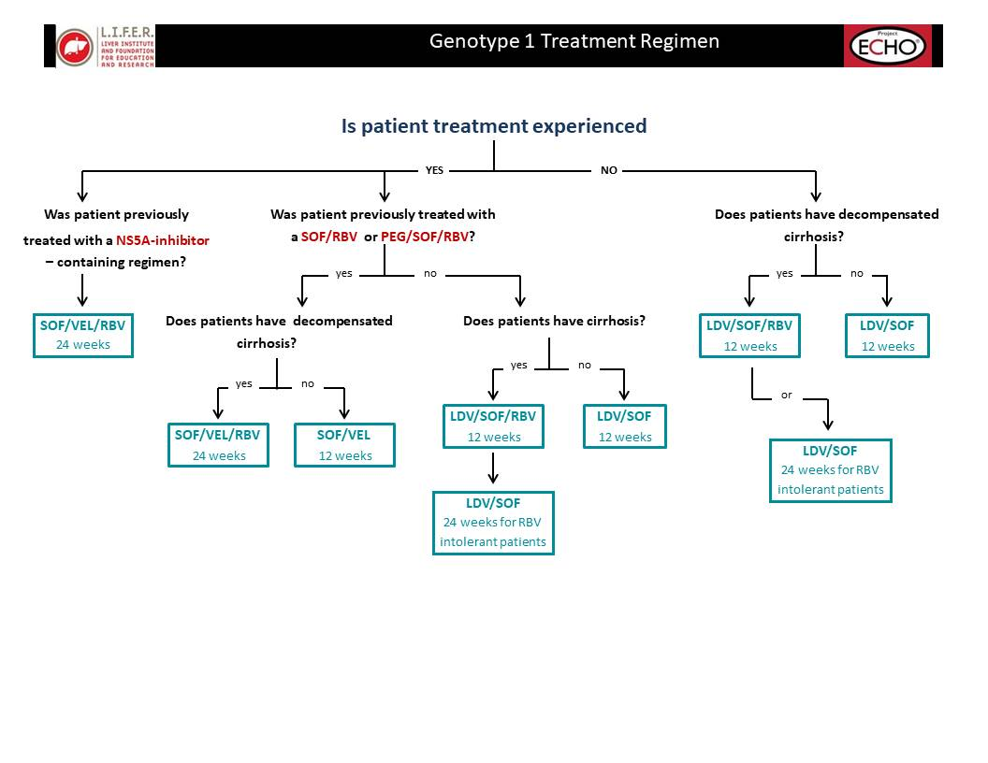
NOTE: All decompensated cirrhotic patients should receive 600mg RBV
All others should receive weight based ribavirin (RBV) dosage: Patients with weight <75kg receive 1000mg RBV daily and ≥75Kg receive 1200mg RBV daily.

Patients Infected with HCV Genotype 2
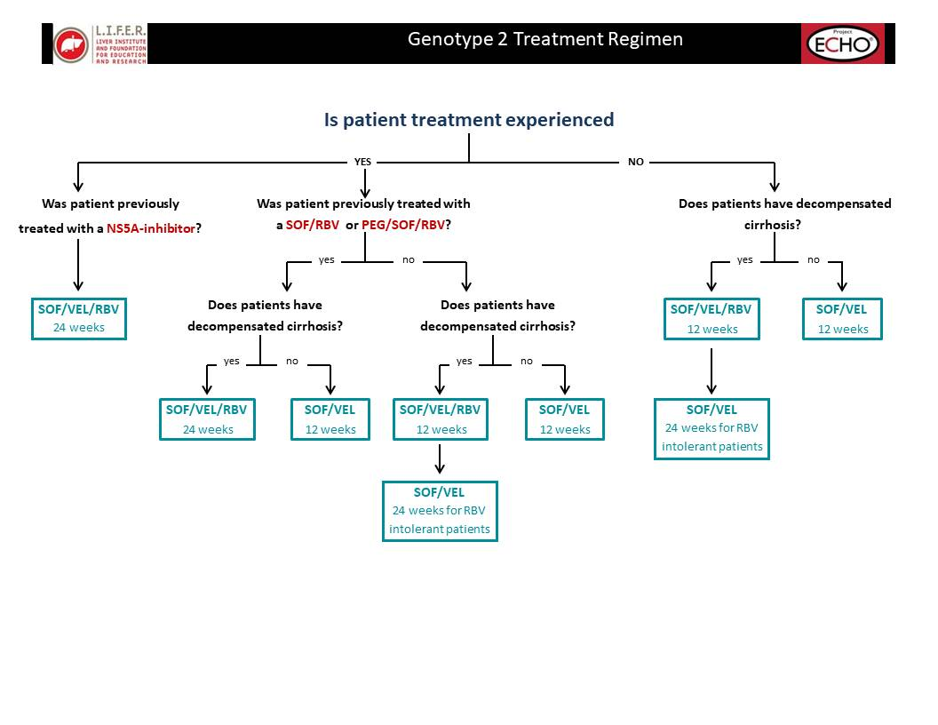
NOTE: All decompensated cirrhotic patients should receive 600mg RBV
All others should receive weight based ribavirin (RBV) dosage: Patients with weight <75kg receive 1000mg RBV daily and ≥75Kg receive 1200mg RBV daily.

NOTE: All decompensated cirrhotic patients should receive 600mg RBV
All others should receive weight based ribavirin (RBV) dosage: Patients with weight <75kg receive 1000mg RBV daily and ≥75Kg receive 1200mg RBV daily.

Patients Infected with HCV Genotype 3
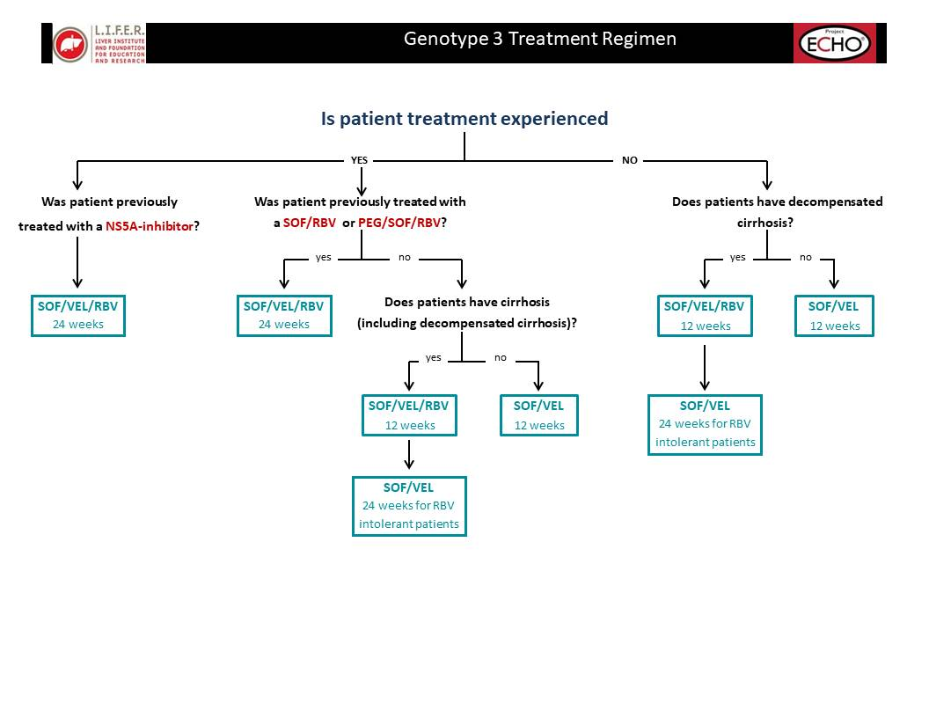

NOTE: All decompensated cirrhotic patients should receive 600mg RBV
All others should receive weight based ribavirin (RBV) dosage: Patients with weight <75kg receive 1000mg RBV daily and ≥75Kg receive 1200mg RBV daily.

Patients Infected with HCV Genotype 4
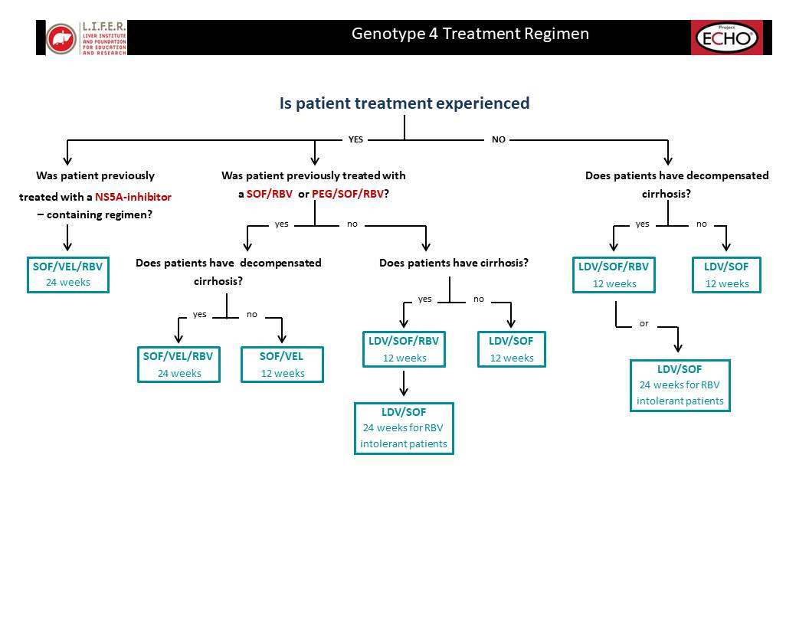
NOTE: All decompensated cirrhotic patients should receive 600mg RBV
All others should receive weight based ribavirin (RBV) dosage: Patients with weight <75kg receive 1000mg RBV daily and ≥75Kg receive 1200mg RBV daily.

Appendix 3.
Scientific Meeting Presentations of the HCV Elimination Program
Abstracts
- Hepatitis C screening among the population of Georgia within the national elimination program

Abstract Presented at EASL, 2019; Vienna, Austria.
Authors:
David Sergeenko,¹ Maia Lagvilava,¹ Ana Aslanikashvili,² Maia Tsereteli,² Davit Baliashvili,³ Vladimer
Getia,² Alexander Turdziladze,² Irma Khonelidze,² Maia Alkhazashvili,² Ekaterine Adamia,¹ Paata
Imnadze,² Amiran Gamkrelidze²
1 Ministry of Internally Displaced People from Occupied Territories, Labour, Health and Social
Affairs, Tbilisi, Georgia
2 National Center for Disease Control and Public Health, Tbilisi, Georgia
3 Emory University, Rollins School of Public Health, Department of Epidemiology, Atlanta, United States
Background and Aims: Georgia is high hepatitis C (HCV) prevalence country. According to the latest
nationwide seroprevalence study conducted in 2015, 7.7% of the population is anti-HCV antibody
positive and 5.4% has chronic hepatitis C infection. Since the launch of the National HCV Elimination
Program in 2015, the country of Georgia has stepped up its efforts to achieve the goals of the National
HCV Strategy and identify 90% of the HCV infected population by 2020. Therefore, screening
campaigns became massive and rigorous in the country, with the active involvement from public and
private organizations. Over 800 sites provide HCV screening across the country free-of-charge,
following the National HCV Screening Protocol approved by the Ministry of Health. Full coverage is
achieved among blood donors, pregnant women, hospitalized patients and military recruits.
Methods: This analysis was prepared based on the data from the unified electronic HCV screening
database, which is being used by all screening provider sites. The database is administered by the
National Center for Disease Control and Public Health and it captures information of each HCV
screening performed in the country. We looked at the numbers of screened individuals by different
populations, as well as positivity rates among them
Results: Since the launch of the Elimination Program in April 2015 through April 2018, more than 1.2
million individuals have been screened on HCV, with the overall positivity rate-9%. Positivity rates vary
through the population groups, with the lowest rate among pregnant women (0.5%) to the highest
prevalence in state opioid-substitution therapy beneficiaries (91.3%) (See the figure). Infection is also
highly prevalent in people with hemophilia (62.5%) and people living with HIV (39.7%).
Conclusion: More than one third of the adult population has been screened in Georgia and about half
of estimated number of anti-HCV positive adult population were identified. Although, to reach the
national strategy goals, it is required to increase screening coverage and reach the people who have
never been tested, as well as raise awareness among population and improve infection control in
medical and non-medical facilities to prevent transmission and reduce the number of new infections.
Figure: HCV screening in different population groups (April 2015-April 2018)
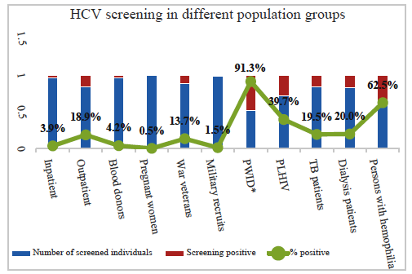

* State Opioid-Substitution Program beneficiaries screened on HCV

- Piloting of integrated HCV, TB and HIV screening model at primary care level in Georgia

Abstract Presented at EASL, 2019; Vienna, Austria.
Authors:
Irma Khonelidze,¹ Amiran Gamkrelidze,¹ Maia Lagvilava,² Maka Danelia,¹ Ketevan Stvilia,¹ Ekaterine
Ruadze,¹ Maia Tsereteli,¹ Irina Karosanidze,³ Vladimer Getia, ¹ Nana Odisharia, ⁴ Anzor Kobalia ⁴
1 National Center for Disease Control and Public Health, Tbilisi, Georgia
2 Ministry of Internally Displaced People from Occupied Territories, Labour, Health and Social
Affairs, Tbilisi, Georgia
3 National Family Medicine Training Center, Tbilisi, Georgia
4 Public Health Unit of Samegrelo-Zemo Svaneti Region, Zugdidi, Georgia
Background and Aims: In 2018, with support of the Global Fund Georgia started a pilot project in
one of the regions of Georgia (Samegrelo-Zemo Svaneti) to test the potential for integration of HCV,
HIV and TB screening services at the regional level and to engage primary healthcare providers in
detection and management of all three diseases under the "one umbrella."
Methods: The integrated screening protocol and training module were developed and almost all
primary healthcare providers (440 professionals) in the region were trained to ensure the quality of
diagnostic procedures, ethical conduct, and accurate recording and reporting through web-based
platform. Trained primary health care physicians currently offer triple screening to patients seeking for
care at medical facilities, and also pursue active case finding using door to door approach for
individual houses, congregate settings or public establishments. In case of AB positive test result,
individuals were asked to provide vein blood samples for RNA testing at the point of care. Local
government has invested in incentives for physicians and nurses providing screening. The horizontal
integrated model has involved local public health department staff as well that along with the National
Family Medicine Training Center was providing supportive monitoring and supervision.
Results: In three years before the pilot initiation only 58 500 people were screened for HCV in
Samegrelo-Zemo Svaneti Region. In 7 months of the pilot project implementation 88, 178 people (90%
of the annual target) were screened, including 66% tested in the rural areas of the region. 2279
(2.58%) were HCV antibody positive (anti HCV+), 1393 (61%) were RNA tested, out of which 1277
(91.7%) were confirmed, 718 (56.2%) were registered at HCV treatment sites and 499 (39%) were
enrolled in treatment. The integrated screening program has allowed 60% increase of the local
population number screened on HCV infection. In addition, within the pilot 37 HIV AB positive
individuals and 192 presumptive TB cases were identified and referred for further confirmation and
treatment.
Conclusion: The project implementation enabled development of sustainable public-private
partnership for effective integration of TB/HIC/HCV screening and early disease detection with
engagement of Central government, the local municipalities, the Global Fund as a donor and local
service providers. It has also become the first precedent of local government contribution to priority
health initiatives. The pilot motivated service providers to explore patient-centered approaches to case
detection and supported decentralization of diagnostic services (HIV and HCV confirmation tests) to
district level non-specialized facilities. Based the promising results obtained during the pilot in
Samegrelo-Zemo Svaneti, It is planned to standardize and roll-out the approach countrywide in 2019-
2020.

- HCV care cascade of PWIDs reached within the Global Fund needle and syringe program in Georgia

Abstract Presented at EASL, 2019; Vienna, Austria.
Authors:
Ketevan Stvilia¹, Irma Khonelidze², Amiran Gamkrelidze¹, Alexander Asatiani², Marine Gogia³,
Guranda Jikia³, Khatuna Kutateladze³
1 National Center for Disease Control and Public Health, Tbilisi, Georgia;
2 National Center for Disease Control and Public Health, Global Fund Programs Implementation Unit, Tbilisi, Georgia;
3 Georgian Harm Reduction Network, Tbilisi, Georgia
Background and aims: Within the Global Fund HIV Program HCV screening is integrated in the
PWID comprehensive service package to support Georgian hepatitis C elimination program. HCV AB
screening positive PWIDs were followed across the HCV care to develop PWID HCV care cascade for
2018
Method: HCV AB rapid test screening is provided by nurses at the Needle and Syringe Program (NSP)
Drop-in centers (16 sites) and mobile ambulatories (6 units) as well as by peer PWIDs countrywide in
Georgia. PWIDs who agree to provide personal ID are registered in the National hepatitis C
elimination database, others are registered in the HIV prevention program database with 15 digit
unique identifier number.
All HCV AB positive PWIDs are referred for HCV RNA testing to HCV treatment sites or collected
samples for core-Ag confirmatory testing are sent to the National Reference Laboratory (Lugar
Center). The National Hepatitis C Elimination Database allows tracking of those PWIDs who are
registered by personal ID across full continuum of HCV care.
Results: During 10 months of 2019 total 23914 PWIDs were reached within the NSP program out of
which 13, 836 were screened on HCV AB with 3324 (24%) positive results. 1221 PWIDs agreed to
provide personal ID for registration in hepatitis C elimination database, out of which 865 (70.8%) were
HCV AB positive and were enrolled in the HCV care cascade analysis. HCV RNA testing was
performed for 608 (70.2%) PWIDs with 84% (511) positivity rate. 255 (49.9%) PWIDs were enrolled in
HCV treatment with a mean of 59.7 (±54) days of led time from confirmation to treatment. Mean time
from HCV AB testing to RNA testing was 16.7 days (±37.8 days). Mean time for full HCV care cascade
of PWIDs from screening to enrollment in treatment program was 74 days (±51.1 days), with the
minimum the same day enrollment and the maximum of 298 days prior initiation of treatment.
Conclusion: Despite the continues efforts to support hepatitis C elimination program through the
Global Fund Needle and Syringe Program in Georgia, the number of PWIDs enrolled in HCV
treatment remains small. Due to criminalization of drug use PWIDs are reluctant to provide personal
information that complicates the monitoring of PWIDs across HCV care. More community based peer
accompanied referral interventions and/or NSP integrated HCV treatment programs are necessary to
increase the number of PWIDs enrolled in the treatment as well as to decrease the time from HCV AB
screening to HCV treatment initiation.

- Evaluation of hepatitis C treatment outcome among people who inject drugs in Georgia

Abstract Presented at 8th International conference on Hepatitis care in substance users, 2019; Montreal, Canada.
Authors:
M. Butsashvili¹, G. Kamkamidze¹, M. Kajaia¹, L. Gulbiani¹, L. Gvinjilia², T. Kuchuloria², A. Gamkrelidze³, E. Adamia⁴, M. Nasrullah⁵, F. Averhoff⁵
¹Health Research Union/Clinic NEOLAB, ²TEPHINET, Tbilisi, Georgia, ³National Center for Disease Control and Public Health, Tbilisi, Georgia, ⁴Ministry of internally displaced persons from the occupied territories, labor, health and social affairs of Georgia, ⁵Division of Viral Hepatitis, National Center for HIV/AIDS, Viral Hepatitis, STD and TB Prevention, CDC, Atlanta, United States.
Background
Georgia embarked on hepatitis C elimination in April 2015. People who inject drugs (PWID) represent a major share of hepatitis C burden in the country. Ensuring access to treatment for HCV infected PWID is needed to reach elimination goals. Integration of treatment services into harm reduction (HR) settings could facilitate access for HCV infected PWID.
Description of model of care
The Ministry of Health established a working group for integration of hepatitis C treatment services into HR settings in early 2018. Four pilot HR centers were selected to implement hepatitis C integrated treatment: one oral substitution therapy (OST) site in Tbilisi and three needle syringe programs (NSP)-one each in Tbilisi, Zugdidi, and Batumi. Three sites conduct HCV antibody screening and have HCV RNA testing (using GeneXpert) available on-site. A simplified laboratory testing algorithm was introduced, and patients having FIB4>1.45 are referred to specialized clinics for treatment while patients with FIB4<1.45 are treated at HR center. Sofosbuvir/ledipasvir (for genotype1) and sofosbuvir/velpatasvir (for genotype 2/3) regimens are used for treatment. We analyzed data from HR program and the national treatment program. In addition, providers at pilot sites were surveyed to assess acceptability of treatment integration.
Results:
During the first two months of treatment services at HR sites, 155 clients tested HCV RNA positive, of whom 44(28.4%) had FIB4>1.45 and were referred to specialized clinics and 111 patients (71.6%) began treatment at HR centers. No patients had completed treatment as of March 2019. Overall, 62 HR staff were surveyed. The majority of respondents (n=60; 96.7%) were supportive of hepatitis C treatment integration into HR centers. The most common reason cited for why they favored treatment integration was “patient/client convenience,” reported by 57/60(95%) of respondents.
Conclusion
Integration of hepatitis C care with HR services is likely feasible at HR centers and it is highly acceptable for personnel who provide HR services.
- Hepatitis C treatment integration with harm reduction services in Georgia: preliminary findings

Abstract Presented at 8th International conference on Hepatitis care in substance users, 2019; Montreal, Canada.
Authors:
M. Butsashvili¹, G. Kamkamidze¹, M. Kajaia¹, L. Gulbiani¹, L. Gvinjilia², T. Kuchuloria², A. Gamkrelidze³, E. Adamia⁴, M. Nasrullah⁵, F. Averhoff⁵
¹Health Research Union/Clinic NEOLAB, ²TEPHINET, Tbilisi, Georgia, ³National Center for Disease Control and Public Health, Tbilisi, Georgia, ⁴Ministry of internally displaced persons from the occupied territories, labor, health and social affairs of Georgia, ⁵Division of Viral Hepatitis, National Center for HIV/AIDS, Viral Hepatitis, STD and TB Prevention, CDC, Atlanta, United States.
Background
Georgia embarked on hepatitis C elimination in April 2015. People who inject drugs (PWID) represent a major share of hepatitis C burden in the country. Ensuring access to treatment for HCV infected PWID is needed to reach elimination goals. Integration of treatment services into harm reduction (HR) settings could facilitate access for HCV infected PWID.
Description of model of care
The Ministry of Health established a working group for integration of hepatitis C treatment services into HR settings in early 2018. Four pilot HR centers were selected to implement hepatitis C integrated treatment: one oral substitution therapy (OST) site in Tbilisi and three needle syringe programs (NSP)-one each in Tbilisi, Zugdidi, and Batumi. Three sites conduct HCV antibody screening and have HCV RNA testing (using GeneXpert) available on-site. A simplified laboratory testing algorithm was introduced, and patients having FIB4>1.45 are referred to specialized clinics for treatment while patients with FIB4<1.45 are treated at HR center. Sofosbuvir/ledipasvir (for genotype1) and sofosbuvir/velpatasvir (for genotype 2/3) regimens are used for treatment. We analyzed data from HR program and the national treatment program. In addition, providers at pilot sites were surveyed to assess acceptability of treatment integration.
Results:
During the first two months of treatment services at HR sites, 155 clients tested HCV RNA positive, of whom 44(28.4%) had FIB4>1.45 and were referred to specialized clinics and 111 patients (71.6%) began treatment at HR centers. No patients had completed treatment as of March 2019. Overall, 62 HR staff were surveyed. The majority of respondents (n=60; 96.7%) were supportive of hepatitis C treatment integration into HR centers. The most common reason cited for why they favored treatment integration was “patient/client convenience,” reported by 57/60(95%) of respondents.
Conclusion
Integration of hepatitis C care with HR services is likely feasible at HR centers and it is highly acceptable for personnel who provide HR services.

- Progress in Hepatitis C Testing as Part of the Hepatitis C Elimination Program in Georgia

International Viral Hepatitis Elimination Meeting, 2019; Amsterdam, the Netherlands.
Authors:
Amiran Gamkrelidze¹, Alexander Turdziladze¹, Irma Khonelidze¹, Maia Tsereteli¹, Vladimer Getia¹, Sophia Surguladze¹
¹National Center for Disease Control and Public Health of Georgia
Introduction
The country of Georgia, with a population of 3.7 million, initiated the world’s first national hepatitis C elimination program in April 2015, which aims to reduce hepatitis C virus (HCV) prevalence by 90% by 2020. In 2015, a seroprevalence study was conducted which estimated that 150,000 Georgian adults were infected by HCV (5.4% of the population). Through the elimination program, screening for hepatitis C is available to all citizens free of charge. The aim is to describe progress in hepatitis C testing as part of hepatitis C elimination program.
Material and Methods
All Georgian citizens have a personal national identification number (ID) assigned at birth which is used for tracking citizens for the different purposes, including healthcare. Information system was created to collect data from the elimination program utilizing the national ID to monitor and evaluate program performance and surveillance. This analysis utilizes data from the national screening registry and treatment databases linked by national ID, and 2014 general population census.
Results
As of June 30 2019, 1,415,804 adults identified with the national ID have been tested for hepatitis C (49.5% of the adult population), of whom 116,622 (8.2%) were anti-HCV positive. In 2015 the positivity rate averaged 27.0%, but has fallen to 4.4% in the first half of 2019. Overall, 92,333 individuals received diagnostic testing to determine viremia, and 75,733 (82.0%) were found to have chronic HCV.
Screening rates are similar for men and women – 49.1% (657,062 individuals) of adult males and 49.8% (758,742 individuals) of adult females have been tested for anti-HCV. Screening coverage is the highest for men (52.0%) in the population aged ≥60 and is the lowest in men aged 30-60 (48.0%) which is also the age group with the highest positivity rate - 20.3%. The lowest positivity rate is seen in men aged 18-29 at 2.3% and the overall positivity rate for adult males is 13.0% which means that 87,427 men have been found to be anti-HCV positive.
Screening coverage is the highest for women (60.3%) in the population aged 18-29 and is the lowest in women aged ≥60 (46.8%) which is also the age group with the highest positivity rate - 5.6%. The lowest positivity rate is seen in women aged 18-29 at 1.1% and the overall positivity rate for adult females is 3.4% which means that 29,195 women have been found to be anti-HCV positive
Conclusions
About half of the adult population has been screened in Georgia and half of estimated number of adults with chronic HCV infection was identified. The highest screening positivity rate was observed in the first year of the program and since then the positivity rate has been declining annually. To gain access to hard-to-reach populations program plans to expand integrated HCV testing and treatment services at the primary healthcare and harm reduction settings throughout the country.

- Efforts to increase HCV viremia testing uptake to reach 2020 hepatitis C elimination goals in Georgia

International Viral Hepatitis Elimination Meeting, 2019; Amsterdam, the Netherlands.
Authors:
Amiran Gamkrelidze¹, Paata Imnadze¹, Maia Alkhazashvili¹, Maia Tsereteli¹, Vladimer Getia¹, Nazibrola Chitadze¹, Tinatin Kuchuloria², Lia Gvinjilia², Irina Tskhomelidze², Shaun Shadaker³, Muazzam Nasrullah³
¹National Center for Disease Control and Public Health of Georgia
²TEPHINET for Georgia National Hepatitis C Elimination Program
³Division of Viral Hepatitis, National Center for HIV/AIDS, Viral Hepatitis, STD and TB Prevention, CDC
Background
In April 2015, the country of Georgia launched the world’s first national program to eliminate hepatitis C, defined as a 90% reduction in prevalence by 2020. In 2017, the data suggested that although large numbers of Georgians were being screened for hepatitis C, the proportion of HCV antibody (anti-HCV) positive persons receiving diagnostic testing to determine current infection was insufficient to meet elimination goals. At that time, although treatment and screening was free for program enrollees, Georgians were required to pay for nucleic acid testing (NAT) to determine current infection. At the end of 2017 the government of Georgia made regulatory changes aimed at improving access to free-of-charge HCV viremia testing through the use of HCV core antigen (HCVcAg). The aim is to describe efforts in Georgia’s hepatitis C elimination program to increase HCV viremia testing uptake to reach 2020 elimination goals.
Material & Methods
Regulatory changes pertaining to Georgia’s national hepatitis C elimination program enacted from December 2017 to March 2018 were reviewed. Additionally, we analyzed data from the national hepatitis C screening registry and treatment database during September 2017 – August 2019.
In December 2017, the government of Georgia approved HCVcAg testing as an alternative to NAT for diagnosing current HCV infection and made all diagnostics including hepatitis C screening and viremia testing (qualitative or quantitative PCR, HCVcAg) free of charge.
The Lugar Center, the national reference laboratory of the National Center for Disease Control and Public Health (NCDC) has provided reflex HCVcAg test-based viremia testing for all anti-HCV positive blood donors and pregnant women identified through state funded programs since January 1, 2018, and for all anti-HCV positive inpatients and persons screened positive at NCDC laboratory sites since March 10, 2018. To facilitate viremia testing uptake, mandatory sample collection from anti-HCV positive inpatients became the responsibility of all inpatient service providers licensed in the country. Since March 1, 2018, hospitals report both screening results and data pertaining to sample collection and transportation to the Lugar Center directly into the hepatitis C screening registry within 24 hours from the service provision.
Results
From December 2017 through August 2019, 24,205 Georgians received HCVcAg testing to determine viremia, an average of 1,153 tests per month. Those tested had a median age of 52 (interquartile range 41-64) and the majority (67.1%; n=16,240) were male. Overall, 72.9% of HCVcAg tests were positive, resulting in the identification of 17,638 individuals needing treatment.
After the introduction of HCVcAg testing among patients of hospitals, the average number of persons receiving viremia testing increased by 58.7%, from 1,195 per month during September 2017 – February 2018 to 1,897 per month during March 2018 – August 2019. This reversed a downward trend since a peak in July 2016, when 2,641 were tested for current HCV infection.
Conclusions
This report highlights policy initiatives aimed at improving rates of HCV viremia and their impact on viremia testing uptake. Introduction of free-of-charge viremia testing paired with reflex HCVcAg testing among hospitals, antenatal clinics, and blood banks improved HCV viremia testing uptake.

Posters
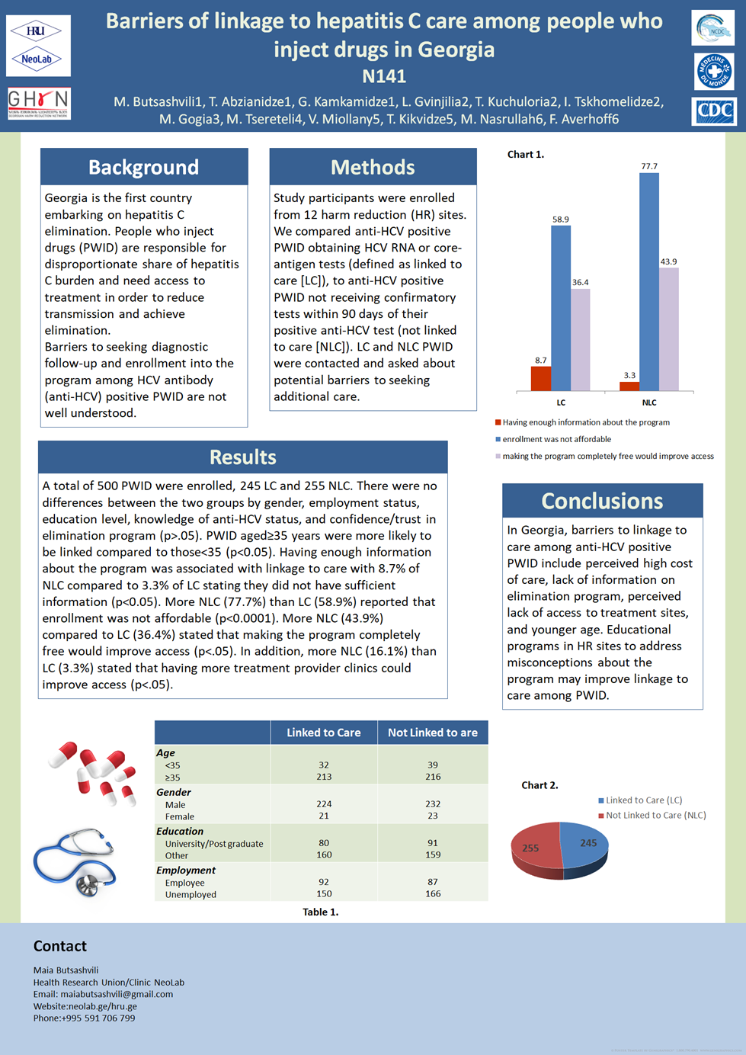

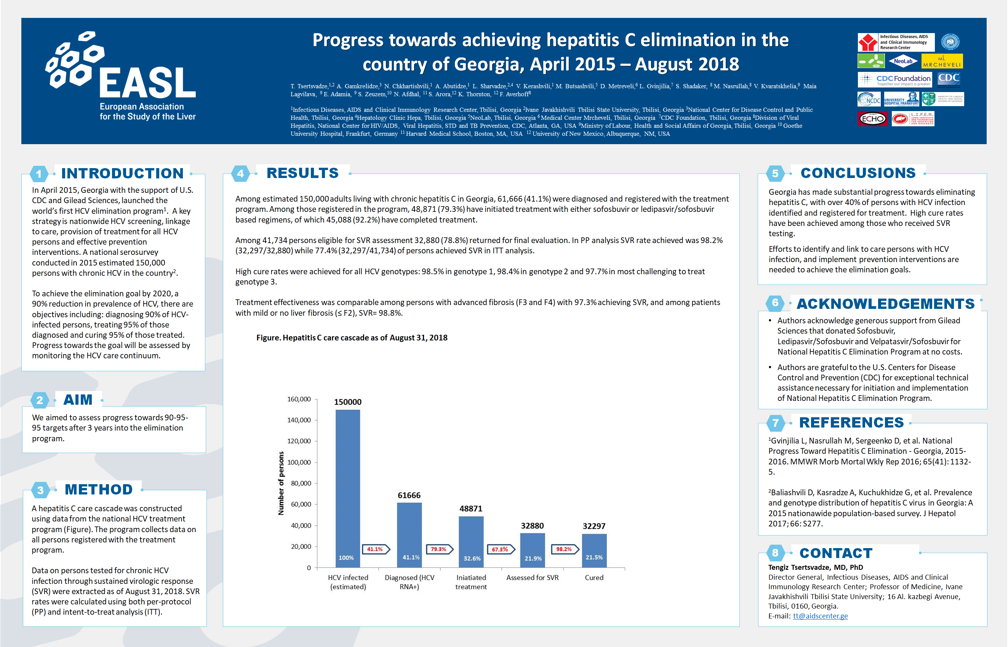

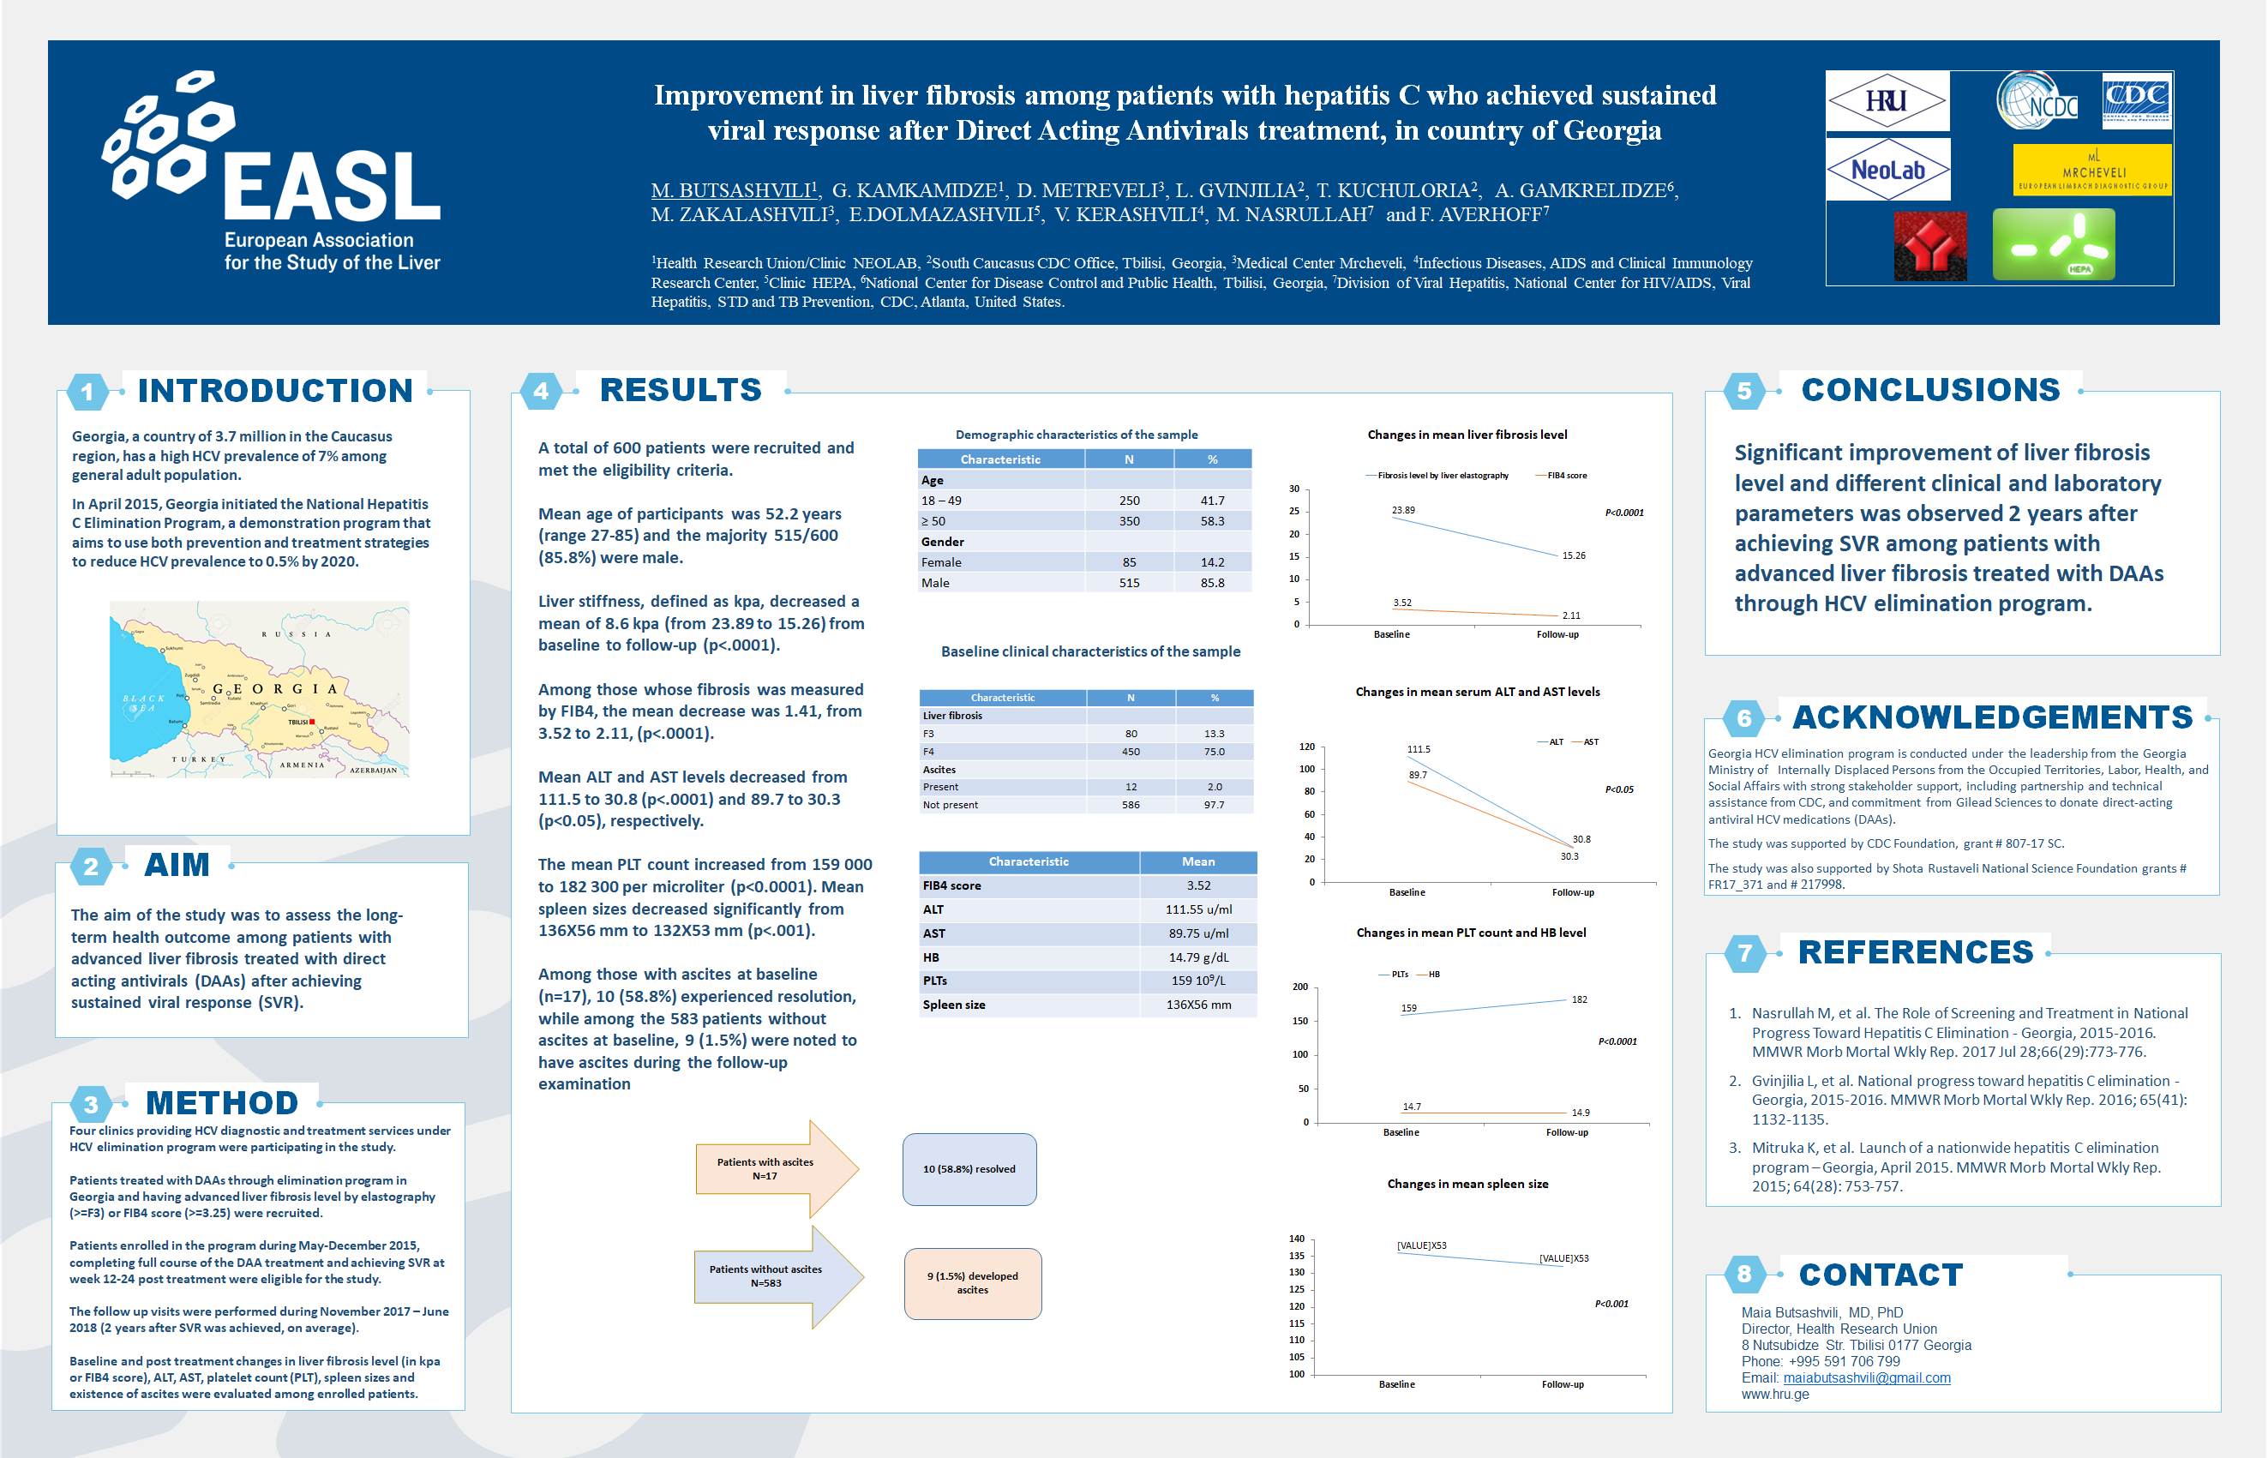
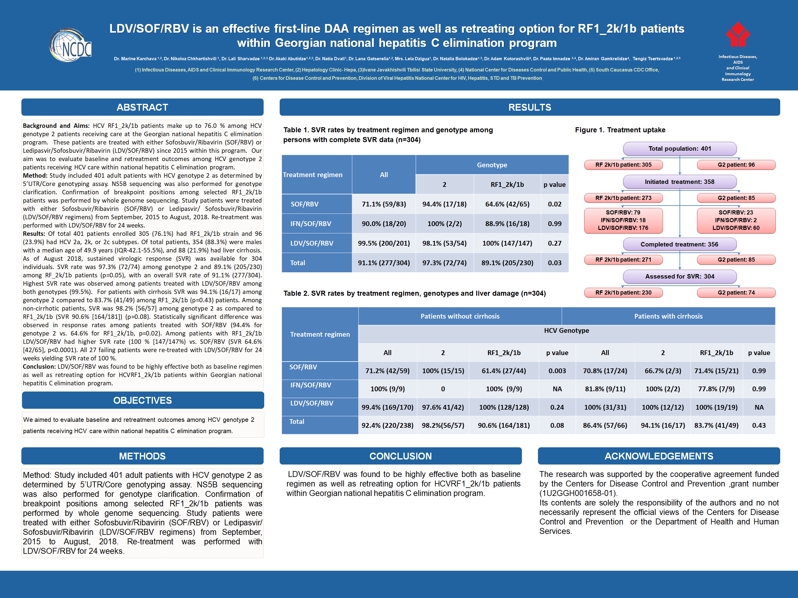

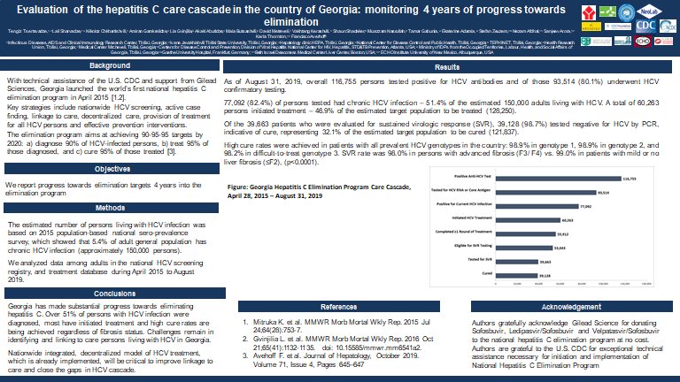

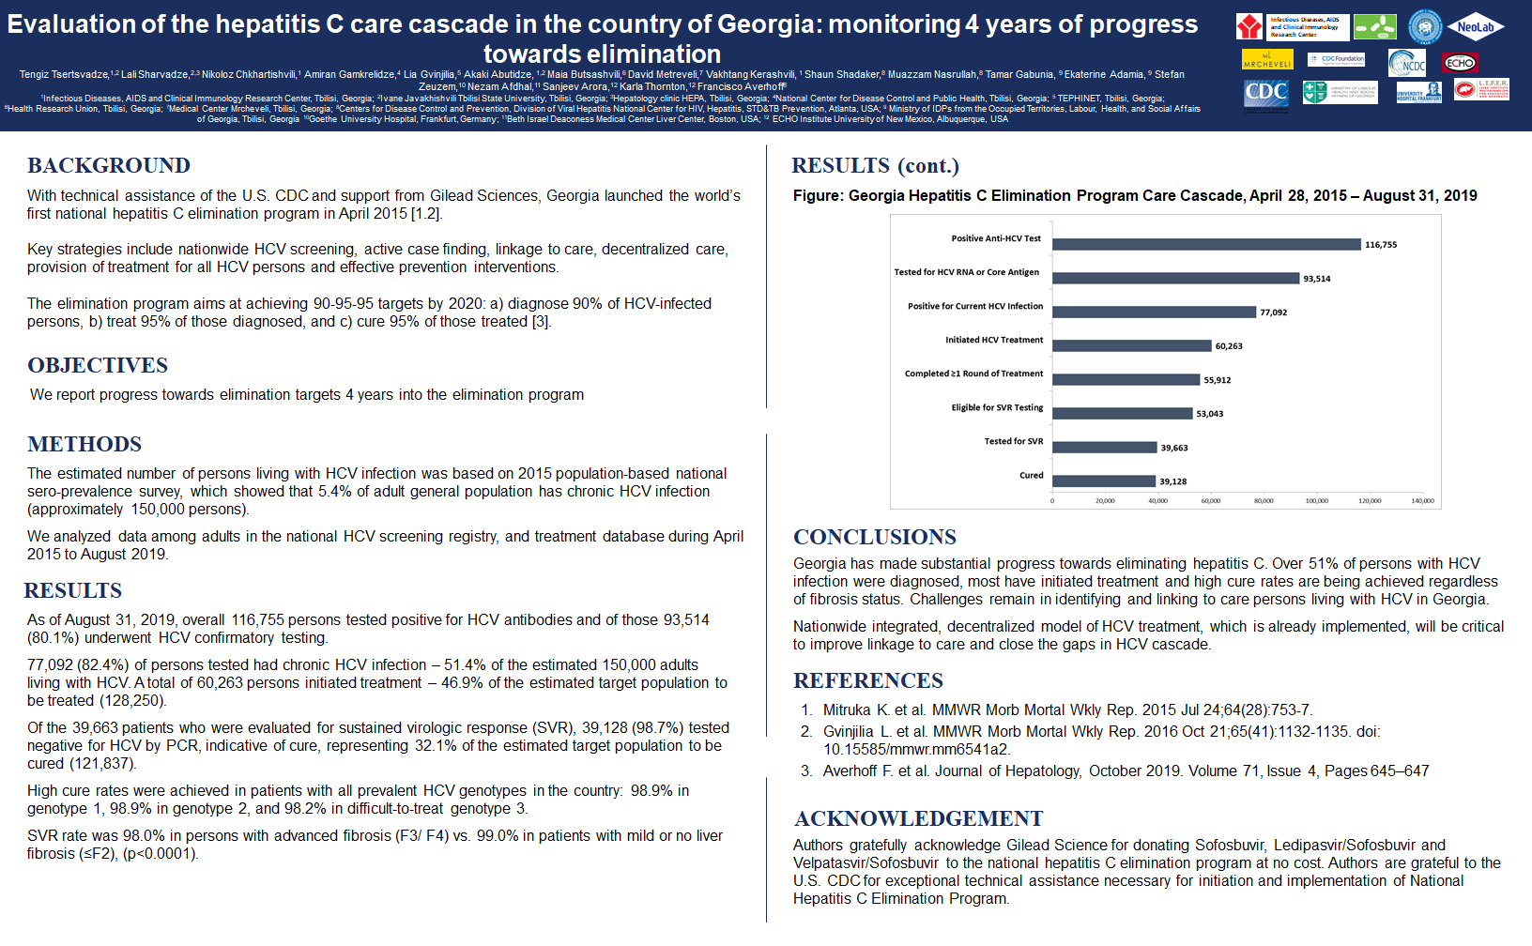

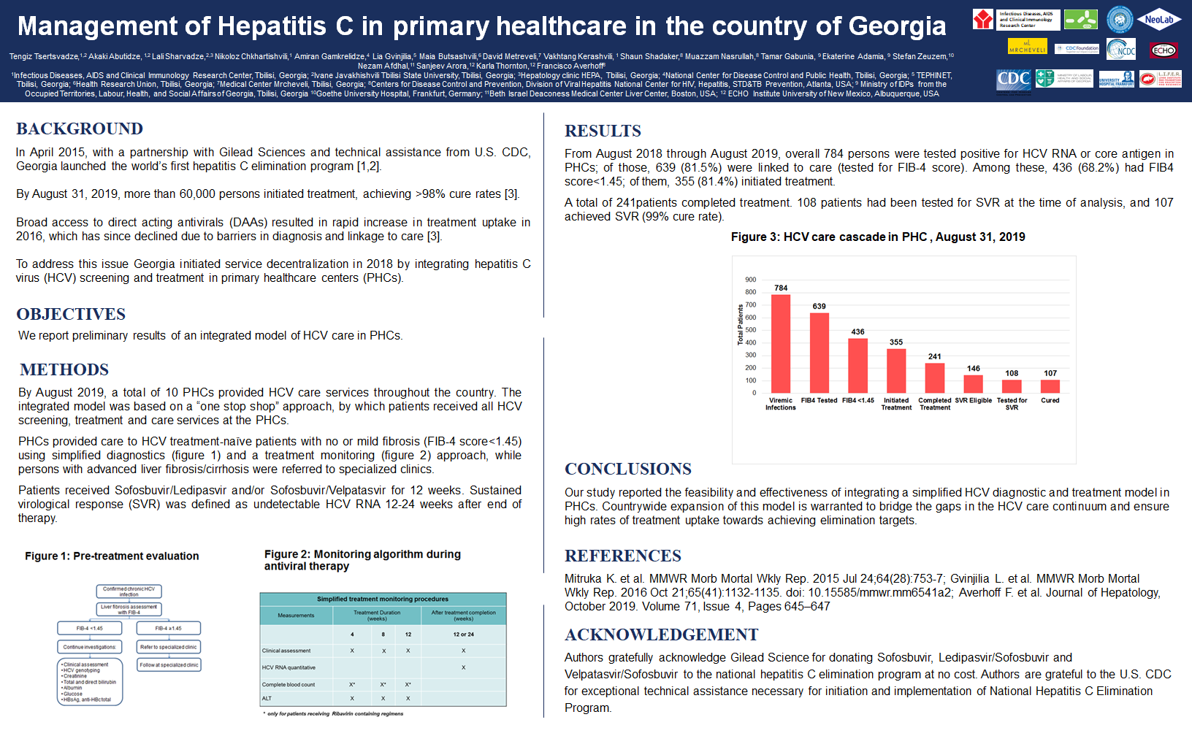
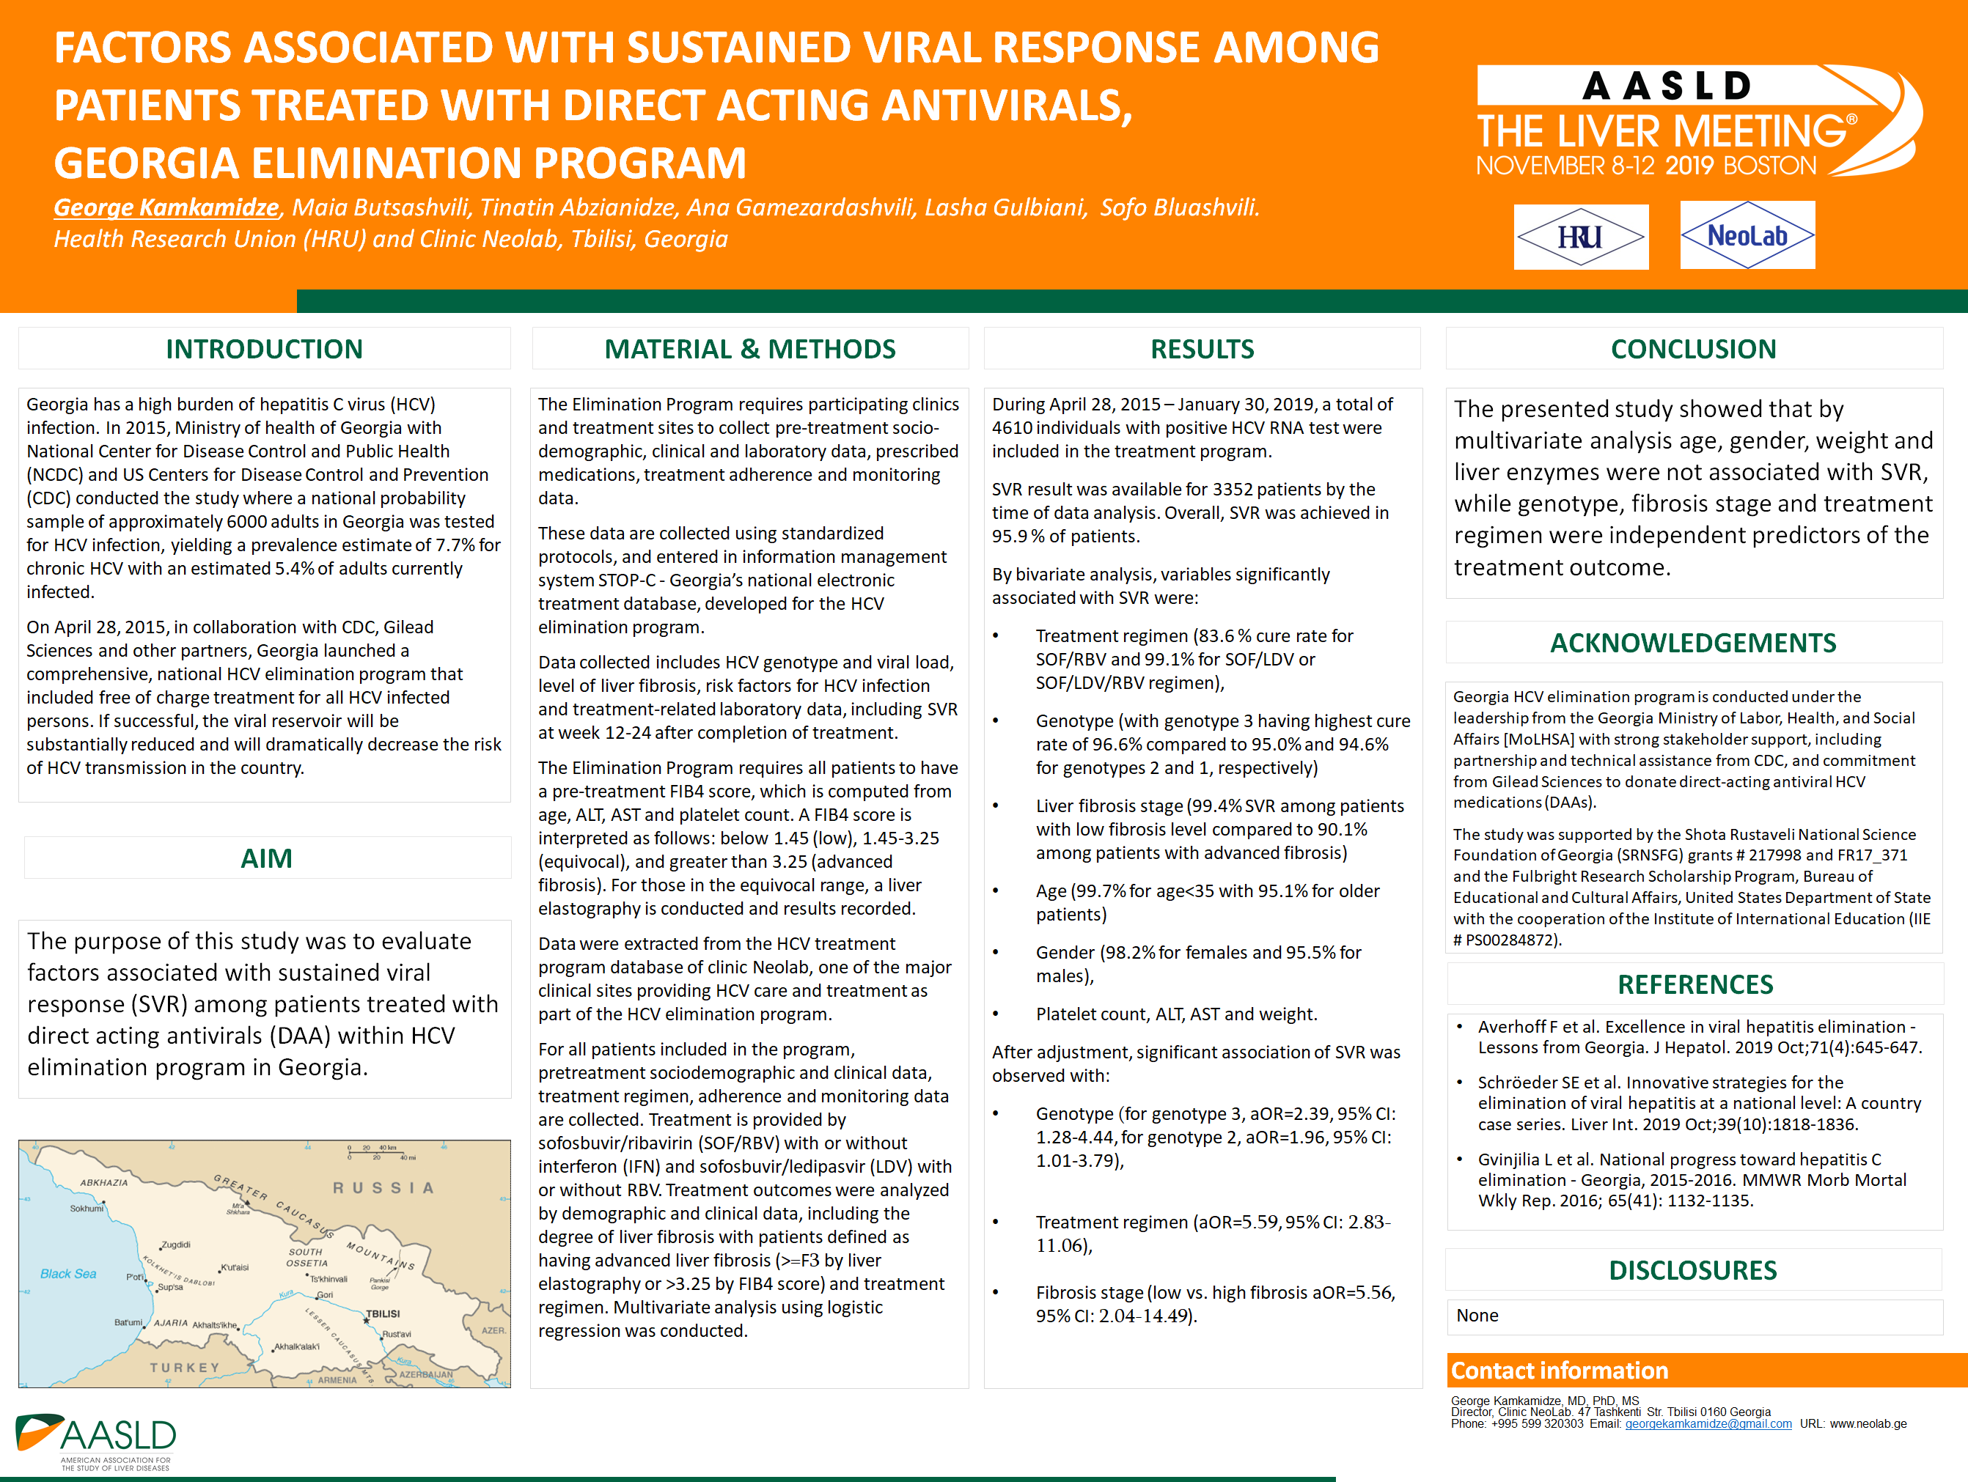
Oral Presentations

- Best practice talk - Georgia, Amiran Gamkrelidze
Presented at International Viral Hepatitis Elimination Meeting, 2018; Amsterdam, the Netherlands
- Hepatitis C care cascade in the country of Georgia: monitoring progress towards elimination, Tengiz Tsertsvadze
Presented at International Viral Hepatitis Elimination Meeting, 2018; Amsterdam, the Netherlands
- The road to elimination in Georgia, April 2015- August 2018, David Sergeenko
Presented at International Liver Congress, 2019; Vienna, Austria
- The critical role of partnerships in HCV elimination, Georgia ,April 2015- August 2018, David Sergeenko
Presented at International Liver Congress, 2019; Vienna, Austria
- The HCV care cascade and treatment outcomes, April 2015- August 2018, Tengiz Tsertsvadze
Presented at International Liver Congress, 2019; Vienna, Austria
- HCV micro-elimination among people who inject drugs in pursuit of national elimination, April 2015- August 2018, Maia Butsashvili
Presented at International Liver Congress, 2019; Vienna, Austria
- Beyond treatment: HCV elimination provides collateral benefits to the health system. April 2015 - August 2018, Francisco Averhoff
Presented at International Liver Congress, 2019; Vienna, Austria
- Key role of partnerships in global HCV elimination, April 2015- August 2018 , Muazzam Nasrullah
Presented at International Liver Congress, 2019; Vienna, Austria
- Key challenges and strategies to reach HCV elimination, April 2015- August 2018, Amiran Gamkrelidze
Presented at International Liver Congress, 2019; Vienna, Austria
- HIV, Hepatitis C and harm reduction in Georgia, Marina Gogia
Presented at International Forum on Infectious Diseases, 2019; Istanbul, Turkey
- Scaling-up of an effective model of harm reduction-based and peer-supported hepatitis C treatment for PWID in Georgia, George Soselia
Presented at International Harm Reduction Conference, 2019; Porto, Portugal
- HBV/HCV co-infection among patients enrolled in HCV elimination program in Georgia, Maia Butsashvili
Presented at 2nd Transcaucasus Symposium on HBV Infection, 2019; Tbilisi, Georgia
- Progress towards eliminating hepatitis C in Georgia: overcoming challenges through decentralization of services, George Kamkamidze
Presented atTranslating science to end HIV in Eastern Europe and Central Asia, AIDS 2018 Post-Conference Symposium, 2019; Tbilisi, Georgia
- Approaches to providing hepatitis C viremia testing to PWIDs in Georgia. HEAD start project in Georgia, Maia Japaridze
Presented at 8th International conference on Hepatitis care in substance users, 2019; Montreal, Canada
- Georgian experience in HCV elimination – is that a way towards HBV elimination?, Francisco Averhoff
Presented at 2nd Transcaucasus Symposium on HBV Infection, 2019; Tbilisi, Georgia
- Progress towards hepatitis C elimination in Georgia, Tengiz Tsertsvadze
Presented at International Meeting on HCV Micro-Elimination in HIV/HCV Co-Infection, 2019; Tbilisi, Georgia
- Integrating HCV care in primary healthcare, Akaki Abutidze
Presented at International Meeting on HCV Micro-Elimination in HIV/HCV Co-Infection, 2019; Tbilisi, Georgia
- Longer-term liver outcomes among HIV/HCV co-infected patients after curing hepatitis C, Natalia Bolokadze
Presented at International Meeting on HCV Micro-Elimination in HIV/HCV Co-Infection, 2019; Tbilisi, Georgia
- HBV re-activation in HBV/HCV co-infected patient, Lali Sharvadze
Presented at International Meeting on HCV Micro-Elimination in HIV/HCV Co-Infection, 2019; Tbilisi, Georgia
- Perspectives of HCV Micro-elimination in HIV/HCV Co-infection in Georgia, Nikoloz Chkhartishvili
Presented at International Meeting on HCV Micro-Elimination in HIV/HCV Co-Infection, 2019; Tbilisi, Georgia
- HCV reinfection among HIV patients after DAA therapy in the country of Georgia, Pati Gabunia
Presented at International Meeting on HCV Micro-Elimination in HIV/HCV Co-Infection, 2019; Tbilisi, Georgia
- Integrating HCV care in harm reduction services, Maia Butsashvili
Presented at International Meeting on HCV Micro-Elimination in HIV/HCV Co-Infection, 2019; Tbilisi, Georgia
- Evaluation of the Hepatitis C Care Cascade in the Country of Georgia: Monitoring Progress towards Elimination, Tengiz Tsertsvadze
Presented at International Viral Hepatitis Elimination Meeting, 2019; Amsterdam, the Netherlands

Appendix 4

Publications Related to the HCV Elimination Program
Abstracts
- Confidence in the Georgia national HCV elimination program among women of reproductive age
Georgian Med News. 2019 October;( 295):105-109
Authors:
Gamezardashvili A¹, Butsashvili M¹, Kajaia M², Gulbiani L², Abashidze G³, Kapanadze M⁴, McNutt
LA⁵, Kamkamidze G⁶.
- 1Health Research Union (HRU), Tbilisi, Georgia; 2Clinic Neo-Lab, Tbilisi, Georgia ;3University of Georgia, Tbilisi, Georgia.
- 1 Health Research Union (HRU), Tbilisi, Georgia; 2Clinic Neo-Lab, Tbilisi, Georgia.
- 1 Health Research Union (HRU), Tbilisi, Georgia.
- 3 University of Georgia, Tbilisi, Georgia.
- 4 Institute for Health and the Environment; State University of New York, Albany, NY, USA.
- 1 Health Research Union (HRU), Tbilisi, Georgia; 2Clinic Neo-Lab, Tbilisi, Georgia ;3 University of Georgia, Tbilisi, Georgia; 4 Institute for Health and the Environment; State University of New York, Albany, NY, USA.

Abstract
Georgia is among the countries with a very high prevalence of hepatitis C virus (HCV) infection. The recent availability of highly effective, direct-acting antivirals (DAAs) capable of curing >90% of persons treated has made HCV elimination a possibility. All adult citizens infected with HCV are eligible to receive free DAAs through the Georgia National HCV Elimination Program (Program). From April 2015 to December 2018, 54,087 persons were enrolled in the Program throughout the country. However, more than 20,000 individuals are aware of their HCV antibody positive status but did not have HCV RNA testing, a necessary step to determine treatment needs. We hypothesized that a reason for hesitance to enroll in the Program may be a low level of trust of the Program. A cross-sectional study was conducted in Tbilisi, the capital of Georgia. Reproductive aged women were randomly selected from three maternity care centers during prenatal care. The self-administered questionnaire included questions on socio-demographic information, knowledge about HCV infection and trust in the Program. A total of 2185 women of reproductive age were enrolled in the study. The mean age was 28.5 (age range: 17-46) years. The majority of the study participants (76.4%) had a university degree. The vast majority of study participants (>95%) were married and 95.1% were Georgian ethnicity. Almost 90% of the participants were aware of their HCV infection status. Most women (85.3%) had heard of HCV elimination program in Georgia; 74.6% stated that they trust the Program. However, almost 10% of surveyed women stated they would refuse to get enrolled in the Program if their anti-HCV test result is positive. Trust in the Program was higher among women aged >25 years (80.7%) compared to younger women (68.4%) (p<0.0001). Level of education was also associated with trust to the program: more women with higher education level reported that they trust the Program (78.7%) compared to women with lower education level (68.5%) (p<0.0001). Trust in the Georgia National HCV Elimination Program is not sufficiently high among women of reproductive age in Georgia. Effective educational campaigns are needed to improve trust to the Program for this targeted group.

- Hepatitis B vaccination: knowledge and attitude among women of reproductive age in Georgia
Georgian Med News. 2019 October; ( 295):109-114
Authors:
Abzianidze T.,¹ Butsashvili M.,¹ Kajaia.,² Kochlamazashvili M.,² Kipiani E.,³ McNutt LA.,⁴ Kamkamidze G.⁵
- 1Health Research Union (HRU), Tbilisi, Georgia; 2Clinic Neo-Lab, Tbilisi, Georgia ;3University of Georgia, Tbilisi, Georgia.
- 1Health Research Union (HRU), Tbilisi, Georgia; 2Clinic Neo-Lab, Tbilisi, Georgia.
- 3 University of Georgia, Tbilisi, Georgia.
- 4 Institute for Health and the Environment; State University of New York, Albany, NY, USA.
- 1 Health Research Union (HRU), Tbilisi, Georgia; 2Clinic Neo-Lab, Tbilisi, Georgia ;3 University of Georgia, Tbilisi, Georgia; 4 Institute for Health and the Environment; State University of New York, Albany, NY, USA.

Abstract

Georgia is a country with high prevalence of hepatitis B. Based on a 2015 population serosurvey, the prevalence of hepatitis B surface antigen (HBsAg) is 2.9% and prevalence of anti-HBc is 25.5% in general population. Hepatitis B vaccine has been included in the national immunization schedule of Georgia only since 2002. Thus, most reproductive aged women were not vaccinated during young childhood. Cross-sectional study was conducted in the capital of Georgia, Tbilisi. Reproductive aged women were randomly selected and then recruited from three maternity care centers during prenatal care. The self-administered questionnaire included questions on socio-demographic information, hepatitis B vaccination status and awareness of HBV infection status. A total of 2185 reproductive aged women were enrolled in the study. The mean age was 28.5 (age range 17-46) years. Most (76.4%) had a bachelor and/or master's degree. 20.0% of respondents never heard about HBV. Very few (3.3%) knew they were infected with HBV. We could not determine if women were chronically infected or were exposed and developed antibodies. HBV knowledge was limited: 57.5% were not aware of available HBV treatment; 51.6% didn't know HBV infection could be prevented (35.8% named HBV vaccination, 29.3% named condom use). Only 10% of study participants reported being vaccinated for HBV. Awareness of HBV infection was higher among women over age 25 (72.1%) compared to women aged 25 years or less (27.9%) (P<0.0001). Among women who reported having an HBV infection, 40.6% did not name vaccine as a prevention method and 38.2% did not have information about availability of HBV treatment (P<0.05). Based on our study results, knowledge about HBV infection and vaccination is very low among reproductive aged women in Georgia. Women's health centers can be a good place to reach reproductive aged women for counseling on HBV infection and promote vaccination against hepatitis B.

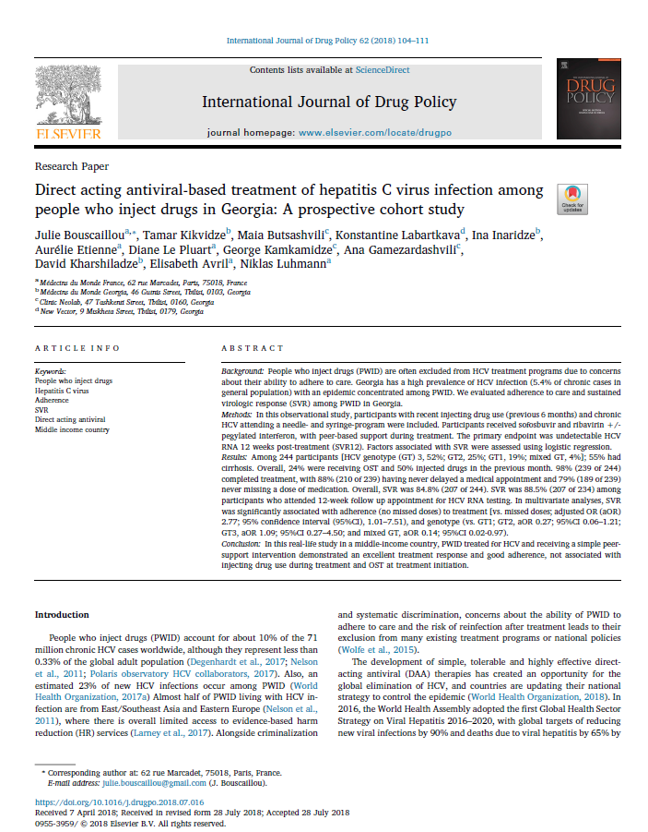

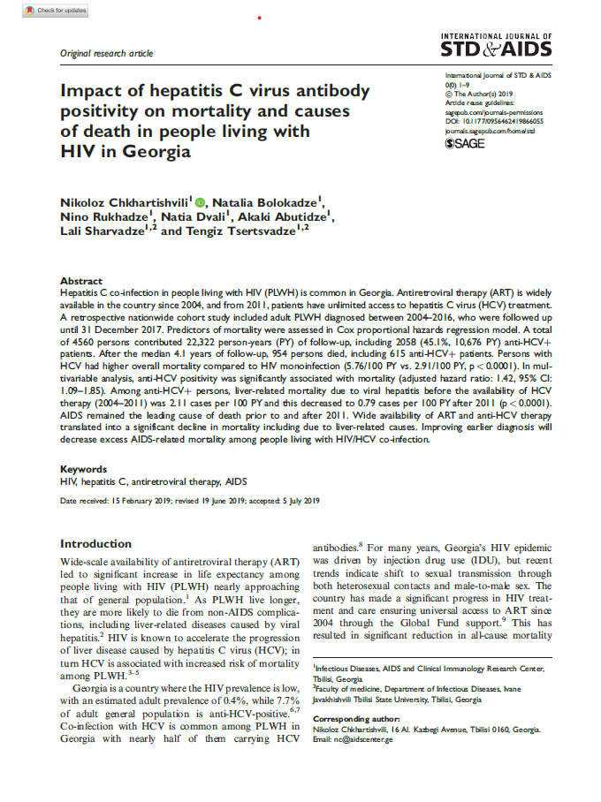

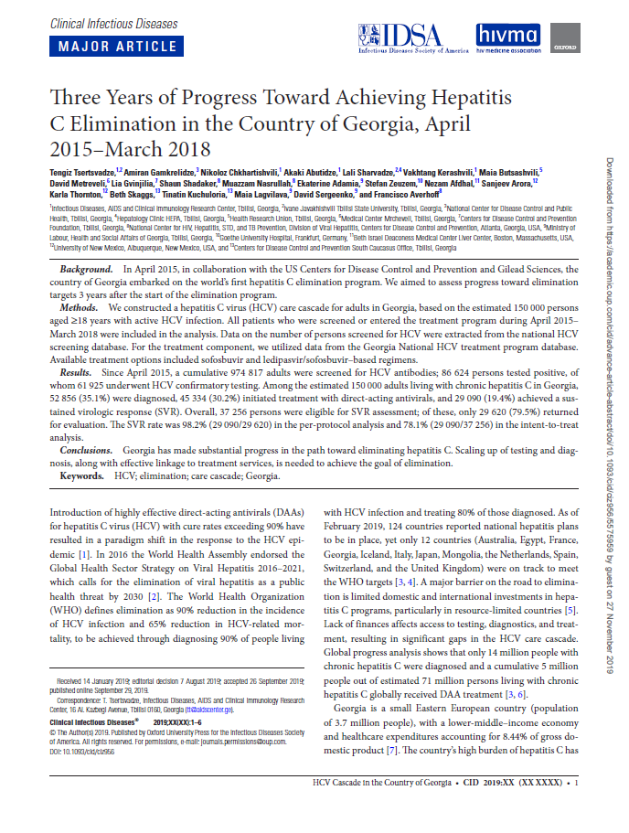

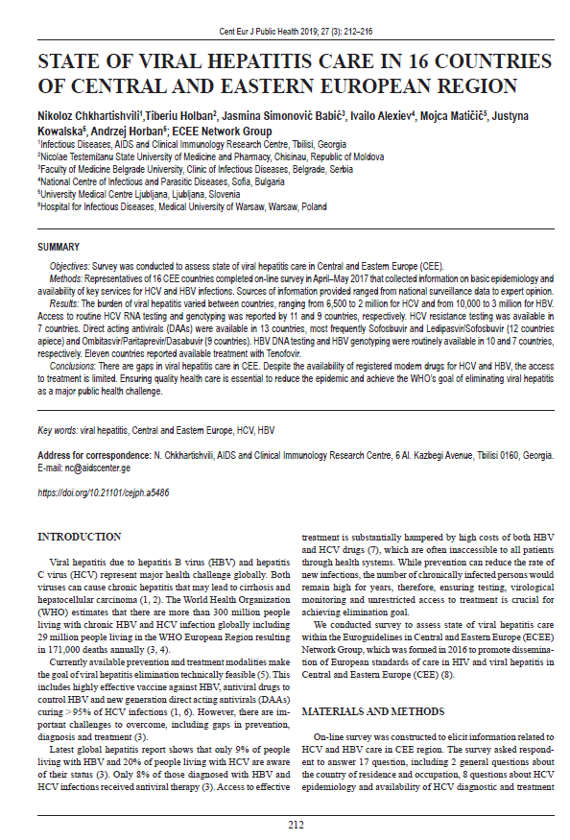

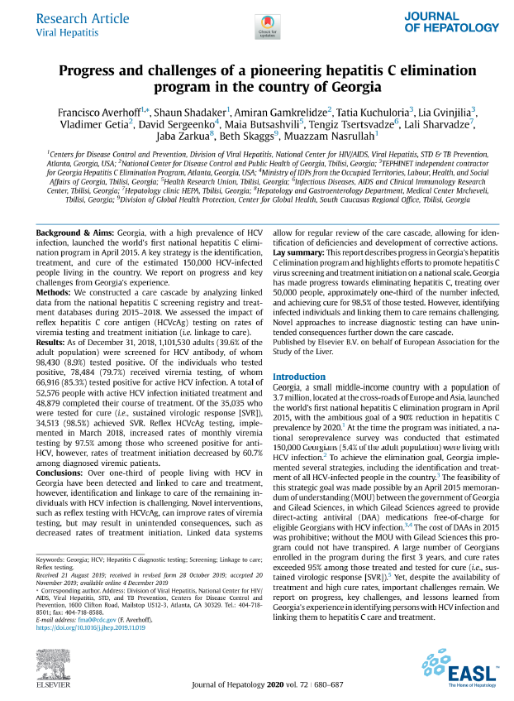

Available from: http://www.ncdc.ge/Pages/User/Documents.aspx?ID=33a11d14-e71c-4b28-ad39-d6670090664c
Available from: https://www.moh.gov.ge/uploads/files/2019/Failebi/25.04.2019-2.pdf
Available from: https://doi.org/10.1016/j.jhep.2019.06.026
Available from: https://www.moh.gov.ge/uploads/files/2017/akordeoni/failebi/Georgia_HCV_Elimination_Strategy_2016-2020.pdf
Georgia launched its State Safe Blood Program in 1997 which aims at ensuring the safety of blood and blood components through high-quality testing of donors blood for HCV, HBV, HIV and syphilis, availability and equal accessibility to blood products.
https://matsne.gov.ge/ka/document/view/4049939?publication=0
a) concerns for healthcare quality and patient safety b) medical facility changed the address c) non-compliances identified during preceding years d) reports on healthcare quality improvement efforts are not available etc. https://matsne.gov.ge/ka/document/view/1507093?publication=0
https://www.who.int/gpsc/ipc-components-guidelines/en/ WHO eight core components constitute of: IPC programmes; IPC guidelines; IPC education and training; HAI Surveillance ; multimodal strategies; monitoring audit of IPC practices and feedback; workload and staffing and bed occupancy; built environment, materials and equipment for IPC at the facility level.
http://ssa.gov.ge/files//01_GEO/KANONMDEBLOBA/Saagentos-Aqtebi/504.pdf
the high volume of beneficiaries with viral hepatitis infection, geographical accessibility and being an HCV care provider

