- The invited person will receive the invitation by email.
- Open the email and click on Open Microsoft Teams.

- Click on Send code to receive the One Time Password to join the Team.
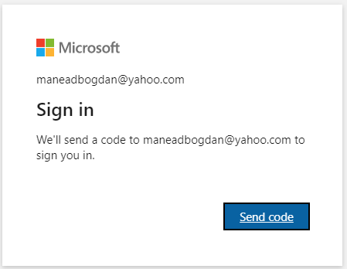
- The second email containing OTP will be received.
- The email content looks like this. Note the 8-digit OTP.
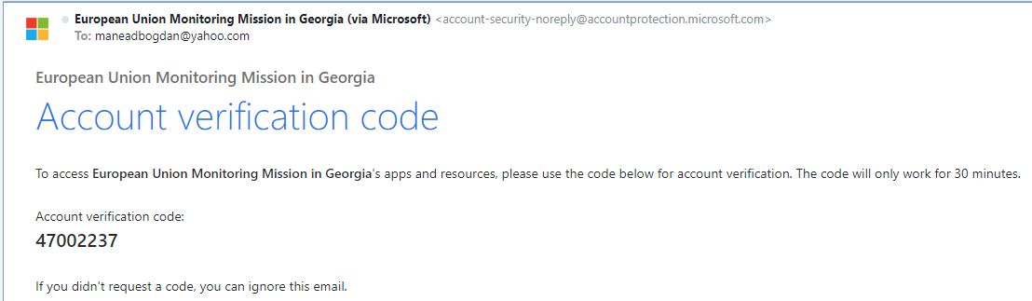

- The invited person must Accept the agreement to continue the joining process.
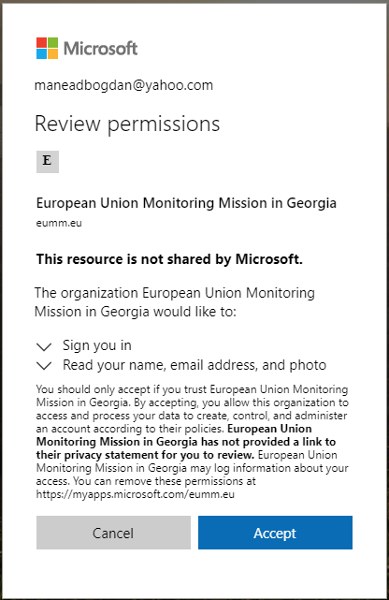
- Wait until access is granted.

- The person can either use the Windows Teams application or join via a web browser.
