All cause total health spending, source composition in PPP $, Georgia
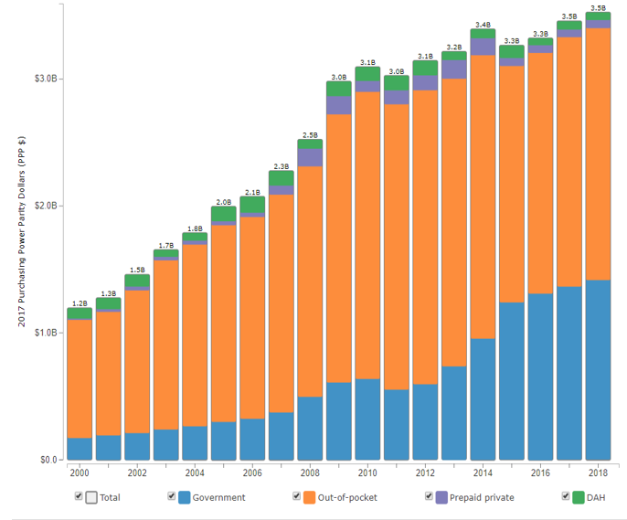

All cause total health spending in PPP $ trend, Georgia

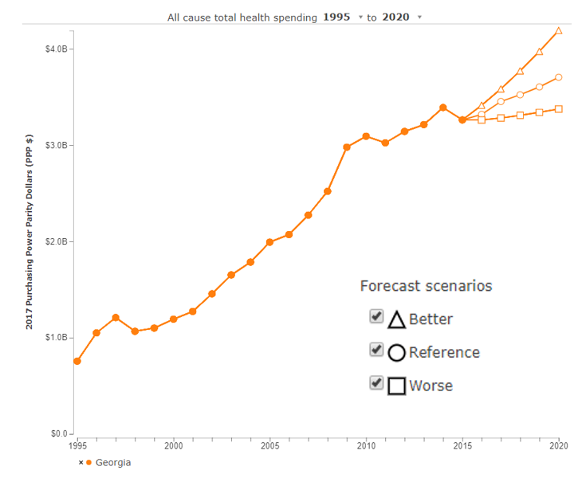

Health spending per capita, source composition in PPP $, Georgia
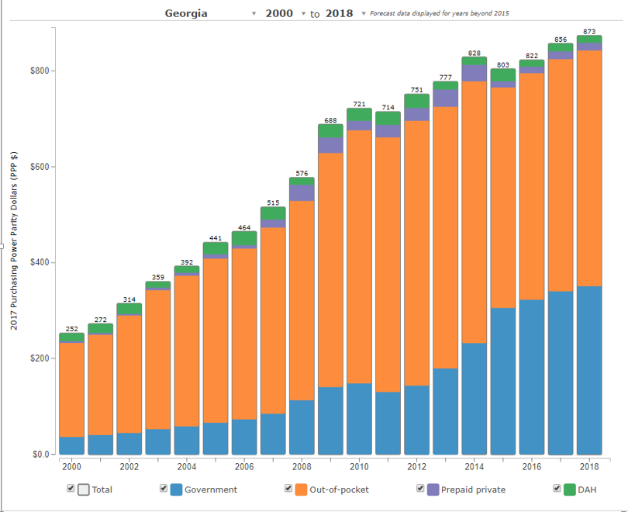
Health spending per capita in PPP $, trend, Georgia

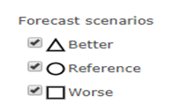
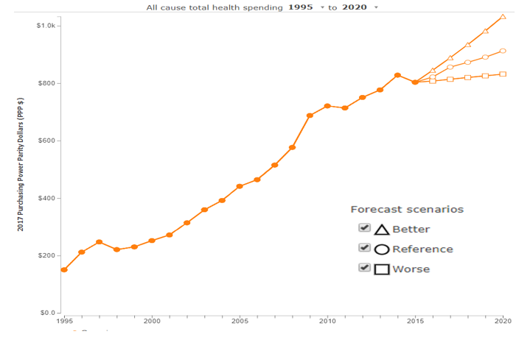
Health spending share of GDP, source composition in %, Georgia
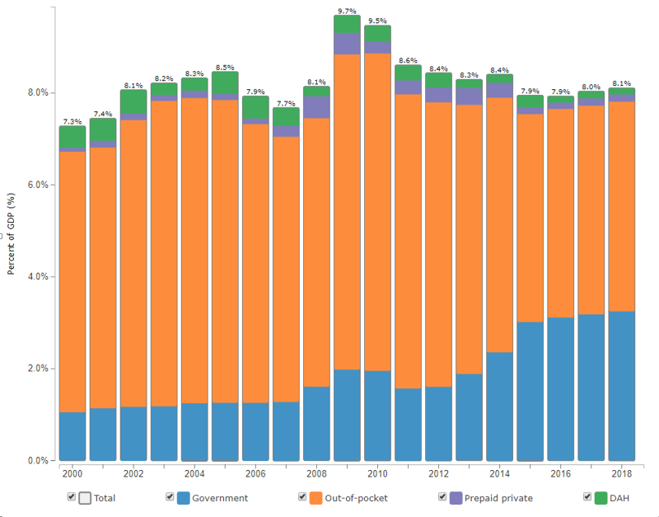

Health spending share of GDP, trend, Georgia

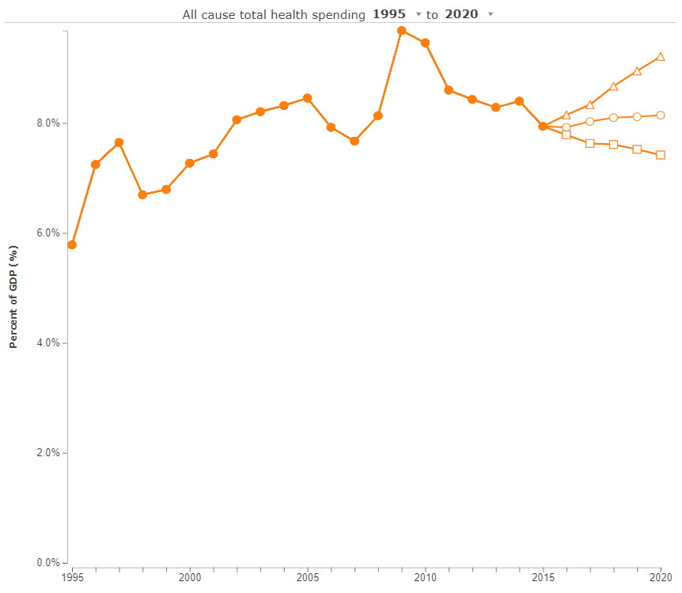
Total spending for health, source composition in %, Georgia
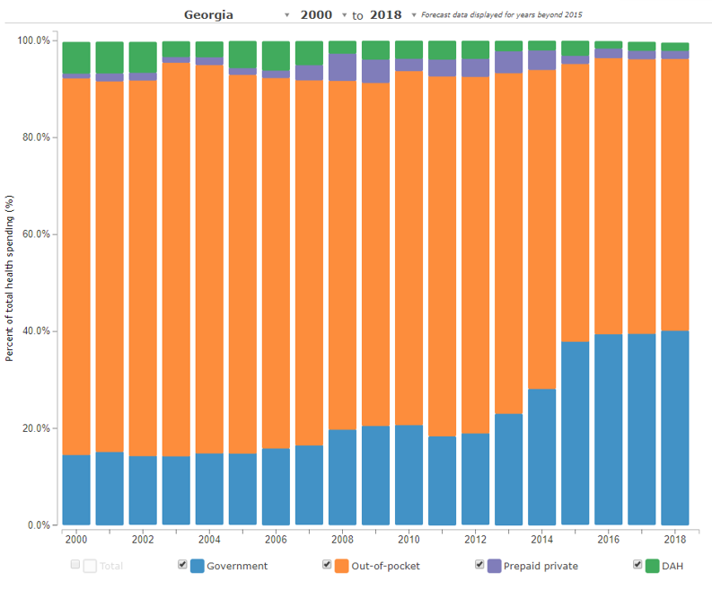

HIV total health spending, source composition in PPP $, Georgia

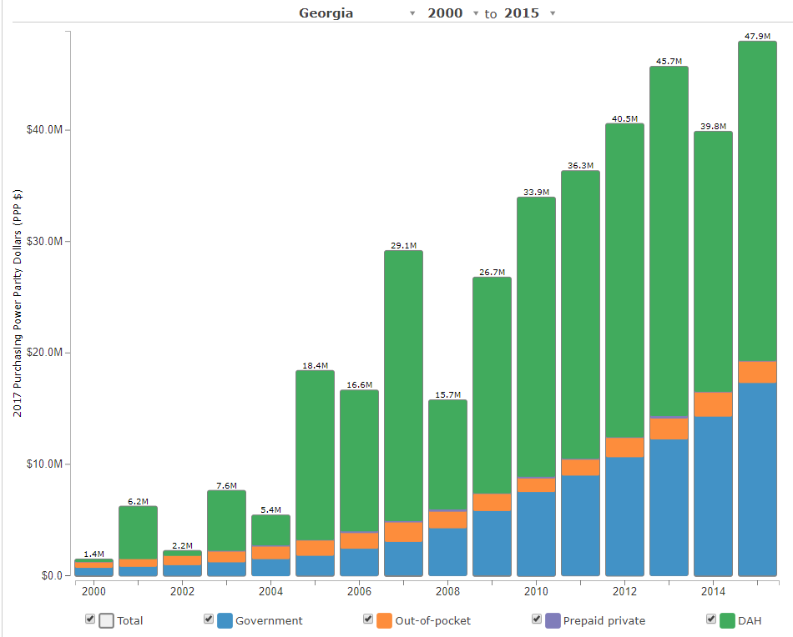

HIV total health spending in PPP $ trend, Georgia

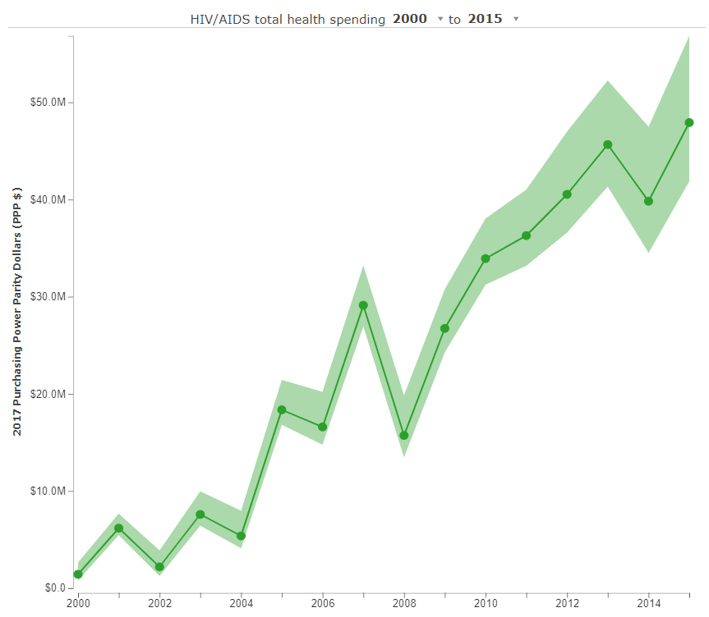

HIV health spending share of GDP, source composition in %, Georgia

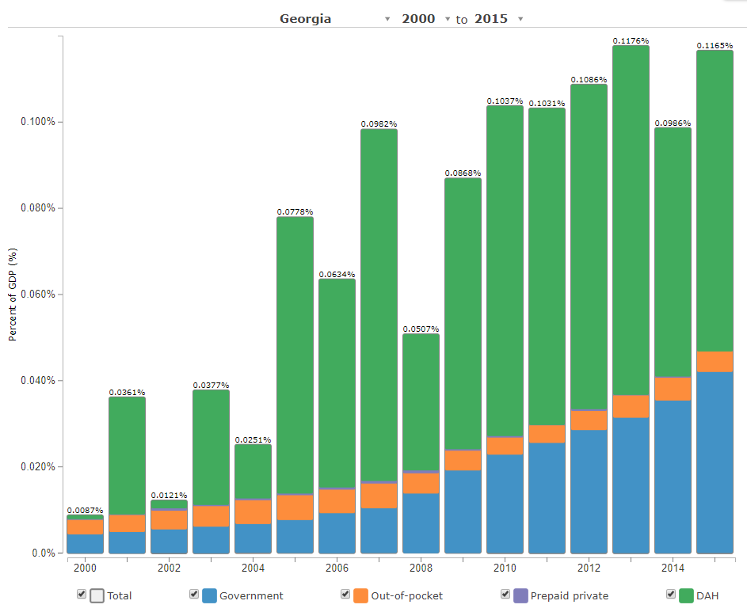

HIV health spending share of GDP, trend, Georgia
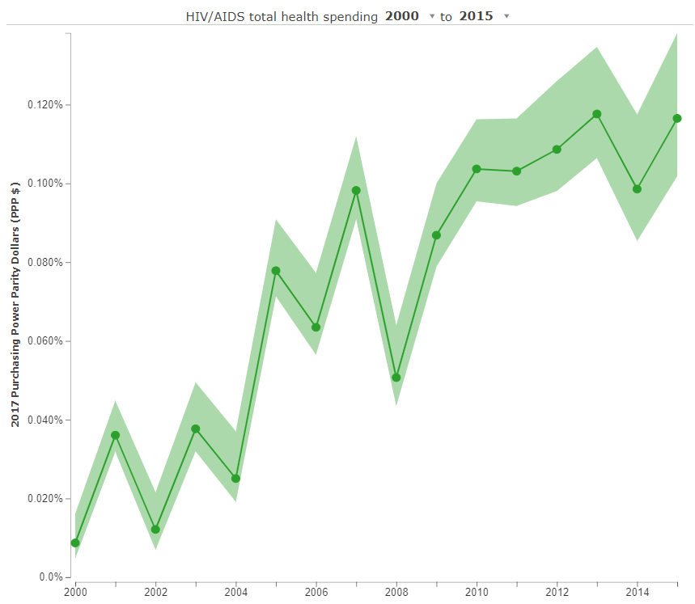

HIV health spending per prevalent case in PPP $, Georgia

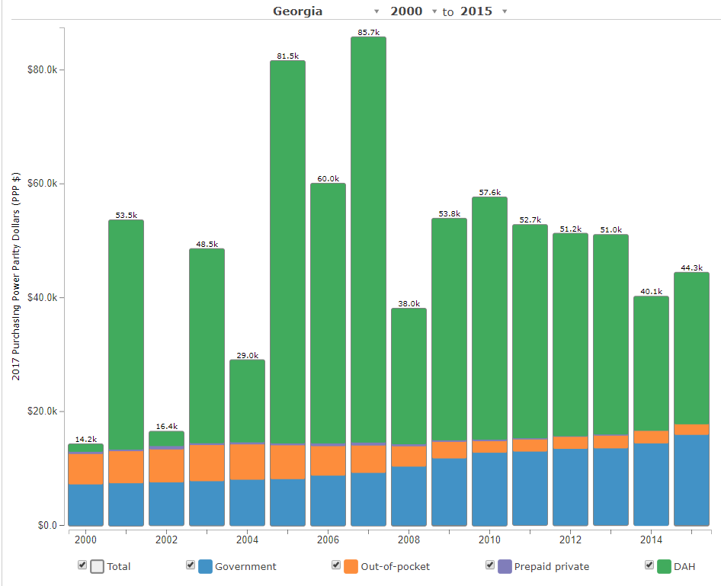
HIV health spending per prevalent case in PPP $, trend, Georgia

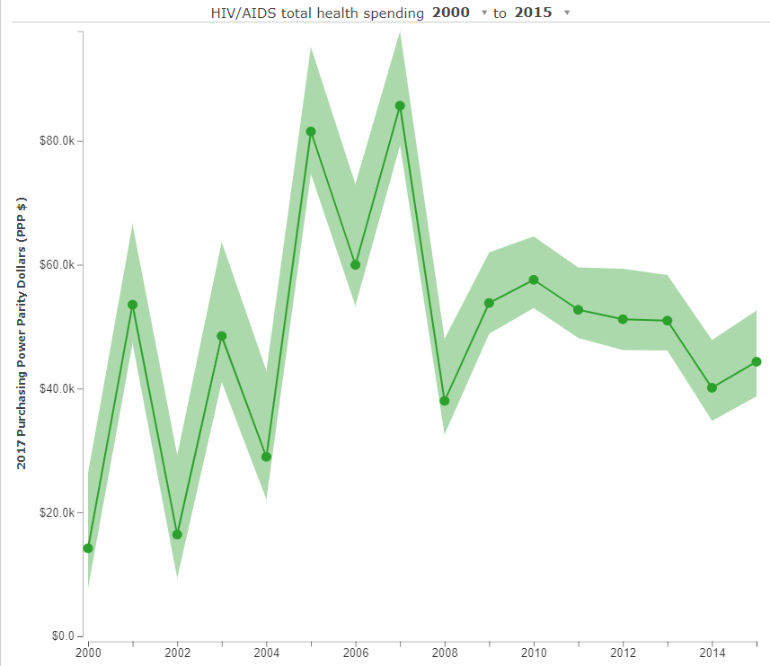
HIV total spending for health, source composition in %, Georgia

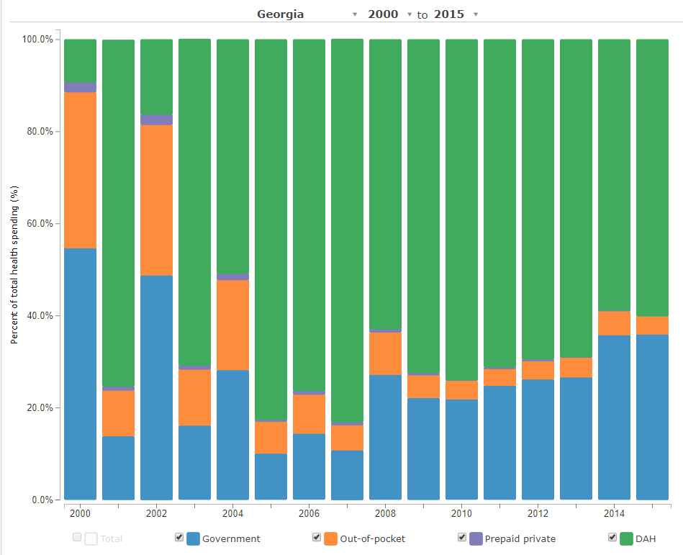

Source: https://vizhub.healthdata.org/fgh/

