Template for Case Studies
Regional Forum on Sustainable Development (21-22 March 2019, Geneva)
Governments and other stakeholders are kindly asked to provide concrete case studies and examples of practical solutions from their experience in SDG implementation. The case studies will be compiled in a document and shared with participants in advance of the Forum (please see last year’s case study compilation). A selection of case studies will be presented during the peer learning segment.

The Regional Forum on Sustainable Development (21-22 March 2019, Geneva) creates a regional space for peer learning and sharing of practical solutions in implementing the SDGs. Governments and other stakeholders will mutually learn from sharing concrete experiences, best practices and challenges. Case studies will form the basis of the peer learning segment.

When?

Why?

How?
Please submit the case study by 31 January 2019 to regionalforumunece@un.org.

SDG addressed
The case study must address one of the themes discussed at the round tables (see below). Please tick the relevant box.
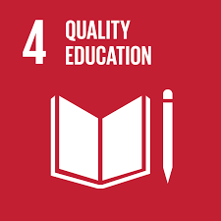
☒ Learning without Limits: Lifelong Learning and Inclusive Education
☐ The Power of Knowledge for Change: Education and Learning as Drivers of
Sustainable Development
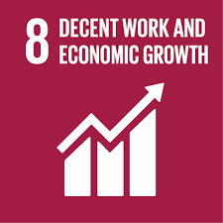
☐ The Growth We Want: Solutions for Sustained, Inclusive and Sustainable
Economic Growth
☐ The Future of Work: Productive Employment and Decent Work for All
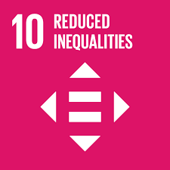
☐ Bridging the Gap: Achieving Greater Income and Economic Equality ☐ Towards a World of Equal Opportunity: Tackling inequality caused by exclusion
and discrimination
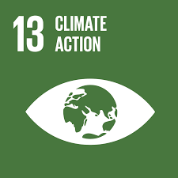
☐ Acting for Climate: Stepping Up Climate Change Policies, Action and
Awareness in the Region
☐ Coping with Climate Change: Strengthening Resilience and Adaptation
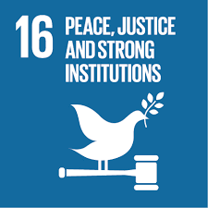
☐ Strengthening Institutions for Change: Fostering Effective and Inclusive
Governance for Sustainable Development
☐ Empowering People to Protect the Planet: The Environmental Dimension of SDG 16

Please fill in the template below.

Title
Empowering older people to ensuring their inclusion in the development of digital technologies through life-long learning

Summary
The project emerged from the fast development of science and technology in the past few decades that had enormous influence on every-day life. Experiences have shown that many people – and especially senior citizens – found it hard to keep up with technological progress. Older persons are less active on the Internet. However, they too are noticing that many aspects of every-day life, such as hotel reservations, online shopping, online banking or communication through messenger services, are increasingly webcasted. Anyone who is not on-line, is excluded from participation in a 21st-century society. Those who are on-line have more possibilities. To exchange good practices Austria hosted an expert conference on the ethical issues of modern technologies and especially on “Digitalization & Education – A Life-Long Learning Process” in November 2018.
Three case studies in the UNECE region were presented::
Austria: Low-threshold training for older persons “TiK - Technology in Brief – Tablet for everyone”
France: Digital Bus, Digital Voucher, Digital Culture Check
Germany: Digital Social Space for and in Old Age, Low-threshold digital communication and networking structures, Digital literacy skills

Situation
The number of people who are 65 years old and above has risen to 194.9 million among the UNECE region’s population of 1.27 billion (15.4 per cent) and will increase to more than a fifth of the total population in 2030. To empower older people and to ensure their inclusiveness and equality in full participation in social, economic and cultural life the access to new digital and communication technologies and the right to life-long learning and digital training for older persons is essential.
Austria: 80 percent of people between 55 and 64 years are using internet, but only 52% of people between 65 and 74 years.
Germany: In terms of figures, some 10 million persons in Germany over the age of 60 do not use the Internet – for a number of different reasons. (Compared with other states of the EU, where more than two-thirds of the elderly are online, Germany ranks only in the upper middle field)

Strategy
Austria: In the UNECE Ministerial Declaration of Lisbon 2017 on “A sustainable society for all ages: Realizing the potential of living longer” the strategy of e-inclusion plays an important role as well as in in the Austrian Strategy on Life-Long Learning 2020 and the Federal Plan for Senior Citizens “Ageing and the Future”. Measures have been set in research, information, further training, quality assurance and support of pilot projects to leave no one behind. The prospect of life-long learning broadens the scope of individual options: empowerment, self-determination and fulfilment.
Germany: Germany is working on taking into account the interests of older persons and families, children and young people as best as possible. The strategy is to work on this jointly with several other partners and in close exchange with welfare organisations, providers, the housing sector and education providers, with the joint goal of creating an enabling living environment.

Results and lessons learned
Austria: A good practice in adult education for senior citizens is the project “TiK – Technology in Brief – Tablets for everyone”. The high-tech project follows an intergenerational approach through the training offered by young volunteers (age 16 to 30) as so-called “Tablet-Trainers”, who are educated along a special Tablet-education-curriculum. The courses have the distinction of a multitude of methods and flexible leading questions and a special commitment of the young trainers. They offer low-threshold courses voluntarily for only a small expense allowance. The further development of the courses is ensured by the feedback of the participants and the trainers who also elaborated their own special materials and barrier-free hand-outs for the elderly. The courses are within easy reach for those interested and much attention is paid to a wide geographical distribution of the “TiK-modules” and of information on www.digitaleseniorinnen.at. Participants of the courses are persons and especially economically disadvantaged women on a low educational level. Until the end of 2018 more than 2000 persons learned with the modules and another 1000 persons participated in the course-programme. The oldest participant who just takes part in a course is 97 years old, he gets his education by a young man in a nursery home. A patent application was filed for the project and the German name is a registered trademark. The project was awarded several times on the federal and provincial level.
Germany: 1: Older persons require needs-oriented and user-oriented digital support in their every-day lives. 2: Older persons need low-threshold, digital communication and networking structures.
3: Older persons need digital skills and access to them.
Many multigenerational homes (federal program) are already advancing the topic of "Digital in Old Age" (through voluntary helpers, with special computer and Internet courses for the elderly, with practical support). Mentoring partnerships between younger and older generations help to eliminate barriers and promote social interaction.

Contact Austria
Name: Christoph Angster
Organisation: Federal Ministry of Labour, Social Affairs, Health and Consumer Protection
E-Mail: Christoph.angster@sozialministerium.at
Contact Germany:
Name: Martin Amberger
Organisation: Federal Ministry for Family Affairs, Senior Citizens, Women and Youth, Germany
E-Mail: Martin.Amberger@bmfsfj.bund.de

☐ Please tick this box if you do not wish your contact details to be published in the compiled document. The document will be published on our website. Please bear in mind that other stakeholders might wish to contact you in regard to the case study.

