Obstetrics and Gynecology Development Plan until 2020

2012

The document was drafted by the ENS Working Group:
Aivar Ehrenberg
Helle Karro
Ivo Saarma
Piret Veerus
Lee Tammemäe
Made Laanpere
Eva-Kaisa Zupping
Kadri-Liina Vahula
Tiiu Hermlin
Katrin Täär
Külli Frolova
Shadow the Haavel
Maike Parve
Ferenc Szirko
Reet Lindström

Thank you for your cooperation: Estonian Medical Birth Registry, Estonian Health Insurance Fund

Table of Contents
1. Introduction
2. Speciality development
2.1. The definition and the nature of the specialty
2.2. Specialty Development Priorities
2.3. Comparison of speciality status and the priorities of the European Union countries and the rest of the world
3. Distribution of services
3.1. Division of patients and services between hospital and non-hospital specialized care and primary care
3.1.1. Non-hospital services, the distribution of
3.1.2. Specialist care at hospitals
3.2. Patient and service division between acute care hospitals
3.3. Rare diseases
3.4. Rare conditions
4. 24/7 and on-call Service
5. Load standards
6. Estimates of the need for services, beds, specialists, new technologies and medical devices by 2020
6.1. Service need
6.2. Bed need
6.3. Specialist need
6.4. New technologies and the need for medical devices (including drugs)
7. Regulatory environment and necessary changes
7.1 Legislation
7.2. Treatment guidelines
7.3. Other standards and regulations
8. Raising the profession's responsibility as an observer of medical qualification
9. E-Health

1. Introduction
A woman's health is affected not only himself, but to a significant extent in the next generation 's health and development. This includes many health problems that only affect women. For example, pregnancy and childbirth, which is a biological and social processes, but pose increased health risks that need medical assistance. Complications related to pregnancy and childbirth and the consequences of unsafe sex (including HIV / AIDS) continue to be one of the leading causes of death among young women in low-income countries. Unwanted pregnancies, abortions, pregnancy and childbirth -related complications , and sexually transmitted infections, and reproductive cancers side affects significantly the woman's sexual and reproductive health, violence (including domestic violence) , and the sexual exploitation of children. Estonian Women's Medical Society believes that obstetrics and gynecology specialist is a priority of sexual and reproductive rights of when human rights ensuring that continues specialty priority throughout the world by the World Health Organization (WHO) report on women's health, " Women and Health: Today's Evidence, Tomorrow's Agenda 2009 ' underlines that reproductive and sexual health are key areas for women's health.
It is important for every citizen, regardless of their nationality, place of residence and social class, to have access to high-quality medical care. Patient-centered approach and the high professional ethics of the doctor are important to ENS when providing medical services.

2. Development of specialty
2.1. Definition and nature of specialty
Obstetrics and Gynecology is a single medical discipline that deals with the prevention, diagnosis and treatment of female genital diseases, as well as gynecological endocrinology, reproductive medicine and maternity care. Obstetrics and Gynecology specializes in Perinatology, Urogenecology, Reproductive Medicine, Gynecological Oncology.

2.2. Priorities for specialty development
The general priorities for the development of the profession are set out in documents developed by the WHO, EBCOG ( European Board and College of Obstetrics and Gynecology ) and FIGO ( International Federation of Obstetrics and Gynecology ).
In doing so, the emphasis will be on ensuring a better and more consistent quality of healthcare provision, based on:
- Providing patient-centered medical services;
- Evidence-based;
- Ensuring continuing vocational training and competence assessment;
- Updating / upgrading treatment guidelines and developing new treatment guidelines;
- Correct documentation to allow for quality control of treatment, including regular collection and analysis of quality indicators;
- Each hospital that provides obstetrics and gynecology services must have a senior specialist in charge of the field, who will coordinate field development;
- When providing obstetric services, a pediatrician on-call service must be provided at the hospital;
- Optimization of the service network, taking into account the availability, consistency and consistent quality of assistance, including:
  - Increasing the share of day care;
  - Increase in the independent role of midwives in, inter alia, shared maternity care for monitoring normal pregnancies, postnatal care and family planning counseling;
  - Outpatient obstetrics and gynecology services (first aid, pregnancy monitoring) near the place of residence;
  - Increasing the proportion of outpatient procedures - gynecological surgery is becoming less invasive and more procedures can be performed in outpatient or day care settings;
- Continuing development and concentration of sub-specialties of the specialty (urogenecology, gynecological oncology, perinatology);
- Enhance prevention of unwanted pregnancies, sexually transmitted infections and cancer of the female genital tract;
- Ensure uniform principles of prophylactic gynecological screening based on the age of the woman.

Development needs and challenges to be addressed
- To ensure quality outpatient service throughout Estonia, you must:
  - to increase the potential of GPs and midwives in out-of-hospital care (especially in rural areas) (maternity care, including postpartum monitoring, disease prevention, contraception);
  - ensure the presence of resident gynecologists in all hospitals in the hospital network . Several hospitals (eg Valga Hospital, Ida-Viru Central Hospital) do not have enough resident gynecologists. Narva Hospital faces a sharp shortage of doctors due to the age structure of doctors;
  - in local hospitals, preferably to develop outpatient care rather than hospital care, as has sometimes been the case;
  - to monitor quality of service.
- Optimization of Obstetrics. Childbirth is distributed among too many hospitals, which affects both the quality of care and the ability of medical institutions to cope. The centralization of premature and other complicated births has not been finally resolved.
- Increase in multiple pregnancies due to artificial insemination . This is a global problem arising from the use of infertility drugs and technologies due to the use of ovulation stimulating drugs and the transplantation of more than one embryo in the case of extra-utero fertilization.
- Despite a significant decline in induced abortions, the abortion rates are about twice as high as in the Nordic countries . The high percentage of repeat abortions is of particular concern.
- Development of medical records
  - There are no personal identification numbers in the pregnancy termination database. This prevents linking to other registers and data analysis.
  - Estonian Medical Birth Registry (EMSR) - deficient coding of maternal diseases and classification of maternal causes of death (directly and indirectly related to pregnancy / childbirth) and proper documentation. It is important to work through the chain of events leading to the death of the mother as clearly as possible, as the maternal mortality rate is relatively high compared to the Nordic countries.
  - It is necessary to establish an IVF registry to assess the effectiveness of assisted reproductive technology and to monitor the health of the children conceived in this way.
  - A registry for cervical cancer screening is necessary . Cervical cancer does not show a downward trend. Disease screening is opportunistic, and the percentage of population-based screening is unsatisfactory.
- Sexual health problems
    - Prevalence of HIV infection among pregnant women, especially in Tallinn and Ida-Virumaa, congenital HIV infection of newborns. Pregnant drug addiction is a problem. Outpatient specialist medical care should provide more HIV diagnostics. The increasing number of HIV-positive pregnant women necessitates a good and effective networking between different professionals.
    - A network of youth counseling centers, which has been providing free sexual health preventive services to young people under 25 for an important part of primary care, is an important part of this . The continuation of the youth center service is necessary because it has played a key role in reducing the sexual risk behavior of young people. Project-based funding for counseling on (sexual) health behaviors among young people is not sustainable.
- The residency program in Gynecologists meets the minimum EU requirements but is too short to allow for adequate training in related and sub-specialties.
- Pricing of health care services and payment for services based on DRG does not allow the introduction of modern therapies. Examples include the cost of laparoscopic or urogenital surgery supplies, fetal ECG monitoring. Pricing applications for new treatment services are a responsibility of professional societies. The training of the medical staff and the resources of the professional association do not allow this task to be performed.
- The need for certain services is increasing, both as a result of increasing age-related health problems (genitalia, cancer) and increasing expectations for quality of life in old age. The continuing change in reproductive behavior (postponing delivery until later) increases the need for prenatal diagnosis and treatment for infertility.
- Violence, especially intimate partner violence, is associated with both sexual risk behaviors and a variety of medical conditions, including pregnancy and the health of the newborn. Recognition of violence requires a code of practice, along with training for all gynecologists.

2.3. Comparison with the development of the profession and its priorities in the Member States of the European Union and the rest of the world
The WHO Reproductive Health Indicators (WHO 2006) are still used worldwide to assess the situation and changes in the field of reproductive health, of which:
• Total fertility rate
• Use of contraceptives
• Maternal mortality rate
• Prenatal coverage with antenatal surveillance
• Births in the presence of a qualified health care professional
• Availability of basic obstetrics
• Perinatal mortality rate
• Share of newborns with low birth weight (<2500 g)
• Prevalence of syphilis in pregnant women (positive serology)
• The incidence of anemia in pregnant women
• Abortion referral rate (inpatient care)
• Incidence of infertility in women
• The incidence of HIV infection in pregnant women
• HIV prevention

Within the framework of the EURO-PERISTAT project in 2008 The European Perinatal Health Report, prepared by the European Commission (EU), highlights the differences between the various reproductive health indicators and indicators across the European Union (EU). Significant inequalities in access to and quality of health care in EU countries led to the need for uniform standards, guidelines and the development of indicators to ensure the highest possible level of quality in obstetrics and gynecology across the EU. Adherence to common standards is particularly important in a situation where patients are now entitled to scheduled healthcare in all EU Member States. During the following years, the major challenge for the EU Member States, including Estonia, for the health care industry in the European Parliament and Council Directive 2011/24 / EU of 09.03.2011, the patient's right to the application of the cross-border healthcare, are implemented.
European Board and College of Obstetrics and Gynecology (EBCOG) on 2011.a. prepared in women's health tracking European standards (Standards of Care for Women's Health in Europe ). EBCOG guidelines and standards for the development takes into account the WHO, The Royal College of Obstetricians and Gynaecologists (RCOG) and the National Institute of Clinical Excellence (NICE) published by the obstetrics and gynecology standards relating to the documents. Their base was developed 16 standards relating to pre-pregnancy women and co-normative guidance and monitoring of obstetric management and quality assurance, neonatal monitoring, post-natal period, as well as professional training and training for residents of the requirements that should be observed and taken into account in Estonia.
In the context of the European Union Directive on the Free Movement of Patients, all EU countries must strive for the highest quality and standard of obstetrics and gynecology services. Increased migration from developing countries and politically unstable countries to the EU also has a significant impact on health statistics in EU countries, which is why it is important that specialty indicators are collected according to the same standards.
It is important to pay attention to teenage pregnant women and pregnant women with age> 35.a, because these groups have increased the risk of premature childbirth, the fetus in utero growth retardation and perinatal mortality. The most common causes for teenagers here are unwanted pregnancies, low social status, poverty, lack of family support. Older pregnant women have more comorbidities and are at greater risk of having a baby with a malformation . The increasing age of primary births in the EU will certainly have an impact on perinatal health outcomes. Accordingly according to the special attention paid to teenage pregnancies percentage of the reduction, to strive towards that, as a large number (> 90%) of pregnant women would turn female doctor already during the first trimester of pregnancy, and improved antenatal surveillance tactics / techniques to help elderly pregnant women to reach the expected birth of the fire quickly (or give birth yourself as a whole as well as being a healthy child).
Within the EU should clearly define what is considered labor induction and stimulation methods, because many countries do not read amniotoomiat methods include induction and pay attention to drug-induced birth to. All possible methods and the different medications used should be highlighted.
Compared to other EU Member States, Estonia is among the average in terms of its indicators, and efforts must be made to reach the level of the Nordic countries.
Fertility is best characterized by the total fertility rate (the number of children born by a woman by the end of her fertile life, provided that the fertility behavior remains the same during the year under review). Compared to 2000 it has even risen. 2000 the corresponding figure was 1.38. 1.65, in Finland last year 1.87 and in Latvia 1.32. Although we have a low birth rate (recovery rate of 2.1), we have an average birth rate compared to EU countries.
Compared to 2000 the abortion rate has decreased almost twice - in 2000 the number of legally induced abortions per 1,000 women of childbearing age was 37.2 in 2010. but 21.6. The corresponding figure for Finland was in 2010. on the other hand, more than 2 times lower than our rate - 8 legal induced abortions per 1000 women of childbearing potential. The high percentage of repeat abortions remains a cause for concern.
In 2007, contraceptives were used. 83% of women according to the "Estonian Women's Health Survey" (asked to use contraception during the last intercourse). The most popular contraceptive was the condom (33.6%), followed by combined hormonal contraception (28%) and the intrauterine device (16% of women). An alarming number of women of childbearing age (24.3%) still use aborted sex as a method of contraception.
The maternal mortality rate was in Estonia in 2008. 12 cases per 100,000 live births, 7 cases in Finland and 5 cases in Sweden. The corresponding figure for the EU is 2-10 / 100 000 live births.
Pregnancy monitoring of pregnant women is> 90%, which is also a target for EU countries. The first visit during pregnancy took place in 2010. 84% of pregnant women before 12 weeks gestation (> 90% intentional). Ultrasound was performed in 95% of pregnant women before the 21st week of pregnancy.
Perinatal mortality (2010) is compared to 2000. dropped from 8.1 cases to 5.8 per 1,000 births. (The corresponding figure for the EU is 4.8-11).
The proportion of newborns with birth weight below 2500g was in 2010. 4.3%. Compared to 2000 (4.6%) it has remained relatively unchanged. In the EU, the corresponding figure is 4.2-8.5% of live births.
Incidence of cervical cancer has not significantly decreased in spite of an organized cervical cancer screening (PAP test). The annual number of new cases of cervical cancer remains between 150 and 160; mortality from cervical cancer has fallen slightly, to 50-60 deaths a year. Organized screening in 2010 nearly 67% of women covered by occupational health insurance, yet only 1/10 of all women screened; 9/10 are screened opportunistically. Instead, it would be necessary to conduct a population-based screening and include uninsured women in the screening.

3. Distribution of services
3.1. Division of patients and service provision between hospital and non-hospital specialized care and primary care
Obstetric and gynecological health care is divided into outpatient and inpatient specialist care, with the participation of midwives in addition to gynecologists. Obstetric and gynecological services are also supported by GPs according to their professional standard.

3.1.1. Distribution of services outside the hospital
Primary care
Primary care activities include: normal (non-complicated) pregnancy monitoring, postpartum monitoring and breastfeeding counseling, continuation of contraception and hormone therapy, general patient health counseling, and certain preventive activities. These tasks are workable for a family doctor or midwife.
As a rule, about ten visits occur during pregnancy. In the case of shared maternity care, two of these would be recommended to a gynecologist. Currently, only a few percent of pregnant women are seen by a family doctor. In the near future, conditions need to be created where, in addition to shared maternity care with gynecologists, midwives are motivated to provide health care on their own or as part of family physician practice, mainly in rural areas. It is important that frequently used services, including ambulatory care, maternity care (antenatal care), post-natal counseling and patronage, and disease prevention are provided as close to the place of residence as possible.
Specialist non-hospital care
The gynecologist is active in monitoring high-risk pregnant women and preventing and treating women's diseases. It is important that the woman's right to go to the gynecologist without a referral is preserved.

3.1.2. Specialized hospital care
In day care conditions antenatal diagnostic procedures are performed, abortions (with and without uterine abrasion), uterine abrasions in case of menstrual cycle disorders, hysteroscopies, cervical conisations, minor genital surgeries, extracorporeal fertilization. Day care can be applied to operations and procedures that do not require hospitalization and where the patient does not require intensive care and the need for follow-up after the procedure does not exceed 4 hours.
The widespread adoption of day care needs to be supported by the price list for treatment services. Day care must be made economically attractive to the medical institution to compensate for the drop in income due to the reduction in hospital care cases.
Inpatient services include obstetric services, uterine and uterine surgeries, major genital surgeries, laparoscopic surgeries (both diagnostic and curative), treatment of ectopic pregnancy and inflammatory diseases of the female genital tract (and menstrual disorders), and treatment.
Inpatient oncogeneology service is provided in central and regional hospitals.

3.2. Distribution of patients and service provision between acute care hospitals
NB In the field of obstetrics and gynecology the central hospitals of Tallinn play the role of regional hospitals!

Obstetrics

Figure 1 Number of births 2000-2010 ( Estonian Medical Birth Registry, EMSR)
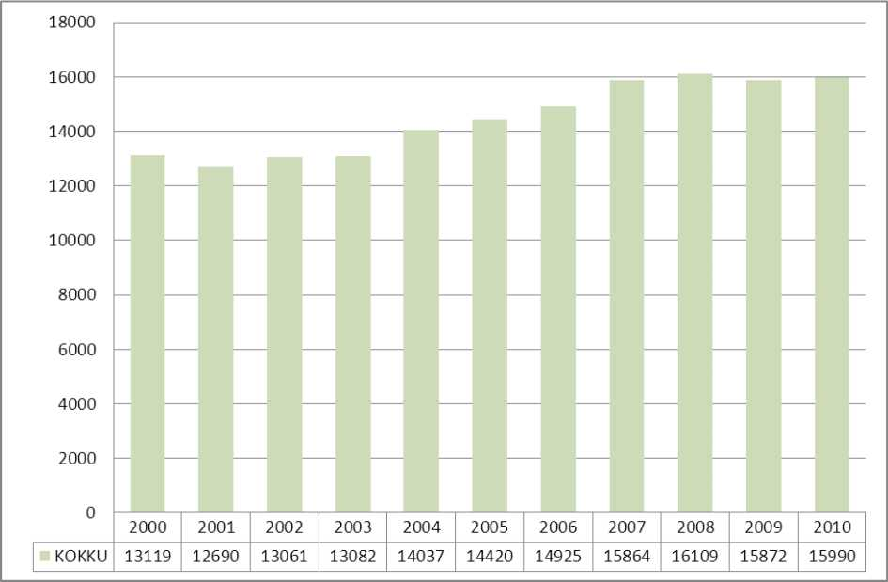

Table 1 Distribution of births (EMSR)
 | 2008 | 2009 | 2010
Estonia | 16 109 | 15 872 | 15 918
Including Tallinn and Harju County | 8 329 | 8 063 | 8 205
Tartu | 2 482 | 2 703 | 2 769
Pärnu | 1 059 | 1 047 | 967
Total | 11 870 (74%) | 11 813 (74%) | 11 941 (75%)
Ida-Virumaa | 1 124 (7.5%) | 1 202 (7.5%) | 1 046 (6.4%)
Other regions | 3 015 (19%) | 2 857 (18%) | 2 931 (18%)

In 2010, 15 990 children were born in Estonia out of 15 918 deliveries, 64.3% of deliveries took place in three major hospitals (East Tallinn Central Hospital, West Tallinn Central Hospital and Tartu University Hospital). These hospitals are an advanced stage in which high-risk laborers, including premature labor, are referred to give birth. Leaving aside 379 deliveries on the islands, the remaining 4 705 deliveries were spread over 13 hospitals. Four outpatient departments (Pärnu Hospital SA, Narva Hospital SA, Rakvere Hospital AS and Fertilitas AS) had more than 500 deliveries per year.
Figure 2 Distribution of childbirth by hospital type (EMSR) *
Distribution of deliveries by hospital
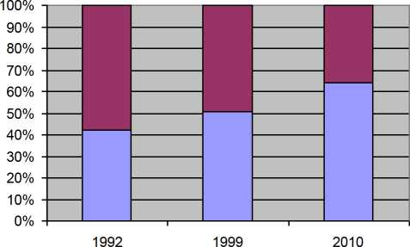
□ Other (Red)
□ Regional (Blue)
* Regional hospitals include the University of Tartu Hospital and the Women's Clinics of Tallinn Central Hospitals.

Pregnancy pathology
Based on treatment bills submitted to the Estonian Health Insurance Fund (EHIF) in 2010, it was found that 60% of maternity pathology beds were spent in regional hospitals. Given the share of deliveries, this figure could have been higher. The number of maternity pathology bed days at Virumaa Hospitals: Rakvere Hospital - 3.37 days for each delivery in this hospital, 2.41 in the Narva Hospital and 1.78 in IVKH respectively. By comparison, the figure for East Tallinn Central Hospital was 0.97. It is believed that the bed fund was used inappropriately in these hospitals.

Gynecology

Figure 3 Gynecology bed days by hospital type in 2010 (EHIF) *.
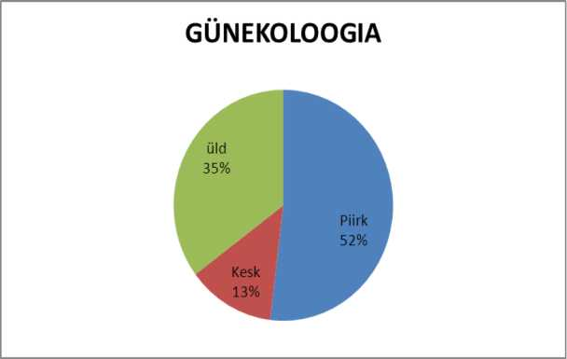
* Regional hospitals mean the hospitals of Tartu University Hospital, PERH and Tallinn.
Legend: Green-General; Red-Central; Blue-Regional

Figure 4 Distribution of gynecological cases between inpatient and day care in a year by type of hospital
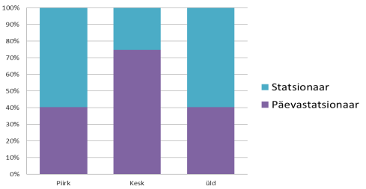
Legend: Lilac-Day-hospital; Blue-Inpatient
Legend2: Columns from left- Regional/Central/General

It is striking that in 2010 majority of cases in general hospitals were treated in inpatient setting. However, the need for inpatient care cannot be higher in general hospitals than in central and regional hospitals. This proportion of inpatient care in general hospitals is not justified.

Outpatient services, which should definitely be available in counties with less than 40 000 inhabitants.
Maternity care and all outpatient gynecological services must be available, except for specialist appointments (oncology, infertility treatment). The day care unit must be able to have a pregnancy termination service, perform minor gynecological surgeries on the external genitals, abrasion of the uterine cavity.

3.3. Rare diseases
Treatment of rare diseases is organized in Estonia or, if this is not possible, abroad. It is not possible to make general suggestions here, treatment is tailored to the specific situation.

3.4. Rare conditions
See p. 2.3

4. On-call service
Obstetrics and gynecology on-call service in general hospitals means:
- 24-hour midwife on-site;
- 24-hour gynecologist on call (home on-call within 30 minutes) or on-site duty;
Other relevant clinical and support specialties must be guaranteed
- 24-hour pediatrician consultation (home on-call service within 30 minutes of hospital admission);
- 24-hour anesthetic, operative treatment (home on-call within 30 minutes);
- Blood service or on-site availability of blood products.
Starting with 700 deliveries, it is necessary to ensure that the gynecologist is on duty 24 hours a day.

Obstetrics and gynecology on-call service in central and regional hospitals - In addition to the general hospital requirements, it is necessary to provide a 24/7 on-site gynecologist.

Pediatric Service
The ENS believes that there should be a 24/7 pediatric consultation facility in all obstetric wards.
A pediatrician presence or challenge is required:
- Caesarean section;
- if fetal asphyxia (or other pathology) is suspected before birth or if the newborn is born with asphyxia or any other medical condition.
- if there are significant abnormalities in the new-born condition;
- In the case of a normal birth and a healthy newborn child, pediatric consultation is required before leaving the hospital.

In East-Tallinn and West-Tallinn Central Hospitals and at the University of Tartu Clinic, where high-risk obstetricians are referred, specialists must be on site 24 hours a day; in addition, a 24-hour intensive care facility for children is required.
In order to optimize on-call service, it should be concentrated in hospitals with at least 500 births per year.
The decisive factor in the provision of on-call service is whether the hospital in question is intended to continue the operation of the maternity ward.

Table 2 Possible development scenarios of the watch service in hospitals in different regions of Estonia until 2020
On-call service providers 01.01.2011 | FORECAST FOR 2020  Scenario A  (moderate optimization) | FORECAST FOR 2020 Scenario B (radical optimization)
North Estonia | North Estonia | North Estonia
AS East Tallinn Central Hospital Women's Clinic | AS East Tallinn Central Hospital Women's Clinic | AS East Tallinn Central Hospital Women's Clinic
West Tallinn Central Hospital Women's Clinic | West Tallinn Central Hospital Women's Clinic | West Tallinn Central Hospital Women's Clinic
Virumaa | Virumaa | Virumaa
Ida-Viru Central Hospital | Ida-Viru Central Hospital
AS Rakvere Hospital | AS Rakvere Hospital | AS Rakvere Hospital
SA Narva Hospital | SA Narva Hospital | SA Narva Hospital
West Estonia | West Estonia | West Estonia
Pärnu Hospital | Pärnu Hospital | Pärnu Hospital
Kuressaare Hospital SA | Kuressaare Hospital SA | Kuressaare Hospital SA
SA Hiiumaa Hospital | SA Hiiumaa Hospital | SA Hiiumaa Hospital
Central Estonia | Central Estonia | Central Estonia
AS Järvamaa Hospital | AS Järvamaa Hospital
AS Viljandi Hospital | AS Viljandi Hospital | AS Viljandi Hospital
South Estonia | South Estonia | South Estonia
AS South Estonian Hospital | AS South Estonian Hospital
AS Põlva Hospital
Tartu University Hospital Women's Clinic | Tartu University Hospital Women's Clinic | Tartu University Hospital Women's Clinic
AS Valga Hospital | AS Valga Hospital | AS Valga Hospital or AS South Estonia Hospital

According to ENS, it is desirable to optimize the hospital network so that the maternity wards are guaranteed 500 deliveries per year. As a first step, a change could be introduced to the effect that the state buys on-call service only from hospitals with at least 400 births a year. At the same time, it is necessary to provide obstetric service in Saaremaa and Hiiumaa regardless of the number of deliveries.

5. Load standards

Outpatient care:
Physician burden on outpatient work: 6.5 hours reception, normally 2 patients per hour, 5 days a week, 45 weeks a year e. 2925 (6.5x2x5x45) patients.
In pregnancy pathology
350 patients a year.
In gynecology
320 patients a year.
Day care
6.5 patients per day (6.5 * 5 * 45), 1462 patients per year.

6. Forecasts of need for services, beds, specialists, new technologies and medical devices by 2020
6.1. Service demand forecast

Figure 5. The number of women by age group
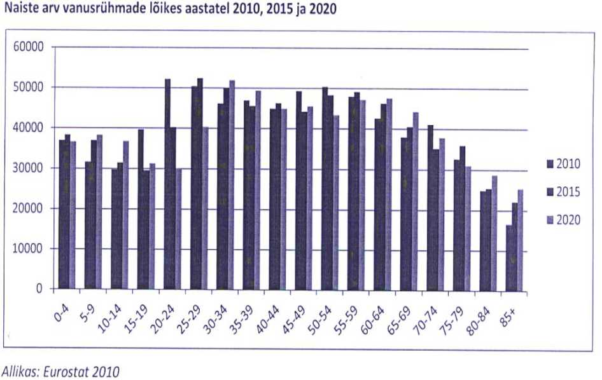

Table 3. Overall fertility rate per 1000 women of childbearing age by residence, 1992-2010 (EMSR)
Place of residence | 1992 | 1993 | 1994 | 1995 | 1996 | 1997 | 1998 | 1999 | 2000 | 2001 | 2002 | 2003 | 2004 | 2005 | 2006 | 2007 | 2008 | 2009 | 2010
ESTONIA | 48.6 | 41.7 | 39.3 | 37.9 | 37.5 | 36.0 | 35.1 | 36.1 | 38.1 | 36.8 | 37.9 | 38.0 | 40.8 | 41.9 | 43.7 | 46.7 | 47.8 | 47.6 | 48.6
County  Harju County | 38.5 | 32.3 | 31.2 | 30.3 | 29.2 | 28.5 | 29.2 | 31.5 | 34.6 | 34.8 | 36.6 | 39.6 | 44.8 | 47.3 | 51.8 | 55.8 | 58.1 | 57.4 | 59.3
including Tallinn | 37.8 | 31.4 | 30.8 | 28.9 | 27.8 | 27.1 | 28.0 | 30.8 | 34.2 | 34.6 | 36.0 | 39.5 | 44.9 | 47.6 | 52.0 | 54.3 | 55.6 | 53.7 | 54.6
Hiiumaa | 70.5 | 69.4 | 57.9 | 62.3 | 53.7 | 48.8 | 40.7 | 35.4 | 39.1 | 40.8 | 34.0 | 33.5 | 26.2 | 32.6 | 27.9 | 28.1 | 32.7 | 25.2 | 35.0
Ida-Virumaa | 37.9 | 31.5 | 30.9 | 31.8 | 32.8 | 30.3 | 31.3 | 32.7 | 35.2 | 33.7 | 35.7 | 32.9 | 35.5 | 36.0 | 33.2 | 35.5 | 34.2 | 33.9 | 31.5
Jõgeva County | 65.5 | 55.5 | 56.0 | 51.6 | 50.6 | 51.0 | 45.0 | 45.6 | 46.7 | 41.5 | 37.3 | 32.3 | 35.0 | 35.6 | 34.3 | 32.3 | 34.1 | 36.7 | 34.3
Järva County | 62.5 | 52.3 | 46.2 | 45.4 | 49.0 | 45.6 | 42.3 | 39.9 | 40.0 | 37.0 | 38.0 | 36.0 | 37.1 | 37.5 | 36.6 | 37.3 | 39.1 | 37.8 | 39.8
Läänemaa | 58.2 | 54.1 | 52.6 | 42.5 | 50.4 | 46.4 | 45.1 | 38.2 | 37.4 | 37.3 | 34.9 | 32.0 | 32.7 | 32.8 | 34.2 | 33.9 | 38.5 | 34.3 | 33.7
Lääne-Virumaa | 55.2 | 52.3 | 49.8 | 48.1 | 45.9 | 46.5 | 43.2 | 43.4 | 46.1 | 41.7 | 40.2 | 39.1 | 37.7 | 37.2 | 40.3 | 41.6 | 40.4 | 39.2 | 40.0
Põlva county | 62.6 | 52.9 | 53.7 | 53.6 | 53.4 | 44.6 | 39.8 | 44.6 | 38.3 | 36.3 | 39.7 | 37.9 | 37.0 | 37.1 | 35.3 | 35.1 | 38.5 | 39.5 | 38.6
Pärnu county | 56.8 | 48.4 | 46.8 | 41.2 | 42.1 | 42.4 | 40.1 | 40.2 | 40.8 | 39.7 | 40.8 | 38.7 | 38.2 | 39.2 | 41.6 | 45.8 | 48.5 | 48.4 | 45.0
Raplamaa | 62.2 | 58.5 | 48.1 | 51.1 | 49.0 | 45.4 | 40.6 | 40.8 | 41.6 | 36.4 | 39.8 | 31.4 | 40.7 | 37.7 | 40.0 | 44.4 | 44.1 | 43.0 | 46.9
Saaremaa | 65.5 | 59.4 | 53.6 | 51.5 | 41.2 | 45.0 | 39.3 | 42.1 | 40.5 | 37.0 | 34.5 | 31.8 | 35.7 | 34.5 | 37.6 | 35.7 | 36.6 | 37.2 | 38.2
Tartu County | 55.8 | 45.5 | 42.4 | 40.7 | 40.6 | 38.2 | 38.4 | 38.2 | 40.2 | 38.7 | 42.2 | 42.5 | 44.5 | 44.3 | 44.6 | 50.3 | 50.8 | 53.4 | 55.0
Valga county | 61.7 | 52.7 | 54.7 | 46.2 | 51.9 | 45.3 | 47.4 | 42.1 | 49.7 | 46.9 | 43.0 | 38.9 | 39.1 | 39.4 | 40.5 | 37.0 | 41.2 | 39.2 | 36.1
Viljandi County | 57.1 | 57.3 | 49.2 | 49.5 | 50.0 | 49.0 | 42.5 | 44.4 | 40.8 | 39.1 | 37.4 | 38.2 | 36.8 | 34.9 | 34.1 | 38.4 | 36.7 | 35.1 | 37.8
Võrumaa | 66.8 | 58.0 | 51.3 | 53.0 | 52.7 | 48.1 | 44.5 | 41.5 | 43.4 | 40.8 | 38.9 | 36.9 | 34.0 | 39.0 | 37.3 | 38.4 | 34.8 | 35.3 | 39.0

Figure 6. Specific fertility rate per 1000 women of childbearing age 1992-2010 (EMSR)
Fertility rate per 1,000 women of childbearing age, 1992-2010
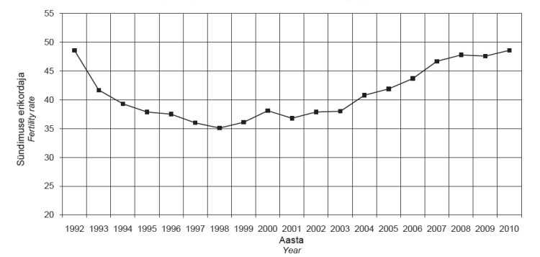

Looking at the change in the specific birth rate by the mother's place of residence, it is striking that over the last decade it has increased mainly in the areas surrounding larger centers.

Table 4. Changes in the specific fertility rate in different counties of Estonia, 2000-2011
Change in specific factor | County
Increased | Harju, Tartu, Pärnu, Rapla
Has not changed | Järva, Põlva, Saare
Fallen | Hiiu, Ida-Viru, Lääne-Viru, Jõgeva, West, Võru, Valga, Viljandi

Figures 7-9 Changes in the fertility rate by mother's place of residence, 2000-2010 ( EMSR)

Fertility rate has increased
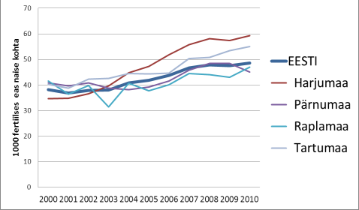

Fertility rate has remained stable
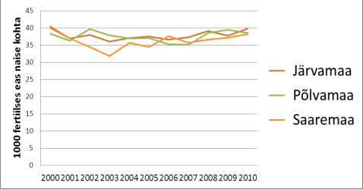

Fertility rate has decreased
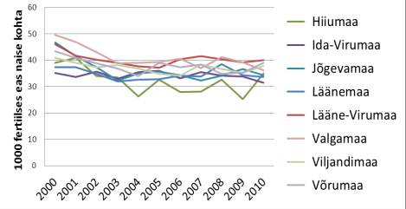

Table 5. Number of women of childbearing age and childbirth in 2010 and forecast for 2020 (Statistics Estonia, National Institute for Health Development)
County / number of women in the age group | 15-19 | 20-24 | 25-29 | 30-34 | 35-39 | 40-44 | together
Harju County | 13055 | 20660 | 23554 | 25918 | 23120 | 18841 | 125148
Hiiu county | 328 | 416 | 261 | 101 | 185 | 316 | 1607
East-Viru County | 3595 | 5493 | 5093 | 4097 | 4846 | 5033 | 28157
jogeva County | 1178 | 1410 | 976 | 469 | 729 | 1109 | 5871
Järva county | 1042 | 1345 | 1148 | 493 | 664 | 997 | 5689
western Province | 766 | 1032 | 754 | 358 | 583 | 921 | 4414
Lääne-Viru county | 2024 | 2476 | 1981 | 1206 | 1689 | 2001 | 11377
Põlva county | 947 | 1233 | 818 | 469 | 681 | 939 | 5087
Pärnu county | 2610 | 3407 | 2963 | 2183 | 2450 | 2947 | 16560
Rapla County | 1209 | 1411 | 1163 | 763 | 985 | 1157 | 6688
Saare county | 1106 | 1487 | 1091 | 538 | 774 | 1140 | 6136
Tartu county | 3964 | 5622 | 6420 | 6070 | 5282 | 4895 | 32253
Valga county | 1041 | 1293 | 860 | 591 | 887 | 1010 | 5682
Viljandi county | 1657 | 2070 | 1547 | 1024 | 1200 | 1570 | 9068
Võru county | 1184 | 1470 | 1017 | 559 | 847 | 1210 | 6287
Estonia total, 2010 | 35706 | 50825 | 49646 | 44839 | 44922 | 44086 | 270024
birth rate / 1000 women | 17.3 | 61.8 | 103.8 | 89.2 | 46.3 | 10.5
Number of deliveries in 2010 | 618 | 3141 | 5153 | 4000 | 2080 | 463 | 15454
Women projection for 2020 | 31587 | 29691 | 39561 | 51962 | 50138 | 45716 | 248655
Estimated number of deliveries in 2020 | 546 | 1835 | 4106 | 4635 | 2321 | 480 | 13924

According to Statistics Estonia's forecast, the number of women of childbearing age (15-45 years) in Estonia will decrease by eight percent by 2020.
Assuming the birth rate per 1000 women does not change, the number of births will decrease by 10% over the same period.
The decline in the number of deliveries varies by region. As can be seen, the specific fertility rate per 1000 women of childbearing age is highest in Tallinn / Harju County and Tartu. In our opinion, this reflects the better coping (employment, wage levels) of women / families in the two major centers of attraction in the country. There is a leverage effect in peripheral areas - the general decline in the number of fertile women across the country is accompanied by the migration of younger populations to larger cities or even abroad. Therefore, there is reason to believe that the actual decrease in the number of births in some regions of Estonia may be up to 20% in 2020 compared to today.
Figures 10-14 Changes in the number of births in different regions of Estonia, 2000-2010 (EMSR)
Births of Virumaa
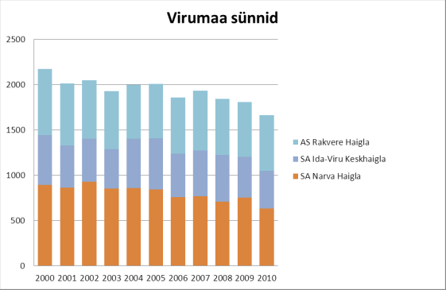
Legend, from top: Rakvere Hospital, Ida-Viru Central Hospital, Narva Hospital.

Births of Northern Estonia
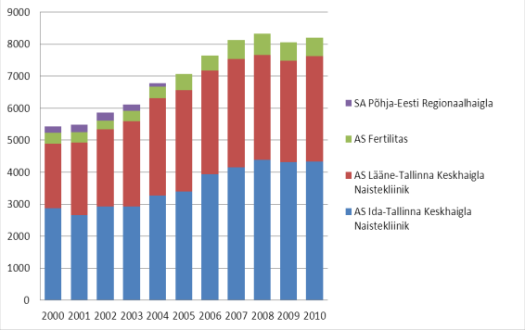
Legend, from top: North Estonian Regional Hospital, Fertilitas Hospital (private), West Tallinn Central Hospital Women's Clinic, East Tallinn Central Hospital Women's Clinic

Births of Western Estonia
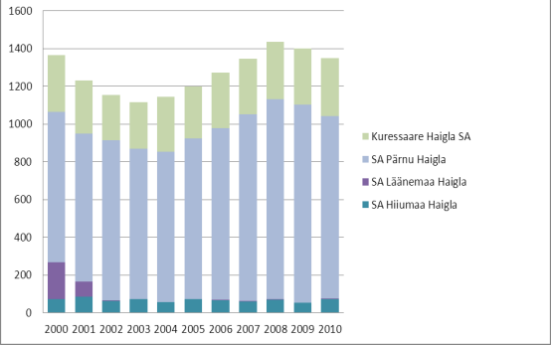
Legend, from top: Kuressaare Hospital, Pärnu Central Hospital, Läänemaa Hospital, Hiiumaa Hospital

Births of Central Estonia
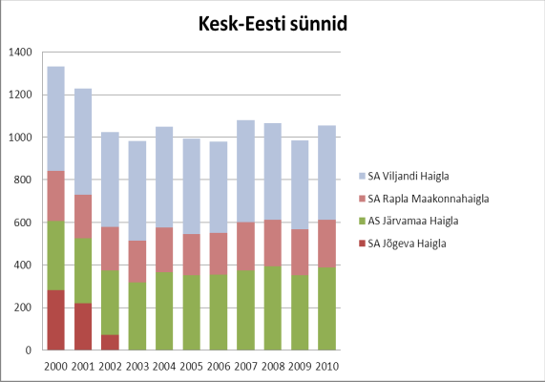
Legend, from top: Viljandi Hospital, Rapla County Hospital, Järvamaa Hospital, Jõgeva Hospital

Births of Southern Estonia
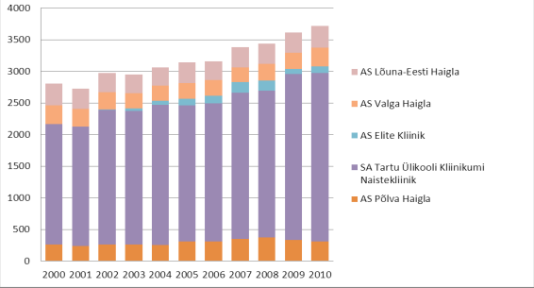
Legend, from top: South-Estonia Hospital, Valga Hospital, Elite Clinic (private), Tartu University Clinic Womens Hospital (Regional Hospital), Põlva Hospital

- A significant increase in the number of births in the next few years is unlikely
- The largest decline is likely to occur between 2020 and 2030, during which time the number of births may fall to 12-13,000.
- The mother's age at birth of her first child was 26.3 in 2010 in Estonia and will reach 29 in the 10-to-15 age range (see http://esa.un.org./unpd/Panel profiles.htm )
- The structure of diseases is changing as a result of falling birth rates and aging populations
- The need for a gynecologist service may increase as people's expectations for access to and quality of health care increase and people's demands for quality of life rightly so

Concentration of population and medical care in large cities

Table 6 Population by county at the beginning of 2011 (Statistics Estonia)
County | Population in 2011 | Population in 2001 | Change, %
Harju | 528,468 | 524,972 | +0.7
Hiiu | 10,000 | 10,438 | -4.2
Ida-Viru | 167,542 | 178,896 | -6.3
Jõgeva | 36,550 | 38,223 | -4.4
Järva | 35,963 | 38,682 | -7.0
West | 27,283 | 28,548 | -4.4
Lääne-Viru | 66,861 | 67,610 | -1.1
Põlva | 30,778 | 32,527 | -5.4
Pärnu | 88,327 | 90,998 | -2.9
Rapla | 36,652 | 37,505 | -2.3
Saaremaa | 34,577 | 35,887 | -3.7
Tartu | 150,535 | 149,488 | +0.7
Valga | 33,889 | 35,683 | -5.0
Viljandi | 55,275 | 57,798 | -4.4
Võru | 37,494 | 39,714 | -5.6

Table 7 Changes in the number of women by county, 2001-2011 (Statistics Estonia)
County | Number of women in 2011 | Number of women in 2001 | Change, %
Harju | 284217 | 284252 | 0%
Hiiu | 5233 | 5418 | -4%
Ida-Viru | 93480 | 97981 | -5%
Jõgeva | 19447 | 20161 | -4%
Järva | 19298 | 20612 | -5%
West | 14666 | 15251 | -4%
Lääne-Viru | 36039 | 36259 | -1%
Põlva | 16212 | 16984 | -5%
Pärnu | 47449 | 48712 | -2%
Rapla | 19174 | 19615 | -2%
Island | 18405 | 19081 | -4%
Tartu | 81380 | 81331 | + 1%
Valga | 18224 | 19103 | + 5%
Viljandi | 29572 | 30759 | -4%
Võru | 20008 | 20991 | -5%

The number of women in rural areas has decreased. At the same time, the number of women in Tartu and Valga has increased.
In Tallinn, the female population has remained unchanged.

Table 8 Estimates of change in treatment cases by 2020
 | 2020
Change in treatment incidence, in addition to demographic change (%)
Outpatient visits | - 5%
Day care | - 5%
Hospitalization | + 5%

The number of outpatient visits is falling due to the decline in the number of women of childbearing age and the increased provision of primary care for pregnant women.
The number of day care cases is expected to decrease due to the decrease in the number of women of childbearing age and the decrease in the number of abortions.
We expect an increase in hospitalization due to the aging of the population and an increase in the quality of life-enhancing services, which mainly refers to the increase in genital depression and incontinence surgeries.

6.2. Estimated number of beds

Table 9 Number of hospital beds at the end of the year, hospital beds per 100,000 population and bed occupancy, 2003-2010 (National Institute for Health Development)
 | Number of treatment beds
 | 2003 | 2004 | 2005 | 2006 | 2007 | 2008 | 2009 | 2010
Obstetrics and Gynecology Treatment Beds | 616 | 596 | 542 | 525 | 503 | 509 | 497 | 451
.. Obstetrics | 242 | 230 | 231 | 231 | 233 | 236 | 236 | 215
..Pregnancy pathology | 90 | 88 | 88 | 78 | 73 | 70 | 65 | 61
..Gynecology | 284 | 278 | 223 | 216 | 197 | 203 | 196 | 175

 | Acute care beds per 100,000 inhabitants
 | 2003 | 2004 | 2005 | 2006 | 2007 | 2008 | 2009 | 2010
Obstetrics and Gynecology Treatment Beds | 46th | 44 | 40 | 39 | 38 | 38 | 37 | 34
.. Obstetrics | 18th | 17th | 17th | 17th | 17th | 18th | 18th | 16th
..Pregnancy pathology | 7th | 7th | 7th | 6th | 5 | 5 | 5 | 5
..Gynecology | 21st | 21st | 17th | 16th | 15th | 15th | 15th | 13th

 | Bed occupancy * |  |  |  | 2007 | 2008 | 2009 | 2010
 | 2003 | 2004 | 2005 | 2006
Obstetrics and Gynecology Treatment Beds | 53 | 54 | 54 | 57 | 59 | 57 | 53 | 55
.. Obstetrics | 54 | 56 | 56 | 56 | 57 | 56 | 52 | 56
..Pregnancy pathology | 62 | 65 | 63 | 64 | 69 | 67 | 57 | 62
..Gynecology | 50 | 50 | 49 | 55 | 57 | 53 | 52 | 53

The optimum bed occupancy rate in the maternity ward could be 70% in hospitals with more than 1000 births, 65% in hospitals with 500-1000 births and 60% in hospitals with less than 500 births.
The average length of stay in hospitals with more than 1000 births could be 3.3 days; in other hospitals for 3.5 days.

Table 10 Number of births and maternity beds in different regions of Estonia in 2011 and forecast for 2020 * (2011 data - ENS survey)
Maternity beds | 2011 |  | 2020
 | Childbirth | beds | Childbirth | beds
North Estonia | 7555 | 79 | 6930 | 91
Central Estonia | 964 | 23rd | 740 | 12
South Estonia | 3445 | 59 | 3101 | 43
Virumaa | 1494 | 24th | 1345 | 21
West Estonia | 1232 | 26th | 1109 | 17
 | 14690 | 211 | 13225 | 184
* beds intended for hospital stays directly related to childbirth

Pregnancy pathology - hospital beds for pregnancy. Larger hospitals have an open pregnancy pathology bed, smaller hospitals have a bed. The calculations are based on the ratio of the beds of SA TU Clinic: 8 beds for 2434 births.
Patients with pregnancy pathology are admitted to the maternity ward after the 21st week of pregnancy. Only central hospitals (regional hospitals) are required to have separate beds (or wards) where more operational activities are concentrated and high-risk pregnant women are referred for treatment.

Table 11 Pregnancy pathology beds forecast for different regions of Estonia by 2020
Pregnancy pathology | 2020
 | Childbirth | beds
North Estonia | 6930 | 23
Central Estonia | 740 | 3
South Estonia | 3101 | 10
Virumaa | 1345 | 5
West Estonia | 1109 | 4
 | 13225 | 45

Table 12 Prognosis of pregnancy pathology and childbirth beds by 2020 .
 | Childbirth | Pregnancy pathology | TOGETHER
2010 | 215 | 61 | 276
2020 | 184 | 45 | 229

Gynecological hospitalization and day surgery is best provided in counties in/at/with general surgery departments, which jointly provide anesthesiological and operative service and other services necessary for work (availability of laboratory tests, blood service, radiological diagnostics including ultrasound) (2011 data - ENS survey)

Table 13 Estimated number of gynecological beds in different regions of Estonia by 2020
Gynecological beds (including intensive care) | 2011 | 2020
North Estonia | 60 | 60
Central Estonia | 9th | 5
South Estonia | 39 | 23
Virumaa | 25th | 21
West Estonia | 16th | 14
TOTAL | 149 | 123

Table 14 Estimated number of gynecological beds by hospital type by 2020
Gynecological beds (including intensive care) | 2011 | 2020
Regional hospitals | 77 | 75
Other hospitals | 72 | 48
TOTAL | 149 | 123

Table 15 Estimated number of day care beds in different regions of Estonia by 2020
Day beds | 2011 | 2020
North Estonia | 34 | 34
Central Estonia | 0 | 7
South Estonia | 7 | 15
Virumaa | 10 | 12
West Estonia | 6 | 12
TOTAL | 57 | 80

Table 16 Estimated number of day care beds by type of hospital by 2020
Day beds | 2011 | 2020
Regional | 34 | 34
Other | 23 | 46
TOTAL | 57 | 80

6.3. Need for specialist doctors

Human resource supply in maternity wards

Table 17 Number of gynecologists in Estonia in 2011 (ENS survey, 2011)
Number of employees | Outpatient work | Retirement age in 2015
267 | 120.1 (45%) | 65 (24.3%)

- There are 334 gynaecologists registered in Estonia, many of whom no longer work (e.g. work outside health sector or retired) or work outside Estonia
- During next 5 years 35 gynaecology residents are expected to graduate. At the same time as 65 (25%) of gynaecologists reach retirement age by 2015. The situation at Narva Hospital is most dire - 56% of gynecologists will reach retirement age by 2015!
- During the period 2005-2010 only 3 gynaecologist started working in county general hospitals after residency
- The low proportion of outpatient work is clearly noticeable, clearly below necessary level
- General hospitals in several counties are under-staffed with gynecologists: Rakvere, Valga, Rapla, Järva, Põlva

There are 186 paediatricians in the hospitals of the Hospital Master Plan 2015 (546 paediatricians registered in Estonia), 57 of them outside Harju and Tartu counties.
There are 41 positions of pediatricians in maternity wards, of which only 4 are outside Harju and Tartu counties. In most county hospitals, preparedness is based on the Pediatric Departments and this is realised based on need and capacities.
At the same time, existing pediatricians have to provide all pediatric care (appointments, inpatient care), so the availability of pediatric 24/7 consultation in many county hospitals is limited or even non-existent. The lack of pediatricians in counties is also striking.

Table 18 Number of midwives in Estonia, 2011 (ENS survey, 2011)
Number of employees | Independent work | Retirees until 2015
351 | 107 (30%) | 52 (14.8%)

Staffing with midwives is satisfactory in most regions, while in the counties the proportion of independent work by midwives is modest.
Outpatient care : In 2010 , there were 4 779 166 gynecological outpatient invoices (contacts/appointments), 62 890 appointments for gynecologists and 103 533 for midwives (16%), and 18 1648 ultrasound examinations ( EHIF statistics for insured persons).
Physician burden on outpatient work: 6.5 hours reception, normally 2 patients per hour, 5 days a week, 45 weeks a year i.e. 2 925 (6.5x2x5x45) patients.
Gynecologists needed: 215 (628 740/2 925) to maintain the same volume of work.
If we were to increase the proportion of midwife's independent appointments to 25% out of all appointments, we might need 150 gynecologists for outpatient work .
Obstetrics: In 2010 there were 15 990 births, 25% or 3997 need medical care (post-operative births). It takes about 2 hours for a doctor to work for 1 delivery. 7 995 hours per year. By 2020, we forecast 13 225 deliveries - the need for working hours would be reduced to 6 612 hours.
Physician working hours of 8 hours, of which 6,5 hours are patient-related, totaling 1462 (6,5 * 5 * 45) medical hours per year or 5,4 doctors for extraordinary/emergency deliveries. The decrease in the number of births does not significantly reduce the number of operative births, i.e. the need for doctors remains the same.
For on-call/duty shifts 37 gynecologists (5 * 2 on-call/duty cycles) i.e. 10 on-call/duty cycles i.e. 10 * 6729 hours (on-call time per year) / 1800 (on-call hours for physicians) up to the level of the central hospital. To provide obstetric care also in county and private hospitals – additional 37 gynecologists in 10 hospitals for on-call duty
In total, 79.4 gynecologists would be needed to continue working in obstetrics at current levels.
Pregnancy pathology: There were 15 320 bed days in pregnancy pathology in 2010. The average hospital stay was 2.5 days, thus 7612 patients.
Doctor's load of 6 patients a day (2 hours for writing and meetings) i.e. 1350 patients per year (6 * 5 * 45)
Gynecologists needed 5.6.
Gynecology: 11 153 inpatient patients in gynecology in 2010 (23,480 bed days, ALOS 2.1 days)
Operational activity 70% or 7807 operations per year.
Gynecologist workload: 1 operation time 2 hours, 1 doctor 1 OP per day and (1 additional assist for 2 hours, visit, examinations, procedures 2.5 hours), meetings and writing 1.5 hours i.e. 225 OP per year.
Gynecologists needed 34.7 (7807/225) .
Day care: In 2010, there were 16 196 treatment cases, with a physician load of 6.5 patients per day (6.5 * 5 * 45), and 1462 patients per year.
Gynecologists need 11.1
Currently there are 217 full-time gynecologists (50 are non- full-time gynecologists, ie those who only provide on-call services or work part-time in some hospitals ), 105 of these reach retirement age by 2020. Hence, there will be 86 gynecologist shortage by 2020 not taking into account possible departures to other countries or outside health sector. In order to maintain the current situation , 15 residents should be trained each year (graduating).
Total foreseeable need ( given that care provision locations remain the same and workload will be optimised): 150 (minimum need for gynaecologists in outpatient care assuming midwives take more than 30% of outpatient admissions ) + 79.4 (emergency childbirth with on-call duty) + 5.6 (minimum number of physicians for pregnancy pathology) + 22 ( minimum number of gynecologists for operative gynecology ) + 11 ( minimum number of physicians required for day care patients, both pregnant and day surgery ) = 268 gynecologists.
Estimated number of gynecologists in 2020: Currently number of gynaecologists (and not positions) 217 - 105 (retired people by 2020) + 70 (residency graduates by 2020) = 182 gynecologists will be employed by 2020.
The deficit is 268-182 = 86, excluding leaving Estonia and temporarily absent from work.
If half of retirees were to continue working in 2020, there would be FULL-TIME gynecologists (217-105 / 2 + 70) = 235.
Missing 33 i.e. every year should be trained 10-11 residents (graduating).
The need for gynecologists in 2020 will depend on the realization of the plan - the possible consolidation of the network of obstetric departments, the movement of outpatient care to primary level, changes in the hourly load of doctors, etc. The need for gynecologists is estimated to be in the range of 260-300.

6.4. Need for new technologies and medical devices (including medicines)

New technologies that have already proven themselves.
The nationwide roll-out of several technological innovations over the last decade has been stuck in the face of lack of expertise, geographical isolation of patients, or organizational weaknesses. For the technologies mentioned in this section, their cost is not a major obstacle to implementation - the services are included in the list of health services of the Estonian Health Insurance Fund. Equal access to research / treatment for patients is a realistic option in the near future. To do this, it is necessary to: inform doctors / midwives; stand for good quality of research / treatment; to inform health care providers about the benefits of new technologies and to work towards adequate financing of these services by the Estonian Health Insurance Fund.

Priority lines of action:
Prenatal Integrated Screening Test: This test is the most effective method for screening for Fetal Down Syndrome. In 2010, 91.4% of pregnant women passed a pre-natal screening test. However, only 38% of pregnancies were screened for I trimester and only 14% of integrated I and II screens were made. An obstacle to the implementation of the 1st and 2nd trimester integrated screening tests is the lack of sonographers accredited by the Fetal Medicine Foundation (FMF). In the spring of 2011, there were 19 accredited I trimester ultrasound practitioners in Estonia, mostly in Tallinn and Tartu.
Medicament Abortion: ensure equal opportunities for women across the country to choose medicament induced abortion (medicament induced vs surgical)
Pelvic Reconstructive Surgery : Introduce the use of implants to support the pelvic floor.
Hysteroscopy: The ability to perform hysteroscopy must be guaranteed in every gynecological ward. Hysteroscopy should be preferred over uterine abrasion when elective surgical intervention is considered (eg removal of endometrial polyps).

Possible future developments
The technologies listed below are either still under development or, due to their high cost, will only be available to individual healthcare facilities in the near future:
- Fetal Monitors with ECG Analyzer (STAN Method)
- Computerized fetal monitors (central monitoring)
- 3D sonography
- Robotic surgery
- Preimplantation diagnostics (embryo diagnostics)
- Cryopreservation of ova / ovarian tissue
- Determination of fetal rhesus from maternal blood.

7. Regulatory environment and necessary changes
7.1 Legislation

Proposals for legislative changes.
“Pregnancy Abortion and Sterilization Act (RKSS)”. As of 01.01.2009, an amendment to § 5 (2) has been introduced in the RKSS, which is in conflict with children's rights and may worsen access to health care for risk groups. The changes were not previously approved by the Estonian Society of Gynecologists. The Ministry of Social Affairs has initiated in 2010 a "Bill on Amendments to the Pregnancy Cancer and Sterilization Act", which is still pending. Unconditional need is for the proposals contained in the bill to be transposed into the following Acts: Miscarriage and Sterilization Act, Illness and Health Related Problems With Pregnancy Cancellation in a Stage Three Hospital, Pregnancy Cancellation Research and Procedures, Formal Advice Pregnancy Advice Act Form.
ENS deems it necessary to amend the wording of § 6 (1) of RKSS (the proposal is not currently reflected in the draft) as follows: "Pregnancy may be terminated if it has not lasted longer than 11 weeks" ". The current wording has led to different interpretations and different treatment of patients, as the magnitude of pregnancy is assessed by weeks and days.
Legislation must regulate the following issues, on which ENS has made its views known: surrogate motherhood, home birth .
In addition, legislative issues: ENS believes that the legal age of sexual initiation should be 16 and that domestic violence related to the high risk of sexual and reproductive health in Estonia should be treated as a separate type of crime as it would facilitate the provision of assistance to victims in the health system.
Late births of newborns born after the 22nd week of pregnancy and with a birth weight greater than 500 g should be made possible for the burial of the newborn .
Artificial Insemination and Embryo Protection Act (KVEKS). Throughout Europe, assisted reproductive technologies (ART) are increasing the number of multiple births (11-25 / 1000 women in 2008). ART gives birth to up to 5% of all births. Maternal and infant mortality rates are higher in multiple births, and multiple pregnancies are more common in older women, as are infertility problems. Women who become pregnant as a result of ART have a higher risk of having problems during pregnancy (premature birth, congenital birth defects and low birth weight), perinatal mortality and unwanted birth. It is also statistically important to gather information on which ART technique has been used (ovulation induction, IUI, IVF, ICSI, frozen embryo transfer, etc.). Changes should be introduced in the CWS to reduce the possibility of multiple pregnancies and to optimize the expense of financial resources (meaning only one embryo transfer for women with a good prognosis of pregnancy and limiting the number of IVF attempts to be reimbursed).

7.2. Treatment guidelines
The guidelines for the preparation of treatment guidelines should, where possible, take into account the guidelines developed by WHO, the University of Tartu and the Estonian Health Insurance Fund, and at the same time limited human resources for its implementation. Treatment guides should be updated every 3 years. Collaboration with affiliated professionals is important in developing treatment guidelines.
The following guidelines are to be developed:
1) Infertility treatment
2) Violence and gynecological patient

7.3. Other standards and regulations

Registers and databases.
ENS sees the need to establish a screening and IVF registry. The Estonian medical birth register must be able to obtain information on maternal mortality.
The pregnancy termination database should be transformed into a pregnancy registry, which would be personalized and would also collect data on miscarriages and ectopic pregnancies.
EHIF services and their prices.
DRG-based pricing does not allow cost-based billing for some modern gynecological surgeries. For example, pelvic floor surgery and uterine artery embolization require the use of expensive disposable supplies, resulting in inadequate pricing and substantial loss of hospital service.
The cost of childbirth needs to be reviewed after deciding which hospitals will continue to provide obstetric care.
Action programs and development plans
PUBLIC HEALTH DEVELOPMENT PLAN 2009-2020.
ENS generally agrees with sexual and reproductive health activities in the development plan. The development plan must pay much more attention to analyzing needs and funded activities. An analysis of the needs and outcomes of infertility treatment is inevitable.
Cervical screening coverage can be increased at the expense of opportunistic screening. This requires new tactics as the existing one has not fully justified itself.
Addressing violence and assisting victims of violence require general guidelines for women physicians.

8. Raising the responsibility of the profession as a specialist medical specialist
There are no plans to change the system for assessing the competence of doctors. The competency reassessment shall be on a voluntary basis every 5 years.

9. E-health
Obstetrics and gynecology have no specific needs for e-health. The main problem is the complexity (read: impossibility) of querying patient health information between healthcare providers.

