Selection of providers for contracting:
Background, supportive interventions and selection criteria

2020

Contents
Background 3
What is a contract? 3
Whom to contract? 4
Contracting process, two examples 5
General considerations and context for provider selection 6
An example of hospital sector reform plan 7
Referral mechanisms 10
Main types of criteria in provider contracting 12
Possible criteria in Primary health care 13
Possible criteria in specialist care (hospitals) 13
Suggestions for Georgia 13
Development of contracting process 13
Possible components of referral mechanisms 14
Appendix 1. Main examples of who/what will be contracted in health care setting 15
Annex 2. Additional material on referral management 18

Background

What is a contract?
Before going into selection criteria for contracting a basic question “What is a contract?” needs to be defined and understood as this has implications for why, what, how the criteria are created as well on the process of contracting, etc.
Thus, the most common understanding is that a contract is “an agreement between two or more parties that creates obligations that are enforceable or otherwise recognized by law”. This includes, but is not limited to any document that has terms and conditions e.g. leases, letters of agreement, memoranda of understanding, letters of intent and interagency or intra-system agreements.
In the health sector and health financing context, a contract is a policy tool that should be aligned with goals of national strategic documents and converts these into action at health care provider and service delivery level.

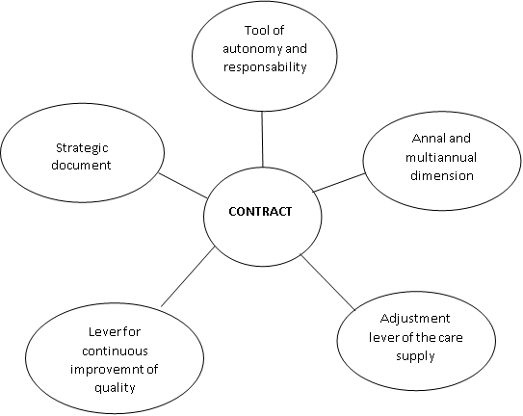
Figure 1. Key “roles” of a contract in health care and health financing context

Contracting can also be conceptualised as a process that culminates with a signed document with agreed responsibilities and rights of respective parties which in turn leads to health care service delivery and population health improvement based on these agreements set in the contract.
In the context of healthcare service provider contracting which is intended to improve population health, several steps precede the signed contract that are rooted in the population health needs (Fig 2). As the ultimate goal of health systems is to improve population health status and its equitable distribution between population groups, the contracting (and service delivery) needs to be based on the population health needs with the set-up of provider network, services purchased, payment mechanisms and contracts themselves follow from the population health needs and should be designed to maximise population health improvement as a response to the population health need.

Figure 2. Logical steps leading to contracting of health care service providers

As indicated above, a contract is a policy tool for steering and modifying health service delivery and provider behaviour with the goal to maximise population health improvement (in the framework of available funds). Thus, the goals of the contracting are tied to the wider (sub)goals of health system that support achievement of the health systems ultimate goal of population health. All health systems in the world have their particular set or combination of goals defined in their respective national policies and hence, the contracting mechanisms and contracts for service delivery can be designed to achieve various and combined goals that all help the country to move toward attainment of better health status for their population. Some of the examples for potential goals for contracting (as a tool for health status improvement) can be e.g. control of health care expenditure, improvement of service delivery performance, increasing health outcomes and improving access, reshaping the health system, shifting care from one level to other(s), optimising provider network, etc.

Whom to contract?
Classically, all providers have been contracted individually (Fig 3). However, there are also other options (Fig 4 and Annex 1). Contracting of a single provider (e.g. hospital) is usually the simplest and fastest as the complexity of the contract and what is contracted is the lowest. However, when factors like integration of care is prioritised in addition to pure volume of services or similar things, the possibilities of whom and how to contract become more varied. Taking the example of integrated care further, there might be a need to incentivise collaboration of primary and specialist care. One of the possibilities to do that lie in contracting an alliance of primary and specialist care providers where the roles, tasks, responsibilities and coordination mechanisms are defined in the service provision contract or as an annex to the contract. The service being contracted might become something like “integrated primary and specialist care provision in catchment area X” instead of contracting individual services (e.g. volume of appendectomies, volume of GP visits, etc.) This would also mean that the integrated primary and specialist care has to be defined somewhere and new population-based service delivery, health outcome and integration indicators and targets need to be developed as part of the contract. At the same time, the payments to the provider alliance would become conditional on their collaboration and comprehensive management of the patients as well as on change in population health indicators if these are part of the contract. Conceptually, such approach to contracting is closer to the ultimate goal for health service purchasing – improvement of population health compared to purchasing that currently usually targets service volume (instead of outcomes.
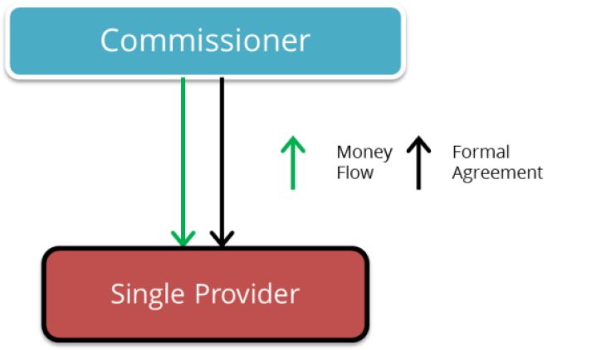
Figure 3. Classical provider contracting with single juridical entity is contracted

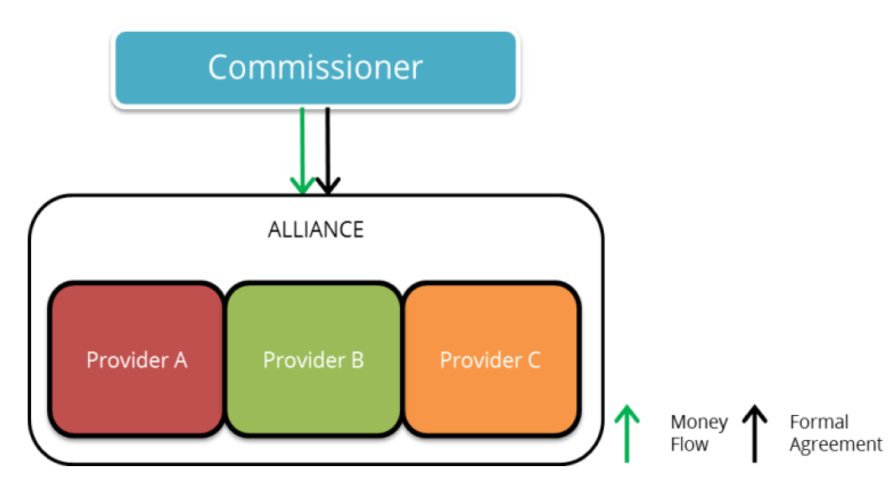
Figure 4. An example of contracting an alliance of health care providers (juridical entities) that have formed a legal alliance and are contracted as one contracting unit

Contracting process, two examples
As said before, contracting process and the resulting contracts depend on population health needs, national (and/regional) policy priorities, institutions and capacities in the health sector, health care service provider network and many other factors.
First example of health care service provider contracting below comes from Estonia (Fig 5) where (almost) all public health sector funds are pooled into Estonian Health Insurance Fund (EHIF) which is a public independent institution operating according to dedicated legislation and inside the legal framework created by the Ministry of Social Affairs of Estonia (covers social and health care as well as some aspects of labour market). EHIF in Estonia is thus a strategic purchaser that purchases health care services from all health care providers in the country. The starting point for contracting process in this case are the population health and service demand and need assessment on one hand and the 4-year budget of EHIF on the other. Estonian Hospital Master Plan 2015 defines the strategic health care providers for specialist care based on a strategic plan for regional distribution of population, hospital locations, hospital service profiles across levels of care and other factors – these strategic health care providers have a preferential status in contracting but depending on population health needs other providers are contracted as well. In order to ensure long-term service provision and certainty of service availability for population, framework contracts are signed with selected service providers. Framework contracts set the basic contract principles, roles, responsibilities as well as approximate volume of services contracted. Based on this, annual contracts with exact service volumes and service reimbursement prices are agreed.

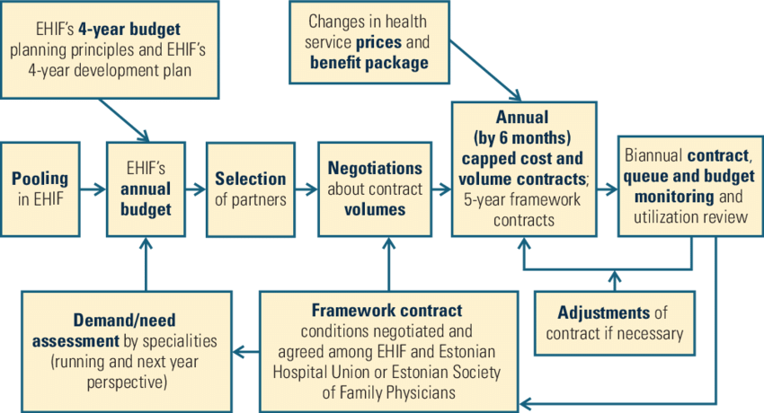
Figure 5. Example of contracting procedure: the case for Estonian Health Insurance Fund

Second example comes from France and Figure 6 depicts a flowchart of decision points similar to the Estonian example. The contracting process again starts with population health and service need assessment followed by geographical distribution of the service need, also taking into account special needs of each region and area. Further, hospitals from strategic network are contracted first and additional providers are selected if additional capacity for service delivery has to be contracted to match population need for services.
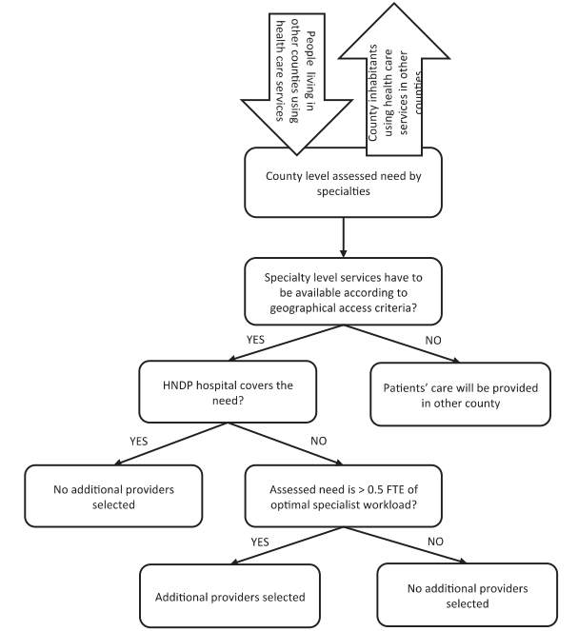
Figure 6. Example of contracting procedure: the case for France

General considerations and context for provider selection
Introduction of provider selection for contracting in primary health care (PHC) and specialist (both out- and inpatient) care have an impact on the wider health care service provider network as well as to access to health care services (location of service provision) and what as well as how services are provided. As a result, selection of providers can and will have impact on other aspects of health care system and it is advisable to plan the changes in other areas and not to wait for self-organisation and -adaption of the system. Thus, provider selection should be part of a wider heath care and health financing reform.
There are several crucial areas (or tools) needed for implementation of complex reforms:
- a policy with clearly delineated goals and responsibilities for institutions taking part in the reform effort;
- a network of organisations to engage in the broad set of functions needed;
- effective means of engaging with populations;
- a range of technical and management capacities; and
- an awareness of the multiple agency relationships that are created by the broader financing environment and the provider incentives generated by multiple financing flows.
To summarize the above points. It is advisable to create a comprehensive plan that takes into account various possible impacts of the main policy intervention (e.g. provider selection for contracting) either create mitigation plans for possible adverse effects or plan activities in other areas of health system that support the main intervention so that one is in a better position to ensure that the reform effort is steered toward desired outcome(s). A policy example on hospital sector reform plan is given in the next sub-section of this document.
Further, a mapping of available resources is necessary to make sure that the resources needed for reform implementation are there and that whether and what additional resources need to be created to ensure that the reformed health care system will be able to deliver the desired outputs and outcomes. A possible example of the latter in case of selective contracting of health care providers can be whether the necessary capacity to provider planned services in needed volume and locations will be there after a selection of all providers will be delivering the services as well as what additional resources are needed to ensure necessary services, their volumes and in key locations. It is important to highlight that there are number of ways to mitigate potential scarcity of resources e.g. strengthened role of PHC along with improved referral mechanisms, quality of care measures, different payment mechanisms for changing incentives, etc. Strengthened referral mechanisms are addressed in further detail below.
The next important aspect for implementation of a complex reform is engaging and informing public so that people know what and how will improve for them as a result of the reform. Ideally, ordinary people should get a role in the reform effort as well so they can support the reform effort as well as monitor its progress.
Finally, it is essential to make sure that the technical and managerial roles and capacities are in place to steer the reform progress, keep it on track and adapt it dynamically as new evidence or circumstances arise. It is also important to keep in mind the roles, mandates, incentives and relationships of all the institutions engaged in making the reform happen – there is a need to align these incentives so that they all work for achieving the shared reform goals.

An example of a hospital sector reform plan
The example of a hospital reform plan comes from Estonia where the comprehensive Estonian Hospital Masterplan 2015 (EHM2015) was created and launched in year 2000 to fully reshape the specialist care provision and service provider network in the country.
There were 3 main components to the EHM2015:
- defining levels of care and the services provided on each of the levels
- regionalisation of hospital network ensuring that more common (less complex) services are easily accessible to the whole population while more complex services are concentrated to regional and national centres for economies of scale while still ensuring equitable access to the whole population
- designing a network of strategic health care service providers that have preference for contracts of service provision for public funds
The starting point for regionalisation of hospital network and defining levels of care for the new provider network was analysis of existing service volumes for all health care providers and regional distribution of the services in the context of population age-sex distribution across the country and access of health care services by patients in their native county versus in other counties. Population change and migration projections (e.g. increasing urbanisation) were taken into account and coupled with patterns service access by patients (i.e. close to home versus other regions) to create a model of baseline population distribution for the coming years. Next, theoretical service need for population age-sex distribution was estimate which was then used to estimate service volumes by specialities for all the regions in the country. Available and needed service volume for all the regions was compared as a next step and minimum service volume criteria necessary to maintain adequate quality of care were set which in turn helped to define service profile and level of care for each of the health care service provider. Additionally, in case of highly specialised care, monoprofile health care providers were merged to create multiprofile health care providers to improve economies of scale for infrastructure, staffing, etc. on one hand and to improve possibilities for integration of care across specialities on the other. The estimates for service need and the capacity of health care providers to provide these in combination to their location and accessibility were used to designate strategic hospitals that form a comprehensive hospital network with established patient pathways from low to high specialisation and back to treatment, patient management and follow-up down to primary health care.

Distribution of specialised services by levels of care
Distribution of health care service delivery between levels of care is a widespread approach to define and specify roles of various health care service providers. In its most basic form, such a division can be conceptualised as a care pyramid of community care, primary health care and specialised care with the community care being the least specialised but most widely provided and accessible while the specialist care is conversely with the smallest provision volume due to the fact that only relatively small proportion of the population has diseases requiring (highly) specialised services compared to community and primary care (see also Fig 9). Hence, the levels of care help to optimise and rationalise health care service volumes by creating patient flows (that are supported by clearly defined referral mechanisms). The levels of care also help to ensure best quality of care, esp. in specialised care by concentrating less frequent disease management and treatment so that minimum necessary patient numbers are there for specialists to keep and improve their skills.
In Estonian case, specialist care was divided into 3 main levels of care (Level 4 to Level 2) with additional level formed by dividing certain transplantations between the providers of Level 2 care due to very low number of cases (Fig 7). For each level of care, necessary services were defined based on the analyses described above and a licencing system was created to allocate and manage service packages that each of the health care service providers are allowed and required to provide. Figure 8 provides an additional example from international literature on levels of hospitals, their approximate sizes and staffing along with common terms to define levels of hospitals in literature. It is also worth noting that the Estonian designation of hospital levels is up-side-down compared to the common designation in international literature.
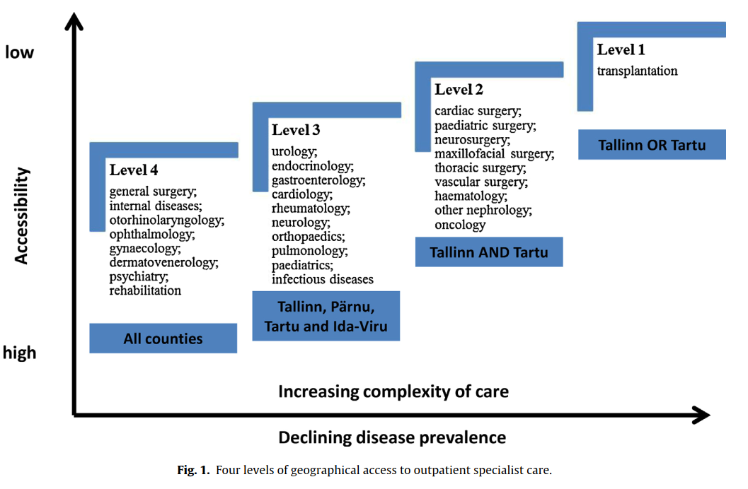
Figure 7. Levels of (outpatient) specialist care in Estonia

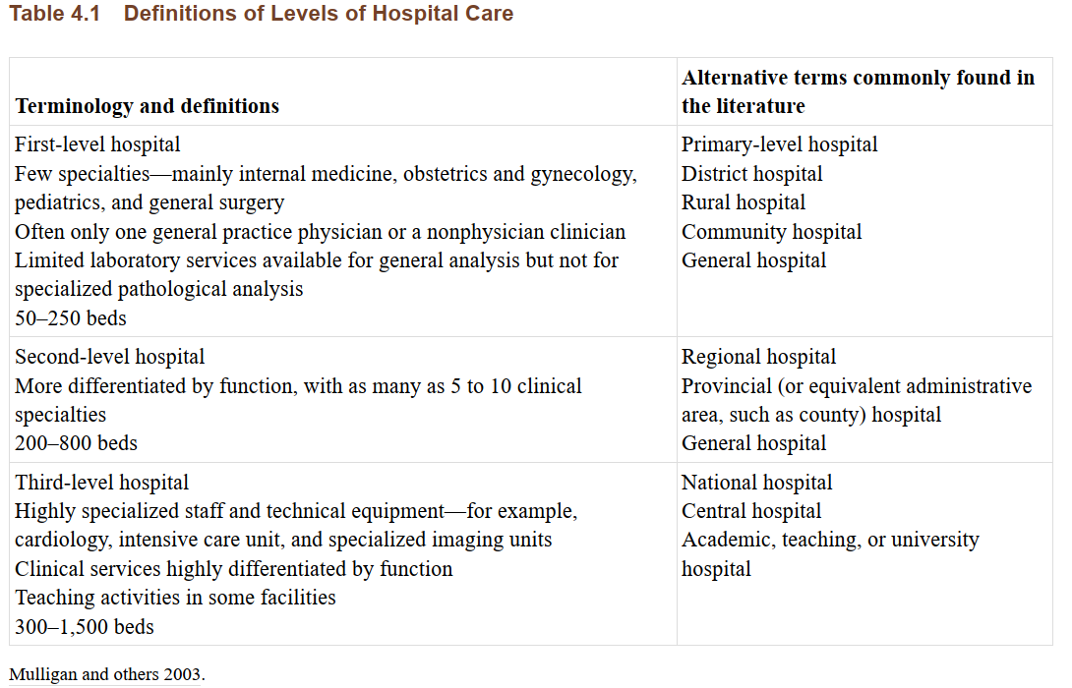
Figure 8. Definitions and levels of hospital care based on international literature

Regionalisation of hospital network
The key factor for planning regional distribution of Estonian hospitals was ease and equity of access to specialised health care services. Therefore, two main (preference) criteria were set for selection of priority hospitals for strategic partnership so there would be reasonable distances between population as well as between hospitals themselves on county (rayon) level. First, maximum distance between hospitals was set to 60-70km or maximum 60min drive. Second, the hospitals had to be on main routes and travel directions so that the flow of patients from their homes to each consecutive level of care would be in the same direction with all the hospitals also being easily accessible in various population centres.
The hospital network itself was regionalised as well where 4 hospital areas were created by designating 4 central hospitals for the 15 counties (rayons). Each of the 4 areas would have 1 central level hospital that would also provide the lowest level of specialist care and would be a referral hospital for the local hospitals in counties. These for areas were further grouped into 2 regions dividing the county approximately on the North-South axis due to the travel times between the counties. The two highest level regional hospitals would be referral points for central (and in some cases for local hospitals) while also providing the services on central hospital level for the closest population. The population for the 4 areas was planned as follows: North-West (population 615 000, including capital), North-East (pop 355 000), South-East (pop 330 000), South-West (140 000, including islands). The two regions would thus have 755 and 685 thousand populations for the services with highest specialisation.

Referral mechanisms
As indicated above, clear referral mechanisms are necessary to for strengthening continuity of care and ensuring that resources are used in an optimal manner i.e. that highly specialised resources are not wasted on cases treatable in primary care while patients in need for highly specialised treatment are denied it because of patients that could be treated in lower levels of care. Referral mechanisms are doubly important if provider network optimisation is a starting point for health care service re-design as this usually infers shifting service provision toward primary care so that the resources for highly specialised care could be used more effectively and only for the patients who cannot be treated on other levels of care.

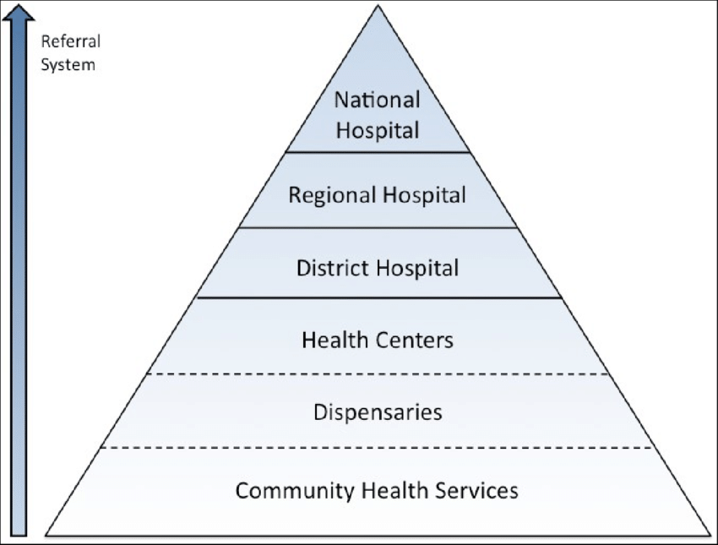
Figure 9. Possible levels of care based on the proportion of population served (and increasing complexity of cases)

Figure 9 thus presents a potential referral system where only those patients that need increasingly specialised care are referred to levels of care where they can get it while the main bulk of patients are treated on the levels corresponding to their needs. It is also worth pointing out that in order to ensure continuity of care discharge management or downward referral mechanisms are in place as well. Namely, if as an example cardiac surgery is performed then the patient should be discharged (i.e. referred down) to lower level of care after patient’s condition is stabilised and follow-up treatment can be done on a lower level of care, etc. until down to community care where regular support for patient self-management and rehabilitation can be provided.
The main referral flows are depicted on Figure 10 which also highlights key aspects and tools that need to be in place for a referral mechanism to work properly. First, clear roles are necessary for members of the referral pathway e.g. who initiates and who receives and what are their responsibilities in these particular roles as well as whether and what role and responsibilities the patient has in referral. Second, referral practicalities like referral form, communication channels and what information needs to be communicated and when, information to patients (what, when, how) and monitoring of all the referrals and their results needs to be in place. Third, oversight and monitoring, incentive mechanisms and continuous improvement of the referral mechanisms and tools needs to be in place to reap the benefit referrals can offer.
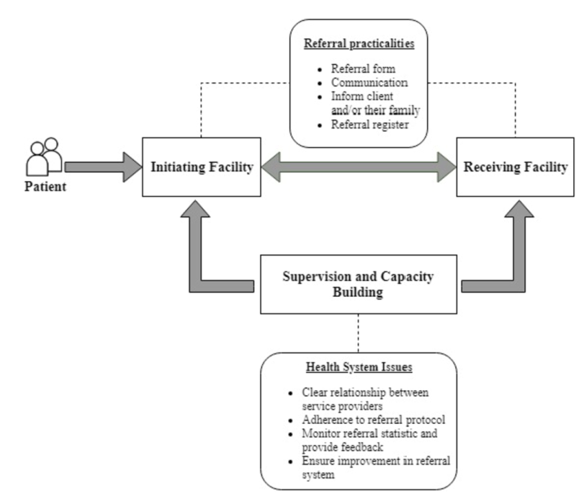
Figure 10. Main referral flows

Following from above, it is illustrative to see what have been the root causes for referral failures in other countries, and in India in this particular example:
- Lack of skilled and motivated manpower, especially in secondary level
- Inadequate infrastructure in the PHCs
- Non adherence on the referral system guidelines
- Lack of accountability in each level for controlling of unnecessary referrals
- Lack of back referral of minor cases coming directly to higher level
- Non-availability of universal health card like in developed countries where the health facility for primary treatment or screening is indicated for a particular population
This example clearly highlights the need for clear roles, responsibilities and accountability mechanisms along the referral pathway as well as the need to control for avoiding the unnecessary referrals (i.e. unnecessary specialist consultations and hospital admissions) which is the key goal for the referral mechanisms in the first place. It also highlights that in order to shift unnecessary admissions and consultations to lower levels of care, the infrastructure, human resource and skillset capacities need to be in place on the lower levels to actually handle the service and patient volume that is being shifted to lower levels of care (down to PHC and community care). Further, the referral rules need to be clear and application of these rules has to be monitored and enforced while national health insurance system covering majority (or the whole) population provides a perfect information platform for this where the referrals and patient movement through health care system can be monitored. The latter can be applied also for non-insured patients and visits/admissions covered from out-of-pocket if reporting such clinical activities and referrals would be mandated by national health statistics needs, provider licencing systems and health care service provision contracts with public health care service purchaser. Finally, the point on minor cases coming directly to higher level thus bypassing referral mechanisms is a concern for proper organisation or a referral mechanism which can be at least partly mitigated by increase of health insurance coverage as well as negative (financial) incentives to patients (and/or providers) in case the referral pathway is bypassed.
Further background information on various referral management approaches and complexity of referral management systems is presented in Appendix 2.

Main types of criteria in provider contracting
There are 4 main types of criteria in the contracting process:
- Basic qualification criteria
- Preference criteria
- Selection criteria
- Contract criteria/clauses
Basic qualification criteria are about minimum criteria that are necessary to make sure that the provider is eligible to apply for contract selection in the first place. In a sense, these are the “hard” criteria that have to be fulfilled for all entering the selection process for contracting. Some of the most common ones are for example licence for health care service provision in the country or region and licence to provide particular service that is being contracted. Other can be for example, certain level of accreditation (esp. for complicated services), availability of required human resources, sound financial status (e.g. assessed based on past fiscal reporting, no conviction on fraud, minimum quality criteria fulfilled (e.g. based on results of quality indicators, buildings in sound order, quality management system in place, etc.), certain size (e.g. capacity of provide minimum required volume of service) or location (e.g. close to population to be served).
The preference criteria are “soft” criteria for basic qualification. Examples can include factors whether the provider is in public or private ownership (e.g. preference for public ownership for use of public funds), designation as a strategic partner, availability of other complimentary services in addition to the one being contracted (i.e. preference for multiprofile providers if provision of integrated care is a priority in the country).
When the qualification and preference criteria are satisfied then the next level of criteria are those of selection criteria which are used to rank applicants and award contracts to the selection of potential providers ranking the highest among those which are eligible based on the qualification and preference criteria. It is also worth reminding that there are at least two ways (or components) to set the threshold for awarding contracts based on the ranking. First is a minimum required level for particular selection criteria (or combination of those) that has to be exceeded for the contract awarding. Second is availability of funds which might impose an additional threshold for contracting so that not all providers exceeding minimum selection criteria will be awarded a contract. Other similar thresholds can be applied e.g. maximum service volume to be contracted and distributed between providers. Conversely, if the providers in the preferential contracting list are not able to provide required volume of service, those that fulfil basic qualification criteria but not the preference criteria can be awarded with service contract as well in the amount of service volume that remains uncontracted after contracting the preferred providers (e.g. private providers in case all service provision capacity of publicly owned providers has been already contracted).

Possible selection criteria for provider contracting
The numbers provided below are primarily rough examples of what kind of selection criteria could be used and with ballpark estimates of the target levels for these criteria. The key here is that these threshold numbers (as well as criteria themselves) very much depend on the structure of the health care system, population concentration and distribution, geographical barriers and other factors.
As an example, the number of patients per primary care doctor assumes first of all family medicine type of arrangement in PHC where patient list is attached to one physician who can work in a single practice close to where patients live and there are no nurse (or feldsher) outposts and low levels of community care. However, when the patients for that particular PHC practice are distributed over wider area or between several hard-to-reach settlements, separate nurse points in these settlements would be needed and the role of the physician would shift more toward management and support to the nurse points while these provide the first level of care and triage of patients. Such organisation of care would automatically mean that the number of nurses per doctor should be higher while the overall number of patients per physician should be higher as well as the physician’s case load would be lower due to the triage and care provision by the nurses. Also, in such organisational set-up it would often make sense to form group practices instead of single practitioner practices which would also provide better platform for diagnostic services that need to be kept at minimum in practices with single physicians. Additionally, referral patterns would change as well as first triage will be already done on community level and referrals from primary health care centres should be lowered as well (compared to single physician practices) due to the better diagnostic and treatment capacities of the primary health care centre.
Similar aspects need to be taken into consideration with all the selection criteria and their threshold levels below and ideally, these threshold levels should be calculated based on the health care service model, estimated service need, population distribution and access (travel) times for people in need for particular health care service.

Primary Health Care (PHC)
Examples of selection criteria for PHC:
- Patients per doctor: max 2300/min 1700 or 1600±400, etc
- Nurses per doctor: 1 if <2000 pat, 2 if >2000 pat
- Opening hours: service available 8-20 (in some form)

Specialised care (hospitals)
Examples of selection criteria for hospitals:
- Lowest level of specialised care (local)
  - Size >50 beds
  - 8 basic specialties on lowest level
- Middle level (regional)
  - >100 beds
  - 8+10 specialties
- Highest level (national)
  - >250 beds
  - 8+10+ most remaining specialties
- Monoprofile only for the highest level of specialisation if needed volume of service not available in multiprofile hospital(s)

Basic indicators of hospital sector in Georgia
Figures 11-15 present numbers of all and acute care hospitals, numbers of all and acute care hospital beds and average length of stay in acute care hospitals in Georgia in comparison to other countries of the WHO European region.
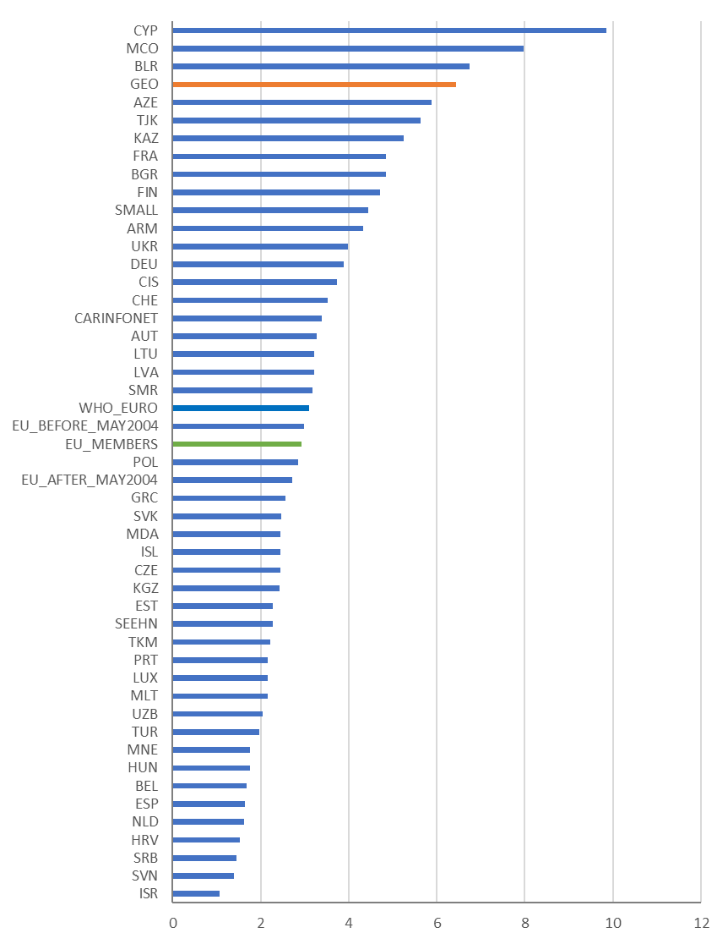
Figure 11. Hospitals per 100 000 population in 2014, WHO European region (WHO 2020)

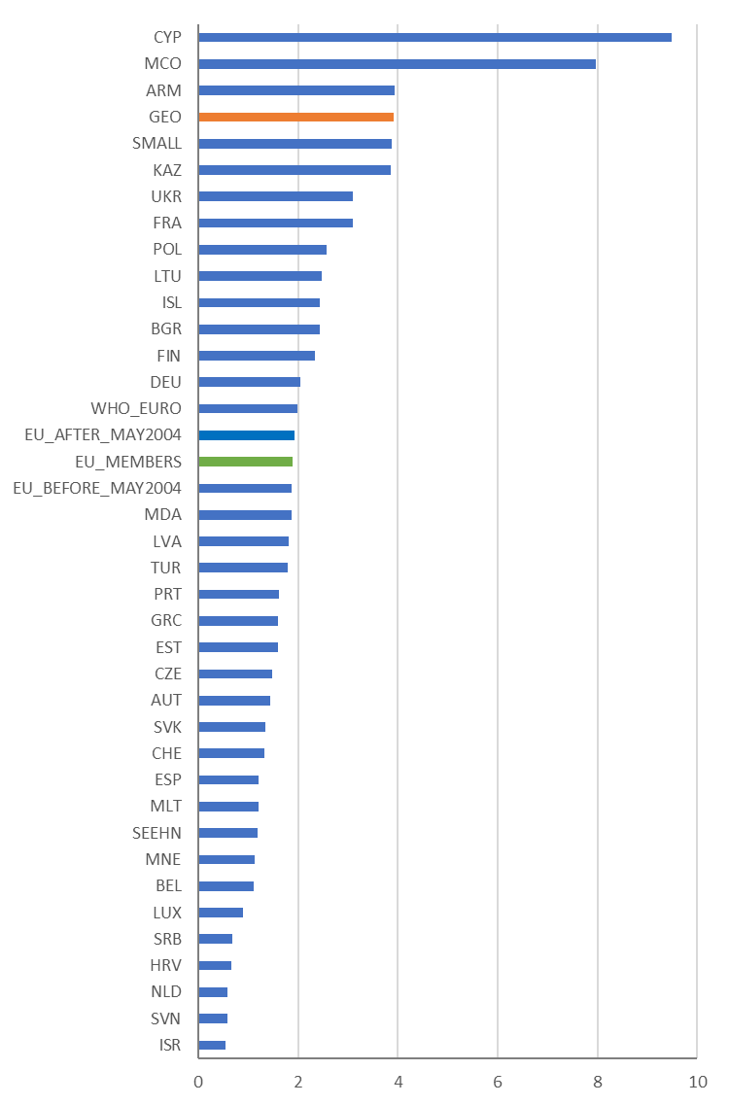
Figure 12. Acute care hospitals per 100 000 population in 2014, WHO European region (WHO 2020)

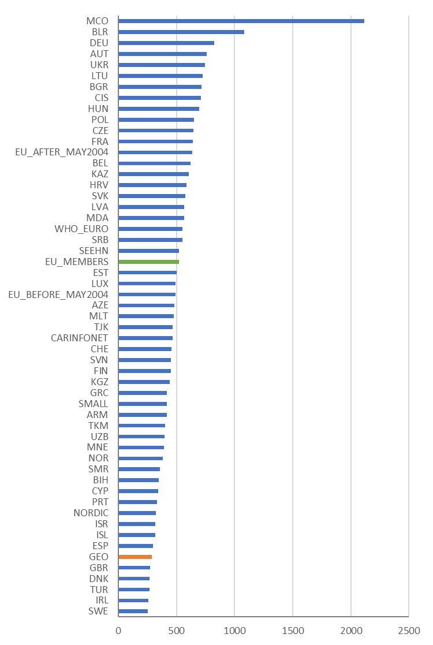
Figure 13. Hospital beds per 100 000 population in 2014, WHO European region (WHO 2020)

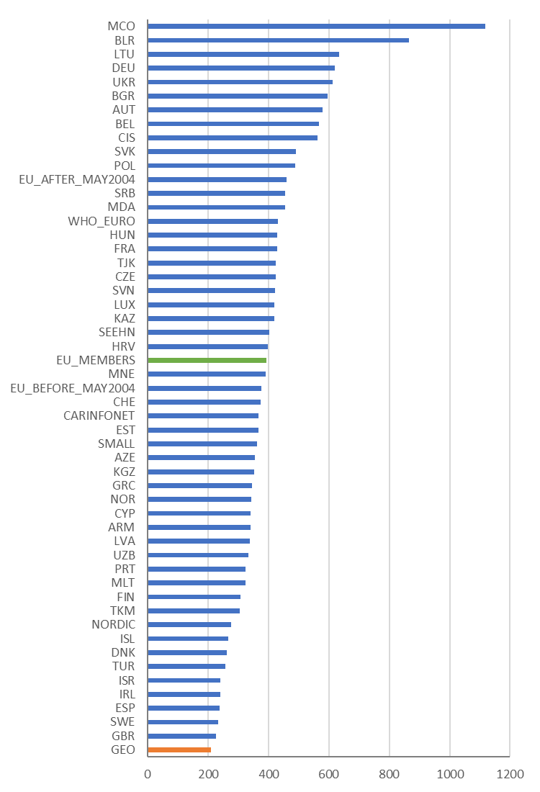
Figure 14. Acute care hospital beds per 100 000 population in 2014, WHO European region (WHO 2020)

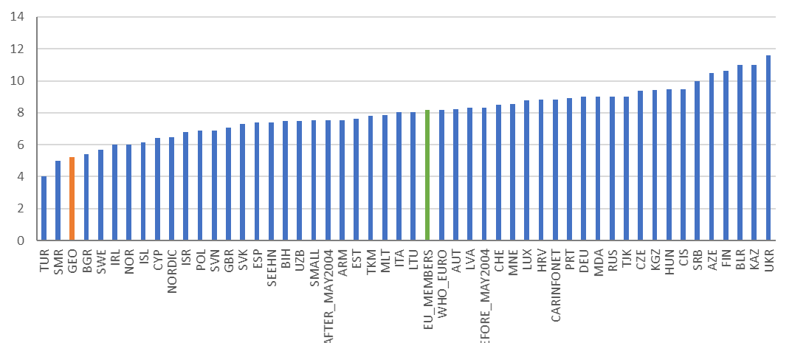
Figure 15. Average length of stay (days) in all hospitals in 2014, WHO European region (WHO 2020)

The summary conclusion from these indicators is that Georgia has high number of hospitals per capita, about 2/3 of these for acute care. At the same time, Georgia has low number of beds per capita, especially acute care beds. Thus, on average, hospitals in Georgia seem to be quite small with low number of beds. Additionally, average length of stay is extremely short which is a risk factor for medical errors and inadequate follow-up of the cases. The short average length of stay is potentially a (partial) by-product of un-capped service (and cost) volume, fee-for-service payment mechanism, no selection for contracting and weak monitoring of quality of care (and enforcement with contracts or other tools).

Possible policy options in Georgia in the context of health care provider selection for contracting
Overall, there seems to be ample room for consolidating and optimisation of specialised health care service provision as evident from Figures 11-15. This is further supported by Figure 16 which shows that large proportion of Georgian hospitals have less than 50 beds which is often considered a minimum viable size for a hospital and especially for an acute care hospital.
However, there are several options how the health care provider selection for contracting can be approached and what selection criteria could be considered in Georgia. Also, each of such options have their own implications for reform needs in other aspects of health care system as shown before.
As an example, selective contracting for larger multiprofile hospitals which can provide better economies of scale as well as better platform for integration of care and service quality improvements could be considered. However, other factors like geographical accessibility of the services as well as population distribution and need for services should be taken into account when setting the parameters of selective contracting. While doing this, exact locations of all providers should be checked along with service profile.
Further, there are exceptions to most rules e.g. assuming that 50 beds and a defined service profile are conditions for contracting, then in remote or difficult-to-access places with small populations smaller providers could be contracted as well. Such providers could be further incentivised to network and create formal collaboration agreements with larger providers so that care continuity is ensured. Similarly, existing provider networks or providers with service provision in multiple places could be contracted. And an additional condition for provision of services in distant and hard-to-reach locations could be set if such larger provider or alliance of providers would be contracted.

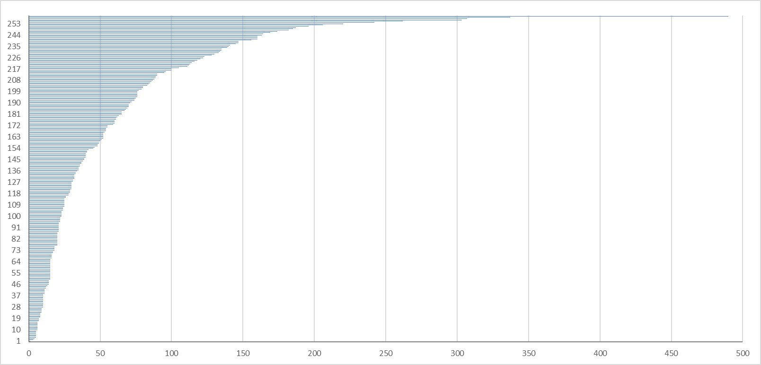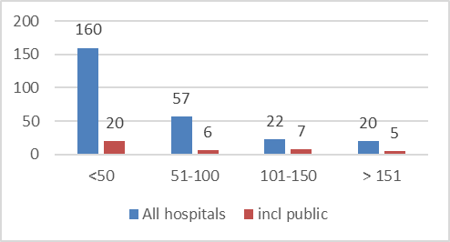
Figure 16. Hospitals in Georgia by number of beds in 2019 (MoH 2019). Red line indicates the proportion of hospitals with less than 50 beds.
Additionally, the providers to be contracted could be mandated to engage in patient pathway coordination with other providers on lower and higher levels of care and an additional payment component to incentivise care integration could be added to the payment mix. As a side-note – review of payment mechanisms is advisable even without introduction of such new payment mechanisms as the extremely low average length of stay raises a question of potential exploitation of fee-for-service type payment mechanisms (partially includes DRGs as well).
And as indicated before, selection criteria for contracting should ideally be based on estimated service demand, service delivery capacity estimates as well as review of service profiles and annual volumes of all providers.

Development of contracting process
It is important to highlight that in currently there is no actual contracting of providers in Georgian health care system – providers can submit their application to join the public health care service payment scheme, the applications are approved and all invoices are reimbursed after that at reimbursement prices set by the SSA. However, a contract between purchaser and provider is not signed, there are no caps for volume or cost of the service provision. Additionally, providers are free to charge additional out-of-pocket payments from payments according to their own service pricelists which means that the actual service prices that patients face, are not regulated nor capped, creating high financial burden for patients. Further, as the service provision volumes or costs are not capped, providers have strong financial incentives to cut one treatment case into short admissions which all are invoiced separately while putting health of patients at risk due to very short length of stay during which it is difficult to tackle patient conditions in systematic, comprehensive and integrated manner.
Following from the considerations above, Figure 17 proposes a stepwise approach toward implementation of full contracting for providers where various selection criteria, quality measures and incentives, clear responsibilities and accountabilities, etc. is built into the service purchasing mechanisms in Georgia.
Figure 17. Stepwise approach toward full contracting mechanism in Georgia

Possible components of referral mechanisms
A part of this document was expressly dedicated to referral mechanisms and their high relevance for ensuring continuity of care and optimisation of health care delivery system. The following bullet-points outline tools and actions that could be considered in Georgia for strengthening referral mechanisms in the country. These tools and actions are grouped into three categories: things that can help (supportive to referral system); possible tools (things that can be used to make referrals happen), and; monitoring (learning and improving referral system and enforcing rules)
Things that can help
- Tasks and roles for GPs and other levels of care clearly defined
- Services clearly defined by levels of care (for referral)
- Treatment guidelines defined across levels of care
- Rules of referrals clearly defined and linked to treatment guidelines
  - Monitor and link to contract payments
- Campaigns to improve status of PHC
- Capacity building of everyone involved
- Unified electronic referral system for all providers
Possible tools
- Gatekeeping
  - no public funding if visiting specialist without GP referral
- Appoint responsible person for care coordination (GP)
- Use standardized referral forms with mandatory data and checklists (electronic?)
- Discharge management (e.g. specialist only gets payment if patient referred back to GP with proper information)
- Shift funding from specialist care to PHC (increase of salaries in PHC)
- Balance financial (and other) incentives having impact on referrals
  - consider provider payment mechanisms in PHC and specialist care
Monitoring
- Whether and where to the patient was referred in specialist care (tracking care pathway)
- Whether referral letter was filled (properly)
- Discharge management
  - whether patient was referred back to GP (with proper discharge letter)
- Consecutive referrals to specialists
  - i.e. whether patient was „bounced“ between specialists instead of GP coordinating care (esp. inside one care provider)
- Measuring avoidable specialist consultation and hospitalizations for PHC-sensitive conditions

Appendix 1. Main examples of who/what will be contracted in health care setting

Single Provider

Loose federation
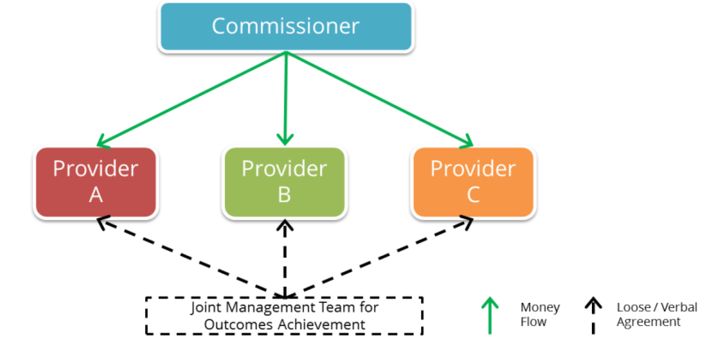

Formal federation
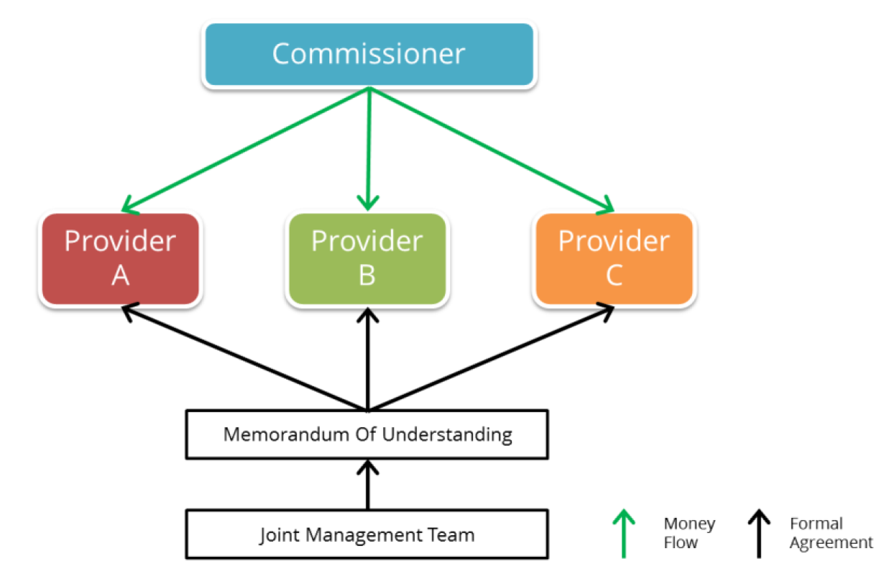

Alliance contracting (ver 1)

Alliance contracting (ver 2)
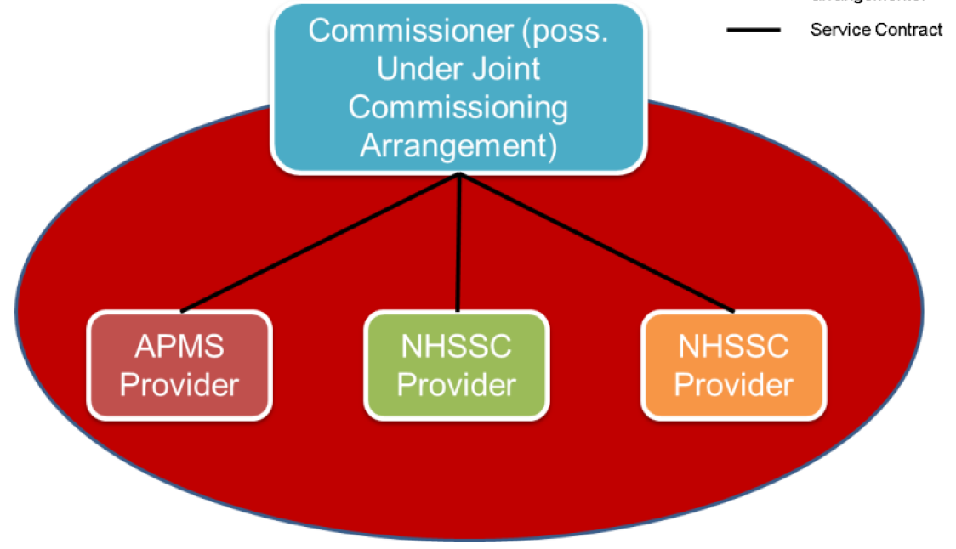

Prime contractor – corporate joint venture
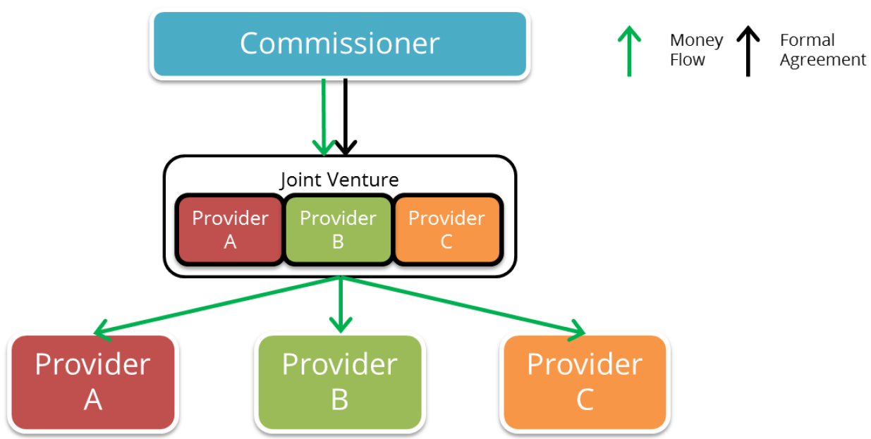

Prime contractor – integrator
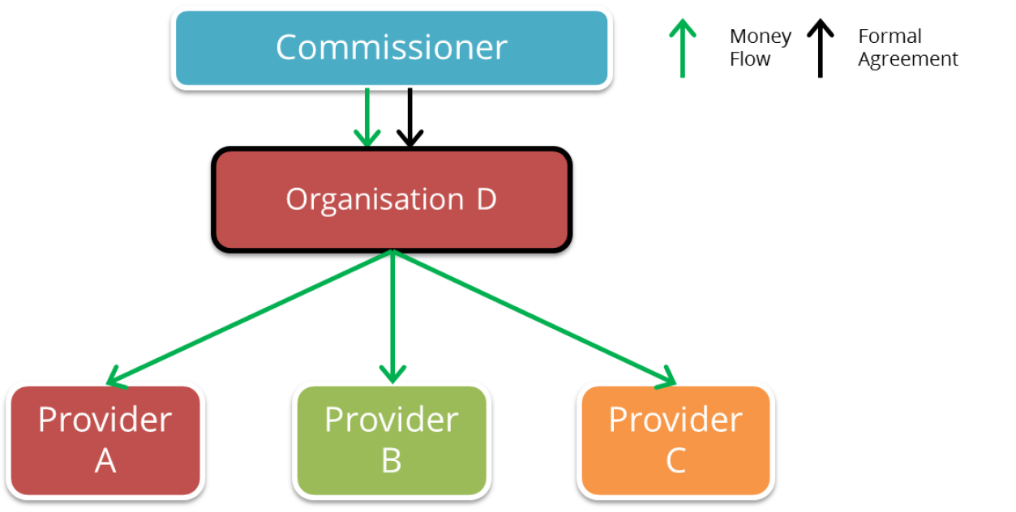

Prime contractor – lead provider
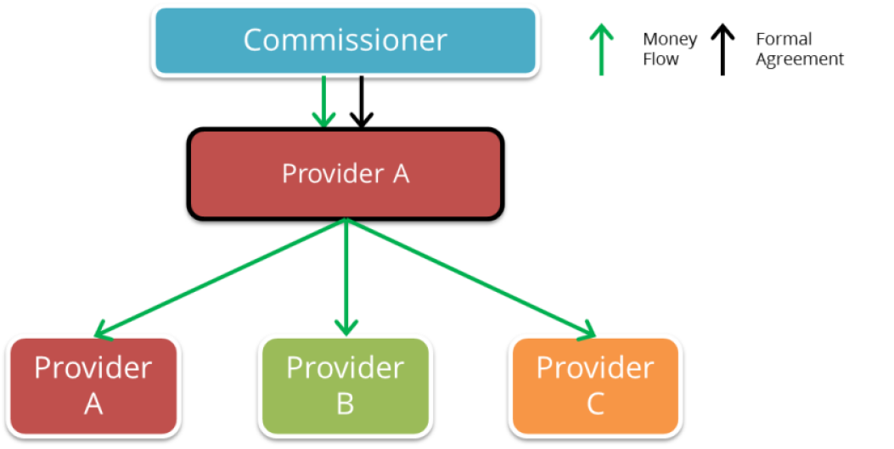

Annex 2. Additional material on referral management
Strengths and weaknesses of referral management approaches
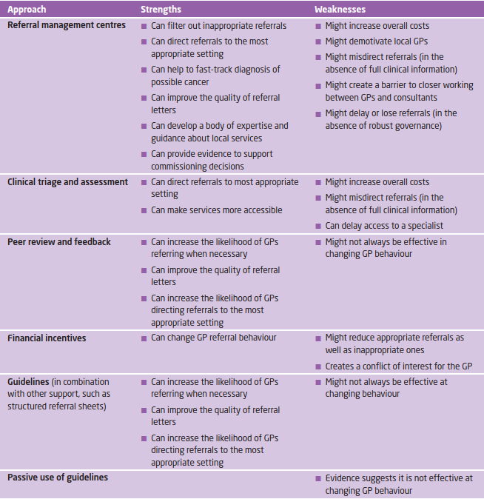

Complexity of referral management approaches
