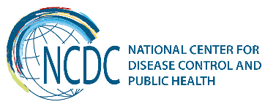
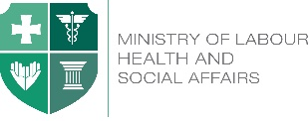

GEORGIA Brief
Universal Health Care in Georgia:
Moving towards Universal Access to
Health Care Services

Introduction
Introducing Universal Health Care in Georgia in February 2013 aimed at improving the general population’s access to healthcare, has benefited more Georgians, particularly those relatively less well-off, from gaining access to health services when ill and being less prone to impoverishment or catastrophic out-of-pocket spending on healthcare. This was achieved through a strong political commitment and process to create an equitable health financing system.
Georgia achieved substantial progress in moving towards universal health coverage (WHO European Health Report, 2015)
Key Achievements
- Increasing public health spending
Universal heath care and health policy oriented towards the population health and well-being is confirmed by unprecedented increase in state allocations for healthcare sector in the last few years, from GEL 450 million in 2012 to GEL 986.2 million in 2017. Public health spending as a share of GDP has also increased from 1.7% in 2012 to 3% in 2017.
- Extending entitlement to publicly financed health services to the whole population
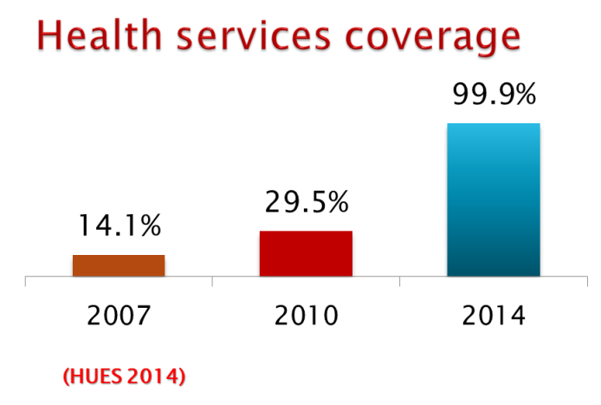
In 2013, after implementation of the UHC program, service coverage has increased significantly and rapidly from 29.5% of the population in 2010, to about 40% by the end of 2012 and up to 99.9% by 2014.

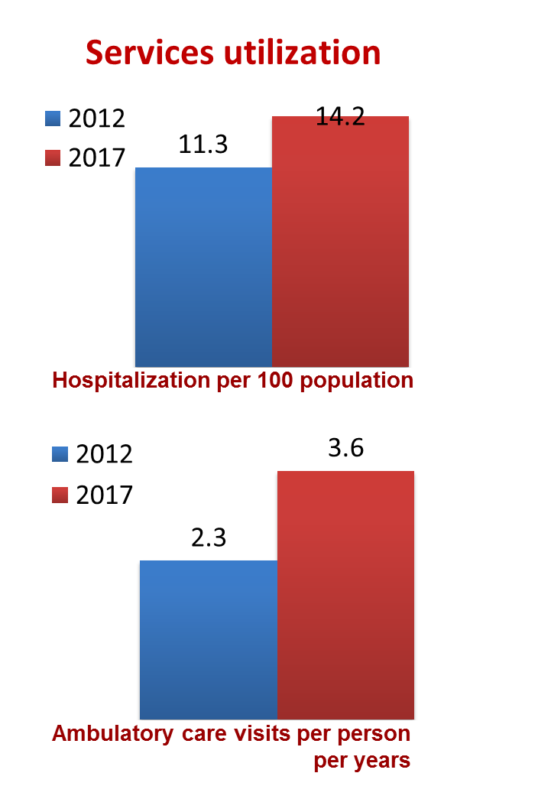
- Improving the likelihood of people using health services when sick

On average, there are 3.6 outpatient visits per capita per year in 2017 compared to just 2.3 in 2012, and hospitalization rates have seen a steady increase from 11.3 in 2012 to 14.2 in 2017, which largely is explained by the introduction of UHC program, which offered coverage to a vast number of people in Georgia who were previously uninsured. The largest increase in using health services among those who reported being ill occurred among lower and middle-income household.

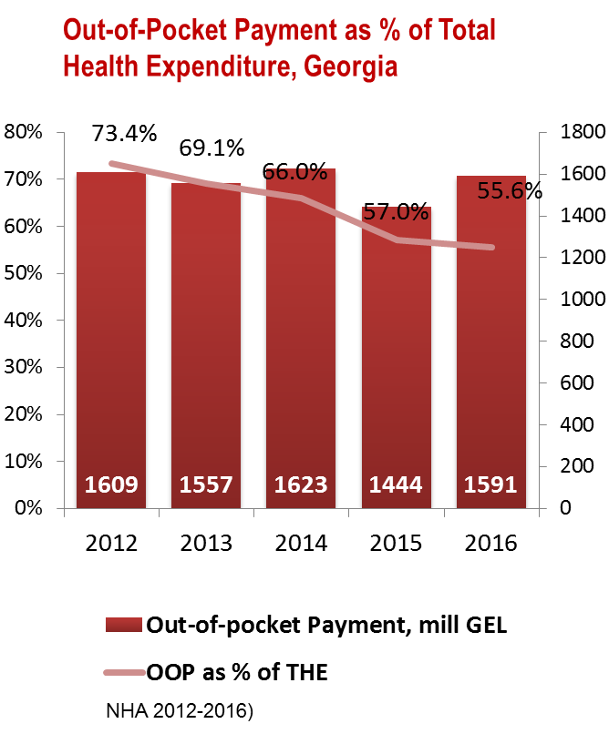

- Improving overall financial protection
UHC program has significantly reduced the out-of-pocket payments and improved financial protection of the population. Out-of-pocket spending declined from73% in 2012 to 56% in 2016.

- Improving user experience of the health system
Survey conducted by the US Agency for International Development in 2014 showed that 80.3% of the surveyed beneficiaries were satisfied with the outpatient service and 96.4% expressed satisfaction with hospital level emergency care within the universal health care program.

The UHC program beneficiary has the right to choose a healthcare facility throughout Georgia.
From February 28 to July 1, 2013, the first phase of the UHC program provided the primary healthcare services by the family physician and emergency outpatient and inpatient care.
The second phase of UHC program launched in July 1, 2013 extended the services covered and include planned ambulatory care, elective surgery, chemo-, hormone-, and radiotherapy, obstetrics and cesarean sections, basic drugs for target groups of the population.
In May 2017, to further reform the program, elaboration of new criteria for differentiation of beneficiaries (according to beneficiaries' revenue) has been implemented for provision of more needs oriented services and development of "social justice" approach.
Since March 1, 2017, selective contracting was introduced for childbirth and caesarean section and neonatal intensive care services, from July - II-III level intensive care, and from January 2018, selective contracting is used for providers of emergency hospital services.
From July 1, 2017, persons suffering from chronic conditions, who are registered in the unified database of "socially vulnerable families" with the rating score not exceeding 100,000, are eligible for the state program providing drugs for chronic conditions. The program provides patients with selected drugs for chronic cardiovascular diseases, chronic obstructive pulmonary disease, diabetes (type 2) and thyroid conditions. From September 2018, program was expanded and covers not only social vulnerable groups, also pensions and disabled persons.

Challenges
The government continues the strategic reforms in the healthcare sector aimed to reduce negative economic impact on households due to health expenditure, further improving access to health care services and population’s health. Emphasis will be also made on strengthening strategic purchasing capacity of the Social Services Agency, administering the UHC program and improving the quality of medical care.
Some of the challenges faced by the health care system include:
- Low public health spending - despite a substantial increase in the government’s budget allocation to health in recent years, public health spending as a share of GDP is still low and in comparison with countries at a similar level of income public health spending is below average.
- High out-of-pocket expenditures on health - although the UHC Program has been associated with a reduction in the OOP share of total health spending (73 percent in 2012 to 57 percent in 2015), Georgia still has one of the highest shares of OOP in the region. Pharmaceuticals are a major cost driver. While medicines are provided free of charge to patients for inpatient use, the UHC program has a limited outpatient drug benefit.

- The outpatient visit rate remains very low - the care seeking behavior in Georgia is skewed towards hospital-based, inpatient care, whereas outpatient services – and in particular primary healthcare – are under-utilized. Strengthening primary health care through improvement of quality and efficiency, including medicines provision, development of an incentive system that enables primary care providers to take more responsibility for patient care, especially for patients with chronic conditions, and revision of the system for planning and generation of human resources for primary health care are important policy and program priorities.

_________________________________________________________________________________
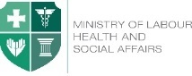  Ministry of Labour, Health and Social Affairs of Georgia  144, A. Tsereteli avenue. Tbilisi, Georgia, 0119  www.moh.gov.ge | 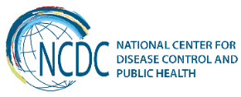  National Center for Disease Control and Public Health  9, M. Asatiani street. Tbilisi, Georgia, 0177  www.ncdc.ge

