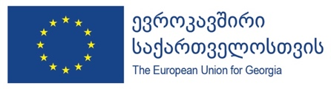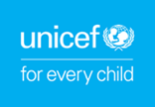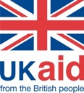

Introduction of Results of Behaviour Insight Study
Three waves of Behaviour Insight Study were conducted in Georgia and the report comparing results of all three waves is already available. To communicate results to wider public, WHO will organize an online presentation for interested parties including government, civil society organizations and media.
Date: 15 July, 2020
Key partners: MoH, European Union, UNICEF (implementing partner), UKAid (donor for Unicef)
Duration: 1 Hour
Speakers: EU, WHO, UNICEF, ISSA
Tentative Agenda:
- Brief introduction by EU, WHO and UNICEF officials (5 minutes)
- Presentation of the results by ISSA (30 minutes)
- Q&A (20 minutes)
List of Invitees:
- Media
- International and local organizations working on COVID-19 response
Materials:
- Press statement to go out right after the event.
- Full study report available at request.
- Project brief to be sent to media alongside above materials.
Technical Considerations:
- Platforms: Zoom.
- Language: Georgian, with simultaneous English translation available.
- Invitations: sent by the WHO, EU, UNICEF, UKAid, and MoH to their counterparts.
- Visibility: logos of WHO, EU, UNICEF, UKAid, and MoH to be applied to all materials related to the event.

