Universal Healthcare

Universal Health Coverage (UHC) of the population is the major Global Health priority and means that all people have access to health services they need without the risk of financial hardship when paying for them. This requires an efficient health system that provides the entire population with access to high quality services, health workers, medicines and technologies. It also requires a financing system to protect people from financial hardship and impoverishment from health care costs.

After general elections of October 2012, a new Government came into power with a clear determination to improving social and health status of the Georgian population. The strong political will pledged in the election platform was translated into an unprecedented, almost 2-fold expansion of budgetary allocation for health in 2013.

The second major step towards securing enjoyment of health rights in the country was the launch of a Universal Health Care Program in February 2013. Georgia now has a foundation of universal entitlements within its health system, representing a major step towards improving access to health services for the entire population.

All citizens are provided with medical care among them 130 thousand individual has only private or corporate insurance, while the rest of the population is covered by the universal health care program or health insurance financed by state budget (military, soldiers, etc.).

From February 28 to July 1, 2013, the first phase of the UHC program provided the primary healthcare services by the family physician and emergency outpatient and inpatient care.

The second phase of UHC program launched in July 1, 2013 extended the services covered and include planned ambulatory care, urgent outpatient and inpatient care, elective surgery, chemo-, hormone-, and radiotherapy, obstetrics and cesarean sections, basic drugs for target groups of the population.

In May 2017, to further reform the program, elaboration of new criteria for differentiation of beneficiaries (according to beneficiaries' revenue) has been implemented for provision of more needs oriented services and development of "social justice" approach.

From July 1, 2017, persons suffering from chronic conditions, who are registered in the unified database of "socially vulnerable families" with the rating score not exceeding 100,000, are eligible for the state program providing drugs for chronic conditions. The program provides patients with selected drugs for chronic cardiovascular diseases, chronic obstructive pulmonary disease, diabetes (type 2) and thyroid conditions.

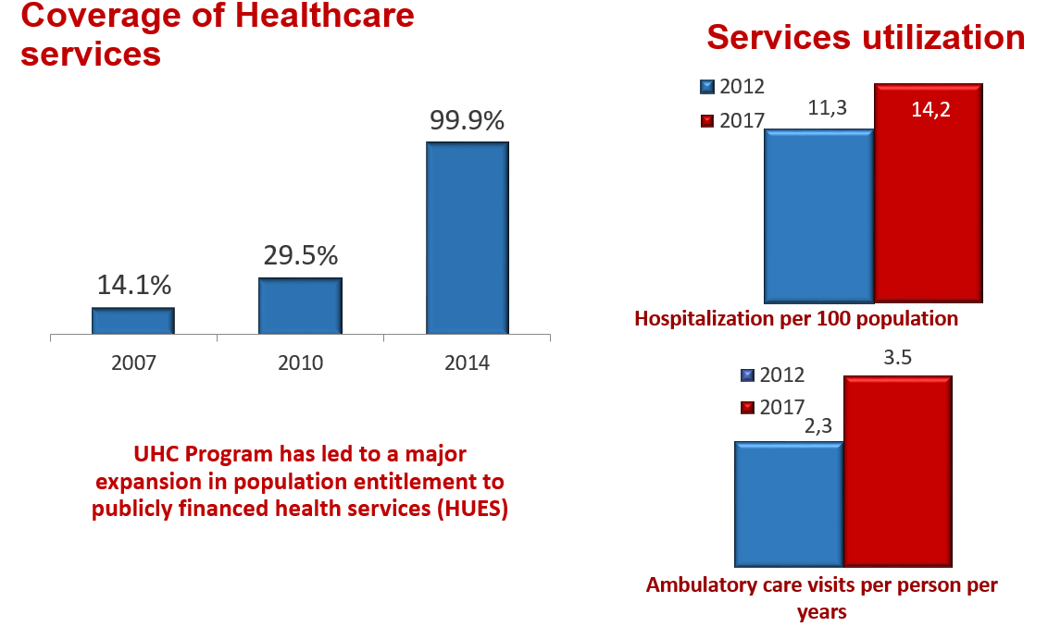
According to the WHO European Health Report, 2015, Universal Healthcare Program was recognized as successful. Survey conducted by the US Agency for International Development in 2014 showed that 80.3% of the surveyed beneficiaries were satisfied with the outpatient service and 96.4% expressed satisfaction with hospital level emergency care within the universal health care program.

According to the WHO latest available data, the average number of out-patient encounters in the European Region is about 6 per capita. In Georgia, during last 2 decades, this indicator did not exceed 2.2. In the frame of the UHC programme the numbers of out- and in-patient encounters continued to grow due to increased accessibility of healthcare services. In 2016, the number of contacts with out-patient facilities per capita reached 3.9.

According to the survey conducted by the World Bank, WHO and the USAID, the main achievements of the Universal Healthcare Program are: increased accessability to the medical services; increased utilization of the medical services; reduced financial barriers and increased coverage.

In order to ensure quality medical services, from March 1, 2017 has been started selective contracting of service providers for deliveries and ceasearian sections as well as neonatal intensive care; from July – 2nd and 3rd level intensive treatment/care providers and from January 2018 – selection of emergency in-patient care and antenatal services service providers has been started.

State Health programs Expenditure, mill GEL
 | 2013 | 2014 | 2015 | 2016 | 2017
Universal health care | 70 | 338 | 574 | 681 | 710
Public health programs | 31 | 53 | 69 | 73 | 73
Programs in priority areas | 95 | 124 | 140 | 149 | 158
Total | 436 | 583 | 783 | 903 | 941

Healthcare expenditures

In Georgia, the total health care expenditures are growing each year, indicating increased demand for health services and the growth of the population's solvency. The share of the total health expenditures in GDP (%) is fairly high among other countries of the European Region. Georgia, from own economy, spends on healthcare almost as much, as the European Region’s high income countries (8%-9%).

Since 2013, the Government of Georgia has laid the foundation for public health and welfare oriented health policy. Last years the state budget allocations for the health sector substantially increased (in 2012 - 450 million GEL; in 2016 - 1017 million GEL). State expenditure on health, as a share of the GDP is growing annually (in 2012 - 1.7%, in 2016 - 3%), although, this share is still lower than in the Western Europe (EU15) - 8%, EU (EU28) – 7.3%, and the average for European 53 countries – 5.7%.

In 2014-2015, the State spending on health per capita substantially increased: in 2014 - 186 GEL; in 2015 - 246 GEL. This, on the one hand, could be explained by reduction of the number of population, registered by the general census, and, on the other hand, by the increased State funding on health. According to the WHO and the World Bank, the country has improved access to health care and provided better financial protection for the population by implementing cost-effective reforms.

In 2012-2016, the sources of healthcare financing were distributed as follows: State (in 2012 - 21%; in 2016 - 37%), private (in 2012 - 77%; in 2016 - 61%), international aid and grants (in 2012 - 2.3%; in 2016 - 1.6%). To compare the trends, in 2015, a cost of hepatitis C treatment drugs provided by a pharmaceutical company Gilead to the country, (1,2 billion lari) was not included into the National Health Report.
Out-of pocket payments constituted the highest share of private expenditure, of which only 7% was spent on direct insurance payments, the rest funds were spent on healthcare services. The share of the out-of-pocket payments in total health expenditures has significantly decreased from 73% (in 2012) to 56% (in 2016), mainly due to the lower cost of hospitalization, which is a direct consequence of the universal healthcare program.
Dynamics of the Health Expenditures, Georgia

State spending on health per capita, Georgia

Healthcare expenditures, Georgia

 | 2012 | 2013 | 2014 | 2015 | 2016
GDP, mln GEL | 26167.3 | 26847.4 | 29150.5 | 31755.6 | 34028.5
Total expenditure on health, mln GEL | 2190.5 | 2254.3 | 2460.2 | 2518.7 | 2860.6
Health expenditure, total (% of GDP) | 8.4% | 8.5% | 8.5% | 8.5% | 8.4%
Health expenditure, public, mln GEL | 450.3 | 547.9 | 693.2 | 914.0 | 1063.7
Health expenditure, public (% of total health expenditure) | 20.6% | 24.3% | 28.2% | 36.3% | 37.2%
Health expenditure, public (% of GDP) | 1.7% | 2.0% | 2.4% | 2.9% | 3.1%
General government expenditure on health as a percentage of total State budget | 5.3% | 6.3% | 7.2% | 8.6% | 9.7%
Health expenditure, private, mln GEL | 1689.7 | 1655.5 | 1720.4 | 1558.9 | 1750.5
Health expenditure, private (% of total health expenditure) | 77.1% | 73.4% | 69.9% | 61.9% | 61.2%
Direct out-of-pocket health expenditure, mln GEL | 1608.8 | 1557.0 | 1623.4 | 1443.8 | 1591.0
International aid for healthcare, mln GEL | 50.5 | 50.9 | 46.5 | 45.8 | 46.5
International aid for healthcare, (% of total health expenditure) | 2.3% | 2.3% | 1.9% | 1.8% | 1.6%
Total expenditures on health per capita, GEL | 488 | 502 | 660 | 677 | 767
Total expenditures on health per capita, USD | 295 | 302 | 374 | 298 | 324
Total expenditures on health per capita, international dollars | 571 | 601 | 772 | 792 | 898
Public health expenditure per capita, GEL | 100 | 122 | 186 | 246 | 358
Public health expenditure per capita, USD | 61 | 73 | 105 | 108 | 121
Public health expenditure per capita, international dollars | 117 | 146 | 218 | 288 | 335
Out-of-pocket expenditure on health per capita, GEL | 376 | 369 | 462 | 419 | 470
Out-of-pocket expenditure on health per capita, USD | 228 | 222 | 261 | 185 | 198
Out-of-pocket expenditure on health per capita, international dollars | 440 | 441 | 540 | 490 | 549
International aid for health per capita, GEL | 11 | 11 | 12 | 12 | 12
International aid for health per capita, USD | 7 | 7 | 7 | 5 | 5
International aid per capita on health, international dollars | 13 | 14 | 15 | 14 | 15
Source: Ministry of Labour, Health and Social Affairs

