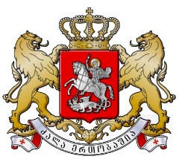 | 

Multiple Indicator Cluster Survey (MICS)
Stakeholders Meeting
March 22, 2018
Administration of the Government of Georgia
7, Ingorokva Str., Tbilisi

Agenda

16:00-16:20 - Welcome and opening remarks by:
Ms. Maya Tskitishvili, Head of Administration of the Government of Georgia
Mr. Niels Scott, UN Resident Coordinator
Ms. Laila O. Gad, UNICEF Representative
Mr. Tengiz Tsekvava, Geostat Deputy Director

16:20 -16:50 - Presentation of MICS by UNICEF

16:50-17:20 - Discussion

17:20-17:30 - Closing Remarks

