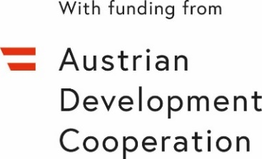
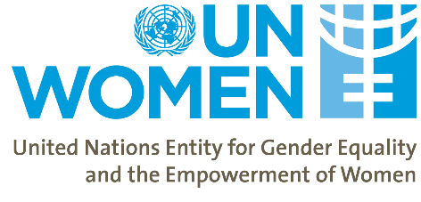
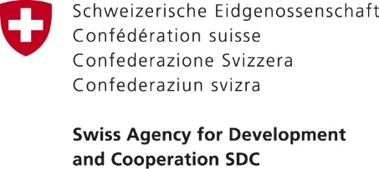

Women’s Economic Empowerment in the South Caucasus
First Main Phase

First Georgia Stakeholders Meeting
11:00 am, 13 October 2020
Location: Virtual (Zoom Meetings)

Agenda

11:00 – 11:20 | Introduction and Welcome Remarks:  - Ms. Tamar Sabedashvili, Country Representative a.i. UN Women Georgia  - Ms. Lela Akiashvili, Prime Minister’s Advisor on Human Rights and Gender Equality Issues, Government of Georgia  - Ms. Tamar Tsivtsivadze, Head of Program in Georgia, Swiss Cooperation Office for the South Caucasus  - Mr. Vakhtang Mshvidobadze, Programme Manager, Coordination Office for Technical Cooperation of the Austrian Embassy, Tbilisi
11:20 – 11:30 | Presentation and Adoption of TOR  - Mehjabeen Alarakhia, Programme Manager, UN Women Georgia
11:30 – 12:15 | Women’s Economic Empowerment in South Caucasus Project (WEESC)  Presentation of the Project – Achievements and Plans.  - Mehjabeen Alarakhia, Programme Specialist, UN Women  - Nani Bendeliani, Project Analyst, UN Women
12:15 – 12:55 | Questions & Answers  - Discussion
12:55 – 1:00 | Closing remarks

