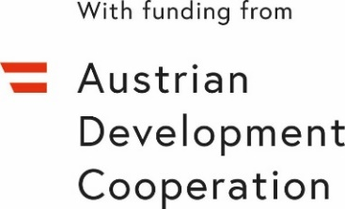
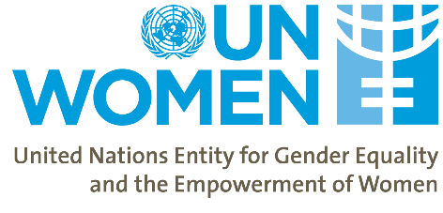
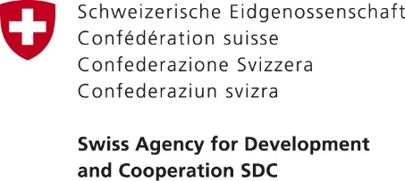

Women’s Economic Empowerment in the South Caucasus
First Main Phase

Evaluation Reference Group and Stakeholders Meeting
Georgia
17 February 2021, 5:00pm (Tbilisi time)
Location: Virtual (Zoom Meetings)
https://unwomen.zoom.us/j/98405476553?pwd=WlFSVWlZRTduWTVIeko1bXBrajlzUT09

Agenda

5:00 – 5:15 | Introduction and Welcome Remarks:  - Ms. Tamar Sabedashvili, Country Representative a.i. UN Women Georgia  - Ms. Lela Akiashvili, Prime Minister’s Advisor on Human Rights and Gender Equality Issues, Government of Georgia  - Ms. Tamar Tsivtsivadze, Head of Program in Georgia, Swiss Cooperation Office for the South Caucasus  - Mr. Vakhtang Mshvidobadze, Programme Manager, Coordination Office for Technical Cooperation of the Austrian Embassy, Tbilisi
5:15 – 6:15 | Presentation of Preliminary Findings of Evaluation of WEESC Project  - Jane Jamieson, Team Leader, Project Services International (PBJRT) Inc  - Anna Iluridze, Country Specialist, Project Services International (PBJRT) Inc  Discussion
6:15 – 6:45 | Women’s Economic Empowerment in South Caucasus Project (WEESC)  Presentation of the Project – Highlights of Achievements and Plans.  - Mehjabeen Alarakhia, Programme Specialist, UN Women  - Nani Bendeliani, Project Analyst, UN Women  Discussion
6:45 – 7:00 | Closing remarks

