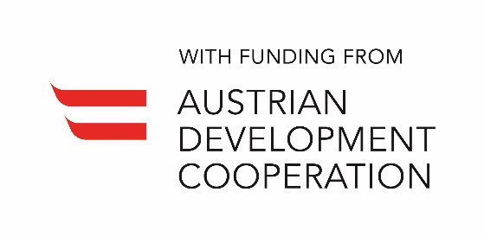 | 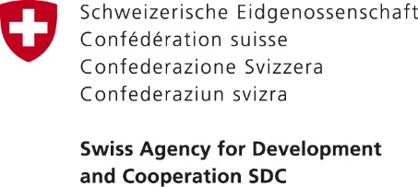 | 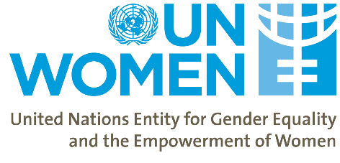

Women’s Economic Empowerment in the South Caucasus
First Main Phase
Terms of Reference for the Project Stakeholders Meetings

Committee Name: | Stakeholders’ Group
Type: | Project’s Advisory Body
Project Title: | Women’s Economic Empowerment in the South Caucasus
Countries: | Georgia
Duration: | 36 months
Starting Date: | 13 August 2018
Implementing Agency: | UN Women Georgia
Responsible Parties: | Kakheti Regional Development Foundation (KRDF); Association of Financiers of Local Self-Government Units of Georgia (GFA); International School of Economics at Tbilisi State University (ISET); Academy of the Ministry of Finance

Background:
With the support of the Swiss Agency for Development and Cooperation (SDC) and the Austrian Development Agency (ADA), UN Women launched the project “Women’s Economic Empowerment in the South Caucasus” in August 2018. The project aims at ensuring that women, particularly poor and socially excluded, in Armenia, Azerbaijan and Georgia are economically empowered and participate in relevant decision-making. Special emphasis is placed on strengthening the capacity of government institutions to develop and implement more gender-inclusive laws, policies and programmes that directly target women or impact their lives. As part of the implementation of the Regional Project, a Stakeholders’ Group will be established in each country.
Purpose:
The Stakeholders’ Group is established:
- To provide strategic guidance to the project activities taking into consideration the national political and economic context;
- To coordinate and identify synergies between the project activities and work of other actors in the country at a technical level;
- To enhance ownership and sustainability of the project results with the national stakeholders.

Authority:
Stakeholders’ Group (SG) recommendations that have been discussed and agreed upon by SG members will be utilized as guidance for project implementation. SG decisions will be made by the consensus of the members, and the outcome of deliberation must be captured in writing (SG meeting reports).
Membership:
As per the approved Project Document, the Stakeholders’ Group will be composed of the following members:
- Head of gender equality mechanisms from the executive branch of the Government;
- Representatives of the SDC and ADA
- Relevant Government entities – Ministry Responsible for Labour; Ministry of Economy and Sustainable Development; Rural Development Agency; National Statistics Office of Georgia (GEOSTAT); Academy of the Ministry of Finance; Ministry of Regional Development and Infrastructure.
- Relevant UN Agencies – ILO; UNFPA
- NGO Partners – KRDF; Taso Foundation; CARE International; GFA; ISET; Mercy Corps; Women’s Information Centre, etc
- Representative from Georgian Trade Unions Confederation;
- Representative of UN Women Georgia Country Office;

Any SG member may designate an alternate from their organization to participate in a Group’s meeting on his/her behalf. Project partners or experts relevant to the SG discussions may be invited to participate on an as-needed basis, including in an advisory capacity.
Meeting Arrangements:
The SG meetings will take place at least once a year and as needed in Tbilisi. The Stakeholder meeting with be co-chaired by UN Women and a relevant government institution.
SC Report:
The report from the Stakeholder Group meeting with agreements and action points will be drafted by UN Women in Georgia and circulated for inputs and endorsement by the SG members.

