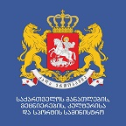
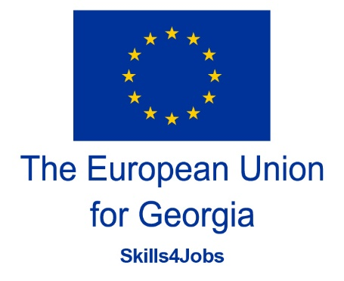

Fourth meeting of the Steering Committee for
“EU Support to Skills Development for Matching the Labour Market Needs of Georgia - Feedback on the Policy Matrix and indicators passport”
Tuesday, February 9, 2021

Join Zoom Meeting:

https://zoom.us/j/92261445333?pwd=M1ZTYU1yUFJqUU00cm1hcy9MS0toZz09

Meeting ID: 922 6144 5333
Passcode: 284328

Agenda
12:00-12:10 | Opening Remarks:  - Tamar Kitiashvili, Deputy Minister of Education, Science, Culture and Sport of Georgia  - Mathieu Bousquet, Head of Unit, DG NEARC1, Deputy Director for Neighborhood East and Institution Building
Session I: Progress Report on Compliance with 2020 year Indicators within Policy Matrix
12:10 – 12:25 | Peter Tasker - Expert, Review Mission;
12:25 – 12:45 | Comments by line Ministries regarding 2020 year Indicators within Policy Matrix:  - Ministry of Education, Science, Culture and Sport of Georgia  - Ministry of Internally Displaced Persons from the Occupied Territories, Labour, Health and Social Affairs of Georgia
12:45 – 13:00 | Q/A
Session II: 2021 year Indicators within Policy Matrix, Challenges and Update
13:00 – 13:10 | Ministry of Education, Science, Culture and Sport
13:10 – 13:20 | Ministry of Internally Displaced Persons from the Occupied Territories, Labour, Health and Social Affairs
13:20 – 13:30 | Ministry of Economy and Sustainable Development
13:30-13:40 | LEPL Youth Agency
13:40-13:50 | Discussion
Session III: Comments by Accompanying Projects
13:50-13:55 | David Handley, Team Leader and Skills Development Expert, Gopa
13:55-14:00 | Cay Etzold, Resident Twinning Adviser, NCEQE
14:00-14:05 | Valeria Kubalova, Resident Twinning Adviser, MoIDPLHSA
14:05-14:10 | Nino Kochishvili, EU Delegation to Georgia; Grand Project;
14:10 | Wrap-up and Closure

