

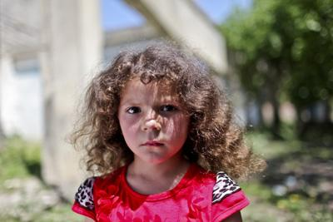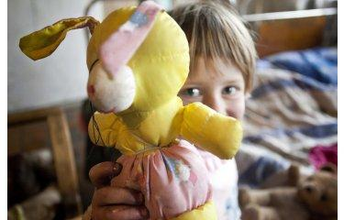
Sources: http://unicef.ge/62/unciefis_gantskhadeba_socialuri_dacvis_sistemis_shesakheb/304/lngeng
Impact Evaluation of Targeted Social Assistance (TSA) in Georgia
Final Report
September 14, 2020


Team
LTA Program Manager – María Carolina Latorre

Principal Investigator – Orazio Attanazio
Senior Quantitative Researcher – Jaime Millán-Quijano
Senior Qualitative Researcher – Claudia Peñaranda
Junior Researchers – Jimena Iguavita and Daniela Vivas
Local researcher – Zviad Barkaia
Statisticians – Jhon Jairo Romero and Daniela Velez

Impact Evaluation of Targeted Social Assistance (TSA) in Georgia
Final report
Table of Contents
Presentation 1
Chapter 1 6
1.1 Object of evaluation 6
1.2 Context of the evaluation 7
1.3 Theory of change 9
Chapter 2 11
2.1 Purpose of the evaluation 11
2.2 Objectives of the evaluation 11
2.3 Scope of the evaluation 12
Chapter 3 13
3.1 UNICEF contribution to the TSA 13
3.1.1 Methods, Data Collection, Sampling and Analysis 13
3.2 TSA-Impact 14
3.2.1 Methods, Data Collection, Sampling and Analysis 14
3.2.2 Sampling Strategy 21
3.3 Ethical considerations 26
3.3.1 Obligations of the evaluators 26
Chapter 4 28
4.1 UNICEF contribution to the TSA 28
4.1.1 What was UNICEF’s contribution to the TSA? 28
4.1.2 How relevant was UNICEF’s contribution to the TSA? 28
4.1.3 How efficient was UNICEF’s contribution to the TSA? 29
4.1.4 How effective was UNICEF’s contribution to the TSA? 31
4.1.5 Were such contributions designed in a way that considers equity, human rights, gender equality and the needs of different vulnerable groups? 32
4.2 TSA IMPACT 33
4.2.1 Size of the treatment 34
4.2.2 Labour market participation, income, and incentives to work 36
4.2.3 Expenditure 39
4.2.4 Education 41
4.2.5 Health 47
4.2.6 Childhood development 50
4.2.7 Poverty 53
4.3 VOUCHER vs CASH? - Experimental study 55
4.3.1 Income and savings 56
4.3.2 Expenditure 56
4.3.3 Consumption 57
4.3.4 Prices 58
4.3.5 Health and childhood development 59
4.3.6 Household costs 60
Chapter 5 61
Evaluation conclusions, lessons learned and recommendations 61
5.1 Conclusions 61
5.1.1 UNICEF contribution to the TSA 61
5.1.2 TSA impacts 62
5.1.3 The effect of vouchers and messages as part of the child benefit. 63
5.2 Lessons learned 64
5.3 Recommendations 64
5.3.1 UNICEF contribution to the TSA 64
5.3.2 TSA 65
5.4 Summary, intended users and targeted group of action 65
Bibliography 69
Appendix 0. Ethical clearance 71
Appendix 1. Complementary figures 80
Appendix 2. Complementary tables - RDD 82
Appendix 3. RCT supporting tables 119
Appendix 4. support for the RDD analysis 127
Appendix 5. Terms of reference 147
Appendix 6. Evaluation matrix 166
Appendix 7. List of interviewees 168
Appendix 8. Data collection instruments 169

list of figures
Figure 1.1 - Population, economy and poverty in Georgia 7
Figure 1.2 -Education and health in Georgia 8
Figure 1.3 - Social protection and gender in Georgia 8
Figure 1.4 - Child development in Georgia 9
Figure 1.5 - Theory of change of the TSA programme 10
Figure 3.1 - Proportion of households with children by PMT score (first interview) 17
Figure 3.2 - Sample design implemented in each stage 23
Figure 4.1 - Expected TSA benefit by first interview PMT score 34
Figure 4.2 - Labour market outcomes by first interview PMT score 36
Figure 4.3 - FRD estimates for labour market outcomes 37
Figure 4.4 - FRD (IV) estimates for labour market outcomes for households with children 38
Figure 4.5 - FRD (IV) estimates total income for households with children 39
Figure 4.6 - FRD (IV) estimates of TSA benefits on total income, expenditure and savings for households with children 40
Figure 4.7 - FRD estimates of TSA benefits on expenditure composition for households with children 40
Figure 4.8 - FRD estimates of TSA benefits on education enrolment (September 2019) by age category and gender 42
Figure 4.9 - FRD estimates of TSA impact on the probability to advance to the next level for individuals from 6 to 12 years old. 44
Figure 4.10 - FRD estimates of TSA benefits on the expectations of university returns (youth’s from16 to 18) 45
Figure 4.11 - FRD estimates of TSA benefits on education enrolment (September 2019) by age category and gender 46
Figure 4.12 - FRD estimates of TSA benefits on some vaccines 47
Figure 4.13 - FRD estimates of TSA impact on the use of health services for women from 14 to 25 years old. 49
Figure 4.14 - FRD estimates of TSA impact on the perceive health status by gender of the household head for households with children. 50
Figure 4.15 - FRD estimates of TSA impact on children’s alimentation. 51
Figure 4.16 - FRD estimates of TSA impact on children’s healthy activities. 52
Figure 4.17 - FRD estimates of TSA impact on the probability to advance to the next level for individuals from 6 to 12 years old. 53
Figure 4.18 - FRD estimates of TSA impact on multidimensional poverty by household head’s gender 54

list of tables
Table 3.1 – Stakeholders interviewed 14
Table 3.2 - TSA benefits by PMT score 16
Table 3.3 - Sample size and MDE for cut-off and subpopulation 22
Table 3.4 - Sample surveyed and MDE for cut-off and subpopulation 24
Table 4.1 - TSA estimated benefits around the cut-offs for households with and without children. 35
Table 4.2 - Comparison impact of food voucher, messages and cash transfer in TSA on income and savings 56
Table 4.3 - Comparison impact of food voucher, messages and cash transfer in TSA on expenditure 57
Table 4.4 - Comparison impact of food voucher, messages and cash transfer in TSA on food consume 58
Table 4.5 - Comparison impact of food voucher, messages and cash transfer in TSA on food prices 58
Table 4.6 - Comparison impact of food vouchers, messages and cash transfers in TSA on child health 59
Table 4.7 - Household expenses to buy food 60
Table 5.1 – Summary of conclusions, lessons learned and recommendations from the evaluation 66

Acronyms
ATT | Average Treatment on the Treated
CBP | Child Benefit Programme
CEDAW | Convention on the Elimination of All Forms of Discrimination Against Women
CRC | Convention on the Rights of the Child
ET | Evaluation Team
FRDD | Fuzzy regression discontinuity design
FRD-IV | First interview in a fuzzy regression discontinuity design
GDP | Gross Domestic Product
GEEW | Gender equality and empowerment for women
GEL | Georgian Lari
GoG | Government of Georgia
HIV | Human Immunodeficiency Virus
ITT | Intention to treat Estimate
IV | Instrumental variable
LTA | Long Term Agreement
MDE | Minimal Detectable Effect
MOH | Ministry of Health
P.P. | Percentage points
PMT | Proxy Means Test
RCT | Randomized Control Trial
RD | Regression Discontinuity
RDD | Regression Discontinuity Design
SMS | Short Message Service
SSA | Social Service Agency
TD | Tetanus-Diphtheria
TOR | Terms of Reference
TSA | Targeted Social Assistance
UNEG | United Nations Evaluation Group
UNICEF | United Nations International Children's Emergency Fund
USD | United States Dollar

Presentation
UNICEF-Georgia has appointed Econometría Consultores to assess the impact of the Targeted Social Assistance programme (TSA) on children and adults for the outcomes determined during the inception phase of the evaluation, as well as UNICEF’s contribution to the programme. The outcomes include poverty, health, education, early childhood development, incentives to work and other relevant variables.
The objective of the impact evaluation is to provide accountability and relevant information for future decision-making by the Government of Georgia (GoG), UNICEF and other stakeholders involved in social protection. TSA programme (the evaluated object) implementation started in 2006 in Georgia and the evaluation considers this time frame for the estimation of impacts on beneficiaries, and the period of 2009 onwards for the analysis of UNICEF’s contribution to its implementation.
The first part of the project corresponded to the inception phase, which was undertaken between September and December 2018. The corresponding deliverables for this phase were an inception mission report, an inception report draft, and a final inception report.
The second phase of the evaluation ran from January 2019 to March 2020 and included the following deliverables: i) a methodology report; ii) a literature review and data collection instruments report; iii) a final report; and iv) a presentation of evaluation findings to key stakeholders.
This document corresponds to the third deliverable of the second phase of the evaluation, the final report, and contains six chapters with: the background; evaluation purpose, objectives and scope; evaluation methodology; evaluation findings; conclusions and lessons learned; and recommendations.

Executive summary
The object of evaluation is the TSA programme in Georgia. The programme consists of monetary social assistance linked to a household welfare index or vulnerability score. The assistance is paid to families while taking into account the number of family members, including children under 18 years of age.
The main objectives of the evaluation are:
- To determine the effect of the TSA programme on the living conditions of children and households, and if such effect is positive or negative, intended or unintended, and direct or indirect.
- To evaluate UNICEF’s contribution, in terms of relevance, effectiveness and efficacy, to the TSA from 2009 onwards.
The specific objectives of the evaluation are:
- To assess the impact of the TSA on children and adults for the outcomes that were determined during the inception phase, such as poverty, health, education, early childhood development, labour market participation, individuals’ behaviour, individuals’ expectations, etc.
- To evaluate UNICEF’s contribution to the TSA by identifying its relevance, efficiency and effectiveness in making the TSA more child sensitive, as well as assessing if such contributions were designed in a manner which considers equity, human rights (specifically child rights), gender equality and the needs of different vulnerable groups (e.g. people with disabilities or ethnic minorities).
- In addition, outside the terms of reference (TOR), we show impact analysis results for two possible extensions of the TSA child benefit in this report: (i) Giving part of the child benefit as a food voucher; and (ii) sending information to households about how the child benefit impacts the total benefit the household receives.
The assessment of the UNICEF contribution to the TSA programme was based on primary qualitative data collected through interviews with key stakeholders. The number of stakeholders interviewed was selected by the Evaluation Team (ET) and UNICEF. There was a total of 26 stakeholders interviewed from different organisations to gather diverse perceptions from different fields.
The methodology agreed upon to answer the research questions related to UNICEF’s contribution to the TSA programme is based on stakeholder perceptions on the relevance, efficiency and effectiveness of said contribution. A desk review of documents about social programmes in Georgia was conducted based on stakeholder perceptions. The primary qualitative data also collected was triangulated with the findings from that review. The use of qualitative and desk review methods on the same topic allows for cross-checking the findings and gives more confidence to the results.
The main findings are:
The contribution of UNICEF to the TSA is regarded as essential by the stakeholders interviewed for the evaluation, which included government officers and representatives of international organisations. The technical assistance provided for the revised proxy means test (PMT) formula and productive communication between UNICEF and the government are both among UNICEF’s main contributions to the TSA that were identified by stakeholders.
UNICEF’s contributions to the TSA are considered relevant since the objectives of TSA and UNICEF are perceived as being harmonious, and the technical assistance provided to revise the PMT formula contributed to ensuring the TSA programme addresses the unique needs of households with children. However, it is also perceived that the TSA objective of supporting poor households to prevent their poverty from escalating into extreme poverty is too ambitious, and that there is no social policy framework in Georgia that could support the implementation of the programme.
The methodology and the technical assistance provided by UNICEF has helped make the use of resources allocated to the programme efficient and is perceived as such. In addition, UNICEF is seen as an actor that has efficiently targeted their financial and technical assistance while providing important inputs for programme implementation. Nevertheless, there are efficiency related aspects of UNICEF’s contribution to the TSA that are perceived as not having reached their full potential. For example, social agents are mostly young employees that use their position as a starting point for their career, implying they soon leave their positions which generates a time and resource loss from the investment in training. Another example is the lack of a monitoring system to supervise the impact of the TSA and the implementation process.
The UNICEF contribution to the TSA has been effective because it has made the programme become more child-sensitive and prioritized child poverty for the government. It has also been acknowledged that UNICEF has strengthened the performance of the programme through its involvement and the technical assistance provided. However, the effectiveness of UNICEF’s contribution to the TSA is stymied because there are not objectives, strategies and actions clearly defined in the programme design, nor is there a public unit that could plan, evaluate and support decision-makers.
Finally, the equity, human rights and gender approach of the TSA design is identified by stakeholders when examining the assistance provided to vulnerable groups such as single mothers, pregnant women and female-headed households.
To evaluate the impact of the TSA on household welfare, a Fuzzy Regression Discontinuity Design strategy was used. Data from several administrative sources and a detailed household survey were also used. The cash transfer households receive could reduce liquidity constraints allowing them to increase consumption or invest to overcome poverty. However, given that the benefits are allocated using poverty measures (the PMT score), the TSA may reduce the incentives to overcome poverty because once the household is no longer designated as being in poverty, it losses the benefits. The main results of the evaluation are the following:
- TSA benefits reduce the probability of having a formal job for those individuals close to the cut-off where households lose benefits per household member. The same behaviour is not found with respect to informal labour market employment. Given that formal employment allows authorities to identify increases in a household’s income, it is concluded that individuals have less incentives to find a formal job because they prefer to remain on TSA benefits.
- We also found that for households close to the cut-off, where the benefits per member are lost, total income is smaller than for those who are just above the cut-off, even when we add up the benefits households are receiving.
- We found some positive results on tertiary education enrolment for women, and on the time parents spend with their children (younger than 6 years old).
In addition to the TSA evaluation, we set up an experimental evaluation of two possible changes in the TSA programme, the inclusion of a food voucher and communicating the information about the child benefit using SMS. For this evaluation municipalities were randomly allocated for four groups. These groups are divided by those who: (1) receive part of the child benefit as a food voucher; (2) receive an SMS; (3) receive the SMS and get part of the child benefit as a food voucher; and (4) a control group receiving the TSA benefits as usual. The voucher aims to increase food consumption, especially for children. The SMS aims to increase the share of expenses allocated to children by showing households how important the child benefit is within the TSA benefit. These are the main results of the experiment:
- The voucher does not increase food consumption or the composition of the food basket. However, given that the voucher was accepted only in some shops, households using the voucher system had an increase in the cost (in time and money) of reaching a food market.
- The SMS had a positive impact, increasing household expenditure on education.
- We do not find any complementarity between the SMS and the voucher.

Policy recommendations:

- UNICEF should continue to work with the GoG to improve TSA implementation and provide high quality technical assistance, advocacy and coordination of inter-institutional leadership.
- UNICEF should assist the GoG by developing a social policy framework, in which the objectives, design and implementation process of the TSA are clearly defined and agreed upon.
- To increase the efficiency of UNICEF’s contribution to the TSA, motivational benefits could be provided to social agents to stay longer at their positions. UNICEF could also advocate for the development of a monitoring system to supervise the entire implementation process and not just the impact of the TSA.
- UNICEF should also advocate for the establishment of a public unit that continues to head the TSA programme. This unit could plan, evaluate, and support decision-makers.
- Finally, the GoG should assess the outcomes of the programme for vulnerable groups such as single mothers, pregnant women and female-headed households, in order to clearly identify their specific needs and if and how much the TSA programme should be adjusted to provide more assistance to these population groups.
- The GoG could introduce some conditionalities to reduce the negative incentives of this targeted transfer. For instance, the benefit could be contingent on evidence of a formal job search or human capital investments such as post-secondary education, tertiary education or vocational job training.
- We do not recommend expanding the voucher system. It is not increasing food consumption, but it does increase the cost of travel to the market for households.
- Using an SMS seems to influence household behaviour, with small cost. The GoG and UNICEF could use this strategy to induce other positive investments for the TSA benefit.

Background

Object of evaluation
The object of evaluation is the TSA programme in Georgia. The programme consists of monetary social assistance linked to a household welfare index or vulnerability score. The assistance is paid to families while taking into account the number of family members, including children under 18 years of age. The allowance amount varies from GEL 60 to GEL 100 per family member, depending on their social rating score which considers variables related to the household monthly consumption and their needs. It is estimated using the PMT formula (UNICEF, 2017). The programme was launched in 2006 and has been running continuously since. It has cost a total of GEL 270 million annually, around 9% of Georgia’s social protection budget (World Bank, 2015).
The TSA programme covers all of the regions in Georgia, except for Abkhazia and S. Ossetia, reaching around 12% of the population. The intended beneficiaries are households living below the poverty line and those not getting the minimum income to subsist. Although the TSA programme design and implementation are not based on a specific gender approach, female beneficiaries are included as part of the target population.
UNICEF has played a key role in the TSA programme’s technical design and implementation. Research focused on Georgia and carried out by UNICEF has laid the ground work for TSA reforms and provided recommendations aimed at transitioning to a social protection system (Baum, Mshvidobadze, & Posadas, 2016). UNICEF’s role has been mainly as a technical advisor to the government on how beneficiaries of the programme can be better targeted, and as an advocate for the inclusion of the Child Benefit Programme (CBP) to the cash transfer of the TSA. The CBP provides a set amount of cash to targeted households per child.
The evaluation was designed under a rights-based framework, following the Convention on the Rights of the Child (CRC) and the Convention on the Elimination of All Forms of Discrimination Against Women (CEDAW). Articles specific to elements in the evaluation are: Article 16 of the CRC, ‘No child shall be subjected to arbitrary or unlawful interference with his or her privacy, family, home or correspondence, nor to unlawful attacks on his or her honour and reputation.’ All information was anonymised and the beneficiaries data was protected; and Article 27 of the CRC, ‘States Parties recognize the right of every child to a standard of living adequate for the child's physical, mental, spiritual, moral and social development.’ All recommendations from the evaluation are aimed to improve the TSA programme, which can contribute to vulnerable households with children.
The evaluation takes into account Article 2 of the CEDAW which states, ‘States Parties condemn discrimination against women in all its forms…’. This means male and female beneficiaries be considered equally for the purposes of the evaluation.
Actors involved in the TSA programme include but are not limited to: public institutions that define and oversee the implementation of social policies; Parliament which approves funds allocated for social programmes; beneficiary households; and national and international organisations actively involved in social policy. All these were included in the evaluation, either as interviewees (key stakeholders) or as the unit of analysis for the impact estimation (beneficiaries).

Context of the evaluation
The TSA programme was designed and implemented in Georgia, a country with a population of close to four million people. Females make up 52.3% of the population and around 30% are younger than 24 years of age (Figure 1.1).

Figure 1.1 - Population, economy and poverty in Georgia

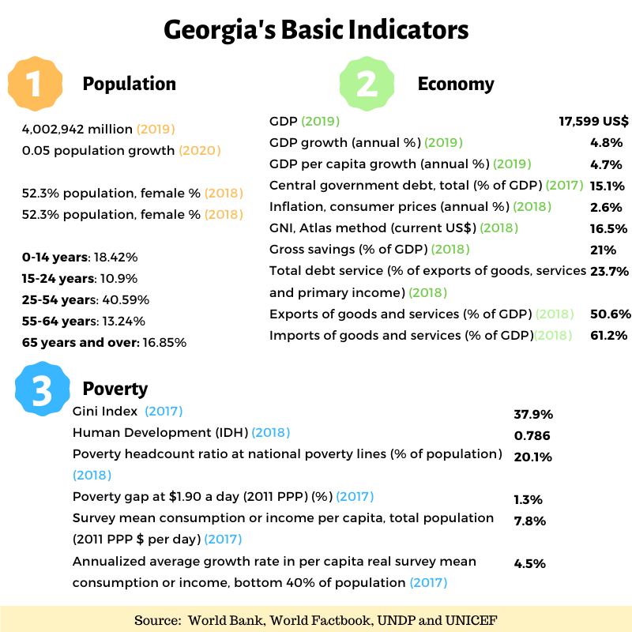

Although the country’s economic performance is favourable, with annual GDP growth of 4.8% in 2019 and controlled inflation of 2.6% in 2018, the percentage of households under the poverty line is 20% and the country ranks 70 out of 183 countries in the Human Development Index created by the UN (Figure 1.1).
While government expenditure on education is only 3.8% of GDP, the country has achieved high rates of school enrolment (99% for primary school, 106% for secondary school and 60% for tertiary education). The country also boasts a 99% literacy rate (Figure 1.2).

Figure 1.2 -Education and health in Georgia
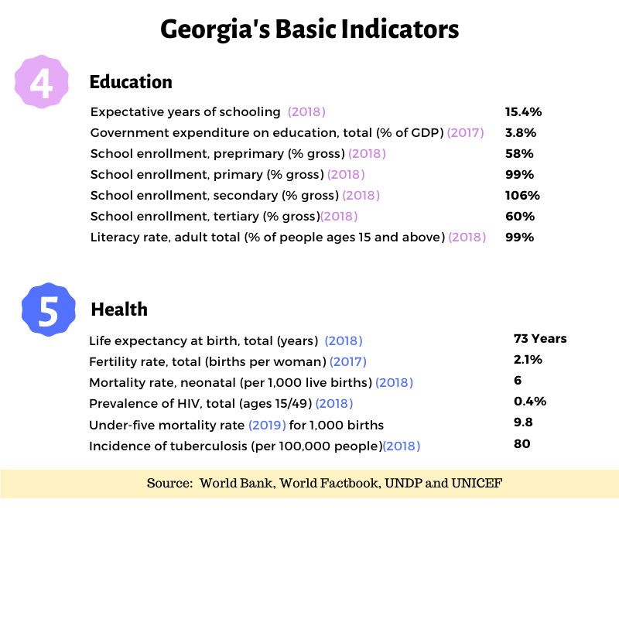
The life expectancy at birth is 73 years, and other health indicators like fertility rates, neonatal mortality rates, prevalence of HIV and
incidence of tuberculosis are well within average levels (Figure 1.2).
Indicators on social protection and the labour force show that 18.4% of children are employed and that 14.2% of the population is unemployed.

Figure 1.3 - Social protection and gender in Georgia
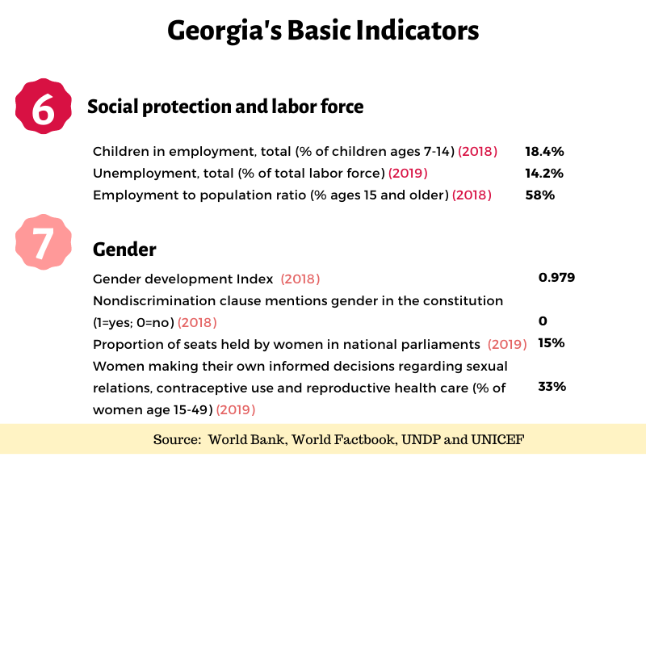
Although there is no information on the percentage of informal workers, 58% of the population are employed and 28% are part of the inactive population group.
Georgia ranks 75th out of 162 countries in the Gender Development Index. Only 15% of the seats in the national parliament are held by women and 33% of women are able to make their own decisions regarding their sexual health.
Finally, indicators on child development show high rates of attendance in early childhood education (78%), and early stimulation and responsive care (78%). Child survival rates are high but domestic violence rates against children are high (67%), and breastfeeding rates for children 0-5 months of age are low (20%) (Figure 1.4).

Figure 1.4 - Child development in Georgia
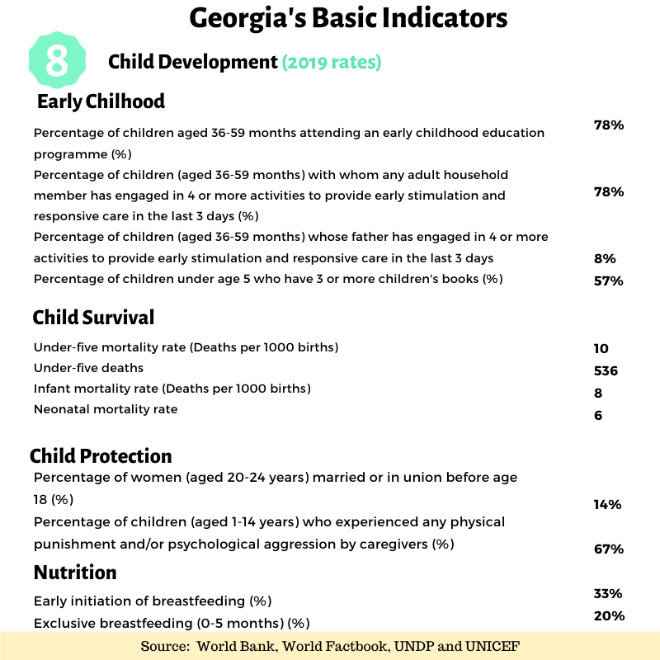
These figures show how relevant the TSA programme in Georgia is. The programme considers the vulnerability of households by their capacity to consume and their ability to meet basic needs. Even though Georgia has reached above-average levels of education and health coverage, 20% of the population are still below the poverty line and 14% of the labour force are unemployed. This implies that there is a significant amount of vulnerable households requiring social assistance from the government.

Theory of change
The TSA’s theory of change was defined based on information collected during the evaluation. The inputs identified are financial, physical, human, and technical resources provided by the GoG and UNICEF, as well as the technical assistance, available information, and norms and policies available for the implementation of the programme. These inputs are used for processes and activities undertaken for the implementation of the programme, such as: institutional coordination; beneficiary targeting; registration and verification of targeted beneficiaries; the provision of the monetary transfers to those beneficiaries; training social agents; monitoring and evaluation; and communication activities.
The outputs generated by these processes and activities are the implementation of the child benefit programme and the PMT formula methodology used for targeting beneficiaries. These outputs help achieve the final outcomes and impacts expected from the programme. The intended results from the intervention are the support of poor households and contributions to the improvement of their living conditions, particularly their health, education and early childhood development. Increasing productivity of beneficiary families by encouraging employment or investment in productive activities is another intended result. Figure 1.5 presents the theory of change of the TSA described above.

Figure 1.5 - Theory of change of the TSA programme
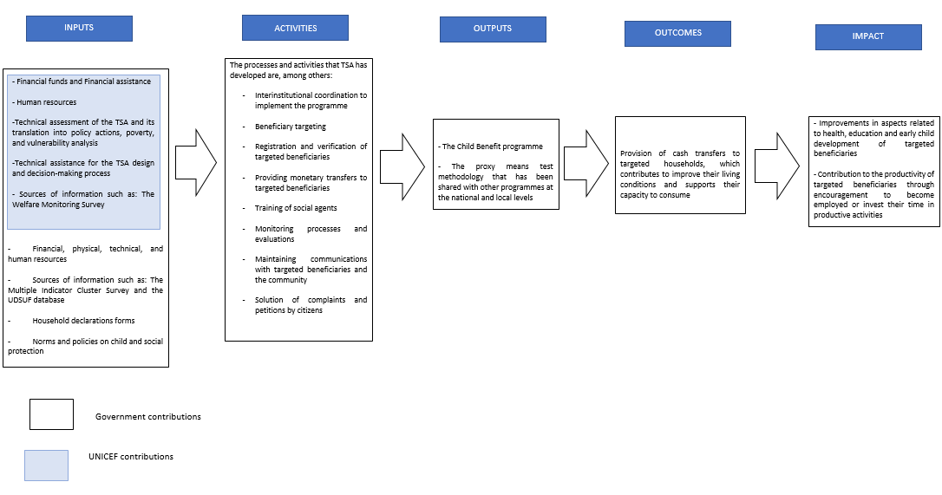
Source: Elaborated by Econometría Consultores based on information collected for the evaluation

Evaluation purpose, objectives and scope

Purpose of the evaluation
The main purpose of the impact evaluation, as established in the TOR, is to provide relevant elements for decision-making, in terms of accountability and learning, to the GoG, UNICEF and other stakeholders involved in the social protection system of the country. The evaluation is expected to contribute to the implementation of the TSA programme.
The intended primary users of the evaluation are UNICEF and the GoG, particularly the Social Security Administration (SSA), which administers the TSA, the Ministry of Internally Displaced Persons from the Occupied Territories, Labour, Health and Social Affairs (MOH) and the Parliament of Georgia, which defines and oversees social policies and budget allocation.
Stakeholder participation in the evaluation has been mainly by way of the reference group composed by UNICEF-Georgia staff, and as national-level stakeholder interviewees.

Objectives of the evaluation
The main objectives of the evaluation are:
- To determine the effect of the TSA programme on the living conditions of children and households, and if such effect is positive or negative, intended or unintended and direct or indirect.
- To evaluate UNICEF’s contribution (in terms of relevance, effectiveness and efficacy) to the TSA from 2009 onwards.
The specific objectives of the evaluation are:
- To assess the impact of the TSA on children and adults for the outcomes that were determined and clarified during the inception phase, such as poverty, health, education, early childhood development, labour market participation, individuals’ behaviour, individuals’ expectations, etc.
- To evaluate UNICEF’s contribution to the TSA by identifying its relevance, efficiency and effectiveness in making TSA more child sensitive, as well as assessing if such contributions were designed in a way that considered equity, human rights (specifically child rights), gender equality and the needs of different vulnerable groups (e.g. people with disabilities or ethnic minorities).
In addition, the GoG introduced some changes to the child benefit. First, the benefit increased from GEL 20 to GEL 50 per child. Second, part of the child benefit (GEL 30) were given a “food voucher” that can only be used to buy food in certain shops. Third, the government sent an SMS to the households explaining how much of the total transfer comes from the child benefit.
The latter two changes aim to increase child welfare by increasing household expenditure in food and other children investment. We propose a randomize control trial of the food voucher and the SMS to test its impacts on household expenditure. Thus, an added objective of this evaluation is:
- To evaluate the impact of the “food voucher” and the SMS on household expenditure and child welfare.

Scope of the evaluation
The primary focus of the evaluation is to assess the impacts of the TSA programme on children and, adults when possible. Further elaboration on equity gaps was also requested and subsequently analysed when data were available.
The geographical scope of the evaluation is national, excluding the Abkhazia and South Ossetia regions. Finally, the temporal scope was 2006 onwards for the impact assessment and 2009 onwards for the assessment of UNICEF’s contribution.

Evaluation methodology
In this chapter we present the methodology of the impact evaluation including the extensions of the TSA due to the changes introduced by the GoG. In addition, we present the particularities associated with the qualitative sample for the evaluation of UNICEF’s contribution to TSA. This chapter then concludes by providing details on ethical considerations that were considered.
The evaluation questions defined in the TOR and which the methodology attempted to respond to are:
- What is the impact of the TSA on child and adult poverty, health, education, early childhood development and beneficiaries’ incentives to work?
- How different is the impact across gender, urban/rural settlement status and other covariates when applicable?
- What measures can be undertaken to improve the impact of the TSA in the future?
- What was UNICEF’s contribution to the TSA?
- How relevant was UNICEF’s contribution to the TSA?
- How efficient was UNICEF’s contribution to the TSA?
- How effective was UNICEF’s contribution to the TSA?
- Was such a contribution designed in a way to consider equity, human rights (most importantly the child rights), gender equality and needs of different vulnerable groups (e.g. persons with disabilities or ethnic minorities)?
It is important to note that neither the TSA programme nor the evaluation research questions include a gender equality and empowerment for women (GEEW) approach. Therefore, integrating GEEW into the analysis is a limitation for this evaluation.

UNICEF contribution to the TSA

Methods, Data Collection, Sampling and Analysis
The assessment of the UNICEF contribution to the TSA programme was based on primary qualitative data collected through interviews with key stakeholders. The number of stakeholders interviewed was selected by the ET and UNICEF. There was a total of 26 stakeholders interviewed from different organisations in order to gather different perceptions from diverse fields.
The time and budget restrictions of the evaluation were considered when selecting the total sample.
Table 3.1 summarises the stakeholders interviewed.

Table 3.1 – Stakeholders interviewed
ORGANIZATION | TOTAL STAKEHOLDERS INTERVIEWED | NATIONAL/LOCAL
Legislative
Parliament of Georgia | 2 | National
UNICEF
UNICEF | 4 | National
Executive
Ministry of Internally Displaced Persons from the Occupied Territories, Labour, Health and Social Affairs (until recently Ministry of Labour, Health and Social Affairs) | 3 | National
Social Service Agency (SSA, under MOH) | 3 | National
Municipal Department of Finance | 2 | Local
Experts and Advisors
UNICEF external advisors | 7 | National
International Organizations
World Bank | 2 | National
UNDP | 1 | National
Source: Elaborated by Econometría
The methodology agreed upon to answer the research questions related to UNICEF’s contribution to the TSA programme is based on stakeholder perceptions on the relevance, efficiency and effectiveness of said contribution.
A desk review of documents about social programmes in Georgia was conducted based on stakeholder perceptions. Primary qualitative data also collected was triangulated with the findings from that review. The use of qualitative and desk review methods on the same topic allows for the cross-checking of the findings and gives more confidence to the results.
The data collection instruments and the desk review criteria were based on the research questions included in the TOR. Both the desk review information and the qualitative data were categorized and compared to determine areas of agreement and divergence, as well as conclusions.

TSA-Impact

Methods, Data Collection, Sampling and Analysis
- Impact evaluation using a fuzzy regression discontinuity design (RDD)
We estimated the TSA’s impacts using an RDD. Estimations captured the impact of the programme around the different PMT cut-offs used by the programme to allocate benefits.
The RDD depends on two main assumptions. The first assumption is, other observable and non-observable variables are continuous around the cut-offs. This means the only difference between an individual just below the cut-off and someone just above the cut-off is the benefit received from the TSA. In order to support this assumption we reviewed the documentation on social protection at national and regional levels to collect information about other social services received by TSA beneficiaries. We focused on programmes that also use PM scores to allocate benefits. We found certain municipalities use the PMT at 57,000 (57K) to determine who can access subsidized medication and who can access municipality canteens. These benefits are considerably smaller than the TSA; nevertheless, we need to take into account access to these two programs when we read the results at 57K.
The second assumption is, individuals cannot manipulate their score. This means that being just above or below a given cut-off is considered random. Unfortunately, we have evidence that individuals and/or Social Agents around the 65,000 (65K) and 100,000 (100K) cut-offs do manipulate their scores. In Appendix 1 we show sufficient evidence that the manipulation at 65K comes from households asking for a reassessment in order to reduce their initial score and get larger TSA benefits. We also show that using the PMT score from the first time a household is interviewed solves the problem and identifies the effect of the TSA.
Meanwhile, at 100K, we found that the manipulation of the PMT is already happening the first time a household is interviewed and works opposite of the hypothesis where households try to reduce their score to obtain the child benefit. In this case, we cannot correct the manipulation. We excluded these households from the analysis. We cannot estimate the causal impact of the child benefit alone because there is a difference of households above 100K not being eligible for the child benefit while those under 100K are eligible.
- Implementation of the RD
In this section we describe the features of the impact evaluation. Firstly, the universe of analysis is all the households which have been assessed by the SSA to get a PMT score. Given that we will use the RDD analysis, we divide our analysis into five (5) to consider individuals around each TSA cut-off. Table 3.2 summarizes how the TSA programme assigns benefits using the PMT score and predetermined cut-offs (30K, 57K, 60K, 65K and 100K).

Table 3.2 - TSA benefits by PMT score
PMT SCORE | BENEFIT PER INDIVIDUAL | CHILD BENEFIT
30K or less | GEL 60 | GEL 50
More than 30K to 57K | GEL 50 | GEL 50
More than 57K to 60K | GEL 40 | GEL 50
More than 60K to 65K | GEL 30 | GEL 50
More than 65K to 100K | 0 | GEL 50
More than 100K | 0 | 0
Source: Econometria Consultores. 2020
To determine the region around each cut-off, we follow Calonico, Cattaneo, & Titijunik (2014).
Econometría collected information on several outcome variables from two sources. First, we used administrative records on education, use of health services, income, labour market participation and the use of other social services. In this case, the estimated impact for the variable Y at cut-off c is:
$$τ_{c,h}^{Y}=\frac{μ_{Y-}-μ_{Y+}}{μ_{T-}-μ_{T+}}$$
$μ_{Y-}$ is the average of Y for the individuals just below the cut-off in a neighbourhood of size h. $μ_{T-}$ is the average probability of belonging to a TSA treatment group T for the individuals just below the cut-off in a neighbourhood of size h. $μ_{Y+}$ and $μ_{T+}$are the analogous values for the individuals just above the cut-off.
Second, we collected information from an extensive household survey about other outcome variables that are not available in administrative databases. Figure 3.1 shows that an average of 40% of households have children. Given the importance of the child benefit, we decided to focus our analysis on households with children. For that reason, we sampled only households with children to increase the level of precision of our estimations.

Figure 3.1 - Proportion of households with children by PMT score (first interview)
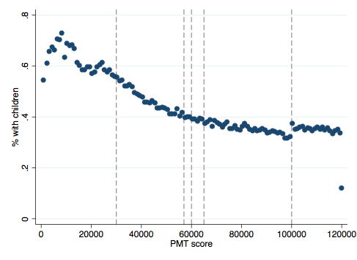
Source: Own calculations using PMT data from SSA Georgia
We randomly chose households with children around each cut-off. To maximize the use of this random sample of households, Econometría divided the universe into three regions.
- Region 1: Households around 30,000
- Region 2: Households between 54,000 to 70,000.
- Region 3: Households around 100,000
Our estimations in Region 1 were used to estimate the impact around the first cut-off, comparing households that receive GEL 60 per member + child benefit, against households that receive GEL 50 per member + child benefit.
In Region 2, we mixed the sample to estimate the impact around three different cut-offs in the following way:
- Using households whose scores were between 54K to 60K, we estimated the impact of receiving GEL 50 per member + child benefit against receiving GEL 40 per member + child benefit
- Using households whose scores were between 57K to 65K, we estimated the impact of receiving GEL 40 per member + child benefit against receiving GEL 30 + child benefit
- Using households whose scores were between 60K to 70K we estimated the impact of receiving GEL 30 + child benefit against only the child benefit
The estimations in Region 3 were used to estimate the impact of the child benefit because the sole difference between households before and after 100K is that the ones below are only eligible for the child benefit and the ones after are not eligible for any TSA benefit.
We can use the same set of households for more than one analysis by taking the sample in this manner.
It is important to note that we estimated TSA’s impacts on adult outcomes; however, the estimations were constrained to adults living in households with children. In addition, as will be explained later, in the case of estimations using administrative information, we can also include households without children because this does not represent an extra cost for the evaluation.
Therefore, for a given cut-off c, the impact of the TSA benefit T on the outcome Y will be estimated using the Fuzzy Regression Discontinuity Design – Instrumental Variable (FRD-IV) estimate proposed by Lee & Lemieux (2010), where we instrument the probability of receiving the benefit T using the probability of being below the cut-off c from the first interview. If $D_{c}=1$ when the household score is lower than c from the first interview, the estimated impact will be:
$$τ_{c}^{Y}=\frac{μ_{Y|D=1}-μ_{Y|D=0}}{μ_{T|D=1}-μ_{T|D=0}}$$
To better understand how we estimate $τ_{c}^{Y}$let us give an example. Consider Region 2, around 57K. In this case, D = 1 if the household had a score from the first interview between 54K and 57K, and 0 if the score was just above 57K and below or equal 60K. T = 1 if the household is actually receiving GEL 50 per member and the child benefit, and 0 otherwise. Thus, $τ_{c}^{Y}$ quantifies any change in the outcome Y around the cut-off. However, it takes into account how many households remain that are receiving the GEL 50 per member from the first interview that did not change their score and now receive larger or smaller benefits.
The main limitation of an RDD is that the estimated impacts only apply for households around the cut-offs. However, in this case we use the advantage of multiple cut-offs to explain how the impacts change when the PMT changes. The second limitation is that detailed survey data is only available for households with children. Though, we can estimate the impacts for adults living in households with children. In addition, we made a great effort collecting administrative information that allowed us to analyse the effect of TSA adults who do not live with children for multiple outcomes.
- Voucher vs cash
As previously explained, this evaluation and experiment supported the additional changes by the GoG to the TSA by evaluating possible changes in the child benefit. The GoG wanted to understand the effect of giving part of the transfer as a food voucher. The proposal was to divide the GEL 50 benefit into GEL 20 as cash and GEL 30 as a food voucher. Families with children receive an extra bank card with GEL 30 deposited per child every month by the bank. The families also receive GEL 20 for the child benefit as part of the total transfer, just as they have. Households are only allowed to use this extra card in specific grocery shops.
The question we aim answer is: Is it better to give GEL 30 in a voucher or is it better to give GEL 30 as cash? This discussion is still debated throughout economic literature. One branch of literature argues that unconditional transfers allow households to allocate their income in the most efficient way according to their needs. A second branch argues that conditional transfers, like vouchers, may have some advantages, particularly when policy makers target a specific population or want to change certain behaviour(s) of individuals (Gahvari & Currie, 2008).
To answer this question, Econometría implemented a Randomized Control Trial (RCT). In coordination with Liberty Bank and the GoG, we randomly divided municipalities into two different groups (arms):
- Arm 1 (voucher): In these municipalities we started the implementation of the food voucher. From March 2019, households with children received GEL 20 in cash and GEL 30 on the food card per child.
- Arm 2 (cash only): In these municipalities the new child benefit (GEL 50 per child) was included as part of the total transfer to the household (cash).
We could test the extent to which the food voucher increases or decreases food consumption and child outcomes by comparing households between these two groups.
In addition, UNICEF and the GoG wanted to understand the effect that information has on households’ investment decisions. Therefore, we added two groups (arms) to the RCT study.
- Arm 3 (voucher + message): Individuals that receive GEL 20 cash and GEL 30 in a voucher. Additionally, they received a message(s) reminding them that GEL 50 are benefits to be used for children.
- Arm 4 (cash + message): Individuals that receive GEL 50 cash. Additionally, they received a message(s) reminding them that GEL 50 are benefits to be used for children.
The message received by the households was the following:
“Tqven ojaxs chaericxa saarsebo shemceoba 00000L. saidanac "bavshvis kvebis baratze" daricxulia ojaxis 16 clamde asakis wevr(eb)istvis gankuTvnili 000L”
Which translates to:
“Your family received social assistance benefit 00000 GEL, from which 000 GEL is transferred to a “child food voucher” card for each family member under 16”
The hope behind this message is that households would link the child benefit directly with investments to children. Then, we can make the following comparisons:
- Arm 1 and Arm 3 vs Arm 2 and 4: This comparison quantifies the importance of getting a voucher instead of getting cash.
- Arm 1 and Arm 2 vs Arm 3 and Arm 4: This comparison quantifies the importance of receiving a message.
- Arm 1 vs Arm 2: This comparison quantifies the importance of the voucher when there is no message.
- Arm 3 vs Arm 4: This comparison quantifies the importance of the voucher when households are receiving a message about the child benefit.
- Arm 1 vs Arm 3: This comparison quantifies the importance of receiving a message when the households are receiving the voucher.
- Arm 2 vs Arm 4: This comparison quantifies the importance of receiving a message when the households are receiving cash only.
To implement the study, we used the following scheme:
- Group allocation was done at the municipality level; thus, all individuals in the same municipality were treated equally. Allocating the treatment at the municipality level made the implementation by Liberty Bank easier and reduced the probability of treatment contamination.
- In February 2019, we randomly assigned all municipalities into the 4 groups described above, 18 municipalities per arm. We excluded Tbilisi because its size stopped us from treating it as one group, which would have created imbalance with the other groups.
- In March 2019, depending on the arm each municipality was allocated to, households started to receive the voucher and/or the SMS.
- Following previous literature, we waited 6 months to collect the data to be able to identify changes in household expenditures.
Then, to estimate the effect of the voucher, the message and the possible complementarities between both, one can compare the average of the outcome variable Y for each group. However, to maximise the use of data, we propose a regression approach as follows:
$$Y= β_{0}+β_{1}V+β_{2}M+ β_{3}VM+ε$$
In this equation, $β_{0}$ is the average value of Y for the control group (cash only), V is a dummy equal to 1 if the municipality is in an arm with vouchers, and M is equal to 1 if the municipality is in an arm with the message. Therefore, the estimated impact of the voucher is$β_{1}$, $β_{2}$ is the estimated impact of the message and $β_{1}+β_{2}+β_{3}$ is the impact of receiving both the voucher and the message. The complementarity between voucher and message is represented by the value of $β_{3}$.

Sampling Strategy
In this chapter we summarise the main features of the sampling methodology implemented. The main objectives of this study were to estimate the impact of Georgia’s TSA programme on child and adult poverty, health, education, early childhood development and beneficiaries’ incentive to work, as well as to explain how the experimental study was planned and implemented.
Given that we used RDD analysis, we divided our analysis into three regions, which included individuals around each TSA cut-off using the score from the first time each household was interviewed to avoid score manipulation.
- Region 1: Households around 30k - We used the resulting optimal bandwidth
- Region 2: Households who score around 57k, 60k and 65k, taking individuals with scores from 54k to 70k - We mix the sample to estimate the impact around three different cut-offs:
- G1: Around 57k we used individuals from 54k to 60k, using a bandwidth of 3k
- G2: Around 60k we used individuals from 57k to 65k, using a bandwidth of 3k
- G3: Around 65k we used individuals from 60k to 70k, using a bandwidth of 5k
- Region 3: Households around 100k - We used the resulting optimal bandwidth
We also implemented an experimental study to measure the effects of the programme’s changes from January 2020. The programme first increased the child benefit from GEL 10 to GEL 50. Additionally, the government now gives GEL 30 out of 50 as a food voucher, which will only be expendable in certain shops.
To test if the voucher increases child food consumption, we randomly assigned municipalities to 4 different arms.
- Arm 1 (Voucher + Message): Individuals received GEL 20 cash and a GEL 30 voucher. Additionally, they received a message(s) reminding them that GEL 50 are benefits to be used for children.
- Arm 2 (Cash + Message): Individuals received GEL 50 cash. Additionally, they received a message(s) reminding them that GEL 50 are benefits to be used for children.
- Arm 3 (Voucher): In these municipalities, the implementation continued as planned and households with children received GEL 20 in cash and GEL 30 on the food card per child.
- Arm 4 (Cash only): In these municipalities, the new child benefit received was GEL 50 in cash per child.
The main data limitation of this analysis is that Tbilisi was exclude from the experimental design. The size of the capital city stopped us from being able to randomly assign it to any one arm without compromising the balancing of other arms.
- Sample Size
We defined the universe of study was the households in Georgia that have children, and with scores between 2.5k and 200k. We constrained the universe using the distance between each of the two cut-offs. Thus, our universe of study was 62,948 households.
The sample size was 7,200 households for all 5 cut-offs. In each cut-off the sample size was distributed in equal parts, or 1,440 households. In turn, this sample size was divided into 720 households just below each cut-off and 720 household just above each cut-off. This sample size allows us to have a Minimal Detectable Effect (MDE) of around 8.2 percentage points (pp) between control and treatment households. As it was a probabilistic sampling and only the families in the sample had to be surveyed, an amount greater than the expected amount was selected. The objective was to not decrease the sample below the expected minimum. The rate of no response was 18%.
Table 3.3 shows the required number of households in each cut-off.

Table 3.3 - Sample size and MDE for cut-off and subpopulation (Treatment-T, Control-C)
TARGET POPULATION | SAMPLE SIZE FOR CUT-OFF
TARGET POPULATION | CUT-OFF 1 |  | CUT-OFF 2 |  | CUT-OFF 3 |  | CUT-OFF 4 |  | CUT-OFF 5 |  | TOTAL |  | TOTAL
TARGET POPULATION | T | C | T | C | T | C | T | C | T | C | T | C | TOTAL | MED
Households with children under 16 years old. | 720 | 720 | 720 | 720 |  | 720 |  | 720 | 720 | 720 | 3600 | 3600 | 7200 | 8.2%
Source: Econometria Consultores. 2018
- Sample Design
We implemented a three-stage stratified, conglomerated and probabilistic sample design for household selection. Figure 3.2 shows the sample design implemented in each stage.

Figure 3.2 - Sample design implemented in each stage

Stage 1

Primary Sample Unit: Municipality
Sample methodology: Sampling without replacement, stratifying by region and arms
Algorithm: Negative Coordinate Algorithm

Stage 2

Secondary Sample Units: City and ZIP codes/Village
Sample methodology: Sampling without replacement with probability proportional to size
Algorithm: Sunter method

Stage 3

Tertiary Sample Units: Households
Sample methodology: Sampling without replacement
Algorithm:Fan-Muller-Rezucha algorithm
Source: Econometria Consultores. 2020
We conducted a cluster analysis in order to make homogenous groups of municipalities. The analysis created five clusters of municipalities. One of those clusters was generated specifically for the capital city of Tbilisi, and this is because this municipality is so much larger than the others; thus, Tbilisi was not part of the experiment so we selected households from Tbilisi only for the RDD analysis.
Within the clusters, we associated the municipalities to the arms previously specified. Then we selected municipalities for each cluster of each arm. In the first stage, we established stratums by considering the region and the arm classification of the municipalities. Within each stratum, we selected municipalities by sampling without replacement using a negative coordinate algorithm. Then, within each municipality we selected sampling areas (ZIP code/village) by sampling without replacement with probability proportional to size (πpt) using the number of beneficiary households as an auxiliary variable. Finally, in each city or ZIP code/village selected we selected households of the universe of study by sampling without replacement and by implementing the Fan-Muller Rezucha algorithm.
- Sample Surveyed
We surveyed 7,392 households in 46 municipalities. Nevertheless, the sample surveyed had to be sufficient to conduct the experimental study in order to measure the effects of the programme’s changes sample weight. Table 3.4 summarises the distribution of the sample surveyed by each cut-off.

Table 3.4 - Sample surveyed and MDE for cut-off and subpopulation (Treatment-T, Control-C)
TARGET POPULATION | SAMPLE SIZE FOR CUT-OFF
TARGET POPULATION | CUT-OFF 1 |  | CUT-OFF 2 |  | CUT-OFF 3 |  | CUT-OFF 4 |  | CUT-OFF 5 |  | TOTAL |  | TOTAL
TARGET POPULATION | T | C | T | C | T | C | T | C | T | C | T | C | TOTAL | MED
Households with children under 16 years old. | 864 | 952 | 727 | 731 |  | 913 |  | 870 | 1,155 | 1,180 | 4,390 | 4,646 | 7,392 | 8.1%
Source: Econometria Consultores. 2020
Thus, with the sample surveyed it was possible to conduct the experimental study with a Minimal Detectable Effect (MDE) that was less than was planned.
- Sample Weights
Sample weights are the elements that allow the results of the sample to be expanded to the universe of study. It is calculated as the inverse of the inclusion probability. The sample weights are the weights that each observation unit has in each sampling design stage. In this case, three stages were established in the design.
The basic expansion factor of the selected household is:
$$F_{basic}=\frac{1}{P_{Mun}*P_{zipcode}*P_{HH}}$$
where $P_{Mun}$ is the inclusion probability of the municipality, $P_{zipcode}$ is the inclusion probability of the ZIP code/Village and $P_{HH}$ is the inclusion probability of the household.
- Inclusion probability of the municipality: A simple random sampling without replacement MAS was implemented. The probability of selection is induced by the mechanism of selection of each municipality and is given by:
$$P_{Mun}=\frac{Number of municipalities selected in each strata}{Total municipalities in each strata}$$
The strata were the combination of region and ARM.
- Inclusion probability of the ZIP code/Village: A sampling without replacement with probability proportional to size was implemented using the number of beneficiary households as an auxiliary variable. Thus, the probability of selection is given by:
$$P_{zipcode}= \frac{n_{I}x_{kI}}{T_{I}}$$
where $n_{I}$ is the number of ZIP codes/villages selected in the municipality $I$, $x_{kI}$ is the number of beneficiary households in ZIP code$k$ of the municipality $I$ and $T_{I}$ is the total number of beneficiary households in the municipality $I$.

Inclusion probability of the household: A simple random sampling without replacement MAS was implemented. The probability of selection is induced by the mechanism of selection of each household and is given by:
$$P_{HH}=\frac{Number of household selected in the Zipcode selected}{Total housedolds in the Zipcode selected}$$
- Sample Weights adjusted for response
One of the problems of non-response is that those surveyed do not restore the universe of study. Furthermore, non-response may not be a random behaviour, which would lead to having biased estimates due to this differential loss not being considered. Therefore, it is necessary to adjust the basic expansion factors to have estimates for the total of the universe of study to reduce the biases that could be caused by the non-response.
Based on the available information that we have on households who answered and those who did not answer the instrument, we built a model that determines the probability of answering the instrument based on the information that is available for all selected records.
The general logit model was expressed as:
$$y_{k}=E\left(y_{k}\right)+ε_{k}$$
The observations $y_{k}$ are independent Bernoulli random variables. Their expected values are given by:
$$E\left(y_{k}\right)=\frac{e^{X'β}}{1+e^{X'β}}=π_{k}$$
Variable y takes the value of 1 if the household answered the instrument and it takes the value of zero in any other case. X is the set of available variables that characterize the selected households. We considered the ARM to which the household belonged and the number of children and adults in the household.
The final expansion factor adjusted for non-response for household k will be given by:
$$F_{k}=\frac{F_{basic}}{π_{k}}$$

Ethical considerations
Although Econometría was not involved in the primary quantitative data collection, the ethical guidelines established by the United Nations Evaluation Group (UNEG) were considered and adhered to the evaluation.
In particular, the principles of “Intentionality of Evaluation”, “Obligations of Evaluators”, “Obligations to Participants”, and “Evaluation Process and Products”, guided the design and development of the evaluation, and were adhered to by the research team.

Obligations of the evaluators
Econometría has its own guidelines and ethics committee, which is in charge of the supervision of every evaluation Econometría conducts. Some of the procedures are:
- Designing the activity to get valid information by developing protocols that clarify objectives and procedures, applying community definitions, and reviewing and discussing all instruments for data collection with experts.
- Confirming that all stakeholders are well informed and understand the evaluation purpose, their role in it, limits to the activity and the next steps.
- Receiving consent from all stakeholders if requested.
In addition, Econometría developed the evaluation with consideration to the obligations of evaluators established by UNEG, which are as follows:
- Independence: The analysis was solely constructed based on the evidence gathered, with no bias from the research team.

- Impartiality: The primary qualitative information was collected involving actors from different types of organisations and the assessment was made considering strengths and weaknesses of the topics analysed.

- Credibility: All the analysis presented is supported by quantitative and qualitative evidence.

- Conflicts of interest: The methodology, workplan and data collection instruments were discussed and agreed upon with UNICEF and the reference group of the evaluation.

- Honesty and integrity: UNICEF have been fully informed of the evaluation’s development and the deliverables submitted contain all the requested information.

- Accountability: Econometría has fulfilled the evaluation requirements in terms of deliverables, data collection and communications management.

Finally, the ethical clearance is included as Appendix 0.

Evaluation findings
This section presents the TSA impact evaluation findings. It follows the research questions of the TOR that are divided into two categories, UNICEF’s contribution to the TSA, and the impact of the TSA on the socio-economic conditions of beneficiaries.

UNICEF contribution to the TSA
The first part of the evaluation findings shows the analysis regarding the UNICEF contribution to the TSA, as well as the relevance, efficiency, and effectiveness of this contribution. It also includes the assessment of the equity, human rights and gender approach of the TSA design.
The analysis of UNICEF’s contribution to the TSA programme is based on the theory of change proposed in section 1.3, where UNICEF’s role is mostly evident in the inputs provided and activities developed for the implementation of the programme.

What was UNICEF’s contribution to the TSA?
The contribution of UNICEF to the TSA is regarded as vital by the stakeholders. The general perception from the actors that participate in the programme is that there has been a constant improvement in TSA’s implementation and that UNICEF has been a critical partner and played a significant role in achieving the TSA objectives since its inception.
Among the main contributions of UNICEF to the TSA programme identified by stakeholders are the productive communication between UNICEF and the GoG, and the technical assistance provided for the revised PMT formula. One stakeholder stated:
“UNICEF is more flexible and is faster in responses, as to the analytics UNICEF has a strong one. There is excellent communication, both informal and formal, with UNICEF."
(Stakeholder interviewed on October 23rd 2019)

How relevant was UNICEF’s contribution to the TSA?

UNICEF's contribution to the TSA is highly relevant, considering that the objectives of the TSA and UNICEF are perceived as being harmonious.
Stakeholders also find that the technical assistance provided to revise the PMT formula helped ensure the TSA programme addresses the unique needs of households with children and makes it relevant to the current needs of vulnerable households in Georgia. As some of them affirm:
"Without UNICEF's contribution, the revised formula would probably ignore the extra needs of households with children."
(Stakeholder interviewed on September 25th 2019)
"The formula was revised, and accuracy of targeting was improved with UNICEF contribution."
(Stakeholder interviewed on September 25th 2019)
In addition, according to UNICEF (2019), starting from January 2019, the GoG planned to increase child benefits for children who live in families with a TSA score below 100,000. In January 2020, the level of the benefit was increased to GEL 50 a month per child. This is an encouraging move for those in poverty. It is estimated that if the benefit had been set at that level in 2017, the child poverty rate would have been 25.3% instead of 27.4%. A GEL 50 a month benefit for every child in 2017 would have reduced child poverty to 18.8%.
Despite these positive perceptions on the relevance of UNICEF’s contribution to the TSA, stakeholders also perceive that the TSA objective of supporting poor households to prevent their poverty from escalating into extreme poverty is too ambitious. Most respondents mentioned that the programme is not able to eradicate poverty and that it is ineffective in overcoming unemployment, possibly because of the low incentives to look for a job and from a shortage of qualified labour.
Additionally, stakeholders mentioned that there is little relationship between the structure of UNICEF’s contribution and the social policy framework of Georgia. UNICEF’s planning has not been reflected in the development of a social policy structure by the GoG.

How efficient was UNICEF’s contribution to the TSA?
The methodology and the technical assistance provided by UNICEF, which has helped make better use of the resources allocated from the programme were significant inputs by UNICEF to the TSA that were acknowledged by stakeholders. These have made it possible to slightly increase the number of households covered by TSA. According to a stakeholder:
“UNICEF’s financing and monitoring are crucial for the programme to be able to function well, and technical resources are also important."
(Stakeholder interviewed on September 25th 2019)
UNICEF is seen as an actor that has targeted their financial and technical assistance efficiently. This comes from its effort to expand coverage and the positive impact of the TSA of improving social rights and living conditions of vulnerable populations.
The provision of inputs for programme implementation, such as monetary funds, financial assistance, human resources, analytical support, data provision, expertise, and strong advocacy for children's rights is another perceived element of how efficient UNICEF’s contribution to the TSA has been. Stakeholders also recognise that the algorithm developed by UNICEF to identify violence is a secondary benefit generated by its contribution to the TSA. As some stakeholders stated:
"UNICEF's resources, financial fund, analytical capacity and human recourses are crucial for the programme."
(Stakeholder interviewed on September 13th 2019)
“Analytical support was fully provided by UNICEF, and it is the largest contribution to this programme."
(Stakeholder interviewed on September 20th 2019)
Some stakeholders mentioned that social agents are mostly young employees that use that position to start their career, implying that they usually leave their jobs soon thereafter. This generates a loss in the time and resources invested in their training and could be an area where the efficiency of UNICEF’s contribution to the TSA is falling short. As one stakeholder mentioned:
"Social agents, mostly being young employees who use this position as career start, soon leave the job."
(Stakeholder interviewed on September 10th 2019)
Additionally, the lack of a monitoring system to supervise not just the impact of the TSA but all the implementation processes hinders the capacity to identify aspects in which the programme could improve. As some stakeholders said:
“One of the changes or adjustments could help UNICEF make the programme more efficient is related to a monitoring system."
(Stakeholder interviewed on September 25th 2019)
"UNICEF is not generating information, and the database is not shared with UNICEF. UNICEF is not monitoring the process, but it monitors the impact of the process."
(Stakeholder interviewed on October 10th 2019)
Finally, some actors believe that the budget for the programme must be better distributed. Also, if its objectives remain ambitious, more public resources should be allocated, and UNICEF’s contribution should be broader.

How effective was UNICEF’s contribution to the TSA?
The contribution of UNICEF to the TSA is perceived as being useful for the programme to become more child-sensitive and for child poverty to become a priority for the government. According to one stakeholder:
"Promotion of the child's rights and child-sensitive actions is solely UNICEF's contribution to the programme."
(Stakeholder interviewed on September 13th 2019)
UNICEF is acknowledged as having contributed to strengthening the performance of the programme, mainly through training social agents, establishing formal agreements among different stakeholders, promoting inter-institutional coordination, reducing inclusion and exclusion errors, reducing the probability of government manipulation, and putting a process of monitoring and evaluation in place. In relation to this strengthening, stakeholders stated:
"Minimising the exclusion and inclusion errors is also one of the important achievements of the organisation."
(Stakeholder interviewed on September 13th 2019)
"UNICEF is not a decision-maker, but it provides significant recommendations for the process in terms of articulation, sometimes UNICEF facilitated and coordinated communication among other stakeholders. The relation between the GoG and UNICEF is, in general, fruitful."
(Stakeholder interviewed on October 23th 2019)
However, the effectiveness of UNICEF’s contribution to the TSA is limited because there are no objectives, strategies or actions clearly defined in the programme design, nor a public unit that can plan, evaluate and support decision-makers. This leads to fragmented policies that are not sufficient to achieve all TSA objectives fully and to cover all the households in poverty in Georgia. As one stakeholder points out:
"First of all, the main objective should be determined and understood. One of the main problems is that the main objective of the programme is not well determined and understood. As a consequence, expectations are different at different levels according to the interviewee."
(Stakeholder interviewed on October 23th 2019)
When discussing limitations in the targeting process, some stakeholders mentioned that assets should be included as an independent variable in the model for accuracy and that using consumption to measure poverty fails to capture some economic shocks accurately.
Some actors stated that the lack of subjective variables ignored families with high scores that removed them from the universe. They think a subjective assessment would be an effective mechanism to include potential beneficiaries that were excluded because of PMT errors. As some stakeholders mentioned:
“Removal of subjective variables negatively affected the formula."
(Stakeholder interviewed on October 7th 2019)
"One of the main problems is the elimination of the "Subjective Element", which means the ability of the Social Agent to evaluate the condition of the households and not just the external variables. The subjective element was the way to include the potential beneficiaries to the programme that were excluded because of the PMT Error.”
(Stakeholder interviewed on October 18th 2019)
Finally, when evaluating households’ economic conditions, some actors claimed that the training provided to social agents is not permanent, fails to ‘resemble reality’ and that there could be manipulation to the PMT score by the government or the beneficiaries of the programme. Interviewers could be exposed to potential corruption or political influence. According to a stakeholder:
“The training of social agents does not resemble reality, as there is no permanent training. Training is conducted periodically and only regarding child issues, and disclosure and socialisation of processes with citizens in activities do not resemble reality."
(Stakeholder interviewed on October 10th 2019

Were such contributions designed in a way that considers equity, human rights, gender equality and the needs of different vulnerable groups?
The equity, human rights and gender approach of the TSA design has been identified in the assistance provided to vulnerable groups such as single mothers, pregnant women, and female-headed households. As some stakeholders mentioned:
"When considering gender, I think that single mothers and pregnant women are taken specifically into account for the needs index, and TSA is pretty gender-sensitive."
(Stakeholder interviewed on September 13th 2019)
"Female-headed households have a higher risk of poverty; therefore, such households have a higher probability of being covered by the programme."
(Stakeholder interviewed on September 25th 2019)
Additionally, a secondary benefit of the programme which was identified is its contribution to the identification of violence against women. According to a stakeholder:
"It is not the purpose of the programme to identify violence against females; however, a special survey that social agents have, which helps identify violence in the family, is good."
(Stakeholder interviewed on September 20th 2019)
A more detailed analysis of a gender and vulnerable groups approach by the TSA is presented in the following section of impacts.

TSA IMPACT
As explained before, under simple assumptions, the impact estimation using an RDD is close to an RCT around each cut-off. The results of the assumptions’ test are in Appendix A4. To summarise the results:
- We found evidence of PMT manipulation at 65K for both households with and without children. The manipulation occurs when households have a second interview. For this reason, we use the score of the households’ first interview in a fuzzy regression discontinuity design (FRD-IV)
- We also found evidence of manipulation at 100K for households with children. In this case, the manipulation occurs during the first interview. Our evidence points to manipulation during the interview process but not from the households:
  - The PMT distribution sharply increases after 100K. If households were changing their score to get the child benefit, the distribution should drop sharply after 100K.
  - We found that the probability of having children jumps after 100K. This means that the proportion of households with children is larger just after 100K.
- Regarding continuity of observable variables, we found that some of the variables for certain municipalities use PMT and the 57K cut-off to determine access to assistance for pharmaceuticals and the municipal canteen.
- We found few significant changes around some cut-offs for other observable variables.

This information led us to:
- Use a FRDD using the households’ first score for the analysis.
- Consider that at 57K, the estimates could also include the effect of access to other social benefits. These other benefits are smaller than the ones related to the TSA; however, this was taken into account when explaining the results (particularly for health indicators).
- Exclude this cut-off from the evaluation because the conditions for impact evaluation using RDD at 100K did not hold. This analysis was the only one in which we compared households with the child benefit with households without any benefit. Therefore, we could not estimate the impact of the child benefit alone.
In this section we show evidence using multiple information sources, including the household survey described in Section 3. We first describe the size of treatment following the impact analysis on income, expenditure, education, health, child development and poverty indexes as well as labour markets.

Size of the treatment
The TSA gives a grant to each household depending on their PMT score as shown in Table 3.2. Using this information and household composition, we estimate the benefit each household received and plotted it with respect to the household’s PMT score.

Figure 4.1 - Expected TSA benefit by first interview PMT score
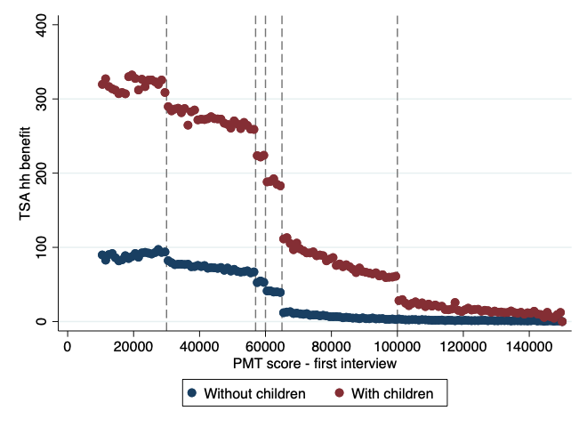 | 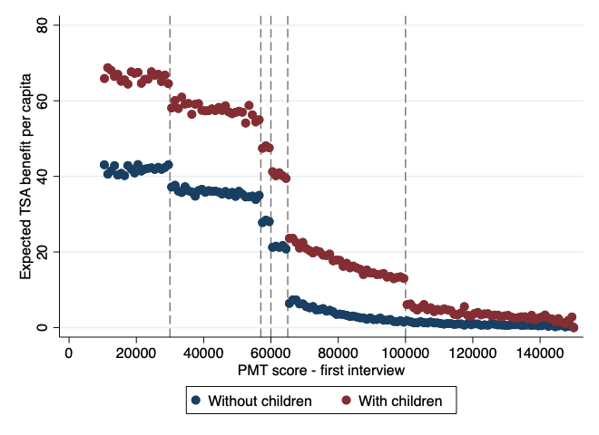
Total household benefit | Benefit per capita
Notes: PMT data from Georgian Social Services Agency. Bin size 1000 points.
Source: Econometria Consultores. 2020
We observed that the total benefits do change. Therefore, the differences in outcome variables for individuals just below and just above each cut-off is the result of households receiving a larger benefit when they have a score lower than the cut-off from the first interview.
Table 4.1 shows the size of the effect. The first panel shows that the probability of becoming a TSA beneficiary for a given group during the first interview increases around 50 pp. Additionally, the control group’s mean in this case represents the number of households which get to change their TSA benefit group by changing their PMT score. One can see that this probability is larger around the 65K cut-off (17% and 18% for households with and without children, respectively). The following is an example to better understand these estimates. On the one hand, imagine the households which have a score from the first interview between 59K to 60K. According to the programme’s design, these households are going to receive 40 GEL per member plus GEL 50 per child. On the other hand, the households whose first score was between just above 60K and below or equal to 61K should receive GEL 30 per member plus GEL 50 per child. According to our estimates, 15% of the households just above 60K and below or equal to 61K were able to change their score and after the second interview got a PMT lower than 60K and are now receiving GEL 40 per member plus GEL 50 per child.
The proceeding two panels show the change in the TSA benefit per capita around each cut-off. We focus on the results of the last panel (IV), which represents the change in the benefit for households which did not have a change in their score. This change would explain every other change in the outcome variables for the following analysis.

Table 4.1 - TSA estimated benefits around the cut-offs for households with and without children.
 | WITH CHILDREN |  |  |  | WITHOUT CHILDREN
 | 30K | 57K | 60K | 65K | 30K | 57K | 60K | 65K
TSA group | 0.570** | 0.618** | 0.544** | 0.538** | 0.522** | 0.571** | 0.637** | 0.475**
 | (0.017) | (0.042) | (0.053) | (0.040) | (0.016) | (0.031) | (0.034) | (0.030)
Control group mean | 0.108 | 0.138 | 0.156 | 0.172 | 0.071 | 0.076 | 0.042 | 0.184
Bandwidth | 10990.40 | 1903.98 | 906.03 | 2075.73 | 13659.96 | 1507.31 | 1079.91 | 1875.71
Effective N | 21684 | 4795 | 2250 | 5201 | 31190 | 6695 | 4807 | 8987
TSA benefit per capita (Reduced form) | 6,239** | 10,929** | 6,833⁺ | 17,953** | 5,319** | 5,827** | 8,808** | 12,495**
 | (1,402) | (2,903) | (2,920) | (2,433) | (1,025) | (1,507) | (1,577) | (1,295)
Control group mean | 57,508 | 45,157 | 40,451 | 21,413 | 38,159 | 28,546 | 20,159 | 8,851
Bandwidth | 10670.46 | 2341.85 | 1097.34 | 2381.16 | 12402.81 | 1846.85 | 1124.33 | 1939.35
Effective N | 21059 | 5871 | 2712 | 5953 | 28089 | 8223 | 5055 | 9276
TSA benefit per capita (IV estimate) | 11,805** | 17,925** | 12,419** | 33,479** | 10,186** | 11,331** | 13,594** | 26,322**
 | (2,891) | (3,707) | (3,445) | (2,919) | (1,737) | (1,874) | (1,915) | (1,338)
Control group mean | 56,816 | 45,168 | 41,321 | 21,397 | 38,149 | 28,230 | 20,453 | 8,850
Bandwidth | 7231.52 | 2465.77 | 1936.57 | 2202.22 | 13032.27 | 2463.72 | 1231.76 | 1949.14
Effective N | 14381 | 6197 | 4819 | 5528 | 29671 | 10912 | 5558 | 9328
Note: Standard errors clustered at municipality level in parentheses + p < 0.05, * p < 0.01, ** p < 0.001. Effective N is the number of observations within the optimal bandwidth as Calonico, Cattaneo, & Titijunik (2014)
Source: Econometria Consultores. 2020
The following paragraphs answer if these changes in income allow households to make better investments and increase their welfare. However, an alternative hypothesis in the literature argues that this transfer discourages work search or “visible” investments that increase income to not lose benefits.

Labour market participation, income, and incentives to work
The hypothesis of possible negative incentives of the TSA in the labour market is tested in the following. Information for all adults from the Governmental Income Database is used. From this data we can identify which individuals have a formal job and what their income is in that job. Biannual data from August 2018 to February 2020 is used.
Figure 4.2 shows how the probability of having a formal job and the average income correlate with the PMT. We observe how the probability of having a formal job is below 10%. However, for households with children from 57K the slope is positive and 65K for households without children. The behaviour of the household’s income per capita is the same. This may show that the incentives to look for a formal job differ for households with access to the TSA benefits and households without TSA benefits. Given that access to the TSA depends on poverty levels (measured by the PMT score), a household receiving the TSA benefits may reject a job offer or not look for a job because they may be afraid or losing their benefits if their income increases.

Figure 4.2 - Labour market outcomes by first interview PMT score
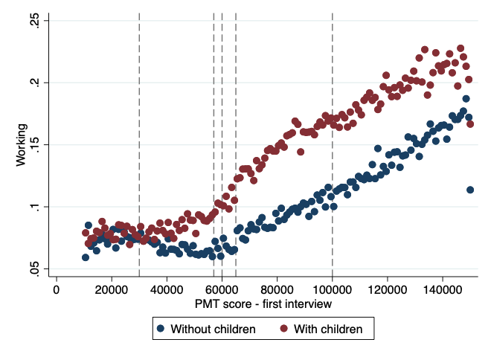 | 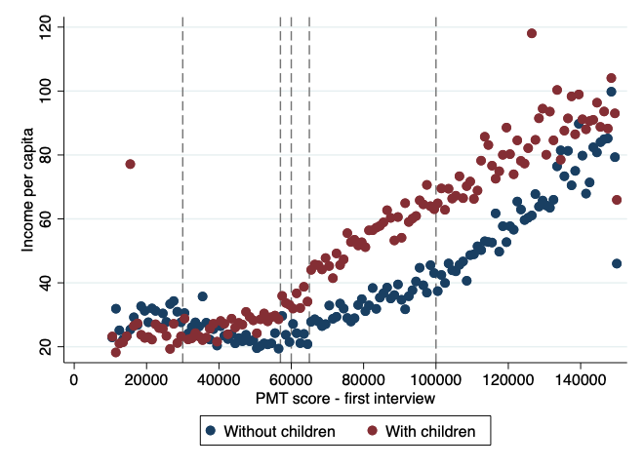
- Probability of having a formal job | - Formal labour income per capita
Notes: PMT data from Georgian Social Services Agency and Income data. Bin size 1000 points
Source: Econometria Consultores. 2020
Additionally, we test this hypothesis by estimating the effect of being a TSA beneficiary on labour market outcomes by cut-off. Figure 4.3 shows the resulting coefficients of such estimations. Tables 2.1 and 2.2 in Appendix 2 show all the coefficients including the results by gender. Following the previous figure, Panel A shows the probability of having a formal job drops by 6 pp for TSA beneficiaries just before the 65K cut-off for households with children. With respect to the participation rate of the control group (13%), this reduction represents a 50% drop. For households without children (Panel A) the reduction in participation in the formal labour market is larger around the 57K cut-off (4 pp); however, this reduction is not statistically significant. When we aggregate all adults within a household, the negative effects are not significant anymore (Panels C to F).

Figure 4.3 - FRD estimates for labour market outcomes
Probability of having a formal job
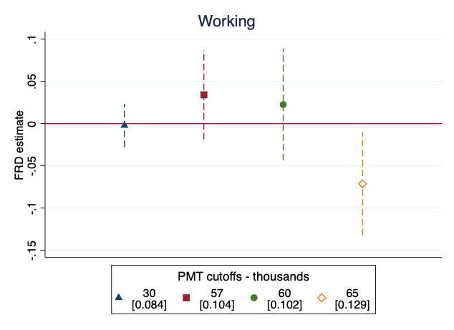 | 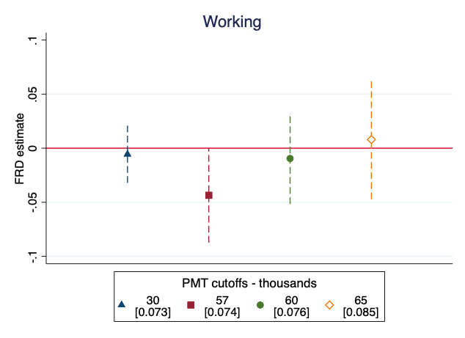
- Households with children | - Households without children
Probability of at least one adult from the households having a formal job
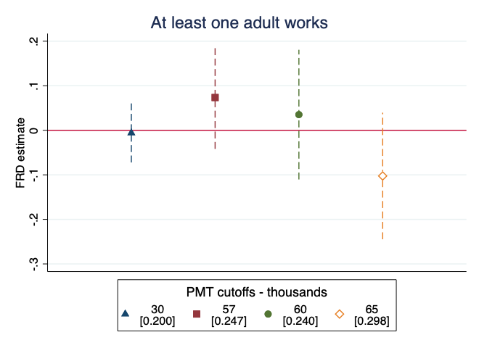 | 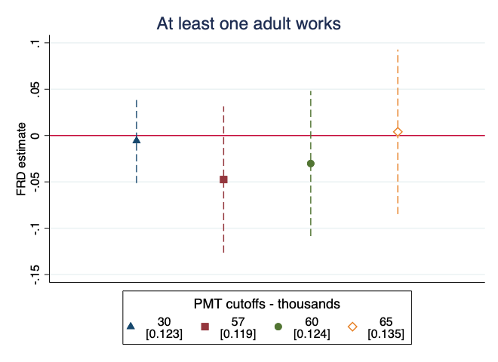
- Households with children | - Households without children
Formal labour household income per capita
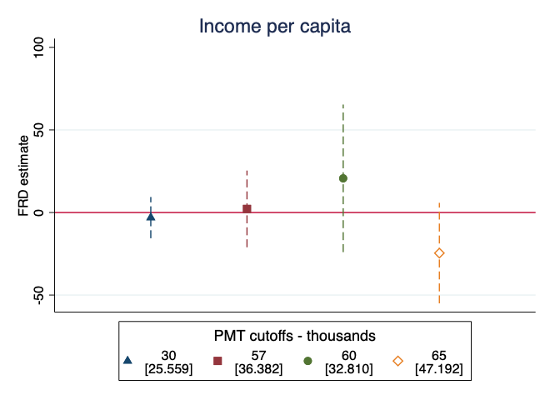 | 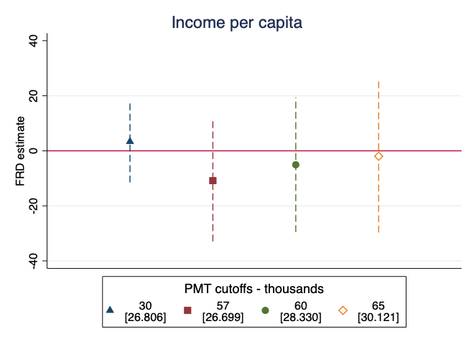
- Households with children | - Households without children
Notes: PMT data from Georgian Social Services Agency and Income data. All estimations following (Calonico, Cattaneo, & Titijunik, 2014)Control group average in squared brackets [ ]. Standard errors clustered at municipality level. Estimations control by month and region fixed effects.
Source: Econometria Consultores. 2020
Using the survey data, we can further investigate the effect of TSA on labour market outcomes for households with children, because we do not restrict our analysis to formal labour market participation. Figure 4.4 shows how participation in the labour force decreases by 5 pp at 57K. In addition, total employment reduces at 57K and 65K (Panel B), by 5 and 10 pp, respectively. Panel C and D compare informal and formal labour market participation. We observe that the effect at 65K is driven by formal labour market participation where the rate is 5 pp and significant. When we estimate the effect on informal labour market participation, we do not find any significant effects.

Figure 4.4 - FRD (IV) estimates for labour market outcomes for households with children
- Economically active population | - Employment rate
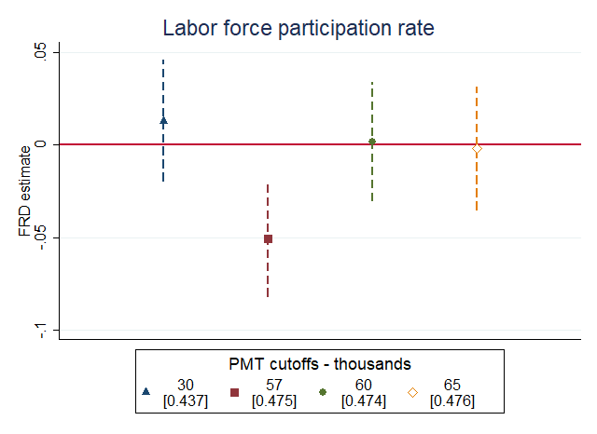 | 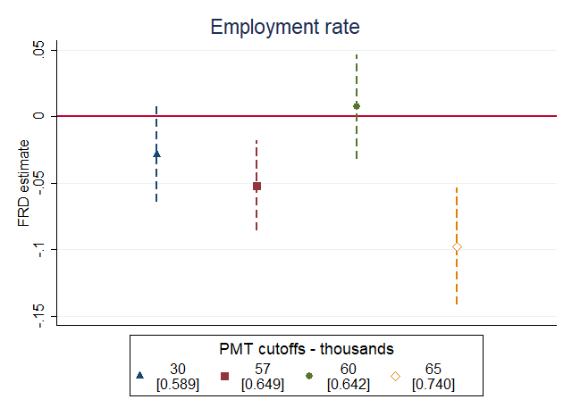
- Self-employment | - Employment with permanent contract
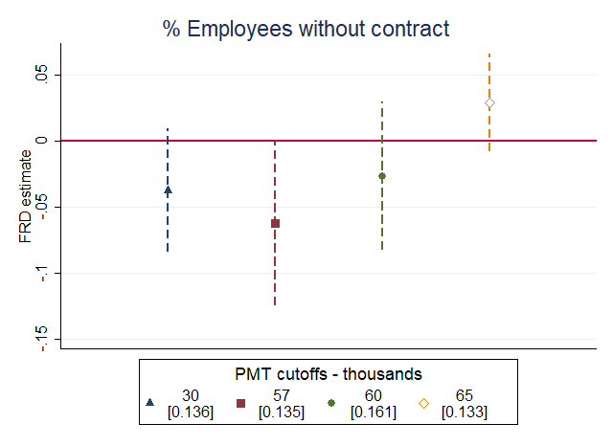 | 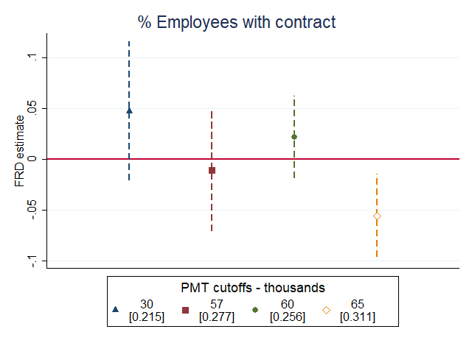
Notes: Household survey and PMT data from Georgian Social Services Agency. FRD estimates are IV estimations of being a TSA beneficiary using the discontinuity at each cut-off to instrument the TSA group as (Lee & Lemieux, 2010) Control group average in squared brackets [ ]. Estimates and standard errors using sample weights and the survey design.
Source: Econometria Consultores. 2020
We also find that the negative effects of participation in the labour market and the probability of having a contract are stronger for men, while there is no gender differences with respect to the negative effect we found on the employment rate (see Table 2.3 in Appendix 2).
Furthermore, we can analyse the effect of the TSA benefit over total household income. Figure 4.5 shows that when we only take into account the household income from their economic activities (excluding TSA) it reduces by GEL 120 for TSA beneficiaries around the 65K cut-off (Panel A). Even when the TSA benefits are added, the programme beneficiaries’ income is still GEL 100 less than the non-beneficiaries above the cut-off (Panel B).

Figure 4.5 - FRD (IV) estimates total income for households with children
- Monthly income (excluding TSA benefits) | - Monthly income
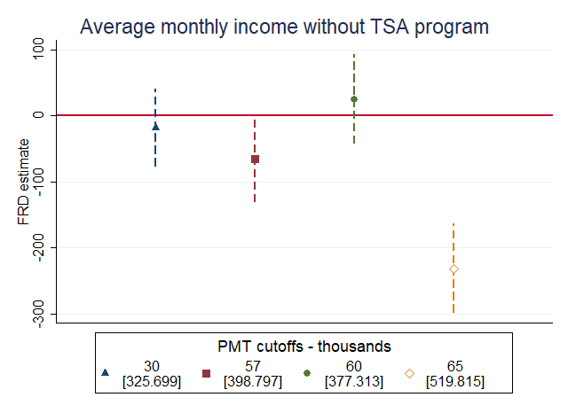 | 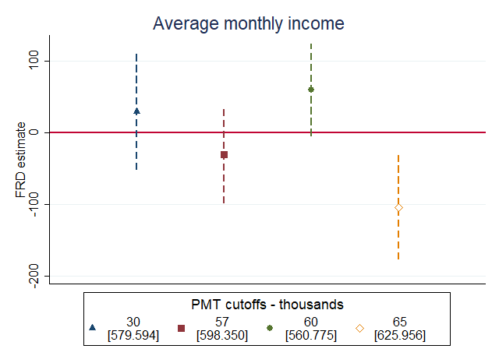
Notes: As per table 4.4
Source: Econometria Consultores. 2020
All these negative effects, especially around 65K, can be explained by the fact that once an individual finds a formal job and registers in the income database, the SA has the responsibility to reassess the household. Thus, if the formal job’s wage is below the benefit the household is receiving, the individual has no incentive to accept such job. Furthermore, in some cases even when the wage is larger than the expected benefit, the individual will only accept the job offer if the wage offer also covers their “value of leisure”. Therefore, when we add the benefit to the total income, there is a negative effect around 65K.

Expenditure
Given that we found a negative effect on income, this could mean a reduction on expenditure and/or household savings. Panel A in Figure 4.6 shows the negative effect on income, while Panel B shows a reduction in total expenditure, which is not statistically significant. It can be concluded that the effect on income is systematic while the adjustment in expenditure or savings is not. Some households reduce expenditure while some reduce savings.

Figure 4.6 - FRD (IV) estimates of TSA benefits on total income, expenditure and savings for households with children
A. Monthly income | B. Monthly expenditure
 | 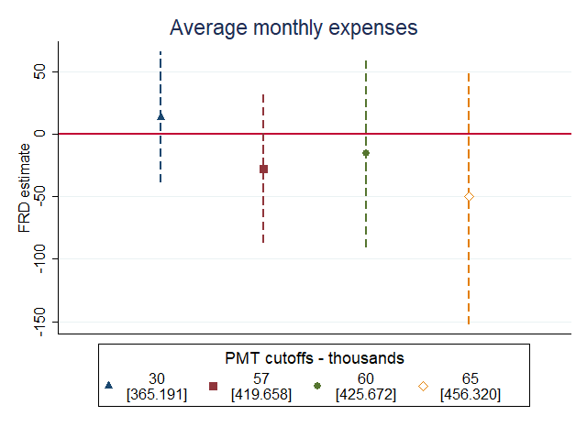
C. Monthly savings | D. Households with savings
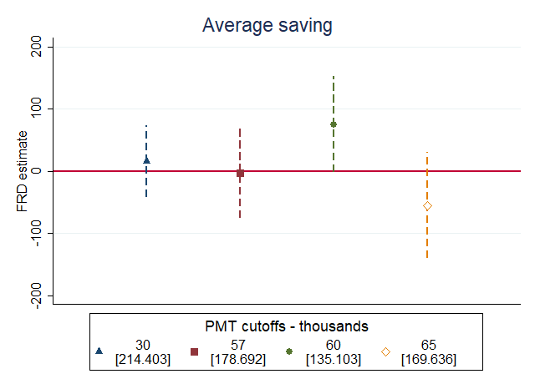 | 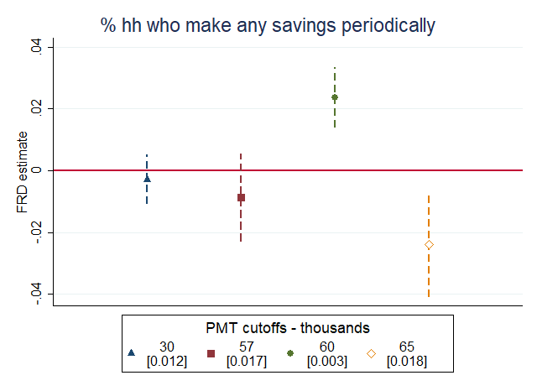
Notes: As per table 4.4
Source: Econometria Consultores. 2020
Afterwards we analyse if the exogenous change in income around the cut-offs changes the expenditure composition. Figure 4.7 shows instrumental variable (IV) estimates for the impact of each TSA group on the participation of different groups on total household expenditure. Some changes in expenditure composition were found. However, around 65K, the negative shock on income seems to reduce transport expenditure and other expenses such as clothing, leisure, and housing appliances. This could also be due to lower employment rates.

Figure 4.7 - FRD estimates of TSA benefits on expenditure composition for households with children
- Food inside the household | - Food outside the household
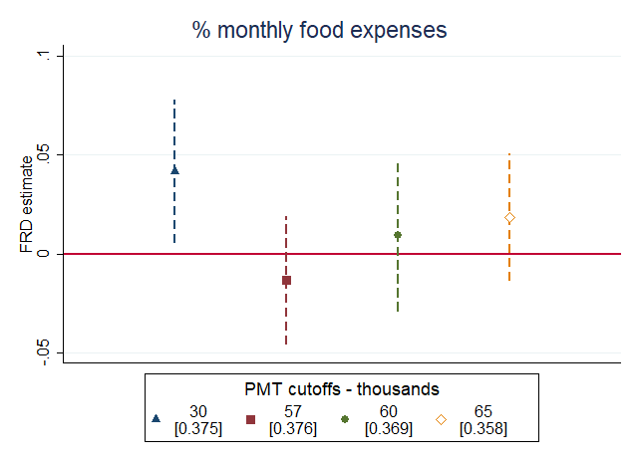 | 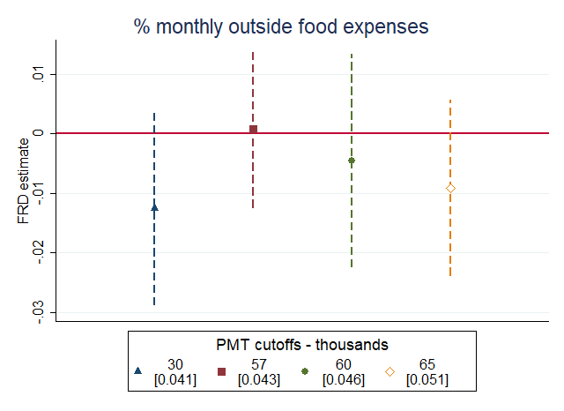
- Household expenses | - Health
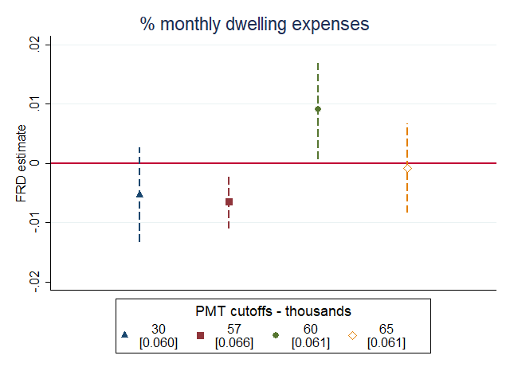 | 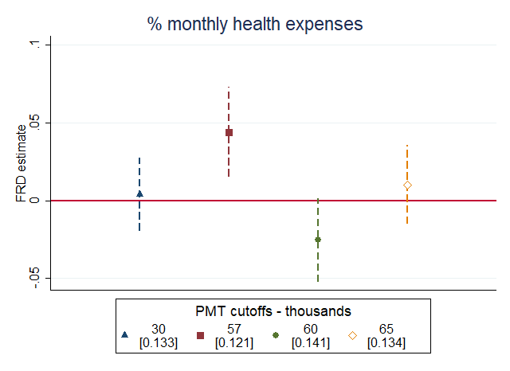
- Childcare | - Transport
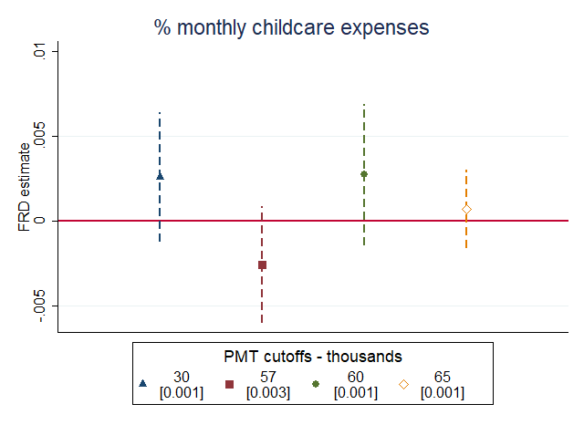 | 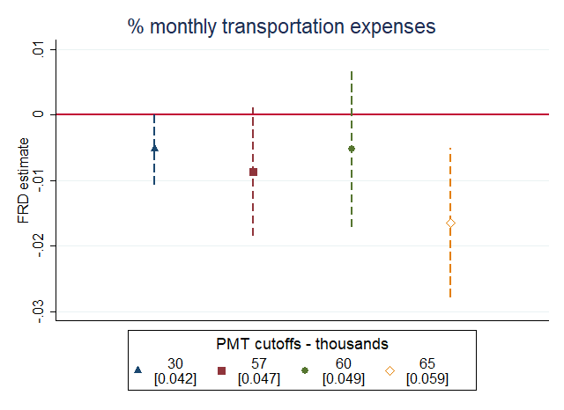
- Education | - Other
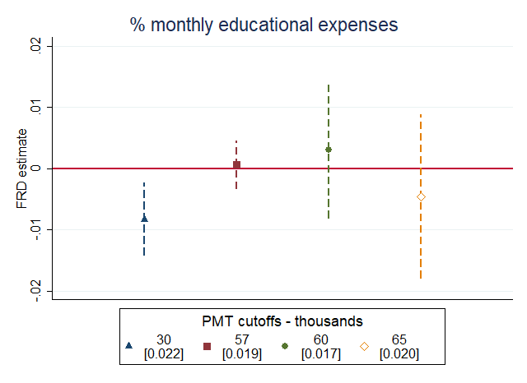 | 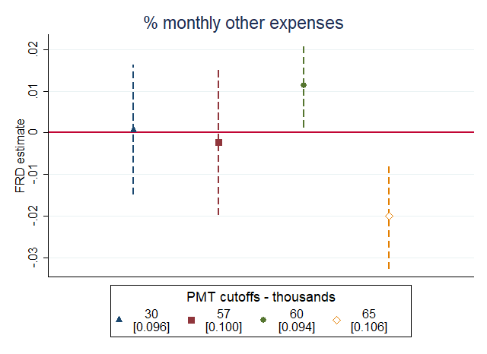
Notes: As per tables 4.4.
Source: Econometria Consultores. 2020

Education
For this analysis we divide the estimates by level while considering that education is compulsory from 6 to 16 years old (primary and secondary education). First, we use administrative data of enrolment and completion or withdrawal rates of individuals from 6 to 18 years old. The survey data is used to further understand some features that may affect the decisions related to education.
The effect the transfer may have on educational choices is once again twofold. On the one hand, the transfer can discourage human capital investments when households want to remain beneficiaries of the programme. On the other hand, the cash transfer reduces liquidity constraints allowing households to invest in human capital (Carneiro & Heckman, 2002).
It is important to note that in this analysis all households are eligible for the child benefit. Therefore, the estimates only represent the changes in the TSA benefit per household member around each cut-off.
Using survey data, we found some negative effects around 60K and 65K for children in primary school and upper-secondary school when looking at enrolment, respectively. When we use administrative data, the effects are still negative but they are not statistically significant anymore.

Figure 4.8 - FRD estimates of TSA benefits on education enrolment (September 2019) by age category and gender
All (survey data)
- 6 to 12 | - 13 to 16
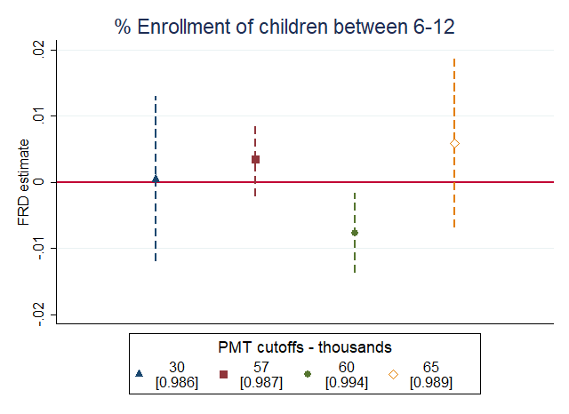 | 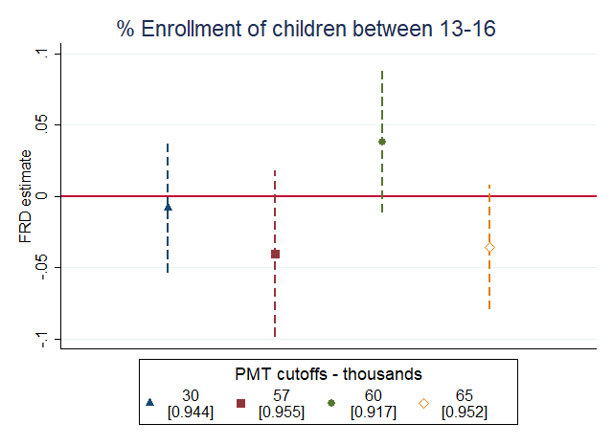
- 17 to 18
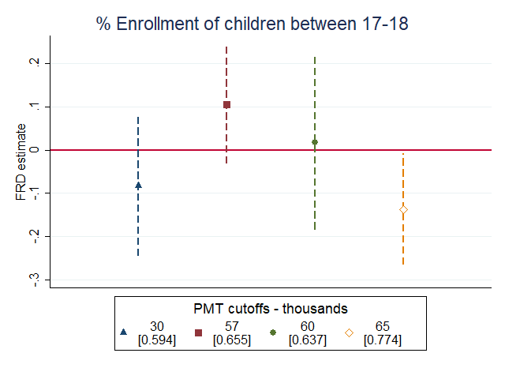

Girls
- 6 to 12 | - 13 to 16
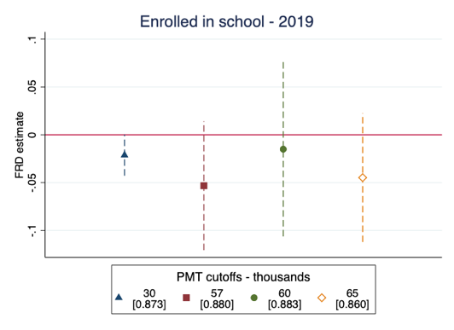 | 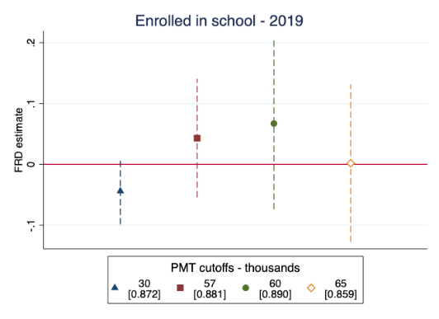
- 17 to 18
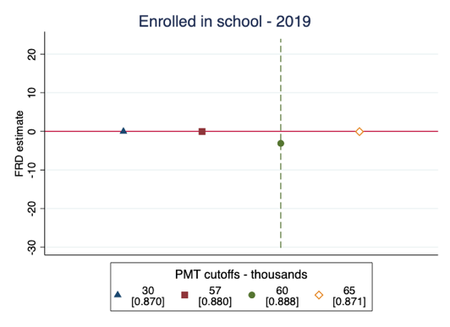

Boys
- 6 to 12 | - 13 to 16
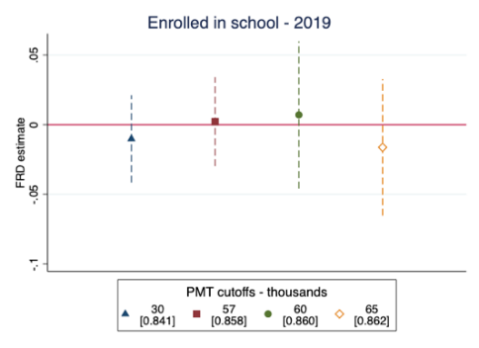 | 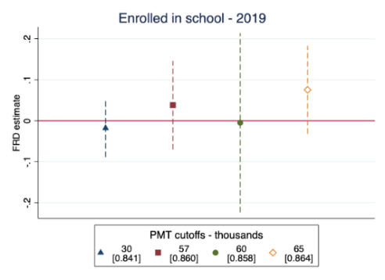
- 17 to 18
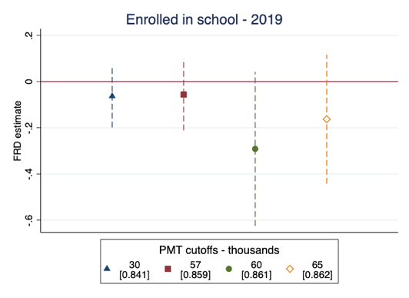
çNotes: As per tables 4.3 and 4.4. In addition al estimations from figures d to i Include fixed effects for the grade the child was enrolled in 2018.
Source: Econometria Consultores. 2020
We can also observe which individuals enrolled in 2018 successfully advanced to the next level of education. For primary education, we found that the probability of advancing to the next level is reduced by 3 pp for boys. The effect for girls is positive although it is not significant.

Figure 4.9 - FRD estimates of TSA impact on the probability to advance to the next level for individuals from 6 to 12 years old.
- Boys | - Girls
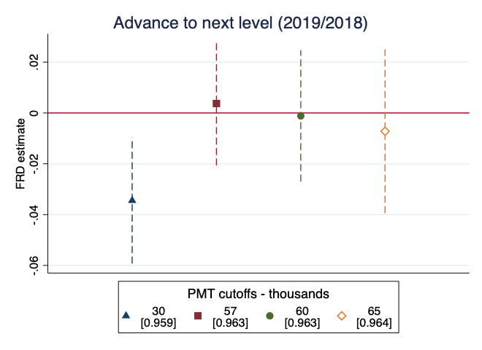 | 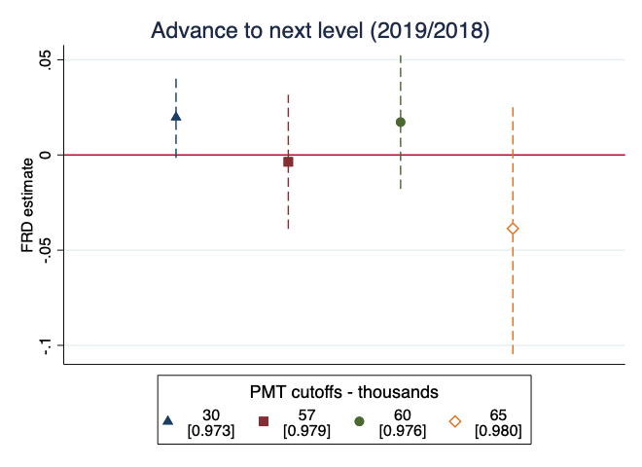
Notes: As per table 4.3 including fixed effects of the grade the child was enrolled in 2018
Source: Econometria Consultores. 2020
We also collected information from children finishing secondary education and their parents about their expected returns from obtaining a bachelor degree. First, we asked youths about how likely it is that they complete a bachelor’s degree. In general, we found that 65% of women and 40% of men think they will get a bachelor’s degree. Furthermore, we found a negative effect for women at 65K. The perceived success rate for women just above 65K, who are not eligible for GEL 30 per household member, is 77%. This perceived probability drops to 57% for women who are below 65K and are beneficiaries receiving GEL 30 per member. We also found a negative effect for men at 30K, which has a reduction of around 15 pp.
We also asked youths about their expected earnings upon completion of a bachelor’s degree. We then compute the expected earnings from obtaining bachelor degree. We find no differences around the cut-offs for women but for young men the expected earnings fall by GEL 395 at 30K, a 50% decrease. There is an increase of GEL 272 at 57K, a 36% increase. When we asked parents, the expected earnings are less than the ones reported by youths, but we do not find any significant change around the cut-offs.

Figure 4.10 - FRD estimates of TSA benefits on the expectations of university returns (youth’s from16 to 18)
Women
- Getting a bachelor’s degree – youth’s view | - Expected earnings from college – youth’s view
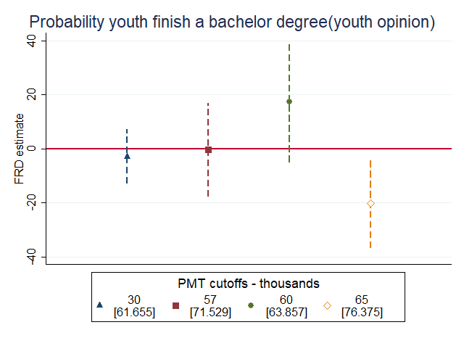 | 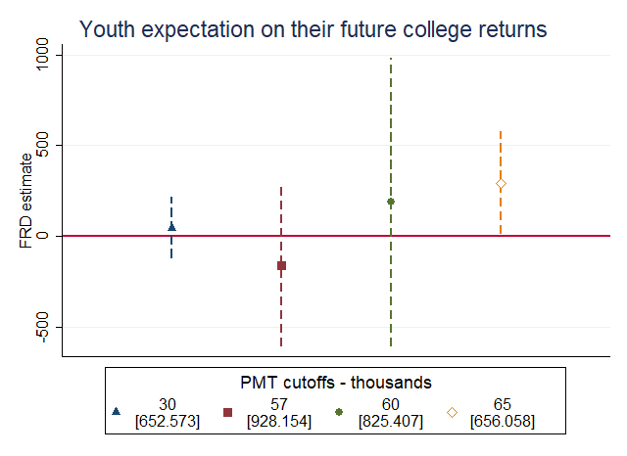
- Expected earnings from college – parent’s view
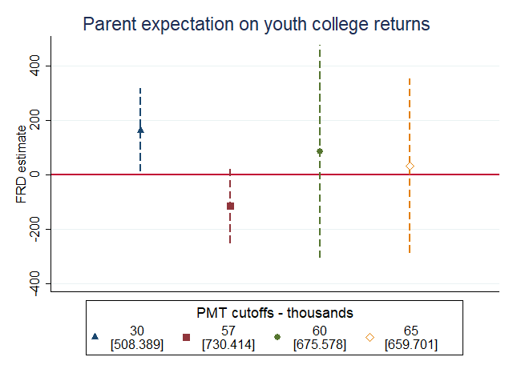

Men
- Getting a bachelor degree – youth’s view | - Expected earnings from college – youth’s view
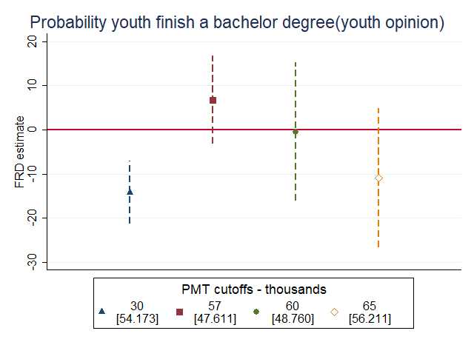 | 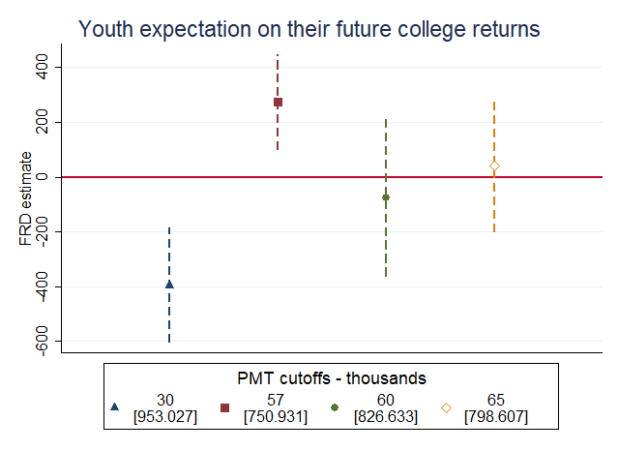
- Expected earnings from college – parent’s view
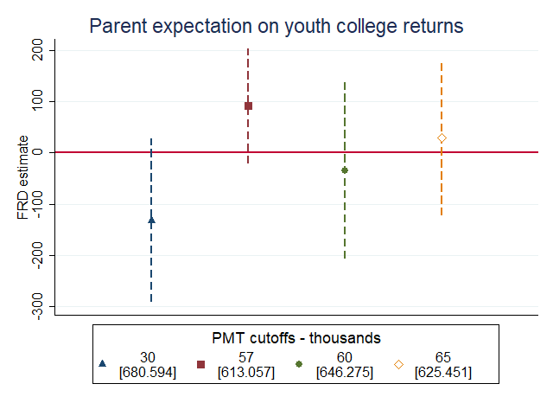
Notes: As per tables 4.3
Source: Econometria Consultores. 2020
Using administrative data, we looked at the enrolment and result of tertiary education for all adults from 18 to 25 years old. Figure 4.11 shows some significant positive effects, mostly for women. The probability of having a tertiary education degree increases by 10 pp (from 3% to 13%) at 57K. The probability of being currently enrolled in tertiary education increases 4 pp at 65K and the probability of dropping out from tertiary education is reduced by 16 pp at 30K. For men, the probability of being currently enrolled in tertiary education increases by 20 pp from a baseline of 13%.

Figure 4.11 - FRD estimates of TSA benefits on education enrolment (September 2019) by age category and gender
Women
- Has a degree | - Currently enrolled
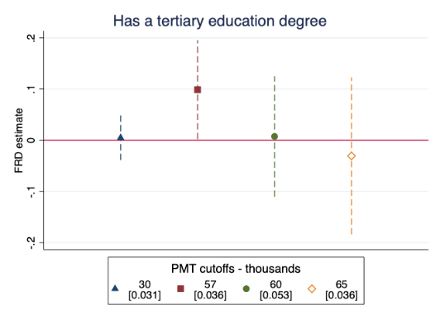 | 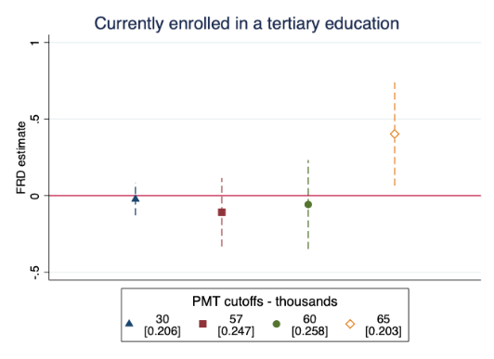
- Dropout
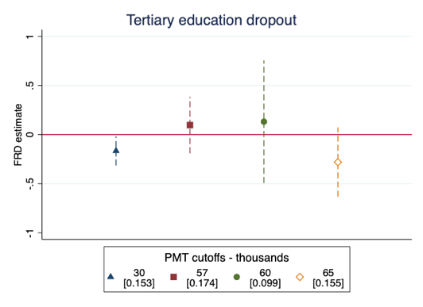

Men
- Has a degree | - Currently enrolled
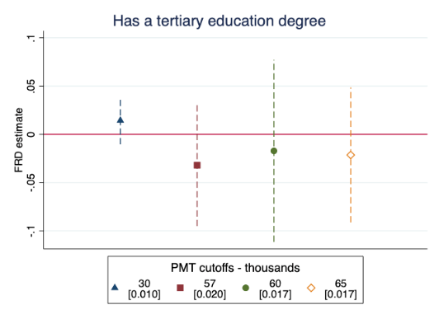 | 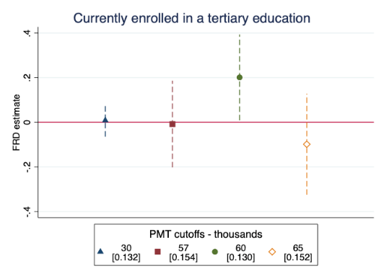
- Dropout
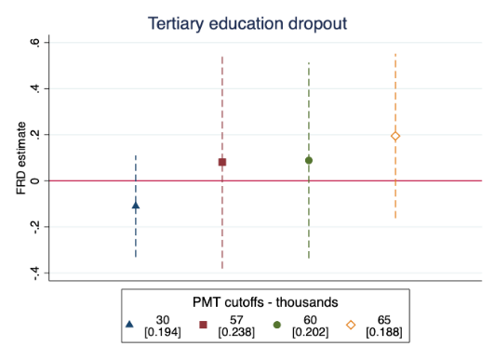

Notes: As per tables 4.3
Source: Econometria Consultores. 2020
The probability of having a university degree increases at 30K by 4 pp, which represents a 64% change. The proportion of individuals from 16 to 18 who do not want to study at university is reduced at 57K.

Health
Analysis begins by looking at children’s health. Using administrative records from the Ministry of Health, we check if children’s were up-to-date in their vaccinations shots and we do no significant changes around any cut-off. In addition, we checked the Tetanus-Diphtheria (TD) vaccination rates for teenagers and found large positive effect for women at the 57K cut-off. It is important to remember that at 57K some households also have access to medication expenses, which can be explaining this effect.

Figure 4.12 - FRD estimates of TSA benefits on some vaccines
Women
- Children with up-to-date vaccines | - TD (teenagers)
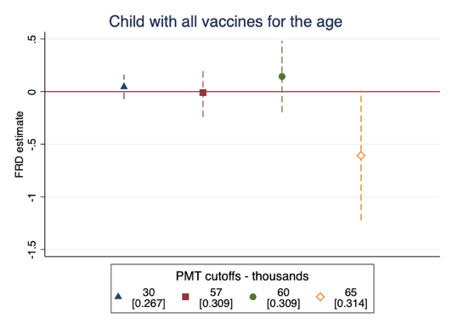 | 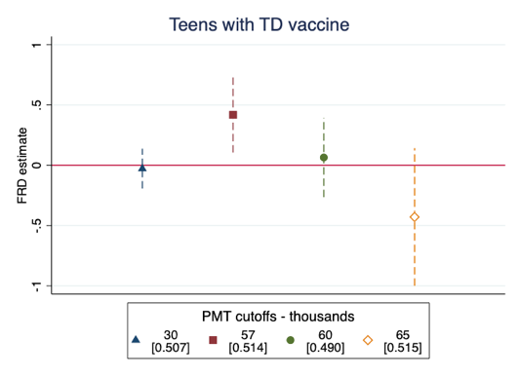
Men
- Children with up-to-date vaccines | - TD (teenagers)
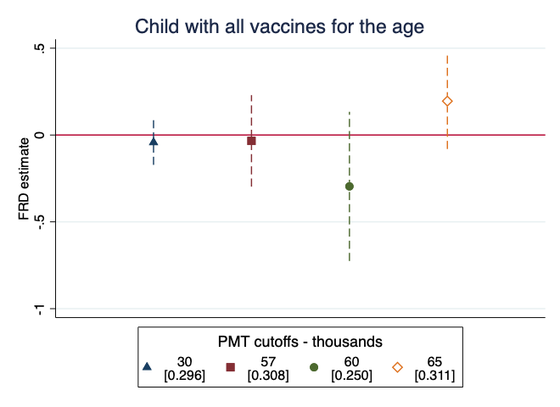 | 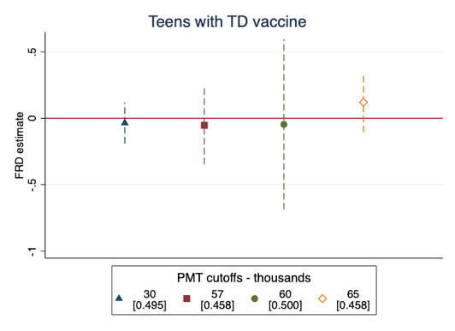
Notes: As per table 4.3
Source: Econometria Consultores. 2020
Using survey data, we checked to see if individuals knew of an available health centre close to their homes. We only found a small positive effect around 57K (0.5 pp with respect to a baseline of 99%).
We investigated if the benefits may modify fertility decisions due to the ambiguous effects of income shock. Using administrative data from pregnancy and birth registries for young women (14 to 25 years old), we tested changes in motherhood, pregnancy, and teenage pregnancy rates around the cut-offs. We divided the analysis by households with and without children and found no evidence of changes to the rates of any of these variables around any cut-off (Table 2.20 & 2.21. in Appendix 2).
We also examined how many women had a regular or sexual health check-up in the last year (Figure 4.13). We found that the probability of having had a health check increases at 57K for households with children and at 60K for households without children. The effect of the extra GEL 10 per person increases the probability of attending a regular health check by 31 pp for households with children at 57K (the baseline is 46%). For women in households without children at 60K, the effect of the extra GEL 10 GEL is an increase of 63 pp (from a baseline of 33%). Finally, we find no effects regarding sexual health check-ups in the last year.

Figure 4.13 - FRD estimates of TSA impact on the use of health services for women from 14 to 25 years old.
Health check-ups
- Household with children | - Household without children
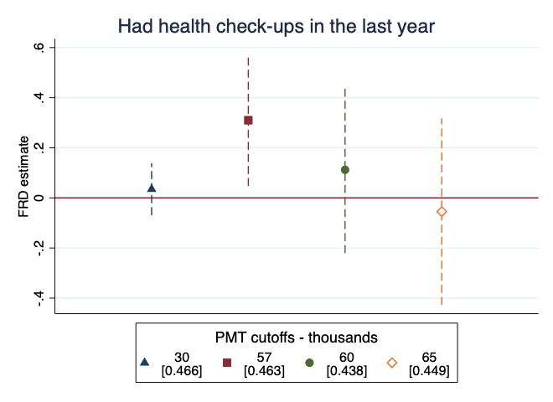 | 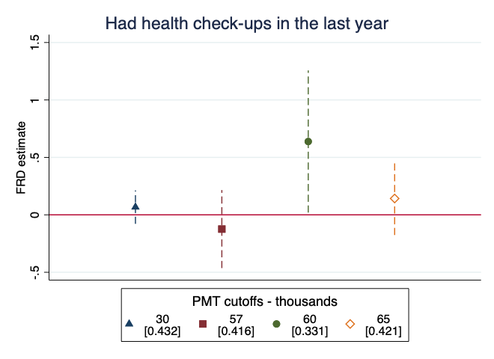
Sexual health check-ups
- Household with children | - Household without children
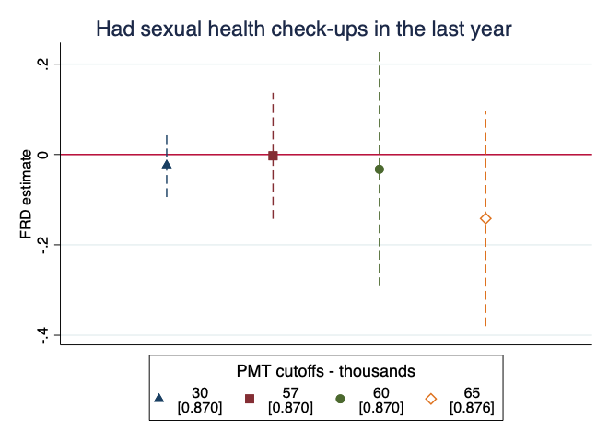 | 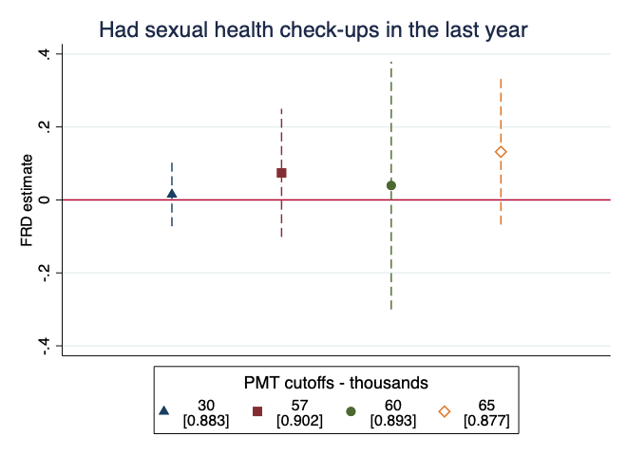
Notes: As per table 4.3 including age fixed effects
Source: Econometria Consultores. 2020
We also used survey data from mothers on the birthweight of their last child born if less than 6 years old. Around 60K, the proportion of mothers who reported their last child was underweight at birth falls 4.2 pp from a 9.5% baseline. We also investigate possible effects on pregnant women’s healthy behaviour and found that at 30K the probability of having an antenatal visit falls by 27 pp from a baseline of 100%. This contradicts the positive effects of an income shock but may be explained by the fear of being reassessed by the SA. Changes in household composition are one of the reasons for computing the PMT score again (see the resulting coefficients in Table 2.22 in Appendix 2). However, we do not have enough evidence on this.
Lastly, we asked heads of household about the general health status of the family. Figure 4.14 shows the effect of the TSA on health perceived to be bad or very bad. When the head of household is a women, the perception of bad health rises by approximately 10 pp for all cut-offs, except 60K. At 60K, the perception of poor health falls by 10 pp. For households with male heads, a perception of better health only occurs around 30K (a reduction of 7 pp). Around 65K we found an increase of 6 pp (from 10% baseline), on the proportion of households that feel their health is bad or very bad.

Figure 4.14 - FRD estimates of TSA impact on the perceive health status by gender of the household head for households with children.
- Female household head | - Male household head
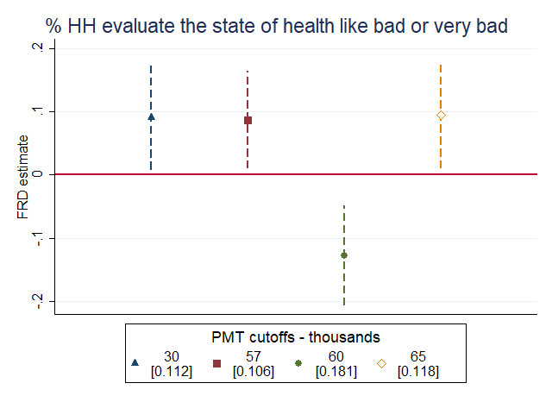 | 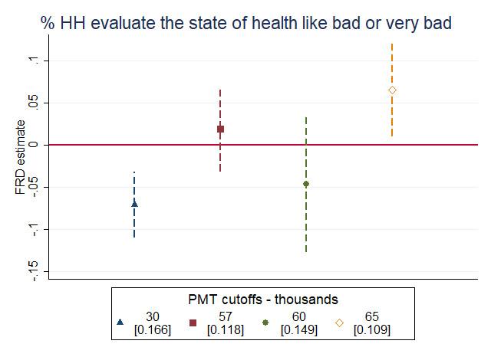
Notes: As per table 4.3
Source: Econometria Consultores. 2020

Childhood development
We have already shown some indicators regarding children, primary education and general health. In this section we describe the impacts focused on two types of effects, alimentation, and healthy behaviour and activities.

Figure 4.15 - FRD estimates of TSA impact on children’s alimentation.
Girls
- % breastfed (under 2 y.o.) | - % properly fed (under 2 y.o.)
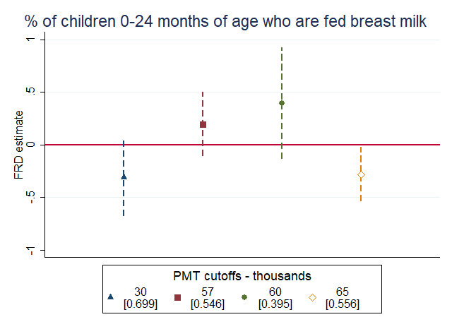 | 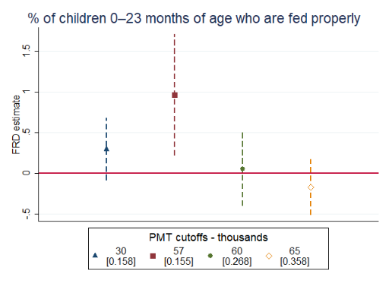
- % eat vegetables (under 6 y.o.) | - % eat meat (under 6 y.o.)
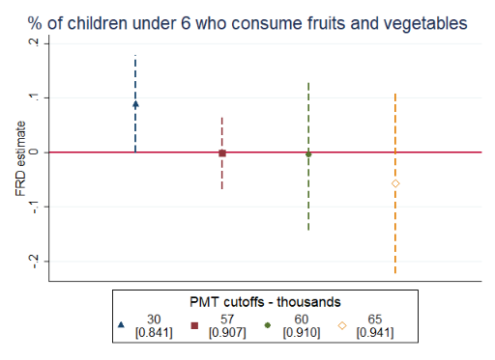 | 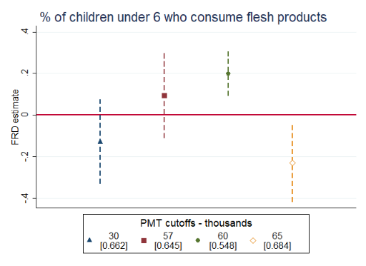
- % eat diary (under 6 y.o.)
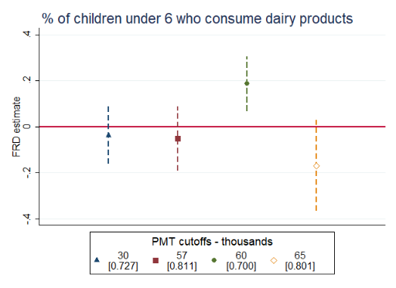

Boys
- % properly fed (under 2 y.o.) | - % eat vegetables (under 6 y.o.)
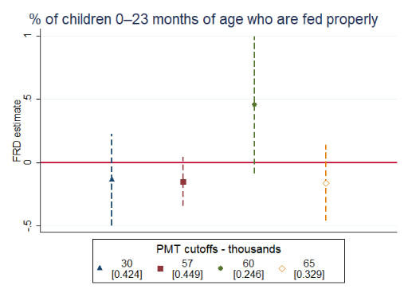 | 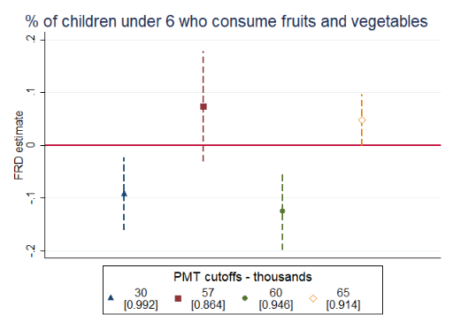
- % eat meat (under 6 y.o.) | - % eat dairy (under 6 y.o.)
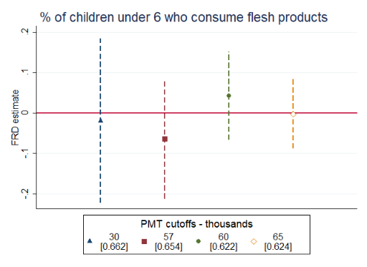 | 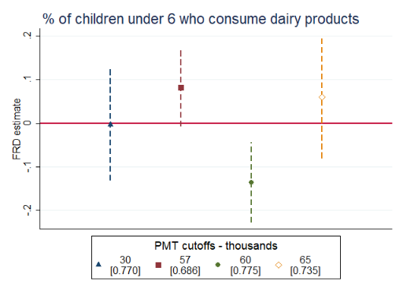
Notes: As per table 4.3
Source: Econometria Consultores. 2020
Figure 4.15 summarises the main results on child alimentation. Panel A shows a 50% reduction at 65K on breastfeeding of children younger than 2 years old (28 pp). In addition, we found a positive effect in the proportion of mothers who reported their girls are properly fed at 57K. There was no change for boys.
We also checked the proportions of boys and girls who ate vegetables, fruits, meat, and dairy products and find important differences by gender. While the proportion of girls that consumed meat and dairy increased at 57K, the proportion of boys consuming fruits and dairy decreased. We also found a statistically significant reduction in fruit and vegetable consumption at 30K for boys.
Figure 4.16 shows the main results regarding some activities. For girls we only found a small increase in the proportion who practice any type of sport at 30K. For boys, we found interesting results. On one hand, at 60K we found a reduction in the time adults spent with their children, which goes together with a reduction in the proportion of kids who practiced a sport. On the other hand, at 65K, the time adults spent with children rose for TSA beneficiaries, which was coupled with a higher probability of boys practicing a sport. The results at 65K can be the result of lower labour market participation caused by the TSA.

Figure 4.16 - FRD estimates of TSA impact on children’s healthy activities.
Girls
- Hours with an adult | - Proportion who practice a sport
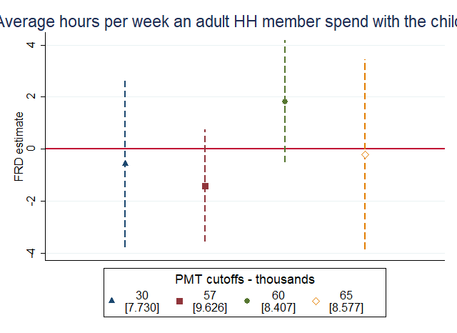 | 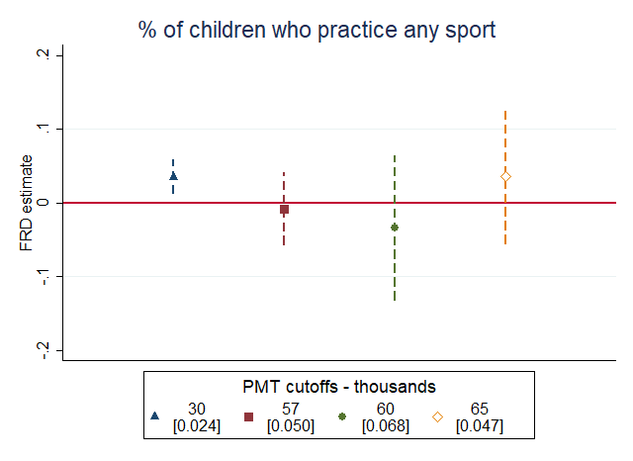
Boys
- Hours with an adult | - Proportion who practice a sport
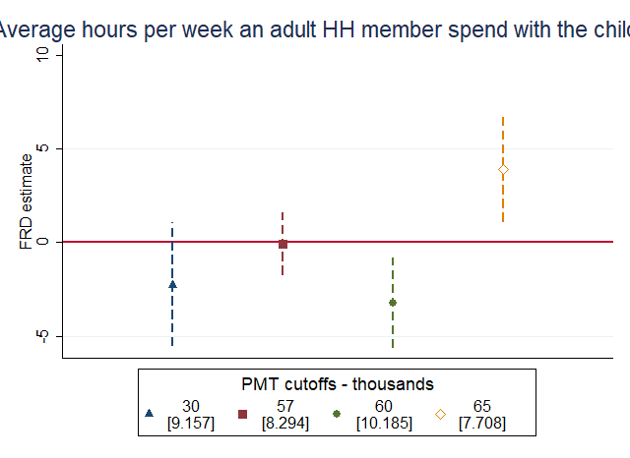 | 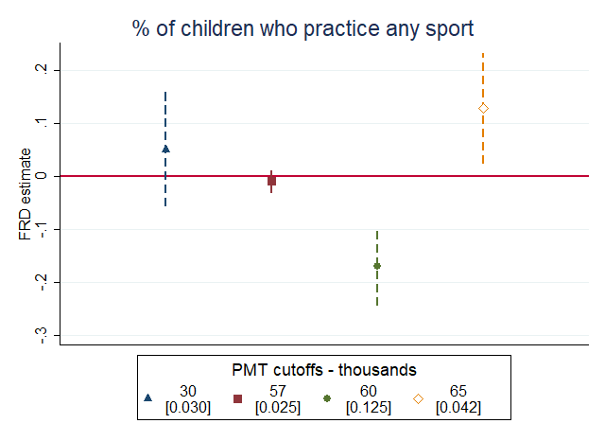
Notes: As per table 4.3
Source: Econometria Consultores. 2020

Poverty
The analysis concludes by measuring possible impacts in household poverty. We have found negative effects regarding labour market participation and income, mostly at 65K. Panel A in Figure 4.17 shows that at 65K the TSA represented almost half of the household income. Just after 65K, the TSA comprised 22% of total income, a drop. There was an increase in the participation of other social assistance in total income at 57K of 2 pp that was different from PMT. We asked households what other assistance they receive and found that this discontinuity comes from a jump in receiving other municipality assistance, from 4% to 6%. This effect may be negligible because all other social assistance does not add up to 10% of total income while the TSA represents close to 40% of the total income.

Figure 4.17 - FRD estimates of TSA impact on the probability to advance to the next level for individuals from 6 to 12 years old.
- TSA participation | - Other social assistance participation
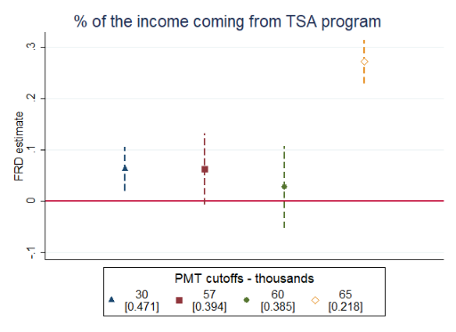 | 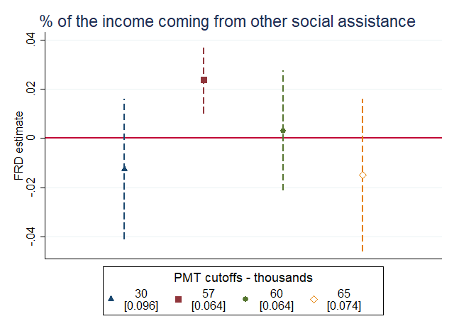
- All social assistance participation
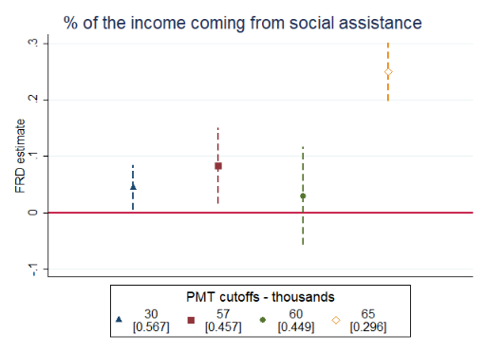
Notes: As per table 4.3
Source: Econometria Consultores. 2020
No positive impacts for multidimensional poverty were found. However, the poverty index increased by 3 pp, a 10% increase, at 65K when the head of household head was a woman. At 60K, the probability of being poor by MPI standards also increased.

Figure 4.18 - FRD estimates of TSA impact on multidimensional poverty by household head’s gender
Female household head
- MPI | - Poor by MPI
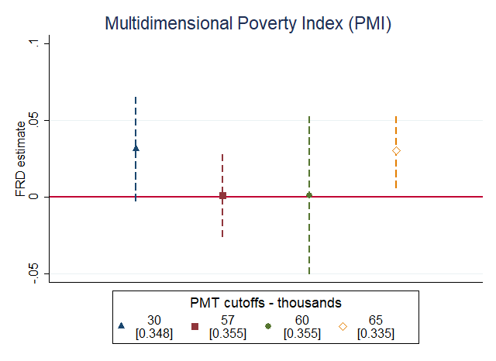 | 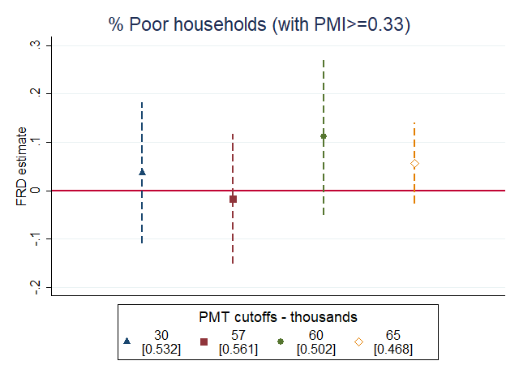
Male household head
- MPI | - Poor by MPI
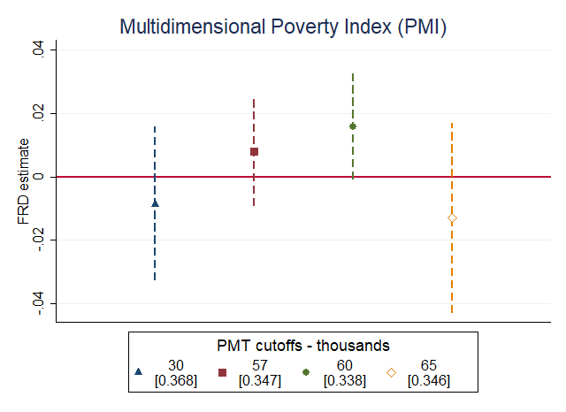 | 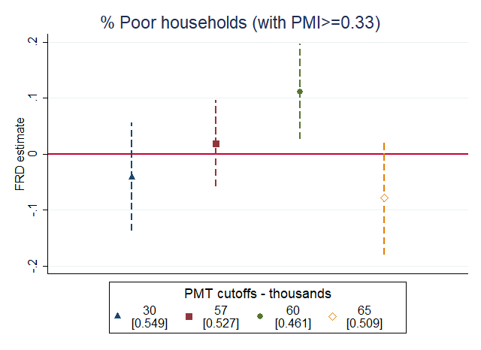
Notes: As per table 4.3
Source: Econometria Consultores. 2020

VOUCHER vs CASH? - Experimental study
There is little rigorous evidence comparing food assistance via cash or food voucher. This study implemented an experimental trial to measure the differentiated effects between a food voucher, which is only able to be spent in certain shops, and a cash transfer. We randomly assigned municipalities to 4 different arms:
- Arm 1 (Voucher + Message): Households received GEL 20 cash and a GEL 30 voucher. Additionally, they received a message(s) reminding them that GEL 50 are benefits to be used for children.
- Arm 2 (Cash + Message): Households received GEL 50 cash. Additionally, they received a message(s) reminding them that GEL 50 are benefits to be used for children.
- Arm 3 (Voucher): In these municipalities, the implementation continued as planned and households with children received GEL 20 in cash and GEL 30 per child on a food voucher.
- Arm 4 (Cash Only): In these municipalities, households received the new child benefit amount of GEL 50 per child in cash.
To ensure that randomisation was successful, we compared baseline characteristics across households that received a voucher, households that only received cash, and households that received a message(s). We did not find differences in the variables at baseline (Appendix 3).
The analysis’ focus was on households that were TSA beneficiaries; however, we show the results for total households in Appendix 4. Therefore, our estimates recover the average treatment on the treated (ATT), while the analysis in Appendix 3 shows the intention to treat estimate (ITT).
Once again, we estimate the impact using the following equation:
$$Y= β_{0}+β_{1}V+β_{2}M+ β_{3}VM+ε$$

Income and savings
The analysis begins by comparing the impact of vouchers on household income and savings. Table 4.2 shows the resulting coefficients for a series of income outcomes. We also test the hypothesis that $β_{1}+ β_{2}+ β_{3}=0$ to show if the arm that received the voucher and the message is different than the arm with cash only.
We found the food voucher does not increase the average monthly income with or without the TSA programme. We found a significant increase on average monthly savings is seen when the voucher is used. However, when the household also received the message, the effects cancelled one another out.

Table 4.2 - Comparison impact of food voucher, messages and cash transfer in TSA on income and savings
 | VOUCHER | MESSAGE | VOUCHER  MESSAGE | CONSTANT | F
Average monthly income | 15.026 | -25.515 | -7.619 | 576.93 | 0.179
Average monthly income | (39.480) | (21.219) | (57.315)
Number of observations | 3626 | 3626 | 3626
Average monthly income without TSA program | -11.751 | -36.989 | 22.825 | 348.043 | 0.528
Average monthly income without TSA program | (32.903) | (21.272) | (47.507)
Number of observations | 3626 | 3626 | 3626
% of households that save periodically | -0.002 | -0.003 | 0.009 | 0.011 | 0.077
% of households that save periodically | (0.010) | (0.009) | (0.013)
Number of observations | 3626 | 3626 | 3626
Average savings | 106.091* | 24.900 | -120.768+ | 151.585 | 0.077
Average savings | (35.509) | (31.545) | (53.894)
Number of observations | 3626 | 3626 | 3626
Significance level + 0.05 * 0.01 ** 0.001. Standard errors in parenthesis clustered at municipality level. Tbilisi is not included. F test of sum of B1+B2+B3 = 0.
Source: Econometría Consultores

Expenditure
Table 4.3 shows that the voucher does not increase average monthly expenses. Conversely, total expenditures decreased by GEL 91 when the household had the voucher. The policy’s aim is to increase food expenditure when the voucher is used. However, we did not find differences between the two alternatives when analysing the participation different expenses on the total expenditure. We did find a reduction in food expenditure when the household received the message(s) by 12 pp.
The share of educational expenses over the total expenses increased when the household received a message. This effect complements the objective of the SMS. The increase of 1.2 pp, though small, represents twice the rate of participation with respect to the control group.
In addition, the voucher and the message do not complement each other but instead cancel one another out.

Table 4.3 - Comparison impact of food voucher, messages and cash transfer in TSA on expenditure
 | VOUCHER | MESSAGE | VOUCHER  MESSAGE | CONSTANT | F
Average monthly expenses | -91.066+ | -50.416 | 113.149+ | 425.345 | 1.059
Average monthly expenses | (35.736) | (35.294) | (49.523)
Number of observations | 3626 | 3626 | 3626
% monthly food expenses | -0.060 | -0.120+ | 0.133+ | 0.435 | 1.531
% monthly food expenses | (0.039) | (0.047) | (0.056)
Number of observations | 3626 | 3626 | 3626
% monthly outside food expenses | -0.004 | 0.015 | -0.005 | 0.04 | 0.319
% monthly outside food expenses | (0.010) | (0.016) | (0.017)
Number of observations | 3626 | 3626 | 3626
% monthly educational expenses | 0.004 | 0.012+ | -0.007 | 0.013 | 6.171+
% monthly educational expenses | (0.004) | (0.006) | (0.007)
Number of observations | 3626 | 3626 | 3626
% monthly health expenses | 0.020 | 0.050* | -0.062+ | 0.128 | 0.272
% monthly health expenses | (0.018) | (0.014) | (0.024)
Number of observations | 3626 | 3626 | 3626
% monthly housing expenses | -0.002 | 0.007 | -0.003 | 0.064 | 0.070
% monthly housing expenses | (0.011) | (0.008) | (0.012)
Number of observations | 3626 | 3626 | 3626
% monthly transportation expenses | 0.011 | 0.014 | -0.014 | 0.039 | 1.663
% monthly transportation expenses | (0.008) | (0.013) | (0.015)
Number of observations | 3626 | 3626 | 3626
% monthly childcare expenses | 0.001 | 0.000 | -0.001 | 0 | 0.436
% monthly childcare expenses | (0.001) | (0.000) | (0.001)
Number of observations | 3626 | 3626 | 3626
% monthly other expenses | 0.014 | 0.015 | -0.007 | 0.095 | 2.293
% monthly other expenses | (0.010) | (0.015) | (0.020)
Number of observations | 3626 | 3626 | 3626
Significance level + 0.05 * 0.01 ** 0.001. Standard errors in parenthesis. -Tbilisi is not included
Source: Econometría Consultores

Consumption
Although the amount of money spent on food is similar across treatment arms, the types of food bought may differ. No difference in the types of food purchased was found. We alsoi discovered that if a household received a message to use the benefit on children, consumption behaviour does not change (Table 4.4.).

Table 4.4 - Comparison impact of food voucher, messages and cash transfer in TSA on food consume
 | VOUCHER | MESSAGE | VOUCHER  MESSAGE | CONSTANT | F
% food expenses in other products | 0.015 | 0.014 | -0.034 | 0.085 | 0.068
% food expenses in other products | (0.022) | (0.021) | (0.031)
Number of observations | 3188 | 3188 | 3188
% food expenses in Non-alcoholic beverages | 0.016 | 0.007 | -0.029 | 0.08 | 0.059
% food expenses in Non-alcoholic beverages | (0.018) | (0.021) | (0.035)
Number of observations | 3188 | 3188 | 3188
% food expenses in Fruits and vegetables | -0.016 | 0.014 | 0.055 | 0.099 | 2.516
% food expenses in Fruits and vegetables | (0.022) | (0.029) | (0.042)
Number of observations | 3188 | 3188 | 3188
% food expenses in Milk and dairy products | -0.008 | -0.011 | 0.010 | 0.098 | 0.139
% food expenses in Milk and dairy products | (0.021) | (0.023) | (0.029)
Number of observations | 3188 | 3188 | 3188
% food expenses in Fats and oils | -0.005 | 0.009 | -0.009 | 0.13 | 0.029
% food expenses in Fats and oils | (0.019) | (0.018) | (0.031)
Number of observations | 3188 | 3188 | 3188
% food expenses in bakery products | -0.015 | -0.071 | 0.010 | 0.447 | 3.466
% food expenses in bakery products | (0.047) | (0.037) | (0.064)
Number of observations | 3188 | 3188 | 3188
Significance level + 0.05 * 0.01 ** 0.001. Standard errors in parenthesis. - Tbilisi is not included
Source: Econometría Consultores

Prices
Previous literature shows that the use of food vouchers may have an effect on prices due to an exogenous increase in the demand of certain goods, especially when competition among food stores is poor. The voucher’s effects on the prices of some products were subsequently examined. There was no available information from shops on prices but households reported purchase prices. We found little evidence about the negative externality of prices (Table 4.5). A reduction of sugar and sausage prices was seen but no other items demonstrated a price increase.

Table 4.5 - Comparison impact of food voucher, messages and cash transfer in TSA on food prices
 | VOUCHER | MESSAGE | VOUCHER  MESSAGE | CONSTANT | F
Price for a kilo of sugar | -0.133* | -0.044 | 0.028 | 1.765 | 12.906*
Price for a kilo of sugar | (0.040) | (0.044) | (0.057)
Number of observations | 2735 | 2735 | 2735
Price for a litter of Sunflower oil | -0.092 | 0.019 | 0.038 | 3.522 | 0.152
Price for a litter of Sunflower oil | (0.094) | (0.069) | (0.118)
Number of observations | 2545 | 2545 | 2545
Price for a kilo of apple | -0.060 | -0.202 | 0.392+ | 1.492 | 1.912
Price for a kilo of apple | (0.132) | (0.123) | (0.164)
Number of observations | 856 | 856 | 856
Price for a kilo of potatoes | 0.044 | 0.023 | -0.036 | 0.958 | 0.506
Price for a kilo of potatoes | (0.049) | (0.043) | (0.057)
Number of observations | 2035 | 2035 | 2035
Price for an egg | 0.006 | -0.001 | -0.010 | 0.308 | 0.626
Price for an egg | (0.010) | (0.007) | (0.012)
Number of observations | 1766 | 1766 | 1766
Price for a liter of matsoni | 0.643 | 0.216 | -0.047 | 2.254 | 6.113+
Price for a liter of matsoni | (0.326) | (0.319) | (0.469)
Number of observations | 621 | 621 | 621
Price for a kilo of butter | -0.915 | -0.344 | 0.320 | 9.994 | 2.420
Price for a kilo of butter | (0.612) | (0.652) | (0.820)
Number of observations | 1712 | 1712 | 1712
Price for a kilo of sausage | -1.347+ | -0.204 | 0.675 | 8.823 | 2.265
Price for a kilo of sausage | (0.624) | (0.612) | (0.850)
Number of observations | 797 | 797 | 797
Price for a kilo of chicken | -0.043 | -0.474 | 0.686 | 6.873 | 0.136
Price for a kilo of chicken | (0.498) | (0.586) | (0.731)
Number of observations | 802 | 802 | 802
Price for a kilo of macaroni | -0.032 | 0.099 | 0.014 | 1.85 | 1.629
Price for a kilo of macaroni | (0.087) | (0.062) | (0.114)
Number of observations | 2188 | 2188 | 2188
Price for a kilo of flour | 0.042 | -0.012 | 0.019 | 1.147 | 2.275
Price for a kilo of flour | (0.034) | (0.024) | (0.041)
Number of observations | 1576 | 1576 | 1576
Price for a kilo of bread | 0.236 | 0.075 | -0.393 | 1.51 | 0.356
Price for a kilo of bread | (0.151) | (0.170) | (0.204)
Number of observations | 1689 | 1689 | 1689
Significance level + 0.05 * 0.01 ** 0.001. Standard errors in parenthesis. - Tbilisi is not included
Products with more 500 observations included. In Appendix 5 includes every product
Source: Econometría Consultores

Health and childhood development
The impact of food vouchers and messages on household practices for children under 6 years old was analysed. As a result, we found that the voucher does not improve children’s food and health assistance compared to cash transfers. We did find a small reduction in the proportion of children who consume dairy products, but the effect ceases when the household also receives the message.

Table 4.6 - Comparison impact of food vouchers, messages and cash transfers in TSA on child health
 | VOUCHER | MESSAGE | VOUCHER  MESSAGE | CONSTANT | F
% of children under 6 who have a medical centre to go | 0.006 | 0.011 | -0.024 | 0.988 | 0.163
% of children under 6 who have a medical centre to go | (0.009) | (0.009) | (0.017)
Number of observations | 2156 | 2156 | 2156
% of children under 6 who up to date on shots | 0.002 | 0.005 | -0.001 | 0.941 | 0.032
% of children under 6 who up to date on shots | (0.031) | (0.034) | (0.045)
Number of observations | 2154 | 2154 | 2154
% of children under 6 who consume fruits and/or vegetables | -0.074 | 0.017 | 0.076 | 0.934 | 0.541
% of children under 6 who consume fruits and/or vegetables | (0.041) | (0.027) | (0.047)
Number of observations | 2156 | 2156 | 2156
% of children under 6 who consume flesh products | 0.037 | 0.096 | -0.014 | 0.556 | 3.262
% of children under 6 who consume flesh products | (0.081) | (0.090) | (0.111)
Number of observations | 2156 | 2156 | 2156
% of children under 6 who consume dairy products | -0.130+ | -0.066 | 0.149+ | 0.805 | 0.789
% of children under 6 who consume dairy products | (0.052) | (0.054) | (0.073)
Number of observations | 2156 | 2156 | 2156
Significance level + 0.05 * 0.01 ** 0.001. Standard errors in parenthesis. -Tbilisi is not included
Source: Econometría Consultores

Household costs
Lastly, expenses required to travel to and from shops that accept the food vouchers was examined. Table 4.7 exhibits that households spend 27 minutes going to stores that accept vouchers. In contrast, they spend 17 minutes going to an alternative shop. Additionally, when the majority of households buy their food at a market they walk there directly (72.6%), while public transportation is usually needed when traveling to a shop accepting vouchers (63.2%). This indicates larger time and transportation expenses required to shop with the voucher.

Table 4.7 - Household expenses to buy food
 | TIME TO ARRIVE | % HOUSEHOLD WHO GO WALKING | % HOUSEHOLD GO PUBLIC TRANSPORT
Voucher shop | 27.01 minutes | 32.32% | 63.19%
Market | 17.06 minutes | 72.57% | 23.70%
Significance level + 0.05 * 0.01 ** 0.001. Standard errors in parenthesis. -Tbilisi is not included
Source: Econometría Consultores

Evaluation conclusions, lessons learned and recommendations
This chapter presents the conclusions, lessons learned, and recommendations generated from the evaluation. A summary table is presented at the end of the section which links each conclusion with its corresponding lesson learned and recommendation. The primary intended users and targeted group of action for each recommendation are also included.
It is also important to note that the information presented in this section is the result of analysis based on the theory of change proposed in Section 1 of this document. The conclusions, lessons learned and recommendations consider the aspects related to the inputs provided by UNICEF and the GoG, the activities conducted to implement the programme, as well as the improvements that may be considered to achieve higher quality outputs, results and impacts of the TSA over its beneficiaries.

Conclusions

UNICEF contribution to the TSA
The contribution of UNICEF to the TSA is seen as essential by the stakeholders interviewed for the evaluation, which include government officials and representatives from international organisations. Productive communication between UNICEF and the government, and the technical assistance provided for the revised PMT formula are among UNICEF’s main contributions to the TSA that were identified by stakeholders.
UNICEF’s contribution to the TSA is considered relevant since the objectives of TSA and UNICEF are perceived as being harmonious, and the technical assistance provided to revise the PMT formula helped ensure the TSA programme addresses the unique needs of households with children. However, the TSA objective of supporting poor households to prevent their poverty from escalating into extreme poverty is perceived as too ambitious. There is no social policy framework in Georgia that could endorse the implementation of the programme.
The methodology and the technical assistance provided by UNICEF has helped make the allocated resources for the programme more efficiently. UNICEF’s contribution to the TSA is subsequently seen as efficient. In addition, UNICEF is seen as an actor that has targeted their financial and technical assistance efficiently, and which provides important inputs for programme implementation. Nevertheless, there are efficiency related aspects of UNICEF’s contribution to the TSA that are not perceived to have reached their full potential. For example, SAs are mostly young employees that use their position as a starting point for their career, implying they soon leave their positions and an investment in training then produces a loss of time and resources. Another example is the lack of a monitoring system needed to supervise the impact of the TSA and the implementation process.
UNICEF’s contribution to the TSA has been effective since it has been made the programme to more child-sensitive and made child poverty a priority for the government. UNICEF has been acknowledged for strengthening the performance of the programme through its involvement and the technical assistance provided. However, the effectiveness of UNICEF’s contribution to the TSA is stymied because there are not objectives, strategies and actions clearly defined in the programme design, nor is there a public unit that can plan, evaluate and support decision-makers.
Finally, the equity, human rights and gender approach of the TSA design is identified when examining the assistance provided to vulnerable groups such as single mothers, pregnant women and female-headed households. Our estimates found that around the 60K and 65K marks, some measures of poverty are greater for TSA beneficiaries than for comparable non-beneficiaries.
This evaluation cannot inform on the impacts of the child benefit. Our estimations around 30K, 57K, 60K and 65K of the impact of the TSA include the effect of both benefits by member and by child. However, the child benefit does not vary around these cut-offs; therefore, all results represent the changes in the benefit per member while keeping the child benefit constant. At 100K, where households only receive the child benefit, the assumptions necessary to identify the impact are not present. Thus, we excluded theses estimates from the analysis.

TSA impacts
A cash transfer such as the TSA aims to reduce households’ liquidity constraints allowing them to invest and in turn increase their wealth and reduce poverty. However, targeted transfers, may reduce incentives to work or to invest because an increase in income may cause the loss of the benefit.
Using an FRD, we found strong evidence that there is little incentive to find a job. Multiple estimates show that participating in the TSA reduces the incentives to work in the formal labour market and reduces the total income of households, especially at 65K where the probability of losing the benefit per individual increases. We do not find evidence for the same behaviour in the informal labour market. This also supports the idea behind the negative incentive. On the other hand, when an individual has an informal job he or she does not report this income to the government’s income database. This leads to official income appearing the same and SSAs are not mandated to reassess PMT scores. On the other hand, if an individual finds a formal job and reports this new income to the government, the SSA will receive this report and should reassess the household. In the latter case, it is possible that the PMT increases in such way that a household may cross the cut-off and lose the TSA benefit.
What is more, our estimates show that at 65K, TSA beneficiaries have a lower income by GEL 100 than households just above the cut-off. This means that some households prefer to forego extra income to remain on TSA. Additionally, teens living in households receiving the TSA perceive themselves as having a lower probability of getting a bachelor’s degree in the future than those who are in households without benefits. This is an additional indicator that teens may also prefer to remain as beneficiaries instead of investing in human capital.
Finally, the evidence of score manipulation at 65K also shows that many households are willing to change their behaviour to become TSA beneficiaries. As shown prior, the TSA may represent up to 50% of the total income of a household, making for an attractive option for households who are not yet beneficiaries.
However, we found interesting effects coming from the reduction of liquidity constraints. The probability of enrolling in tertiary education significantly increases at 65K for women. We found an increase in the time parents spend with their children coupled with an increase in the probability that children practice a sport.
By aggregating these results, we did not find evidence that the objective of the TSA to minimise poverty is being reached. The negative incentives seem to overcome few positive effects in education and child wellbeing.

The effect of vouchers and messages as part of the child benefit.
In addition to the main objectives of the evaluation, we set up an RCT to test if giving part of the child benefit as a food voucher and sending a message to households to distinguish the child benefit within the total benefit changes household behaviour and increases children’s welfare. The voucher aimed to increase food consumption in the household, specifically children’s food consumption. Meanwhile, the message aimed to increase investment in children by giving information on how important the allocation of the child benefit to children is within the total benefit. The RCT allowed us to compare the expenditure composition of households with the voucher and/or the SMS with households that only receive the child benefit in cash, which has been normal practice.
Our estimations are conclusive. The voucher does not increase food consumption or change the food basket composition within the household. More so, shopping in the locations that allow the use of the voucher increases the time and transport cost for households.
We did find a positive effect on education expenditure. Households who receive the SMS allocate 2.5% of their total expenditure to education, while the households who did not receive the SMS allocate 1.3% to education, on average. Given that the marginal cost of sending a message is negligible, sending information about the child benefit may be a good opportunity to incentivise certain investments.

Lessons learned
Based on the findings from the evaluation, some of the lessons learned from the analysis of UNICEF’s contribution to the TSA and the impacts achieved by the programme are:
- Coordinated actions between an agency like UNICEF and the GoG are key to fulfilling the outcomes of the project. The advocacy, resources and technical assistance provided by UNICEF, as well as its constant communication with the Government have been essential in achieving results.
- Constant monitoring and evaluation are required to improve the design and implementation of programmes that consider the main necessities of the population. The example of the PMT methodology and its effect on targeting beneficiaries proves the relevance of this practice
- The RCT evaluation of the voucher and SMS provided important and accurate evidence about their impacts. Without this pilot intervention and its impact evaluation the GoG would have had less information at the moment to decide what to do in the future regarding these new strategies.
- In the following sections some possible changes to the programme are proposed. Similar to what the evaluation puts forth for the voucher and message strategies, we propose evaluating the impact of the possible changes by using pilot interventions designed to estimate possible causal effects.

Recommendations

UNICEF contribution to the TSA
UNICEF should continue to work with the GoG to improve TSA implementation and provide high quality technical assistance, advocacy and coordination of inter-institutional leadership.
UNICEF should assist the GoG by developing a social policy framework, in which the objectives, design and implementation process of the TSA are clearly defined and agreed upon.
To increase the efficiency of UNICEF’s contribution to the TSA, motivational benefits could be provided to social agents to stay longer in their positions. UNICEF could also advocate for the development of a monitoring system to supervise the entire implementation process and not just the impact of the TSA.
UNICEF should also advocate for the establishment of a public unit that continues to lead the TSA programme. This unit could plan, evaluate, and support decision-makers.
Finally, the GoG should assess the outcomes of the programme on vulnerable groups such as single mothers, pregnant women and female-headed households to clearly identify their specific needs and the relevance of adjusting the TSA programme to provide more assistance to these population groups.

TSA
When considering our findings, we propose the following:
- The TSA should find strategies to incentivise households to join the labour market, especially the formal labour market. Benefits could be determined and based on beneficiaries providing evidence of an active job search or investing in human capital, such as upper-secondary education, tertiary education, vocational training, etc.
- Setting up pilot interventions estimate the impact of possible changes to the programme to evaluate their impact and allow for the expansion of only those which are cost beneficial.
- We propose not to extend the voucher. It implies larger costs for the households and does not increase food consumption.
- The messages sent to households did influence education expenditure. Setting up a series of messages could shape household consumption, furthering larger investments in children.

Summary, intended users and targeted group of action
The table below presents a summary of the conclusions, lessons learned and recommendations from the evaluation, as well as the intended users and targeted group of action for each.

Table 5.1 – Summary of conclusions, lessons learned and recommendations from the evaluation
CONCLUSION | LESSON LEARNED | RECOMMENDATION | TIME FRAME | PRIMARY INTENDED USERS | TARGETED GROUP OF ACTION
The contribution of UNICEF to the TSA is regarded as essential by the stakeholders interviewed for the evaluation, which include government officers and representatives from international organisations. Productive communication between UNICEF and the government, and the technical assistance provided for the revised PMT formula are among the main contributions of UNICEF to the TSA that were identified by stakeholders. | Coordinated actions between an agency like UNICEF and the Government are key to fulfilling the outcomes of the project. | UNICEF should continue to work with the GoG to improve TSA implementation and providing high quality technical assistance, advocacy and coordination of inter-institutional leadership. | Short-term | UNICEF and the GoG | UNICEF
The UNICEF contribution to the TSA is considered relevant since the objectives of TSA and UNICEF are perceived as being harmonious, and the technical assistance provided to revise the PMT formula contributed to ensuring the TSA programme addresses the unique needs of households with children. However, it is also perceived that the TSA objective of supporting poor households to prevent their poverty from escalating into extreme poverty is too ambitious, and that there is no social policy framework of Georgia that could endorse the implementation of the programme | The advocacy, resources and technical assistance provided by UNICEF, as well as its constant communication with the Government have been essential in achieving results. | UNICEF should assist the GoG by developing a social policy framework, in which the objectives, design and implementation process of the TSA are clearly defined and agreed upon. | Short-term | UNICEF and the GoG | GoG
The methodology and the technical assistance provided by UNICEF has helped make the use of the resources allocated of the programme better. This makes the perception of the UNICEF contribution to the TSA efficient. In addition, UNICEF is seen as an actor that has targeted their financial and technical assistance efficiently, and which provides important inputs for programme implementation. Nevertheless, there are efficiency related aspects of UNICEF’s contribution to the TSA that are perceived to have not reached their full potential. For example, social agents are mostly young employees that use that position as starting point for their career, implying that they soon leave their positions and a time and resources loss is generated by way of training investment. Another example is the lack of a monitoring system to supervise the impact of the TSA and the entire implementation process | Constant monitoring and evaluation are required to improve the design and implementation of programmes that consider the main necessities of the population. The example of the PMT methodology and its effect on targeting beneficiaries proves the relevance of this practice | To increase the efficiency of UNICEF contribution to the TSA, motivational benefits could be provided to social agents to stay longer at their positions. UNICEF could also advocate for developing a monitoring system to supervise the entire implementation process and not just the impact of the TSA. | Medium-term | GoG | UNICEF
The UNICEF contribution to the TSA has been effective since it has been useful for the programme to became more child-sensitive and for child poverty to become a priority for the government. It is also acknowledged that UNICEF has contributed to strengthening the performance of the programme through its involvement and the technical assistance provided. However, the effectiveness of UNICEF’s contribution to the TSA is stymied because there are not objectives, strategies and actions clearly defined in the programme design, nor is there a public unit that could plan, evaluate and support decision-makers. |  | UNICEF should also advocate for the establishment of a public unit that continues to lead the TSA programme. This unit could plan, evaluate, and support decision-makers. | Medium-term | GoG | UNICEF
The equity, human rights and gender approach of the TSA design is identified when examining the assistance provided to vulnerable groups such as single mothers, pregnant women and female-headed households. | Constant monitoring and evaluation are required to improve the design and implementation of programmes that consider the main necessities of the population. | The GoG should assess the outcomes of the programme on vulnerable groups such as single mothers, pregnant women and female-headed households, in order to clearly identify their specific needs and the relevance of adjusting the TSA programme to provide more assistance to these population groups | Long-term | GoG | UNICEF
The impact evaluation shows strong evidence about the TSA lowering the incentives to get a formal job. We also found that households prefer to forgo part of their income in order to remain as part of the Program. However, we do not find significant changes regarding the informal labour market.  In addition, households change their behaviour to reduce their PMT and get into the TSA Program. | The negative incentives are overshadowing some positive effects. | Introduce some conditionalities related with formal job searches and/ or human capital accumulation | Short-medium term | GoG | GoG
We do not find evidence that the voucher is increasing food consumption or the shape of the food basket. However, the voucher implies an increase in the costs or going to the shops for the households. | The voucher is not fulfilling its goal. | We propose not to extend the implementation of the food voucher. | Short-medium term | GoG | GoG
We do find evidence that the SMS increased the share of education expenditure in the household. | Households do respond to information about the child benefit. | Use SMSs or other information channels to incentivise behaviour and investments within households. | Short-medium term | UNICEF and the GoG | UNICEF and the GoG
 | Pilot interventions using RCTs can test the extent to which changes to the TSA programme can (or cannot) increase household welfare. | Use pilot interventions and a clear evaluation strategy before introducing changes to the programme at the national level. | Short-medium term | UNICEF and the GoG | UNICEF and the GoG
Source: Econometría Consultores

Bibliography
Attanasio, O., & Kaufmann, K. (. (2009). Educational choices, subjective expectations, and credit constraints . (No. w15087). National Bureau of Economic Research.
Baum, T., Mshvidobadze, A., & Posadas, J. (2016). Continuous Improvement: Strengthening Georgia’s Targeted Social Assistance Program. World Bank. Washington DC: Direction in Development.
Calonico, S., Cattaneo, M., & Titijunik, R. (2014). Robust nonparametric confidence intervals for regression-discontinuity designs. Econometrica, 82(6), 2295-2326.
Carneiro, P., & Heckman, J. J. (2002). The evidence on credit constraints in post-secondary schooling. The Economic Journal 112(482), 705–734.
Econometria Consultores . (2019a). TSA impact evlauation - Methodology report.
Econometria Consultores. (2019b). TSA impact evaluation - Literature review report.
Gahvari, & Currie. (2008). Transfers in Cash and In-Kind: Theory Meets the Data. JOURNAL OF ECONOMIC LITERATURE. VOL. 46, NO. 2, JUNE 2008 (pp. 333-83).
Gugushvili A. (2011). Understanding poverty in georgia. Caucasus analitical Digest No . 34 , 21 .
Hidrobo, M., Hoddinott, J., Peterman, A., Margolies, A., & Moreira, V. (2014). Cash, food, or vouchers? Evidence from a randomized experiment in northern Ecuador. Journal of Development Economics, 107, 144-156.
Lee, D., & Lemieux, T. (2010). Regression discontinuity designs in economics. Journal of economic literature, 48(2), 281-355.
The World Bank. (2013). The Impact of Targeted Social Assistance on Labor Market Outcomes in the Republic of Georgia.
Trenouth, L., Colbourn, T., Fenn, B., Pietzsch, S., Myatt, M., & Puett, C. (2018). The cost of preventing undernutrition: cost, cost-efficiency and cost-effectiveness of three cash-based interventions on nutrition outcomes in Dadu, Pakistan. Health policy and planning, 33(6), 743-754.
UNFPA. (2014). Population Situation Analysis: Georgia.
UNICEF. (2018). Terms of reference for IMpact Evaluation of TSA Georgia.
UNICEF. (2019). A detailed analysis of Targeted Social Assistance and Child Poverty.
World Bank. (2013). The Impact of Targeted Social Assistance on Labor Market Outcomes in the Republic of Georgia.
World Bank. (2018). Georgia: First, Second and Third Development Policy Operations.
UNICEF. (2017). Social Assistance description and recommendations 2014-2016: analysis of Social Benefits/Assistance provided to the population of Georgia by central and municipal governments . Tbilisi.
World Bank. (2015). The impact of targeted social assistance on labor market in Georgia. Social protection and labor global practice.

Appendix 0. Ethical clearance

APPLICATION FOR ETHICAL EVALUATION
Title of the study | Impact evaluation of Targeted Social Assistance (TSA) in Georgia
Sector of the study | Non-Conditional Cash Transfers
Study’s director | Orazio Attanasio
IRB request date | August 12, 2019
Fieldwork expected date | October 2019
Duration of the fieldwork (in months) | 2
Place of the study | Georgia
Study’s start date | January 2019
Study´s finish date | March 2020
Brief description of the need to convene the Ethics Committee. | Requested by UNICEF
Source: Bases on Jara Maria Inés. 2017
Ethics Committee conformation approval | YES: NO:
Ethics Committee members | María Gloria Cano Jairo Nuñez Mauricio Olivera
Ethics Committee meeting date | Day: 30 | Month: 08 | Year: 2019
Consecutive number | 8
Source: Based on Jara Maria Inés. 2017
GENERAL INFORMATION
Content Verification | YES | NO | D/A1 | OBSERVATIONS
0. Abstract |  |  | X
1. Introduction | X
2. General context | X
3. State of the arts | X
4. Justification | X
5. General Objectives | X
5.1. Specific Objectives | X
7. Methodological approach | X
7.1. Type of study | X
7.2. Sources of information | X |  |  | Even though there is reference about the use of administrative data and other sources of information, the study protocol should be more specific about access to secondary information. Specifically, it could be explained more if the information that is expected to be obtained is available; In the case of health, it is difficult to think that this information is provided. The same goes for job information. It is important that the document specifies more on how and when the information will be obtained and what kind of restrictions will be taken to access information that is generally anonymous. Likewise, how to create the program data with the administrative data.
7.3. Provides permits from competent authorities to access sources |  | X |  | Related to the previous point, it is recommended that the study protocol refers to how and when the information will be obtained and what kind of restrictions will be taken to access information that is generally anonymous.
7.4. Data Collection Tools | X

ETHICAL ASPECTS OF THE STUDY
Category | Considerati ons | Guiding Question | Evidence |  |  | Observations
Category | Considerati ons | Guiding Question | YES | NO | D/A | Observations
SOCIAL VALUE | Social Relevance | Are improvements proposed in the living conditions or welfare of the population? | X
SOCIAL VALUE | Social Relevance | Does the study produce knowledge in the population that opens up new opportunities in the solution of problems, even if it is not immediate? | X
SOCIAL VALUE | Social Relevance | Does the study mention who or to whom the results of the research may be useful? | X
COHERENC E OF THE STUDY | Lead thread of the study | Does the study account for its limits? | X
COHERENC E OF THE STUDY | Lead thread of the study | Is the object of study well contextualized? | X
COHERENC E OF THE STUDY | Lead thread of the study | Do the objectives clearly define the scope of the study? | X
COHERENC E OF THE STUDY | Lead thread of the study | Is there a clear and sufficient justification for the study? | X
COHERENC E OF THE STUDY | Lead thread of the study | Does it contain a theoretical framework that supports the development of the study? | X

Category | Considerati ons | Guiding Question | Evidence |  |  | Observations
Category | Considerati ons | Guiding Question | YES | NO | D/A | Observations
Category | Considerati ons | Is the methodological approach well defined? | X
Category | Considerati ons | Are the (qualitative / quantitative) analyzes proposed coherent with the objectives, theoretical framework and methodological approach? | X
Category | Considerati ons | Does it adequately justify the subjects who enter the study? | X
RESPECT | Socio- economic and cultural knowledge of the study population | Does the construction and design of the study consider the different worldviews of the population, with the aim of preventing cultural violence? |  |  | X | Context may not apply in this case. There is no cultural violence in the country.
RESPECT | Principles | Is respect provided for, the principles of action without harm and justice in dealing with the population? | X
RESPECT | No Harm Principles | Are possible risks to the study community contemplated? |  | X | X | Experimental evaluation will add benefits to the families involved.  It is not contemplated, but no risk is visualized given the way in which the experiments are designed
RESPECT | No Harm Principles | Are protection measures envisaged for the study group in case of possible risks? |  |  | X | It is also not contemplated
Category | Considerati ons | Guiding Question | Evidence |  |  | Observations
Category | Considerati ons | Guiding Question | YES | NO | D/A | Observations
Category | Considerati ons | Are the possible benefits or positive impacts to the study group contemplated and reported? | X
Category | Justice | Is the selection of the population equitable? (for surveys, focus groups, etc., that are not excluded or violate rights) | X |  |  | Replicates the focalization done by the government.  Randomness assures equitable selection and also implementing the program by municipality reinforces it.
Category | Justice | Is it expected that the information provided to the people in the study group will be fair? | X
Category | Informed Consent | Does the project contain informed consent? | X |  |  | Although, not in all the instruments, and may be more complete. In the survey, the informed consent can be more explicit, asking if the participant agrees to answer the survey, explaining there is no good and bad answers, and that can feel free to stop answering at any time. Also, the informed consent can be completed in the qualitative instruments asking if the participant agrees to answer the interview.
Category | Informed Consent | Are the objectives of the study made explicit to the participant? | X |  |  | It is recommended that more information is given to the informant in order to have a more comprehensive understand of the objectives of the evaluation.
Category | Informed Consent | Is the language of informed consent understandable to the participants? | X

Category | Considerati ons | Guiding Question | Evidence |  |  | Observations
Category | Considerati ons | Guiding Question | YES | NO | D/A | Observations
Category | Considerati ons | Does the study respect the participant's autonomy to withdraw at any time during the process? |  | X |  | This has to be explicitly explained to the participant in the informed consent.
Category | Considerati ons | Does the consent foresee the need for the assistance of guardians when dealing with children and adolescents or people with cognitive disabilities? |  |  | X
Category | Considerati ons | Is the confidentiality of the information collected protected? | X |  |  | The study protocol should be more explicit on the procedure for the protection of the information collected.
Category | Considerati ons | Is the anonymity of the participants guaranteed? | X |  |  | The study protocol should be more explicit procedure for the anonymity of the participants, although in the survey´s informed consent it is mentioned
PROTECTIO N | Information protection mechanisms | Does the study describe the procedures for collecting the information? | X
PROTECTIO N | Information protection mechanisms | Is there evidence of ways to protect the information received and the one resulting of the investigation? | X |  |  | There is no explicit procedure for the protection of the information collected
ENVIROMEN T |  | Does it show respect for the environment? |  |  | X

Category | Considerati ons | Guiding Question | Evidence |  |  | Observations
Category | Considerati ons | Guiding Question | YES | NO | D/A | Observations
Category | Environmen tal Sensibility | Are measures foreseen to minimize risks and to optimize the positive impacts to the environment in case these exist in the study? |  |  | X
ETHICAL LIMITATION S | Ethical aspects section | Does the project contain the ethical aspects section? | X |  |  | It has a section with general ethical considerations. It should be more developed.
ETHICAL LIMITATION S | Ethical aspects section | Are the ethical aspects formulated in the project sufficient? | X |  |  | Sections 3.5.1 and 3.5.2 should be developed showing how the possible ethical challenges of the project are addressed.
ETHICAL LIMITATION S | Ethical aspects section | Are the ethical provisions formulated in the study coherent with the methodological approach? |  | X |  | Ethical aspects may be specified and adapted to this evaluation, there are very general.
WORK TEAM |  | Has the work team carried out a course of protection for the participants of a study? |  |  | X
SOCIALIZAT ION OF RESULTS | Provision for Socialization of results | Are strategies for socializing results proposed? |  |  | X | This is UNICEF´s responsibility  Econometria should propose a way to socialize the results, both to the beneficiaries, and inside Unicef.  Possibly also to the academic field.
Source: Based on Jara Maria Inés. 2017

ETHIC’S EVALUATION REPORT
RESULTS
Approved | Yes with observations
Pending
Not approved
Date and evaluation minute number | Day:  01 | Month  09 | Year  2019
Date and evaluation minute number | Minute No. | 8
Name and Signature of the Director of ECONOMETRÍA CONSULTORES S. A. | Name | Mauricio Olivera
 | Signature
OBSERVATIONS
1. GENERAL INFORMATION
2. ETHICAL ASPECTS OF THE STUDY | - In the survey, the informed consent can be more explicit, asking if the participant agrees to answer the survey, explaining there is no good and bad answers, and that can feel free to stop answering at any time.  - Also, the informed consent can be completed in the qualitative instruments asking if the participant agrees to answer the interview.  - Explicit procedure to protect the collected information may be added.  - Ethical aspects may be specified and adapted to this evaluation, there are very general.
Source: Bases on Jara Maria Inés. 2017

Appendix 1. Complementary figures

Figure A1.1. Probability of not having information about who asked for a second interview (the SA or the household) with respect to the PMT score at the first interview.
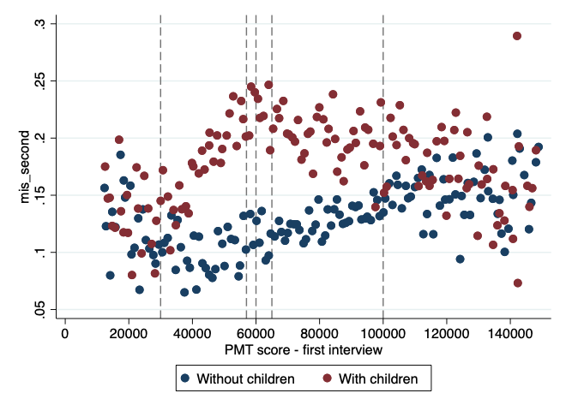
Source: PMT data from Georgian Social Services Agency.

Appendix 2. Complementary tables - RDD

Table A2.1 - FRD estimates for labor market outcomes at individual level for individuals with children.
 | 30K | 57K | 60K | 65K
Working | -0.002 | 0.034 | 0.023 | -0.071⁺
Working | (0.013) | (0.027) | (0.034) | (0.031)
Control group mean | 0.084 | 0.104 | 0.102 | 0.129
Bandwidth | 8682.66 | 2629.09 | 1520.52 | 2519.26
Effective N | 141384 | 54231 | 31125 | 51219
Labor income | -0.328 | 3.545 | 31.236 | -55.025⁺
Labor income | (10.634) | (19.468) | (30.999) | (24.019)
Control group mean | 42.467 | 58.574 | 52.873 | 75.892
Bandwidth | 7709.29 | 2829.36 | 1129.13 | 2446.58
Effective N | 125688 | 58581 | 22800 | 49767
Income if working | 56.314 | -146.091 | 95.836 | -100.298
Income if working | (107.577) | (110.550) | (210.933) | (96.076)
Control group mean | 517.212 | 568.052 | 516.948 | 581.827
Bandwidth | 5360.48 | 2714.01 | 1027.26 | 3240.82
Effective N | 7079 | 5588 | 2186 | 7962
Labor income change | 1.834 | -0.215 | 26.248⁺ | -11.748
Labor income change | (4.221) | (8.288) | (12.967) | (8.697)
Control group mean | 6.483 | 7.833 | 5.307 | 7.300
Bandwidth | 7247.00 | 2188.82 | 983.01 | 2228.35
Effective N | 117990 | 45138 | 20025 | 45336
Find a job | 0.007 | -0.001 | 0.000 | -0.024
Find a job | (0.006) | (0.013) | (0.016) | (0.017)
Control group mean | 0.035 | 0.041 | 0.041 | 0.048
Bandwidth | 8353.53 | 2686.79 | 1378.83 | 1912.69
Effective N | 125836 | 50620 | 25437 | 34773
Lost a job | 0.051 | -0.137 | -0.310 | 0.064
Lost a job | (0.057) | (0.083) | (0.161) | (0.076)
Control group mean | 0.304 | 0.278 | 0.310 | 0.271
Bandwidth | 11423.85 | 2508.95 | 1111.48 | 2626.31
Effective N | 13531 | 4627 | 2122 | 5869
Note: Standard errors in parentheses
⁺ p < 0.05, * p < 0.01, ** p < 0.001
Table A2.2 - FRD estimates for labor market outcomes at individual level for women with children.
 | 30K | 57K | 60K | 65K
Working | -0.002 | 0.033 | -0.001 | -0.052
 | (0.015) | (0.029) | (0.048) | (0.033)
Control group mean | 0.073 | 0.084 | 0.096 | 0.108
Bandwidth | 8955.57 | 2572.64 | 1234.36 | 2828.68
Effective N
Labor income | -6.286 | 6.209 | 16.083 | -33.251⁺
 | (8.148) | (21.100) | (22.337) | (16.604)
Control group mean | 29.477 | 37.162 | 39.278 | 44.433
Bandwidth | 8956.87 | 2706.73 | 1109.95 | 3065.42
Effective N
Income if working | -108.155 | -174.165 | 348.837 | -5.789
 | (73.234) | (169.484) | (224.618) | (217.357)
Control group mean | 402.658 | 439.582 | 407.597 | 415.105
Bandwidth | 8312.79 | 2921.68 | 1168.51 | 1482.59
Effective N
Labor income change | 2.071 | 4.542 | 16.092⁺ | 10.058
 | (2.961) | (7.504) | (8.177) | (8.112)
Control group mean | 6.061 | 6.755 | 8.635 | 8.099
Bandwidth | 9482.06 | 2732.09 | 873.85 | 2370.06
Effective N
Labor income change (yearly) | -1.581 | 7.016 | 32.652 | 6.181
 | (5.758) | (16.112) | (21.666) | (16.211)
Control group mean | 12.006 | 11.310 | 13.699 | 13.533
Bandwidth | 8115.43 | 2691.75 | 849.34 | 1891.98
Effective N
Find a job | 0.012 | 0.000 | 0.015 | -0.030
 | (0.008) | (0.013) | (0.018) | (0.019)
Control group mean | 0.029 | 0.033 | 0.041 | 0.041
Bandwidth | 7368.52 | 2794.34 | 1050.11 | 2173.58
Effective N
Find a job (yearly) | 0.011 | -0.003 | 0.011 | -0.027
 | (0.008) | (0.016) | (0.029) | (0.028)
Control group mean | 0.037 | 0.039 | 0.047 | 0.051
Bandwidth | 12509.45 | 2921.34 | 1059.35 | 2170.81
Effective N
Lost a job | 0.059 | -0.139 | -0.056 | -0.212
 | (0.084) | (0.121) | (0.254) | (0.114)
Control group mean | 0.275 | 0.263 | 0.277 | 0.255
Bandwidth | 7641.17 | 2530.21 | 1160.79 | 2998.18
Effective N
Lost a job (yearly) | -0.012 | -0.174 | -0.222 | -0.384
 | (0.120) | (0.126) | (0.295) | (0.417)
Control group mean | 0.284 | 0.292 | 0.289 | 0.279
Bandwidth | 7607.71 | 2527.54 | 1338.17 | 1364.50
Effective N
Note: Standard errors in parentheses
⁺ p < 0.05, * p < 0.01, ** p < 0.001
Table A2.3 - FRD estimates for labor market outcomes at individual level for men with children.
 | 30K | 57K | 60K | 65K
Working | 0.002 | 0.042 | 0.068 | -0.066
Working | (0.014) | (0.042) | (0.062) | (0.041)
Control group mean | 0.100 | 0.130 | 0.111 | 0.158
Bandwidth | 13613.24 | 2519.58 | 1247.86 | 3374.63
Effective N
Labor income | 7.204 | 4.196 | 12.575 | -80.631
Labor income | (20.936) | (33.749) | (53.606) | (48.528)
Control group mean | 60.080 | 88.230 | 75.369 | 119.565
Bandwidth | 5805.91 | 2735.88 | 1605.68 | 2333.18
Effective N
Income if working | 198.161 | -122.859 | -132.819 | -94.345
Income if working | (184.656) | (132.051) | (212.137) | (143.401)
Control group mean | 630.628 | 676.182 | 655.658 | 753.147
Bandwidth | 5763.30 | 3025.18 | 1135.08 | 3018.21
Effective N
Labor income change | 0.352 | -11.491 | 35.738 | -39.364⁺
Labor income change | (8.302) | (14.273) | (26.140) | (16.680)
Control group mean | 6.891 | 8.240 | 1.805 | 5.141
Bandwidth | 6779.58 | 1715.35 | 1011.33 | 2768.50
Effective N
Labor income change (yearly) | 13.002 | -25.224 | 79.912⁺ | -100.465*
Labor income change (yearly) | (22.313) | (26.207) | (39.362) | (34.061)
Control group mean | 16.389 | 24.292 | 6.186 | 20.379
Bandwidth | 6726.25 | 1852.14 | 969.96 | 3556.50
Effective N
Find a job | -0.003 | -0.003 | -0.010 | -0.012
Find a job | (0.007) | (0.023) | (0.028) | (0.027)
Control group mean | 0.042 | 0.051 | 0.044 | 0.060
Bandwidth | 11278.52 | 1922.01 | 1575.86 | 1852.12
Effective N
Find a job (yearly) | -0.006 | -0.017 | 0.009 | -0.059
Find a job (yearly) | (0.012) | (0.027) | (0.037) | (0.043)
Control group mean | 0.055 | 0.067 | 0.054 | 0.078
Bandwidth | 10145.44 | 2408.46 | 1538.84 | 1735.96
Effective N
Lost a job | -0.003 | -0.102 | -0.430⁺ | 0.270⁺
Lost a job | (0.080) | (0.105) | (0.188) | (0.120)
Control group mean | 0.336 | 0.296 | 0.338 | 0.291
Bandwidth | 13071.98 | 2619.95 | 1081.54 | 3251.55
Effective N
Lost a job (yearly) | 0.103 | -0.209 | -0.594⁺ | 0.485*
Lost a job (yearly) | (0.114) | (0.118) | (0.262) | (0.163)
Control group mean | 0.374 | 0.334 | 0.389 | 0.314
Bandwidth | 12412.87 | 2746.93 | 1071.43 | 2884.16
Effective N
Note: Standard errors in parentheses
⁺ p < 0.05, * p < 0.01, ** p < 0.001
Table A2.4 - FRD estimates for labor market outcomes at individual level for individuals without children.
 | 30K | 57K | 60K | 65K
Working | -0.006 | -0.044 | -0.010 | 0.008
Working | (0.014) | (0.022) | (0.021) | (0.028)
Control group mean | 0.073 | 0.074 | 0.076 | 0.085
Bandwidth | 12894.53 | 1955.70 | 1724.08 | 1617.03
Effective N | 185580 | 50262 | 45459 | 44874
Labor income | -3.807 | -21.831 | 3.592 | -6.930
Labor income | (9.208) | (13.041) | (15.608) | (22.309)
Control group mean | 37.732 | 38.213 | 39.903 | 44.490
Bandwidth | 12376.71 | 2830.24 | 1686.33 | 1572.31
Effective N | 177717 | 72153 | 44559 | 43854
Income if working | -33.617 | -103.167 | 101.325 | -331.739
Income if working | (85.265) | (138.594) | (222.470) | (322.439)
Control group mean | 507.462 | 540.936 | 516.377 | 520.953
Bandwidth | 14115.76 | 3177.38 | 1056.54 | 1711.96
Effective N | 15333 | 5302 | 1942 | 3637
Labor income change | -1.300 | 3.927 | -3.881 | 9.665
Labor income change | (5.974) | (10.604) | (5.090) | (6.416)
Control group mean | 4.534 | 5.298 | 5.950 | 5.017
Bandwidth | 11059.38 | 2157.74 | 1578.11 | 1721.43
Effective N | 157866 | 55170 | 41598 | 47796
Find a job | -0.003 | -0.022⁺ | -0.004 | 0.012
Find a job | (0.005) | (0.010) | (0.010) | (0.013)
Control group mean | 0.029 | 0.030 | 0.031 | 0.030
Bandwidth | 13720.47 | 1853.25 | 1549.72 | 1531.70
Effective N | 184809 | 44843 | 38133 | 39742
Lost a job | 0.019 | 0.058 | -0.021 | 0.084
Lost a job | (0.062) | (0.148) | (0.135) | (0.123)
Control group mean | 0.295 | 0.304 | 0.295 | 0.278
Bandwidth | 13931.76 | 2245.35 | 1240.39 | 2417.10
Effective N | 13428 | 3567 | 2128 | 4592
Note: Standard errors in parentheses
⁺ p < 0.05, * p < 0.01, ** p < 0.001
Table A2.5 - FRD estimates for labor market outcomes at individual level for women without children.
 | 30K | 57K | 60K | 65K
Working | 0.018 | -0.016 | 0.003 | -0.006
 | (0.018) | (0.024) | (0.026) | (0.028)
Control group mean | 0.067 | 0.059 | 0.064 | 0.073
Bandwidth | 9624.69 | 2104.85 | 1781.92 | 2050.23
Effective N
Labor income | 6.270 | -0.503 | 5.013 | -30.868
 | (8.948) | (11.812) | (12.878) | (18.150)
Control group mean | 28.702 | 23.795 | 27.843 | 31.544
Bandwidth | 10578.75 | 2110.14 | 1726.94 | 1806.15
Effective N
Income if working | 17.561 | 98.512 | 82.732 | -643.520
 | (74.758) | (114.104) | (150.762) | (329.448)
Control group mean | 428.799 | 406.554 | 438.551 | 430.685
Bandwidth | 10983.33 | 2498.45 | 1106.81 | 1955.84
Effective N
Labor income change | 6.117 | -5.542 | 2.105 | 1.139
 | (3.439) | (5.028) | (4.978) | (4.648)
Control group mean | 5.199 | 4.888 | 5.284 | 5.221
Bandwidth | 9184.48 | 2114.02 | 1529.33 | 1959.12
Effective N
Labor income change (yearly) | 10.283 | 0.872 | 13.155 | -23.466
 | (6.358) | (10.621) | (11.281) | (18.193)
Control group mean | 11.078 | 8.104 | 10.766 | 12.744
Bandwidth | 10909.04 | 2267.88 | 1111.19 | 1894.28
Effective N
Find a job | -0.005 | -0.019 | 0.008 | -0.011
 | (0.006) | (0.012) | (0.014) | (0.015)
Control group mean | 0.024 | 0.023 | 0.026 | 0.026
Bandwidth | 11536.35 | 1718.69 | 1035.78 | 1754.50
Effective N
Find a job (yearly) | 0.006 | -0.015 | 0.012 | -0.029
 | (0.009) | (0.018) | (0.020) | (0.021)
Control group mean | 0.032 | 0.028 | 0.029 | 0.031
Bandwidth | 11430.26 | 1971.66 | 1090.38 | 1691.51
Effective N
Lost a job | -0.098 | 0.015 | -0.065 | -0.107
 | (0.082) | (0.151) | (0.135) | (0.170)
Control group mean | 0.256 | 0.264 | 0.262 | 0.243
Bandwidth | 14561.72 | 3071.18 | 1101.01 | 1929.91
Effective N
Lost a job (yearly) | 0.028 | -0.119 | -0.286 | 0.004
 | (0.125) | (0.229) | (0.167) | (0.148)
Control group mean | 0.278 | 0.307 | 0.241 | 0.265
Bandwidth | 12617.55 | 2398.09 | 1091.39 | 2511.69
Effective N
Note: Standard errors in parentheses
⁺ p < 0.05, * p < 0.01, ** p < 0.001
Table A2.6 - FRD estimates for labor market outcomes at individual level for men without children.
 | 30K | 57K | 60K | 65K
Working | -0.020 | -0.064⁺ | -0.023 | 0.024
 | (0.018) | (0.025) | (0.032) | (0.048)
Control group mean | 0.083 | 0.088 | 0.091 | 0.100
Bandwidth | 11878.69 | 2620.50 | 1611.75 | 1623.19
Effective N
Labor income | -12.374 | -45.720⁺ | 1.232 | 20.308
 | (14.380) | (19.994) | (31.805) | (42.779)
Control group mean | 49.431 | 55.884 | 53.684 | 60.787
Bandwidth | 11670.95 | 3143.26 | 1545.92 | 1523.64
Effective N
Income if working | -65.356 | -242.756 | 249.901 | 175.594
 | (146.224) | (268.245) | (444.288) | (642.295)
Control group mean | 588.911 | 651.237 | 582.641 | 603.701
Bandwidth | 14239.92 | 3092.01 | 1277.70 | 1697.04
Effective N
Labor income change | -8.602 | 15.830 | -10.914 | 20.496
 | (12.893) | (21.918) | (10.152) | (13.352)
Control group mean | 3.971 | 6.927 | 6.717 | 5.077
Bandwidth | 11243.77 | 2379.18 | 1561.74 | 1747.81
Effective N
Labor income change (yearly) | -16.486 | 32.310 | 4.290 | 42.773
 | (21.407) | (36.340) | (26.593) | (29.392)
Control group mean | 11.984 | 22.506 | 19.310 | 20.058
Bandwidth | 12196.52 | 2746.20 | 1566.76 | 1578.95
Effective N
Find a job | 0.002 | -0.025⁺ | -0.023 | 0.038⁺
 | (0.009) | (0.012) | (0.014) | (0.019)
Control group mean | 0.037 | 0.038 | 0.040 | 0.038
Bandwidth | 11778.40 | 2629.35 | 1534.59 | 1913.77
Effective N
Find a job (yearly) | 0.009 | -0.024 | -0.029 | 0.068⁺
 | (0.014) | (0.016) | (0.024) | (0.031)
Control group mean | 0.052 | 0.049 | 0.056 | 0.052
Bandwidth | 10235.60 | 2780.20 | 1551.63 | 1455.07
Effective N
Lost a job | 0.150 | 0.181 | -0.160 | 0.593
 | (0.086) | (0.202) | (0.253) | (0.464)
Control group mean | 0.330 | 0.326 | 0.334 | 0.300
Bandwidth | 14633.93 | 2744.75 | 1505.71 | 1873.08
Effective N
Lost a job (yearly) | 0.244 | 0.086 | -0.278 | 0.494
 | (0.145) | (0.237) | (0.389) | (0.617)
Control group mean | 0.384 | 0.346 | 0.380 | 0.348
Bandwidth | 10837.13 | 3026.84 | 1496.80 | 1905.21
Effective N
Note: Standard errors in parentheses
⁺ p < 0.05, * p < 0.01, ** p < 0.001
Table A2.7 - FRD estimates for labor market outcomes at household level for households with child.
 | 30K | 57K | 60K | 65K
Total number of workers | -0.026 | 0.077 | 0.119 | -0.173
 | (0.043) | (0.080) | (0.106) | (0.104)
Control group mean | 0.242 | 0.300 | 0.288 | 0.367
Bandwidth | 7825.44 | 2451.27 | 1356.93 | 2102.94
Effective N | 44178 | 17652 | 9672 | 14883
Proportion of workers | -0.000 | 0.035 | 0.010 | -0.064
 | (0.015) | (0.029) | (0.048) | (0.034)
Control group mean | 0.084 | 0.109 | 0.109 | 0.133
Bandwidth | 8366.09 | 2674.38 | 1016.34 | 2354.55
Effective N | 47157 | 19299 | 7212 | 16578
At least one adult works | -0.006 | 0.074 | 0.035 | -0.103
 | (0.034) | (0.059) | (0.074) | (0.072)
Control group mean | 0.200 | 0.247 | 0.240 | 0.298
Bandwidth | 7175.88 | 2667.29 | 1322.37 | 2106.33
Effective N | 40530 | 19221 | 9417 | 14883
Total income | -11.397 | -3.801 | 150.308 | §-145.154⁺
 | (33.991) | (58.339) | (100.283) | (67.809)
Control group mean | 122.621 | 169.584 | 151.335 | 222.700
Bandwidth | 7244.25 | 2617.05 | 982.25 | 2563.65
Effective N | 40962 | 18834 | 6987 | 18165
Income per capita | -3.101 | 2.163 | 20.686 | -24.584
 | (6.373) | (11.850) | (22.798) | (15.531)
Control group mean | 25.559 | 36.382 | 32.810 | 47.192
Bandwidth | 7132.24 | 2523.95 | 1062.07 | 1959.31
Effective N | 40278 | 18153 | 7545 | 13815
Change in the proportion of workers | 0.003 | -0.006 | 0.013 | -0.003
 | (0.005) | (0.009) | (0.012) | (0.016)
Control group mean | 0.010 | 0.011 | 0.010 | 0.010
Bandwidth | 10364.09 | 2876.57 | 1185.46 | 1990.81
Effective N | 58191 | 20745 | 8457 | 14142
Change in the total number of workers | 0.013 | -0.003 | 0.034 | -0.012
 | (0.013) | (0.025) | (0.030) | (0.038)
Control group mean | 0.028 | 0.029 | 0.025 | 0.033
Bandwidth | 9901.03 | 2873.66 | 1445.93 | 1921.38
Effective N | 55653 | 20745 | 10422 | 13656
Change in total income | 3.472 | 1.332 | 81.934⁺ | -32.232
 | (12.442) | (21.185) | (37.272) | (24.643)
Control group mean | 18.811 | 22.085 | 15.025 | 20.409
Bandwidth | 7121.93 | 2601.85 | 964.52 | 2114.84
Effective N | 40203 | 18777 | 6843 | 14946
Change in income per capita | 0.107 | 1.148 | 11.205 | -6.785
 | (2.550) | (4.139) | (8.009) | (5.610)
Control group mean | 3.953 | 4.851 | 3.772 | 4.574
Bandwidth | 7152.14 | 2558.27 | 1125.61 | 1984.19
Effective N | 40398 | 18396 | 7971 | 14043
Note: Standard errors in parentheses
⁺ p < 0.05, * p < 0.01, ** p < 0.001
Table A 2.8 - FRD estimates for labor market outcomes at household level for households without child.
 | 30K | 57K | 60K | 65K
Total number of workers | -0.029 | -0.077 | -0.036 | 0.028
 | (0.031) | (0.054) | (0.055) | (0.064)
Control group mean | 0.153 | 0.144 | 0.150 | 0.168
Bandwidth | 13152.39 | 1614.36 | 1561.53 | 1627.75
Effective N | 89991 | 21492 | 21399 | 23253
Proportion of workers | 0.009 | -0.029 | -0.021 | 0.016
 | (0.012) | (0.019) | (0.020) | (0.023)
Control group mean | 0.055 | 0.054 | 0.057 | 0.063
Bandwidth | 11336.78 | 1663.89 | 1695.71 | 1605.53
Effective N | 76485 | 22158 | 23205 | 22908
At least one adult works | -0.006 | -0.048 | -0.030 | 0.004
 | (0.023) | (0.040) | (0.040) | (0.045)
Control group mean | 0.123 | 0.119 | 0.124 | 0.135
Bandwidth | 13451.99 | 1603.33 | 1478.50 | 1629.37
Effective N | 92226 | 21369 | 20088 | 23253
Total income | -19.515 | -28.589 | 2.098 | -11.615
 | (21.211) | (32.742) | (38.037) | (46.560)
Control group mean | 77.511 | 73.791 | 78.792 | 87.060
Bandwidth | 12921.82 | 1858.48 | 1282.56 | 1718.62
Effective N | 88272 | 24702 | 17421 | 24492
Income per capita | 3.358 | -10.854 | -5.058 | -1.972
 | (7.572) | (11.257) | (12.482) | (14.144)
Control group mean | 26.806 | 26.699 | 28.330 | 30.121
Bandwidth | 13598.25 | 1747.17 | 1356.09 | 1718.41
Effective N | 93192 | 23190 | 18351 | 24492
Change in the proportion of workers | -0.002 | -0.003 | 0.000 | 0.005
 | (0.004) | (0.008) | (0.006) | (0.008)
Control group mean | 0.005 | 0.006 | 0.006 | 0.005
Bandwidth | 13724.98 | 1795.22 | 1270.86 | 1812.38
Effective N | 94218 | 23961 | 17235 | 25998
Change in the total number of workers | -0.005 | -0.019 | -0.012 | 0.016
 | (0.009) | (0.018) | (0.019) | (0.016)
Control group mean | 0.018 | 0.016 | 0.018 | 0.013
Bandwidth | 12887.05 | 1684.86 | 1165.21 | 1891.48
Effective N | 87978 | 22461 | 15690 | 27090
Change in total income | 0.176 | 1.029 | -5.939 | 20.728
 | (11.649) | (18.312) | (11.073) | (12.435)
Control group mean | 9.344 | 9.580 | 12.472 | 10.650
Bandwidth | 9706.21 | 1630.64 | 1353.53 | 1888.33
Effective N | 65106 | 21774 | 18351 | 26955
Change in income per capita | -3.749 | 8.353 | 1.727 | 7.476
 | (4.549) | (12.237) | (4.200) | (4.461)
Control group mean | 2.968 | 1.110 | 4.592 | 3.824
Bandwidth | 10906.78 | 1486.28 | 1407.51 | 1834.47
Effective N | 73410 | 19731 | 19059 | 26259
Note: Standard errors in parentheses
⁺ p < 0.05, * p < 0.01, ** p < 0.001
Table A2.9 - FRD estimates for labor market outcomes (using survey data) for households with child.
 | 30K | 57K | 60K | 65K
% Employees with permanent contract | -0.017 | -0.056 | 0.005 | -0.075*
% Employees with permanent contract | (0.022) | (0.033) | (0.034) | (0.024)
Control group mean | 0.113 | 0.151 | 0.142 | 0.185
Number of observations | 1596 | 1343 | 1570 | 1790
% Employees with temporal contract | 0.088+ | 0.038 | 0.037 | -0.028
% Employees with temporal contract | (0.038) | (0.028) | (0.027) | (0.028)
Control group mean | 0.094 | 0.128 | 0.113 | 0.129
Number of observations | 1596 | 1343 | 1570 | 1790
% Employees with contract | 0.070 | -0.018 | 0.041 | -0.103+
% Employees with contract | (0.046) | (0.043) | (0.036) | (0.037)
Control group mean | 0.207 | 0.279 | 0.255 | 0.315
Number of observations | 1596 | 1343 | 1570 | 1790
% Employees without contract | -0.055 | -0.101 | -0.051 | 0.054
% Employees without contract | (0.032) | (0.045) | (0.049) | (0.034)
Control group mean | 0.142 | 0.146 | 0.162 | 0.131
Number of observations | 1596 | 1343 | 1570 | 1790
% EAP without a written contract(temp/perm) | -0.036 | -0.068+ | -0.029 | 0.010
% EAP without a written contract(temp/perm) | (0.019) | (0.028) | (0.032) | (0.020)
Control group mean | 0.084 | 0.095 | 0.104 | 0.098
Number of observations | 2555 | 2031 | 2337 | 2563
% EAP with a written contract(temp/perm) | 0.030 | -0.032 | 0.029 | -0.117*
% EAP with a written contract(temp/perm) | (0.027) | (0.027) | (0.022) | (0.026)
Control group mean | 0.123 | 0.184 | 0.164 | 0.234
Number of observations | 2555 | 2031 | 2337 | 2563
Unemployment rate | 0.041 | 0.080* | -0.013 | 0.173*
Unemployment rate | (0.024) | (0.024) | (0.033) | (0.034)
Control group mean | 0.406 | 0.342 | 0.358 | 0.254
Number of observations | 2555 | 2031 | 2337 | 2563
Self-employment rate | -0.035 | 0.021 | 0.014 | -0.066
Self-employment rate | (0.034) | (0.031) | (0.027) | (0.036)
Control group mean | 0.387 | 0.380 | 0.374 | 0.414
Number of observations | 2555 | 2031 | 2337 | 2563
Employment rate | -0.041 | -0.080* | 0.013 | -0.173*
Employment rate | (0.024) | (0.024) | (0.033) | (0.034)
Control group mean | 0.594 | 0.658 | 0.642 | 0.746
Number of observations | 2555 | 2031 | 2337 | 2563
Labor force participation rate | 0.019 | -0.078* | 0.003 | -0.004
Labor force participation rate | (0.022) | (0.023) | (0.027) | (0.029)
Control group mean | 0.435 | 0.484 | 0.474 | 0.476
Number of observations | 5651 | 4380 | 4906 | 5345
Average monthly income | 29.419 | -30.760 | 59.626 | -104.738*
Average monthly income | (38.561) | (31.308) | (30.762) | (34.622)
Control group mean | 579.594 | 598.350 | 560.775 | 625.956
Number of observations | 1812 | 1458 | 1644 | 1783
Average of the household member that have any income | 0.217 | 0.086 | 0.046 | 0.859*
Average of the household member that have any income | (0.184) | (0.202) | (0.201) | (0.199)
Control group mean | 4.034 | 3.792 | 3.775 | 3.248
Number of observations | 1812 | 1458 | 1644 | 1783
Note: Standard errors in parentheses
⁺ p < 0.05, * p < 0.01, ** p < 0.001
Table A2.10 - FRD estimates for labor market outcomes (using survey data) for households with child by sex
 | Female |  |  |  | Male
 | 30K | 57K | 60K | 65K | 30K | 57K | 60K | 65K
% Employees with permanent contract | -0.031 | -0.070 | 0.058 | -0.126+ | -0.002 | -0.036 | -0.033 | -0.039
% Employees with permanent contract | (0.046) | (0.042) | (0.053) | (0.049) | (0.017) | (0.038) | (0.050) | (0.050)
Control group mean | 0.187 | 0.216 | 0.179 | 0.251 | 0.065 | 0.106 | 0.119 | 0.141
Number of observations | 556 | 500 | 607 | 696 | 1040 | 843 | 963 | 1094
% Employees with temporal contract | 0.136+ | 0.054 | 0.005 | 0.059 | 0.066 | 0.037 | 0.055 | -0.085*
% Employees with temporal contract | (0.052) | (0.061) | (0.066) | (0.044) | (0.047) | (0.044) | (0.031) | (0.025)
Control group mean | 0.109 | 0.186 | 0.187 | 0.153 | 0.084 | 0.089 | 0.064 | 0.114
Number of observations | 556 | 500 | 607 | 696 | 1040 | 843 | 963 | 1094
% Employees with contract | 0.105 | -0.017 | 0.063 | -0.067 | 0.063 | 0.001 | 0.022 | -0.124+
% Employees with contract | (0.077) | (0.065) | (0.093) | (0.066) | (0.050) | (0.065) | (0.067) | (0.052)
Control group mean | 0.295 | 0.401 | 0.366 | 0.405 | 0.148 | 0.195 | 0.183 | 0.254
Number of observations | 556 | 500 | 607 | 696 | 1040 | 843 | 963 | 1094
% Employees without contract | -0.037 | -0.145+ | 0.028 | 0.015 | -0.061+ | -0.065 | -0.105 | 0.080+
% Employees without contract | (0.053) | (0.056) | (0.063) | (0.044) | (0.026) | (0.039) | (0.050) | (0.033)
Control group mean | 0.168 | 0.191 | 0.164 | 0.156 | 0.124 | 0.113 | 0.160 | 0.113
Number of observations | 556 | 500 | 607 | 696 | 1040 | 843 | 963 | 1094
% EAP without a written contract(temp/perm) | -0.041 | -0.122+ | 0.048 | -0.032 | -0.033+ | -0.039 | -0.066+ | 0.033
% EAP without a written contract(temp/perm) | (0.034) | (0.045) | (0.051) | (0.024) | (0.015) | (0.020) | (0.026) | (0.021)
Control group mean | 0.116 | 0.151 | 0.114 | 0.134 | 0.068 | 0.065 | 0.098 | 0.078
Number of observations | 780 | 647 | 789 | 885 | 1775 | 1384 | 1548 | 1678
% EAP with a written contract(temp/perm) | 0.023 | -0.047 | 0.107 | -0.150+ | 0.034 | -0.012 | 0.002 | -0.104*
% EAP with a written contract(temp/perm) | (0.055) | (0.043) | (0.067) | (0.061) | (0.031) | (0.035) | (0.039) | (0.033)
Control group mean | 0.206 | 0.317 | 0.253 | 0.345 | 0.080 | 0.115 | 0.112 | 0.174
Number of observations | 780 | 647 | 789 | 885 | 1775 | 1384 | 1548 | 1678
Unemployment rate | 0.120+ | 0.087 | -0.162+ | 0.265* | 0.002 | 0.063* | 0.053 | 0.124*
Unemployment rate | (0.047) | (0.062) | (0.055) | (0.065) | (0.042) | (0.019) | (0.026) | (0.032)
Control group mean | 0.307 | 0.211 | 0.309 | 0.147 | 0.457 | 0.410 | 0.387 | 0.313
Number of observations | 780 | 647 | 789 | 885 | 1775 | 1384 | 1548 | 1678
Self-employment rate | -0.102+ | 0.082 | 0.008 | -0.083 | -0.003 | -0.012 | 0.010 | -0.053
Self-employment rate | (0.042) | (0.077) | (0.061) | (0.046) | (0.041) | (0.030) | (0.032) | (0.042)
Control group mean | 0.371 | 0.321 | 0.324 | 0.375 | 0.396 | 0.410 | 0.403 | 0.435
Number of observations | 780 | 647 | 789 | 885 | 1775 | 1384 | 1548 | 1678
Employment rate | -0.120+ | -0.087 | 0.162+ | -0.265* | -0.002 | -0.063* | -0.053 | -0.124*
Employment rate | (0.047) | (0.062) | (0.055) | (0.065) | (0.042) | (0.019) | (0.026) | (0.032)
Control group mean | 0.693 | 0.789 | 0.691 | 0.853 | 0.543 | 0.590 | 0.613 | 0.687
Number of observations | 780 | 647 | 789 | 885 | 1775 | 1384 | 1548 | 1678
Labor force participation rate | 0.008 | -0.076 | -0.037 | 0.011 | 0.034 | -0.101* | 0.040 | -0.006
Labor force participation rate | (0.021) | (0.042) | (0.034) | (0.036) | (0.038) | (0.020) | (0.023) | (0.031)
Control group mean | 0.260 | 0.289 | 0.301 | 0.294 | 0.667 | 0.744 | 0.709 | 0.713
Number of observations | 3135 | 2426 | 2758 | 3002 | 2516 | 1954 | 2148 | 2343
Note: Standard errors in parentheses
⁺ p < 0.05, * p < 0.01, ** p < 0.001
Table A2.11 - FRD estimates for primary education outcomes by age and gender for boys from 6 to 18 years old
 | 30K | 57K | 60K | 65K
Enrolled in school - 2019 | -0.010 | 0.002 | 0.008 | -0.016
 | (0.016) | (0.016) | (0.027) | (0.025)
Control group mean | 0.841 | 0.858 | 0.860 | 0.862
Bandwidth | 11483.33 | 2620.42 | 1413.19 | 1717.31
Effective N | 10714 | 2923 | 1557 | 1868
Advance to next level (2019/2018) | -0.034* | 0.004 | -0.001 | -0.007
 | (0.013) | (0.012) | (0.013) | (0.016)
Control group mean | 0.959 | 0.963 | 0.963 | 0.964
Bandwidth | 9105.49 | 2531.61 | 926.84 | 2011.22
Effective N | 7135 | 2335 | 833 | 1849
Note: Standard errors in parentheses
⁺ p < 0.05, * p < 0.01, ** p < 0.001
Table A2.12 - FRD estimates for primary education outcomes by age and gender for girls from 6 to 18 years old
 | 30K | 57K | 60K | 65K
Enrolled in school - 2019 | -0.021 | -0.053 | -0.015 | -0.045
 | (0.011) | (0.034) | (0.047) | (0.034)
Control group mean | 0.873 | 0.880 | 0.883 | 0.860
Bandwidth | 12192.66 | 2590.44 | 1137.50 | 2682.90
Effective N | 10932 | 2763 | 1216 | 2735
Advance to next level (2019/2018) | 0.020 | -0.004 | 0.017 | -0.039
 | (0.011) | (0.018) | (0.018) | (0.034)
Control group mean | 0.973 | 0.979 | 0.976 | 0.980
Bandwidth | 8592.24 | 2449.84 | 1176.43 | 1822.66
Effective N | 6447 | 2169 | 1056 | 1544
Note: Standard errors in parentheses - ⁺ p < 0.05, * p < 0.01, ** p < 0.001
Table A2.13 - FRD estimates for secondary education outcomes by age and gender for boys from 6 to 18 years old
 | 30K | 57K | 60K | 65K
Enrolled in school - 2019 | -0.018 | 0.038 | -0.005 | 0.076
 | (0.036) | (0.055) | (0.112) | (0.055)
Control group mean | 0.841 | 0.860 | 0.858 | 0.864
Bandwidth | 8483.96 | 2589.54 | 1111.21 | 2785.72
Effective N | 3664 | 1381 | 553 | 1508
Advance to next level (2019/2018) | -0.018 | 0.019 | -0.140 | 0.069
 | (0.042) | (0.060) | (0.170) | (0.076)
Control group mean | 0.959 | 0.963 | 0.964 | 0.966
Bandwidth | 7170.83 | 2423.56 | 955.14 | 2379.51
Effective N | 2963 | 1237 | 456 | 1232
Note: Standard errors in parentheses
⁺ p < 0.05, * p < 0.01, ** p < 0.001
Table A2.14 - FRD estimates for secondary education outcomes by age and gender for girls from 6 to 18 years old
 | 30K | 57K | 60K | 65K
Enrolled in school - 2019 | -0.044 | 0.043 | 0.067 | 0.002
 | (0.028) | (0.050) | (0.072) | (0.066)
Control group mean | 0.872 | 0.881 | 0.890 | 0.859
Bandwidth | 9220.81 | 3047.18 | 1516.69 | 2542.58
Effective N | 4008 | 1507 | 738 | 1295
Advance to next level (2019/2018) | -0.036 | 0.054 | 0.078 | -0.054
 | (0.030) | (0.064) | (0.060) | (0.072)
Control group mean | 0.972 | 0.980 | 0.977 | 0.979
Bandwidth | 8643.87 | 2320.41 | 2356.47 | 2982.92
Effective N | 3681 | 1109 | 1108 | 1484
Note: Standard errors in parentheses
⁺ p < 0.05, * p < 0.01, ** p < 0.001
Table A2.15 - FRD estimates for upper secondary education outcomes by age and gender for boys from 6 to 18 years old
 | 30K | 57K | 60K | 65K
Enrolled in school - 2019 | -0.064 | -0.056 | -0.292 | -0.163
 | (0.069) | (0.079) | (0.170) | (0.143)
Control group mean | 0.841 | 0.859 | 0.861 | 0.862
Bandwidth | 9655.01 | 2408.93 | 1242.47 | 3223.68
Effective N | 1671 | 492 | 273 | 640
Advance to next level (2019/2018) | -0.030 | -0.162 | -0.272 | -0.186
 | (0.099) | (0.093) | (0.192) | (0.159)
Control group mean | 0.960 | 0.962 | 0.966 | 0.966
Bandwidth | 8733.86 | 2942.69 | 1331.28 | 4080.87
Effective N | 940 | 423 | 203 | 576
Note: Standard errors in parentheses
⁺ p < 0.05, * p < 0.01, ** p < 0.001
Table A2.16 - FRD estimates for upper secondary education outcomes by age and gender for grils from 6 to 18 years old
 | 30K | 57K | 60K | 65K
Enrolled in school - 2019 | -0.043 | -0.039 | -3.122 | -0.083
 | (0.050) | (0.322) | (13.820) | (0.082)
Control group mean | 0.870 | 0.880 | 0.888 | 0.871
Bandwidth | 7302.16 | 1940.38 | 1023.37 | 5362.20
Effective N | 1205 | 350 | 165 | 914
Advance to next level (2019/2018) | -0.060 | -0.364 | -0.613 | -0.241
 | (0.067) | (0.502) | (0.549) | (0.168)
Control group mean | 0.972 | 0.980 | 0.975 | 0.979
Bandwidth | 9196.43 | 1968.35 | 1321.95 | 2836.24
Effective N | 1168 | 266 | 187 | 393
Note: Standard errors in parentheses
⁺ p < 0.05, * p < 0.01, ** p < 0.001
Table A2.17 - FRD estimates for educational outcomes from survey data
 | 30K | 57K | 60K | 65K
% Enrollment of children between 6-16 | -0.001 | -0.017 | 0.008 | -0.005
% Enrollment of children between 6-16 | (0.013) | (0.012) | (0.012) | (0.014)
Control group mean | 0.972 | 0.980 | 0.974 | 0.977
Number of observations | 2643 | 1906 | 2165 | 2323
% Enrollment of children between 6-12 | 0.001 | 0.005 | -0.014+ | 0.011
% Enrollment of children between 6-12 | (0.009) | (0.004) | (0.005) | (0.011)
Control group mean | 0.986 | 0.986 | 0.995 | 0.988
Number of observations | 1813 | 1337 | 1547 | 1619
% Enrollment of children between 13-16 | -0.010 | -0.055 | 0.066 | -0.060
% Enrollment of children between 13-16 | (0.027) | (0.037) | (0.041) | (0.036)
Control group mean | 0.945 | 0.960 | 0.916 | 0.955
Number of observations | 830 | 569 | 618 | 704
% Enrollment of children between 17-18 | -0.120 | 0.171 | 0.035 | -0.328+
% Enrollment of children between 17-18 | (0.114) | (0.089) | (0.178) | (0.142)
Control group mean | 0.609 | 0.625 | 0.636 | 0.824
Number of observations | 242 | 128 | 150 | 164
% Over 18 who have some vocational education | -0.015 | -0.019 | 0.011 | -0.009
% Over 18 who have some vocational education | (0.026) | (0.018) | (0.019) | (0.019)
Control group mean | 0.154 | 0.160 | 0.152 | 0.157
Number of observations | 5123 | 4036 | 4542 | 4926
% Over 18 who have university education | 0.045* | 0.009 | 0.026 | -0.047+
% Over 18 who have university education | (0.015) | (0.035) | (0.028) | (0.017)
Control group mean | 0.076 | 0.118 | 0.104 | 0.132
Number of observations | 5123 | 4036 | 4542 | 4926
Note: Standard errors in parentheses
⁺ p < 0.05, * p < 0.01, ** p < 0.001
Table A2.18 - FRD estimates on children vaccination women
 | 30K | 57K | 60K | 65K
Child with all vaccines for the age | 0.044 | -0.010 | 0.144 | -0.607
 | (0.059) | (0.119) | (0.174) | (0.315)
Control group mean | 0.267 | 0.309 | 0.309 | 0.314
Bandwidth | 11863.28 | 2602.45 | 1207.80 | 1914.02
Effective N | 4605 | 1384 | 622 | 924
All children in the hh have all vaccines for the age | 0.001 | -0.039 | 0.196 | -0.549
 | (0.060) | (0.112) | (0.165) | (0.314)
Control group mean | 0.186 | 0.242 | 0.215 | 0.229
Bandwidth | 10516.81 | 2738.08 | 1158.09 | 1797.05
Effective N | 4061 | 1447 | 595 | 871
Hepatitis b | 0.023 | 0.153 | 0.038 | -0.149
 | (0.067) | (0.124) | (0.179) | (0.269)
Control group mean | 0.774 | 0.764 | 0.810 | 0.797
Bandwidth | 10483.01 | 2288.28 | 1211.13 | 1847.36
Effective N | 4044 | 1197 | 627 | 893
BCG | 0.050 | 0.129 | -0.045 | -0.152
 | (0.062) | (0.123) | (0.179) | (0.279)
Control group mean | 0.761 | 0.763 | 0.816 | 0.797
Bandwidth | 12066.41 | 2164.96 | 1170.92 | 1758.27
Effective N | 4676 | 1147 | 605 | 851
DPaT_HepB_Hib_IPV | -0.009 | 0.024 | 0.384⁺ | 0.284
 | (0.057) | (0.130) | (0.178) | (0.188)
Control group mean | 0.541 | 0.544 | 0.531 | 0.542
Bandwidth | 13432.51 | 2137.87 | 1128.39 | 2766.20
Effective N | 5220 | 1137 | 580 | 1358
PCV | -0.021 | 0.129 | -0.210 | 0.252
 | (0.064) | (0.132) | (0.170) | (0.273)
Control group mean | 0.683 | 0.681 | 0.690 | 0.695
Bandwidth | 11859.73 | 2676.22 | 1051.06 | 1755.73
Effective N | 4499 | 1380 | 520 | 830
Rota | 0.013 | -0.074 | 0.075 | -0.260
 | (0.075) | (0.162) | (0.190) | (0.320)
Control group mean | 0.602 | 0.616 | 0.624 | 0.635
Bandwidth | 11638.72 | 2088.43 | 1169.16 | 1794.75
Effective N | 4522 | 1116 | 602 | 871
MMR | -0.259⁺ | -0.235 | -0.352 | -0.031
 | (0.129) | (0.256) | (0.346) | (0.210)
Control group mean | 0.854 | 0.826 | 0.845 | 0.852
Bandwidth | 8914.36 | 3499.20 | 950.51 | 2884.27
Effective N | 877 | 420 | 124 | 379
DPT_DPaT | -0.109 | -0.051 | -0.277 | -0.524
 | (0.076) | (0.203) | (0.180) | (0.322)
Control group mean | 0.626 | 0.680 | 0.662 | 0.659
Bandwidth | 11226.20 | 1602.40 | 1676.34 | 2107.67
Effective N | 3725 | 726 | 718 | 891
DT | -0.248 | 0.062 | -0.072 | -0.529
 | (0.178) | (0.351) | (0.351) | (0.312)
Control group mean | 0.651 | 0.632 | 0.667 | 0.677
Bandwidth | 8386.84 | 2699.42 | 1050.51 | 2807.20
Effective N | 819 | 358 | 137 | 368
Teens with TD vaccine | -0.028 | 0.418* | 0.065 | -0.429
 | (0.084) | (0.160) | (0.168) | (0.291)
Control group mean | 0.507 | 0.514 | 0.490 | 0.515
Bandwidth | 9439.15 | 2737.89 | 1805.03 | 2354.29
Effective N | 3053 | 1003 | 673 | 912
Note: Standard errors in parentheses
⁺ p < 0.05, * p < 0.01, ** p < 0.001
Table A2.19 - FRD estimates on children vaccination men
 | 30K | 57K | 60K | 65K
Child with all vaccines for the age | -0.043 | -0.034 | -0.296 | 0.195
 | (0.066) | (0.134) | (0.219) | (0.141)
Control group mean | 0.296 | 0.308 | 0.250 | 0.311
Bandwidth | 11357.54 | 1664.09 | 1213.68 | 2187.86
Effective N | 4840 | 922 | 612 | 1157
All children in the hh have all vaccines for the age | 0.010 | -0.072 | -0.200 | 0.191
 | (0.064) | (0.126) | (0.197) | (0.122)
Control group mean | 0.214 | 0.205 | 0.188 | 0.245
Bandwidth | 10680.54 | 2035.94 | 1210.70 | 2618.56
Effective N | 4579 | 1116 | 612 | 1386
Hepatitis b | 0.036 | 0.123 | 0.264 | -0.104
 | (0.072) | (0.130) | (0.299) | (0.146)
Control group mean | 0.772 | 0.810 | 0.739 | 0.795
Bandwidth | 9870.86 | 2198.37 | 1043.81 | 2124.81
Effective N | 4227 | 1204 | 508 | 1124
BCG | 0.017 | 0.015 | 0.257 | -0.116
 | (0.073) | (0.137) | (0.290) | (0.122)
Control group mean | 0.762 | 0.793 | 0.721 | 0.777
Bandwidth | 9983.53 | 2634.95 | 1062.82 | 2753.22
Effective N | 4268 | 1432 | 521 | 1472
DPaT_HepB_Hib_IPV | -0.129 | 0.066 | -0.100 | 0.195
 | (0.072) | (0.122) | (0.266) | (0.157)
Control group mean | 0.562 | 0.539 | 0.525 | 0.561
Bandwidth | 10317.69 | 2311.01 | 1151.04 | 1816.55
Effective N | 4412 | 1263 | 578 | 959
PCV | -0.158⁺ | 0.172 | -0.126 | 0.375⁺
 | (0.076) | (0.125) | (0.244) | (0.157)
Control group mean | 0.695 | 0.700 | 0.703 | 0.693
Bandwidth | 9642.64 | 2047.98 | 1200.66 | 2301.94
Effective N | 4054 | 1100 | 593 | 1193
Rota | -0.010 | -0.120 | -0.611 | 0.187
 | (0.086) | (0.162) | (0.430) | (0.178)
Control group mean | 0.614 | 0.620 | 0.582 | 0.618
Bandwidth | 10237.74 | 1921.53 | 950.19 | 2053.14
Effective N | 4379 | 1075 | 466 | 1086
MMR | 0.022 | -0.313⁺ | -0.285 | 0.319
 | (0.107) | (0.158) | (0.384) | (0.279)
Control group mean | 0.845 | 0.835 | 0.869 | 0.827
Bandwidth | 13745.53 | 3631.21 | 1142.19 | 3407.39
Effective N | 1512 | 508 | 147 | 485
DPT_DPaT | -0.042 | -0.049 | -0.369 | 0.227
 | (0.093) | (0.189) | (0.340) | (0.155)
Control group mean | 0.654 | 0.646 | 0.604 | 0.640
Bandwidth | 9601.86 | 1468.08 | 1102.63 | 2812.77
Effective N | 3571 | 668 | 473 | 1330
DT | -0.316⁺ | -0.230 | -0.152 | 0.449
 | (0.136) | (0.206) | (0.318) | (0.305)
Control group mean | 0.628 | 0.663 | 0.656 | 0.611
Bandwidth | 13005.85 | 3638.13 | 1497.87 | 2999.69
Effective N | 1427 | 508 | 206 | 429
Teens with TD vaccine | -0.036 | -0.053 | -0.046 | 0.120
 | (0.079) | (0.150) | (0.327) | (0.115)
Control group mean | 0.495 | 0.458 | 0.500 | 0.458
Bandwidth | 11894.06 | 2354.39 | 945.21 | 4957.24
Effective N | 3815 | 918 | 362 | 1889
Note: Standard errors in parentheses
⁺ p < 0.05, * p < 0.01, ** p < 0.001
Table A2.20 - FRD estimates on young women’s health outcomes for women with child
 | 30K | 57K | 60K | 65K
Ever pregnant | -0.002 | -0.041 | 0.058 | 0.006
 | (0.035) | (0.088) | (0.131) | (0.162)
Control group mean | 0.200 | 0.219 | 0.198 | 0.216
Bandwidth | 12595.85 | 1971.04 | 1346.87 | 1817.85
Effective N | 9868 | 1739 | 1201 | 1642
Teen pregnancy | 0.009 | -0.041 | -0.015 | -0.031
 | (0.013) | (0.026) | (0.044) | (0.054)
Control group mean | 0.011 | 0.017 | 0.011 | 0.020
Bandwidth | 7547.75 | 3174.49 | 1215.74 | 1925.92
Effective N | 6097 | 2775 | 1103 | 1732
Already a mother | -0.002 | -0.014 | 0.003 | -0.053
 | (0.036) | (0.078) | (0.138) | (0.112)
Control group mean | 0.154 | 0.163 | 0.147 | 0.171
Bandwidth | 10619.03 | 2276.89 | 1139.51 | 2619.83
Effective N | 8380 | 2008 | 1029 | 2360
Teen mothers | -0.008 | -0.051 | -0.013 | 0.026
 | (0.008) | (0.031) | (0.055) | (0.034)
Control group mean | 0.006 | 0.010 | 0.004 | 0.013
Bandwidth | 9581.69 | 1919.04 | 1196.43 | 2391.44
Effective N | 7589 | 1682 | 1088 | 2130
Had health check-ups in the last year | 0.035 | 0.310⁺ | 0.112 | -0.055
 | (0.053) | (0.134) | (0.170) | (0.190)
Control group mean | 0.466 | 0.463 | 0.438 | 0.449
Bandwidth | 12950.19 | 1666.84 | 1588.96 | 2305.07
Effective N | 10118 | 1456 | 1409 | 2052
Had sexual health check-ups in the last year | -0.024 | -0.003 | -0.033 | -0.142
 | (0.036) | (0.071) | (0.132) | (0.122)
Control group mean | 0.870 | 0.870 | 0.870 | 0.876
Bandwidth | 10039.34 | 2597.91 | 1157.50 | 2351.15
Effective N | 7898 | 2312 | 1050 | 2088
Note: Standard errors in parentheses
⁺ p < 0.05, * p < 0.01, ** p < 0.001
Table A2.21 - FRD estimates on young women’s health outcomes for women without child
 | 30K | 57K | 60K | 65K
Ever pregnant | 0.001 | -0.108 | -0.010 | -0.110
 | (0.051) | (0.093) | (0.216) | (0.100)
Control group mean | 0.154 | 0.114 | 0.149 | 0.173
Bandwidth | 13102.59 | 2290.15 | 1168.35 | 2834.74
Effective N | 5014 | 1082 | 532 | 1360
Teen pregnancy | 0.011 | -0.040 | 0.011 | -0.028
 | (0.010) | (0.033) | (0.015) | (0.024)
Control group mean | 0.005 | 0.007 | 0.016 | 0.011
Bandwidth | 10098.79 | 2399.05 | 1899.88 | 2578.56
Effective N | 3890 | 1120 | 866 | 1245
Already a mother | 0.026 | -0.117 | -0.208 | 0.001
 | (0.050) | (0.074) | (0.183) | (0.084)
Control group mean | 0.098 | 0.064 | 0.103 | 0.110
Bandwidth | 10663.48 | 2225.50 | 1172.94 | 3038.04
Effective N | 4102 | 1056 | 535 | 1466
Teen mothers | 0.012 | 0.009 | -0.024 | -0.001
 | (0.010) | (0.008) | (0.017) | (0.030)
Control group mean | 0.005 | 0.009 | 0.005 | 0.007
Bandwidth | 10087.31 | 2339.75 | 916.24 | 4785.86
Effective N | 3887 | 1099 | 385 | 2282
Had health check-ups in the last year | 0.067 | -0.124 | 0.638⁺ | 0.142
 | (0.074) | (0.173) | (0.316) | (0.162)
Control group mean | 0.432 | 0.416 | 0.331 | 0.421
Bandwidth | 13039.20 | 2087.41 | 1352.27 | 2883.65
Effective N | 4994 | 995 | 618 | 1387
Had sexual health check-ups in the last year | 0.015 | 0.074 | 0.039 | 0.132
 | (0.044) | (0.090) | (0.173) | (0.102)
Control group mean | 0.883 | 0.902 | 0.893 | 0.877
Bandwidth | 13002.75 | 2228.42 | 1174.88 | 2199.68
Effective N | 4985 | 1056 | 535 | 1059
Note: Standard errors in parentheses
⁺ p < 0.05, * p < 0.01, ** p < 0.001
Table A2.22 - FRD estimates on children’s health from survey data
 | 30K | 57K | 60K | 65K
% of children under 6 who have a medical center to go | -0.007 | 0.005+ | 0.004 | -0.007
% of children under 6 who have a medical center to go | (0.004) | (0.002) | (0.016) | (0.016)
Control group mean | 0.999 | 0.990 | 0.989 | 0.993
Number of observations | 1058 | 838 | 939 | 1016
% children under 6 who have up to date on shots | -0.019 | 0.009 | -0.064+ | 0.016
% children under 6 who have up to date on shots | (0.031) | (0.058) | (0.027) | (0.024)
Control group mean | 0.940 | 0.925 | 0.963 | 0.952
Number of observations | 1055 | 838 | 938 | 1014
% of children under 6 who consume fruits and vegetables | 0.002 | 0.040 | -0.070 | 0.003
% of children under 6 who consume fruits and vegetables | (0.022) | (0.025) | (0.038) | (0.033)
Control group mean | 0.913 | 0.883 | 0.929 | 0.926
Number of observations | 1058 | 838 | 939 | 1016
% of children under 6 who consume flesh products | -0.075 | 0.015 | 0.114+ | -0.102*
% of children under 6 who consume flesh products | (0.065) | (0.042) | (0.038) | (0.031)
Control group mean | 0.664 | 0.650 | 0.586 | 0.649
Number of observations | 1058 | 838 | 939 | 1016
% of children under 6 who consume dairy products | -0.019 | 0.026 | 0.010 | -0.038
% of children under 6 who consume dairy products | (0.037) | (0.034) | (0.040) | (0.037)
Control group mean | 0.749 | 0.742 | 0.740 | 0.763
Number of observations | 1058 | 838 | 939 | 1016
Note: Standard errors in parentheses
⁺ p < 0.05, * p < 0.01, ** p < 0.001
Table A2.23 - FRD (IV) estimates on pregnant women’s health
Stat | _30K | _57K | _60K | _65K
% pregnant women with antenatal visit during her pregnancy | -0.275* | 0.079 | -0.111 | 0.277
 | (0.071) | (0.132) | (0.191) | (0.180)
Control group mean | 1.030 | 0.881 | 0.933 | 0.770
Number of observations | 148.000 | 99.000 | 103.000 | 128.000
% live-births for women who have been pregnant(12Mo) | -0.149 | -0.074 | 0.216 | -0.160
 | (0.107) | (0.080) | (0.140) | (0.173)
Control group mean | 0.959 | 0.932 | 0.838 | 0.929
Number of observations | 134.000 | 92.000 | 91.000 | 115.000
% women who have been pregnant in the last 12 months | 0.013 | 0.012 | 0.020 | -0.051
 | (0.025) | (0.030) | (0.037) | (0.030)
Control group mean | 0.075 | 0.066 | 0.056 | 0.088
Number of observations | 2027.000 | 1517.000 | 1697.000 | 1804.000
% of children under 6 who had low birth weight | 0.014 | -0.009 | -0.042+ | 0.029
 | (0.035) | (0.008) | (0.018) | (0.034)
Control group mean | 0.061 | 0.071 | 0.095 | 0.077
Number of observations | 1042.000 | 830.000 | 931.000 | 1009.000
Note: Standard errors in parentheses
⁺ p < 0.05, * p < 0.01, ** p < 0.001
Table A2.24 - FRD (IV) estimates on children’s alimentation and healthy behaviour for child
 | 30K | 57K | 60K | 65K
% of children over 2 who not walk yet | -0.002 | -0.004* | -0.047+ | 0.042
% of children over 2 who not walk yet | (0.003) | (0.000) | (0.018) | (0.020)
Control group mean | 0.005 | 0.003 | 0.031 | 0.004
Number of observations | 845 | 659 | 748 | 806
Average hours per week children spend walking | -0.349 | -1.111 | -0.360 | 1.090
Average hours per week children spend walking | (0.699) | (0.568) | (0.629) | (0.734)
Control group mean | 10.190 | 11.590 | 11.653 | 10.994
Number of observations | 927 | 751 | 837 | 899
Average hours per week children use electronic devices | -0.955 | -1.234 | -1.839 | 1.595
Average hours per week children use electronic devices | (1.088) | (0.826) | (1.078) | (0.875)
Control group mean | 6.850 | 6.514 | 7.414 | 6.423
Number of observations | 1058 | 838 | 939 | 1016
Average hours per week an adult HH member read at child | 0.366 | 0.128 | -0.419 | 0.078
Average hours per week an adult HH member read at child | (0.321) | (0.299) | (0.657) | (0.576)
Control group mean | 1.548 | 1.717 | 1.973 | 1.918
Number of observations | 1058 | 838 | 939 | 1016
Average hours per week an adult HH member spend with the child | -1.368 | -0.615 | -0.919 | 2.091
 | (1.199) | (0.752) | (0.714) | (1.118)
Control group mean | 8.405 | 8.894 | 9.343 | 8.076
Number of observations | 1058 | 838 | 939 | 1016
% of children who practice any sport | 0.043 | -0.006 | -0.109* | 0.087+
% of children who practice any sport | (0.027) | (0.010) | (0.032) | (0.033)
Control group mean | 0.028 | 0.036 | 0.098 | 0.044
Number of observations | 975.000 | 786.000 | 878.000 | 946.000
% of children 0–23 months of age who are fed properly | 0.121 | 0.427+ | 0.235 | -0.157
% of children 0–23 months of age who are fed properly | (0.097) | (0.147) | (0.172) | (0.131)
Control group mean | 0.248 | 0.300 | 0.251 | 0.340
Number of observations | 190 | 158 | 170 | 188
% of children 0–5 months of age who are fed just with breast milk | 1.225+ | -0.087 | 0.441 | 0.543
 | (0.342) | (0.137) | (0.220) | (0.523)
Control group mean | 0.108 | 0.340 | 0.146 | -0.030
Number of observations | 45 | 31 | 35 | 38
% of children 0-24 months of age who are fed breast milk | -0.306 | 0.196 | 0.394 | -0.281+
% of children 0-24 months of age who are fed breast milk | (0.167) | (0.137) | (0.241) | (0.117)
Control group mean | 0.699 | 0.546 | 0.395 | 0.556
Number of observations | 213 | 179 | 191 | 210
Note: Standard errors in parentheses
⁺ p < 0.05, * p < 0.01, ** p < 0.001
Table A2.25 - FRD (IV) estimates on children’s alimentation and healthy behaviour for girls
Stat | _30K | _57K | _60K | _65K
% of children over 2 who not walk yet | -0.004 | 0.000 | -0.036 | 0.026
 | (0.004) | (.) | (0.023) | (0.025)
Control group mean | 0.008 | 0.000 | 0.021 | 0.005
Number of observations | 429.000 | 317.000 | 348.000 | 373.000
Average hours per week children spend walking | 0.220 | 0.244 | -1.573 | 0.796
 | (0.864) | (1.181) | (1.303) | (1.341)
Control group mean | 10.019 | 10.716 | 11.640 | 11.163
Number of observations | 471.000 | 370.000 | 394.000 | 418.000
Average hours per week children use electronic devices | -0.349 | -0.846 | -0.805 | -0.802
 | (0.967) | (1.095) | (0.897) | (1.341)
Control group mean | 5.920 | 6.273 | 6.603 | 7.035
Number of observations | 532.000 | 415.000 | 449.000 | 470.000
Average hours per week an adult HH member read at child | 0.426 | 0.012 | 0.605 | -0.781
 | (0.496) | (0.421) | (0.499) | (0.719)
Control group mean | 1.506 | 2.049 | 1.714 | 2.172
Number of observations | 532.000 | 415.000 | 449.000 | 470.000
Average hours per week an adult HH member spend with the child | -0.562 | -1.410 | 1.835 | -0.211
 | (1.440) | (0.970) | (1.071) | (1.657)
Control group mean | 7.730 | 9.626 | 8.407 | 8.577
Number of observations | 532.000 | 415.000 | 449.000 | 470.000
% of children who practice any sport | 0.035* | -0.008 | -0.034 | 0.036
 | (0.011) | (0.022) | (0.045) | (0.042)
Control group mean | 0.024 | 0.050 | 0.068 | 0.047
Number of observations | 492.000 | 388.000 | 413.000 | 439.000
% of children 0–23 months of age who are fed properly | 0.297 | 0.964+ | 0.049 | -0.173
 | (0.157) | (0.324) | (0.197) | (0.133)
Control group mean | 0.158 | 0.155 | 0.268 | 0.358
Number of observations | 93.000 | 90.000 | 91.000 | 84.000
% of children 0–5 months of age who are fed just with breast milk | 17.833 | 0.724 | 0.167 | 1.217
 | (27.419) | (0.298) | (0.186) | (5.214)
Control group mean | -2.523 | 0.108 | 0.049 | -0.373
Number of observations | 22.000 | 19.000 | 21.000 | 15.000
% of children 0-24 months of age who are fed breast milk | -0.374 | 0.395 | 0.267 | -0.154
 | (0.258) | (0.251) | (0.324) | (0.171)
Control group mean | 0.729 | 0.470 | 0.386 | 0.483
Number of observations | 103.000 | 98.000 | 101.000 | 97.000
% of children under 6 who consume fruits and vegetables | 0.088 | -0.001 | -0.005 | -0.057
 | (0.040) | (0.030) | (0.063) | (0.076)
Control group mean | 0.841 | 0.907 | 0.910 | 0.941
Number of observations | 532.000 | 415.000 | 449.000 | 470.000
% of children under 6 who consume flesh products | -0.129 | 0.095 | 0.198* | -0.231+
 | (0.091) | (0.093) | (0.049) | (0.086)
Control group mean | 0.662 | 0.645 | 0.548 | 0.684
Number of observations | 532.000 | 415.000 | 449.000 | 470.000
% of children under 6 who consume dairy products | -0.037 | -0.052 | 0.187* | -0.169
 | (0.056) | (0.062) | (0.054) | (0.089)
Control group mean | 0.727 | 0.811 | 0.700 | 0.801
Number of observations | 532.000 | 415.000 | 449.000 | 470.000
Note: Standard errors in parentheses
⁺ p < 0.05, * p < 0.01, ** p < 0.001
Table A2.26 - FRD (IV) estimates on children’s alimentation and healthy behaviour for boys
Stat | _30K | _57K | _60K | _65K
% of children over 2 who not walk yet | 0.000 | -0.006* | -0.055 | 0.053
 | (0.005) | (0.001) | (0.030) | (0.032)
Control group mean | 0.002 | 0.005 | 0.039 | 0.004
Number of observations | 416.000 | 342.000 | 400.000 | 433.000
Average hours per week children spend walking | -0.955 | -2.216+ | 0.588 | 1.309
 | (1.231) | (0.718) | (0.744) | (1.012)
Control group mean | 10.402 | 12.280 | 11.659 | 10.861
Number of observations | 456.000 | 381.000 | 443.000 | 481.000
Average hours per week children use electronic devices | -1.658 | -1.542 | -2.762 | 3.430+
 | (1.418) | (1.137) | (1.502) | (1.413)
Control group mean | 7.851 | 6.712 | 8.161 | 5.972
Number of observations | 526.000 | 423.000 | 490.000 | 546.000
Average hours per week an adult HH member read at child | 0.299 | 0.126 | -1.268 | 0.725
 | (0.314) | (0.303) | (0.925) | (0.522)
Control group mean | 1.595 | 1.444 | 2.203 | 1.730
Number of observations | 526.000 | 423.000 | 490.000 | 546.000
Average hours per week an adult HH member spend with the child | -2.256 | -0.070 | -3.230+ | 3.880*
 | (1.502) | (0.753) | (1.106) | (1.280)
Control group mean | 9.157 | 8.294 | 10.185 | 7.708
Number of observations | 526.000 | 423.000 | 490.000 | 546.000
% of children who practice any sport | 0.051 | -0.010 | -0.170* | 0.127+
 | (0.049) | (0.010) | (0.034) | (0.048)
Control group mean | 0.030 | 0.025 | 0.125 | 0.042
Number of observations | 483.000 | 398.000 | 465.000 | 507.000
% of children 0–23 months of age who are fed properly | -0.136 | -0.151 | 0.453 | -0.161
 | (0.157) | (0.079) | (0.235) | (0.133)
Control group mean | 0.424 | 0.449 | 0.246 | 0.329
Number of observations | 97.000 | 68.000 | 79.000 | 104.000
% of children 0–5 months of age who are fed just with breast milk | 0.103 | -0.792 | 1.543 | 0.877
 | (0.168) | (.) | (0.461) | (0.273)
Control group mean | 0.467 | 0.733 | 0.346 | -0.058
Number of observations | 23.000 | 12.000 | 14.000 | 23.000
% of children 0-24 months of age who are fed breast milk | -0.229 | 0.009 | 0.519+ | -0.364+
 | (0.152) | (0.147) | (0.200) | (0.143)
Control group mean | 0.657 | 0.619 | 0.422 | 0.610
Number of observations | 110.000 | 81.000 | 90.000 | 113.000
% of children under 6 who consume fruits and vegetables | -0.093+ | 0.074 | -0.125* | 0.048
 | (0.031) | (0.047) | (0.034) | (0.022)
Control group mean | 0.992 | 0.864 | 0.946 | 0.914
Number of observations | 526.000 | 423.000 | 490.000 | 546.000
% of children under 6 who consume flesh products | -0.020 | -0.064 | 0.042 | -0.003
 | (0.093) | (0.067) | (0.050) | (0.040)
Control group mean | 0.662 | 0.654 | 0.622 | 0.624
Number of observations | 526.000 | 423.000 | 490.000 | 546.000
% of children under 6 who consume dairy products | -0.003 | 0.082 | -0.136* | 0.061
 | (0.059) | (0.040) | (0.042) | (0.065)
Control group mean | 0.770 | 0.686 | 0.775 | 0.735
Number of observations | 526.000 | 423.000 | 490.000 | 546.000
Note: Standard errors in parentheses
⁺ p < 0.05, * p < 0.01, ** p < 0.001
Table A2.27 - FRD (IV) estimates on poverty indicators for individuals
Stat | _30K | _57K | _60K | _65K
% Poor households (with PMI>=0.33) | -0.013 | 0.004 | 0.111+ | -0.025
 | (0.041) | (0.038) | (0.051) | (0.037)
Control group mean | 0.543 | 0.541 | 0.477 | 0.494
Number of observations | 1812.000 | 1458.000 | 1644.000 | 1783.000
Multidimensional Poverty Index (PMI) | 0.006 | 0.005 | 0.010 | 0.004
 | (0.010) | (0.008) | (0.014) | (0.010)
Control group mean | 0.361 | 0.350 | 0.345 | 0.342
Number of observations | 1812.000 | 1458.000 | 1644.000 | 1783.000
Average monthly income | 29.419 | -30.760 | 59.626 | -104.738*
 | (38.561) | (31.308) | (30.762) | (34.622)
Control group mean | 579.594 | 598.350 | 560.775 | 625.956
Number of observations | 1812.000 | 1458.000 | 1644.000 | 1783.000
% of the income coming from TSA program | 0.063* | 0.062 | 0.027 | 0.271*
 | (0.020) | (0.032) | (0.038) | (0.020)
Control group mean | 0.471 | 0.394 | 0.385 | 0.218
Number of observations | 1796.000 | 1451.000 | 1635.000 | 1777.000
Average monthly income without TSA program | -18.316 | -65.508 | 25.130 | -231.130*
 | (27.702) | (30.132) | (32.480) | (31.980)
Control group mean | 325.699 | 398.797 | 377.313 | 519.815
Number of observations | 1812.000 | 1458.000 | 1644.000 | 1783.000
% hh who make any savings periodically | -0.003 | -0.009 | 0.024* | -0.024*
 | (0.004) | (0.007) | (0.005) | (0.008)
Control group mean | 0.012 | 0.017 | 0.003 | 0.018
Number of observations | 1812.000 | 1458.000 | 1644.000 | 1783.000
Average saving | 15.795 | -2.890 | 75.303 | -54.599
 | (27.248) | (33.480) | (36.736) | (40.516)
Control group mean | 214.403 | 178.692 | 135.103 | 169.636
Number of observations | 1812.000 | 1458.000 | 1644.000 | 1783.000
% of the income coming from social assistance | 0.044+ | 0.083+ | 0.030 | 0.250*
 | (0.019) | (0.031) | (0.041) | (0.025)
Control group mean | 0.567 | 0.457 | 0.449 | 0.296
Number of observations | 1812.000 | 1458.000 | 1644.000 | 1783.000
% of the income coming from other social assistance | -0.012 | 0.024* | 0.003 | -0.015
 | (0.013) | (0.006) | (0.012) | (0.015)
Control group mean | 0.096 | 0.064 | 0.064 | 0.074
Number of observations | 1796.000 | 1451.000 | 1635.000 | 1777.000
% HH without assistance when some member needed it | -0.014 | 0.078+ | 0.021 | -0.058
 | (0.033) | (0.032) | (0.069) | (0.034)
Control group mean | 0.392 | 0.348 | 0.344 | 0.380
Number of observations | 1812.000 | 1458.000 | 1644.000 | 1783.000
Average number of occupants for each room | 0.165+ | 0.008 | 0.000 | 0.251*
 | (0.069) | (0.104) | (0.127) | (0.059)
Control group mean | 1.961 | 1.875 | 1.875 | 1.721
Number of observations | 1812.000 | 1458.000 | 1644.000 | 1783.000
Average of the household member that have any income | 0.217 | 0.086 | 0.046 | 0.859*
 | (0.184) | (0.202) | (0.201) | (0.199)
Control group mean | 4.034 | 3.792 | 3.775 | 3.248
Number of observations | 1812.000 | 1458.000 | 1644.000 | 1783.000
% HH evaluate the state of health like bad or very bad | -0.012 | 0.044+ | -0.075+ | 0.079*
 | (0.022) | (0.020) | (0.032) | (0.019)
Control group mean | 0.147 | 0.113 | 0.161 | 0.112
Number of observations | 1812.000 | 1458.000 | 1644.000 | 1783.000
Note: Standard errors in parentheses
⁺ p < 0.05, * p < 0.01, ** p < 0.001
Table A2.28 - FRD (IV) estimates on poverty indicators for women
Stat | _30K | _57K | _60K | _65K
% Poor households (with PMI>=0.33) | 0.036 | -0.017 | 0.112 | 0.057
 | (0.069) | (0.061) | (0.077) | (0.040)
Control group mean | 0.532 | 0.561 | 0.502 | 0.468
Number of observations | 649.000 | 506.000 | 603.000 | 644.000
Multidimensional Poverty Index (PMI) | 0.031 | 0.001 | 0.001 | 0.030+
 | (0.016) | (0.012) | (0.024) | (0.012)
Control group mean | 0.348 | 0.355 | 0.355 | 0.335
Number of observations | 649.000 | 506.000 | 603.000 | 644.000
Average monthly income | 99.700 | 26.321 | 6.299 | -80.397
 | (66.591) | (38.511) | (57.175) | (62.818)
Control group mean | 519.453 | 519.897 | 519.388 | 570.629
Number of observations | 649.000 | 506.000 | 603.000 | 644.000
% of the income coming from TSA program | 0.034 | 0.147+ | -0.166+ | 0.333*
 | (0.037) | (0.056) | (0.064) | (0.037)
Control group mean | 0.483 | 0.333 | 0.435 | 0.220
Number of observations | 647.000 | 503.000 | 600.000 | 642.000
Average monthly income without TSA program | 29.680 | -48.662 | 56.801 | -249.562*
 | (45.365) | (39.122) | (41.373) | (60.049)
Control group mean | 282.331 | 354.519 | 320.057 | 480.072
Number of observations | 649.000 | 506.000 | 603.000 | 644.000
% hh who make any savings periodically | 0.010 | -0.009 | 0.015 | -0.024
 | (0.008) | (0.012) | (0.014) | (0.017)
Control group mean | 0.004 | 0.012 | 0.004 | 0.019
Number of observations | 649.000 | 506.000 | 603.000 | 644.000
Average saving | 64.970 | 30.396 | 14.125 | -58.094
 | (39.975) | (39.080) | (65.520) | (48.891)
Control group mean | 175.341 | 136.498 | 132.366 | 169.638
Number of observations | 649.000 | 506.000 | 603.000 | 644.000
% of the income coming from social assistance | 0.031 | 0.178* | -0.168+ | 0.305*
 | (0.035) | (0.039) | (0.067) | (0.040)
Control group mean | 0.578 | 0.406 | 0.512 | 0.313
Number of observations | 649.000 | 506.000 | 603.000 | 644.000
% of the income coming from other social assistance | 0.009 | 0.035 | 0.006 | -0.012
 | (0.023) | (0.023) | (0.035) | (0.024)
Control group mean | 0.092 | 0.075 | 0.076 | 0.083
Number of observations | 647.000 | 503.000 | 600.000 | 642.000
% HH without assistance when some member needed it | 0.024 | 0.107+ | -0.038 | 0.006
 | (0.066) | (0.036) | (0.115) | (0.058)
Control group mean | 0.371 | 0.354 | 0.385 | 0.380
Number of observations | 649.000 | 506.000 | 603.000 | 644.000
Average number of occupants for each room | 0.171 | 0.189 | -0.202 | 0.465*
 | (0.158) | (0.159) | (0.231) | (0.126)
Control group mean | 1.968 | 1.791 | 1.915 | 1.614
Number of observations | 649.000 | 506.000 | 603.000 | 644.000
Average of the household member that have any income | 0.366 | 0.545+ | -0.614 | 0.874*
 | (0.360) | (0.238) | (0.299) | (0.285)
Control group mean | 3.795 | 3.249 | 3.624 | 3.053
Number of observations | 649.000 | 506.000 | 603.000 | 644.000
% HH evaluate the state of health like bad or very bad | 0.091+ | 0.087+ | -0.128* | 0.094+
 | (0.039) | (0.035) | (0.037) | (0.040)
Control group mean | 0.112 | 0.106 | 0.181 | 0.118
Number of observations | 649.000 | 506.000 | 603.000 | 644.000
Note: Standard errors in parentheses
⁺ p < 0.05, * p < 0.01, ** p < 0.001
Table A2.29 - FRD (IV) estimates on poverty indicators for men
Stat | _30K | _57K | _60K | _65K
% Poor households (with PMI>=0.33) | -0.041 | 0.019 | 0.111+ | -0.078
 | (0.044) | (0.035) | (0.039) | (0.047)
Control group mean | 0.549 | 0.527 | 0.461 | 0.509
Number of observations | 1163.000 | 952.000 | 1041.000 | 1139.000
Multidimensional Poverty Index (PMI) | -0.009 | 0.008 | 0.016 | -0.013
 | (0.011) | (0.008) | (0.008) | (0.014)
Control group mean | 0.368 | 0.347 | 0.338 | 0.346
Number of observations | 1163.000 | 952.000 | 1041.000 | 1139.000
Average monthly income | -7.361 | -74.777+ | 87.201+ | -108.379+
 | (39.140) | (33.366) | (32.423) | (36.193)
Control group mean | 614.598 | 651.367 | 589.730 | 655.235
Number of observations | 1163.000 | 952.000 | 1041.000 | 1139.000
% of the income coming from TSA program | 0.079* | 0.007 | 0.131* | 0.226*
 | (0.024) | (0.028) | (0.032) | (0.027)
Control group mean | 0.465 | 0.434 | 0.354 | 0.218
Number of observations | 1149.000 | 948.000 | 1035.000 | 1135.000
Average monthly income without TSA program | -43.246 | -82.026+ | 6.781 | -207.194*
 | (36.157) | (32.885) | (40.902) | (32.835)
Control group mean | 351.005 | 428.874 | 415.738 | 540.385
Number of observations | 1163.000 | 952.000 | 1041.000 | 1139.000
% hh who make any savings periodically | -0.010* | -0.009 | 0.028+ | -0.025+
 | (0.003) | (0.009) | (0.010) | (0.010)
Control group mean | 0.017 | 0.021 | 0.003 | 0.018
Number of observations | 1163.000 | 952.000 | 1041.000 | 1139.000
Average saving | -10.186 | -27.964 | 108.016* | -52.017
 | (30.939) | (34.991) | (34.683) | (56.143)
Control group mean | 237.052 | 207.181 | 137.909 | 169.590
Number of observations | 1163.000 | 952.000 | 1041.000 | 1139.000
% of the income coming from social assistance | 0.051 | 0.023 | 0.137* | 0.204*
 | (0.023) | (0.033) | (0.041) | (0.030)
Control group mean | 0.562 | 0.491 | 0.410 | 0.287
Number of observations | 1163.000 | 952.000 | 1041.000 | 1139.000
% of the income coming from other social assistance | -0.025 | 0.019 | 0.002 | -0.020
 | (0.014) | (0.010) | (0.012) | (0.014)
Control group mean | 0.098 | 0.056 | 0.057 | 0.069
Number of observations | 1149.000 | 948.000 | 1035.000 | 1135.000
% HH without assistance when some member needed it | -0.035 | 0.064 | 0.053 | -0.105*
 | (0.042) | (0.047) | (0.042) | (0.021)
Control group mean | 0.404 | 0.343 | 0.317 | 0.381
Number of observations | 1163.000 | 952.000 | 1041.000 | 1139.000
Average number of occupants for each room | 0.160 | -0.105 | 0.110 | 0.120
 | (0.108) | (0.111) | (0.087) | (0.111)
Control group mean | 1.956 | 1.931 | 1.852 | 1.780
Number of observations | 1163.000 | 952.000 | 1041.000 | 1139.000
Average of the household member that have any income | 0.147 | -0.253 | 0.396+ | 0.898*
 | (0.152) | (0.179) | (0.154) | (0.228)
Control group mean | 4.176 | 4.158 | 3.888 | 3.350
Number of observations | 1163.000 | 952.000 | 1041.000 | 1139.000
% HH evaluate the state of health like bad or very bad | -0.071* | 0.019 | -0.047 | 0.066+
 | (0.018) | (0.023) | (0.037) | (0.025)
Control group mean | 0.166 | 0.118 | 0.149 | 0.109
Number of observations | 1163.000 | 952.000 | 1041.000 | 1139.000
Note: Standard errors in parentheses
⁺ p < 0.05, * p < 0.01, ** p < 0.001

Table A2.30 - FRD (IV) estimates on poverty
 | 100K
% Poor households (with PMI>=0.33) | 0.044
% Poor households (with PMI>=0.33) | (0.046)
Control group mean | 0.526
Number of observations | 2333
Multidimensional Poverty Index (PMI) | 0.009
Multidimensional Poverty Index (PMI) | (0.011)
Control group mean | 0.355
Number of observations | 2333
Average monthly income | -231.260+
Average monthly income | (87.168)
Control group mean | 819.165
Number of observations | 2333
% of the income coming from TSA program | 0.222*
% of the income coming from TSA program | (0.025)
Control group mean | 0.034
Number of observations | 2329
Average monthly income without TSA program | -331.584*
Average monthly income without TSA program | (89.102)
Control group mean | 803.279
Number of observations | 2333
% Household who make any savings periodically | 0.014
% Household who make any savings periodically | (0.021)
Control group mean | 0.032
Number of observations | 2333
Average saving | 21.893
Average saving | (57.198)
Control group mean | 157.223
Number of observations | 2333
% of the income coming from social assistance | 0.206*
% of the income coming from social assistance | (0.030)
Control group mean | 0.101
Number of observations | 2333
% of the income coming from other social assistance | -0.012
% of the income coming from other social assistance | (0.012)
Control group mean | 0.063
Number of observations | 2329
% Household without assistance when some member needed it | 0.042
% Household without assistance when some member needed it | (0.046)
Control group mean | 0.408
Number of observations | 2333
Average number of occupants for each room | 0.177
Average number of occupants for each room | (0.097)
Control group mean | 1.449
Number of observations | 2333
Average of the household member that have any income | 0.954*
Average of the household member that have any income | (0.175)
Control group mean | 2.347
Number of observations | 2333
% HH evaluate the state of health like bad or very bad | -0.037
% HH evaluate the state of health like bad or very bad | (0.042)
Control group mean | 0.135
Number of observations | 2333

Table A2.31 - FRD (IV) estimates on poverty
 | Female household head | Male household head
 | 100K
% Poor households (with PMI>=0.33) | 0.011 | 0.058
% Poor households (with PMI>=0.33) | (0.102) | (0.057)
Control group mean | 0.548 | 0.517
Number of observations | 757 | 1576
Multidimensional Poverty Index (PMI) | 0.003 | 0.011
Multidimensional Poverty Index (PMI) | (0.024) | (0.020)
Control group mean | 0.361 | 0.352
Number of observations | 757 | 1576
Average monthly income | -230.028 | -221.308
Average monthly income | (183.201) | (118.169)
Control group mean | 746.907 | 853.702
Number of observations | 757 | 1576
% of the income coming from TSA program | 0.326* | 0.169*
% of the income coming from TSA program | (0.032) | (0.032)
Control group mean | 0.013 | 0.043
Number of observations | 757 | 1572
Average monthly income without TSA program | -352.208 | -310.781+
Average monthly income without TSA program | (181.727) | (121.971)
Control group mean | 738.544 | 834.521
Number of observations | 757 | 1576
% Household who make any savings periodically | 0.063* | -0.010
% Household who make any savings periodically | (0.019) | (0.023)
Control group mean | 0.016 | 0.040
Number of observations | 757 | 1576
Average saving | 99.786 | -14.065
Average saving | (138.025) | (72.366)
Control group mean | 111.984 | 177.774
Number of observations | 757 | 1576
% of the income coming from social assistance | 0.337* | 0.139*
% of the income coming from social assistance | (0.038) | (0.043)
Control group mean | 0.071 | 0.114
Number of observations | 757 | 1576
% of the income coming from other social assistance | 0.004 | -0.020
% of the income coming from other social assistance | (0.021) | (0.022)
Control group mean | 0.057 | 0.065
Number of observations | 757 | 1572
% Household without assistance when some member needed it | 0.096 | 0.015
% Household without assistance when some member needed it | (0.126) | (0.076)
Control group mean | 0.391 | 0.415
Number of observations | 757 | 1576
Average number of occupants for each room | 0.071 | 0.234+
Average number of occupants for each room | (0.161) | (0.100)
Control group mean | 1.460 | 1.446
Number of observations | 757 | 1576
Average of the household member that have any income | 1.194* | 0.864*
Average of the household member that have any income | (0.281) | (0.233)
Control group mean | 2.065 | 2.478
Number of observations | 757 | 1576
% Household evaluate the state of health like bad or very bad | -0.071 | -0.024
 | (0.088) | (0.033)
Control group mean | 0.166 | 0.120
Number of observations | 757 | 1576
Table A2.32 - FRD (IV) estimates on expenditure
 | 100K
Average monthly expenses | 253.154*
Average monthly expenses | (55.266)
Control group mean | 661.942
Number of observations | 2333
% monthly food expenses | 0.021
% monthly food expenses | (0.020)
Control group mean | 0.328
Number of observations | 2333
% monthly outside food expenses | -0.015
% monthly outside food expenses | (0.007)
Control group mean | 0.050
Number of observations | 2333
% monthly educational expenses | 0.006+
% monthly educational expenses | (0.002)
Control group mean | 0.015
Number of observations | 2333
% monthly health expenses | -0.033
% monthly health expenses | (0.023)
Control group mean | 0.162
Number of observations | 2333
% monthly dwelling expenses | -0.011
% monthly dwelling expenses | (0.008)
Control group mean | 0.076
Number of observations | 2333
% monthly transportation expenses | -0.016+
% monthly transportation expenses | (0.007)
Control group mean | 0.069
Number of observations | 2333
% monthly childcare expenses | 0.001
% monthly childcare expenses | (0.001)
Control group mean | 0.002
Number of observations | 2333
% monthly other expenses | 0.004
% monthly other expenses | (0.010)
Control group mean | 0.102
Number of observations | 2333
Table A2.33 - FRD (IV) estimates on expenditure by sex household head
 | Female household head | Male household head
 | 100K
Average monthly expenses | -329.813* | -207.243+
Average monthly expenses | (77.253) | (85.972)
Control group mean | 634.923 | 675.928
Number of observations | 757 | 1576
% monthly food expenses | 0.053 | 0.005
 | (0.038) | (0.028)
Control group mean | 0.322 | 0.331
Number of observations | 757 | 1576
% monthly outside food expenses | -0.027+ | -0.007
 | (0.012) | (0.009)
Control group mean | 0.042 | 0.054
Number of observations | 757 | 1576
% monthly educational expenses | 0.006 | 0.006+
 | (0.004) | (0.002)
Control group mean | 0.017 | 0.015
Number of observations | 757 | 1576
% monthly health expenses | -0.065 | -0.017
 | (0.037) | (0.023)
Control group mean | 0.170 | 0.159
Number of observations | 757 | 1576
% monthly dwelling expenses | -0.012 | -0.011
 | (0.010) | (0.010)
Control group mean | 0.079 | 0.075
Number of observations | 757 | 1576
% monthly transportation expenses | -0.009 | -0.018
 | (0.007) | (0.010)
Control group mean | 0.053 | 0.077
Number of observations | 757 | 1576
% monthly childcare expenses | 0.004 | -0.001
 | (0.002) | (0.002)
Control group mean | 0.000 | 0.003
Number of observations | 757 | 1576
% monthly other expenses | -0.003 | 0.008
 | (0.012) | (0.013)
Control group mean | 0.100 | 0.103
Number of observations | 757 | 1576

Table A2.34 - FRD (IV) estimates on labor market outcomes
 | 100K
Labor force participation rate | -0.057+
Labor force participation rate | (0.019)
Control group mean | 0.534
Number of observations | 7509
Self-employment rate | 0.015
Self-employment rate | (0.036)
Control group mean | 0.346
Number of observations | 3853
Unemployment rate | 0.108*
Unemployment rate | (0.028)
Control group mean | 0.213
Number of observations | 3853
Employment rate | -0.108*
Employment rate | (0.028)
Control group mean | 0.787
Number of observations | 3853
% Employees with contract | -0.071
% Employees with contract | (0.041)
Control group mean | 0.433
Number of observations | 3037
% Employees with permanent contract | -0.091
% Employees with permanent contract | (0.042)
Control group mean | 0.258
Number of observations | 3037
% Employees with temporal contract | 0.020
% Employees with temporal contract | (0.022)
Control group mean | 0.175
Number of observations | 3037
% Employees without contract | -0.014
% Employees without contract | (0.018)
Control group mean | 0.127
Number of observations | 3037
% EAP without a written contract(temp/perm) | -0.024
% EAP without a written contract(temp/perm) | (0.013)
Control group mean | 0.100
Number of observations | 3853
% EAP with a written contract(temp/perm) | -0.099+
% EAP with a written contract(temp/perm) | (0.035)
Control group mean | 0.341
Number of observations | 3853
Table A2.35 - FRD (IV) estimates on labor market outcomes for households with child by sex
 | Female | Male
 | 100K
Labor force participation rate | 0.002 | -0.117*
Labor force participation rate | (0.023) | (0.036)
Control group mean | 0.327 | 0.785
Number of observations | 4121 | 3388
Self-employment rate | 0.001 | 0.030
Self-employment rate | (0.045) | (0.040)
Control group mean | 0.283 | 0.378
Number of observations | 1334 | 2519
Unemployment rate | 0.164* | 0.085
Unemployment rate | (0.044) | (0.046)
Control group mean | 0.143 | 0.250
Number of observations | 1334 | 2519
Employment rate | -0.164* | -0.085
Employment rate | (0.044) | (0.046)
Control group mean | 0.857 | 0.750
Number of observations | 1334 | 2519
% Employees with contract | -0.087 | -0.072
% Employees with contract | (0.041) | (0.053)
Control group mean | 0.550 | 0.364
Number of observations | 1137 | 1900
% Employees with permanent contract | -0.132 | -0.072
% Employees with permanent contract | (0.081) | (0.057)
Control group mean | 0.336 | 0.213
Number of observations | 1137 | 1900
% Employees with temporal contract | 0.046 | 0.000
% Employees with temporal contract | (0.067) | (0.024)
Control group mean | 0.214 | 0.152
Number of observations | 1137 | 1900
% Employees without contract | 0.017 | -0.032
% Employees without contract | (0.038) | (0.028)
Control group mean | 0.120 | 0.131
Number of observations | 1137 | 1900
% EAP without a written contract(temp/perm) | -0.007 | -0.033
% EAP without a written contract(temp/perm) | (0.033) | (0.020)
Control group mean | 0.103 | 0.099
Number of observations | 1334 | 2519
% EAP with a written contract(temp/perm) | -0.158* | -0.081
% EAP with a written contract(temp/perm) | (0.050) | (0.044)
Control group mean | 0.472 | 0.274
Number of observations | 1334 | 2519
Table A2.36 - FRD (IV) estimates for educational outcomes from survey data
 | 100K
% Enrollment of children between 6-16 | -0.008
% Enrollment of children between 6-16 | (0.007)
Control group mean | 0.989
Number of observations | 2849
% Enrollment of children between 6-12 | -0.002
% Enrollment of children between 6-12 | (0.005)
Control group mean | 0.992
Number of observations | 1990
% Enrollment of children between 13-16 | -0.016
% Enrollment of children between 13-16 | (0.021)
Control group mean | 0.979
Number of observations | 859
% Enrollment of children between 17-18 | -0.034
% Enrollment of children between 17-18 | (0.174)
Control group mean | 0.765
Number of observations | 175
% Over 18 who have some vocational education | 0.003
% Over 18 who have some vocational education | (0.025)
Control group mean | 0.191
Number of observations | 7002
% Over 18 who have university education | -0.094+
% Over 18 who have university education | (0.034)
Control group mean | 0.188
Number of observations | 7002
Table A2.37 - FRD (IV) estimates for educational outcomes from survey data
 | Female | Male
 | 100K
% Enrollment of children between 6-16 | 0.009 | -0.021+
% Enrollment of children between 6-16 | (0.011) | (0.008)
Control group mean | 0.986 | 0.991
Number of observations | 1375 | 1474
% Enrollment of children between 6-12 | 0.018* | -0.019+
% Enrollment of children between 6-12 | (0.003) | (0.007)
Control group mean | 0.986 | 0.997
Number of observations | 943 | 1047
% Enrollment of children between 13-16 | -0.015 | -0.010
% Enrollment of children between 13-16 | (0.038) | (0.021)
Control group mean | 0.986 | 0.969
Number of observations | 432 | 427
% Enrollment of children between 17-18 | 0.088 | -0.191
% Enrollment of children between 17-18 | (0.082) | (0.271)
Control group mean | 0.791 | 0.728
Number of observations | 99 | 76
% Over 18 who have some vocational education | 0.003 | 0.001
% Over 18 who have some vocational education | (0.038) | (0.033)
Control group mean | 0.196 | 0.185
Number of observations | 3869 | 3133
% Over 18 who have university education | -0.095+ | -0.096+
% Over 18 who have university education | (0.038) | (0.040)
Control group mean | 0.216 | 0.155
Number of observations | 3869 | 3133

Table A2.38 - FRD (IV) estimates on children’s alimentation and healthy behavior
 | 100K
% of children over 2 who not walk yet | -0.002*
% of children over 2 who not walk yet | (0.000)
Control group mean | 0.001
Number of observations | 995
Average hours per week children spend walking | -1.015
Average hours per week children spend walking | (1.556)
Control group mean | 11.649
Number of observations | 1141
Average hours per week children use electronic devices | 0.094
Average hours per week children use electronic devices | (0.607)
Control group mean | 7.486
Number of observations | 1289
Average hours per week an adult HH member read at child | -0.696
Average hours per week an adult HH member read at child | (0.487)
Control group mean | 2.064
Number of observations | 1289
Average hours per week an adult HH member spend with the child | -0.062
 | (0.801)
Control group mean | 8.221
Number of observations | 1289
% of children who practice any sport | 0.028
% of children who practice any sport | (0.038)
Control group mean | 0.030
Number of observations | 1197
% of children 0–23 months of age who are fed properly | -0.177
% of children 0–23 months of age who are fed properly | (0.212)
Control group mean | 0.441
Number of observations | 265
% of children 0–5 months of age who are fed just with breast milk | 0.084
 | (0.223)
Control group mean | 0.250
Number of observations | 52
% of children 0-24 months of age who are fed breast milk | -0.163
% of children 0-24 months of age who are fed breast milk | (0.151)
Control group mean | 0.652
Number of observations | 294
Table A2.39 - FRD (IV) estimates on children’s alimentation and healthy behavior by sex
 | Female | Male
 | 100K
% of children over 2 who not walk yet | 0.000 | -0.004*
% of children over 2 who not walk yet | (.) | (0.001)
Control group mean | 0.000 | 0.002
Number of observations | 475 | 520
Average hours per week children spend walking | 3.480 | -4.778+
Average hours per week children spend walking | (2.149) | (1.654)
Control group mean | 10.326 | 12.765
Number of observations | 544 | 597
Average hours per week children use electronic devices | 1.860 | -1.227
Average hours per week children use electronic devices | (1.977) | (1.572)
Control group mean | 7.044 | 7.790
Number of observations | 617 | 672
Average hours per week an adult HH member read at child | -0.758 | -0.642
Average hours per week an adult HH member read at child | (0.779) | (0.440)
Control group mean | 2.094 | 2.038
Number of observations | 617 | 672
Average hours per week an adult HH member spend with the child | -1.603 | 1.346
 | (1.926) | (1.500)
Control group mean | 9.159 | 7.350
Number of observations | 617 | 672
% of children who practice any sport | -0.003 | 0.045
% of children who practice any sport | (0.012) | (0.063)
Control group mean | 0.026 | 0.038
Number of observations | 570 | 627
% of children 0–23 months of age who are fed properly | -0.794 | 0.231
% of children 0–23 months of age who are fed properly | (0.519) | (0.194)
Control group mean | 0.679 | 0.229
Number of observations | 130 | 135
% of children 0–5 months of age who are fed just with breast milk | -0.247 | 0.436*
 | (0.412) | (0.062)
Control group mean | 0.399 | 0.139
Number of observations | 25 | 27
% of children 0-24 months of age who are fed breast milk | -0.014 | -0.172
% of children 0-24 months of age who are fed breast milk | (0.191) | (0.161)
Control group mean | 0.685 | 0.573
Number of observations | 142 | 152
Table A2.40 - FRD (IV) estimates on children’s health
 | 100K
% of children under 6 who have a medical center to go | -0.023+
% of children under 6 who have a medical center to go | (0.010)
Control group mean | 0.998
Number of observations | 1289
% children under 6 who have up to date on shots | -0.005
% children under 6 who have up to date on shots | (0.033)
Control group mean | 0.963
Number of observations | 1288
% of children under 6 who consume fruits and vegetables | -0.141*
% of children under 6 who consume fruits and vegetables | (0.031)
Control group mean | 0.971
Number of observations | 1289
% of children under 6 who consume flesh products | -0.130
% of children under 6 who consume flesh products | (0.067)
Control group mean | 0.698
Number of observations | 1289
% of children under 6 who consume dairy products | -0.177+
% of children under 6 who consume dairy products | (0.069)
Control group mean | 0.792
Number of observations | 1289
Table A2.41 - FRD (IV) estimates on children’s health by sex
 | Girls | Boys
 | 100K
% of children under 6 who have a medical center to go | -0.035+ | -0.014
% of children under 6 who have a medical center to go | (0.013) | (0.011)
Control group mean | 1.002 | 0.996
Number of observations | 617 | 672
% children under 6 who have up to date on shots | 0.053 | -0.058*
% children under 6 who have up to date on shots | (0.077) | (0.011)
Control group mean | 0.930 | 0.994
Number of observations | 617 | 671
% of children under 6 who consume fruits and vegetables | -0.165+ | -0.127*
% of children under 6 who consume fruits and vegetables | (0.057) | (0.025)
Control group mean | 0.967 | 0.978
Number of observations | 617 | 672
% of children under 6 who consume flesh products | -0.176 | -0.106
% of children under 6 who consume flesh products | (0.114) | (0.112)
Control group mean | 0.688 | 0.714
Number of observations | 617 | 672
% of children under 6 who consume dairy products | -0.158 | -0.190
% of children under 6 who consume dairy products | (0.086) | (0.116)
Control group mean | 0.788 | 0.795
Number of observations | 617 | 672

Appendix 3. RCT supporting tables

- Balance test
 | Voucher (1) | Voucher + SMS (2) | Cash (3) | Cash + SMS (4) | 1-2 | 1-3 | 1-4 | 2-3 | 2-4 | 3-4
PMT score (1st interview) | 46404.61 | 47135.50 | 46349.26 | 47004.01
 | (1011.61) | (973.91) | (671.92) | (758.44)
TSA hh benefit | 305.71 | 302.94 | 306.32 | 307.09
 | (11.61) | (8.14) | (2.98) | (5.65)
Expected TSA benefit per capita | 62.32 | 62.68 | 62.44 | 62.93
 | (1.01) | (0.72) | (0.37) | (0.90)
Active TSA beneficiary | 1.00 | 1.00 | 1.00 | 1.00
 | (0.00) | (0.00) | (0.00) | (0.00)
One interview only | 0.66 | 0.66 | 0.64 | 0.65
 | (0.02) | (0.05) | (0.03) | (0.03)
Family size | 4.84 | 4.83 | 4.87 | 4.87
 | (0.20) | (0.12) | (0.04) | (0.11)
Children in HH | 1.96 | 2.02 | 1.95 | 1.93 |  |  |  |  | ⁺
 | (0.07) | (0.04) | (0.03) | (0.02)
Household with children | 1.00 | 1.00 | 1.00 | 1.00
 | (0.00) | (0.00) | (0.00) | (0.00)

Significance level + 0.05 * 0.01 ** 0.001. Standard errors clustered at region level in parenthesis. Tbilisi is not included

- Expenditure

 | VOUCHER | MESSAGE | VOUCHER  MESSAGE | CONSTANT | F
Average monthly expenses | -97.362* | -35.401 | 114.189+ | 438.929 | 0.770
Average monthly expenses | (35.022) | (34.931) | (47.806)
Number of observations | 4222 | 4222 | 4222
% monthly food expenses | -0.059 | -0.119+ | 0.129+ | 0.43 | 1.524
% monthly food expenses | (0.039) | (0.045) | (0.054)
Number of observations | 4222 | 4222 | 4222
% monthly outside food expenses | -0.001 | 0.020 | -0.011 | 0.039 | 0.610
% monthly outside food expenses | (0.011) | (0.017) | (0.020)
Number of observations | 4222 | 4222 | 4222
% monthly educational expenses | 0.003 | 0.011+ | -0.005 | 0.013 | 6.374+
% monthly educational expenses | (0.004) | (0.005) | (0.007)
Number of observations | 4222 | 4222 | 4222
% monthly health expenses | 0.016 | 0.044* | -0.051+ | 0.13 | 0.425
% monthly health expenses | (0.019) | (0.015) | (0.024)
Number of observations | 4222 | 4222 | 4222
% monthly dwelling expenses | -0.002 | 0.009 | -0.006 | 0.063 | 0.027
% monthly dwelling expenses | (0.010) | (0.007) | (0.012)
Number of observations | 4222 | 4222 | 4222
% monthly transportation expenses | 0.011 | 0.013 | -0.011 | 0.042 | 1.775
% monthly transportation expenses | (0.009) | (0.012) | (0.015)
Number of observations | 4222 | 4222 | 4222
% monthly childcare expenses | 0.001 | 0.001 | -0.002 | 0 | 0.369
% monthly childcare expenses | (0.001) | (0.000) | (0.001)
Number of observations | 4222 | 4222 | 4222
% monthly other expenses | 0.013 | 0.015 | -0.008 | 0.094 | 2.206
% monthly other expenses | (0.009) | (0.014) | (0.019)
Number of observations | 4222 | 4222 | 4222
- Consumption
 | VOUCHER | MESSAGE | VOUCHER  MESSAGE | CONSTANT | F
% food expenses in other products | 0.024 | 0.011 | -0.041 | 0.086 | 0.176
% food expenses in other products | (0.024) | (0.019) | (0.032)
Number of observations | 3738 | 3738 | 3738
% food expenses in non-alcoholic beverages | 0.017 | 0.009 | -0.029 | 0.079 | 0.012
% food expenses in non-alcoholic beverages | (0.019) | (0.019) | (0.034)
Number of observations | 3738 | 3738 | 3738
% food expenses in Fruits and vegetables | -0.019 | 0.005 | 0.057 | 0.104 | 1.648
% food expenses in Fruits and vegetables | (0.023) | (0.028) | (0.041)
Number of observations | 3738 | 3738 | 3738
% food expenses in Milk and dairy products | -0.003 | -0.006 | 0.003 | 0.097 | 0.059
% food expenses in Milk and dairy products | (0.022) | (0.021) | (0.029)
Number of observations | 3738 | 3738 | 3738
% food expenses in Fats and oils | -0.004 | 0.006 | -0.002 | 0.127 | 0.002
% food expenses in Fats and oils | (0.019) | (0.016) | (0.029)
Number of observations | 3738 | 3738 | 3738
% food expenses in bakery products | -0.020 | -0.061 | 0.013 | 0.441 | 3.260
% food expenses in bakery products | (0.047) | (0.032) | (0.061)
Number of observations | 3738 | 3738 | 3738
- Prices
 | VOUCHER | MESSAGE | VOUCHER  MESSAGE | CONSTANT | F
Price for a liter of lemonade | 0.234* | 0.001 | -0.342 | 0.878 | 0.926
Price for a liter of lemonade | (0.054) | (0.122) | (0.171)
Number of observations | 478 | 478 | 478
Price for a liter of Coca-Cola | 0.042 | 0.152 | -0.062 | 1.614 | 1.630
Price for a liter of Coca-Cola | (0.072) | (0.130) | (0.160)
Number of observations | 307 | 307 | 307
Price for a liter of water | 0.003 | 0.014 | 0.026 | 1.092 | 0.910
Price for a liter of water | (0.044) | (0.038) | (0.061)
Number of observations | 433 | 433 | 433
Price for a kilo of chocolate | 3.691 | -1.700 | -5.608 | 16.03 | 1.762
Price for a kilo of chocolate | (4.362) | (3.287) | (5.135)
Number of observations | 239 | 239 | 239
Price for a kilo of sugar | -0.133* | -0.044 | 0.028 | 1.765 | 12.906*
Price for a kilo of sugar | (0.040) | (0.044) | (0.057)
Number of observations | 2735 | 2735 | 2735
Price for a liter of Sunflower oil | -0.092 | 0.019 | 0.038 | 3.522 | 0.152
Price for a liter of Sunflower oil | (0.094) | (0.069) | (0.118)
Number of observations | 2545 | 2545 | 2545
Price for a kilo of apple | -0.060 | -0.202 | 0.392+ | 1.492 | 1.912
Price for a kilo of apple | (0.132) | (0.123) | (0.164)
Number of observations | 856 | 856 | 856
Price for a kilo of potatoes | 0.044 | 0.023 | -0.036 | 0.958 | 0.506
Price for a kilo of potatoes | (0.049) | (0.043) | (0.057)
Number of observations | 2035 | 2035 | 2035
Price for an egg | 0.006 | -0.001 | -0.010 | 0.308 | 0.626
Price for an egg | (0.010) | (0.007) | (0.012)
Number of observations | 1766 | 1766 | 1766
Price for a liter of matsoni | 0.643 | 0.216 | -0.047 | 2.254 | 6.113+
Price for a liter of matsoni | (0.326) | (0.319) | (0.469)
Number of observations | 621 | 621 | 621
Price for a kilo of butter | -0.915 | -0.344 | 0.320 | 9.994 | 2.420
Price for a kilo of butter | (0.612) | (0.652) | (0.820)
Number of observations | 1712 | 1712 | 1712
Price for a kilo of sulguni | -0.263 | -0.475 | -0.456 | 14.761 | 66.408*
Price for a kilo of sulguni | (0.417) | (1.877) | (1.918)
Number of observations | 101 | 101 | 101
Price for a kilo of cheese | -0.317 | -0.716 | 0.690 | 9.753 | 0.526
Price for a kilo of cheese | (0.629) | (0.437) | (0.778)
Number of observations | 314 | 314 | 314
Price for a kilo of sausage | -1.347+ | -0.204 | 0.675 | 8.823 | 2.265
Price for a kilo of sausage | (0.624) | (0.612) | (0.850)
Number of observations | 797 | 797 | 797
Price for a kilo of chicken | -0.043 | -0.474 | 0.686 | 6.873 | 0.136
Price for a kilo of chicken | (0.498) | (0.586) | (0.731)
Number of observations | 802 | 802 | 802
Price for a kilo of pork | -2.122* | -0.639 | 0.818 | 12.768 | 2.895
Price for a kilo of pork | (0.689) | (1.602) | (2.064)
Number of observations | 97 | 97 | 97
Price for a kilo of beef | 0.783 | 1.262+ | -1.163 | 14.678 | 3.042
Price for a kilo of beef | (0.470) | (0.497) | (0.701)
Number of observations | 223 | 223 | 223
Price for a kilo of macaroni | -0.032 | 0.099 | 0.014 | 1.85 | 1.629
Price for a kilo of macaroni | (0.087) | (0.062) | (0.114)
Number of observations | 2188 | 2188 | 2188
Price for a kilo of flour | 0.042 | -0.012 | 0.019 | 1.147 | 2.275
Price for a kilo of flour | (0.034) | (0.024) | (0.041)
Number of observations | 1576 | 1576 | 1576
Price for a kilo of bread | 0.236 | 0.075 | -0.393 | 1.51 | 0.356
Price for a kilo of bread | (0.151) | (0.170) | (0.204)
Number of observations | 1689 | 1689 | 1689
- Health
 | VOUCHER | MESSAGE | VOUCHER  MESSAGE | CONSTANT | F
% of children under 6 who have a medical center to go | 0.006 | 0.010 | -0.022 | 0.989 | 0.135
% of children under 6 who have a medical center to go | (0.008) | (0.008) | (0.015)
Number of observations | 2448 | 2448 | 2448
% of children under 6 who up to date on shots | 0.005 | 0.007 | -0.003 | 0.937 | 0.104
% of children under 6 who up to date on shots | (0.030) | (0.031) | (0.041)
Number of observations | 2445 | 2445 | 2445
% of children under 6 who consume fruits and/or vegetables | -0.080 | 0.001 | 0.099+ | 0.935 | 0.606
% of children under 6 who consume fruits and/or vegetables | (0.040) | (0.023) | (0.045)
Number of observations | 2448 | 2448 | 2448
% of children under 6 who consume flesh products | 0.043 | 0.109 | -0.020 | 0.546 | 4.294+
% of children under 6 who consume flesh products | (0.079) | (0.087) | (0.107)
Number of observations | 2448 | 2448 | 2448
% of children under 6 who consume dairy products | -0.123+ | -0.081 | 0.158+ | 0.803 | 0.920
% of children under 6 who consume dairy products | (0.049) | (0.049) | (0.068)
Number of observations | 2448 | 2448 | 2448

- Childhood
 | VOUCHER | MESSAGE | VOUCHER  MESSAGE | CONSTANT | F
% of children over 2 who not walk yet | -0.014 | -0.006 | 0.005 | 0.018 | 3.476
% of children over 2 who not walk yet | (0.008) | (0.010) | (0.010)
Number of observations | 1946 | 1946 | 1946
Average hours per week children spend walking | 1.214 | 2.601 | -3.180 | 10.102 | 0.404
Average hours per week children spend walking | (1.411) | (1.325) | (1.766)
Number of observations | 2163 | 2163 | 2163
Average hours per week children use electronic devices | -1.181 | -2.106+ | 2.048 | 7.886 | 1.428
Average hours per week children use electronic devices | (0.974) | (1.004) | (1.262)
Number of observations | 2448 | 2448 | 2448
Average hours per week an adult HH member read at child | -1.131 | -0.950 | 1.259 | 2.497 | 0.682
Average hours per week an adult HH member read at child | (0.953) | (1.017) | (1.067)
Number of observations | 2448 | 2448 | 2448
Average hours per week an adult HH member spend with the child | -0.330 | -1.825 | 2.065 | 8.86 | 0.006
 | (1.575) | (1.633) | (2.187)
Number of observations | 2448 | 2448 | 2448
% of children who practice any sport | -0.014 | -0.051 | 0.023 | 0.083 | 1.203
% of children who practice any sport | (0.038) | (0.042) | (0.047)
Number of observations | 2277 | 2277 | 2277
Age-appropriate breastfeeding | 0.143 | 0.228* | -0.227 | 0.208 | 4.074
Age-appropriate breastfeeding | (0.082) | (0.079) | (0.112)
Number of observations | 451 | 451 | 451
% of children 0–5 months of age who are just fed with breast milk | 0.186 | 0.420+ | -0.230 | 0.129 | 11.755*
 | (0.105) | (0.155) | (0.187)
Number of observations | 96 | 96 | 96
% of children 0-24 months of age who are fed breast milk | -0.050 | 0.029 | -0.037 | 0.546 | 0.416
% of children 0-24 months of age who are fed breast milk | (0.103) | (0.088) | (0.114)
Number of observations | 502 | 502 | 502
- Poverty
 | VOUCHER | MESSAGE | VOUCHER  MESSAGE | CONSTANT | F
Average monthly income | 6.677 | -31.347 | 10.296 | 590.235 | 0.124
Average monthly income | (39.920) | (21.113) | (56.047)
Number of observations | 4222 | 4222 | 4222
% of the income coming from TSA program | 0.034 | 0.037 | -0.048 | 0.398 | 0.595
% of the income coming from TSA program | (0.022) | (0.026) | (0.041)
Number of observations | 4199 | 4199 | 4199
Average monthly income without TSA program | -9.018 | -31.681 | 28.796 | 375.763 | 0.127
Average monthly income without TSA program | (33.366) | (21.666) | (46.588)
Number of observations | 4222 | 4222 | 4222
% hh who make any savings periodically | -0.004 | -0.005 | 0.009 | 0.013 | 0.009
% hh who make any savings periodically | (0.009) | (0.008) | (0.013)
Number of observations | 4222 | 4222 | 4222
Average saving | 104.039* | 4.054 | -103.893 | 151.306 | 0.013
Average saving | (37.249) | (32.645) | (55.842)
Number of observations | 4222 | 4222 | 4222
% of the income coming from social assistance | 0.045 | 0.038 | -0.056 | 0.473 | 0.587
% of the income coming from social assistance | (0.022) | (0.030) | (0.043)
Number of observations | 4222 | 4222 | 4222
% of the income coming from other social assistance | 0.008 | 0.005 | -0.010 | 0.076 | 0.026
% of the income coming from other social assistance | (0.017) | (0.016) | (0.023)
Number of observations | 4199 | 4199 | 4199
% HH without assistance when some member needed it | 0.010 | -0.022 | 0.125 | 0.321 | 3.083
% HH without assistance when some member needed it | (0.071) | (0.103) | (0.121)
Number of observations | 4222 | 4222 | 4222
Average number of occupants for each room | 0.089 | 0.024 | -0.041 | 1.694 | 0.338
Average number of occupants for each room | (0.135) | (0.086) | (0.181)
Number of observations | 4222 | 4222 | 4222
Average of the household member that have any income | 0.113 | -0.092 | -0.078 | 3.884 | 0.103
Average of the household member that have any income | (0.160) | (0.134) | (0.248)
Number of observations | 4222 | 4222 | 4222
- Prices
 | VOUCHER | MESSAGE | VOUCHER  MESSAGE | CONSTANT | F
Price for a litter of lemonade | 0.234* | 0.001 | -0.342 | 0.878 | 0.926
Price for a litter of lemonade | (0.054) | (0.122) | (0.171)
Number of observations | 478 | 478 | 478
Price for a litter of Coca-Cola | 0.042 | 0.152 | -0.062 | 1.614 | 1.630
Price for a litter of Coca-Cola | (0.072) | (0.130) | (0.160)
Number of observations | 307 | 307 | 307
Price for a litter of water | 0.003 | 0.014 | 0.026 | 1.092 | 0.910
Price for a litter of water | (0.044) | (0.038) | (0.061)
Number of observations | 433 | 433 | 433
Price for a kilo of chocolate | 3.691 | -1.700 | -5.608 | 16.03 | 1.762
Price for a kilo of chocolate | (4.362) | (3.287) | (5.135)
Number of observations | 239 | 239 | 239
Price for a kilo of sugar | -0.133* | -0.044 | 0.028 | 1.765 | 12.906*
Price for a kilo of sugar | (0.040) | (0.044) | (0.057)
Number of observations | 2735 | 2735 | 2735
Price for a litter of Sunflower oil | -0.092 | 0.019 | 0.038 | 3.522 | 0.152
Price for a litter of Sunflower oil | (0.094) | (0.069) | (0.118)
Number of observations | 2545 | 2545 | 2545
Price for a kilo of apple | -0.060 | -0.202 | 0.392+ | 1.492 | 1.912
Price for a kilo of apple | (0.132) | (0.123) | (0.164)
Number of observations | 856 | 856 | 856
Price for a kilo of potatoes | 0.044 | 0.023 | -0.036 | 0.958 | 0.506
Price for a kilo of potatoes | (0.049) | (0.043) | (0.057)
Number of observations | 2035 | 2035 | 2035
Price for an egg | 0.006 | -0.001 | -0.010 | 0.308 | 0.626
Price for an egg | (0.010) | (0.007) | (0.012)
Number of observations | 1766 | 1766 | 1766
Price for a litter of matsoni | 0.643 | 0.216 | -0.047 | 2.254 | 6.113+
Price for a litter of matsoni | (0.326) | (0.319) | (0.469)
Number of observations | 621 | 621 | 621
Price for a kilo of butter | -0.915 | -0.344 | 0.320 | 9.994 | 2.420
Price for a kilo of butter | (0.612) | (0.652) | (0.820)
Number of observations | 1712 | 1712 | 1712
Price for a kilo of sulguni | -0.263 | -0.475 | -0.456 | 14.761 | 66.408*
Price for a kilo of sulguni | (0.417) | (1.877) | (1.918)
Number of observations | 101 | 101 | 101
Price for a kilo of cheese | -0.317 | -0.716 | 0.690 | 9.753 | 0.526
Price for a kilo of cheese | (0.629) | (0.437) | (0.778)
Number of observations | 314 | 314 | 314
Price for a kilo of sausage | -1.347+ | -0.204 | 0.675 | 8.823 | 2.265
Price for a kilo of sausage | (0.624) | (0.612) | (0.850)
Number of observations | 797 | 797 | 797
Price for a kilo of chicken | -0.043 | -0.474 | 0.686 | 6.873 | 0.136
Price for a kilo of chicken | (0.498) | (0.586) | (0.731)
Number of observations | 802 | 802 | 802
Price for a kilo of pork | -2.122* | -0.639 | 0.818 | 12.768 | 2.895
Price for a kilo of pork | (0.689) | (1.602) | (2.064)
Number of observations | 97 | 97 | 97
Price for a kilo of beef | 0.783 | 1.262+ | -1.163 | 14.678 | 3.042
Price for a kilo of beef | (0.470) | (0.497) | (0.701)
Number of observations | 223 | 223 | 223
Price for a kilo of macaroni | -0.032 | 0.099 | 0.014 | 1.85 | 1.629
Price for a kilo of macaroni | (0.087) | (0.062) | (0.114)
Number of observations | 2188 | 2188 | 2188
Price for a kilo of flour | 0.042 | -0.012 | 0.019 | 1.147 | 2.275
Price for a kilo of flour | (0.034) | (0.024) | (0.041)
Number of observations | 1576 | 1576 | 1576
Price for a kilo of bread | 0.236 | 0.075 | -0.393 | 1.51 | 0.356
Price for a kilo of bread | (0.151) | (0.170) | (0.204)
Number of observations | 1689 | 1689 | 1689

Appendix 4. support for the RDD analysis

- Test assumptions.
As we previously explained, the idea behind RDD is that being just above or just below a given cut-off is close to be random, therefore potential outcomes are continuous around the cut-off. As always, we do not observe potential outcomes, only the realized outcomes, however, we can test two features that are necessary for the potential outcomes to be continuous. First, individuals should not be able to alter their score. Second, all other observable and unobservable factors, different to the treatment, should be continuous around the cut-off.
Given the importance of the child benefit, we first test if the probability of having children is continuous around the cut-offs. Figure A4.1 shows that the probability of having children is not continuous at 100K. The proportion of households with children jumps up just after the cut-off, from 27.5% to 32%. This increase is contra intuitive because after 100K households lose the child benefit. Given the importance of the child benefit and the discontinuity in the proportion of households with children at 100K, hence after, we divide all the analysis for households with and without children.
Figure A4.1. Probability of having a child by first interview’s PMT score.
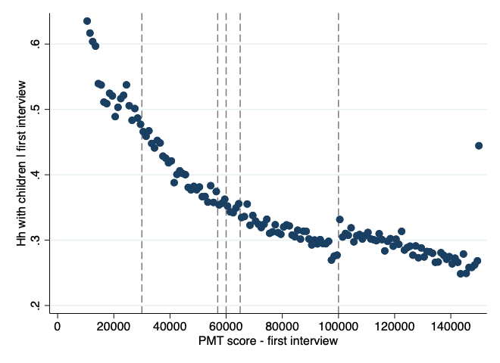
Source: PMT data from Georgian Social Services Agency.

We first test the assumption that households cannot manipulate the PMT score. If this condition holds, the distribution of the PMT would be continuous around the cut-offs. Figure A4.2 shows the PMT distribution for the first and last interview each household had.

Figure A4.2. PMT score distribution for the first and last interview of each household.
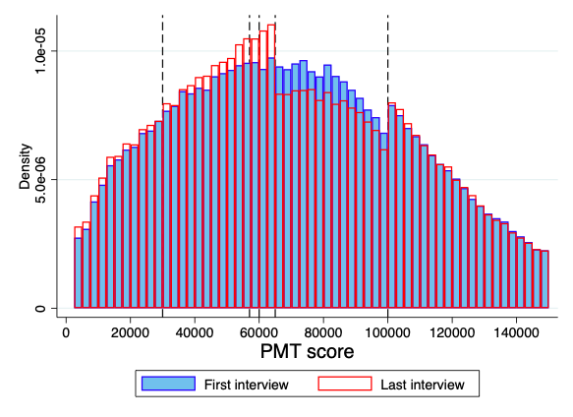 | 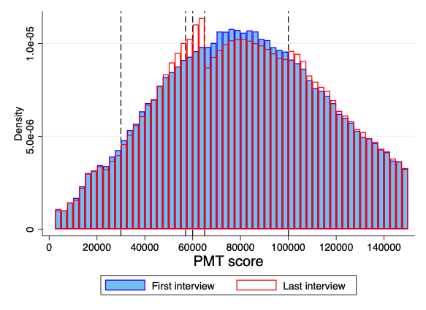
With children | Without children
Source: PMT data from Georgian Social Services Agency.

We can observe that in both cases, for households with and without children, there is obvious score manipulation at the 65K cut-off. The last interview’s distribution drops sharply just after 65K. Also, for households with children the PMT score does not look continuous around the 100K cut-off. For all previous cut-offs (30K, 57K and 60K) the score does look continuous.
Around 65K the score for the first interview is indeed continuous around 65K, showing that when the interview comes for the first time (and households cannot “prepare” for it) households cannot manipulate the score. However, the distribution for the last interview, which decides the benefits a household could receive, sharply falls after 65K showing that households somehow find the way to reduce their score in order to get the TSA benefit.
In addition, figure A4.2 shows that the reason of the discontinuity may come from households asking for a second interview when they are not happy with the initial results (being above 65K and losing the benefits per household member). First, before 65K and after 100K, more than 70% of the households have only one interview. But, just after 65K that proportion drops to 55% and slowly increases to below 70% just before 100K. Additional interviews come from different sources. First, when the household composition and/or wealth changes the SA visits again to reassess the household in order to give a new PMT score which may end up in a different benefit. Second, after 2 years, households could ask for the second interview if they do not agree with the initial assessment.
Figure A4.2 right hand panel shows how for small scores (around 30K), 70% of the additional interviews are requested by the SA. After 65K this proportion drops from around 60% to 40% just below 100K. This behaviour supports the idea that after 65K households have incentives to change their score in order to gain benefits.
Figure A4.2. Probability of having only one interview and probability of having a second interview requested by the SA with respect to the PMT score at the first interview.
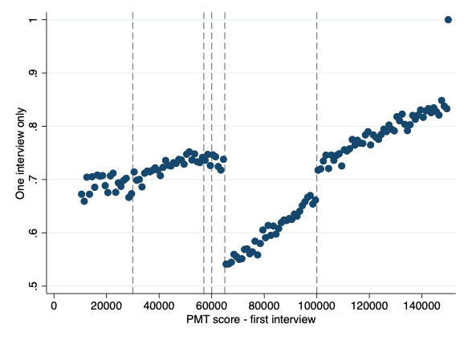 | 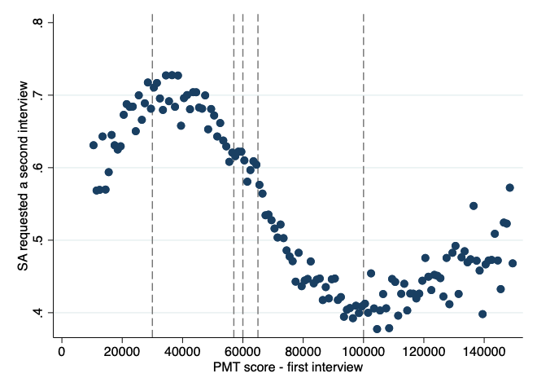
Proportion of households with one interview only | Proportion of households who got a second interview by request of the SA (only for households with more tan one interview)
Source: PMT data from Georgian Social Services Agency. The data about whether the SA requested or not a second interview has around 18% missing values. The distribution of missing values is shown in figure A1.1 in appendix 1.

Using information about the PMT components we try to understand. What changes between the first and the last interview?
Table A4.1, shows the estimated difference between the last and first interview for a set of covariates, including the components of the PMT. We separate the analysis by who asked for the second interview (household (HH) or SA).

Table A4.1. Estimate change between interviews for a set of covariates for households with children and without children.
 | Hh with children |  |  | Hh without children
 | All | HH | SA | All | HH | SA
Family size | -0.096 | 0.193 | -0.212 | -0.172 | -0.116 | -0.150
Family size | (0.175) | (0.221) | (0.298) | (0.096) | (0.226) | (0.125)
Control group mean | -0.460 | -0.582 | -0.467 | 0.037 | 0.012 | -0.008
Bandwidth | 2393.57 | 2555.31 | 2955.84 | 2206.66 | 2018.95 | 1648.05
Effective N | 2173 | 1065 | 854 | 3842 | 1042 | 1726
Adults in HH | -0.206 | 0.044 | -0.393 | -0.125 | -0.120 | -0.070
Adults in HH | (0.127) | (0.167) | (0.212) | (0.075) | (0.173) | (0.107)
Control group mean | -0.427 | -0.520 | -0.355 | -0.071 | -0.079 | -0.120
Bandwidth | 2586.38 | 2726.87 | 2802.12 | 2362.27 | 1905.24 | 1651.65
Effective N | 2337 | 1133 | 808 | 4110 | 989 | 1735
Children in HH | 0.105 | 0.133 | 0.195 | -0.048 | 0.038 | -0.072
Children in HH | (0.081) | (0.107) | (0.153) | (0.036) | (0.065) | (0.048)
Control group mean | -0.027 | -0.052 | -0.114 | 0.110 | 0.075 | 0.108
Bandwidth | 2270.86 | 2397.91 | 2675.66 | 1948.47 | 2715.34 | 1951.91
Effective N | 2068 | 1009 | 773 | 3422 | 1436 | 2031
Hh's head age | -2.513 | -5.403 | -4.260 | -0.569 | -2.128 | 1.264
Hh's head age | (2.368) | (3.855) | (3.039) | (0.969) | (2.121) | (1.221)
Control group mean | -1.981 | -2.777 | 0.615 | 0.801 | 0.148 | 1.043
Bandwidth | 1658.09 | 1459.98 | 2693.48 | 1934.72 | 2062.01 | 1622.25
Effective N | 1488 | 617 | 778 | 3402 | 1064 | 1702
Hh's average age | -1.671 | -1.564 | -4.636⁺ | -0.454 | -3.741⁺ | 0.217
Hh's average age | (1.220) | (1.696) | (2.271) | (0.837) | (1.901) | (0.962)
Control group mean | 1.207 | 1.077 | 2.337 | 0.228 | 0.776 | 0.125
Bandwidth | 2066.07 | 2545.71 | 2418.94 | 2421.01 | 1681.77 | 1807.23
Effective N | 1882 | 1059 | 694 | 4215 | 863 | 1882
Less than 2 y.o. | -0.080 | -0.137 | 0.020 | -0.014 | -0.014 | -0.013
Less than 2 y.o. | (0.064) | (0.098) | (0.099) | (0.018) | (0.041) | (0.021)
Control group mean | -0.021 | -0.030 | 0.004 | 0.039 | 0.046 | 0.030
Bandwidth | 2299.91 | 2108.86 | 2813.19 | 1933.89 | 2067.50 | 2214.29
Effective N | 2085 | 896 | 811 | 3402 | 1064 | 2276
2 to 5 y.o. | 0.040 | -0.015 | 0.172 | -0.019 | -0.001 | -0.026
2 to 5 y.o. | (0.081) | (0.126) | (0.098) | (0.010) | (0.022) | (0.015)
Control group mean | -0.112 | -0.129 | -0.127 | 0.023 | 0.015 | 0.026
Bandwidth | 1989.10 | 2236.24 | 2490.14 | 2801.87 | 2888.52 | 2543.01
Effective N | 1800 | 953 | 720 | 4907 | 1560 | 2584
6 to 17 y.o. | 0.089 | 0.119 | 0.008 | -0.008 | 0.053 | -0.063
6 to 17 y.o. | (0.060) | (0.094) | (0.062) | (0.029) | (0.051) | (0.043)
Control group mean | 0.018 | 0.062 | -0.017 | -0.012 | 0.000 | -0.013
Bandwidth | 1470.45 | 1736.92 | 2861.99 | 1900.56 | 2226.84 | 1629.25
Effective N | 1330 | 736 | 828 | 3341 | 1153 | 1702
18 to 64 y.o. | -0.005 | 0.017 | 0.032 | -0.043 | 0.026 | -0.052
18 to 64 y.o. | (0.020) | (0.017) | (0.032) | (0.035) | (0.058) | (0.053)
Control group mean | -0.011 | -0.019 | -0.011 | -0.004 | -0.033 | 0.001
Bandwidth | 2571.71 | 2297.56 | 2278.05 | 1745.07 | 1951.80 | 1574.30
Effective N | 2328 | 968 | 646 | 3065 | 1016 | 1641
65 y.o. or older | -0.045 | -0.006 | -0.129 | 0.024 | -0.042 | 0.097
65 y.o. or older | (0.058) | (0.095) | (0.097) | (0.037) | (0.063) | (0.060)
Control group mean | -0.072 | -0.112 | -0.050 | 0.022 | 0.028 | 0.033
Bandwidth | 2375.50 | 2217.02 | 2451.69 | 1547.77 | 2191.41 | 1406.11
Effective N | 2152 | 942 | 710 | 2707 | 1132 | 1446
Agricultural land area | -0.007 | 0.643 | -0.016 | -1.158 | 0.065 | -0.056
Agricultural land area | (0.056) | (0.652) | (0.069) | (1.078) | (0.053) | (0.061)
Control group mean | -0.010 | -0.668 | -0.093 | 0.017 | -0.013 | 0.038
Bandwidth | 1925.82 | 5983.89 | 2448.63 | 1507.86 | 1679.47 | 1236.95
Effective N | 1747 | 2348 | 705 | 2627 | 858 | 1297
Cows and buffaloes | 0.108 | 0.089 | 0.364 | -0.017 | 0.029 | -0.021
Cows and buffaloes | (0.096) | (0.075) | (0.255) | (0.032) | (0.061) | (0.052)
Control group mean | -0.066 | -0.071 | -0.145 | -0.039 | -0.058 | -0.043
Bandwidth | 2523.65 | 2258.51 | 2518.33 | 2559.71 | 1792.97 | 2184.30
Effective N | 1726 | 736 | 543 | 3432 | 735 | 1700
Bee hives | -0.001 | -0.001 | -0.001 | -0.003 | -0.000 | -0.005
Bee hives | (0.001) | (0.003) | (0.002) | (0.022) | (0.001) | (0.041)
Control group mean | 0.000 | 0.000 | 0.000 | 0.019 | -0.000 | 0.031
Bandwidth | 1866.87 | 5380.17 | 2385.88 | 3017.13 | 2344.12 | 2550.65
Effective N | 900 | 1194 | 312 | 3489 | 831 | 1629
Poultry | 0.283 | -1.191 | 1.950 | 0.105 | -0.413 | 0.348
Poultry | (0.622) | (0.629) | (1.310) | (0.259) | (0.449) | (0.430)
Control group mean | -0.482 | 0.501 | -1.275 | -0.701 | -0.265 | -1.205
Bandwidth | 2096.46 | 2087.51 | 2735.39 | 2263.18 | 1681.87 | 1942.26
Effective N | 1667 | 769 | 659 | 3662 | 805 | 1878
Travel vehicles or trucks | -0.095 | -0.052 | -0.044 | 0.026 | 0.075 | 0.011
Travel vehicles or trucks | (0.049) | (0.080) | (0.061) | (0.016) | (0.039) | (0.020)
Control group mean | 0.106 | 0.073 | 0.043 | 0.008 | 0.001 | 0.010
Bandwidth | 1832.19 | 2280.85 | 2229.09 | 1909.18 | 2233.06 | 1721.85
Effective N | 1657 | 961 | 631 | 3335 | 1155 | 1802
Tractors | -0.007 | 0.003 | -0.020 | -0.001 | 0.001 | -0.000
Tractors | (0.008) | (0.004) | (0.025) | (0.001) | (0.001) | (0.001)
Control group mean | 0.006 | -0.004 | 0.020 | 0.000 | -0.001 | 0.000
Bandwidth | 2665.73 | 1796.39 | 2596.07 | 1609.13 | 2183.50 | 1538.72
Effective N | 2071 | 657 | 635 | 2719 | 1081 | 1545
Monetary income + state pension + social package | -39.252 | -103.808 | -50.277 | 7.348 | 43.015 | 41.605
Monetary income + state pension + social package | (67.089) | (128.013) | (80.848) | (23.913) | (47.659) | (40.603)
Control group mean | 65.282 | 167.025 | -54.036 | 7.236 | 3.941 | -44.223
Bandwidth | 3031.39 | 3176.38 | 3066.41 | 2274.54 | 1693.46 | 1818.95
Effective N | 2754 | 1327 | 878 | 3949 | 867 | 1893
Monetary income (salary and others) | -23.296 | -92.890 | -8.854 | 17.405 | 56.156 | 56.204
Monetary income (salary and others) | (66.105) | (125.070) | (75.031) | (17.861) | (33.127) | (32.797)
Control group mean | 70.236 | 172.627 | -51.337 | -7.941 | -11.249 | -61.401
Bandwidth | 3048.87 | 3179.05 | 3074.12 | 2494.43 | 1559.12 | 1782.70
Effective N | 2762 | 1327 | 879 | 4329 | 796 | 1866
State pension (standardized) | -9.055 | 0.740 | -42.077⁺ | -7.570 | -2.082 | -0.790
State pension (standardized) | (11.634) | (18.529) | (17.932) | (8.989) | (17.209) | (12.055)
Control group mean | -7.666 | -6.620 | -5.934 | 15.461 | 5.185 | 13.879
Bandwidth | 2442.92 | 2482.23 | 2655.97 | 2150.96 | 1807.24 | 2313.00
Effective N | 2219 | 1042 | 768 | 3766 | 937 | 2351
Social package (standardized) | -2.699 | -7.743 | -1.836 | -8.812⁺ | -6.430 | -11.573
Social package (standardized) | (5.187) | (5.372) | (10.597) | (4.367) | (5.727) | (6.656)
Control group mean | 1.140 | -1.044 | 4.585 | 3.241 | 7.101 | 1.324
Bandwidth | 2510.85 | 2394.53 | 3066.78 | 1967.59 | 1938.67 | 1788.05
Effective N | 2275 | 1009 | 878 | 3452 | 1008 | 1866
Public services expenditure | -21.723 | -78.536 | 42.919 | 13.183 | 26.842 | 23.423
Public services expenditure | (33.007) | (50.471) | (45.365) | (15.721) | (24.040) | (26.043)
Control group mean | 37.364 | 67.416 | -13.223 | 28.803 | 21.930 | 29.809
Bandwidth | 1766.63 | 2093.50 | 2346.69 | 1989.60 | 1708.94 | 2027.82
Effective N | 1588 | 890 | 665 | 3489 | 872 | 2096
Households members (Ln) | -0.014 | 0.065 | -0.052 | -0.099⁺ | -0.094 | -0.091
Households members (Ln) | (0.046) | (0.055) | (0.073) | (0.041) | (0.092) | (0.057)
Control group mean | -0.122 | -0.143 | -0.137 | -0.008 | -0.025 | -0.011
Bandwidth | 2128.07 | 2469.98 | 2938.11 | 2100.25 | 2052.16 | 1646.55
Effective N | 1944 | 1030 | 850 | 3687 | 1057 | 1726
Able to work among adults (%) | -0.039 | 0.071 | -0.350 | -0.061 | -0.054 | 0.034
Able to work among adults (%) | (0.158) | (0.160) | (0.194) | (0.082) | (0.217) | (0.108)
Control group mean | -0.274 | -0.303 | -0.105 | -0.026 | 0.019 | -0.108
Bandwidth | 2006.24 | 2709.55 | 2815.65 | 2164.42 | 1384.30 | 1782.94
Effective N | 1826 | 1125 | 811 | 3786 | 703 | 1866
Male household's head | -0.024 | 0.011 | -0.019 | -0.051 | 0.096 | -0.172*
Male household's head | (0.059) | (0.093) | (0.123) | (0.050) | (0.093) | (0.066)
Control group mean | 0.025 | 0.050 | -0.060 | -0.041 | -0.050 | -0.044
Bandwidth | 2067.86 | 1872.54 | 2085.56 | 1681.88 | 1924.72 | 1262.35
Effective N | 1882 | 788 | 591 | 2966 | 999 | 1320
At least one child (0 to 15) | -0.000 | 0.072 | -0.021 | 0.007 | 0.070 | -0.023
At least one child (0 to 15) | (0.037) | (0.044) | (0.069) | (0.030) | (0.062) | (0.035)
Control group mean | -0.085 | -0.092 | -0.120 | 0.013 | 0.018 | 0.011
Bandwidth | 2026.67 | 2184.14 | 2760.03 | 2447.67 | 2233.86 | 2762.51
Effective N | 1848 | 931 | 795 | 4249 | 1156 | 2822
Children over 18 living outside | 0.051 | -0.019 | 0.030 | -0.011 | -0.123 | 0.028
Children over 18 living outside | (0.053) | (0.078) | (0.101) | (0.037) | (0.072) | (0.044)
Control group mean | -0.060 | -0.042 | -0.077 | 0.014 | 0.055 | -0.019
Bandwidth | 2110.29 | 2038.60 | 2650.89 | 2101.26 | 2111.84 | 2228.99
Effective N | 1933 | 867 | 768 | 3685 | 1088 | 2283
Adults with higher education (%) | -0.007 | 0.008 | -0.027 | -0.029 | -0.160⁺ | 0.018
Adults with higher education (%) | (0.041) | (0.052) | (0.105) | (0.034) | (0.080) | (0.040)
Control group mean | -0.061 | -0.049 | -0.053 | -0.021 | -0.006 | -0.029
Bandwidth | 1899.08 | 2372.39 | 1819.46 | 2345.25 | 2021.42 | 2278.99
Effective N | 1716 | 999 | 515 | 4073 | 1047 | 2325
Residential area (Ln) | 0.014 | 0.002 | -0.080 | -0.002 | 0.023 | 0.014
Residential area (Ln) | (0.057) | (0.095) | (0.117) | (0.043) | (0.106) | (0.056)
Control group mean | -0.007 | 0.045 | -0.041 | 0.015 | 0.042 | -0.032
Bandwidth | 2757.17 | 1986.12 | 2966.83 | 2613.09 | 2647.73 | 2422.51
Effective N | 2490 | 835 | 855 | 4551 | 1392 | 2473
Rooms (Ln) | 0.020 | 0.060 | -0.114 | 0.005 | 0.012 | 0.022
Rooms (Ln) | (0.049) | (0.074) | (0.082) | (0.043) | (0.097) | (0.050)
Control group mean | -0.017 | -0.050 | 0.034 | 0.010 | 0.039 | -0.009
Bandwidth | 2082.76 | 2324.12 | 2135.07 | 1795.41 | 2168.98 | 2113.08
Effective N | 1905 | 975 | 604 | 3157 | 1117 | 2197
Floor material is parquet | -0.002 | 0.035 | -0.051 | 0.015 | -0.004 | 0.004
 | (0.039) | (0.059) | (0.060) | (0.017) | (0.020) | (0.025)
Control group mean | -0.032 | -0.050 | 0.010 | -0.004 | 0.000 | -0.000
Bandwidth | 2599.92 | 1869.11 | 2022.11 | 1987.92 | 2405.47 | 2116.06
Effective N | 2345 | 785 | 579 | 3489 | 1249 | 2197
Household with another housing premises | -0.029 | -0.099 | 0.073 | -0.039⁺ | 0.005 | -0.058
Household with another housing premises | (0.044) | (0.057) | (0.049) | (0.019) | (0.026) | (0.032)
Control group mean | 0.035 | 0.062 | 0.000 | 0.021 | 0.006 | 0.015
Bandwidth | 1810.99 | 2051.70 | 2639.39 | 2576.85 | 1888.40 | 1704.21
Effective N | 1647 | 871 | 763 | 4478 | 972 | 1783
Household without special areas | -0.002 | 0.041 | -0.038 | 0.006 | -0.016 | 0.015
Household without special areas | (0.016) | (0.028) | (0.030) | (0.018) | (0.029) | (0.022)
Control group mean | -0.000 | -0.036 | 0.033 | -0.005 | -0.003 | -0.011
Bandwidth | 2383.32 | 1825.80 | 2201.50 | 2125.84 | 1912.66 | 2044.84
Effective N | 2165 | 774 | 626 | 3719 | 994 | 2116
Other residence --flat/house area (sqm) | -4.799 | -9.049 | 0.193 | -1.714 | 0.066 | -3.111
 | (2.901) | (4.816) | (1.814) | (1.636) | (1.390) | (1.859)
Control group mean | 3.678 | 5.555 | -0.170 | 0.045 | -0.426 | 0.286
Bandwidth | 1744.48 | 1732.44 | 2212.04 | 2110.60 | 2078.04 | 2261.39
Effective N | 1569 | 736 | 629 | 3706 | 1071 | 2314
Other residence --summer house area (sqm) | 1.506 | 0.918 | 3.890 | 1.115 | -0.166 | 2.209
Other residence --summer house area (sqm) | (1.114) | (0.680) | (3.131) | (0.970) | (0.415) | (1.615)
Control group mean | -0.851 | -0.357 | -2.178 | 0.207 | 0.352 | -0.121
Bandwidth | 2576.95 | 2364.76 | 2395.79 | 1988.58 | 1892.86 | 1773.09
Effective N | 2328 | 993 | 684 | 3489 | 982 | 1854
Standard errors clustered at municipality level in parentheses + p < 0.05, * p < 0.01, ** p < 0.001
We do not find changes in households assets, but we find changes in the household composition. The following figure summarize the possible strategy. Panel a shows than in average household size reduces between interviews, possible due to death of an old member or some members moving out to create a new household. However, after 65K, the average household size change is smaller. When we check if the household size changes due to changes in the number of children or adults, panels b and c show that the changes in children are random and continuous around all cut-offs, while the change in the number of adults is not continuous around 65K.
Figure A4.3 – Changes in selected covariates between first and last interview.
- Household size | - Adults in the household
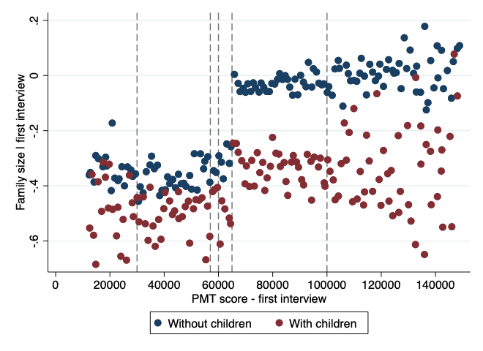 | 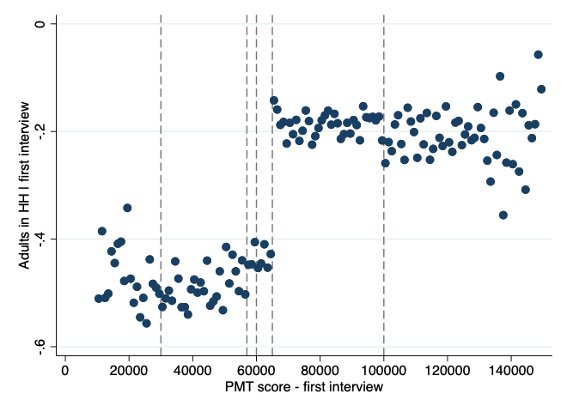
- Children in the household | - Proportion of 18 to 64
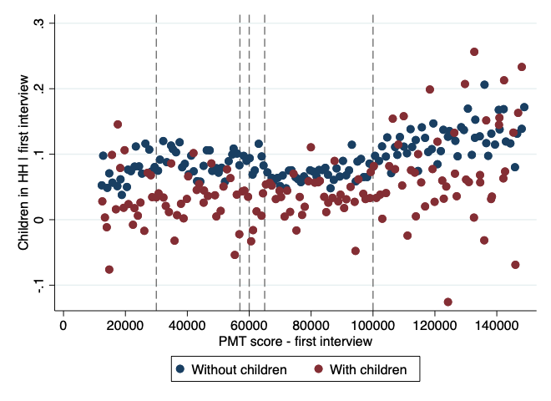 | 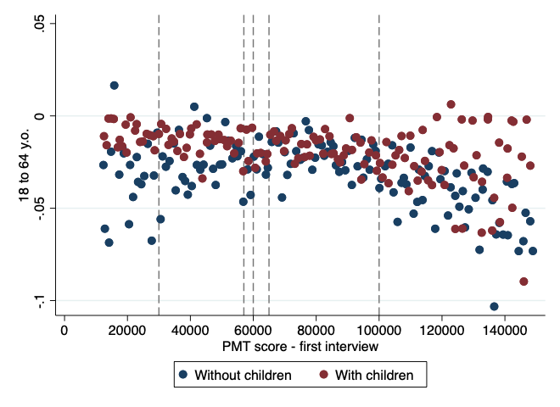
- Proportion of 65 years or more | - State pension
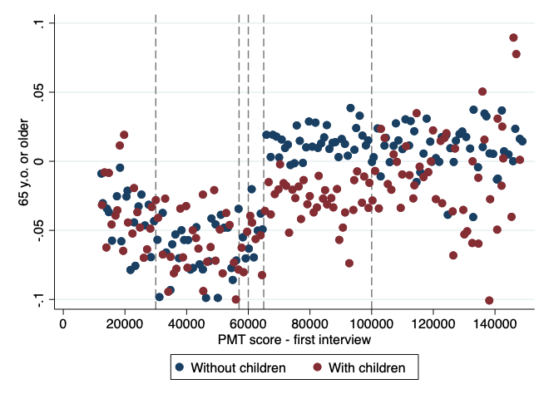 | 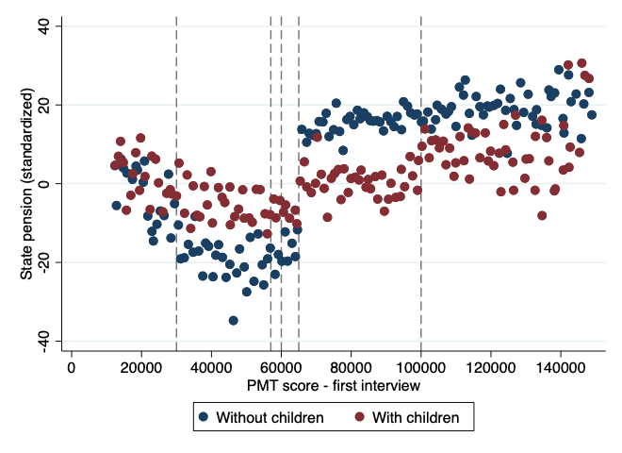
Notes: Changes between interviews only for households with more than one interview. Bin size 1000.
Source: Econometria Consultores. 2020
There after, we divide adults from working adults (18 to 64) to adults after 65, we find that the discontinuity comes from the number of older adults. We find also a change in the income coming from pensions, which is also not continuous around 65K. For the latest we infer that households may try to include old relatives to the household in order to reduce their score.
Second, in order to identify the impact of the TSA benefit, all other observable (and unobservable) confounding factors should be continuous around the cut-offs. Conditional on having or not children in the first interview, we test for continuity of other observable variables, including those who enter into the PMT equation. Tables A4.2 and A4.3 show the estimated change of a set of variables by cut-off for households with and without children respectively. Even though there are some indicators were the difference around some cut-offs are statistically significant, we do not find any systematic changes that could rise doubts about the continuity assumption.

Table A4.2. Continuity test around each cut-off for households with children.
 | 30K | 57K | 60K | 65K | 100K
Family size | -0.080 | -0.048 | 0.301 | -0.014 | 0.001
 | (0.118) | (0.160) | (0.199) | (0.157) | (0.120)
Control group mean | 4.950 | 4.930 | 4.671 | 4.805 | 4.942
Bandwidth | 8838.92 | 2463.01 | 1493.69 | 2412.36 | 13166.61
Effective N | 17512 | 6197 | 3756 | 6038 | 25289
Adults in HH | -0.099 | -0.165 | 0.173 | 0.140 | -0.021
 | (0.096) | (0.131) | (0.150) | (0.147) | (0.097)
Control group mean | 3.029 | 3.120 | 2.898 | 2.860 | 3.220
Bandwidth | 9902.67 | 2345.97 | 1456.55 | 2239.87 | 14086.37
Effective N | 19566 | 5871 | 3667 | 5604 | 27091
Hh's head age | -0.887 | -0.852 | -2.068 | 0.671 | -0.493
 | (0.990) | (1.463) | (2.050) | (1.380) | (1.173)
Control group mean | 47.390 | 50.061 | 50.888 | 48.437 | 54.576
Bandwidth | 10067.89 | 2136.79 | 1305.15 | 3173.05 | 16360.41
Effective N | 19870 | 5360 | 3249 | 7945 | 31428
Hh's average age | -0.463 | -0.528 | -0.490 | 1.274 | -0.438
 | (0.473) | (0.751) | (1.055) | (0.732) | (0.439)
Control group mean | 24.368 | 26.278 | 26.008 | 25.025 | 29.306
Bandwidth | 12376.63 | 1958.80 | 1227.58 | 2798.97 | 17977.36
Effective N | 24346 | 4917 | 3046 | 7041 | 34517
Year first interview | -0.035 | -0.004 | 0.022 | 0.047 | -0.006
 | (0.071) | (0.127) | (0.157) | (0.115) | (0.051)
Control group mean | 2016.092 | 2016.409 | 2016.441 | 2016.417 | 2016.424
Bandwidth | 8752.43 | 2345.88 | 1709.11 | 2293.74 | 15517.63
Effective N | 17360 | 5871 | 4263 | 5730 | 29821
First interview in 2019 | -0.000 | -0.007 | 0.005 | 0.001 | -0.005
 | (0.010) | (0.023) | (0.035) | (0.021) | (0.012)
Control group mean | 0.033 | 0.076 | 0.104 | 0.090 | 0.105
Bandwidth | 10874.62 | 2088.70 | 1615.51 | 2420.08 | 15672.36
Effective N | 21458 | 5239 | 4039 | 6076 | 30137
Voucher | 0.021 | -0.011 | 0.073 | 0.006 | 0.026
 | (0.093) | (0.098) | (0.085) | (0.089) | (0.089)
Control group mean | 0.201 | 0.228 | 0.136 | 0.198 | 0.206
Bandwidth | 15117.97 | 2753.10 | 1236.46 | 3417.22 | 27560.72
Effective N | 29573 | 6930 | 3070 | 8518 | 52115
Voucher + SMS | -0.015 | 0.016 | 0.021 | -0.023 | -0.034
 | (0.077) | (0.079) | (0.094) | (0.070) | (0.082)
Control group mean | 0.187 | 0.163 | 0.157 | 0.165 | 0.213
Bandwidth | 15587.87 | 3191.55 | 1540.80 | 3892.36 | 17367.00
Effective N | 30513 | 7807 | 3876 | 9685 | 33324
Cash | -0.012 | -0.005 | 0.063 | -0.035 | -0.016
 | (0.095) | (0.097) | (0.083) | (0.099) | (0.084)
Control group mean | 0.242 | 0.221 | 0.156 | 0.249 | 0.207
Bandwidth | 14009.89 | 3048.25 | 1827.27 | 3933.74 | 24326.88
Effective N | 27467 | 7637 | 4580 | 9793 | 46315
Cash + SMS | 0.009 | -0.065 | -0.113 | 0.038 | -0.006
 | (0.068) | (0.087) | (0.110) | (0.086) | (0.084)
Control group mean | 0.167 | 0.225 | 0.319 | 0.189 | 0.214
Bandwidth | 12982.45 | 2940.85 | 1228.76 | 3891.74 | 20832.75
Effective N | 25490 | 7441 | 3046 | 9685 | 39961
Tbilisi | -0.003 | 0.064 | -0.038 | 0.016 | 0.025
 | (0.129) | (0.125) | (0.132) | (0.126) | (0.113)
Control group mean | 0.205 | 0.160 | 0.216 | 0.197 | 0.162
Bandwidth | 14125.53 | 3113.91 | 1533.14 | 4019.24 | 23086.77
Effective N | 27666 | 7711 | 3848 | 9977 | 44117
Monetary subsistence allowance | 2.781 | 0.925 | -0.638 | 7.980 | -2.617
 | (15.226) | (13.634) | (15.977) | (10.406) | (1.739)
Control group mean | 164.414 | 64.628 | 51.613 | 37.843 | 7.079
Bandwidth | 8994.97 | 2459.11 | 1265.15 | 3010.46 | 11811.20
Effective N | 17809 | 6169 | 3146 | 7579 | 22735
Agricultural land area | -0.011 | -0.038 | -0.018 | -0.126 | -0.485
 | (0.038) | (0.055) | (0.058) | (0.090) | (0.587)
Control group mean | 0.190 | 0.269 | 0.259 | 0.381 | 0.972
Bandwidth | 4335.88 | 2978.77 | 1487.09 | 6415.10 | 18545.89
Effective N | 8514 | 7515 | 3738 | 14138 | 35597
Animal assets | 0.100 | -0.418 | -0.025 | -0.163 | -0.270
 | (0.289) | (0.498) | (0.575) | (0.473) | (0.589)
Control group mean | 1.376 | 2.395 | 2.087 | 2.087 | 3.348
Bandwidth | 13523.27 | 2573.83 | 1323.67 | 2853.35 | 17495.51
Effective N | 26525 | 6478 | 3298 | 7203 | 33595
Vehicles | 0.000 | -0.006 | 0.000 | -0.001 | -0.004
 | (.) | (0.003) | (.) | (0.001) | (0.006)
Control group mean | 0.000 | 0.003 | 0.000 | 0.000 | 0.009
Bandwidth | 0.00 | 1806.40 | 0.00 | 2500.27 | 13173.10
Effective N | 49473 | 4349 | 9466 | 5870 | 20284
Monetary income + state pension + social package | -12.470 | 25.993 | 7.118 | -25.793 | 29.624
 | (19.084) | (39.189) | (40.067) | (34.279) | (30.974)
Control group mean | 265.377 | 248.070 | 194.692 | 251.240 | 367.462
Bandwidth | 12593.33 | 2515.79 | 1191.08 | 2698.42 | 13351.47
Effective N | 24818 | 6324 | 2984 | 6773 | 25657
Monetary income (salary and others) | -14.157 | 30.538 | 11.534 | -33.330 | 33.408
 | (15.658) | (33.256) | (32.350) | (31.087) | (32.332)
Control group mean | 353.078 | 319.879 | 270.793 | 333.047 | 411.918
Bandwidth | 12322.86 | 2405.55 | 1125.60 | 2510.05 | 13685.87
Effective N | 24246 | 6035 | 2788 | 6295 | 26288
State pension (standardized) | -3.061 | -1.801 | -2.909 | 3.216 | -2.328
 | (4.199) | (9.045) | (11.459) | (7.163) | (5.509)
Control group mean | -114.007 | -102.171 | -100.952 | -106.574 | -71.802
Bandwidth | 12336.24 | 2145.23 | 1379.57 | 2898.62 | 20678.90
Effective N | 24268 | 5385 | 3439 | 7309 | 39660
Social package (standardized) | 4.672 | -4.288 | 0.676 | 2.637 | -1.223
 | (3.149) | (5.452) | (7.374) | (5.546) | (2.971)
Control group mean | 26.186 | 32.784 | 24.254 | 24.922 | 26.100
Bandwidth | 10608.73 | 2226.91 | 1281.32 | 2403.26 | 12402.02
Effective N | 20935 | 5584 | 3199 | 6009 | 23859
Public services expenditure | 6.988 | 30.335 | -11.538 | -25.385 | 6.662
 | (19.951) | (30.104) | (36.696) | (27.661) | (37.395)
Control group mean | 166.023 | 231.115 | 272.253 | 290.787 | 378.828
Bandwidth | 8353.01 | 2884.97 | 1219.81 | 2081.85 | 22891.98
Effective N | 16549 | 7274 | 3026 | 5235 | 43729
Households members (Ln) | -0.011 | -0.000 | 0.060 | -0.002 | 0.002
 | (0.025) | (0.033) | (0.042) | (0.034) | (0.026)
Control group mean | 1.536 | 1.533 | 1.490 | 1.513 | 1.545
Bandwidth | 8487.08 | 2493.39 | 1413.44 | 2302.21 | 12796.33
Effective N | 16834 | 6267 | 3556 | 5762 | 24597
Able to work among adults (%) | -0.079 | -0.167 | 0.189 | -0.010 | 0.001
 | (0.074) | (0.101) | (0.112) | (0.101) | (0.066)
Control group mean | 2.177 | 2.318 | 2.067 | 2.127 | 2.387
Bandwidth | 8834.12 | 2268.07 | 1660.96 | 2239.36 | 12484.59
Effective N | 17512 | 5685 | 4159 | 5604 | 24018
Male household's head | -0.018 | 0.074 | -0.016 | 0.111* | -0.007
 | (0.028) | (0.044) | (0.057) | (0.038) | (0.023)
Control group mean | 0.587 | 0.574 | 0.589 | 0.551 | 0.651
Bandwidth | 10331.15 | 2105.50 | 1262.66 | 2110.36 | 16008.44
Effective N | 20409 | 5278 | 3146 | 5299 | 30761
Children over 18 living outside | -0.043 | -0.106⁺ | -0.012 | -0.006 | -0.013
 | (0.028) | (0.042) | (0.066) | (0.051) | (0.043)
Control group mean | 0.360 | 0.503 | 0.466 | 0.410 | 0.575
Bandwidth | 9428.66 | 2081.71 | 1355.45 | 2095.11 | 18690.53
Effective N | 18627 | 5239 | 3386 | 5251 | 35882
Adults with higher education (%) | -0.030 | 0.026 | -0.025 | -0.026 | 0.020
 | (0.040) | (0.060) | (0.076) | (0.052) | (0.052)
Control group mean | 0.185 | 0.199 | 0.205 | 0.239 | 0.341
Bandwidth | 10887.51 | 2844.92 | 1384.33 | 2902.22 | 14860.71
Effective N | 21470 | 7171 | 3465 | 7330 | 28612
Residential area (Ln) | -0.002 | -0.054 | -0.033 | -0.001 | -0.043
 | (0.095) | (0.109) | (0.115) | (0.113) | (0.105)
Control group mean | 4.083 | 4.300 | 4.231 | 4.256 | 4.568
Bandwidth | 9937.31 | 2433.53 | 1228.88 | 2991.02 | 20470.55
Effective N | 19618 | 6124 | 3046 | 7542 | 39265
Rooms (Ln) | -0.041 | -0.044 | 0.020 | -0.025 | -0.022
 | (0.051) | (0.062) | (0.067) | (0.069) | (0.061)
Control group mean | 0.919 | 1.084 | 1.018 | 1.053 | 1.298
Bandwidth | 10766.56 | 2467.30 | 1632.14 | 2568.15 | 22667.38
Effective N | 21245 | 6197 | 4098 | 6431 | 43279
Floor material is parquet | -0.004 | 0.008 | 0.006 | 0.049 | 0.019
 | (0.025) | (0.043) | (0.055) | (0.044) | (0.052)
Control group mean | 0.080 | 0.091 | 0.115 | 0.099 | 0.126
Bandwidth | 9384.76 | 2114.93 | 1680.72 | 2958.23 | 16259.90
Effective N | 18550 | 5298 | 4216 | 7448 | 31232
Household with another housing premises | -0.003 | 0.001 | 0.015 | -0.011 | -0.002
 | (0.008) | (0.014) | (0.024) | (0.018) | (0.015)
Control group mean | 0.031 | 0.031 | 0.036 | 0.042 | 0.070
Bandwidth | 11461.12 | 2333.64 | 1137.18 | 2503.17 | 15562.96
Effective N | 22566 | 5850 | 2818 | 6278 | 29912
Household without special areas | -0.012 | 0.004 | -0.003 | -0.013 | -0.015
 | (0.006) | (0.016) | (0.020) | (0.014) | (0.015)
Control group mean | 0.019 | 0.027 | 0.024 | 0.031 | 0.085
Bandwidth | 8949.37 | 2224.60 | 1075.23 | 2016.79 | 12320.91
Effective N | 17722 | 5584 | 2669 | 5069 | 23719
Other residence --flat/house area (sqm) | 0.008 | 0.960 | 0.038 | 1.291 | -0.211
 | (0.775) | (0.868) | (1.415) | (1.210) | (0.860)
Control group mean | 1.981 | 0.889 | 2.714 | 1.148 | 4.500
Bandwidth | 9581.80 | 2232.85 | 1164.08 | 2728.56 | 18584.77
Effective N | 18963 | 5612 | 2908 | 6861 | 35663
Other residence --summer house area (sqm) | -0.223 | -0.614 | 2.008 | -0.633 | 0.349
 | (0.428) | (0.455) | (1.365) | (0.389) | (0.563)
Control group mean | 0.551 | 0.557 | 0.018 | 0.602 | 0.593
Bandwidth | 11534.92 | 1499.08 | 1425.27 | 2754.28 | 17449.46
Effective N | 22698 | 3736 | 3581 | 6930 | 33498
Standard errors clustered at municipality level in parentheses + p < 0.05, * p < 0.01, ** p < 0.001
Table A4.2. Continuity test around each cut-off for households withou children.
 | 30K | 57K | 60K | 65K | 100K
Family size | -0.088 | 0.030 | -0.218 | 0.013 | -0.027
 | (0.071) | (0.096) | (0.113) | (0.081) | (0.056)
Control group mean | 2.400 | 2.028 | 2.237 | 2.022 | 2.179
Bandwidth | 9567.21 | 2439.81 | 1257.46 | 2690.34 | 19009.07
Effective N | 21348 | 10799 | 5665 | 12844 | 83987
Adults in HH | -0.088 | 0.030 | -0.218 | 0.013 | -0.027
 | (0.071) | (0.096) | (0.113) | (0.081) | (0.056)
Control group mean | 2.400 | 2.028 | 2.237 | 2.022 | 2.179
Bandwidth | 9567.21 | 2439.81 | 1257.46 | 2690.34 | 19009.07
Effective N | 21348 | 10799 | 5665 | 12844 | 83987
Hh's head age | 0.564 | -0.878 | -0.845 | -0.427 | -0.064
 | (0.930) | (0.991) | (1.368) | (0.897) | (0.486)
Control group mean | 61.692 | 66.378 | 67.207 | 66.704 | 65.894
Bandwidth | 10198.67 | 2024.66 | 1217.22 | 2251.09 | 21477.57
Effective N | 22790 | 8990 | 5468 | 10730 | 94302
Hh's average age | 1.247 | -0.429 | 0.279 | 0.083 | 0.425
 | (1.098) | (1.315) | (1.724) | (1.168) | (0.739)
Control group mean | 52.567 | 60.123 | 59.643 | 60.191 | 58.364
Bandwidth | 9684.21 | 2198.91 | 1155.78 | 2791.83 | 17810.98
Effective N | 21622 | 9736 | 5185 | 13347 | 78943
Year first interview | 0.014 | -0.114 | -0.004 | 0.091 | 0.016
 | (0.071) | (0.073) | (0.098) | (0.068) | (0.046)
Control group mean | 2015.873 | 2016.090 | 2016.054 | 2015.945 | 2016.031
Bandwidth | 12759.37 | 1942.18 | 1211.50 | 2636.89 | 17001.80
Effective N | 28967 | 8666 | 5468 | 12531 | 75469
First interview in 2019 | 0.003 | -0.016 | -0.021 | 0.022⁺ | -0.002
 | (0.006) | (0.010) | (0.013) | (0.010) | (0.005)
Control group mean | 0.019 | 0.028 | 0.043 | 0.014 | 0.035
Bandwidth | 10100.94 | 1975.33 | 1352.38 | 1886.84 | 17406.42
Effective N | 22592 | 8783 | 6122 | 9034 | 77213
Voucher | 0.026 | 0.022 | -0.002 | 0.018 | 0.020
 | (0.083) | (0.081) | (0.085) | (0.077) | (0.077)
Control group mean | 0.175 | 0.179 | 0.211 | 0.197 | 0.201
Bandwidth | 17728.63 | 3182.25 | 2256.87 | 4041.66 | 25846.48
Effective N | 40909 | 13617 | 10286 | 19312 | 111929
Voucher + SMS | -0.028 | -0.019 | -0.028 | 0.002 | -0.006
 | (0.065) | (0.068) | (0.073) | (0.075) | (0.070)
Control group mean | 0.170 | 0.176 | 0.168 | 0.181 | 0.184
Bandwidth | 11970.46 | 3268.87 | 1160.32 | 3609.85 | 19219.71
Effective N | 27042 | 13795 | 5231 | 17176 | 84858
Cash | -0.015 | -0.023 | 0.018 | -0.029 | -0.016
 | (0.091) | (0.091) | (0.098) | (0.091) | (0.086)
Control group mean | 0.251 | 0.256 | 0.253 | 0.252 | 0.246
Bandwidth | 12183.16 | 3177.63 | 1469.46 | 3683.24 | 26639.63
Effective N | 27554 | 13595 | 6649 | 17549 | 115087
Cash + SMS | 0.011 | 0.020 | -0.037 | -0.020 | -0.003
 | (0.085) | (0.087) | (0.085) | (0.082) | (0.080)
Control group mean | 0.222 | 0.231 | 0.243 | 0.234 | 0.225
Bandwidth | 17959.25 | 3273.25 | 2156.17 | 3948.25 | 21017.39
Effective N | 41479 | 13824 | 9829 | 18808 | 92421
Tbilisi | -0.011 | 0.002 | 0.019 | 0.028 | 0.004
 | (0.115) | (0.100) | (0.098) | (0.095) | (0.090)
Control group mean | 0.194 | 0.158 | 0.145 | 0.136 | 0.144
Bandwidth | 16711.76 | 3713.15 | 1549.49 | 3828.69 | 27189.10
Effective N | 38539 | 14733 | 7040 | 18220 | 117296
Monetary subsistence allowance | -2.724 | 1.957 | -9.246 | 6.980 | -0.591
 | (5.599) | (5.499) | (8.107) | (4.818) | (1.446)
Control group mean | 98.201 | 64.520 | 69.105 | 44.569 | 11.474
Bandwidth | 10572.12 | 2323.84 | 1131.13 | 2593.33 | 12383.24
Effective N | 23667 | 10297 | 5104 | 12343 | 55280
Agricultural land area | -0.005 | -0.014 | 0.009 | 0.023 | 0.023
 | (0.024) | (0.078) | (0.046) | (0.042) | (0.054)
Control group mean | 0.135 | 0.200 | 0.210 | 0.212 | 0.331
Bandwidth | 15893.76 | 1483.95 | 1105.27 | 2061.52 | 9915.77
Effective N | 36533 | 6593 | 4963 | 9872 | 44558
Animal assets | -0.102 | 0.155 | -0.241 | 0.014 | -0.030
 | (0.165) | (0.229) | (0.342) | (0.281) | (0.354)
Control group mean | 0.799 | 0.970 | 1.494 | 1.444 | 2.530
Bandwidth | 12219.26 | 2293.45 | 1474.45 | 2445.54 | 21696.74
Effective N | 27628 | 10162 | 6703 | 11628 | 95279
Vehicles | 0.000 | 0.000 | 0.000 | -0.000 | -0.001
 | (.) | (.) | (.) | (0.000) | (0.001)
Control group mean | 0.000 | 0.000 | 0.000 | 0.000 | 0.001
Bandwidth | 27490.00 | 26990.00 | 4990.00 | 10925.75 | 18349.41
Effective N | 62621 | 52320 | 18224 | 38464 | 77393
Monetary income + state pension + social package | -10.771 | 23.230 | -45.564 | 4.397 | -13.718
 | (14.935) | (20.866) | (25.656) | (16.827) | (9.282)
Control group mean | 274.524 | 265.722 | 306.406 | 254.064 | 249.774
Bandwidth | 11621.47 | 2339.16 | 1070.25 | 3056.53 | 15941.08
Effective N | 26189 | 10342 | 4807 | 14580 | 70811
Monetary income (salary and others) | 1.357 | 19.610 | -40.481⁺ | 4.024 | -9.135
 | (10.127) | (15.511) | (16.705) | (12.038) | (9.071)
Control group mean | 288.249 | 262.727 | 291.823 | 249.526 | 253.308
Bandwidth | 7447.92 | 2313.49 | 988.03 | 3006.14 | 14269.96
Effective N | 16332 | 10255 | 4396 | 14334 | 63577
State pension (standardized) | 0.094 | -1.161 | -3.913 | -7.501 | -2.911
 | (7.587) | (8.196) | (9.979) | (7.742) | (3.753)
Control group mean | -51.769 | -20.195 | -11.911 | -15.143 | -21.120
Bandwidth | 10410.27 | 2329.04 | 1684.48 | 2546.57 | 14899.18
Effective N | 23297 | 10297 | 7700 | 12103 | 66277
Social package (standardized) | -3.229 | 5.884 | -3.935 | 5.891 | -3.161⁺
 | (3.059) | (4.027) | (4.674) | (3.641) | (1.447)
Control group mean | 38.577 | 22.506 | 26.915 | 20.469 | 19.573
Bandwidth | 9015.63 | 2063.34 | 1245.33 | 2423.42 | 14493.62
Effective N | 20009 | 9165 | 5620 | 11531 | 64548
Public services expenditure | -1.243 | 4.376 | 15.629 | 9.110 | -5.532
 | (5.996) | (14.353) | (11.421) | (12.432) | (20.497)
Control group mean | 79.419 | 126.795 | 125.292 | 135.636 | 218.192
Bandwidth | 11688.21 | 2328.63 | 1795.87 | 3256.88 | 26693.46
Effective N | 26317 | 10297 | 8168 | 15460 | 115309
Households members (Ln) | -0.034 | 0.011 | -0.099 | 0.010 | -0.012
 | (0.030) | (0.044) | (0.054) | (0.034) | (0.024)
Control group mean | 0.705 | 0.555 | 0.663 | 0.548 | 0.625
Bandwidth | 9358.65 | 2348.07 | 1070.63 | 2966.10 | 18279.15
Effective N | 20853 | 10387 | 4807 | 14141 | 80920
Able to work among adults (%) | -0.072 | 0.074 | -0.144 | 0.038 | -0.002
 | (0.068) | (0.098) | (0.118) | (0.088) | (0.053)
Control group mean | 1.437 | 1.035 | 1.171 | 1.040 | 1.250
Bandwidth | 9970.63 | 1874.22 | 1415.51 | 2610.17 | 16755.87
Effective N | 22299 | 8343 | 6420 | 12432 | 74413
Male household's head | 0.014 | 0.025 | 0.001 | 0.045 | -0.000
 | (0.022) | (0.034) | (0.044) | (0.029) | (0.022)
Control group mean | 0.459 | 0.483 | 0.519 | 0.453 | 0.492
Bandwidth | 10939.35 | 1935.26 | 1121.12 | 2397.53 | 18416.48
Effective N | 24519 | 8615 | 5055 | 11391 | 81492
At least one child (0 to 15) | -0.002 | -0.002 | -0.023 | -0.006 | -0.007
 | (0.015) | (0.017) | (0.019) | (0.017) | (0.007)
Control group mean | 0.126 | 0.067 | 0.070 | 0.072 | 0.066
Bandwidth | 10674.75 | 2146.60 | 1504.27 | 2385.89 | 16753.66
Effective N | 23890 | 9508 | 6855 | 11353 | 74413
Children over 18 living outside | 0.032 | 0.025 | -0.024 | -0.038 | -0.019
 | (0.028) | (0.037) | (0.049) | (0.040) | (0.027)
Control group mean | 0.459 | 0.611 | 0.657 | 0.661 | 0.755
Bandwidth | 9406.12 | 2544.57 | 1283.11 | 2141.78 | 14278.93
Effective N | 20968 | 11258 | 5807 | 10266 | 63615
Adults with higher education (%) | -0.021 | -0.009 | -0.014 | 0.000 | 0.004
 | (0.025) | (0.027) | (0.037) | (0.028) | (0.021)
Control group mean | 0.102 | 0.094 | 0.094 | 0.108 | 0.136
Bandwidth | 9672.21 | 2550.84 | 1323.74 | 3304.30 | 22600.53
Effective N | 21601 | 11297 | 5999 | 15691 | 98909
Residential area (Ln) | -0.026 | -0.006 | -0.067 | -0.028 | -0.019
 | (0.091) | (0.096) | (0.098) | (0.091) | (0.085)
Control group mean | 3.809 | 4.050 | 4.156 | 4.118 | 4.445
Bandwidth | 11313.87 | 2376.33 | 1826.82 | 2339.47 | 24629.73
Effective N | 25420 | 10521 | 8301 | 11114 | 107086
Rooms (Ln) | -0.024 | -0.047 | -0.046 | -0.028 | -0.008
 | (0.046) | (0.057) | (0.066) | (0.052) | (0.052)
Control group mean | 0.674 | 0.892 | 0.939 | 0.908 | 1.169
Bandwidth | 13837.36 | 2417.96 | 1501.05 | 2722.91 | 25230.31
Effective N | 31630 | 10717 | 6855 | 12994 | 109593
Floor material is parquet | 0.041 | -0.042 | 0.048 | 0.008 | -0.005
 | (0.030) | (0.036) | (0.037) | (0.035) | (0.042)
Control group mean | 0.084 | 0.121 | 0.080 | 0.098 | 0.118
Bandwidth | 8513.92 | 2430.94 | 1405.48 | 2685.87 | 26326.09
Effective N | 18832 | 10799 | 6363 | 12795 | 113894
Household with another housing premises | -0.007 | 0.008 | 0.007 | -0.001 | 0.002
 | (0.008) | (0.012) | (0.018) | (0.011) | (0.007)
Control group mean | 0.026 | 0.028 | 0.038 | 0.032 | 0.045
Bandwidth | 11236.42 | 2089.45 | 1593.51 | 2323.23 | 14749.30
Effective N | 25230 | 9254 | 7265 | 11070 | 65642
Household without special areas | 0.001 | 0.001 | 0.018 | -0.013 | -0.001
 | (0.004) | (0.011) | (0.015) | (0.012) | (0.009)
Control group mean | 0.009 | 0.027 | 0.014 | 0.045 | 0.062
Bandwidth | 11871.17 | 2032.60 | 1096.47 | 2364.99 | 14157.35
Effective N | 26798 | 9038 | 4907 | 11248 | 63126
Other residence --flat/house area (sqm) | -0.269 | -0.053 | -0.670 | -0.237 | 0.010
 | (0.566) | (0.736) | (1.339) | (0.695) | (0.424)
Control group mean | 1.418 | 1.629 | 2.890 | 1.820 | 2.504
Bandwidth | 9658.14 | 2218.15 | 1519.01 | 2556.43 | 13874.62
Effective N | 21555 | 9838 | 6901 | 12142 | 61861
Other residence --summer house area (sqm) | 0.059 | 0.249 | -0.310 | -0.324 | -0.555
 | (0.223) | (0.216) | (0.313) | (0.276) | (0.561)
Control group mean | 0.158 | 0.015 | 0.375 | 0.284 | 0.718
Bandwidth | 8909.65 | 1716.87 | 1193.53 | 1927.25 | 19401.18
Effective N | 19759 | 7640 | 5375 | 9231 | 85660
Standard errors clustered at municipality level in parentheses + p < 0.05, * p < 0.01, ** p < 0.001
Based on this evidence we set the following constraints to the analysis:
- Use a FRDD using the households’ first score for the analysis.
- Unfortunately, the conditions for impact evaluation using RDD at 100K do not hold, so we exclude this cut-off for the evaluation.

Appendix 5. Terms of reference
Terms of Reference (ToR) for
Impact Evaluation of Targeted Social Assistance (TSA) in Georgia

- BACKGROUND AND CONTEXT
In 2006 the Law of Georgia on Social Assistance was adopted, giving birth to Targeted Social Assistance (TSA) – a cash transfer program for the most socially vulnerable living below the subsistence minimum. After its introduction, the TSA became the main instrument of the Government of Georgia (GoG) to support poor households.

The TSA is administered by the Social Service Agency of Georgia (SSA) with oversight and guidance from the Ministry of Labor, Health and Social Affairs (MoLHSA). To target poor households, due to informal economy, the TSA program uses a Proxy Means Test (PMT) instead of sole reliance on the data related to income from formal sources. Households willing to receive social assistance apply to SSA and get registered in the United Database for Socially Unprotected Families (UDSUF). After applications are processed, social agents assess economic situation of each household in UDSUF and assign PMT scores in accordance with the Methodology of Socio-Economic Appraisal of Vulnerable Families (GoG Decree #758).

Household assigned scores determine if and how much social assistance a household is entitled to receive. The scores reflect poverty status of a household, lower scores indicate more poverty. Score 100 000 indicates the subsistence minimum.

Due to more than the 5th of 3.7 million people – country’s total population living below the absolute poverty line (majority of them stay chronically poor), about 25% (326,101 households containing 972,623 individuals) of the total population applied and got registered in the UDSUF database. However, only around 12% population have the PMT scores that qualify for and are granted the TSA cash benefits.

Through its biannual panel data research – Welfare Monitoring Survey (WMS) conducted from 2009, UNICEF identified that although households with children were more likely to be in poverty, they were not adequately covered by the TSA. Using WMS data on child poverty as well as on inclusion/exclusion errors of existing TSA targeting mechanism, the UNICEF Social Policy Section advocated with the GoG for reforming the TSA. This translated into a formal agreement between UNICEF, SSA, the Ministry of Labour, Health and Social Affairs of Georgia (MoLHSA) and a reform of TSA was undertaken between 2013-2015.

The goal of the reform was to overhaul the old means tested cash benefit scheme and increase the amount of cash benefits delivered to households with children. The reform is documented in UNICEF-World Bank joint report "Continuous Improvement Strengthening Georgia’s Targeted Social Assistance Program”

As a result of the reform:
- New PMT methodology was developed;
- New Benefit schemes, including cash benefit scheme for children living in poor households were introduced;
- Administrative and business processes of the program were amended;
- New legislation was passed modifying the targeting formula as well as the scheme of benefits. The modified formula ascribes more weight to the needs of families with children.

Moreover, before the reform there was only one category of TSA recipients. In each recipient household, the first family member and the subsequent members were receiving different amounts of cash. However, after the reform in 2015, five categories of TSA recipients were created with every family member in the household receiving equal amount of benefits. Categories were determined by PMT scores:
- Bellow 30001 - Gel 60 per each member;
- From 30001 to 57001 - Gel 50 per each member;
- From 57001 to 60001 - Gel 40 per each member;
- From 60001 to 65001 - Gel 30 per each member;
- Below 100001 - Gel 10 per each child under 16 (if there is a child in a household). Households with scores over 100 000 do not receive any cash benefits from the TSA.

After the reform was finished in 2015 the SSA started to reassess TSA recipient and applicant households in accordance with new PMT formula. The reassessment was finished and the reform became operational in summer 2017.

Figure 1. # of households registered in the Database of Socially Vulnerable Households by welfare score brackets
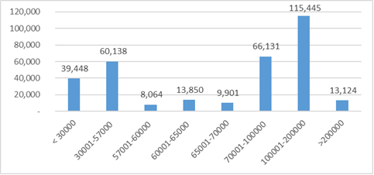
Source: SSA
As of 2017 estimates, majority of the TSA recipients are working age persons – 58%, while among non-beneficiaries this share is 52% (Figure 4). Children are the most over-represented among the beneficiaries. This reflects the recent changes in TSA formula which ascribe more weight to the needs of families with children, but also the fact that children continue to face higher risk of being poor than the working age adults or retired people.

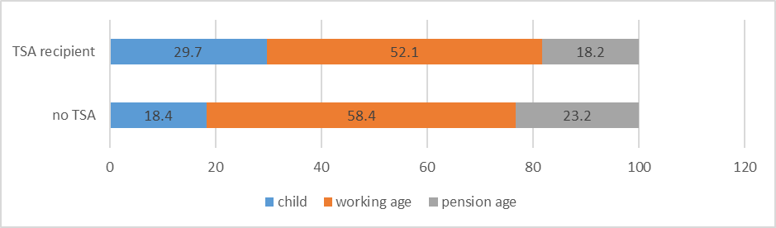
Figure 2. Age cohorts, TSA recipients vs. the rest

Source: WMS 2017

Different Modules and Phases of the Evaluation
In terms of content, the impact evaluation will consist of two different modules:
i) The Impact Assessment of the TSA on children and households;
ii) Evaluation of the UNICEF Contribution to the TSA.

The first module should elaborate on impact of the TSA on different outcomes described below in section 4 of the present ToR. Methodology used should preferable be quasi-experimental (specifically Regression Discontinuity Design) as described in section 5.

The second module should elaborate on UNICEF’s contribution (relevance, effectiveness, efficiency) to the TSA programme. The methodology used should be qualitative and may involve, focus groups, semi-structured or in-depth interviews, etc.

Each module will consist of two phases:
- Inception phase – to clarify the scope, methodology, sampling, research questions and tools;
- Implementation – to conduct the fieldwork, data analysis and reporting.

Roadmap of the ToR
Section 2 and 3 of this ToR describes the object, stakeholders, purpose and rational of the evaluation; Section 4 elaborates on objectives of the evaluation and proposes research questions, evaluation criteria and scope of the evaluation; Section 5 discusses proposed methodology, secondary data sources and primary data collection; Section 6 concerns the ethics; Section 7 elaborates on deliverables; Section 8 and onwards concerns qualification of the evaluation core team members as well as the logistical aspects restated to deadlines, payment, etc.
- OBJECT
The object of the project is TSA (its impact and UNICEF contribution to it), which is financed from the state budget of Georgia, administered nationwide (breakaway Abkhazia and S. Ossetia regions excluded) by the SSA, covering about 12% of population i.e. 130,750 households = 451,538 individuals (as of April 2018) and disbursing around Gel 270 million annually from the state budget.

Stakeholders
Government: SSA administers the TSA, MoLHSA together with the Parliament of Georgia and GoG defines policy and oversees its implementation. Parliament approves social protection (including TSA) funds allocation in the state budget.
Beneficiaries: poor households which got registered in UDSUF database and receive scores qualifying for the cash benefits.
International organizations actively involved in social policy: UNICEF, World Bank Group.
National Organizations: CSOs working on social and child protection issues, development consultancies, academic institutions working on public finance and/or social protection such as Georgian Institute of Public Affairs, Tbilisi State University, Ilia State University.

- PURPOSE AND RATIONALE
Rigorous impact evaluation of the TSA assessing child outcomes has never been conducted before. Hence, with double digit adult and child poverty rate in Georgia for over two decades, the impact evaluation of TSA – the major social protection program of the GoG, carries huge significance to every stakeholder, poor households and tax payers.
This evaluation combines summative and formative aspects i.e. looks at how reformed TSA program is performing in terms of short/medium term impact, assess UNCIEF’s past contribution to the program and informs ongoing as well as future UNICEF engagement in Georgia’s social protection.

- OBJECTIVE, RESEARCH QUESTIONS, CRITERIA AND SCOPE
Overall Objective: The Impact Evaluation should serve dual purpose: accountability and learning relevant for future decision making by GoG, UNICEF and other stakeholders involved in social protection. The project should:

i) Determine if the TSA has an effect or not, whether:
    - Positive or negative;
    - Intended or unintended;
    - Direct or indirect.
ii) Evaluate the UNICEF contribution to the TSA.

Specific Objectives
i) Assess the impact of the TSA on children and adults for the outcomes determined/clarified during the inception phase. Such outcomes should preferably include:
  - Poverty (basic necessities, nutrition, housing, etc.);
  - Health;
  - Education;
  - Early childhood development;
  - Beneficiaries’ incentives to work, time allocation to productive activities and/or investment in productive assets e.g. farming equipment, etc.;
  - Other outcome variables deemed relevant during the inception phase and approved by the Impact Evaluation Steering Committee, which will be created to provide quality assurance to the project.
ii) Evaluate UNICEF’s contribution to TSA, its relevance, efficiency and effectiveness in making TSA more child sensitive – objectives of this module shall be further clarified during the inception phase.

Research questions
- What is the impact of the TSA on child and adult poverty, health, education, early childhood development, beneficiaries’ incentive to work?
- How different is the impact across gender, urban/rural settlement status and other covariates where applicable?
- What measures can be undertaken to improve the impact of the TSA in the future?
- What was the UNICEF’s contribution to the TSA?
- How relevant was UNICEF’s contribution to the TSA?
- How efficient was UNICEF’s contribution to the TSA?
- How Effective was UNICEF’s contribution to the TSA?
- Was such contribution designed in a way to consider equity, human rights (most importantly the child rights), gender equality and needs of different vulnerable groups (e.g. persons with disabilities or ethnic minorities)?
These objectives and questions are subject to modification during the inception phase. Testable hypotheses also shall be developed during the inception phase. Wherever applicable, human rights aspects shall be integrated in research questions/hypotheses.

Scope
Primary focus of the impact assessment are children, however, as much as possible, the impact on adults should also be evaluated. Where possible, the research should further elaborate on equity gaps e.g. between rural v. urban residents, gender, etc.

The geographical scope of the project is national, excluding Abkhazia region and South Ossetia as the GoG does not exercise effective control over these regions. If the inception phase shows that nationally representative research is too costly or methodologically infeasible, the Steering Committee may decide to reduce the territorial scope of the research. Such decision shall be objectively justified and documented to show that no “fishing” for data showing positive impact took place.

The project should be primarily focused on the impact of TSA on the mentioned outcomes and UNICEF’s contribution to the TSA. The impact of GoG’s other social programs should be controlled to account for endogeneity concerns and ensure the unbiasedness of this evaluation but such social programs do not constitute the thematic focus of this project.

When it comes to the chronological scope of the project:
i) the impact assessment module will use primary data collected specifically for this project but will also have an access to UDSUF database which stores the data from 2006;
ii) the module on the evaluation of UNICEF contribution should focus on the period from 2009 onward i.e. when UNICEF started to produce WMS that eventually become the flagship advocacy research and paved the way for UNICEF to become an influential actor on social protection in Georgia;

Evaluation Criteria
In the case of the impact assessment module, the primary criteria shall be the impact on outcomes mentioned in the Specific Objectives sub-section; while in the case of the UNICEF contribution module, the criteria shall be:
- Relevance – UNICEF’s stance in the field of social protection as well as equity, gender equality and human rights (including child rights) where applicable.
- Effectiveness – Extent to which the objectives of the UNICEF’s interventions were fulfilled.
- Efficiency – Extent to which the same results would be achieved with less resources.
Both the evaluation criteria and the chronological scope can be modified if deemed necessary by the Steering Committee upon the recommendation made by an Evaluation team during the inception phase.

- IMPACT EVALUATION DESIGN AND METHODOLOGY
i) Impact Assessment Module
Households in the UDSUF database are distributed across five recipient categories in accordance with PMT scores from 0 to 200 000 (TSA is only granted to households with scores bellow 100001). UNICEF proposes to exploit such assignment based on PMT scores of households in Regression Discontinuity Design (RDD) approach i.e. comparing treatment and control groups from both sides of the TSA thresholds for any of the first three categories of beneficiaries (described in section 1 of this ToR). This subsection describes initial analysis exploring the feasibility of the RDD approach.

Initial examination of the database by UNICEF Office of Research Innocenti (OoR) found clearly visible drop after the 65 000 PMT threshold as shown on the graph bellow.

Figure 3. Discontinuity Check
The horizontal axis represents household PMT scores, the vertical axis represents the percentage of households with each score. The vertical red lines represent the thresholds in the PMT scores (respectively 30k, 57k, 60k, 65k, and 100k).
Source: SSA

An enquiry with the SSA suggests that a plausible reason behind such drop could be that households which get PMT score in the 65 000 - 100 000 range, i.e. they are only eligible Gel 10 child benefit, often appeal and request to get their score re-assessed hoping that their new score will fall below 65 000 thresholds.

The first three categories (i.e. 30k, 57k, 60k thresholds) do not seem to be exposed to similar problem. Thus, during the inception phase, the impact evaluation team should analyse the UDSUF database thoroughly and examine if the assumptions necessary for the validity of RDD hold at thresholds of the first three categories of TSA recipients.

Even if all assumptions for RDD approach hold for these first three categories of TSA recipients, there are two limitations:

First, there is no counterfactual to estimate the effect of overall TSA benefit i.e. compare Gel 30 per member recipient households with nonrecipients, but because the benefit amounts are adjusted in small increments around the first three thresholds, the RDD can only focus on the effects of these increments (e.g. comparing, around the 60k threshold, Gel 40 per member recipient households with Gel 30 per member households).

Second, TSA recipient households may also be receiving other benefits e.g. disability benefit or municipal benefits. Municipal benefits in most cases are also linked with PMT scores from UDSUF database but eligibility criteria, the type and amount of benefits varies across municipalities. These additional benefits make it even more difficult to observe possible impact between the treatment and control groups.

Hence, during the inception phase, the team should examine implications of these limitations on research design, statistical power, sample size, endogeneity issues, etc. If, during the inception phase, the RDD will appear not to be feasible enough for the research, an impact evaluation team should propose other methodologies and approaches.

During the inception phase, the team may undertake secondary data analyses of WMS, UDSUF or any other data they find useful, conduct a focus group/in-depth interviews (with TSA recipients, social workers/agents, TSA management team) and a small-scale pre-test of research instruments to make sure that the research design, instruments and identification strategy are effective to test hypotheses and answer research/evaluation questions. If any qualitative data analyses are involved, it should preferably be done by using NVivo or other similar software allowing tracking/documentation of the analyses.

Machine learning and other innovative methods/practices for data analyses or collection are welcome subject to prior approval by the Steering Committee.

Possible Use of MICS Data / Other Data Sources and Publications
National Statistics Office of Georgia (GeoStat) together with the UNICEF plans to undertake Multiple Indicator Cluster Survey (MICS) in 2018, which is one of the largest household surveys in the world generating over 180 indicators on health, early childhood development, education, multidimensional poverty.

The MICS also include a social transfer module gathering information on respondent’s TSA recipient status as well as the information on other social benefits.

The fieldwork for MICS is conducted with Computer Assisted Personal Interviewing (CAPI) and will finish in December 2018 i.e. datasets will be available soon after.

The MICS dataset is planned to become publicly accessible in march 2019 but if an evaluation team may find it useful, they may be granted the access to the MICS dataset as soon as it is composed.

Other Datasets/Publications Include:
UNICEF – can be found here: www.data.unicef.ge also will be provided to the Evaluation Team by UNICEF Georgia
- WMS 2009-17
- Child poverty Paper 2013, 2015
- In-depth Assessment of the TSA 2018
- UNICEF-World Bank joint report "Continuous Improvement Strengthening Georgia’s Targeted Social Assistance Program.

SSA – Will be provided to the Evaluation Team by the SSA and UNICEF Georgia
UDSUF Database

National Statistics Office (GeoStat)
Integrated Household Survey (SHINDA)

World Bank
The Impact of Targeted Social Assistance on Labour Market in Georgia: a Regression Discontinuity Approach. World Bank (2015). Tuck, et. al.

Regulations (will be provided to the Evaluation Team by UNICEF Georgia)
- Law of Georgia on Social Assistance
- TSA Declaration for PMT scores (Order N 141/n of The Minister of Labour, Health and Social Protection of Georgia of 20 May, 2010)
- Rule for the Assignment and disbursement of Targeted Social Assistance (Order №225/n Of the Minister of Labour, Health and Social Affairs of Georgia 22 August 2006)
- Methodology for Assessment of the Social - Economic Condition of Socially Vulnerable Households (Resolution N 758 (December 31, 2014) of the Government of Georgia)
- On the Reduction of the Level of Poverty in the Country and Measures aimed at Enhancement of the Social Protection of the Population (Decree №126 of the Government of Georgia of 24 April, 2010)

Qualitative Data Collection/Study of Positive and Negative Deviance
Qualitative data collection/analysis can be employed after the RDD fieldwork/analysis are implemented if it will be necessary to properly interpret the quantitative data and provide more nuanced knowledge on TSA impact and/or UNICEF contribution to the program.

If such qualitative data collection/analysis is employed, the evaluation team may consider the study of positive/negative deviance i.e. identify positive and negative outliers (as well as the households which experienced the biggest change compared to previous period, based on retrospective questions in research instruments, if such questions will be used) from the RDD dataset and conduct in-depth or semi-structured interviews to understand the reasons of their deviance i.e. sources of resilience on the one hand (in positively deviant households), and barriers (in negatively deviant households).

The efficacy of the deviance study shall be elaborated during the inception phase.

Comparability with Future Impact Assessment Studies
To observe the dynamics of TSA impact across time, another impact evaluation project may commence by the end of 2020 (or later) which will be subject of a separate ToR and contract.

Thus, the present impact evaluation should be designed and implemented with prospective comparability of its results with 2020 research data in mind.

Avoiding bias
Before designing the data collection and analyses, the impact evaluation team must thoroughly study how social protection works in Georgia and what kind of public health or social benefits are available. These additional benefits must be accounted for to avoid omitted variable and other endogeneity concerns.
Sampling and UDSUF database
i) Impact Assessment Module
If RDD will be chosen as a primary methodology for the research, the UDSUF database of the SSA should be used as a sampling frame. The sample should be the households registered in the UDSUF database with PMT scores right bellow and right above the thresholds of one of the first three categories. The bandwidth shall be determined during the inception phase. All aspects related to methodology or sampling are subject to modification if more efficient or effective solution is found during the inception phase.
The UDSUF database includes exact PMT scores received by each applicant household as well as other individual or household related data. The reevaluation (recalculation of PMT scores) of TSA recipient households by the SSA routinely takes place once in every four years. Reevaluation of a household can happen before the four-year period passes e.g. when a new member is born or adopted as well as when a household member dies.
In addition to sampling, the database which is organized as a panel, may allow secondary data analyses and can be useful especially during the inception phase.
ii) Evaluation of UNICEF Contribution Module
Methodology for this module shall be elaborated during the inception phase.

UNEG Norms and Standards
Methodology, evaluation design and implementation shall adhere to UNEG Norms and Standards for Evaluation.

Research tools, Fieldwork and Training
The impact evaluation team should develop research instruments, indicators and tabulation plan during the inception phase all of which should go through UNCIEF’s external quality assurance mechanisms, approved by UNICEF Georgia and/or Impact Assessment Reference Group prior to the fieldwork.

It is essential to account how the cash benefits recieved by the households are spent, hence the data gathering instruments must be designed in a way to allow mapping of expences, including those expences not related to outcome variables of interest.

Because of the fact that no comparable research exists from previous period(s), if the evaluation team deems neccessary the instruments may also include retrospective questions allowing to measure the change in outcome variables for households over time. Decision on the use of retrospective questions shall be made during the inception phase after careful consideration of efficacy of retrospective questions and challenges/limitations associated with it are considered.
The impact evaluation team will involve in the research highly qualified professionals, sufficient number of interviewers and supervisors for conducting the fieldwork in a quality and timely manner. The team will be responsible for training of the fieldworkers.
If the team does not have fieldworkers in Georgia, they should partner with local research firm/organization. If they are unfamiliar with potential local research partners the UNICEF will provide help to identify and contract potential partners, however the responsibility on the quality of fieldwork will rest on the impact evaluation team. They are expected to provide necessary technical support and oversight to local research organization to ensure quality. The impact evaluation team is expected to travel/stay in Georgia as frequently and as long as required for successful completion of the project.
Data entry, logical control and cleaning
The impact evaluation team (through their local partner organization or themselves) will be responsible for translation, data protection, coding and entry, cleaning and quality assurance. They will be responsible to address data related issues if such are identified during data analysis even after the completion of the fieldworks as per this TOR.
Gender, Human/Child Rights
During the inception phase, where possible, gender and human rights (including child rights) shall be incorporated in the evaluation design and instruments in accordance with UNEG Guidance on Integrating Human Rights and Gender Equality in Evaluations and the UN-SWAP Evaluation Performance Indicators.

Data Disaggregation
Data collection instruments shall be designed in a way to allow data disaggregation by sex, ethnicity, age, disability and other covariates.

- ETHICS
The impact evaluation team is responsible to provide adequate guidance and take appropriate measures to ensure their employees and contractors adhere the highest ethical standards during every stage of their work. Before commencement of the field work, the team will ensure ethical review of full research protocol (that includes all data gathering tools/instruments and methods as well as information on how ethical issues will be dealt with) by an independent and impartial ethics review board as per UNEG Ethical Guidelines and UNICEF Procedure for Ethical Standards in Research, Evaluation, Data Collection and Analysis.

The impact evaluation team can make use of national ethical review boards as well as UNICEF regional Long Term Agreement (LTA) holders – contractors that provide ethical review service (the list of the LTA holders will be provided upon request). The team should keep UNICEF and/or the Steering Committee fully informed on measures undertaken to safeguard full observance of ethical standards and provide UNICEF staff any additional information on this matter if requested. Proposals to apply for the project should clearly identify any potential ethical issues and approaches, as well as quality assurance/oversight mechanisms.

All households -- participants of data collection should be informed of the context and purpose of the impact assessment, as well as the privacy and confidentiality of the information they reveal, their right to refuse or halt their participation at any time. Special attention should be paid to issues specifically relating to:
- No harm;
- Informed consent;
- Privacy and confidentiality;
- Conflict of interest of the evaluation informants;
- Conflict of interest of the evaluation team members.

Protection protocols and procedure should be in place and fieldworkers should be adequately trained in case a survey participant is in distress or attention of public authorities is required (e.g. in case of domestic violence, crime, etc.).

Personal data protection protocols shall be elaborated by the team and strictly adhered with by everyone involved in the project.

- DELIVERABLES
1. First and revised drafts of the inception report (20-25 pages plus annexes as required) at minimum should contain the following:
- Summary;
- Context;
- Purpose;
- Objective and scope of the research;
- Methodology for both modules;
- Key indicators, dependent and independent variables
- Testable hypothesis;
- Research questions;
- Analitical and datat gathering instruments;
- Theory of Change
- Workplan.

2. The first and revised drafts of final evaluation report (40-60 pages plus annexes) at minimum should contain the following:
- Executive summary (4-6 pages);
- Literature review;
- Description of context and situation analysis of Georgia;
- Impact evaluation features including approach and methods as well as its purpose and goals;
- A Theory of change;
- Research findings;
- Evaluation findings structured along the lines of the Development Assistance Committee, Paris 1991. Principles for Evaluation of Development Assistance criteria (DAC) criteria
- Conclusions logically derived from the body of the findings;
- Good practices and lessons learned;
- Recommendations which are feasible and practical to the maximum extent possible;
- The Report must be compliant with UNICEF-Adapted UNEG Evaluation Reports Standards.
3. Presentation of key evaluation findings to stakeholders.
4. Data sets and other materials obtained/created as a result of the project.
5. Project report, describing and documenting the process of the evaluation.

UNICEF (also using its external peer review mechanism) and/or the Steering Committee will provide feedback on the first drafts of inception and final reports, the impact evaluation team will incorporate the feedback and produce the revised (final) drafts of the reports.

In addition to the DAC criteria, the evaluation should also comply with UNICEF evaluation policy, ethical standards and good practices.

UNICEF evaluation report standards and guidelines regarding evaluation and good practices can be found on UNICEF’s website.

The evaluation report will also be assessed and rated against the following assessment tool bellow:

- DURATION AND TIMING (Tentative)
The project shall be completed within the timetable below:

Activity | Responsible | Timing
Inception:
Inception mission to Georgia and desk review | The Team | July 2018
Development of the Inception report (work plan with methodology & approach, including research instruments, etc.)  Feedback by UNICEF and Impact Assessment Reference Group (including external quality assurance review), and Incorporation of the feedback by the impact evaluation team  Ethics Review, Sampling, Selection of local firm for fieldwork | The Team | September 2018  October 2018  November 2018
Pre-test | The Team | December 2019
Field work | The Team | January-February 2019
Reporting:
Development of the draft impact assessment report | The Team | April-May 2019
Review on the draft report and external review (7 days) | UNICEF/MoLHSA | June 2019
Development of the final impact evaluation report | The Team | July 2019
Use of evaluation findings:
Dissemination of the final report to all partners and stakeholders;  Stakeholder Workshop – the impact evaluation team presents findings to GoG and other stakeholders. | UNICEF/ MoLHSA/Team | September 2019

- QUALIFICATIONS
An organization/firm/team interested to apply is required to have:
- At least 8 years of experience in Impact assessment, evaluation experience on social protection interventions especially on cash transfers;
- Prior research/evaluation experience with UNICEF or other UN agencies will be considered as an asset;
- A qualified team for evaluation design/implementation, quantitative and qualitative data collection and analyses;
- Experience in designing and analysing Living Standard Measurement Study type surveys;
- Experience with CAPI will be considered as asset.

- IMPACT ASSESSMENT CORE TEAM
The core team will consist of an international team leader, two international team members and a national team member who is conversant on the local situation, has knowledge of means tested cash transfer programmes and has an excellent command of both English and Georgian (UNICEF can help in recruitment and selection of a national team member). Ideally the core team is gender balanced and culturally diverse, making use of national/regional/international research expertise. No member of the team shall have a conflict of interest as defined by UNEG and UNICEF ethical standards.

The team leader must have a significant impact assessment background. The team leader will be responsible for coordination issues and for submitting quality deliverables. Qualifications and experience required are as follows:

Team leader (international) – Expert in quantitative or mixed methods research
  - Advanced university degree in social sciences research, with strong background in quasiexperimental methods and cash transfer programs
  - 10 years of experience in designing and implementing impact evaluation projects
  - Demonstrated expertise in quantitative and qualitative data collection, analysis and reporting
  - Work experience in Living Standard Measurement Study type surveys
  - Work experience and/or technical knowledge of social assistance programs in international context.
  - Demonstrated capacity and partnership building skills with local partners
  - Good communication skills
  - Knowledge and experience of research on socio-economic issues in ECA region
  - Field experience in ECA countries is an asset
  - Excellent written English language skills, demonstrable with samples of publications
  - Ability to organize and plan complex work following the established timeframes
  - Previous experience working for UNICEF is an asset
  - Previous professional or academic experience on gender and/or human rights focused evaluations/research will be considered as an asset.
team member (international) – Expert in qualitative or mixed methods research
- Advanced university degree in social policy research or related field
- At least 8 years of experience in qualitative research and analyses
- Sound Knowledge and at least 5 years of experience in researching social protection (preferable conditional cash transfer) programmes
- Experience in working with UN organisations and/or UNICEF will be considered as an asset
- Strong analytical and writing skills
- Fluency in written and spoken English
team member (international) – Expert in Quantitative Data Analyses
- Advanced University degree econometrics or statistics, data science
- At least 5 years of experience in data analyses
- Proven academic background/professional experience in implementing Regression Discontinuity Design
- Experience in working with UN organisations and/or UNICEF will be considered as an asset
- Able to work in a team and excellent interpersonal/communication skills
- Strong analytical and writing skills
- Fluency in written and spoken English
- Previous professional or academic experience on gender and/or human rights focused evaluations/research will be considered as an asset.

Team member (national) – Project Assistance – UNICEF can provide help in recruitment
- At least bachelor’s degree in social policy, public administration, or related field
- Familiarity with the work of UNICEF in Georgia
- Experience in working with GoG agencies, especially in the field of social protection
- In depth knowledge of TSA programme. Prior experience with the TSA will be considered an asset
- Fluency in written and spoken English as well as Georgian
- Excellent communication and organization skills
- Excellent computer skills
- Excellent organization skills
- Excellent written and oral translation skills (Georgian-English and vice versa).
During the inception phase, the requirements regarding the number and qualifications of the core team members can be modified subject to prior consent by the UNICEF / Steering Committee.

- MANAGEMENT
The UNICEF Georgia team within the scope of their respective capacities will support the evaluation team to deliver the evaluation objectively, ethically and with the highest possible quality.

The Regional Office will support the assessment of the deliverables through its external quality assurance mechanisms involving peer review.

Evaluations Office will rate the evaluation report by GEROS rating tool mentioned in section 7 of this ToR.

The Steering Committee consisting of major stakeholders will be set up to take major decisions, monitor, oversea and provide quality assurance to planning/implementation of the project. The Steering Committee shall include at least one research/evaluation expert and one ethics focal point responsible for technical soundness and adherence to highest ethical standards respectively. Objectives, functions and composition of the Committee shall be subject to a separate ToR.

For quality assurance considerations, UNICEF (itself or through the Steering Committee) reserves the right to attend/monitor the field work and other activities of the impact evaluation. If such a need arises, the impact evaluation team should provide full access to activities related to the project.

- COPYRIGHT
All materials/data related to or produced as a result of the activities envisaged in this ToR and the subsequent contract will be the property of the UNICEF and cannot be reused, transferred to anyone or otherwise utilized without UNICEF’s prior approval.

- PAYMENT
The consultancy fee will be negotiated between the applying organizations/companies and UNICEF Georgia based on an initial proposal of the applicants. Payment will be carried out in several instalments as agreed between the selected organization/company and UNICEF, after satisfactory implementation of specific parts of the services and after provision of quality reports on the implemented activities.

To verify the quality, full research protocol, inception and final reports will go through UNICEF’s external quality review mechanism which assigns ratings. The protocols and the reports must receive at least “Satisfactory” rating to be considered as duly delivered.

UNICEF reserves the right to withhold all or a portion of payment if performance is unsatisfactory, if deliverables are incomplete or not submitted at all, or for failure to meet deadlines.

The suggested payment schedule is:
- 10% after providing the inception report
- 50% after completing the field work
- 40% after providing the final report

- HOW TO APPLY
An organization/company interested to apply must provide:
- Documents certifying the above qualification requirements;
- CV-s of the key international personnel to be involved in the project (CV of a local team member is not necessary at this stage);
- Information related to a local firm to be used for the field work (not necessary at this stage)
- Tentative project plan in accordance with UNICEF provided timeline – See Bellow;
- Tentative budget in USD with different options in terms of methodology (see below) – such budget shall not at this stage include the fees that will be payable to the local firm for the primary data collection and neither translation costs. The budget shall be sent in a separate email titled: Financial Proposal, or sent printed on paper in sealed envelope to UNICEF Georgia official Address (9 Eristavi street, IV floor, UN House).

Tentative Project Plan and Budget
Project plan: should be around 2 pages long and contain the outline of different steps and timeline related to:
- How the team aims to proceed with the inception phase of the impact evaluation:
  - Type of research (interviews, focus groups, desk research, etc.) they plan to undertake;
  - Steps to be taken for feasibility check of RDD;
- Assuming RDD will work, steps to be taken to complete the implementation Phase.

Budget: should preferably be made in an excel sheet with comments and include:
- The cost of the inception phase;
- Assuming that RDD is feasible, the cost of implementation phase;
- The cost of positive and negative deviance exercise shall be stated separately.

At this stage the budget shall not include the translation costs and costs of local firm for primary data collection; Budget shall include lump sum amounts but also segregated by unit costs where possible.

Further information: can be obtained from Tinatin Baum, Social and Economic Policy Specialist, UNICEF Georgia, at: tbaum@unicef.org, Tel: (995 32) 23 23 88, ext. 217 or from Andria Nadiradze, Monitoring and Statistics Officer, UNICEF Georgia, at: anadiradze@unicef.org, Tel: (995 597) 700 210. Contact hours: from 10 AM to 5 PM local time in Tbilisi.

The letters of interest and respective documentation must be submitted by July 11, 2018.

Appendix 6. Evaluation matrix
Evaluation criteria | # | Category of analysis | Secondary sources | Primary Sources
Evaluation criteria | # | Category of analysis | Use of secondary information | Key informants interviews-KII | Quantitative instrument
Evaluation criteria | # | Category of analysis | a. Government | a. Government | Quantitative instrument
Evaluation criteria | # | Category of analysis | b. UNICEF | b. UNICEF | Quantitative instrument
Evaluation criteria | # | Category of analysis | c. others | c. others; | Quantitative instrument
RELEVANCE | 1 | Are the activities and outputs of the programme consistent with overall TSA goals and UNICEF´s Georgia goals? | All | All | None
RELEVANCE | 2 | How relevant is UNICEF's contribution to the TSA? What strategic advantages does UNICEF have? | All | All | None
RELEVANCE | 3 | What strategies have been followed within UNICEF to address reduction of poverty in benefited households, especially those ones with children? | a,b | b | Yes
RELEVANCE | 4 | How harmonious are the actions carried out by the programme and UNICEF, with the national and international policy and normative framework against the reduction of poverty, the rights of children and the social protection of vulnerable families? | a,b | All | None
RELEVANCE | 5 | Who are the TSA programme partners and what are their roles? To what extent development partners’ contribution to this process was/is in conformity with UNICEF engagement to the programmes? | All | All | None
RELEVANCE | 6 | To what extent were equity, gender equality and human rights standards goals and processes incorporated into the design and implementation of the TSA? To what extent has UNICEF contributed to these? | All | All | None
EFFICIENCY | 1 | How do the GOG, UNICEF, WB and other stakeholders contribute with the inputs (technical, human, financial) that the programme needs for its implementation before and after TSA´s reform? ? | All | All | None
EFFICIENCY | 2 | How much knowledge do the interviewees have about the resources that the programme uses and how sufficient are perceived to be those resources? | All | All | None
EFFICIENCY | 3 | How efficient were the actions carried out by UNICEF, considering the time and the resources required for the programme implementation? | None | All | None
EFFICIENCY | 4 | How timely were the resources contributed by UNICEF to the programme operation? | All | None | None
EFFICIENCY | 5 | What changes or adjustments could make the TSA implementation process more efficient? | All | All | None
EFFICIENCY | 6 | What changes or adjustments could make UNICEF´s contribution to the programme more efficient? | All | All | None
EFFECTIVENESS | 1 | To what extent were the TSA's objectives achieved or are likely to be achieved? | None | All | None
EFFECTIVENESS | 2 | What were the major factors influencing the achievement or non-achievement of the objectives? (positive and negative key factors) | All | All | None
EFFECTIVENESS | 3 | What are the (concrete) contributions of UNICEF for achieving the objectives of TSA? | All | All | None
EFFECTIVENESS | 4 | In regards to the programme, what are the main UNICEF objectives? to what extent were those UNICEF´s objectives achieved? What were the major factors influencing the achievement or non-achievement of these objectives? (positive and negative key factors) | All | All | None

Appendix 7. List of interviewees
Name | Institution | Position
Legislative
Mr. Akaki Zoidze | Parliament of Georgia | Chairperson of the Healthcare and Social Issues Committee
Mr. Zurab Tchiaberashvili | Parliament of Georgia | First Deputy Chairperson of the Healthcare and Social Issues Committee
UNICEF
Ms. Tinatin Baum | UNICEF
Andria Nadiradze | UNICEF | Task Force
Keti Melikadze | UNICEF | Task Force
Tako Ugulava | UNICEF | Task Force
Executive
Mrs Ekaterine Tikaradze | Ministry of Internally Displaced Persons from the Occupied Territories, Labour, Health and Social Affairs (until recently Ministry of Labour, Health and Social Affairs) | Minister
Ms Nino Odisharia | Ministry of Internally Displaced Persons from the Occupied Territories, Labour, Health and Social Affairs (until recently Ministry of Labour, Health and Social Affairs) | Head of Social Protection Department
Ms Tea Gvaramadze | Ministry of Internally Displaced Persons from the Occupied Territories, Labour, Health and Social Affairs (until recently Ministry of Labour, Health and Social Affairs) | Head of Pension and Social Assistance Division
Mr. Dimitri Chkheidze | Social Service Agency (SSA, under MoLHSA) | Deputy Head of IT Department
Mr. Gaioz Talakvadze | Municipal Department of Finance | Head of Municipal Department of Finance, Tbilisi City Hall (former Head of Social Services Agency)
Formers
Mr. Gia Kakachia |  | Former SSA Head (when the TSA revision was initiated)
Experts
Mr. Giorgi Berulava | UNICEF | Expert hired by UNICEF for TSA revision
Ms Nino Shatberashvili | UNICEF | Expert hired by UNICEF for TSA revision, Director of Georgian Association of Social Workers
Mr. Gia Gotua |  | (he did social agents assessment)
Mr. Mamuka Nadareishvili |  | Expert, worked on the methodology

Appendix 8. Data collection instruments
 | IMPACT EVALUATION OF TARGETED SOCIAL ASSISTANCE (TSA) IN GEORGIA | 

HH Household module
HH1. Cluster number: ___ ___ ___ HH2. Household number: ___ ___
HH3. Interviewer’s name and number: HH4. Supervisor’s name and number:
Name ____________________ ___ ___ Name_______________________ ___ ___
HH5. Day / Month / Year of interview: ___ ___ /___ ___ / ___ ___

Enumerator UNICEF IS CONDUCTING A SURVEY ABOUT THE SITUATION OF CHILDREN, FAMILIES AND HOUSEHOLDS. I WOULD LIKE TO TALK TO YOU ABOUT THESE SUBJECTS. THE INTERVIEW WILL TAKE ABOUT25 MINUTES. ALL THE INFORMATION WE OBTAIN WILL REMAIN STRICTLY CONFIDENTIAL AND ANONYMOUS. MAY I START NOW?

Yes, permission is given Go to HH18 to record the time and then begin the
interview.
No, permission is not given Circle 04 in HH9.

HH9. Result of household interview:
Completed | 1
No household member or no competent respondent at home at time of visit | 2
Entire household absent for extended period of time | 3
Refused | 4
Dwelling vacant / Address not a dwelling | 5
Dwelling destroyed | 6
Dwelling not found | 7
Other (specify) | 96

After all questionnaires for the household have been completed, fill in the following information:

HH10. Respondent to Household Questionnaire:
Name ___________________
HH10a. Respondent Code : ___ ___
HH11. Total number of household members: ___ ___
HH12. Number of women age 15-49 years: ___ ___
HH13. Number of women’s questionnaires completed: ___ ___
HH14. Number of children under age 5: ___ ___
HH15. Number of under-5 questionnaires completed: ___ ___
HH16. Field editor’s name and number: Name__________________________ __ __
HH17. Main data entry clerk’s name and number: Name__________________________ __ __

HH18. Record the time.

Hour ...................... __ __

Minutes ................. __ __

FIRST, PLEASE TELL ME THE NAME OF EACH PERSON WHO USUALLY LIVES HERE, STARTING WITH THE HEAD OF THE HOUSEHOLD.

List the head of the household in line 01. List all household members (HL2), their relationship to the household head (HL3), and their sex (HL4)

Then ask: ARE THERE ANY OTHERS WHO LIVE HERE, EVEN IF THEY ARE NOT AT HOME NOW?
If yes, complete listing for questions HL2-HL4. Then, ask questions starting with HL5 for each person at a time. Use an additional questionnaire if all rows in the List of Household Members have been used
Household Characteristics

Size
S1. INCLUDING YOURSELF, HOW MANY PEOPLE ARE PART OF YOUR HOME? | 1
 | 2
 | 3
 | 4
 | 5
 | More than 5
Type of housing
TH2. DO YOU OR SOMEONE LIVING IN THIS HOUSEHOLD OWN THIS DWELLING?  If “No”, then ask: DO YOU RENT THIS  DWELLING FROM SOMEONE NOT LIVING IN THIS HOUSEHOLD?  If “Rented from someone else”, circle “2”.  For other responses, circle “6”. | Own | 1
 | Rent | 2
 | Other (specify) | 6
Productive assets
TH3. DOES ANY MEMBER OF THIS HOUSEHOLD OWN ANY LAND THAT CAN BE USED FOR AGRICULTURE? | Yes | 1
 | No → TH4 | 2
TH4. HOW MANY ROPANIS OR BIGHAS OF AGRICULTURAL LAND DO MEMBERS OF THIS HOUSEHOLD OWN?  If respondent answer in Ropani, circle “1”  and enter the value and if answer in Bigha,  circle “2” and enter the value. If  unknown, circle ‘998’. | Ropani (ropani, ana, paisa) __ __/__ __/__ __ | 1
 | Bigha (bigha, kattha, dhur) __ __/__ __/__ __ | 2
 | Don’t know............... 998
TH5. DOES THIS HOUSEHOLD OWN ANY LIVESTOCK, HERDS, OTHER FARM ANIMALS, OR POULTRY?  [A] MILK COWS, OR BULLS?  [B] HORSES, DONKEYS, OR MULES?  [C] GOATS?  [D] SHEEP?  [E] CHICKEN/DUCKS /PIGEON?  [F] PIGS/SWINE?  [G] YAK NAK OR CHAURI  [H] BUFFALO  [J] RABBIT  If none, record ‘00’. If 95 or more, record  ‘95’.  If unknown, record ‘98’. | Yes | 1
 | No (If the answer is this, go to the nest module) | 2
 | - Milk cows, or bulls
 | - Horses, donkeys, or mules
 | - Goats
 | - Sheep
 | - Chicken/ducks/pigeon
 | - Pigs
 | - Yak Nak or Chauri
 | - Buffaloes
 | - Rabbit
Water and Sanitation
WS1. WHAT IS THE MAIN SOURCE OF DRINKING WATER FOR MEMBERS OF YOUR HOUSEHOLD? | Piped water
 | Piped into dwelling → WS7 | 11
 | Piped into compound, yard or plot → WS7 | 12
 | Piped to neighbor → WS7 | 13
 | Public tap / standpipe → WS6 | 14
 | Tube Well, Borehole → WS6 | 21
 | Dug well
 | Protected well → WS6 | 31
 | Unprotected well → WS6 | 32
 | Water from spring
 | Protected spring → WS6 | 41
 | Unprotected spring → WS6 | 42
 | Rainwater collection → WS6 | 51
 | Tanker-truck → WS6 | 61
 | Cart with small tank / drum → WS6 | 71
 | Surface water → WS6 | 81
 | Bottled water | 91
 | Other (specify) → WS6 | 96
WS2. WHERE IS THAT WATER SOURCE  LOCATED? | In own dwelling → WS7 | 1
WS2. WHERE IS THAT WATER SOURCE  LOCATED? | In own yard / plot → WS7 | 2
WS2. WHERE IS THAT WATER SOURCE  LOCATED? | Elsewhere | 3
WS3. HOW LONG DOES IT TAKE TO GO  THERE, GET WATER, AND COME  BACK? | Number of minutes __ __ __  Don’t know............... 998
WS4. WHAT IS THE MAIN SOURCE OF WATER USED BY YOUR HOUSEHOLD FOR OTHER PURPOSES SUCH AS COOKING AND HANDWASHING? | Piped water
 | Piped into dwelling → WS7 | 11
 | Piped into compound, yard or plot → WS7 | 12
 | Piped to neighbor → WS7 | 13
 | Public tap / standpipe | 14
 | Tube Well, Borehole | 21
 | Dug well
 | Protected well | 31
 | Unprotected well | 32
 | Water from spring
 | Protected spring | 41
 | Unprotected spring | 42
 | Rainwater collection | 51
 | Tanker-truck | 61
 | Cart with small tank / drum | 71
 | Surface water | 81
 | Other (specify) | 96
WS5. WHERE IS THAT WATER SOURCE LOCATED? | In own dwelling → WS7 | 1
WS5. WHERE IS THAT WATER SOURCE LOCATED? | In own yard / plot → WS7 | 2
WS5. WHERE IS THAT WATER SOURCE LOCATED? | Elsewhere | 3
WS6. HOW LONG DOES IT TAKE TO GO THERE, GET WATER, AND COME BACK? | Number of minutes __ __ __  Don’t know............... 998
WS7. DO YOU DO ANYTHING TO THE WATER TO MAKE IT SAFER TO DRINK? | Yes | 1
 | No → WS8A | 2
 | Don´t know →WS8A | 8
WS8. WHAT DO YOU USUALLY DO TO MAKE THE WATER SAFER TO DRINK?  Probe:  ANYTHING ELSE?  Record all items mentioned. | - Boil
 | - Add bleach / chlorine
 | - Strain it through a cloth
 | - Use water filter
 | - Solar disinfection
 | - Let it stand and settle
 | - Other (specify)
 | - Don´t know
WS9. WHAT KIND OF TOILET FACILITY DO MEMBERS OF YOUR HOUSEHOLD USUALLY USE?  If “flush” or “pour flush”, probe:  WHERE DOES IT FLUSH TO?  If not possible to determine, ask  permission to observe the  facility. | Flush / Pour flush
 | Flush to piped sewer system | 11
 | Flush to septic tank | 12
 | Flush to pit (latrine) | 13
 | Flush to somewhere else | 14
 | Flush to unknown place / Not sure /
 | Don’t know where | 15
 | Pit latrine
 | Ventilated Improved Pit latrine (VIP) | 21
 | Pit latrine with slab | 22
 | Pit latrine without slab / Open pit | 23
 | Composting toilet | 31
 | Bucket | 41
 | No facility, Bush, Field | 95
 | Other (specify) | 96
WS10. DO YOU SHARE THIS FACILITY WITH OTHERS WHO ARE NOT MEMBERS OF YOUR HOUSEHOLD? | Yes (Public) | 1
 | Yes (with other HH’s) | 2
 | No → Next module | 3
WS11. INCLUDING YOUR OWN HOUSEHOLD, HOW MANY HOUSEHOLDS USE THIS TOILET FACILITY? | 1
 | 2
 | 3
 | 4
 | 5
 | More than 5
WS12. WHERE IS THIS TOILET MAIN FACILITY LOCATED? | In the household = 1  Outside the household by for private use = 2  Outside the households shared = 3
WS13. WHAT TYPE OF FUEL DOES YOUR HOUSEHOLD MAINLY USE FOR COOKING? | - Gas
 | - Electricity
 | - Solar energy
 | - Firewood
 | - Other (specify)
Handwashing
HW1. PLEASE MENTION ALL  THE OCCASIONS WHEN YOU THINK  IT IS IMPORTANT TO WASH YOUR  HANDS.  Circle all mentioned. | Keep probing.
 | - Before eating
 | - After eating
 | - Before praying
 | - Before breast feeding or feeding a child
 | - Before cooking or preparing food
 | - After defecation/urination
 | After cleaning a child that has:
 | - Defecated/ changing child's nappy
 | - When the hands are dirty
 | - After cleaning toilet or potty
 | - After completing the work
 | - Other (Specify)
 | - Don't know
HW2. IN YOUR HOUSEHOLD WHAT DO YOU USE FOR HANDWASHING? | Soap/detergent | 1
HW2. IN YOUR HOUSEHOLD WHAT DO YOU USE FOR HANDWASHING? | Ash | 2
HW2. IN YOUR HOUSEHOLD WHAT DO YOU USE FOR HANDWASHING? | Mud | 3
HW2. IN YOUR HOUSEHOLD WHAT DO YOU USE FOR HANDWASHING? | Sand | 4
HW2. IN YOUR HOUSEHOLD WHAT DO YOU USE FOR HANDWASHING? | Nothing/ no facility | 5
HW2. IN YOUR HOUSEHOLD WHAT DO YOU USE FOR HANDWASHING? | Other (Specify) | 9
HW3. CAN YOU PLEASE SHOW ME WHERE MEMBERS OF YOUR HOUSEHOLD MOST OFTEN WASH THEIR HANDS?
Expenditure
E1. HOW MUCH DID YOU SPEND IN ___________ IN THE LAST (PERIOD)? | __________________________
Assets, goods and services ownership (proxy for wealth)
AGS1. DOES YOUR HOUSEHOLD HAVE:  A) ELECTRICITY?  B) A RADIO?  C) A TELEVISION?  D) A NON-MOBILE TELEPHONE?  E) A COMPUTER-DESKTOP?  F) INTERNET  G) A REFRIGERATOR?  H) TABLE?  I) CHAIR?  J) BED/COT?  K) SOFA?  L) WARDROBE?  M) WALL CLOCK?  N) ELECTRIC FAN?  O) MICROWAVE OVEN?  P) WASHING MACHINE? |  | Yes | No
 | - Electricity | 1 | 2
 | - Radio | 1 | 2
 | - Television | 1 | 2
 | - Non-mobile telephone | 1 | 2
 | - Computer-Desktop | 1 | 2
 | - Internet | 1 | 2
 | - Refrigerator | 1 | 2
 | - Table | 1 | 2
 | - Chair | 1 | 2
 | - Bed/Cot | 1 | 2
 | - Sofa | 1 | 2
 | - Wardrobe | 1 | 2
 | - Wall clock | 1 | 2
 | - Electric fan | 1 | 2
 | - Microwave oven | 1 | 2
 | - Washing machine | 1 | 2
AGS2. DOES ANY MEMBER OF YOUR HOUSEHOLD OWN:  A) A WATCH?  B) A MOBILE-PHONE?  C) A BICYCLE?  D) A MOTORCYCLE OR MOTOR SCOOTER?  E) AN ANIMAL-DRAWN CART?  F) A CAR OR TRUCK?  G) A BOAT WITH A MOTOR? |  | Yes | No
 | - Watch | 1 | 2
 | - Mobile-phone | 1 | 2
 | - Bicycle | 1 | 2
 | - Motorcycle/Scooter | 1 | 2
 | - Animal-drawn cart | 1 | 2
 | - Car/Truck | 1 | 2
 | - Boat with a motor | 1 | 2
Distribution of rooms
DR1. IS THE COOKING USUALLY DONE IN THE HOUSE, IN A SEPARATE BUILDING, OR OUTDOORS?  If ‘In the house’, probe: IS IT DONE IN A  SEPARATE ROOM USED AS A KITCHEN? | In the house:
 | In a separate room used as kitchen |  | 1
 | Elsewhere in the house |  | 2
 | In a separate building |  | 3
 | Outdoors |  | 4
 | Other (specify) |  | 5
DR2. HOW MANY ROOMS IN THIS HOUSEHOLD ARE USED FOR SLEEPING? | Number of rooms ........................
Housing materials
HM1. MAIN MATERIAL OF THE DWELLING FLOOR:  Record Observation. | Earth/sand | 11
 | Dung | 12
 | Wood planks | 21
 | Palm / Bamboo | 22
 | Parquet or polished wood | 31
 | Vinyl or asphalt strips | 32
 | Ceramic tiles | 33
 | Cement | 34
 | Carpet | 35
 | Linoleum | 36
 | Other (specify) | 96
HM2. MAIN MATERIAL OF THE ROOF:  Record Observation. | Natural roofing
HM2. MAIN MATERIAL OF THE ROOF:  Record Observation. | Thatch / Palm leaf | 12
HM2. MAIN MATERIAL OF THE ROOF:  Record Observation. | Sod | 13
HM2. MAIN MATERIAL OF THE ROOF:  Record Observation. | Rudimentary roofing
HM2. MAIN MATERIAL OF THE ROOF:  Record Observation. | Rustic mat | 21
HM2. MAIN MATERIAL OF THE ROOF:  Record Observation. | Wood planks | 23
HM2. MAIN MATERIAL OF THE ROOF:  Record Observation. | Finished roofing
HM2. MAIN MATERIAL OF THE ROOF:  Record Observation. | Metal / Tin | 31
HM2. MAIN MATERIAL OF THE ROOF:  Record Observation. | Wood | 32
HM2. MAIN MATERIAL OF THE ROOF:  Record Observation. | Calamine / Cement fibre | 33
HM2. MAIN MATERIAL OF THE ROOF:  Record Observation. | Ceramic tiles | 34
HM2. MAIN MATERIAL OF THE ROOF:  Record Observation. | Cement | 35
HM2. MAIN MATERIAL OF THE ROOF:  Record Observation. | Roofing shingles | 36
HM2. MAIN MATERIAL OF THE ROOF:  Record Observation. | Other (specify) | 96
HM3. MAIN MATERIAL OF THE EXTERIOR WALLS:  Record Observation. | Natural walls
 | No walls | 11
 | Cane / Palm / Trunks | 12
 | Dirt | 13
 | Rudimentary walls
 | Bamboo with mud | 21
 | Stone with mud | 22
 | Plywood | 23
 | Cardboard | 24
 | Reused wood | 25
 | Finished walls
 | Cement | 31
 | Stone with lime / cement | 32
 | Bricks | 33
 | Cement blocks | 34
 | Wood planks / shingles | 35
 | Other (specify) | 96
Location
L1. REGION WHERE THE DWELLING IS LOCATED | - Abjasia
L1. REGION WHERE THE DWELLING IS LOCATED | - Samegrelo-Zemo Svaneti
L1. REGION WHERE THE DWELLING IS LOCATED | - Guria
L1. REGION WHERE THE DWELLING IS LOCATED | - Ayaria
L1. REGION WHERE THE DWELLING IS LOCATED | - Racha-Lechjumi y Kvemo Svaneti
L1. REGION WHERE THE DWELLING IS LOCATED | - Imereti
L1. REGION WHERE THE DWELLING IS LOCATED | - Samtsje-Yavajeti
L1. REGION WHERE THE DWELLING IS LOCATED | - Shida Kartli
L1. REGION WHERE THE DWELLING IS LOCATED | - Mtsjeta-Mtianeti
L1. REGION WHERE THE DWELLING IS LOCATED | - Kvemo Kartli
L1. REGION WHERE THE DWELLING IS LOCATED | - Kajeti
L1. REGION WHERE THE DWELLING IS LOCATED | - Tiflis
Religion
R1. WHAT IS THE RELIGION OF THE HEAD OD THIS HOUSEHOLD? | - Christianity | 01
R1. WHAT IS THE RELIGION OF THE HEAD OD THIS HOUSEHOLD? | - Buddhism | 02
R1. WHAT IS THE RELIGION OF THE HEAD OD THIS HOUSEHOLD? | - Islam | 03
R1. WHAT IS THE RELIGION OF THE HEAD OD THIS HOUSEHOLD? | - Bahá'í Faith | 04
R1. WHAT IS THE RELIGION OF THE HEAD OD THIS HOUSEHOLD? | - Judaism | 05
R1. WHAT IS THE RELIGION OF THE HEAD OD THIS HOUSEHOLD? | - No religion | 06
R1. WHAT IS THE RELIGION OF THE HEAD OD THIS HOUSEHOLD? | - Other religion (specify) ________ | 07
Ethnicity
E1. WHAT IS THE MOTHER TONGUE/NATIVE LANGUAGE OF THE HEAD OF THIS HOUSEHOLD?  Write both name and code | Mother Tongue___________________________  Other language (specify) ..............996
E2. TO WHAT ETHNIC GROUP DOES THE HEAD OF THIS HOUSEHOLD BELONG?  Write both name and code | Ethnic group_____________________________  Other ethnic group (specify) .........996

Household Member Characteristics

HL1. WHAT IS THE RELATIONSHIP OF (NAME) TO THE HEAD OF THE HOUSEHOLD? | Head | 01
 | Spouse/Partner | 02
 | Son / Daughter | 03
 | Son-In-Law / Daughter-In-Law | 04
 | Grandchild | 05
 | Parent | 06
 | Parent-In-Law | 07
 | Brother / Sister | 08
 | Brother-In-Law / Sister-In-Law | 09
 | Uncle / Aunt | 10
 | Niece / Nephew | 11
 | Other relative | 12
 | Adopted / Foster / Stepchild | 13
 | Other (Not related) | 96
HL2. DATE OF BIRTH (YYYY/MM/DD) | __ __ __ __/__ __/__ __
HL3. HOW OLD IS (NAME)? | ______ years old
HL4. IS (NAME) MALE OR FEMALE? | Male | 1
HL4. IS (NAME) MALE OR FEMALE? | Female | 2
HL5. WHERE IS (NAME) ORIGINALLY FROM? | _____________________
HL6. WHAT IS (NAME)'S CURRENT MARITAL STATUS? | Single | 1
HL6. WHAT IS (NAME)'S CURRENT MARITAL STATUS? | Married | 2
HL6. WHAT IS (NAME)'S CURRENT MARITAL STATUS? | Separated | 3
HL6. WHAT IS (NAME)'S CURRENT MARITAL STATUS? | Divorced | 4
HL6. WHAT IS (NAME)'S CURRENT MARITAL STATUS? | widowed | 5
HL6. DO YOU HAVE IN CHARGE THE CARE OF THE CHILDREN UNDER 12 YEARS OLD OF YOUR HOUSEHOLD? | Yes | 1
 | No | 2
HL7. WHO SUPPORTS YOU WITH THE CARE OF THE CHILDREN UNDER 12 YEARS OLD OF YOUR HOUSEHOLD? | Spouse/Partner | 01
 | Parent | 02
 | Brother / Sister | 03
 | Uncle / Aunt | 04
 | Niece / Nephew | 05
 | Other relative | 06
HL8. IS THIS PERSON FROM YOUR HOUSEHOLD? | Yes | 1
HL8. IS THIS PERSON FROM YOUR HOUSEHOLD? | No | 2
HL9. (NAME) HAS ANY DIAGNOSED DISEASE OR DISABILITY? | Yes | 1
HL9. (NAME) HAS ANY DIAGNOSED DISEASE OR DISABILITY? | No | 2
HL10. DOES (NAME) NEED A PERMANENT CAREGIVER DUE TO HIS/HER DESEASE OR DISABILITY? | Yes | 1
 | No | 2
HL11. WHO IS THIS PERMANENT CAREGIVER? | Nurse | 01
HL11. WHO IS THIS PERMANENT CAREGIVER? | Parent | 02
HL11. WHO IS THIS PERMANENT CAREGIVER? | Uncle | 03
HL11. WHO IS THIS PERMANENT CAREGIVER? | Other (Not related) | 04
HL12. HOW OFTEN DO YOU READ A NEWSPAPER OR MAGAZINE? | Everyday | 01
HL12. HOW OFTEN DO YOU READ A NEWSPAPER OR MAGAZINE? | Once a week | 02
HL12. HOW OFTEN DO YOU READ A NEWSPAPER OR MAGAZINE? | Once a month | 03
HL12. HOW OFTEN DO YOU READ A NEWSPAPER OR MAGAZINE? | Never | 04
HL13. HOW OFTEN DO YOU LISTEN TO THE RADIO? | Everyday | 01
HL13. HOW OFTEN DO YOU LISTEN TO THE RADIO? | Once a week | 02
HL13. HOW OFTEN DO YOU LISTEN TO THE RADIO? | Once a month | 03
HL13. HOW OFTEN DO YOU LISTEN TO THE RADIO? | Never | 04
HL14. HAVE YOU EVER USED THE INTERNET? | Yes | 1
HL14. HAVE YOU EVER USED THE INTERNET? | No | 2
HL15. IN THE LAST 12 MONTHS, HAVE YOU USED THE INTERNET? | Yes | 1
HL15. IN THE LAST 12 MONTHS, HAVE YOU USED THE INTERNET? | No | 2
HL16. DO YOU HAVE A MOBILE PHONE? | Yes | 1
HL16. DO YOU HAVE A MOBILE PHONE? | No | 2
HL17. WHAT FEATURES DO YOU USE IN YOUR MOBILE PHONE?
HL18. DURING THE LAST YEAR HAVE YOU SEEN/HEARD IN THE SOCIAL MEDIA (TV, RADIO, NEWSPAPERS, OUTDOORS ADVERTISING, ETC.) CAMPAIGNS RAISING AWARENESS ABOUT: | Yes | 1
 | No | 2
HL19. WHERE DID THIS INFORMATION MAINLY COME FROM?

Education

E1. WHAT IS THE HIGHEST LEVEL OF SCHOOL (NAME) HAS ATTENDED? | Elementary (1-6) | 01
E1. WHAT IS THE HIGHEST LEVEL OF SCHOOL (NAME) HAS ATTENDED? | Basic Education (7-9) | 02
E1. WHAT IS THE HIGHEST LEVEL OF SCHOOL (NAME) HAS ATTENDED? | Secondary (10-12) | 03
E1. WHAT IS THE HIGHEST LEVEL OF SCHOOL (NAME) HAS ATTENDED? | Vocational Secondary | 04
E2. WHAT IS THE HIGHEST GRADE (NAME) COMPLETED AT THAT LEVEL? | 1
 | 2
 | 3
 | 4
 | 5
 | 6
 | 7
 | 8
 | 9
 | 10
 | 11
 | 12
E3. AT ANY TIME DURING THE CURRENT SCHOOL YEAR DID (NAME) ATTEND SCHOOL OR ANY EARLY CHILDHOOD EDUCATION PROGRAMME? | Yes | 1
 | No | 2
E4. DURING THIS CURRENT SCHOOL YEAR, WHICH LEVEL AND GRADE OR YEAR IS (NAME) ATTENDING? | Elementary (1-6) | 01
 | Basic Education (7-9) | 02
 | Secondary (10-12) | 03
 | Vocational Secondary | 04
 | 1
 | 2
 | 3
 | 4
 | 5
 | 6
 | 7
 | 8
 | 9
 | 10
 | 11
 | 12
E5. HAS (NAME) EVER ATTENDED SCHOOL OR ANY EARLY CHILDHOOD EDUCATION PROGRAMME? | Yes | 1
 | No | 2
E6. AT ANY TIME DURING THE PREVIOUS SCHOOL YEAR DID (NAME) ATTEND SCHOOL OR ANY EARLY CHILDHOOD EDUCATION PROGRAMME? | Yes | 1
 | No | 2
E7. DURING THAT PREVIOUS SCHOOL YEAR, WHICH LEVEL AND GRADE OR YEAR DID (NAME) ATTEND? | Elementary (1-6) | 01
 | Basic Education (7-9) | 02
 | Secondary (10-12) | 03
 | Vocational Secondary | 04
 | 1
 | 2
 | 3
 | 4
 | 5
 | 6
 | 7
 | 8
 | 9
 | 10
 | 11
 | 12
E8. DO YOU KNOW HOW TO ADD AND SUBSTRACT? (SHOW CARD TO RESPONDENT. if respondent cannot solve the operation, PROBE: CAN YOU SOLVE ANY OF THIS OPERATIONS?) | Yes and can solve = 1  Yes but cannot solve = 2  No
E9. DO YOU KNOW HOW TO READ AND WRITE? (SHOW CARD TO RESPONDENT. IF RESPONDENT CANNOT READ WHOLE SENTENCE, PROBE: CAN YOU READ ANY PART OF THE SENTENCE TO ME?) | Yes | 1
 | No | 2

Health

HH1. IS (NAME) COVERED BY ANY HEALTH INSURANCE? | Yes | 1
HH1. IS (NAME) COVERED BY ANY HEALTH INSURANCE? | No | 2
HH2. WHAT TYPE OF HEALTH INSURANCE IS (NAME) COVERED BY?
HH3. DOES (NAME) HAVE ACCES TO ANY TYPE OF HEALTH CARE? | Yes | 1
HH3. DOES (NAME) HAVE ACCES TO ANY TYPE OF HEALTH CARE? | No | 2
HH4. WITHOUT BEING SICK AND AS A PREVENTIVE MEASURE, DOES (NAME) SEE THE DOCTOR AT LEATS ONCE A YEAR? | Yes | 1
 | No | 2
HH5. HOW MANY TIMES A WEEK DO YOU HAVE BREAKFAST? | Don’t eat breakfast | 1
HH5. HOW MANY TIMES A WEEK DO YOU HAVE BREAKFAST? | 1-2 days a week | 2
HH5. HOW MANY TIMES A WEEK DO YOU HAVE BREAKFAST? | 3-4 days a week | 3
HH5. HOW MANY TIMES A WEEK DO YOU HAVE BREAKFAST? | 5-6 days a week | 4
HH5. HOW MANY TIMES A WEEK DO YOU HAVE BREAKFAST? | Everyday | 5
HH5A. THIS MEAL USUALLY INCLUDES: | - Grains, white roots, tubers and plantains
HH5A. THIS MEAL USUALLY INCLUDES: | - Pulses (beans, peas and lentils)
HH5A. THIS MEAL USUALLY INCLUDES: | - Nuts and seeds
HH5A. THIS MEAL USUALLY INCLUDES: | - Milk and milk products
HH5A. THIS MEAL USUALLY INCLUDES: | - Meat, poultry, fish and organ meat
HH5A. THIS MEAL USUALLY INCLUDES: | - Eggs
HH5A. THIS MEAL USUALLY INCLUDES: | - Dark leafy green vegetables
HH5A. THIS MEAL USUALLY INCLUDES: | - Vitamin A-rich fruits, vegetables, roots and tubers
HH5A. THIS MEAL USUALLY INCLUDES: | - Other vegetables
HH5A. THIS MEAL USUALLY INCLUDES: | - Other Fruits
HH5A. THIS MEAL USUALLY INCLUDES: | - Fortified foods
HH5A. THIS MEAL USUALLY INCLUDES: | - Bread (roti), other foods made from grains
HH6. HOW MANY TIMES A WEEK DO YOU HAVE LUNCH? | Don’t eat lunch | 1
HH6. HOW MANY TIMES A WEEK DO YOU HAVE LUNCH? | 1-2 days a week | 2
HH6. HOW MANY TIMES A WEEK DO YOU HAVE LUNCH? | 3-4 days a week | 3
HH6. HOW MANY TIMES A WEEK DO YOU HAVE LUNCH? | 5-6 days a week | 4
HH6. HOW MANY TIMES A WEEK DO YOU HAVE LUNCH? | Everyday | 5
HH6A. THIS MEAL USUALLY INCLUDES: | - Grains, white roots, tubers and plantains
HH6A. THIS MEAL USUALLY INCLUDES: | - Pulses (beans, peas and lentils)
HH6A. THIS MEAL USUALLY INCLUDES: | - Nuts and seeds
HH6A. THIS MEAL USUALLY INCLUDES: | - Milk and milk products
HH6A. THIS MEAL USUALLY INCLUDES: | - Meat, poultry, fish and organ meat
HH6A. THIS MEAL USUALLY INCLUDES: | - Eggs
HH6A. THIS MEAL USUALLY INCLUDES: | - Dark leafy green vegetables
HH6A. THIS MEAL USUALLY INCLUDES: | - Vitamin A-rich fruits, vegetables, roots and tubers
HH6A. THIS MEAL USUALLY INCLUDES: | - Other vegetables
HH6A. THIS MEAL USUALLY INCLUDES: | - Other Fruits
HH6A. THIS MEAL USUALLY INCLUDES: | - Fortified foods
HH6A. THIS MEAL USUALLY INCLUDES: | - Bread (roti), other foods made from grains
HH7. HOW MANY TIMES A WEEK DO YOU HAVE SUPPER? | Don’t eat supper | 1
HH7. HOW MANY TIMES A WEEK DO YOU HAVE SUPPER? | 1-2 days a week | 2
HH7. HOW MANY TIMES A WEEK DO YOU HAVE SUPPER? | 3-4 days a week | 3
HH7. HOW MANY TIMES A WEEK DO YOU HAVE SUPPER? | 5-6 days a week | 4
HH7. HOW MANY TIMES A WEEK DO YOU HAVE SUPPER? | Everyday | 5
HH7A. THIS MEAL USUALLY INCLUDES: | - Grains, white roots, tubers and plantains
HH7A. THIS MEAL USUALLY INCLUDES: | - Pulses (beans, peas and lentils)
HH7A. THIS MEAL USUALLY INCLUDES: | - Nuts and seeds
HH7A. THIS MEAL USUALLY INCLUDES: | - Milk and milk products
HH7A. THIS MEAL USUALLY INCLUDES: | - Meat, poultry, fish and organ meat
HH7A. THIS MEAL USUALLY INCLUDES: | - Eggs
HH7A. THIS MEAL USUALLY INCLUDES: | - Dark leafy green vegetables
HH7A. THIS MEAL USUALLY INCLUDES: | - Vitamin A-rich fruits, vegetables, roots and tubers
HH7A. THIS MEAL USUALLY INCLUDES: | - Other vegetables
HH7A. THIS MEAL USUALLY INCLUDES: | - Other Fruits
HH7A. THIS MEAL USUALLY INCLUDES: | - Fortified foods
HH7A. THIS MEAL USUALLY INCLUDES: | - Bread (roti), other foods made from grains
HH8. DO YOU USE IODIZED SALT WHEN PREPARING YOUR MEALS? | Always
HH8. DO YOU USE IODIZED SALT WHEN PREPARING YOUR MEALS? | Never
HH8. DO YOU USE IODIZED SALT WHEN PREPARING YOUR MEALS? | Sometimes
HH19. THE HEALTH CONDITION OF (NAME) IS IN GENERAL: | Good
HH19. THE HEALTH CONDITION OF (NAME) IS IN GENERAL: | Regular
HH19. THE HEALTH CONDITION OF (NAME) IS IN GENERAL: | Bad

Early childhood development

ECD1. HOW MANY CHILDREN’S BOOKS OR PICTURE BOOKS DO YOU HAVE FOR (NAME)? | Between 1-4
 | Between 5-8
 | Between 9-12
 | Between 13-16
 | More than 16
ECD2. DOES (HE/SHE) PLAY WITH: | - Homemade toys, such as dolls, cars, or other toys made at home?
ECD2. DOES (HE/SHE) PLAY WITH: | - Toys from a shop or manufactured toys?
ECD2. DOES (HE/SHE) PLAY WITH: | - Household objects, such as bowls or pots, or objects found outside, such as sticks, rocks, animal shells or leaves?
ECD3. IN THE PAST 3 DAYS, DID YOU OR ANY HOUSEHOLD MEMBER AGE 15 OR OVER ENGAGE IN ANY OF THE FOLLOWING ACTIVITIES WITH (NAME): | - Read books or looked at picture books with (name)?
 | - Told stories to (name)?
 | - Sang songs to or with (name), including lullabies?
 | - Took (name) outside the home?
 | - Played with (name)?
 | - Named, counted, or drew things for or with (name)?
ECD4. WHO ENGAGED IN THIS ACTIVITY WITH (NAME)? | Mother/Father
ECD4. WHO ENGAGED IN THIS ACTIVITY WITH (NAME)? | Brother / Sister
ECD4. WHO ENGAGED IN THIS ACTIVITY WITH (NAME)? | Uncle / Aunt
ECD4. WHO ENGAGED IN THIS ACTIVITY WITH (NAME)? | Niece / Nephew
ECD4. WHO ENGAGED IN THIS ACTIVITY WITH (NAME)? | Other relative
ECD5. CAN (NAME) IDENTIFY OR NAME AT LEAST TEN LETTERS OF THE ALPHABET? | Yes | 1
 | No | 2
ECD6. CAN (NAME) READ AT LEAST FOUR SIMPLE, POPULAR WORDS? | Yes | 1
ECD6. CAN (NAME) READ AT LEAST FOUR SIMPLE, POPULAR WORDS? | No | 2
ECD7. DOES (NAME) KNOW THE NAME AND RECOGNIZE THE SYMBOL OF ALL NUMBERS FROM 1 TO 10? | Yes | 1
 | No | 2
ECD8. DOES (NAME) FOLLOW SIMPLE DIRECTIONS ON HOW TO DO SOMETHING CORRECTLY? | Yes | 1
 | No | 2
ECD9. WHEN GIVEN SOMETHING TO DO, IS (NAME) ABLE TO DO IT INDEPENDENTLY? | Yes | 1
 | No | 2
ECD10. DOES (NAME) GET DISTRACTED EASILY? | Yes | 1
ECD10. DOES (NAME) GET DISTRACTED EASILY? | No | 2
ECD11. CAN (NAME) PICK UP A SMALL OBJECT WITH TWO FINGERS, LIKE A STICK OR A ROCK FROM THE GROUND? | Yes | 1
 | No | 2
ECD12. DOES (NAME) GET ALONG WELL WITH OTHER CHILDREN? | Yes | 1
ECD12. DOES (NAME) GET ALONG WELL WITH OTHER CHILDREN? | No | 2
ECD13. DOES (NAME) KICK, BITE, OR HIT OTHER CHILDREN OR ADULTS | Yes | 1
 | No | 2
ECD14. ON HOW MANY DAYS IN THE PAST WEEK WAS (NAME): | - Left alone for more than an hour?
ECD14. ON HOW MANY DAYS IN THE PAST WEEK WAS (NAME): | - Left in the care of another child, that is, someone less than 10 years old, for more than an hour?
ECD15. IS (NAME) SOMETIMES TOO SICK TO PLAY? | Yes | 1
ECD15. IS (NAME) SOMETIMES TOO SICK TO PLAY? | No | 2

Labor market participation

LM1. WHICH WAS THE MAIN ACTIVITY OF (NAME) THE LAST WEEK? | Work in the household without payment
LM1. WHICH WAS THE MAIN ACTIVITY OF (NAME) THE LAST WEEK? | Work in the household for a payment
LM1. WHICH WAS THE MAIN ACTIVITY OF (NAME) THE LAST WEEK? | Work outside the household
LM1. WHICH WAS THE MAIN ACTIVITY OF (NAME) THE LAST WEEK? | Care of a household member (child or ederly)
LM1. WHICH WAS THE MAIN ACTIVITY OF (NAME) THE LAST WEEK? | Looking for a job
LM1. WHICH WAS THE MAIN ACTIVITY OF (NAME) THE LAST WEEK? | Studying
LM1. WHICH WAS THE MAIN ACTIVITY OF (NAME) THE LAST WEEK? | Other ____________
LM2. BESIDES THE ABOVE, DID (NAME) PERFORM ANY PAID ACTIVITY FOR AN HOUR O MORE LAST WEEK? | Yes | 1
 | No | 2
LM3. THOUGH (NAME) DID NOT WORK LAST WEEK FOR AN HOUR OR MORE IN A PAID ACTIVITY, DID (NAME) HAVE ANY WORK OR BUSINESS WHEREBY (NAME) RECEIVES INCOME DURING THAT WEEK? | Yes | 1
 | No | 2
LM4. DID (NAME) WORK WITHOUT PAYMENT FOR AN HOUR OR MORE LAST WEEK? | Yes | 1
 | No | 2
LM5. DO YOU WANT TO FIND A PAID JOB OR TO SET UP A BUSINESS? | - Paid job
LM5. DO YOU WANT TO FIND A PAID JOB OR TO SET UP A BUSINESS? | - Set up a business
LM6. WHICH WAS THE MAIN ACTIVITY YOU DID THE LAST FOUR WEEKS TO FIND A JOB OR TO SET UP A BUSINESS?
LM7. THOUGH (NAME) WANT TO WORK, WHAT IS THE MAIN REASON FOR WHICH (NAME) DID NOT PERFORM ANY ACTIVITY TO FIND A JOB OR SET UP A BUSINESS THE LAST FOUR WEEKS? | Yes | 1
 | No | 2

 | Impact Evaluation of Targeted Social Assistance (TSA) in Georgia  Key Informant Interview

- General information
We are carrying out this survey in order to have a better understanding of the TSA programme implementation.
We have designed some questions about TSA relevance, effectiveness, efficiency and sustainability, for which we expect to collect valuable information from your experiences, opinions and insights about them. We thank you for your time and appreciate your collaboration filling in this survey. Any information you provide will be kept strictly confidential and anonymous.
- First name | - Last name
- E-mail: | - Gender:
- In which organisations are you currently working?

- Please write your current title or position in this organization:

- How long have you been working in this organization: |  | |__|__| Year  |__|__| Months
- From your experience, what are the main objectives of the TSA programme?
- In regard these objectives, what have been the major programme’s achievements so far?
- Has the program had changes in its objectives? If so, what changes? Why

- From your experience, what were the major factors influencing the achievement or non-achievement of these objectives? (positive and negative key factors)

- How do you identify these factors?

- What has the programme done about these influences?

- Relevance
From its beginnings until now, we could identify three major TSA periods and their respective reform (from 2006 to 2009, from 2009 to 2013 and from 2014 until now), what has motivated the different changes that the program has had?

What has been UNICEF's contribution in each of these periods? (Please, let´s start from 2006) and what where your impressions of their contribution?
I would like to show you this brief scheme….. how closely do TSA's actions presented within boxes resemble the reality of the programme implementation?

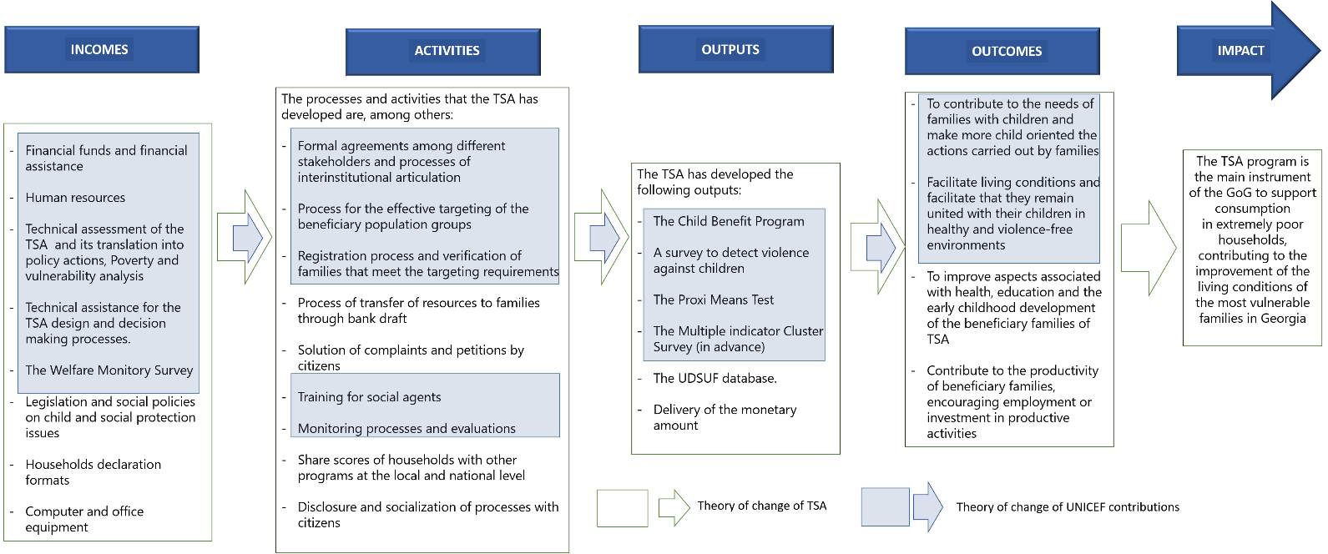
What indicators do you use to monitor the progress of the program through its different processes? (inputs, outputs, outcomes)/ Is it possible to have access to these information in writing or through some database?
TSA is a program aimed at protecting families who are in poverty, from your experience what are the main reasons that explain UNICEF involvement in actions related with poverty and social assistance? Why?
In regards to the programme, what are UNICEF's main objectives? And to what extent were those UNICEF objectives achieved? (Notice that we are talking about UNICEF objectives not TSA objectives)

What has been the major factors influencing the achievement or non-achievement of the UNICEF’s objectives? (positive and negative key factors)
In relation to the scheme, how closely do UNICEF's actions presented within the blue boxes resemble the reality of their contribution to the TSA programme? (Notice that we are talking about UNICEF contribution to TSA Objectives)

What is missing? What's left? Why?

In particular, what are the advantages of the presence and contribution of UNICEF in the TSA?

- Stakeholders´s mapping
Who are the main stakeholders involved in the program and what roles do they play?
How is the articulation process among the stakeholders? How does UNICEF participate in this articulation?

What strengths and weaknesses have you identified in the relationship between the GoG and UNICEF? Why?

How is the process of monitoring and generation of information developed? How does your entity participate? (participation of the GoG, SCO, other agencies)
We have noticed that TSA presents statistics differentiated by sex, so let´s talk about gender equity, how does the program aim to strengthen equity between boys and girls?
How does TSA address and dismantle barriers that violate the rights of women and girls?
How has UNICEF contributed to these processes?
What strengths and weaknesses does the program have for strengthening gender
To what extent does TSA focus on strengthening the rights of children and promote more child-sensitive actions? How does it do it?
How has UNICEF contribute in this regard?

- Efficiency

What are the main inputs / resources (technical, financial and human) that the program needs to be able to function?
Are these inputs / resources sufficient for TSA to meet its objectives? Why?
Since the program started have there been changes in the resources you have needed? Which? Why?
What factors have limited efficiency in the management of program resources?
What changes or adjustments could make the TSA implementation process more efficient?
With what kind of resources does UNICEF contribute to TSA?
Have been changes in the resources with which UNICEF has contributed to the program? Which? Why?
What are the main inputs / resources (technical, financial and human) that UNICEF Georgia needs to contribute to the program?
Are these inputs / resources sufficient to achieve UNICEF's contribution to the program? Why?
What changes or adjustments could make the UNICEF contribution more efficient?

- Sustainability

How is the sustainability of TSA understood?
What are the main changes that TSA seeks to promote in their families beneficiaries (Quality of life, child sensitive decisions, etc.)
What is the sustainability of those changes in the medium and long term?
To what extent does TSA contributes to the strengthening of institutional capacities within the framework of the program?
Which capacities were strengthened as a result of UNICEF's contribution to the TSA? / Who were the main beneficiaries of this capacity building process?
What aspects could condition the sustainability of UNICEF's contribution to the programme?
What risks does the programme face in the future for its sustainability?
How can UNICEF help mitigate these risks?

- Recommendations and lesson learned

From your experience, what lesson learned would you like to share about the implementation/reform of TSA?
¿What could be a possible recommendations or adjustments for the program?
What are your proposals for future directions of UNICEF’s contribution to the programme?
Thanks very much!

Information taken from the Terms of Reference of the evaluation.
Information from The World Bank Factbook
A complete description of the methods in Econometria Consultores (2019a)
As Calonico, Cattaneo, & Titijunik (2014)
We use the Stata command rdrobust using a 2 degree polynomial approximation.
Using all households would have implied that for our estimations over children’s outputs we will have only used around 40% of the sample, which would have considerably affected the precision of the estimates.
For example, in (Hidrobo, Hoddinott, Peterman, Margolies, & Moreira, 2014), and (Trenouth, y otros, 2018). A comprehensive review of the literature can be found in the Econometria Consultores (2019b)
One needs to take into account that individuals do value their time at home, with their families or simply resting. This is known as the “value of leisire”.
The coefficient at 60K for panel f does have a large standard error because the first stage regression estimate is not statistically significant.
All coefficients are in tables 2.11, 2.12, 2.13, 2.14, 2.15, 2.16, 2.17 in appendix 2.
We follow Attanasio & Kaufmann (2009) methodology. The expected return is the mean of the earnings that they could get in the case they obtain a bachelor degree.
We do find a small reduction around 57K when we asked households directly but the coefficient is no longer significant when we use the administrative data. We also find some changes in some particular vaccines but the effect disappeared when we aggregate all vaccines. All coefficients are in table 2.18 & 2.19 in the appendix 2.
TD stands for Tetanus and Diphtheria
Law of Georgia on Social Assistance (2006)
Social Service Agency, www.ssa.gov.ge http://ssa.gov.ge/index.php?lang_id=GEO&sec_id=1242 (accessed January 8, 2018)
The impact of targeted social assistance on labor market in Georgia: a regression discontinuity approach. World Bank (2015). Tuck, et. al.
GeoStat http://www.geostat.ge/index.php?action=page&p_id=188&lang=eng (accessed January 8, 2018)
Social Service Agency, www.ssa.gov.ge; http://ssa.gov.ge/index.php?lang_id=GEO&sec_id=1242 (accessed January 8, 2018)
Datasets of WMS 2009-2017 http://data.unicef.ge/en/datasets/2015-welfare-monitoring-survey (accessed January 8, 2018)
Continuous improvement: strengthening Georgia's targeted social assistance program”, World Banki, UNICEF, Posadas, Mshvidobadze, Baum (2016) https://elibrary.worldbank.org/doi/abs/10.1596/978-1-4648-0900-2_ch1 (accessed January 8, 2018)
Ibid.
SSA at http://ssa.gov.ge/index.php?lang_id=GEO&sec_id=35 (accessed January 10, 2018)
Households with PMT scores over 100 000 might be entitled municipal benefits
Gugushvili, Le Nestour (2018), Indepth Assessment of Georgia’s Targeted Social Assistance. UNCIEF Georgia; SSA http://ssa.gov.ge/index.php?lang_id=&sec_id=1297 (accessed May 8, 2018)
Ibid.
Supranote.
Supranote 7 & 8
Proxy variables (indicators) to measure the outcomes should be agreed with the UNICEF in adnvace
Supranote 12
Agrist, Piscke (2009), Mostly Harmless Econometrics; Lee, Lemieux (2010) Regression Discontinuity Designs in Economics. Journal of Economic Literature, 48(2): 281-355.
Jacobus De Hoop (2018), Initial Examination of TSA Score Density, OoR (Internal Document)
In addition to the TSA, poor households also receive benefits from local governments (eligibility criteria varies by municipality) – this has to be accounted for during data collection and analyses of entire evaluation.
Jacobus De Hoop (2018), Initial Examination of TSA Score Density, OoR (Internal Document)
UNEG Norms and Standards for Evaluation: www.unevaluation.org/document/download/2787
UNEG www.unevaluation.org/document/download/2107
UN-SWAP www.uneval.org/document/download/2433
UNEG Ethical Guidelines www.uneval.org/document/download/548
http://www.unicef.org/evaluation/files/UNICEF_Evaluation_Report_Standards.pdf 28 November 2014; http://www.unicef.org/evaluation/index_60830.html 28 November 2014

