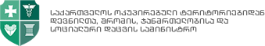

Ministry of Internally Displaced Persons from the Occupied Territories, Labor, Health and Social Affairs

GLOBAL BUDGET AND REIMBURSEMENTS MANUAL

THE GEORGIA EMERGENCY COVID – 19 RESPONSE PROJECT

August, 2020
Tbilisi, Georgia

The GLOBAL BUDGET AND REIMBURSEMENTS MANUAL was prepared in accordance with the Loan Agreement between Georgia and the World Bank (IBRD 9113-GE) dated May 1st, 2020 and the Loan Agreement between Georgia and Asian Infrastructure Investment Bank (L0388A) dated May 21st, 2020.

TABLE OF CONTENTS

I. INTRODUCTION 4
II. KEY LEGAL DOCUMENTS RELATED TO THE IMPLEMENTATION OF THIS MANUAL 4
III. PROJECT DESCRIPTION 5
IV. GOVERNMENT RESPONSE 6
V. GEORGIA, GLOBAL BUDGET PROFILE 6
VI. DESCRIPTION OF CATEGORIES FOR THE GLOBAL BUDGET AND REIMBURSEMENT 7
VII. TREATMENT AND HOSPITAL MOBILIZATION COSTS AT PUBLIC AND PRIVATE HEALTH CARE FACILITIES 7
VIII. QUARANTINE COSTS AT MEDICAL FACILITIES AND HOTELS 10
IX. DEVELOPMENT OF ANNUAL PROJECT BUDGET PROCEDURES 12
X. HEALTH CARE READINESS REIMBURSEMENT PROCEDURES 12
XI. ELIGIBILITY 13

ABBREVIATIONS AND ACRONYMS

AIIB | Asian Infrastructure Investment Bank
ALMP | Active Labor Market Program
BFP | Bank-facilitated procurement
CDC | Centers for Disease Control and Prevention
COVID-19 | Coronavirus disease
CPF | Country Partnership Framework
DA | Designated Account
DLI | Disbursement-linked indicators
DES | Documents Electronic System
ESMF | Environmental and Social Management Framework
EU | European Union
EUR | Euro
F&C | Fraud and corruption
FM | Financial management
FTCF | Fast Track COVID-19 Facility
GDP | Gross domestic product
GoG | Government of Georgia
GEL | Georgian Lari
Ge-GP | Georgian electronic Government Procurement system
HCF | Health care facility
HEIS | Hands-on expanded implementation support
IBRD | International Bank for Reconstruction and Development
ICU | Intensive care unit
ICWMP | Infection Control and Waste Management Plan
IDA | International Development Association
IDP | Internally displaced person
IFI | International financial institutions
IFR | Interim Financial Report
IHR | International Health Regulations
IMF | International Monetary Fund
LA | Loan Agreement
MoF | Ministry of Finance
MoILHSA | Ministry of Internally Displaced Persons from the Occupied Territories, Labor, Health and Social Affairs
MPA | Multiphase Programmatic Approach
NCDC | National Center for Disease Control and Public Health
NCD | Non-communicable disease
NHA | National Health Agency
PAD | Project Appraisal Document
PDO | Project Development Objective
PIU | Project implementation Unit
POM | Project Operations Manual
PMT | Proxy means test
PPE | Personal protective equipment
PPSD | Project Procurement Strategy for Development
SEP | Stakeholder Engagement Plan
SESA | State Employment Support Agency
SOE | Statement of Expenditures
SPRP | COVID-19 Strategic Preparedness and Response Program
SSA | Social Service Agency
STEP | Systematic Tracking of Exchanges in Procurement
TA | Technical Assistance
TSA | Targeted Social Assistance
UHC | Universal Health Care
UNDP | United Nations Development Programme
UNICEF | United Nations Children’s Fund
USAID | United States Agency for International Development
US$ | United States dollar
VHI | Voluntary Health Insurance
WB(G) | World Bank (Group)
WHO | World Health Organization

INTRODUCTION

On April 2, 2020, the World Bank Board of Directors approved the Multiphase Programmatic Approach (MPA), supported under the Fast Track COVID-19 Facility (FTCF). The MPA visibly commits substantial resources and complements funding by countries and activities supported by other partners to help ensure adequate resources to fund a rapid emergency response to COVID-19. In parallel, the Board approved with the MPA the financing of Phase 1 of the Program for 25 Investment Project Financing operations under the Strategic Preparedness and Response Program (SPRP) for countries across the world.
Government of Georgia requested assistance in handling COVID-19 emergency from the World Bank and the Asian Infrastructure Investment Bank. Loans in the amount of EUR 73,1 million and USD 100,0 million were provided from these banks respectively for the implementation of the Georgia Emergency COVID-19 Response Project (the Project). Ministry of Internally Displaced Persons from the Occupied Territories, Labor, Health and Social Affairs (MoILHSA) is the project implementing entity and a project implementation unit (hereinafter, the PIU) is set up within this ministry for day-to-day management of the project.

This Global Budget and Reimbursement Manual sets forth procedures and rules, which are to be followed by the core Ministries in Georgian Government – MoF and MoILHSA with project implementation unit (PIU), participating institutions and all stakeholders involved in the project implementation. The Global Budget and Reimbursement Manual is to promote consistency and transparency in implementation of the project activities, particularly related to activities for health-sector readiness under Part 1 (b) of the Project, containing detailed guidelines and procedures for implementation of Part 1 (b) of the Project, including with respect to: budget allocations, methodology for the estimation, review, approval, and transfer of such budget allocations, detailed reimbursement mechanisms, arrangements for the flow of funds, and such other arrangements and procedures as shall be required for the effective implementation of such activities, in form and substance satisfactory to the Bank.
Guidelines and procedures defined in the given Global Budget Reimbursement Manual are in accordance with the Loan Agreement (LA) and Project Appraisal Document (PAD).

KEY LEGAL DOCUMENTS RELATED TO THE IMPLEMENTATION OF THIS MANUAL

- The GoG Resolution N36 on Unified Healthcare, dated February 21, 2013
- The GoG Resolution N674 on “Approval of the State Healthcare Program for 2020”, dated, December 31,2019
- Resolution N184 of the Government of Georgia, dated March 23, 2020 on establishment of different rules for the implementation of public and other administrative services
- Ordinance of the Minister of Internally Displaced Persons from the Occupied Territories, Labour, Health and Social Affairs of Georgia # N 01-306/o, dated June 30, 2020
- State budget 2020, Law of Georgia on Amendments to the Law of Georgia on the State Budget of Georgia for 2020 (II submission) dated June 29, 2020
- Georgia Emergency COVID-19 Response Project Operations Manual
- International Bank for Reconstruction and Development General Conditions for IBRD Financing, Investment Project Financing, dated December 14, 2018.
- Law of Georgia on Personal Data Protection, dated December 28, 2011
- Law of Georgia "On Public Procurement" dated April 20, 2005
- The GoG Resolution N286, dated May 4, 2020
- LA No 9113-GE between Georgia and the International Bank for Reconstruction and Development (IBRD), dated May 1, 2020, co-financed by the L0388A the Asian Infrastructure Investment Bank (AIIB), dated May 21, 2020

PROJECT DESCRIPTION

PROJECT DEVELOPMENT OBJECTIVES (PDO) - is to prevent, detect, and respond to the threat posed by the COVID-19 pandemic and strengthen national systems for public health preparedness in Georgia.
PDO INDICATORS:
- Number of people tested for COVID-19 identification per MoILHSA protocol;
- Number of COVID-19 patients treated in hospital settings per Social Service Agency (SSA) reimbursement guidelines;
- Share of the population in the poorest quintile who are receiving the COVID-19 pandemic related social assistance programs.
PROJECT COMPONENTS:
COMPONENT 1. Emergency COVID-19 Response – total US$ 71,85 million (WB financing EUR 29.1 million, US$ 31.9 million equivalent, remaining AIIB financing)
SUBCOMPONENT 1.1: Case Detection and Confirmation (EUR 7.3 million, US$ 8.0 million equivalent). This subcomponent will help to strengthen public health laboratories and epidemiological capacity for early detection and confirmation of cases.
SUBCOMPONENT 1.2: Health System Strengthening for Case Management (EUR 21.8 million, US$ 23.9 million equivalent). This subcomponent will contribute to the strengthening of health system preparedness, improve the quality of medical care provided to COVID-19 patients, and minimize the risks for health personnel and patients.
COMPONENT 2. Enabling Health Measures to Contain the COVID-19 Outbreak through Temporary Income Support for Poor Households and Vulnerable Individuals –total US$ 107,85 million (WB financing EUR 43.7 million, US$ 47.8 million equivalent, remaining AIIB financing)
SUBCOMPONENT 2.1: Cash Transfers to Poor and Vulnerable Households (EUR 8.1 million, US$ 8.9 million equivalent).
SUBCOMPONENT 2.2: Temporary Unemployment Assistance for Individuals who lose their Job because of the COVID-19 Outbreak (EUR 35.6 million, US$ 38.9 million equivalent).
COMPONENT 3. Project Management and Monitoring – US$ 0,3 million (WB financing EUR 121,5, US$ 133,0 equivalent, remaining AIIB financing)
This component will support project implementation for the overall administration of the project.

GOVERNMENT RESPONSE

Immediate reforms and fiscal discipline was a necessary prerequisite to attract financial resources from the international partners in order to minimize the negative effects of the pandemic. Following the immediate actions of the GoG, Georgia was the first country to receive increased funding from the International Monetary Fund. Successful negotiations with the IMF enabled the country to attract significant monetary resources from other donors as well. In total USD 1.5 billion budget assistance was allocated, including:

- International Monetary Fund – USD 200.0 million
- Asian Development Bank – USD 400.0 million
- World Bank – USD 250.0 million
- French Development Agency – USD 200.0 million
- KFW – USD 250.0 million
- European Union – USD 200.0 million
- Asian Infrastructure Investment Bank – USD 100 million

In addition, coordinated by the Office of the Business Ombudsmen of Georgia, the special platform along with the dedicated StopCov Fund has been created, to enable the private sector and any individuals to make their contributions. Mobilized funds were directed to meet the most critical needs in a transparent manner and in accordance with the Georgian legislation. As of June 1, 2020, 133 121 907 Gel has been transferred to the StopCov fund. Donations were made by a total of 6 968 entities, including 1,673 individuals; 1 410 private companies; 785 public institutions, including subordinated agencies and 3 100 other donors.

As per Anti-Crisis plan of Georgia, for 2020 the total budget for the measures envisaged in Phase 1 and 2 of COVID-19 is as follows:

- Provide support and social assistance to Georgian citizens - GEL 1.04 billion
- Provide economic support and assist entrepreneurs – GEL 1.76 billion
- Strengthen the health care system and fighting against the pandemic- Gel 350 million

GEORGIA, GLOBAL BUDGET PROFILE

The Government of Georgia has introduced a temporary transfer program to public and private hospitals in the form of a global budget to ensure standby readiness and to compensate the facilities for losses in revenue due to COVID-19.
The goal of the program is to protect the population from infection with the new coronavirus (SARS-CoV-2) (COVID 19) by taking both preventive measures and measures necessary to respond to the disease if it is detected.
The Main characteristics of Covid - 19 Budgeting Scheme in Georgia:
- Service provider – public and private hospitals
- Expenditure type – operating costs
- Budget process – state controlled
- Budget Limitation – mobilized in the state budget; no financial limitations for Covid – 19 confirmed case
- Financing sources – the state budget, StopCov Fund and loans

DESCRIPTION OF CATEGORIES FOR THE GLOBAL BUDGET AND REIMBURSEMENT

To ensure and strengthen planning and clinical care capacity of Georgia’s health systems through inter alia, establishing specialized care units, increasing availability of isolation facilities, increasing availability of critical medical supplies, equipment, and other related goods, and mobilizing additional resources to public and private health care facilities for effective management of cases, including non-severe cases and ensuring readiness for forthcoming COVID-19 cases and treatment, the Government of Georgia initiated the amendment of the State Budget Law, with increased State Budget to Health Sectors.
At the initial stage, the Government of Georgia, represented by the Ministry of Internally Displaced Persons from the Occupied Territories, Labor, Health and Social Affairs, started financing the costs related to the Covid – 19, including quarantine and treatment costs, via Universal Health Care Program, by adding special program named Infectious. The budget transfers were made through the Social Service Development Agency. However, due to the increased budgetary management, the dedicated state budget lines were added in June, 2020, under the health sector budget line and since then Covid-19 cases are financed through these lines (Table #1). Following the decision, all Covid-19 related transactions which were made during previous three months (March, April and May) were technically copied into the newly created Covid-19 budget lines:
Table #1 health sector program budget lines
No | PROGRAM CODE IN STATE BUDGET | PROGRAM
1 | 27 03 03 11 | New coronavirus disease COVID-19 management
2 | 27 03 03 11 01 | Measures to be taken by the Ministry to support the management of New Coronavirus (SARS-CoV-2) infection (COVID-19)
3 | 27 03 03 11 02 | Measures to be taken to manage New Coronavirus (SARS-CoV-2) infection (COVID-19)
4 | 27 03 03 11 03 | Measures to be taken by the Center to support the management of New Coronavirus (SARS-CoV-2) infection (COVID-19)
5 | 27 03 03 11 04 | COVID-19 Emergency Response Management (WB)
6 | 27 04 03 | Equipping / Rehabilitation of Medical Facilities to Provide COVID-19 Emergency Response Measures
7 | 27 04 04 | Financing of COVID-19 Healthcare measures (EIB)
TOTAL AMOUNT DISBURSED AS OF AUGUST 17, 2020 |  | GEL 64,232,591.58

TREATMENT AND HOSPITAL MOBILIZATION COSTS AT PUBLIC AND PRIVATE HEALTH CARE FACILITIES

COVID 19 case management in Georgia is predominantly hospital based. During the first stage early in 2020, infectious disease clinics were selected, including in the cities of Tbilisi, Kutaisi and Batumi. Additionally, to become more prepared for the increased numbers of cases, extra beds were mobilized in two cities, Tbilisi and Batumi. In total, across the country, 3 279 beds have been mobilized for COVID - 19 and 1 050 beds (distributed in 16 fever clinics) for fever management. Additionally, in accordance with the basic needs, new clinics in Rukhi and Batumi were equipped, which began functioning in the beginning of May.

The mobilization of „COVID clinics“ and so called “Fever Clinics” were implemented gradually, depending on the needs; From the first day of the epidemic, in the first mobilization phase, 9 clinics with 826 beds were prepared. Taking into account the increased number of patients, in the second phase of mobilization, 12 clinics, (1247 beds) were emptied gradually. In May of this year, due to the low rate of hospital loads, the inclusion threshold in the program of new clinics increased up to 1600 active cases. Moreover, clinics are given the possibility to safely continue providing other services, by determining “fever zones”.

Being implementing agency of the New Coronavirus (SARS-CoV-2) infection (COVID-19) treatment, the Social Service Agency (Currently the National Health Agency) manages implementation and procures the following services:
- Initial diagnostic assessment of COVID 19 suspected cases (excluding PCR testing of Covid -19, this is implemented by the National Center for Disease Control and Public Health);
- In - patient treatment of confirmed COVID 19 cases;
- COVID-19 unconfirmed case management, which requires hospital treatment for other reasons;

The treatment of the COVID patients for all individuals in Georgia, regardless the nationality and residency status has been fully covered by the GoG funds. Starting from September 1 2020, this regulation will change and the state funding will be limited to Georgian citizens and those holding the residence permit.
The National Health Agency (NHA) uses the specific reimbursement code for initial diagnostic workup of suspected Covid cases that amounts up to Gel 150. NHA issues reimbursement based on actual expenditures within a predefined Gel 150 ceiling.
The treatment costs of confirmed case are fully reimbursed by GoG based actual cost (without limitation).
A special arrangement was set to reimburse personal protective equipment related expenditures. The ministry may choose to centrally procure and distribute PPIs to all participating clinics. Alternatively, NHA will provide cost reimbursement on PPIs if central distribution mechanism was not used and clinics secured their own supplies independently.
Treatment at public and private healthcare facilities are reimbursed equally. The total treatment related costs, as of August, 2020 is about GEL 4 938 651, 34 (Table #2).

Table #2: Inpatient care costs incurred as of August, 2020
TREATMENT | COSTS (IN GEL)
COVID-Diagnostic | 1 059 893,5
COVID-Negative (unconfirmed case management required inpatient treatment) | 2 042 867,14
COVID-Positive (Treatment of a confirmed case of COVID-19) | 1 735 272,63
COVID-REANIMATION I - II - III level intensive treatment | 100 620,22
TOTAL TREATMENT COSTS AS  OF AUGUST 2020 | 4 938 651,34

Full mobilization of designated healthcare facilities in accordance with defined rules (freeing up additional vacant hospital beds). The institutions providing these services are assigned by the ordinance of the Minister (details, see above #N 01-306/o, dated June 30, 2020). The contract signed by both parties is uploaded to the unified electronic system of State Procurement (spa.ge). The supplier is also registered in the e-government finance module of the ministry. The defined services will be paid at a real cost, based on the mutual agreement (the Agency, on the one hand, the Facility on the other). The total hospital mobilization costs, as of August, 2020 is about GEL 19,694,414 (Table #3).

Table #3 Hospital mobilization costs incurred as of August 20, 2020
STATE BUDGET CODE | DESCRIPTION | COST  (IN GEL)
27 03 03 11 02 | Full mobilization of the institutions to prevent the possible spread of the new coronavirus COVID-19 in Georgia (epidemic, pandemic, epidemic outbreak) and to respond to suspicious and / or confirmed cases | 19,694,414
TOTAL | Actual costs of quarantine services, as of august 20, 2020 | 19,694,414

In agreement with the hospital service providers, given that infection control requirements are met, the ministry uses two models for contracting hospitals for delivering COVID related services. A) A full mobilization model invasions switching hospitals completely to managing COVID suspected or confirmed cases and B) Hybrid model, when hospitals allocate a part of their bed capacity to COVID 19 purposes. In this cases hospitals define the number of beds that can safely be used of patients with COVID. With concurrence from the State Procurement Agency, the NHA issues service contracts to “hybrid” hospitals on utilization of certain number of beds for COVID purposes.
The hospitals providing COVID/FEVER services are determined by the Ordinance of the Minister of Internally Displaced Persons from the Occupied Territories, Labour, Health and Social Affairs of Georgia # N 01-306/o, dated June 30, 2020 and the Resolution of the Government of Georgia 322 dated May 23, 2020. Initially total 34 health care facilities were contracted. However due to the effective management of the Pandemic, the number of contracted health care facilities have been decreased. As of August, 2020, there are twelve facilities that are fully or partially mobilized across the country (Ordinance # 01-306 /o, amended on July 31, 2020).
Fully mobilized:
- LTD "Central University Clinic named after the Academician Nikoloz Kipshidze", Rukhi
- LTD Mtskheta Medical Center
- LTD Batumi Republican Clinical Hospital
- LTD Tbilisi Sea Hospital

Partially mobilized (hybrid model):
- JSC Infectious Diseases, AIDS and Clinical Immunology Research Center - 50 beds
- LTD Clinic of Academician Vakhtang Botchorishvili - 73 beds
- LEPL First University Clinic of the Tbilisi State Medical University - 14 beds
- LTD Central University Clinic named after Academician Nikoloz Kipshidze - 25 beds
- LTD Tbilisi Children’s Infection Clinical Hospital - 24 beds
- LTD LG and Company -Tuberculosis and Infectious Diseases Center of West Georgia - 18 beds
- LEPL Military Hospital of the Defence Ministry of Georgia named after Giorgi Abramishvili” - 40 beds
- JSC Sachkhere Regional Hospital-Polyclinic Unification – 50 beds.

The tariff for each vacated bed is determined by the Resolution N674 of the Government of Georgia, dated December 31, 2019. Medical institutions with a total number of beds less than or equal to 80 will be reimbursed by 100 GEL per bed per day; if there will be a need for more than 80 beds in the hospital, 120 GEL per day will be reimbursed for each bed.
National guideline of the clinical management of the COVID patients has been introduced in March 24, 2020 (Ministerial Decree № 01-119/o). NHA monitors compliance with national treatment standards. If substantial deviation is found from the established treatment guidelines NHA may consider costs ineligible. For instance, if COVID 19 diagnoses is not confirmed with PCR test results the case related costs will not be reimbursed.

QUARANTINE COSTS AT MEDICAL FACILITIES AND HOTELS

Quarantine costs of travelers/contacts with fever for individuals who cannot self-isolate at home is fully covered by the Government of Georgia, therefore is reimbursable from the project perspective. Since March 2020 quarantine related arrangements were organized by the Ministry for Economic Development through the Georgian National Tourism Administration. MoLHSA remained in charge of providing clinical teams for medical supervision in hotels providing quarantine services.
1. Medical supervision of the quarantine facilities. The institutions, with which the contracts (the contracts total amount of GEL 1,151,218) was signed. Under the scope of the above-mentioned measure, one medical center (“Abastumani Lung Center”, Ltd.) was determined in the state program of the "Referral Service" (within the framework of the Resolution No. 674 of Government of Georgia, dated December 31, 2019), states that contracts are concluded through a simplified procurement in accordance with Article 10¹ of the Law of Georgia “On Public Procurement”. The contract signed by both parties is uploaded to the unified electronic system of State purchases (spa.ge). The supplier is also registered in the e-government finance module of the ministry. The defined services will be paid at a real (actual) cost, based on the mutual agreement (the Agency, on the one hand, the Healthcare Facility on the other). The maximum cost for each bed is GEL 150 GEL. The agreement signed with one of the facilities is attached to the document as a sample. The services under this agreement are fully provided and not currently valid.

Table #4 Actual Costs for quarantine spaces at medical facilities:
N | ORGANIZATION | BENEFICIARIES | ACTUAL COST (14 DAYS)
1 | JSC Sachkhere Regional Hospital-Polyclinic Unification | 205 | GEL 349,350.00
2 | JSC "National Center for Tuberculosis and Lung Diseases" | 51 | GEL 36,848.00
3 | LTD Viva Medi | 106 | GEL 79,400.00
4 | LTD Abastumani Lung Center* | 75 | GEL 253,738.00
TOTAL |  | 437 | GEL 719,336.00

* The costs of quarantine services provided by Ltd. Abastumani Lung Center were covered based on the Global Budget principles (does not depend on a number of patients, only number of beds are calculated).

2. Contribution of the medical staff to the Quarantine Facilities. Resolution N 674 of the Government of Georgia dated December 31, 2019, states that the Georgian Medical Holding and LTD Regional Healthcare Center will coordinate the provision of this service. The Georgian Medical Holding compiles and sends a list of medical personnel to SSA. The amount of salaries for medical personnel is also determined by the Holding. The Agency concludes a Public Procurement Contract with medical personnel (in accordance with the Article 10^{1,} the Law of Georgia “On Public Procurement”). The agency has currently recruited 300 doctors and nurses. However, the number is regularly changing.

3. Provision of the transportation service to the beneficiaries of the haemodialysis component of the State Program "Dialysis and Kidney Transplantation" throughout Tbilisi. The period was defined corresponding to the duration of the state of emergency and further lifting restrictions on public transport. Contracts were concluded with 11 individual entrepreneurs and persons to ensure the transportation of beneficiaries from their place of residence to a healthcare facilities during Emergency period.

Table #5 Actual Costs of Quarantine service incurred, as of August 20, 2020
STATE BUDGET CODE | DESCRIPTION | COST  (IN GEL)
27 03 03 11 02 | Provision of quarantine measures – hotel services for quarantine spaces (hotels, medical facilities) | 465,598
27 03 03 11 02 | Provision of quarantine measures - provision of quarantine facilities with medical staff and primary medical supplies / medicines | 821 400,9
27 03 03 11 02 | Ensuring quarantine measures - medical supervision | 107 807
27 03 03 11 02 | Provision of transportation of the beneficiaries of the haemodialysis component of the state program "Dialysis and Kidney Transplantation" throughout the city of Tbilisi | 67 500
TOTAL | ACTUAL COSTS OF QUARANTINE SERVICES, AS OF AUGUST 20, 2020 | 1 462 305.9

* Note: the Ltd. Abastumani Lung Center costs, is excluded from the total amount. The center operates within the State Referral Program (under the separate state budget code) and has been reimbursed based on the global budget.

DEVELOPMENT OF ANNUAL PROJECT BUDGET PROCEDURES

Following the information described above, it is envisaged to reimburse project eligible costs under the Emergency COVID-19 Response Project (LA WB IBRD 9113-GE; co-financed by the AIIB L0388A).
In accordance with the Project core documentation (LAs, PAD, POM), the eligible activities will be included in the project budget and the whole project procurement and/or reimbursable, will be managed and administered by the Project Implementation Unit (PIU) established in June, 2020, under the MoILHSA and coordinated by the Ministry.
Considering the emergency status, for the aim to meet immediate goals of the Project, the Financial Manager (FM) prepares the project budget, which includes detailed forecast under each component, based on the information received from corresponding Departments/Agencies under the Ministry. The Project annual budget reflects all expenditures, expenditure items and sources of financing, with co-financing percentages if any. The annual project budget is reviewed approved by the Project Focal Point, the Deputy Minister of MoILHSA.
After internal review and approval, the Project Budget is submitted to the WB for approval and for planning drawdowns. Following the WB approval, the Project Budget through the MoILHSA, is submitted for clearance to the Ministry of Finance (MoF), which reflects the information in the Annual State Budget.
As was mentioned above, due to the Pandemic, the State Budget of 2020 was already amended in June 29. However, based on the analysis of planned and actual expenditures, it can be amended again, going through the same process as budget planning.

HEALTH CARE READINESS REIMBURSEMENT PROCEDURES

There main stakeholders involved into the health care readiness reimbursement procedures of the Project:

The Ministry of Finance - which is a Loan guarantor and leading Ministry. MoF Provides routine oversight of the spending processes ensures compliance with pre-defined plan; leads the annual budget preparation process, etc.

MoILHSA - responsible for the overall implementation and administration of the project, fiduciary functions, environmental and social aspects, through the Project Implementation Unit.

SSA - a legal entity of public law, a state-subordinated institution under the MoILHSA, administers the state social protection programs.

NHA - (Successor of SSA health unit) - a legal entity of public law, a state-subordinated institution under the MoILHSA, administers the state health programs, including Universal Health Care program. The SSA reimburses health facilities for the actual costs of medicines, diagnostics, and consumables using to treat COVID-19 cases.

The SSA reimburses abovementioned costs, since March 2020. A new agency - National Health Agency that was established in August 2020 will take over the SSA functions related to service procurement from August 2020 onward. If requested, the Project will reimburse all eligible costs, through submission of certain documents and approvals. The reimbursement procedure needs clearance from the PIU.
Reimbursement of the expenditures already covered by the SSA/NHA will be done based on Reimbursement Application Form (Annex #1), which includes the Official request from SSA /NHA signed by the Director of the Agency, memo with full summary regarding expenditures to be reimbursed and supporting documents (payment orders or any other confirmation of the transfers made by the SSA/NHA). The Application form will be submitted to the Deputy Minister of the MoILHSA for further submission to the PIU.
The supporting documents submitted under the Application Form will be verified by the FM Consultant and in case of approval will be reimbursed accordingly. Any objections, or request for clarifications should be sent officially to SSA within 2 weeks from the receiving of the application form.
The expenditure reimbursement process description is as follows:
- SSA/NHA submits to the MoILHSA the official letter for reimbursement, Memo and Application Form via Document Electronic System (DES)
- The Minister and/or the Deputy Minister gives formal consent and assigns task via DES for reimbursement to the PIU and the Financial – Economic Department of MoILHSA
- FM – PIU, verifies supporting documents based on project eligibility criteria (accepts/rejects )
- In case of rejection, FM sends the request for additional clarification to the SSA via DES
- In case of acceptance, FM prepares special application, uploads all supporting documents and requests No-objection for the reimbursement
- The World Bank and AIIB clears the documents submitted by the PIU
- The PIU based on the WB/AIIB No-objection will electronically upload the Reimbursement Type of application to the World Bank Client's Connection System (CCS). Designated Signatories (the First Deputy Minister, Project Manager - PIU, the Head of Financial – Economic Department) sign the uploaded Application, which after signature is sent to the WB for reimbursement
- The PIU receives the notification through the Client Connection that the amount is on the Treasury account and will be processed/converted by the MoF.

ELIGIBILITY

Eligible Expenditures of “Emergency Covid-19 Response Project”:

- Component 1: Goods, Works, Non-Consulting services, Consulting services, Operating Costs, and Training for Parts 1 and 3 of the Project
(Part 1: Emergency COVID-19 Response; Part 3: Project Management and Monitoring)

Table #6 Indicative activity and equipment list with tentative costing for component 1 (PAD, 2020)
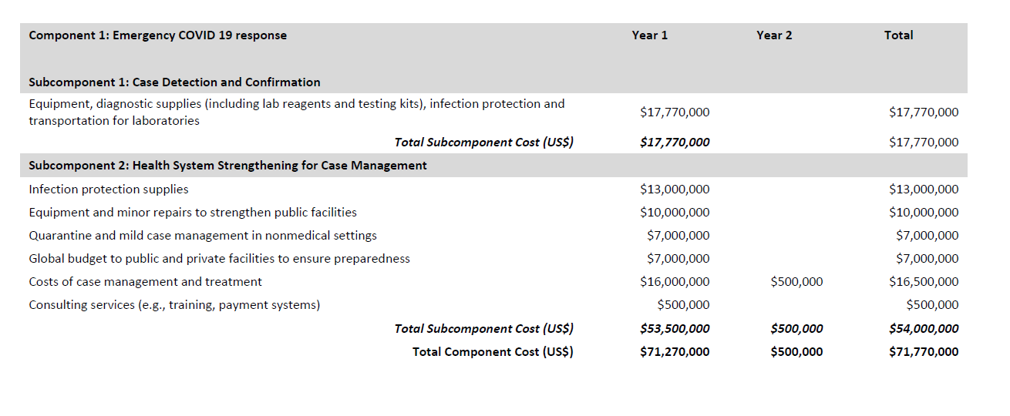

- Component 2: Cash Transfers and Unemployment Benefits for Part 2 of the Project, through temporary income support for poor households and vulnerable individuals

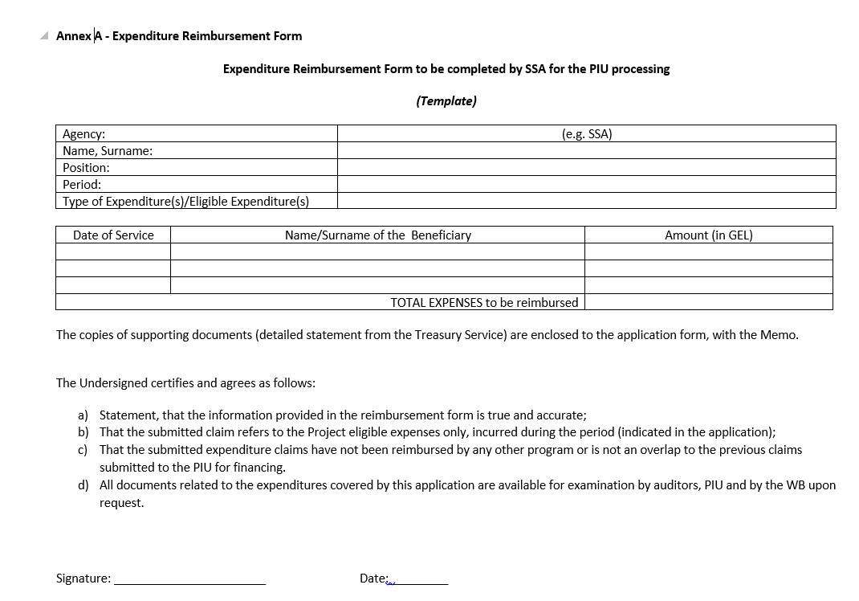

GoG Report on Measures Taken Against Covid-19 http://gov.ge/index.php?lang_id=GEO&sec_id=424&info_id=76338&fbclid=IwAR1h12PkBbzTatKl4RHzgV0pVlLB6ca5OzmMRJMpCCzhr-la-u5QipztUIs
Memo should include detailed list of beneficiary healthcare facilities, types of expenditures, amount paid for each beneficiary and other details.
There are two letters signed by the Minister of Finance regarding authorized persons with corresponding credentials to be responsible to sign the withdrawal applications: (a) Letter N07-05/4953, dated 02.06.2020 presenting Mr. Nikoloz Gagua, the Deputy Minister of MoF (b) Letter N07-05/69900, dated 0707.2020 presenting Mrs. Tamar Gabunia, the First Deputy Minister, MoILHSA, Mrs. Nino Kvernadze, Emergency COVID-19 Response Project Manager and Mr. Beqa Jakeli, the Head of Finance and Economic Department, MoILHSA.

