Dirty Details Of How The Fascists Plan To Destroy America By The End of 2015
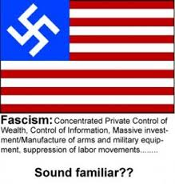
Here is their overall plan:
(1) When the new FCC laws come into effect, this will set up highly regulated (as well in many cases, restricted) access. Many people will no longer be able to afford their service anymore - which in fact, is the plan. To slowdown and choke communication between the American people and the world. Sadly this is only the first step.
NET NEUTRALITY ON THE RECORD (LAST UPDATE 2015-03-18)
https://mega.co.nz/#F!P4lQDCzS!DUQcKxubkeVoZOBKcAUVJg
* BIG LIE #1 exposed: FCC chairman lied saying there will be no taxes due to the new massive trove of FCC regulations. However, this just in: now the FCC chairman admits that there will likely be new taxes on future internet use! Supporters of the "net neutrality" scam beware, you will pay for your naive bliss and arrogant trust in the federal government, as you liberals should already know by now: THEY LIE ALL THE TIME! *
(2) The Obama regime will force through (WITHOUT approval from Congress which is treason and against the law) the TPP. This will highly regulate and choke off imported goods into the United States, and purposely triple the cost of assets and commodities - including energy. This will also set up a de-facto fascist corporate dictatorship void of law - and that is just the tip of the iceberg - they plan to fully ban ammunition imports, etc! Under the TPP, corporations can demand governments change their laws and impose massive sanctions on countries if they don't comply.
THE TPP IS NOW BEING IMPLEMENTED BY STEALTH, AND THE SO-CALLED 'LAWS' REMAIN HIDDEN IN PUBLIC VIEW. HERE IS A PERFECT EXAMPLE OF HOW THIS FASCIST 'TRADE PACT' (NOT REALLY, IT'S NOT EVEN ABOUT TRADE) IS NOW HARMING LOCAL COMMUNITIES AND THEIR ECONOMIES:
Biotech firms sue local Hawaii government for protecting citizens and environment from GMOs
http://www.naturalnews.com/046475_GMOs_Hawaii_biotech_trade_association.html
You can read more about the stealth implementation here:
http://www.thecommonsenseshow.com/2015/02/16/us-economy-days-away-shutting/

LET'S JUST BREAK DOWN THE DETAILED EVENTS FROM WARNING (3):
(3) The CIA is purposely starting proxy wars around the Middle East - this is where World War III will begin. ...
Iraq Arrests ISIS Advisors, US And Israelis Held "Agents of both Mossad and CIA contractors are being held on suspicion of aiding ISIS militants."
http://www.mintpressnews.com/iraq-arrests-isis-advisors-us-and-israelis-held/203250/
http://www.infowars.com/corporate-media-ignores-report-of-u-s-and-israeli-operatives-arrested-aiding-isis/
... The Obama regime has purged all the high-level brass from military leadership, a now effective coup to bring about the end of our military strategy and trust within the ranks. ...
Read more about that purge here:
http://viewsandpreviews.com/sacking-of-commanding-generals-prelude-to-surrender-or-armageddon/
... The Obama regime understands and knows full well that the US has been set up to LOSE World War III. A Conspiracy Of Horrific Implications
The United States Is Being Set Up To Fail
http://quickleak.org/8L6gK2nj
LET'S BREAK DOWN MORE DETAILED EVENTS FROM WARNING (4):
(4) China and Russia are exempted from the fascist TPP. They will not be strangled by this fascist corporate coup - in fact, they have been set up to be the beneficiaries of such treason.
http://www.scmp.com/news/china/article/1637765/xi-jinping-unveils-chinas-plan-asia-pacific-wide-free-trade-pact
China and Russia are well prepared to go to war with the US and have even been re-assured by Obama that they will win World War III.
PUTIN PREPARES TO WIN WORLD WAR III WHILE OBAMA PREPARES TO SURRENDER
http://www.thecommonsenseshow.com/2014/12/08/putin-prepares-to-win-while-obama-prepares-to-surrender/print
AND NOW ... HERE'S THE LAST CARD TO FALL (ALONGSIDE THE DOLLAR):
(5) When World War III plays out, and it gets hot, this overthrown government of the United States has been preparing for war against those who have warned about this - against the preppers – against anyone who stands in the way of their planned World War and their planned destruction of the United States. The overall plan, I have been warned about, is to destroy the US. The "New World Order" was the massive transfer of wealth to China, therefore China and Russia are set to become the new super-powers. In this "Brave New World" America will no longer exist ... it will become an isolated Third World country from which is to be exploited without mercy by the next super powers which (you guessed it) will also become united with these fascists. Prepare for guerrilla warfare. In the meantime, print all the evidence out. The Internet is doomed.
http://www.quickleak.ir/Cvpuy14K
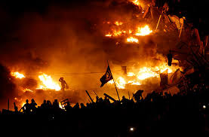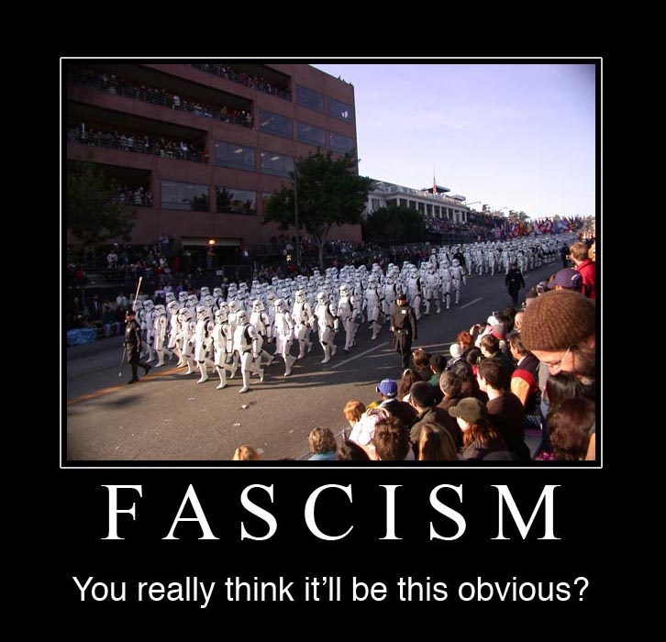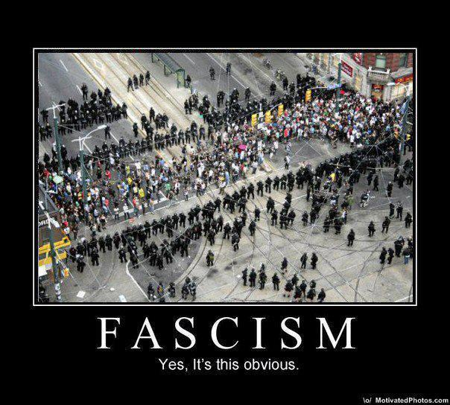

Putin Prepares to Win While Obama Prepares to Surrender
by Dave Hodges | December 8, 2014 7:19 am
[1]
Does anyone really think that any nuclear-armed nation, whether it would be the United States, China and especially Russia will ever accept defeat to a rival nation, in conventional warfare, without subsequently inflicting the maximum penalty on its opponent? There is little question in most experts minds that the loser of a “conventional” World War III will not hesitate to unleash its nuclear weapons as a last ditch means to “even the score”

Obama’s Complacency Is Our Number One National Security Concern
Forbes[2] writer, James Conca, has expressed the view in a dramatic report that when it comes to matching the growing Russian military threat, that America’s most pressing concern is complacency. Conca noted that the recent reports that Russia has gained the upper hand in nuclear weapons capability against the United States, has been met with indifference from this administration.

Making matters worse, Conca observed that this current administration fired the one General who was going to shape up America’s Intercontinental Ballistic Missile command. Now he’s gone and our ICBM’s sit in less than a state of readiness.

Conca notes that even the U.S. State Department has acknowledged that not only has the the U.S. nuclear arsenal fallen behind Russia but so has basic U.S. military technology. The U.S. State Department admits that America is now the underdog should hostilities involving nuclear weapons between the two nations actually break out. Obama is out to lunch and seems oblivious to the threat. The Forbes[2] investigation goes on to say that Russia is absolutely ready and their new long-range cruise missiles that are ready for mobile deployment by land or sea.
.

Hagel Speaks Out and Gets Fired
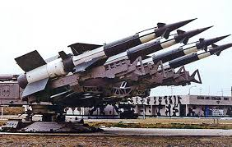[3]Defense Secretary, Chuck Hagel, is now gone from his position. Why? This is probably due to the fact that Defense Secretary Hagel stated that “routine neglect of our nuclear weapons programs over the years has compromised our ability to respond to an actual threat.” This is a clear indictment of the six year presidency of Obama and the fact that he’s done nothing to keep up with Putin. Shortly after this statement, Hagel was fired as Defense Secretary. Is there any doubt what team Obama is playing for?

Russia Withdraws From Nuclear Attacks
Putin announced his warlike intentions, last month, in that he plans to severely scale down nuclear security cooperation with the United States. Translation, Russia does not need, nor want, the protection it formerly achieved through limitations on nuclear weapons.
This aggressive posture, according to The New York Times[4], is seen as Russia’s way of saying that it requires no outside assistance in securing the country’s nuclear assets and network.

Or as observers would say, it could be Moscow’s strong message to the West and the United States in particular that it cannot be pressured about Ukrainian borders, where Russian troops are amassing by the tens of thousands.

Mutually Assured Destruction Is a Thing of the Past
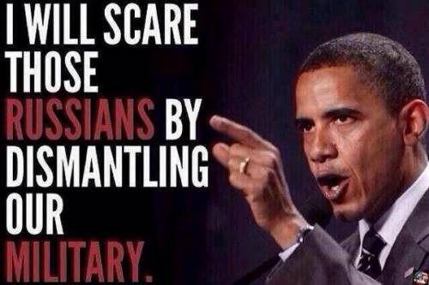[5]
Michael Snyder writing for The Right Side News[6] exposed the fallacy that due to the outdated doctrine of ”mutually assured destruction,” Russia is opposed even to a nuclear confrontation. In fact, Snyder demonstrated that the opposite is true. A nuclear confrontation is something that Putin may not desire, but he is not backing down. The following five developments have been identified which indicate that Russia is fully intending on winning World War III.
1. Radar-beating[7] missile delivery system.

2. Russia has spent nearly $72 billion[8] on arms in 2011 and is planning on spending well over a half a billion dollars to upgrade its weapons systems by 2016 including the development of the ability to cripple America with cyber attacks.

3. Russia’s nuclear forces are turning mobile and the new stealth technology extends fromundetectable bombers[9] to silent running nuclear submarines[10].

4. According to PRAVDA[11], Russia has 5,000 nuclear weapons of different tactical classes including Iskander warheads and torpedo, aerial and artillery warheads, all right next to Europe. The United States has reduced its nuclear arsenal from 31,000 (1967) to a mere 1,600. Obama has openly spoken of reducing our arsenal to 300 nuclear missiles.

5. According to The Financial Times[12], satellite killers were launched into orbit May of 2014. This move by the Russians, parallels what the Chinese have already accomplished and tested. The intent is to blind American forces on the battlefield and at sea.

6. Obama has continued to weaken U.S. nuclear forces through the removal Nineteen nuclear launch officers. This is not a scenario were the United States can simply say “next man up”. These are highly specialized positions requiring highly specialized training that can only be realized through extensive field experience.

Obama Continues To Poke a Stick In the Eye of the Bear

Obama continues to provoke Putin with needless sanctions which do nothing to address the crisis in Ukraine. Meanwhile, it has become clear that Putin is also planning a Red Dawn scenario for the United States. And of course, this would not be possible without the direct complicity of President Obama.
In conclusion, it is one thing to intellectually understand how Obama is destabilizing both the military and its leadership. However, it is emotionally earthshaking to be able to trace Obama’s deliberate treason toward to our national defense. From a military perspective, we are in grave danger and this will be the topic of the next part of this series.
Endnotes:
- [Image]: http://www.thecommonsenseshow.com/siteupload/2014/11/CSS-Offical-New-Logo2.jpg
- Forbes: http://beforeitsnews.com/r2/?url=http://www.forbes.com/sites/jamesconca/2014/11/20/could-russias-new-nuclear-weapons-win-world-war-iii/
- [Image]: http://www.thecommonsenseshow.com/siteupload/2014/11/russian-air-defense.jpg
- The New York Times: http://beforeitsnews.com/r2/?url=http://www.nytimes.com/2014/11/14/world/europe/russia-to-curtail-nuclear-security-efforts-with-us-officials-say.html?_r=0
- [Image]: http://www.thecommonsenseshow.com/siteupload/2014/11/obama-traitor-to-russian-invasion.jpg
- The Right Side News: http://beforeitsnews.com/r2/?url=http://www.rightsidenews.com/2014112535178/editorial/us-opinion-and-editorial/10-signs-that-russia-is-preparing-to-fight-and-win-a-nuclear-war-with-the-united-states.html
- Radar-beating: http://beforeitsnews.com/r2/?url=http://www.popularmechanics.com/technology/military/planes-uavs/russian-made-tech-vs-americas-stealth-warplanes-13506974
- $72 billion: http://beforeitsnews.com/r2/?url=http://en.wikipedia.org/wiki/Russian_Armed_Forces
- undetectable bombers: http://beforeitsnews.com/r2/?url=http://en.wikipedia.org/wiki/Tupolev_Tu-160
- nuclear submarines: http://beforeitsnews.com/r2/?url=http://www.infiltratednation.com/2013/12/new-russian-submarines-are-so-silent.html
- PRAVDA: http://beforeitsnews.com/r2/?url=http://english.pravda.ru/russia/politics/12-11-2014/129015-russia_nato_nuclear_surprise-0/
- The Financial Times: http://beforeitsnews.com/r2/?url=http://www.ft.com/intl/cms/s/2/cdd0bdb6-6c27-11e4-990f-00144feabdc0.html#axzz3K5w4xwak
Source URL: http://www.thecommonsenseshow.com/2014/12/08/putin-prepares-to-win-while-obama-prepares-to-surrender/
http://www.thecommonsenseshow.com/2014/12/08/putin-prepares-to-win-while-obama-prepares-to-surrender/print
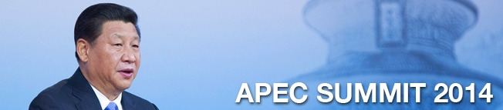
NEWS›CHINA
APEC SUMMIT

Xi Jinping unveils China’s plan for Asia-Pacific free-trade pact
Endorsement of China's plans for FTAAP by Apec's 21 economies hailed as historic by president
PUBLISHED : Tuesday, 11 November, 2014, 11:33pm
UPDATED : Wednesday, 12 November, 2014, 12:49pm
Keira Lu Huang in Beijingkeira.huang@scmp.com

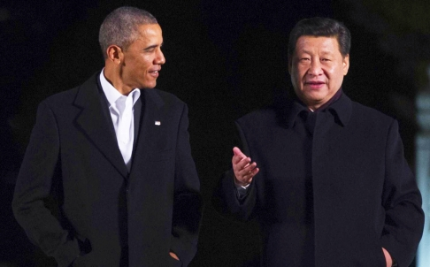
Presidents Barack Obama and Xi Jinping chat informally as they take a stroll at the Zhongnanhai leaders compound in Beijing before enjoying a private dinner. Photo: APF

China upped the ante in its bid to be the Asia-Pacific's economic leader when President Xi Jinping unveiled a plan for a Chinese-led regional free-trade framework to visiting foreign leaders yesterday.
The Asia-Pacific Economic Cooperation summit ended with all 21 Apec economies endorsing China's plan to create a Free Trade Area of the Asia-Pacific (FTAAP). It was the first major international gathering held in China since Xi took power in late 2012.
Addressing leaders including US President Barack Obama, Russian President Vladimir Putin and Japanese Prime Minister Shinzo Abe, Xi hailed the endorsement as a "a decision to be written in history".
Watch: APEC leaders seek free trade progress at annual summit
"[The endorsement] demonstrates the confidence and determination of Apec in advancing regional economic integration," Xi said.
The FTAAP has often been described as a counter to the 12-nation, US-led Trans-Pacific Partnership (TPP) - a claim denied by the chief US trade envoy, Michael Froman. China is promoting its plan just as the TPP appears to have lost steam.
There had been reports that Washington - eager to push ahead on the TPP - had pressured Beijing to downplay the FTAAP idea. A US official told theSouth China Morning Post that the FTAAP proposal would be declared in the annex of the final Apec communiqué.
Xi's high-profile announcement yesterday was effectively the launch of a road map instead of a "feasibility study", a term for actual negotiations the US side has resisted.
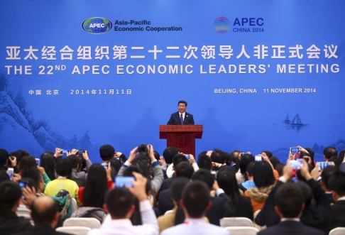Xi Jinping delivers his closing speech at the summit. Photo: EPA
The president also called on member states to work together to raise funds for cross-border infrastructure to help better integrate their economies.
He raised other initiatives to cut red tape and promote the flows of people and capital in the region as part of a blueprint for regional connectivity to be in place by 2025.
Xi, who has built his power on a popular and sweeping anti- corruption campaign in China, successfully lobbied fellow Apec leaders to help weed out graft. Apec leaders have agreed "to set up a cross-border law enforcement network to strengthen transnational anti-corruption efforts", Xi said.
Xi later hosted a private dinner for Obama and walked the US president through the imperial gardens of Zhongnanhai - the residence of China's top leaders since the Qing dynasty.
"A pool begins with many drops of water," Xi told his guest, saying it expressed how he wanted to work with Obama.
The US president told Xi that the day's events were "well managed" and said he was looking forward to having "productive and candid talks" with him today.
The two leaders will have a day-long formal meeting that is expected to be the highlight of a busy week in Chinese diplomacy, which will see Premier Li Keqiang visit Myanmar for the Association of Southeast Asian Nations summit and Xi head to Australia for the G20 summit.

This article appeared in the South China Morning Post print edition as XI unveils China’s plan for regional free-trade pact
http://www.scmp.com/news/china/article/1637765/xi-jinping-unveils-chinas-plan-asia-pacific-wide-free-trade-pact

Sacking of Commanding Generals: Prelude to Surrender, or Armageddon?
Silo based ICBMs, along with the submarine and ship based Nuclear Missiles, carry strategic nuclear warheads with enough punch to obliterate a targeted country many times over. These strategic weapon systems are at the core of US nuclear deterrence essential to maintaining the MAD status – In case Russia and China (it is no more ‘Russia or China’) launch a nuclear strike on US, they can count on the Mutually Assured Destruction.
These weapons systems – the Weapons of true Mass Destruction at the global scale, are always at the ready to launch at the command of the USSTRATCOM, OR at the decision of the local Wing Command – if the Wing Command believes that the USSTRATCOM has become incapable of making a decision. The command of the strategic missile launch wings is an enormous responsibility that requires the nerves of steel – If the time comes, these commanders are expected to make a decision that may very well cause the end of the human civilization on earth, OR, on the other hand, may lead to the surrender of US.
[Note: The notion that the president of the US, or the president of any country for that matter, has the authority or the power to order the launch of strategic nuclear strike belongs only to the world of movies and fictions – there is no “Briefcase” with the ‘electronic keys’ allowing the president to order a nuclear strike. Such decisions are assigned to more stable and responsible heads.]
The people selected for this enormous responsibility are a very special lot. Beside having the required command rank and expertise, they must pass through a string of very thorough psychological and psychiatric screening processes to make sure that they can survive and perform under those very demanding conditions and environment. From among the hundreds of qualified candidates, only a few pass for the task. They are difficult to come by – and, there are very limited number of qualified commanding officers available for the job.
These commanders are, sort of, “saviors of the last resort”. They are counted upon to launch the retaliatory strikes if the nation goes under nuclear attack. They are the guarantee that no surprise nuclear strike on US will be launched.
So, when the commanders at these strategic wings are being selectively relieved of their duties, under some very dubious charges and accusations, then it should be a matter of grave concern to all. We have to consider if the nation’s retaliatory and counter strike capabilities are being deliberately compromised.
So far, from 2012 onward, more than 200 senior commanding officers – quite a few of them at the sensitive strategic nuclear missile command, have been relieved of their duties.
In November of 2014, Colonel Carl Jones, second in command of the 90th Missile Wing at FE Warren air force base, Wyoming, in charge of 150 of the air force’s 450 Minuteman 3 nuclear intercontinental ballistic missiles, was dismissed “for a loss of trust and confidence in his leadership abilities.
At the same time, at the 91st Missile Wing at Minot Air Force Base, North Dakota, which also is responsible for 150 Minuteman 3 missiles, Lieutenant Colonel Jimmy “Keith” Brown was relieved of command “because of a loss of confidence in Brown’s ability to lead his squadron”.
Also disciplined at the North Dakota base was Col. Richard Pagliuco, the commander of the 91st Operations Group. It was not clear what disciplinary action was taken.
Each of these commands is responsible for 150 Minuteman 3 Intercontinental Ballistic Missiles (ICBMs). These missiles carry payloads with 27 times the destructive power of the nuclear bomb dropped on Hiroshima in 1945. They are capable of striking targets some 8,000 miles away within half an hour of their launch and vaporizing everything within a 50-mile radius, killing millions of human beings.
Carrying out simultaneous disciplinary actions against senior officers at two of the Air Force’s three ICBM bases is unprecedented. An Air Force spokesman told the AP that it was merely a “coincidence.”
Overseeing the disciplinary investigations was Maj. Gen. Jack Weinstein who was tapped to head the nuclear war command after his predecessor, Maj. Gen. Michael Carey, was sacked.
In December 2013, Maj. Gen. Michael Carey was fired for going on a drunken binge while on an official trip to Moscow – circumstances of which were very suspicious. Carey oversaw the 20th Air Force, with a total of 450 Minutemen ICBMs at three locations across the U.S.
In October of 2013, the deputy commander of U.S. nuclear forces, Vice Adm. Tim Giardina, was relieved of duty amid a military investigation of allegations that he used counterfeit chips at an Iowa casino. He was second in command of the US Strategic Command.
Below is a partial list of some of the Commanding officers and Generals fired since the second term of Obama:
- Major General Ralph Baker (2 Star)-U.S. Army Commander of the Combined Joint Task Force Horn in Africa (April 2013)
- Major General Michael Carey (2 Star)-U.S. Air Force Commander of the 20th US Air Force in charge of 9,600 people and 450 Intercontinental Ballistic Missiles (Oct 2013)
- Colonel James Christmas-U.S. Marines Commander 22nd Marine Expeditionary Unit Commander Special-Purpose Marine Air-Ground Task Force Crisis Response Unit (July 2013)
- Major General Charles M.M. Gurganus-U.S. Marine Corps Regional Commander of SW and I Marine Expeditionary Force in Afghanistan (Oct 2013)
- Lieutenant General David H. Huntoon (3 Star), Jr.-U.S. Army 58th Superintendent of the US Military Academy at West Point, NY (2013)
- General Carter F. Ham-U.S. Army African Command (Oct 2013)
- General James Mattis-U.S. Marines Chief of CentCom (May 2013)
- Brigadier General Bryan Roberts-U.S. Army Commander 2nd Brigade (May 2013)
- Major General Gregg A. Sturdevant-U.S. Marine Corps Director of Strategic Planning and Policy for the U.S. Pacific Command & Commander of Aviation Wing at Camp Bastion, Afghanistan (Sept 2013)
- Colonel Eric Tilley-U.S. Army Commander of Garrison Japan (Nov 2013)
- Brigadier General Bryan Wampler-U.S. Army Commanding General of 143rd Expeditionary Sustainment Command of the 1st Theater Sustainment Command [TSC] (suspended Oct 2013)
- Colonel Daren Margolin-U.S. Marine in charge of Quantico’s Security Battalion (Oct 2013)
- Command Sergeant Major Don B Jordan-U.S. Army 143rd Expeditionary Sustainment Command (suspended Oct 2013)
- Commander International Security Assistance Force [ISAF] and Commander U.S. Forces Afghanistan [USFOR-A] (Nov 2012)
- General David Petraeus-Director of CIA, former US commander in Afghanistan, was forced to quit in November 2012.
In October 2012, over the Benghazigate, Obama ordered the immediate removal of Rear Admiral Charles M. Gaouette from his command of the powerful Carrier Strike Group Three (CSG-3) currently located in the Middle East.
General John R. Allen-U.S. Marines Commander International Security Assistance Force [ISAF] – Relieved of duties in November 2012.
Beside these firings of the Generals and commanders, there also has been a spate of early retirements, suicides, and unfortunate accidents. All in all, since the second term of the Obama administration, close to 300 commanding generals, admirals, and wing commanders have been shuffled or removed from the scene.
These Commanding officers at the strategic commands couldn’t have posed any danger to any civil administration. Their role was either in the strategic nuclear command, or over the command of the naval fleets – They could have played no role in the event of any ‘Civil Unrest’ or Martial Law scenario.
So, why the ongoing purge of these commanders? It is part of what plan?
The only certainty is that the US nuclear war command is being subjected to a deliberate and wholesale restructuring of its personnel for some unspecified reasons. And, there seems to be only three probable scenarios that fit and do make some sense out of the these ongoing shuffles and purges:
An accommodation has been made with both the Russia and China – In the event of a limited nuclear strike on the US by the Russians and Chinese, the US Strategic Command will be ordered to Stand Down – The surrender and disarmament of the US. Therefore, the officers who could resist, are being removed and replaced by the preferred cadre.
An extreme False Flag operation on the US soil might have been planned – Strategic command could detect it and blow up the cover – so, the resisters have to be removed.
The ground is being prepared for the Armageddon scenario – A preemptive Full Spectrum nuclear strike on both the Russia and China is being planned – The commanders who could stop this madness, and may have contacts with their counterparts in Russia and China, are being removed from the command.
Indeed, all of these three are difficult to believe scenarios – But, we are living in a difficult to believe time.
http://viewsandpreviews.com/sacking-of-commanding-generals-prelude-to-surrender-or-armageddon/

A Conspiracy Of Horrific Implications - The United States Is Being Set Up To Fail

FIRST OFF, A DIRE WARNING TO AMERICA:

#1 ; YOU’RE COMMUNIST PRESIDENT, OBAMA, AND HIS REGIME HAS PURGED OVER 300

HIGH BRASS LEADERS WITHIN THE UNITED STATES MILITARY.

#2 ; OBAMA INTENTIONALY - YES DELIBERATLEY - REDUCED THE NUCLEAR ARSENAL HELD

BY THE UNITED STATES NAVY & AIR FORCE TO RECORD LOWS! THE UNITED STATES HAD

MORE NUKES IN THE 60s THAN NOW, AND MANY OTHER WEAPONS SYSTEMS ARE CANCLED.

#3 ; NOW OBAMA IS INTENTIONALY - YES DELIBERATLEY - PISSING OFF OTHER POWERFUL

NATIONS LIKE CHINA AND RUSSIA, WHILE CHINA AND RUSSIA ARE EXPANDING THEIR ARMS

TO RECORD LEVELS! ARE YOU AWARE OF JUST HOW INSANE YOU’RE PRESIDENT IS?

THE ONLY LOGIC THAT COULD EXPLAIN THIS INSANITY WOULD BE THIS:

WASHINGTON PLANS NUCLEAR WORLD WAR III AND THEY WANT THE UNITED STATES TO LOSE!

BEFORE YOU HAVE PISSY PATRIOTIC STROKE, LET’S LOOK INTO SOME STARTLING EVIDENCE:

FLASHBACK! VIDEO PROOF! GLOBALIST ZBIGNIEW BRZEZINSKI TALKS OPENLY ABOUT

US PLANS TO OVERTHROW UKRAINE GOVERNMENT AND PLANNED INTERVENTION!

Zbigniew Brzezinski, former National Security Advisor to Jimmy Carter

from 1977 to 1981, talked a few years ago, openly, about US plans to

overthrow Ukraine and intended intervention. Little may the globalists

know, the recorded footage was backed up:

http://fileb.ag/liycu1hwg08x

BILDERBERG GROUP TALKED ABOUT NUCLEAR WAR WITH RUSSIA!

http://www.youtube.com/watch?v=8tfV6xsS13U

http://usawatchdog.com/bilderberg-group-worried-about-nuclear-war-with-russia-daniel-estulin/

HACKED US DOCUMENTS REVEAL EXTENT OF UNDISCLOSED US LETHAL AID FOR UKRAINE ARMY

http://www.zerohedge.com/news/2014-11-25/hacked-us-documents-said-reveal-extent-undisclosed-us-lethal-aid-ukraine-army

Joseph_Biden_Ukraine_Delegation_Officials.7z

http://fileb.ag/sjtql15ec8ny

Joseph_Biden_Ukraine_Delegation_Officials.zip

http://filerio.in/mo9gffn4miwp

Joseph_Biden_Ukraine_Delegation_Officials.rar

http://filesave.me/file/47489/Joseph-Biden-Ukraine-Delegation-Officials-rar.html

NATO IS BUILDING UP, CONTINUES TO EXPAND, AND SURROUND RUSSIA

http://sputniknews.com/military/20141210/1015696285.html

FLASHBACK NATO SUMIT 2014, EU-US AGREE TO KEEP FUNDING WAR IN UKRAINE

https://www.wsws.org/en/articles/2014/09/05/nato-s05.html

US-NATO THREATS AGAINST RUSSIA WORSENING

http://globalresearch.ca/us-europe-step-up-threats-against-russia-over-ukraine/5371301

TENSIONS GROW AROUND EUROPE AND RUSSIA, AS OBAMA KEEPS ON STIRING THE POT

http://www.paulcraigroberts.org/2014/04/06/obama-issues-threats-russia-nato-paul-craig-roberts/

WASHINTON AND NATO NOW MAKING THREATS AGAINST RUSSIA AND CHINA (NOT GOOD)

http://www.larouchepub.com/other/2014/4144threats_v_rus_chi.html

FINALLY BIPARTISANSHIP, FASCISTS VOTE TO STIR WORLD WAR III

HERE IS THE VOTE TALLY: https://www.quickleak.org/D6Y8pjRW

YET AGAIN, US THREATENS RUSSIA WITH WAR.

http://www.presstv.ir/detail/2014/12/12/389870/us-threatens-russia-with-missiles/

The Pentagon has threatened Russia with redeploying nuclear cruise missiles

to Europe, accusing Moscow of violating two arms control treaties.

“We don’t have ground-launched cruise missiles in Europe now obviously because

they’re prohibited by the treaty,” said Brian McKeon, principal deputy

undersecretary for policy at the Department of Defense.

“But that would obviously be one option to explore,” he added.

Washington says Moscow violated the Intermediate-Range Nuclear Forces Treaty

and the Treaty on Conventional Armed Forces in Europe.

However, Russia denied the allegation and said the testing of a ground-launched

cruise missile in July 2014 was in compliance with the INF treaty.

Undersecretary for Arms Control and International Security Rose Gottemoeller

announced that US President Barack Obama has written his Russian counterpart

Vladimir Putin about the violation.

Gottemoeller said that the United States were considering a list of “military

countermeasures” against Russia.

McKeon also warned Russia not to engage in an “escalatory cycle of action and

reaction.”

He said Russian and US counter-actions "will make Russia less secure.”

“This violation will not go unanswered, because there is too much at stake,” he said.

Russia says the US missile plans across the globe are a real threat not only to

Russia but also to the whole world, adding the missile systems harm the strategic

balance of forces across the globe.

In October, the US military commissioned its new missile base in southern Romania

amid strong opposition by Russia.

The military base will be the first to feature the Aegis Ashore ballistic missile

system and it will be operational by the end of 2015.

AGB/AGB

SACKING OF COMMANDING GENERALS: PRELUDE TO SURRENDER, OR ARMAGEDDON?

http://viewsandpreviews.com/sacking-of-commanding-generals-prelude-to-surrender-or-armageddon/

The only certainty is that the US nuclear war command is being subjected to a deliberate

and wholesale restructuring of its personnel for some unspecified reasons. And, there

seems to be only three probable scenarios that fit and do make some sense out of the

these ongoing shuffles and purges:

[1] An accommodation has been made with both Russia and China – In the event of a limited

nuclear strike on the US by the Russians and Chinese, the US Strategic Command will be

ordered to Stand Down – The surrender and disarmament of the US. Therefore, the officers

who could resist, are being removed and replaced by the preferred cadre.

[2] An extreme False Flag operation on the US soil might have been planned – Strategic

command could detect it and blow up the cover – so, the resisters have to be removed.

[3] The ground is being prepared for the Armageddon scenario – A preemptive Full Spectrum

nuclear strike on both Russia and China is being planned – The commanders who could stop

this madness, and may have contacts with their counterparts in Russia and China, are being

removed from the command.

Indeed, all of these three are difficult to believe scenarios – But, we are living in a

difficult to believe time.

http://viewsandpreviews.com/sacking-of-commanding-generals-prelude-to-surrender-or-armageddon/

RED ALERT! AMERICA IS BEING OVERTHROWN WARNS FORMER DEFENSE SECRETARY!

http://megaswf.com/f/2708043

http://www.infowars.com/hagel-warned-of-rogue-new-world-order-now-hes-fired/

PUTIN PREPARES TO WIN WORLD WAR III WHILE OBAMA PREPARES TO SURRENDER

http://www.thecommonsenseshow.com/2014/12/08/putin-prepares-to-win-while-obama-prepares-to-surrender/print

by Dave Hodges | December 8, 2014 7:19 AM

Does anyone really think that any nuclear-armed nation, whether it would be the

United States, China and especially Russia will ever accept defeat to a rival nation,

in conventional warfare, without subsequently inflicting the maximum penalty on its

opponent? There is little question in most experts minds that the loser of a

“conventional” World War III will not hesitate to unleash its nuclear weapons

as a last ditch means to “even the score”

Obama’s Complacency Is Our Number One National Security Concern

Forbes writer, James Conca, has expressed the view in a dramatic report that when

it comes to matching the growing Russian military threat, that America’s most

pressing concern is complacency. Conca noted that the recent reports that Russia

has gained the upper hand in nuclear weapons capability against the United States,

has been met with indifference from this administration.

Making matters worse, Conca observed that this current administration fired the

one General who was going to shape up America’s Intercontinental Ballistic Missile

command. Now he’s gone and our ICBM’s sit in less than a state of readiness.

Conca notes that even the U.S. State Department has acknowledged that not only

has the the U.S. nuclear arsenal fallen behind Russia but so has basic U.S.

military technology. The U.S. State Department admits that America is now the

underdog should hostilities involving nuclear weapons between the two nations

actually break out. Obama is out to lunch and seems oblivious to the threat.

The Forbes investigation goes on to say that Russia is absolutely ready and their

new long-range cruise missiles that are ready for mobile deployment by land or sea.

Hagel Speaks Out and Gets Fired

Defense Secretary, Chuck Hagel, is now gone from his position. Why? This is probably

due to the fact that Defense Secretary Hagel stated that “routine neglect of our

nuclear weapons programs over the years has compromised our ability to respond to

an actual threat.” This is a clear indictment of the six year presidency of Obama

and the fact that he’s done nothing to keep up with Putin. Shortly after this

statement, Hagel was fired as Defense Secretary. Is there any doubt what team

Obama is playing for?

Russia Withdraws From Nuclear Treaty

Putin announced his warlike intentions, last month, in that he plans to severely

scale down nuclear security cooperation with the United States. Translation,

Russia does not need, nor want, the protection it formerly achieved through

limitations on nuclear weapons.

This aggressive posture, according to The New York Times[4], is seen as Russia’s

way of saying that it requires no outside assistance in securing the country’s

nuclear assets and network.

Or as observers would say, it could be Moscow’s strong message to the West and the

United States in particular that it cannot be pressured about Ukrainian borders,

where Russian troops are amassing by the tens of thousands.

Mutually Assured Destruction Is a Thing of the Past

Michael Snyder writing for The Right Side News[6] exposed the fallacy that due to

the outdated doctrine of ”mutually assured destruction,” Russia is opposed even

to a nuclear confrontation. In fact, Snyder demonstrated that the opposite is true.

A nuclear confrontation is something that Putin may not desire, but he is not

backing down. The following five developments have been identified which indicate

that Russia is fully intending on winning World War III.

1. Radar-beating missile delivery system.

2. Russia has spent nearly $72 billion[8] on arms in 2011 and is planning on

spending well over a half a billion dollars to upgrade its weapons systems by

2016 including the development of the ability to cripple America with cyber

attacks.

3. Russia’s nuclear forces are turning mobile and the new stealth technology

extends from undetectable bombers to silent running nuclear submarines.

4. According to PRAVDA, Russia has 5,000 nuclear weapons of different tactical

classes including Iskander warheads and torpedo, aerial and artillery warheads,

all right next to Europe. The United States has reduced its nuclear arsenal from

31,000 (1967) to a mere 1,600. Obama has openly spoken of reducing our arsenal

to 300 nuclear missiles.

5. According to The Financial Times, satellite killers were launched into orbit

May of 2014. This move by the Russians, parallels what the Chinese have already

accomplished and tested. The intent is to blind American forces on the battlefield

and at sea.

6. Obama has continued to weaken U.S. nuclear forces through the removal Nineteen

nuclear launch officers. This is not a scenario were the United States can simply

say “next man up”. These are highly specialized positions requiring highly

specialized training that can only be realized through extensive field experience.

Obama Continues To Poke a Stick In the Eye of the Bear

Obama continues to provoke Putin with needless sanctions which do nothing to address

the crisis in Ukraine. Meanwhile, it has become clear that Putin is also planning a

Red Dawn scenario for the United States. And of course, this would not be possible

without the direct complicity of President Obama.

In conclusion, it is one thing to intellectually understand how Obama is destabilizing

both the military and its leadership. However, it is emotionally earthshaking to be

able to trace Obama’s deliberate treason toward to our national defense. From a

military perspective, we are in grave danger and this will be the topic of the next

part of this series.

COULD THIS BE WHY THE GLOBALISTS ARE PUSHING US INTO WAR WITH RUSSIA?

http://pastebin.com/yA1fiq93

ANONYMOUS WARNS OF OBAMA’S PAST FORMER SOVIET AND COMMUNIST TIES! READ THIS!

https://www.quickleak.org/sNFplWJn

http://quickleak.org/8L6gK2nj

CORPORATE MEDIA IGNORES REPORT OF U.S. AND ISRAELI OPERATIVES ARRESTED AIDING ISIS

More evidence U.S. and Israel directly aiding ISIS
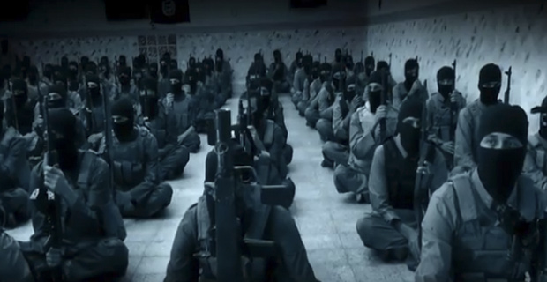
Image Credits: ISIS Video
by KURT NIMMO | INFOWARS.COM | MARCH 9, 2015

A story over the weekend stating American and Israeli military advisors were arrested in Iraq aiding ISIS was not reported by the establishment media.
According to Iraq’s Sarma News Agency and the Iranian Tasnim News Agency, the four foreign military advisors were captured during a military operation in the Tal Abta desert near the city of Mosul in Iraq’s Northern Province of Nineveh.
Three of the arrested men were dual U.S.-Israel citizens and a fourth Persian.
On Thursday Qasim al-Araji, the head of the Badr Organization in Iraq, told parliament on Thursday he hasevidence the U.S. is arming the Islamic Army, according to a report carried by the Arabic language Almasalah.
“What is important is that the US sends these weapons to only those that cooperate with the Pentagon and this indicates that the US plays a role in arming the ISIL,” Iraqi intelligence claimed in December.
Other air drops to ISIS by the United States have gone unreported by the corporate media.
“Ultimately, whether one pallet drifted into ISIS hands by accident in a recent airdrop is a moot point,” writesTony Cartalucci. “Billions in cash, weapons, equipment, and vehicles have already been intentionally supplied to the many groups that ISIS represents, as planned as early as 2007. ISIS is the purposeful creation of the United States in its pursuit of regional hegemony in the Middle East, and ISIS’ atrocities were predicted long before the first shots were fired in 2011 in the Syrian conflict, long before the term ‘Islamic State’ went mainstream.”
http://www.infowars.com/corporate-media-ignores-report-of-u-s-and-israeli-operatives-arrested-aiding-isis/

Iraq Arrests ISIS Advisors, US And Israelis Held
Agents of both Mossad and CIA contractors are being held on suspicion of aiding ISIS militants.
By Veterans Today | March 11, 2015
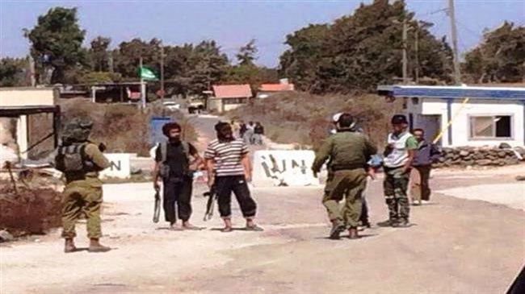

A photo from the Golan Heights depicting IDF soldiers conversing with Jabhat al Nusra terrorists.

TEHRAN – Iraqi Special Forces said they have arrested several ISIL’s foreign military advisors, including American, Israeli and Arab nationals in an operation in Mosul in the Northern parts of the country.
The Iraqi forces said they have retrieved four foreign passports, including those that belonged to American and Israeli nationals and one that belonged to the national of a Persian Gulf Cooperation Council (PGCC) member-state, from ISIL’s military advisors.
The foreign advisors were arrested in a military operation in Tal Abta desert near Mosul city.
Last year, a senior aide to Russian President Vladimir Putin accused Mossad of training ISIL terrorists operating in Iraq and Syria.
Alexander Prokhanov said that Mossad is also likely to have transferred some of its spying experiences to the ISIL leadership, adding that Israel’s military advisors could be assisting the Takfiri terrorists.
Prokhanov said ISIL is a byproduct of US policies in the Middle East.
ISIL is a tool at the hands of the United States. They tell the Europeans that if we (the Americans) do not intervene, ISIL will cause you harm,” he said, adding that Iran and Russia are the prime targets of the ISIL.
“They launched their first terror attack against us just a few days back in Chechnya,” he said, stressing that the ISIL ideology has got nothing to do with the Islam practiced in Iran and some other Muslim countries in the Middle East region.
Prokhanov said the United States and Israel are one and the same when it comes to supporting a terror organization like the ISIL.
http://www.mintpressnews.com/iraq-arrests-isis-advisors-us-and-israelis-held/203250/

The US Economy Is Days Away From Shutting Down
16Feb, 2015by Dave Hodges
Print this articleFont size -16+


If the back up of the container cargo ships, in American ports, continues much longer, our stores will soon look like what is pictured here.

A Telling Report From Tacoma

The Global Economy Has Officially Crashed
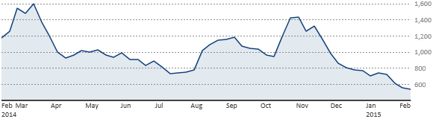
The BDI has officially reached record lows. A global economic collapse is underway.
The Baltic Dry Index has officially hit rock bottom with unprecedented lows. The forces behind the Trans Pacific Partnership have effectively used their influence to greatly stall the delivery of critically important commodities until the TPP is fully implemented among its member nations.
Who is responsible for the crash caused by the failure to move product through the world’s ports?

Trans Pacific Partnership, Was Initiated at U.S. West Coast Ports
on February 13, 2015
The above headlines tells who is behind what is happening, it does not tell you how bad it is going to get. The unions are refusing to back down and it is for darn sure that the TPP will not back down either!
The backlog of ships is a crisis being done on purpose because the private multinational corporations want to empty the shelves in supermarkets nationwide for three or four weeks is designed to force the American people to approve the blackmail contained in the Trans Pacific Partnership. This is the economic end-game which will permit these multinational corporations to become nation-states across the planet.
Most Americans will fail to notice the threat until they can no longer purchase food in the super-markets, or mail-order prescription medications are not shipped. The sheep of this country will still be in denial that this could ever happen. The unions have now been idled, at major American shipping ports, because the multinational corporate owners of the shipping companies are keeping their ships filled with perishable goods at sea until all governmental opposition to the fast-tracked TPP is ended. Watch this video and listen to the what LA City Councilman, Joe Buscaino says when he states that even if product were to be off-loaded, in force, today, it would still take six to eight months to “get back to normal”. The United States economy does not have six to eight months to recover. It does not have six to eight days to survive the economic Armageddon that is coming.

Meanwhile, While We Slept
While the United States is fully preoccupied with global crises ranging from the fight against ISIS in Iraq and Syria, and the conflict in Ukraine, there is another development on the world stage which threatens the economic health of every single American and American based business. Specifically, I am referencing the Trans Pacific Partnership (TPP). The protocols of the TPP establish a free-trade zone/bloc stretching from Vietnam to Chile and Japan. The most draconian free trade agreement in history includes nearly a billion people which encompass almost 40% of the world’s economy. Since Obama failed to fast-track the TPP into law last year, he has made amazing progress and America is nearing its fate with economic Armageddon.


Transferring the American Economy to a Corporate Dictatorship

As America races toward her date with destiny, there is yet another “fundamentally transforming” event coming her way and that event is known as the Trans-Pacific Partnership (TPP).

Many of us in the media believe that some of the effects of the TPP will be felt before the coming war and martial law crackdown. However, after careful analysis, I am convinced that the brunt of the TPP will be felt after the America we know has been totally taken over in a post-war and post-economic collapse scenario. At the end of the day, it does not matter when the implementation of the TPP comes, because when it does, America will no longer be recognizable to anyone who has grown up in this once great country.

The Implementation of the TPP Is Progressing By Stealth

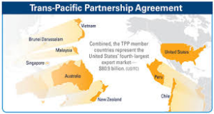

Some of you are reading these words have no idea what the Trans-Pacific Partnership consists of. Most of you have never heard of it. Some of you have heard or read the term, but fail to realize the extreme danger that the implementation of this so-called trade agreement will mean to America and our way of life. A scant few are coming to realize just how dangerous the TPP truly is. For the record, the TPP is masquerading as a free trade agreement involving the US, Australia, Japan, Canada, Brunei, Vietnam, Malaysia, Chile, Mexico, New Zealand, Peru and Singapore. The TPP is much, much more than a free trade agreement.

With regard to the TPP, ignorance of the organization is understandable. We in the truthful part of the media have not fulfilled our duty to fully explore the ramifications of the TPP because so little is publicly known. Obama has taken full advantage of the cloudy environment and is preparing to even bypass the constitutionally required approval of the Congress before implementing the TPP through a process called “fast-tracking”.

Obama Is Bypassing Congressional Approval

Under the TPP, GMO labels for US food would not be allowed. Also not allowed is any form of Congressional oversight.
President Obama are indeed seeking Fast Track Trade Promotion Authority for the TPP as he feverishly attempted to get the deal done by the end of the year. The REAL reason that the cargo container ships are backed upon our ports is because the TPP and Obama is holding all the parties hostage until they get what they want, the fast-tracking approval which will allow Obama to completely ignore Congress in regard to allowing Congress to fulfill its statutory duty in approving all trades. Obama, on behalf of the TPP wants to break the unions and all power of any ancillary support group, which is why we are seeing products backed up in our ports. Under such an agreement, this would permit Obama to sign the trade agreement “without Congressional approval.”

All action, emanating from the U.S. government, with regard to the TPP, is secret. When something is secret and kept from you, it is usually very bad for you!

After “Fast-Tracking”, Obama would send the finalized agreement to Congress and this would subsequently force a vote within 90 days. Congressional debate would be very limited and no amendments would be permitted. Even if Congress wanted to protect the American worker and the American economy from devastation, they cannot if Obama obtains the power to fast-track the TPP.

Let’s be clear, Obama is violating the separation of powers principle of the US Constitution by leaving Congress in the dark and by limiting their ability to use their Congressional powers as they would with any other legislation. The rumors of the TPP policies are so horrific that even the Kool-Aid drinkers from the Democratic party are calling on Obama to allow more transparency. Congress is asking Obama to allow for more transparency? I did not know that we passed a Constitutional amendment which states that Congress works for Obama.

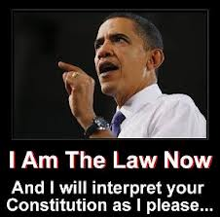

The TPP Represents the Total Loss of US Sovereignty

The TPP is the brain child of the corporations. The TPP places all member nations directly under the control of the TPP instead of their respective national governments. Congress has been denied access to review any of the documents. Alan Grayson (D-FL) was granted a special exemption to view a small part of the TPP and he was told by TPP officials to keep his mouth shut as Grayson recalls that “They maintain that the text is classified information. I’m a member of Congress, but now they tell me that they don’t want me to talk to anybody about it because if I did, I’d be releasing classified information.” Do you realize what this means? The corporate controlled TPP has granted themselves the authority to exercise the governmental power of classifying documents and Congress is included in the exclusion. Do you understand that this means we are living in a corporate dictatorship? It gets even worse.

Meet Your New Government: Monsanto and Walmart

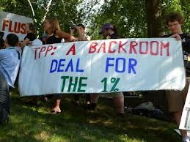
As if it is not egregious enough that Congress is not allowed to view TPP documents, the 600 corporate officials, who form the TPP panel (e.g. corporate officials from corporations such as Monsanto and Walmart), have complete control of the developmental process of the TPP. Obama, Monsanto and Walmart can view any part of the process, Congress and the American public cannot.
Further, a leaked chapter of the TPP speaks to the creation of a TPP Tribunal Council which will have the authority to force member nations to transform its laws, its civil procedures, its criminal procedures, even its electoral process, in order to abide by the TPP Tribunal dictates. The bottom line is that we are witnessing the destruction of the Constitution and the entire legal code of the United States, because once the tribunal makes a ruling with regard to a national law, there is no appeal. The Tribunal consists of unelected bureaucrats who are appointed by the creators of the TPP. The term of office for Tribunal officials is unlimited.
The most disturbing aspect of this agreement is that the TPP totally eviscerates the Tenth Amendment of the US Constitution. If, for example, the State of Arizona wanted to outlaw fracking, the TPP could overrule the local legislation if it so desired. To illustrate how far this unconstitutional corporate power extends, the TPP could declare cocaine trafficking to be legal and this could not be challenged by any level of government, nor is it subject to review by the Supreme Court. Obama and his TPP cronies are writing the obituary for the U.S. Constitution.
The TPP represents the total obliteration of American sovereignty. Oh yeah, I almost forgot to mention another small set of details. How long do you think it will take until the TPP imposes a draconian version of cap and trade upon the American people and small businesses? The cap and trade version of what Obama tried to get passed in the Senate, when he first took office, consisted of reducing everyone’s energy consumption by 80% and utility rates “would necessarily skyrocket.”
Please pause for just one moment and ask yourself if you like would like an 80% reduction of individual and business energy use and what that dramatic reduction of energy use would look like? The rank and file in this country would effectively be living in 1890.
This is Agenda 21 on steroids and it is being fully implemented through the back door. That is why the TPP is being kept from Congress and the American people.
These facts lead me to state that, if any of this is remotely true, then this President needs to be arrested and tried for treason.

Where Is This Headed?

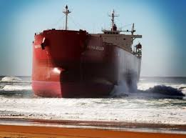
The BDI is now at an all-time low
Obama’s fast tracking of the TPP which was designed to be completed by the end of the year would have coincided with the commencement of many of Obama’s health care reforms which have now been implemented as of February 15, 2015 (e.g. the tripling of Obamacare fines and the full exposure of the “death panels” which deny many kinds of healthcare treatments at age 70 and above). And all of this coincides with communist take-over of the United States economy.

I wish I could accurately state that the loss of sovereignty is the only threat that the TPP poses to the American people. However, to say so, would constitute a grossly inaccurate statement. Under the TPP, the alternative media will be destroyed, guns will be confiscated and the face of American employment will be forever changed in ways that you will not believe. If anything, this article has understated the threat posed to America by the TPP. The TPP is not a free trade agreement, it is a document which introduces a new era into American government. If the TPP passes, we will be living in an absolute fascist corporate dictatorship.

This constitutes a form of economic martial law. And while this article is passing out one nightmare after another, please consider the fact that China and Russia are being purposely left out of the TPP. Why? From an economic standpoint, that makes no sense unless one realizes that we are on a collision course with World War III and the BRIC nations, headed by China and Russia who will be our opponent in the upcoming conflict and the military balance of power is purposely being shifted by senior American politicians which are intentionally designed to weaken both the American economy and the American military.

Massive shortages are at our doorstep and the US economy is days away from shutting down. Walmart is resupplied six times per day. The shortages will soon show up in your shipped medications, food supplies and so forth. The crisis isn’t coming, it is here!

This article only served the purpose of introducing the gravity of the problem. What this truly entails for the average American, and more importantly, what, if anything, can be done about it, will follow in future articles.

Donate to The Common Sense Show

THE COMMON SENSE SHOW

LISTENING INFORMATION

The easiest way to listen is to click the following icon located in the upper right hand part of the website



To Listen By Phone: 832-999-1763

To be a part of the show please call: 1-888-420-9890

We try to provide just about every type of stream anyone would need, so here are the major ones provided for your listening pleasure:

Listen live on Web Stream http://64.27.20.5:1334/listen.pls

Windows Media – http://www.gsradio.net/asx/star3.asx

Winamp – http://www.gsradio.net/live_media/star3.m3u

Real Player – http://www.gsradio.net/live_media/star3.ram

Mobile Devices – http://64.27.20.5:1334/listen.pls

THE COMMON SENSE SHOW

“FREEING AMERICA ONE ENSLAVED MIND AT A TIME!”
http://www.thecommonsenseshow.com/2015/02/16/us-economy-days-away-shutting/

Biotech firms sue local Hawaii government for protecting citizens and environment from GMOs
Friday, August 15, 2014 by: J. D. Heyes
Tags: GMOs, Hawaii, biotech trade association
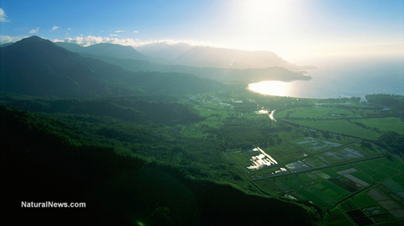
(NaturalNews) Organizations in Hawaii are attempting to block efforts by biotech firms to roll back regulations on GMO crops.
In early August, a coalition of local farmers and environmental groups filed a motion in court to intervene in a lawsuit aimed at overturning a Hawaii County ordinance that imposes a moratorium on the expansion of genetically engineered crops on the Big Island.
On Aug. 1, the Center for Food Safety (CFS), along with three Hawaiian Island farmers, asked a court for permission to join as defendants in a biotech industry suit that is challenging the County of Hawaii's Ordinance 13-121. The law regulates GMOs to prevent them from harming both the local environment and the economy, such as cross-contamination of organic and conventional crops, as well as wild plants, and the associated use of pesticides. The coalition is represented jointly by counsel from CFS and Earthjustice.
"Hawaii County, like every county, has the right to protect its farmers and native environments from genetically engineered crops," said George Kimbrell, CFS senior attorney. "Having GE-free zones is critical for the sustainable future of U.S. agriculture, and to protect Hawai'i's unique ecosystems."
Chemical companies turning the islands into test beds for GMOs
According to eNews Park Forest:
The lawsuit, driven largely by the Biotechnology Industry Organization, the world's largest trade association for the biotech industry representing companies like Monsanto, seeks to dissolve the county's 2013 ordinance to open the island up for the expansion of genetically engineered crop production. These herbicide resistant crops result in intensive pesticide use, which threatens public health, contaminates water, and harms wildlife and neighboring crops. Most GE crops also threaten transgenic contamination of non-GE crops, which has already caused several billion dollars in damage to growers.
"Hawai'i is one of the most biologically diverse, as well as spectacularly beautiful, places in the world, but the chemical companies have been turning the islands into experimental laboratories, unleashing a fountain of pesticides and genetically engineered material into the air, land and waters," said Paul Achitoff, Earthjustice's managing attorney based in Honolulu. "We stand with the people of Hawai'i Island who are trying to protect their island from being transformed into another toxic waste dump."
Hawaii passed the ordinance in question in December 2013. It restricts any future growing of GMO crops in Hawaii County in order to protect local farmers from transgenic contamination and instead seeks to "preserve Hawai'i Island's unique and vulnerable ecosystem while promoting the cultural heritage of indigenous agricultural practices."
However, the regulation does not apply to genetically engineered papayas, which existed on the Big Island before the ordinance was adopted.
Hawaii is the land of GMO experimentation
"In Hawaii we believe that our seeds, crops, and foods should remain free of contamination from genetically engineered plants," said Big Island farmer and agricultural educator Nancy Redfeather.
"Ordinance 13-121 protects me and farmers like me. In Ordinance 13-121, the island/Hawai'i County Council properly acted to protect the life and the health of the lands and our communities, now and for future generations, and we cannot let these corporations take away those vital protections," she added.
CFS and Earthjustice are also working to defend the Kauai County ordinance regulating pesticides and GMO crops from a legal challenge by the biotech industry.
GMO crops are grown very widely across most of the Hawaiian Islands. The climate there allows for growing three or more cycles of crops per year, and that is attractive to agricultural companies. But that also has meant that the islands have become a test bed, of sorts, for all kinds of experimental GMO crops and seed production.
Some of the islands' land has been devoted exclusively to experimentation by some of the agri-giants like Monsanto and Syngenta. Other fields are then used to produce the commercial seed in quantity for export to other states, eNews Park Forest reported.
Sources:
http://www.enewspf.com
http://www.gmwatch.eu
http://www.naturalnews.com
http://science.naturalnews.com
http://www.naturalnews.com/046475_GMOs_Hawaii_biotech_trade_association.html

