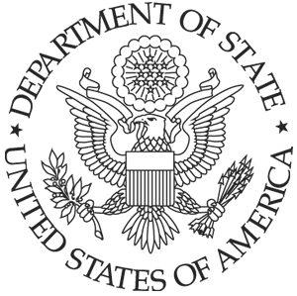U.S. Embassy Rabat, Morocco
Km 5.7, Avenue Mohamed VI
Souissi, Rabat,
Morocco

December 18th, 2017

The U.S. Embassy in Rabat, Morocco has a requirements requesting hotel booking for 33 single rooms check in: January 31, 2018 and check out: February 3, 2018. Breakfast included. Also we would like welcome reception for 33 people in a private location in the same hotel the night of January 31 at 7:00 pm. Food only (light refeshments). Access to cash bar. Please send the quote to Mrs. Karima Qara at the above address or by e-mail to kqara@state.gov, no later than December 27th, 2017:

Description
Hotel booking for 33 single rooms check in: January 31, 2018 and check out: February 3, 2018. Breakfast included. Also we would like welcome reception for 33 people in a private location in the same hotel the night of January 31 at 7:00 pm. Food only (light refeshments). Access to cash bar.

