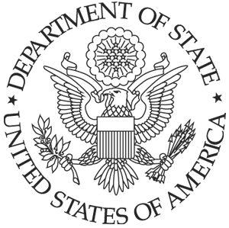U.S. Embassy Rabat, Morocco
Km 5.7, Avenue Mohamed VI
Souissi, Rabat,
Morocco

April 12, 2018

The U.S. Embassy in Rabat, Morocco is requesting quotations for Packing and Storing USG Property and Equipment. The statement of work is as follows:

· To pack excess property, equipment and appliances that cannot be stored at the embassy’s warehouse due to lack of space.

. Place the excess property, equipment and appliances into shipping containers. Number of containers needed to be determined after a survey is done by the contractor of the property, equipment and appliances to be packed.

- Rent required number of shipping containers.

- Transport containers from the embassy’s warehouse or other USG owned property to the packing company’s warehouse for storage.

- Store the containers at the contractor’s warehouse facility for a period of 6 months, perhaps longer.

- Deliver and unpack containers to the embassy warehouse, or other location in the Rabat metropolitan area.

Please submit your quote to Mrs. Zakia Askari by e-mail to askarizx@state.gov, or to Mr. Mustapha Abouabdellah to abouabdellahm@state.gov no later than April 26th, 2018, Reference PR7254730

