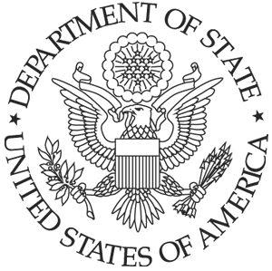U.S. Consulate Casablanca, Morocco
8 Boulevard Moulay Youssef
Casablanca, Morocco

March 27, 2018

The U.S. Consulate in Casablanca, Morocco has a requirement for the following Internet Transport Service. At least 10 MBPS dedicated Internet Circuit. Renewal Date: 06/01/2018. THE LOCAL ISP MUST PROVIDE A SYMMETRICAL INTERNET CONNECTION, ALLOWING UPLOAD AND DOWNLOAD DATA TRANSFERS SIMULTANEOUSLY AT THE SAME SPEED, AND A MINIMUM OF FOUR PUBLIC INTERNET ROUTABLE ADDRESSES FROM THEIR INTERNET ADDRESS. THIS REQUIRES A MASKING BLOCK FROM SUBNET OF /29. IT SHALL NOT BE FILTERED OR BLOCKED FOR ANY IPSEC PORTS OR PROTOCOLS. Duration 12 months.

Please submit your quote for 8 Mbps, 9 Mbps, and 10 Mbps to Mrs. Karima Qara at the above address or by e-mail to kqara@state.gov, no later than April 20, 2018:

Description | Qty
10 MBPS dedicated Internet Circuit | 12 months

