U.S. EMBASSY PRISTINA
UNIVERSITY SUPPORT GRANTS PROGRAM APPLICATION INSTRUCTIONS
______________________________________________________________________________

PLEASE CAREFULLY READ INSTRUCTIONS BEFORE COMPLETING THE APPLICATION FORM

Grant applications must use the standard grant form (found on the U.S. Embassy Pristina website) and be submitted in .doc format. Compressed files may use .ZIP format only. Proposals received in any other formats will not be accepted.

Grant applications must be completed in English. Proposals submitted in other languages will not be reviewed.

Each space for your answers is limited to a certain number of characters. Be aware when you copy and paste longer texts from other documents.

Grant applications will only be accepted from organizations which meet the eligibility requirements of the program.

Project proposals must meet the goals and themes of the University Support Grants Program to be eligible for review.

Organizations should keep a copy of the completed application form for your records.

NOTE: The application form can only be completed using Microsoft Word Software.

GENERAL INFORMATION:
___________________________________________________________________
1.1. Applicant Organization

a. Organization Name (English): Enter the full name of the applicant organization in English.

b. Organization Name (Original): Enter the full name of the applicant organization in
original language.
c. Address: Enter the complete physical address of the organization (street, number, floor, office/apartment #)

d. Town: Enter town name

e. District: Enter district information.

f. Website: Specify the address of the website. Leave blank if the applicant does not have a website.
g. Tax code: Enter the Tax Code ID of your organization (Fiscal Code). 1.2. Organization leader

a. Last Name: Enter the last name of the Rector/Dean of applicant organization

b. First Name: Enter the first name of the Rector/Dean of applicant organization

c. Telephone: Enter contact telephone number of the Rector/Dean (fixed line)

d. Mobile: Enter contact telephone number of the Rector/Dean (Mobile)

e. Fax: Enter the fax number

f. E-mail: Enter e-mail address of the Rector/Dean of the organization. If you have multiple e-mail addresses, include the one you check most frequently.

2. BACKGROUND OF ORGANIZATION:
_______________________________________________________________________
2.1. Description

Provide a short description of the organization including but not limited answers to the following questions:

When was the university accredited?

What kind of degrees/programs does it offer?

What is the mission of the university?

Who is the primary target group (beneficiaries) of the proposed project?

2.2. Previous Grants (U.S. Embassy)

List all grants the university has received in the past from the U.S. Embassy starting with the most recent.

For each grant include: grant period, project title/brief description and the amounts received in US dollars.

2.3. Previous (Other)

List all grants the university has received in the past from other donor agencies starting with the most recent.

For each grant include: grant period, project title/brief description and the amounts received in US dollars.

3. PROJECT DESCRIPTION:
_______________________________________________________________________
3.1. Project information

a. Project Name: Include a short descriptive name for the submitted proposal.

b. Duration (months): Enter the project duration. Project duration cannot exceed 12 months.

c. Start date: Enter the anticipated start date of the project. Please note that proposal review process may take up to four months. Prospective grantees should keep this in mind when planning project.
d. End date: Enter the anticipated end date of the project.

3.2. Executive summary: (max. 1500 characters)

Summarize the entire proposal. Be sure to include brief descriptions of key information from each section of the proposal, including the following questions (2-3 sentences each):

- Who is requesting the grant?
- Why is the project necessary?
- What problems will the project address and where?
- How long will the project last?
- What results does the project expect to achieve?

Sample: The Children are Our Future NGO requests $5,000 to implement an eight-month project that will help teach 30 children from all areas of Kosovo, ages 12-16, the values of a democratic society. The NGO will use the funds to address the lack of after school activities for children from disadvantaged backgrounds through the teaching of American sports such as baseball and basketball, which will prepare them to meet the challenges they will face and to take leadership roles in their community. At the end of this project the beneficiaries will have a better understanding of self-discipline, respect, teamwork and the realization of what sports bring to communities, including stable relationships between all members of society.
3.3. Project Justification: (max. 2000 characters)

Describe the problem or need the project intend to address and the qualifications of the organization/institution to manage the project. Be sure to include following:

- Discuss the type of project that is needed to address the problem. Describe the project’s relevance and importance for Kosovo. Be brief.
- Include any supporting up-to-date statistics and research findings. Be sure to cite each statistic or finding with a parenthetical citation.

3.4. Project Goal and Objectives (max. 1500 characters)

In this section of the proposal, state the overall project goal and the specific objectives that will be achieved during the project.

Goal

The project goal refers to a general, long-term change, such as a change in attitudes or in public policy. Due to limitations in the scope of the intervention, geographic coverage, and available resources, a single project usually will not be able to achieve the goal by itself, but will contribute to the achievement of the goal. Much of the time you will not attempt to measure your goal during the life of your project.

Tips for writing goals:

- Refer to the major social problem
- Refer to your focus population and location
- Use clear terminology

Sample goal: The goal of the proposed project is to raise awareness among Kosovo citizens through increased dialogue that will help to discredit stereotypes and promote trust and understanding between the people of Kosovo.

Objectives

Objectives refer to the intermediate changes desired among the focus population as well as describe the expected results of your project. Objectives are more specific than goals and refer to a specific location and time period. Unlike a goal, which a project will only partially contribute to achieving, the project objectives do need to be achievable and measurable within the scope of the project.

Later, as the project is implemented, you should report on each objective and provide data demonstrating the degree to which the project objectives specified in the proposal were met. In other words, the project objectives will need to be measured by the project.

Well-written objectives identify:

WHO will be reached?
WHAT change will be achieved?
IN WHAT TIME PERIOD the change will be achieved?
WHERE will it be achieved (in what location)?
Relevance for Kosovo?

It is important that objectives be realistic, not just impressive, as unfounded objectives undercut the credibility of the entire project.

Objectives should be "SMART":

- Specific to avoid differing interpretations
- Measurable to monitor and evaluate progress (preferably numerical)
- Appropriate to the problems, goal and your organization
- Realistic achievable, yet challenging and meaningful
- Time-bound - with a specific time for achieving them

Sample objective: At the end of the one-year project, increase awareness among national policymakers (legislators and Ministry of Health officials), women's groups and other nongovernmental organizations of the consequences and extent of unsafe abortion in Country Z and strategies to address it (emergency contraception, post-abortion care, and safe abortion services).

Present your objectives as "Objective 1," "Objective 2," etc., to more easily refer to them in other parts of the document.

3.5. Project Activities (max. 6000 characters)

In this section, provide more details about the specific activities that will be conducted during the grant period. The activities should support the achievement of the objectives. For each activity, include information on the following:

- How will it be conducted?
- Who will lead the activity?
- Who are the beneficiaries? Will the beneficiaries be involved in the design, implementation or evaluation of the activity?
- How many beneficiaries will be directly involved?
- How will the beneficiaries be recruited /attracted? How can participation be maximized?
- When will the activity occur? For how long? What will be the frequency of the activity? (Will it happen once, or will it be repeated?)
- What materials are needed to conduct the activity? Will materials or curricula need to be developed or do they already exist? Will the materials need to be adapted to the new population, and if so, how?
- Will your organization collaborate with other organizations to carry out the activity? What will be the role of each organization?

Please note: Activities must be consistent with the budget.

3.6. Monitoring and evaluation (max. 2000 characters)

This section provides details on how the project effects will be measured. In addition, a well-designed monitoring and evaluation plan will enable project staff to understand how the project is functioning and to make decisions throughout the life of the project.
The monitoring and evaluation section should answer the following questions:

- What indicators will be measured?
- Where will the information or data come from?
- Who will collect the data?
- How and how often will data be collected?
- How and how often will reporting occur?

3.7. Key Personnel (max. 2000 characters)

This section provides details on key personnel that will ensure that the project will be carried out successfully, and that human resources are adequate for the proposed tasks. Be sure to include information on the following:
- Who will work on the project?
- What responsibilities will they have?
- What qualifications do they have?
- What proportion of their time will be used to support the project?

If volunteers will constitute a significant portion of the human resources needed for the completion of the activities, please also include them as Key Personnel. The responsibilities and qualifications of the key personnel should be specified. If the project will rely on a consultant, include the consultant in this section as well. Discuss whether the organization already has the necessary staff for the project, or if additional staff needs to be identified and hired.

3.8. Project Partners (max. 1000 characters)

In this section, please list any implementing partners for the project? Be sure to describe the role and responsibilities of each partner.

3.9. Strengths and Innovation (max. 1500 characters)

This section provides details regarding any innovative or interesting aspects of the project, i.e. what sets it apart from other projects. Provide details on any innovative features in the project design or in the programmatic elements. For example, if the project reaches out youth using new technology which has never been used in this way before, this may be considered innovative. If the project is reaching out to a neglected population, this should also be noted. If the project forges links between groups that have never worked together before in order to address common goals, include this information. These innovative aspects should be highlighted in the Executive Summary and discussed in the activities sections of the proposal, as well.
Not every project may have a reason to strive for innovation. In this case, this section should focus on the project strengths. Strengths may relate to the organization, partners, experience with targeted populations, proven implementation methods, etc.

3.10. Sustainability (max. 2000 characters)

This section provides information on the sustainability of the project/activities once the initial grant or external funding source has ended. It may be difficult to describe the sustainability of a new project; however, sustainability is an essential element in the grant decision-making process and needs to be carefully considered by each grantee for the following reasons:
- To ensure that beneficiaries will continue to be served
- To reassure the donors that their investment will not be lost
- To convince the donor that the organization has planned for the future of the project
- To ensure that the organization's investment (direct and indirect) is not lost

In the proposal, it is important to demonstrate that project sustainability has been considered and that feasible strategies have been explored to achieve some level of sustainability. Project design should consider strategies for generating local income to cover continuing costs of the project as appropriate. Some examples to be explored are as follows:
- Integrate the project into the organizational budget to cover costs through normal fundraising. The project itself may not need to continue, but aspects of it may be incorporated into the regular work of the organization.
- Seek other local, national, or international donors who can support the project and have a long- term interest in the project's success.
- Sign agreements or enter into collaboration with other institutions, such as governmental agencies, which can assume some responsibility for the project or can finance the project.
- Involve the community or beneficiaries in planning for project sustainability.
- Arrange to share organizational expertise gained from the project to other organizations, through the provision of technical assistance or training.
- Improve efficiency and reduce costs.
- Collect fees from clients or users for services and products provided, as appropriate.

4. BUDGET:
____________________________________________

The budget section should include all staffing and resource requirements for the proposed project, as well as a line item narrative that provides additional detail for each proposed expense. The budget must relate directly to project activities. Please remember the following:
- The budget should be presented in U.S. dollars.
- Figures must be rounded to the nearest single unit of currency.

Unallowable Items include:

- Construction services and construction materials
- Public utilities (heating, gas, electricity);
- Office rent
- Prizes, entertainment, alcoholic beverages;
- Donations and Contributions
- Fines and penalties
- Bad debts

Consider the following tips relating to the budget format and costs:

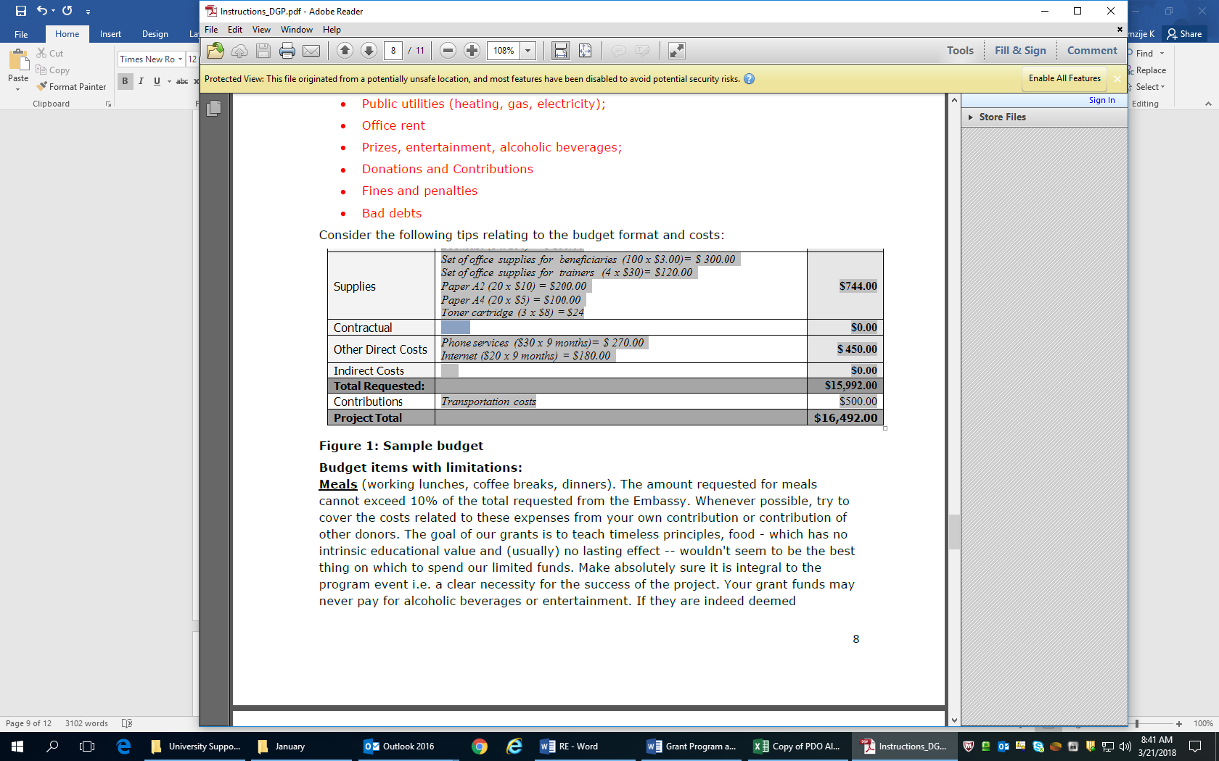

Budget items with limitations:

Meals (working lunches, coffee breaks, dinners). The amount requested for meals cannot exceed 5% of the total requested from the Embassy. Whenever possible, try to cover the costs related to these expenses from your own contribution or contribution of other donors. If food cost is included, make absolutely sure they are integral to the program event i.e. a clear necessity for the success of the project. Your grant funds may never pay for alcoholic beverages or entertainment. Salaries. Salaries may be paid only to persons directly involved in the project. Staff costs should reflect salaries by monthly rate, and the proportion of their time to be spent on the project. For example: Project Coordinator (100%) @$100/month x 12 months = $1,200 Total salary levels (including other sources) should be reasonable and no higher than other local salaries, and certainly US salaries, for similar work. They should be calculated based on the total number of hours to be worked by the employees for the duration of the project. Try to take into account other work they may be performing for other projects or activities when estimating the total hours worked each day on your project.
Equipment: Equipment costs must be well researched and justified. From the activities section, and the budget narrative, it should be clear why your project needs new equipment, e.g. a computer projector. Items that appear unreasonably expensive, or surprisingly inexpensive, will undermine the credibility of the proposal and the project.

4.1. Budget Summary
Standard Categories:
Personnel

Personnel category includes costs for any personnel directly employed by the recipient organization that can be directly attributed to the grant. It does not include personnel that indirectly work on the grant such as financial administration, secretarial or maintenance staff that work for the organization, but not on the grant. It could also include percentages of employees' time as long as that percentage is directly attributed to the grant. This could include project directors who administer several grant programs, persons hired to work on several different programs or work only part time on grant related activities.

Fringe Benefits
Fringe benefits category includes cost for items such as pension plans, expenses for social security, health benefits, or other benefits that conform to an organization's established policy. Again, fringe benefits would be for personnel directly working on the project. Often, this is shown as a percentage of salary or wages and would conform to the organization's established policy.
Travel
Travel category includes costs for domestic and international air fares, per diem rates, hotel costs, and local travel. All travel costs should be directly attributable to a grant project. Travel costs must be reasonable and itemized by the grantee.

Equipment
Equipment is defined as tangible personal property, which has a useful life of more than one year
and a per-unit acquisition cost of at least $5,000.
This would include computer equipment, books, laptops, printer, etc. installations, maintenance and anticipated repair costs.
Supplies
Supplies category includes costs for general office supplies, computer software, consumable automotive supplies, or other expendable supplies.

Contractual

Contractual category includes costs for procurement contracts under an award or sub-tier awards for goods or services. Contractual would include conference room rental, speaker’s fees, including but not limited to per diem and/or travel, security guard service, banking services, accounting services and audits.

Other Direct Costs

Other direct costs could include furniture, lamps, small equipment with a value of less than $100, postage, telephone, internet charges, printing and publishing materials, etc.
Direct costs are costs that can be identified specifically with a particular sponsored project, an instructional activity, or any other institutional activity, or that can be directly assigned to such activities relatively easily with a high degree of accuracy.

Indirect costs

Indirect costs are those that are incurred for common or joint objectives and therefore cannot be identified readily and specifically with a particular sponsored project, an instructional activity, or any other institutional activity. Typical examples of indirect cost for many non-profit organizations may include the costs of operating and maintaining facilities, and general administration and general expenses, such as the salaries and expenses of executive officers, personnel administration, and accounting. Normally the University Grants program does not fund indirect costs; therefore all costs should be represented, whenever feasible, as direct costs.

Contributions:
Proposals that include cost-sharing are often more competitive than those that do not. Cost-sharing refers to that portion of the project or program costs not requested from the U.S. Embassy and can include monetary or third party in-kind contributions. Cost-shares must be realistic and reflect the true value of the item or service being provided.

4.2 Budget Narrative

This section should include brief justifications for each line item of the proposed budget.

4.3 Miscellaneous

This section should provide any additional information about the project that hasn’t been included.

5. CERTIFICATIONS
_______________________________________________________________________
This section provides certification that the information provided in the grant proposal is accurate. Please mark the first checkbox to certify that the statements contained in the form are true, complete and accurate. Mark the second checkbox to certify that you have read, understood and followed the instructions provided with the form. Please remember to sign the form by writing your name in the box and enter the date in the space provided.

